Supplementary Data

Antitumor Triterpenoid Saponin from the Fruits of Avicennia marina
Xiong-Wu Yang^{1,3}, Zhi Dai ^{2,3}, Bei Wang^{1,3}, Ya-Ping Liu^{1,4}, Xu-Dong Zhao^{2,*}, Xiao-Dong Luo^{1,4,}*
1 State Key Laboratory of Phytochemistry and Plant Resources in West China, Kunming Institute of Botany, Chinese Academy of Sciences, Kunming 650201, People’s Republic of China 2 Key Laboratory of Animal Models and Human Disease Mechanisms, Kunming Institute of Zoology, Chinese Academy of Sciences, Kunming 650223, People’s Republic of China 3 University of Chinese Academy of Sciences, Beijing 100049, People’s Republic of China 4 Yunnan Key Laboratory of Natural Medicinal Chemistry, Kunming, 650201, P. R. China

∗ Corresponding authors:
E-mail address: xdluo@mail.kib.ac.cn (X. D. Luo); zhaoxudong@mail.kiz.ac.cn (X. D. Zhao).

Table of Contents
No. | Contents
1 | Fig. S1 ¹H NMR spectrum of compound 1 in DMSO-d₆
2 | Fig. S2 ¹³C NMR spectrum of compound 1 in DMSO-d₆
3 | Fig. S3 COSY spectrum of compound 1 in DMSO-d₆
4 | Fig. S4 HSQC spectrum of compound 1 in DMSO-d₆
5 | Fig. S5 HMBC spectrum of compound 1 in DMSO-d₆
6 | Fig. S6 ROESY spectrum of compound 1 in DMSO-d₆
7 | Fig. S7 HRESIMS spectrums of compound 1 in DMSO-d₆
8 | Fig. S8 UV spectrum of compound 1 in Methanol
9 | Fig. S9 IR spectrum of compound 1
10 | Fig. S10 Optical rotation of compound 1
11 | Fig. S11 The GC spectra of standard D-glucose
12 | Fig. S12 The GC spectra of standard D-glucuronic acid
13 | Fig. S12 The GC spectra of the sugar moieties of compound 1

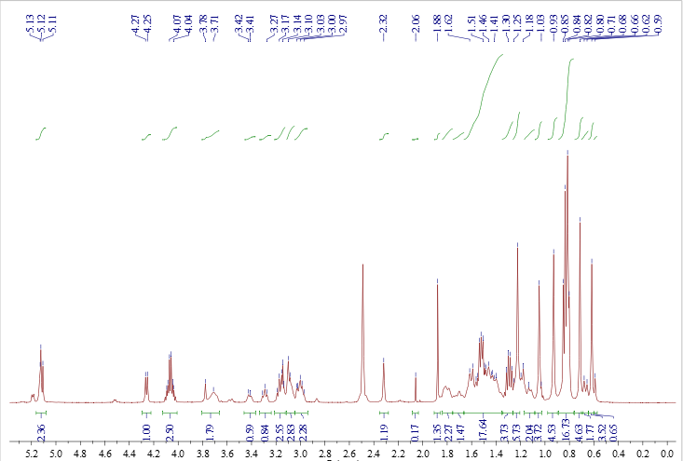
Fig. S1 1H NMR spectrum of compound 1 in DMSO-d₆
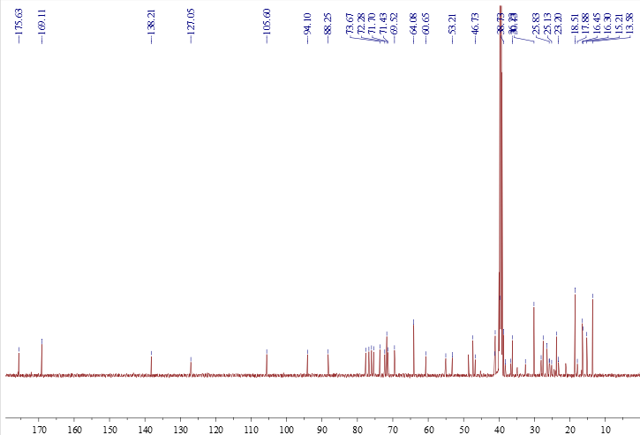
Fig. S2 ¹³C NMR spectrum of compound 1 in DMSO-d₆
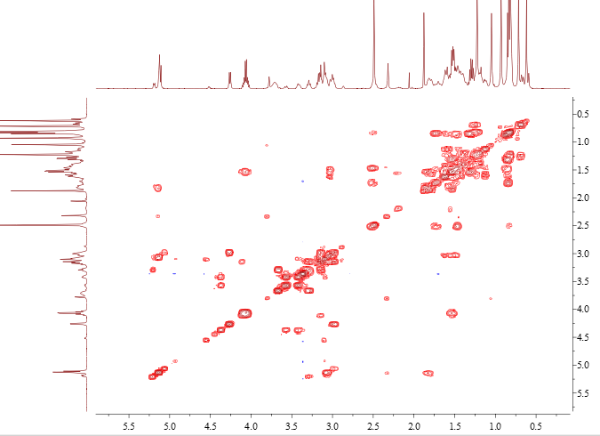
Fig. S3 COSY spectrum of compound 1 in DMSO-d₆
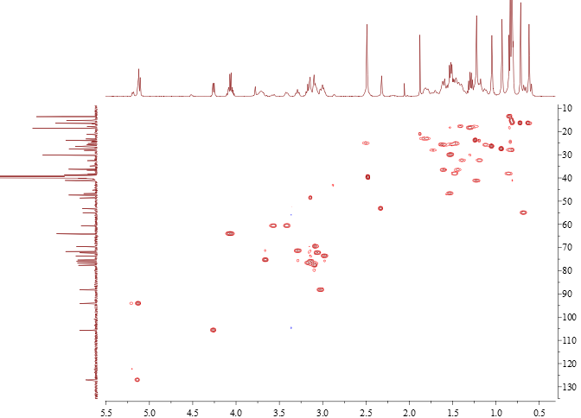
Fig. S4 HSQC spectrum of compound 1 in DMSO-d₆

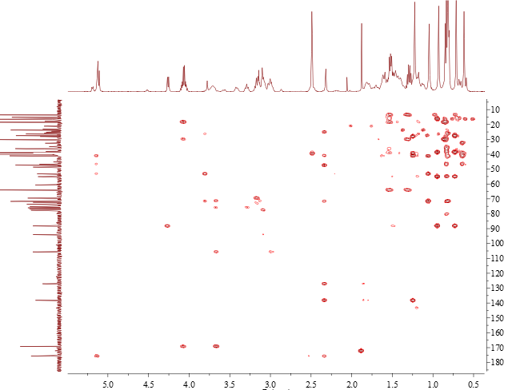
Fig. S5 HMBC spectrum of compound 1 in DMSO-d₆
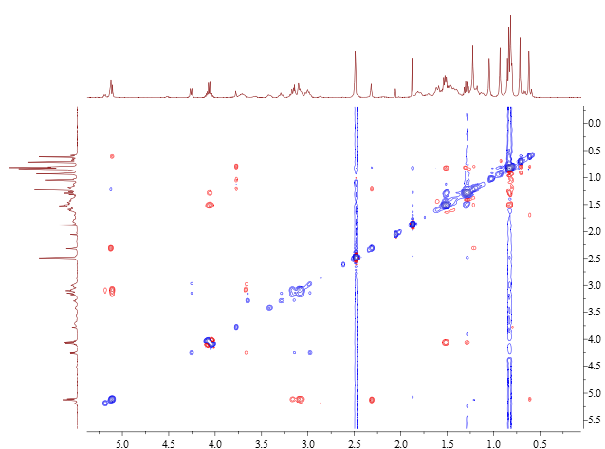
Fig. S6 ROESY spectrum of compound 1 in DMSO-d₆

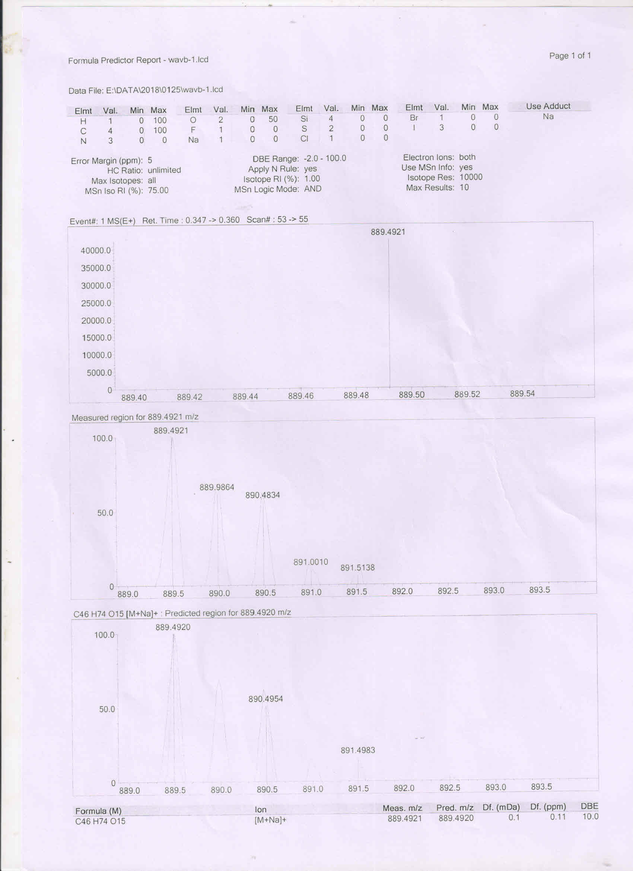
Fig. S7 HRESIMS spectrums of compound 1 in DMSO-d₆

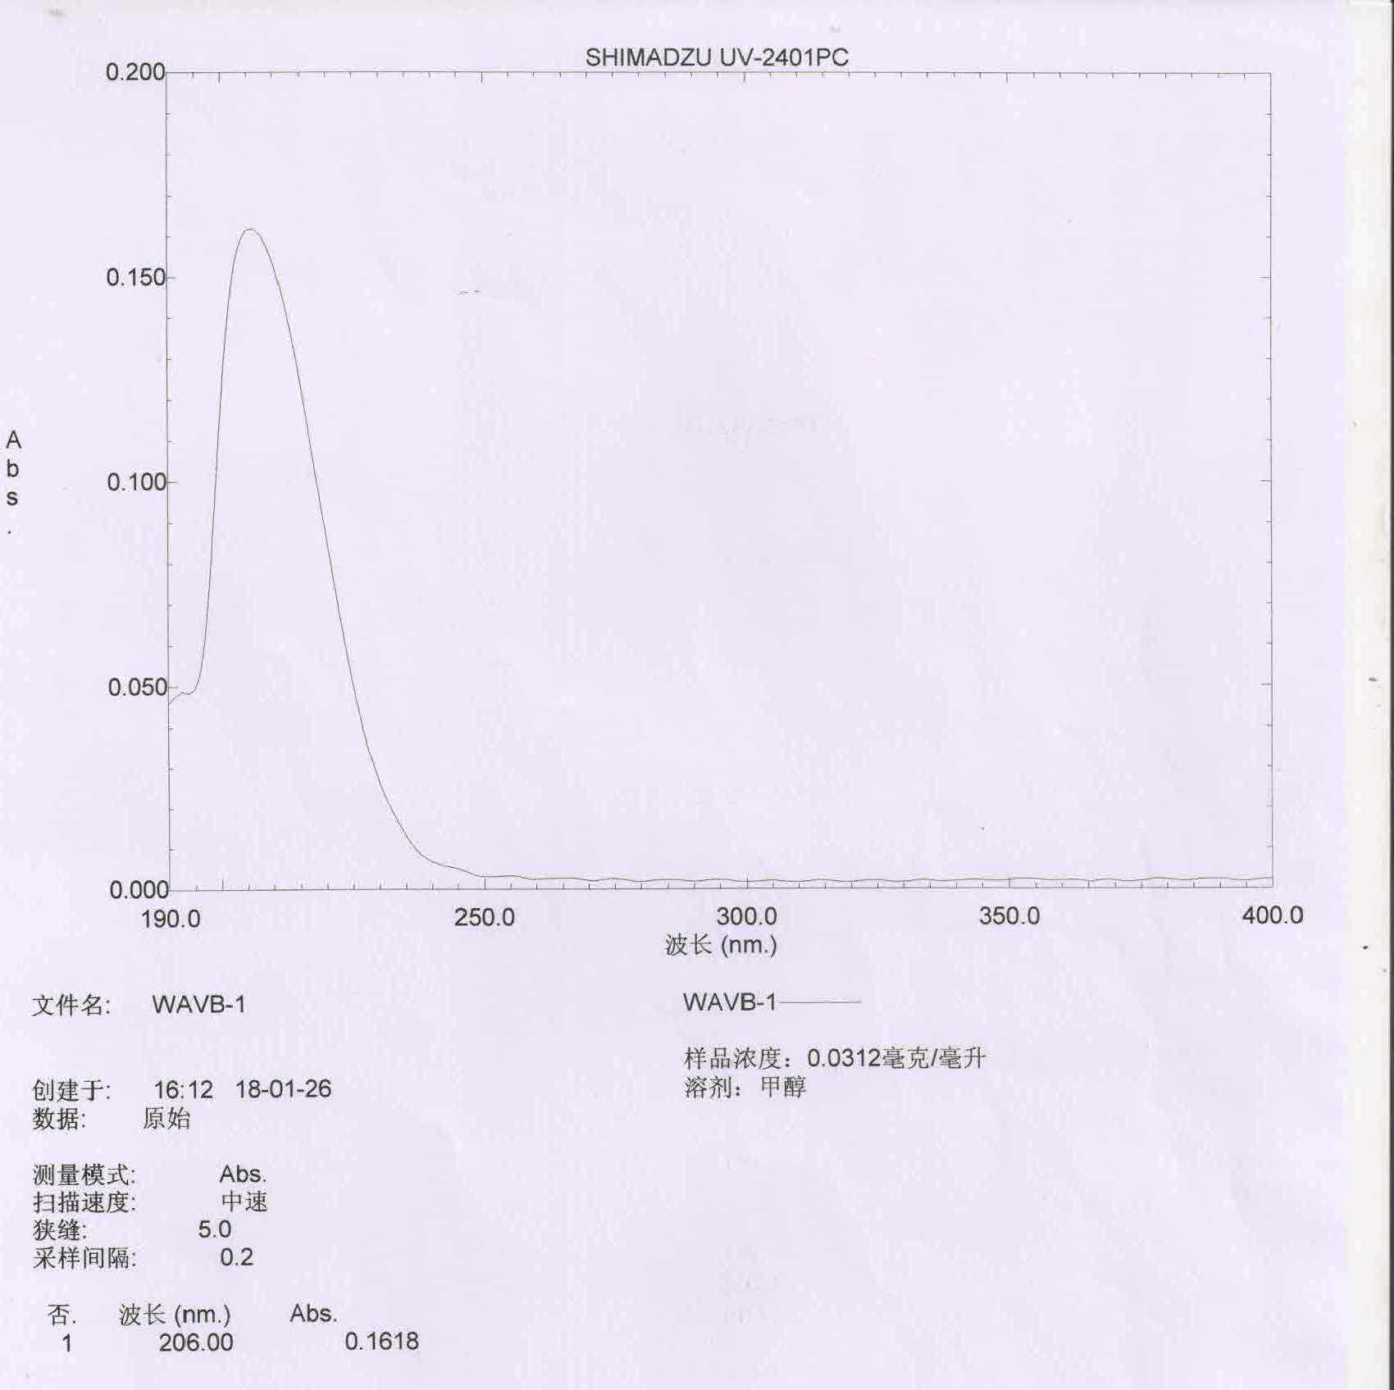
Fig. S8 UV spectrum of compound 1 in Methanol

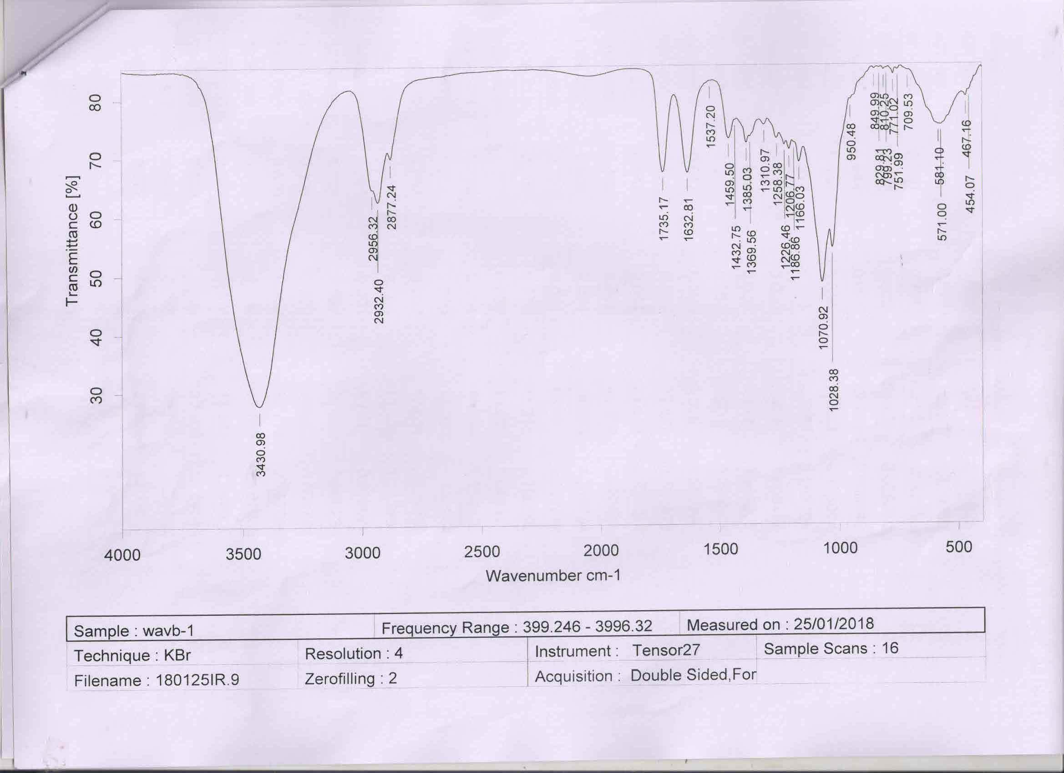
Fig. S9 IR spectrum of compound 1
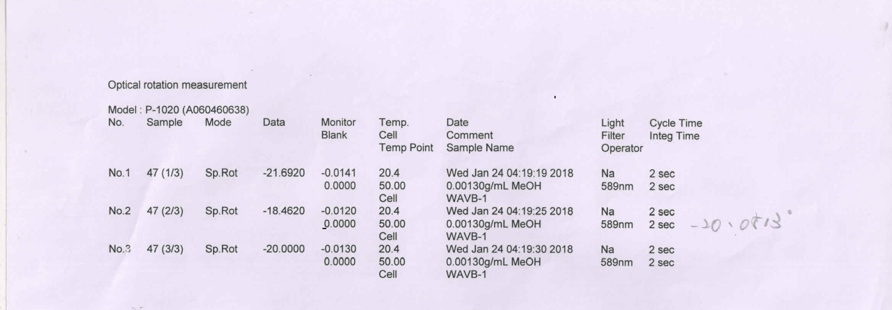
Fig. S10 Optical rotation of compound 1

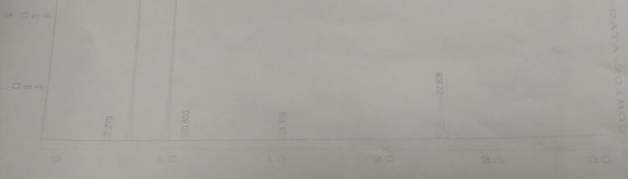
Fig. S11 The GC spectra of standard D-glucose

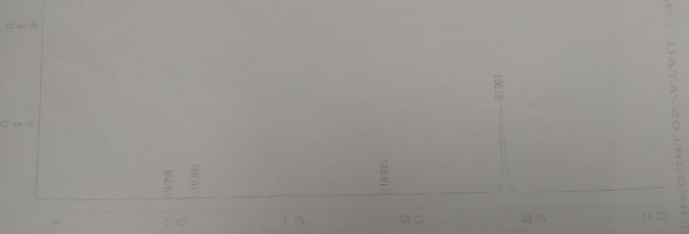

Fig. S12 The GC spectra of standard D-glucuronic acid

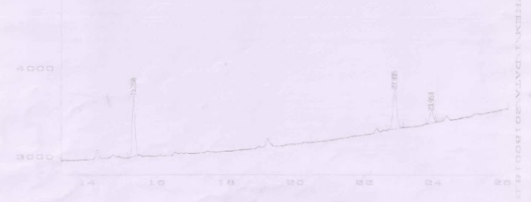
Fig. S12 The GC spectra of the sugar moieties of compound 1

