Phenolic constituents, antioxidative, tyrosinase inhibitory and anti-aging activities from Dendrobium loddigesii Rolfe

Rui-Jing Ma^{a,b,†} ∙ Liu Yang^{a,c,†} ∙ Xue Baiª ∙ Jin-Yu Liª ∙ Ming-Yan Yuan^{a,c} ∙ Ya-Qin Wang^{c} ∙ Yong Xie^{c} ∙ Jiang-Miao Hu^{a,c,}* ∙ Jun Zhouª

ª State Key Laboratory of Phytochemistry and Plant Resources in West China, Kunming Institute of Botany, Chinese Academy of Sciences, Kunming 650201, People′s Republic of China
^{b} College of pharmacy, Guilin Medical University, Guilin 541004, People′s Republic of China
^{c} R & D Center of Dr. Plant, Kunming Institute of Botany, Chinese Academy of Sciences, Kunming 650201, People′s Republic of China

† These authors contribute equally to this work.
Corresponding Author:
* Tel: (86) 871-65223264. E-mail: hujiangmiao@mail.kib.ac.cn

Supporting Materials
 | Pag.
Figure S1 ¹H NMR spectrum of compound 1 | 3
Figure S2 ¹³C NMR spectrum of compound 1 | 4
Figure S3 HSQC spectrum of compound 1 | 5
Figure S4 HMBC spectrum of compound 1 | 6
Figure S5 COSY spectrum of compound 1 | 7
Figure S6 HRESIMS spectrum of compound 1 | 8
Figure S7 IR spectrum of compound 1 | 9
Figure S8 UV spectrum of compound 1 | 10
Figure S9 ¹H NMR spectrum of compound 2 | 11
Figure S10 ¹³C NMR spectrum of compound 2 | 12
Figure S11 HSQC spectrum of compound 2 | 13
Figure S12 HMBC spectrum of compound 2 | 14
Figure S13 COSY spectrum of compound 2 | 15
Figure S14 HRESIMS spectrum of compound 2 | 16
Figure S15 IR spectrum of compound 2 | 17
Figure S16 UV spectrum of compound 2 | 18
Figure S17 ¹H NMR spectrum of compound 3 | 19
Figure S18 ¹³C NMR spectrum of compound 3 | 20
Figure S19 HSQC spectrum of compound 3 | 21
Figure S20 HMBC spectrum of compound 3 | 22
Figure S21 COSY spectrum of compound 3 | 23
Figure S22 HRESIMS spectrum of compound 3 | 24
Figure S23 IR spectrum of compound 3 | 25
Figure S24 UV spectrum of compound 3 | 26

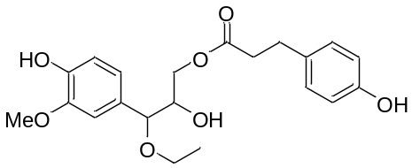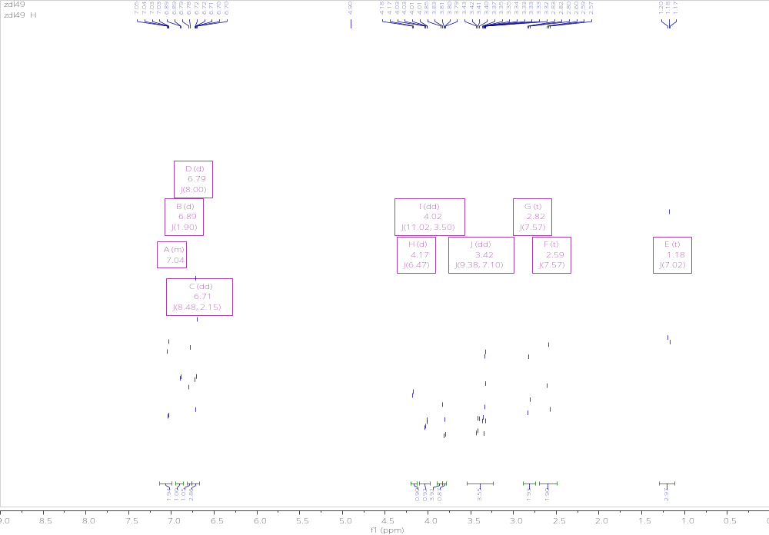
Figure S1. ¹H NMR spectrum (CD₃OD, 500 MHz) of 1

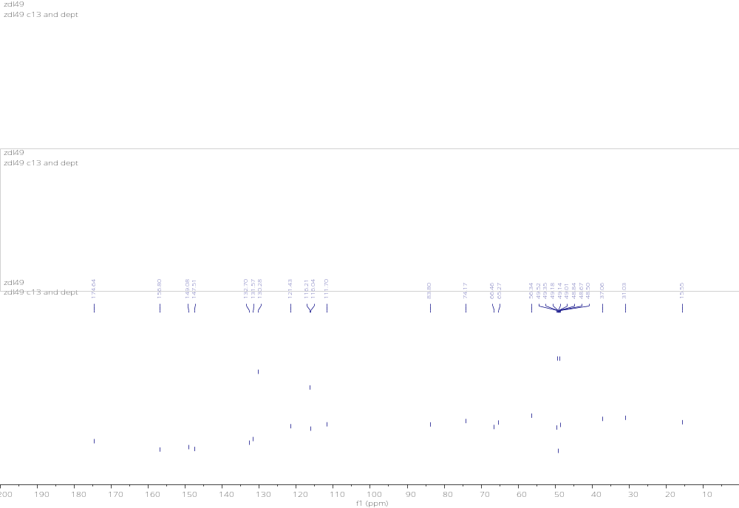
Figure S2. ¹³C NMR spectrum (CD₃OD, 500 MHz) of 1
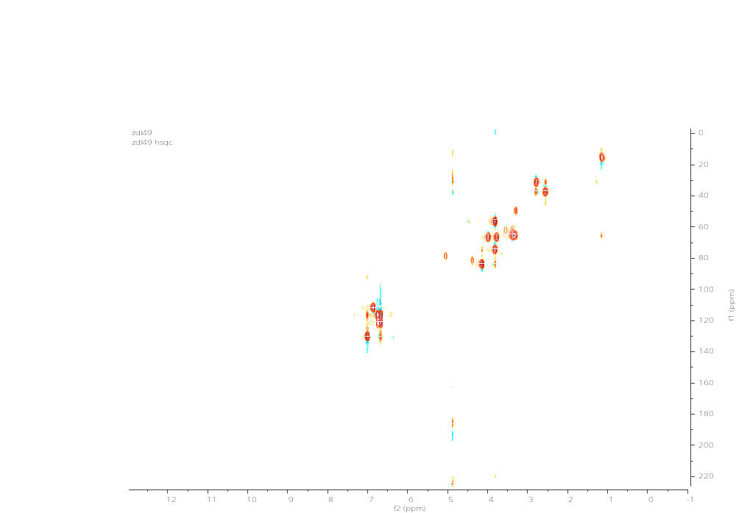
Figure S3. HSQC spectrum (CD₃OD, 500 MHz) of 1
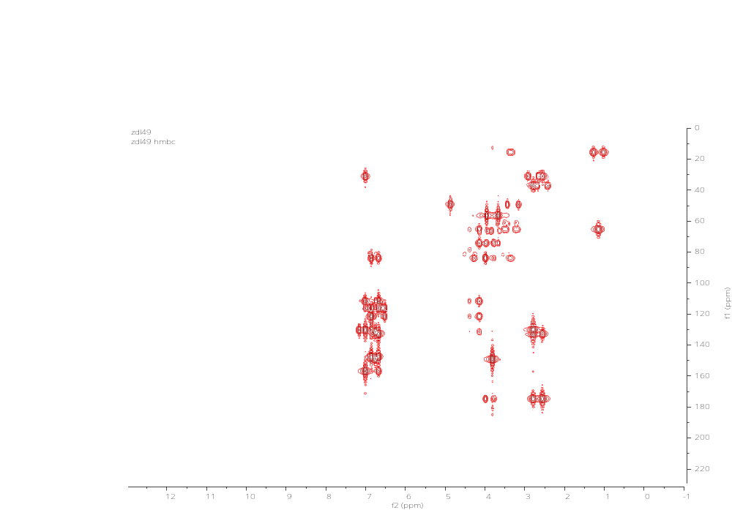
Figure S4. HMBC spectrum (CD₃OD, 500 MHz) of 1
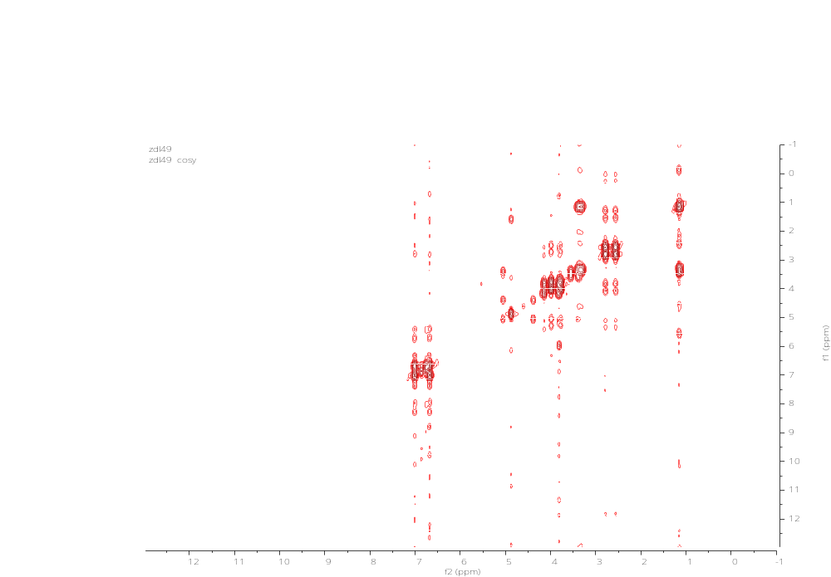
Figure S5. COSY spectrum (CD₃OD, 500 MHz) of 1

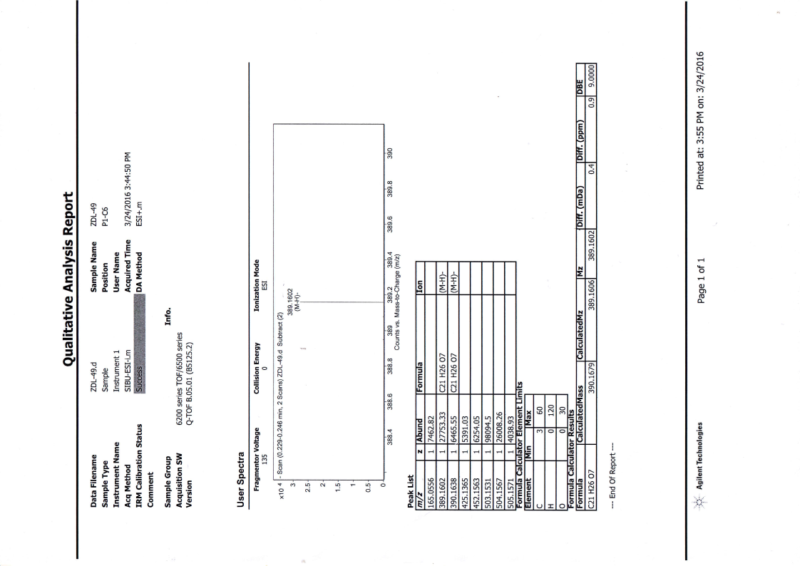
Figure S6. HR-ESI-MS spectrum 1
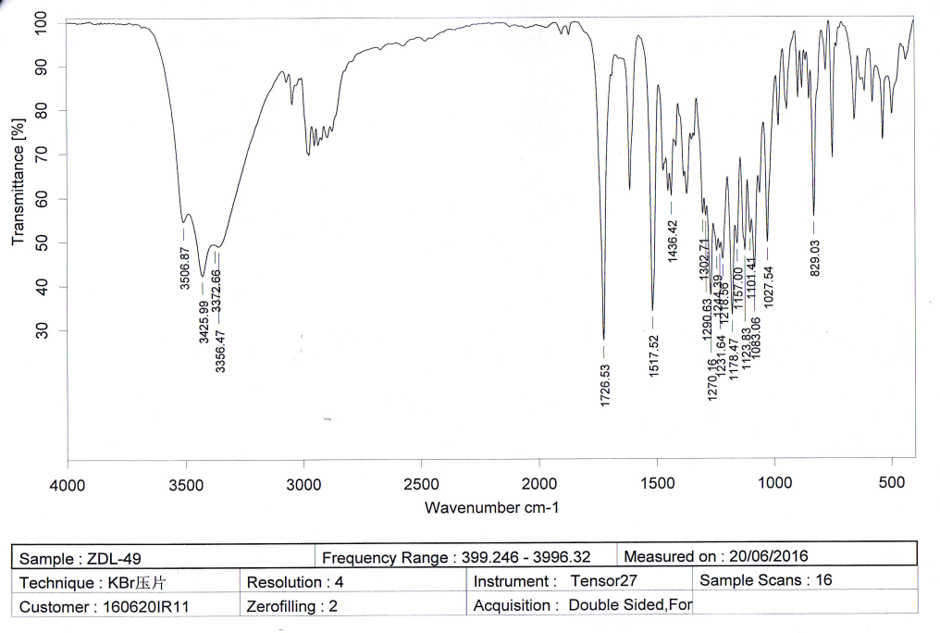
Figure S7. IR spectrum 1

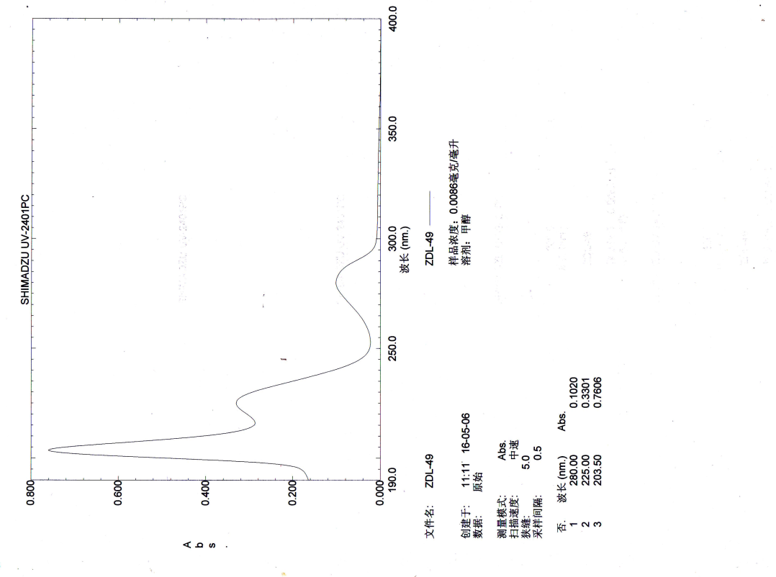
Figure S8. UV spectrum of 1
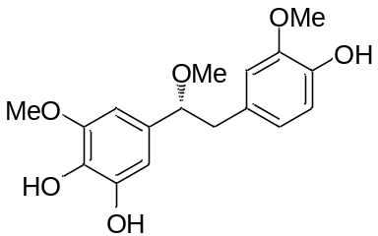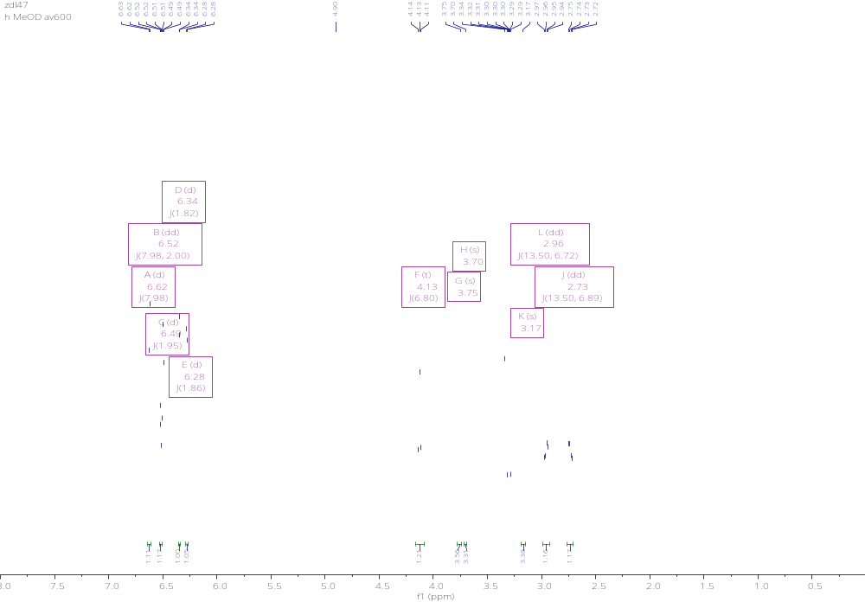
Figure S9. ¹H NMR spectrum (CD₃OD, 600 MHz) of 2
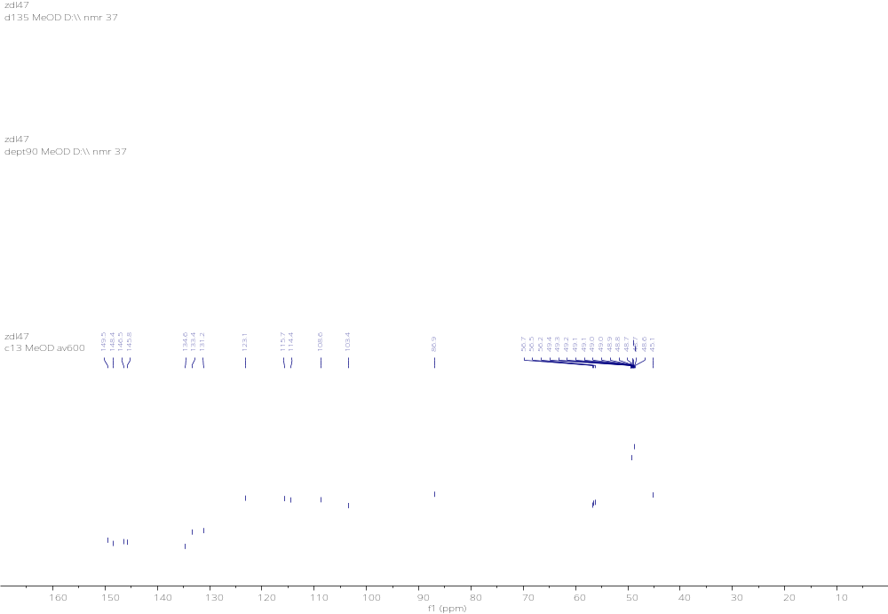
Figure S10. ¹³C NMR spectrum (CD₃OD, 600 MHz) of 2
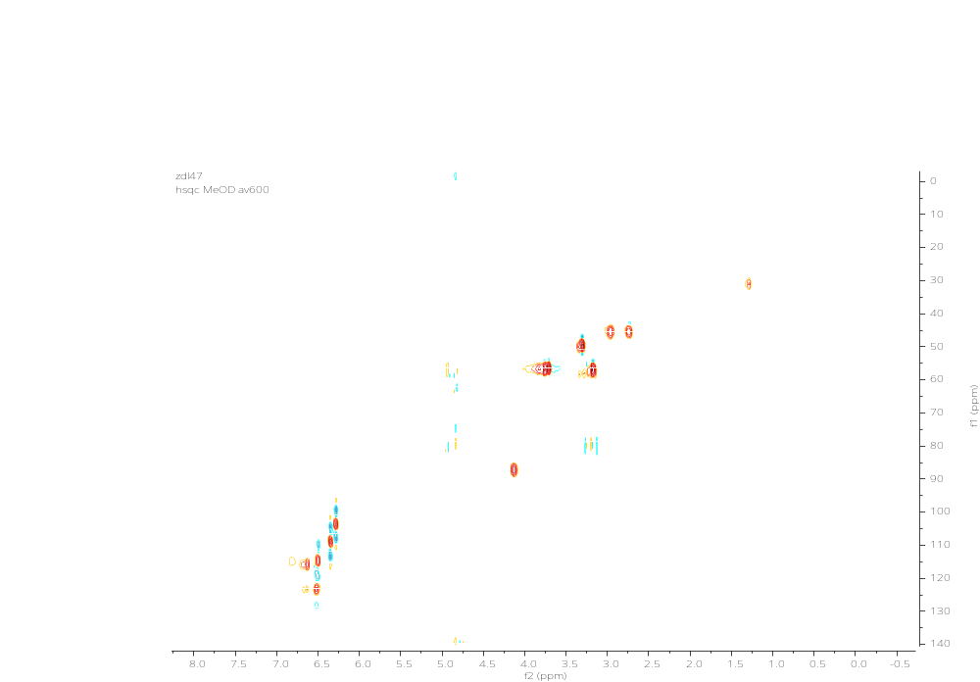

Figure S11. HSQC spectrum (CD₃OD, 600 MHz) of 2
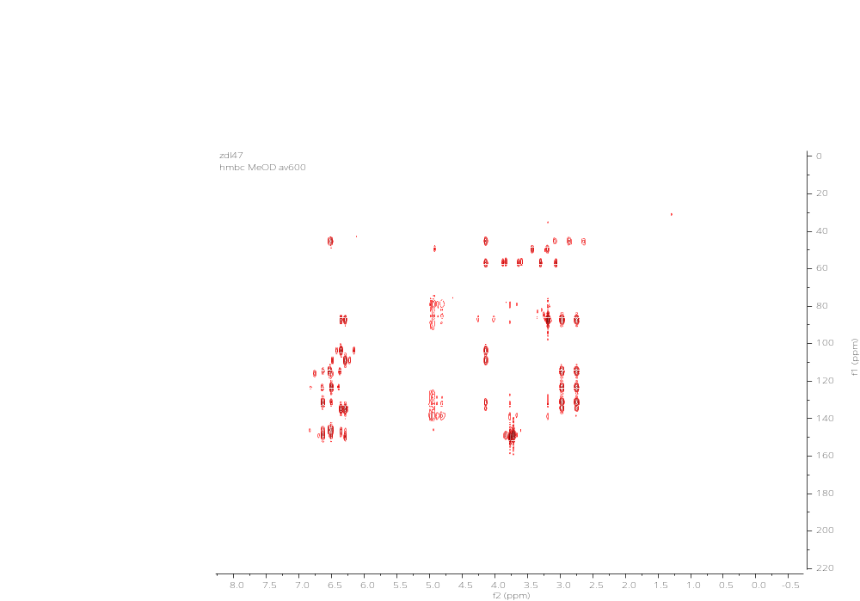
Figure S12. HMBC spectrum (CD₃OD, 600 MHz) of 2

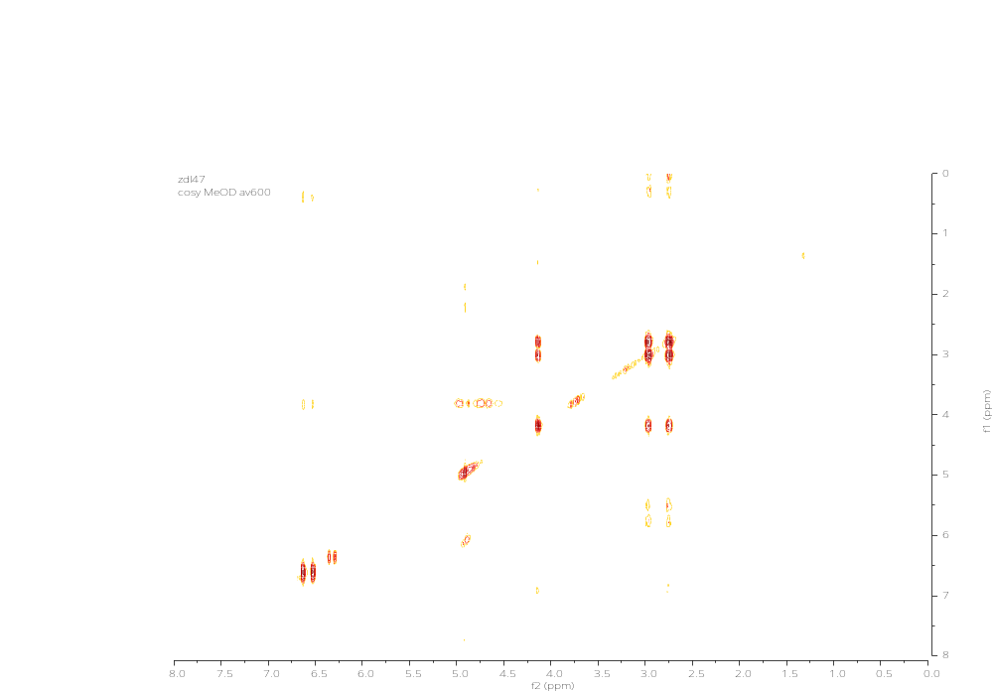
Figure S13. COSY spectrum (CD₃OD, 600 MHz) of 2
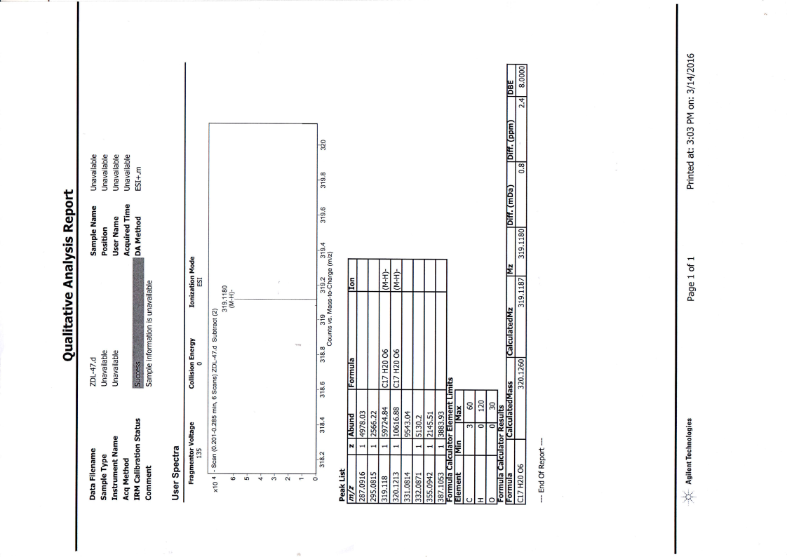
Figure S14. HR-ESI-MS spectrum of 2
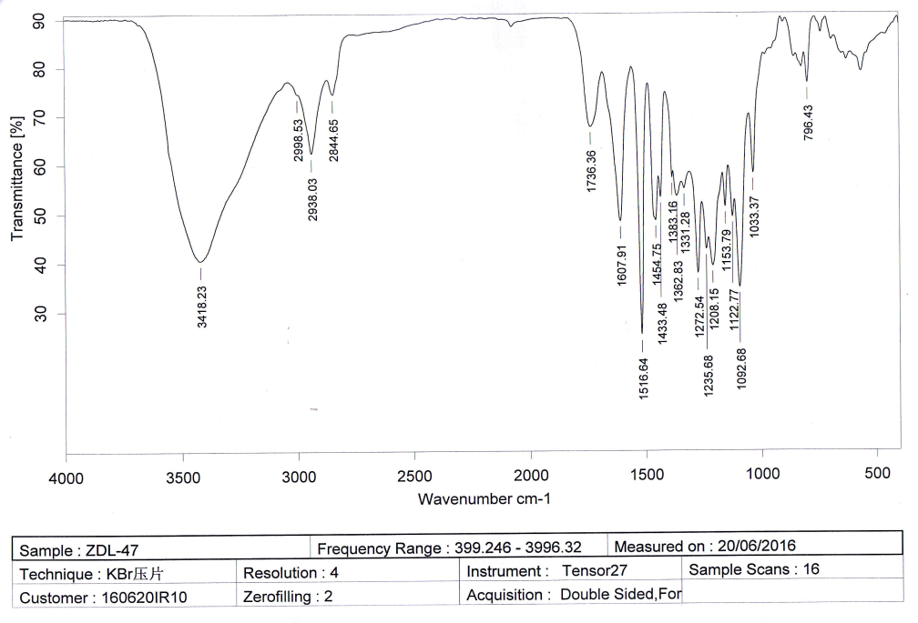
Figure S15. IR spectrum of 2

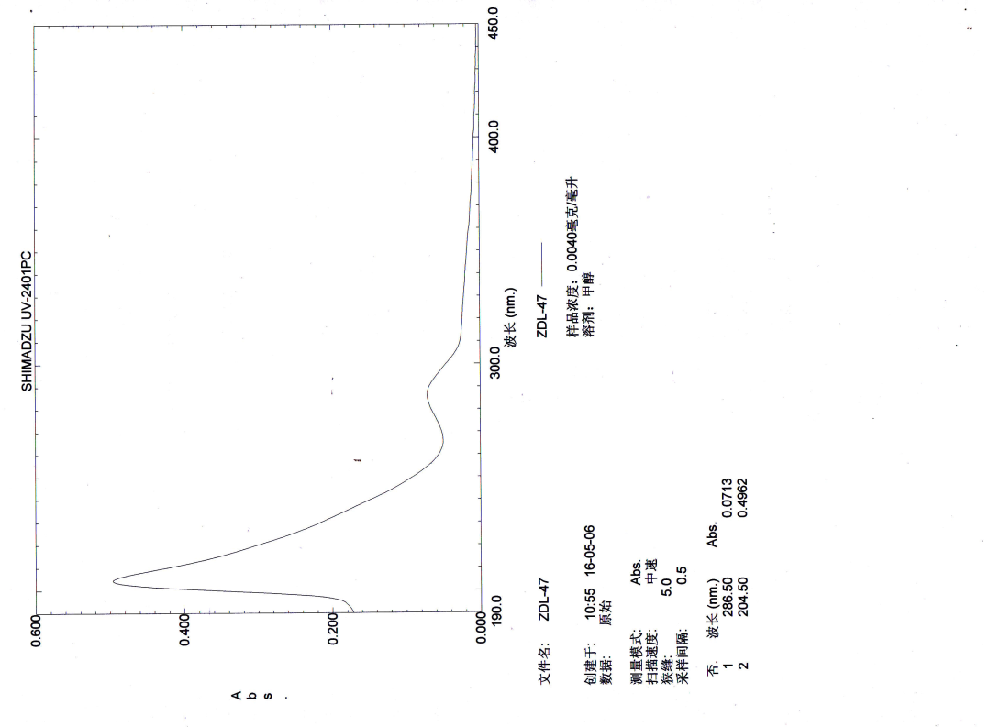
Figure S16. UV spectrum of 2
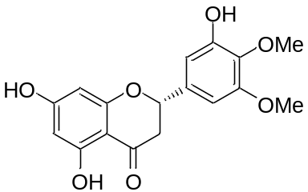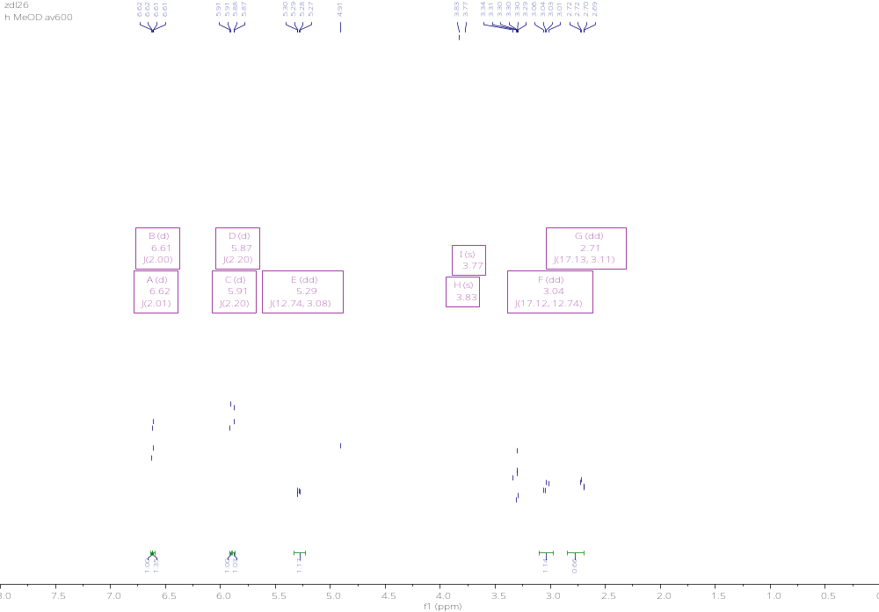
Figure S17. ¹H NMR spectrum (CD₃OD, 600 MHz) of

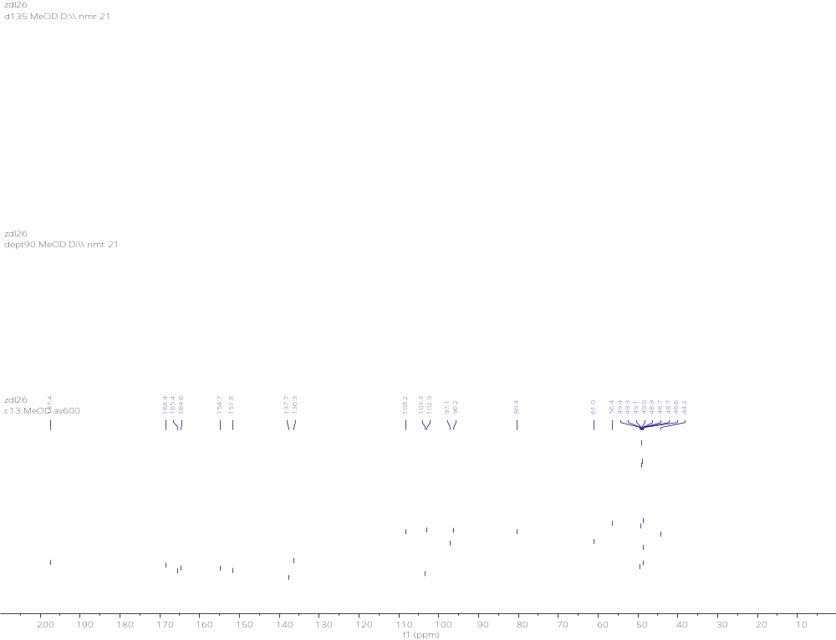
Figure S18. ¹³C NMR spectrum (CD₃OD, 600 MHz) of 3

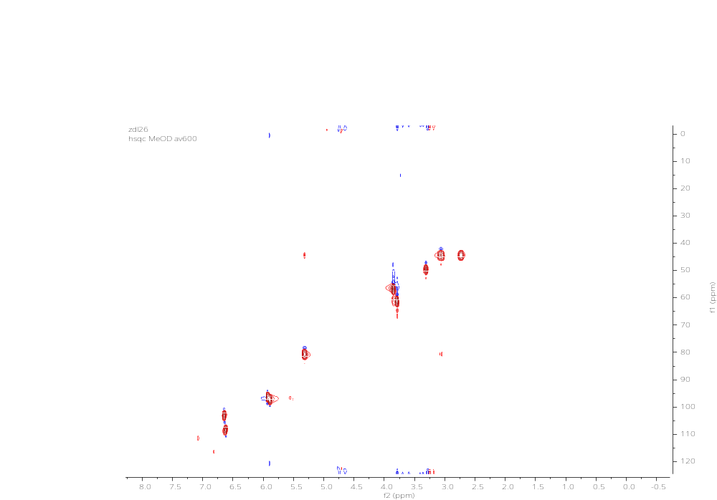
Figure S19. HSQC spectrum (CD₃OD, 600 MHz) of 3

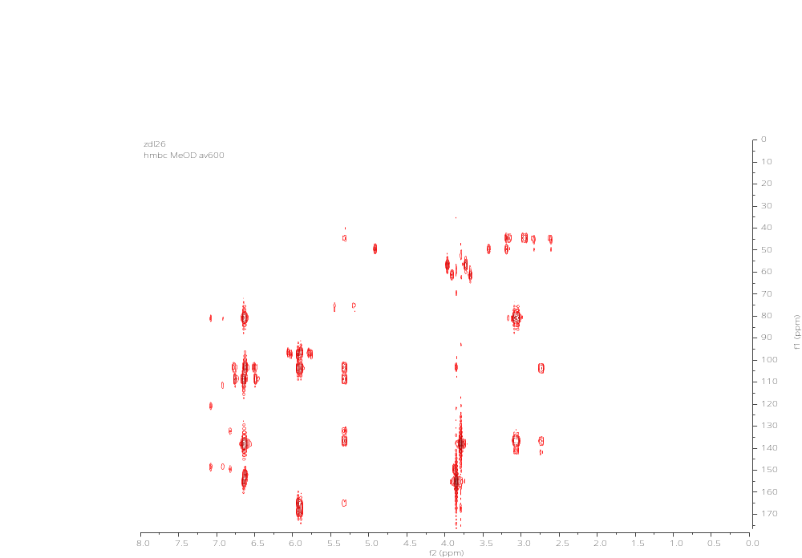
Figure S20. HMBC spectrum (CD₃OD, 600 MHz) of 3

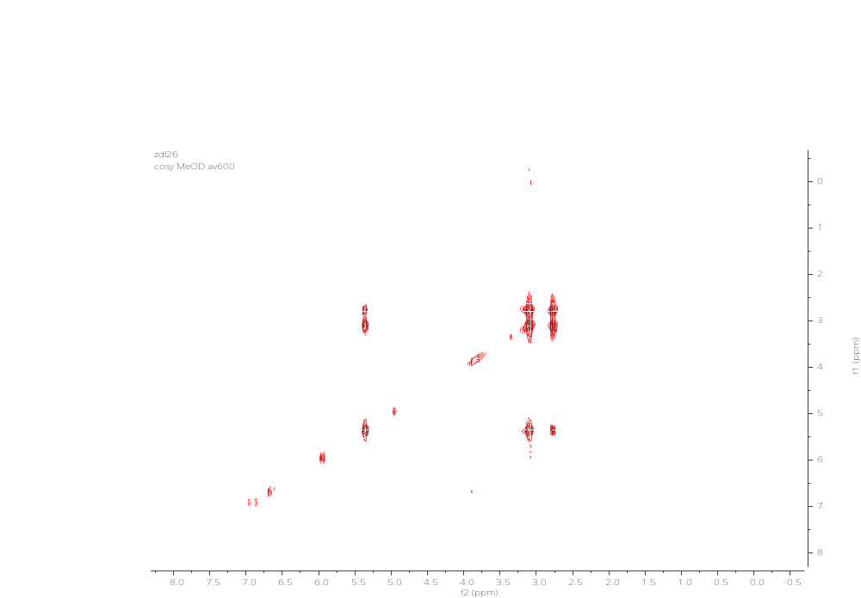
Figure S21. COSY spectrum (CD₃OD, 600 MHz) of 3

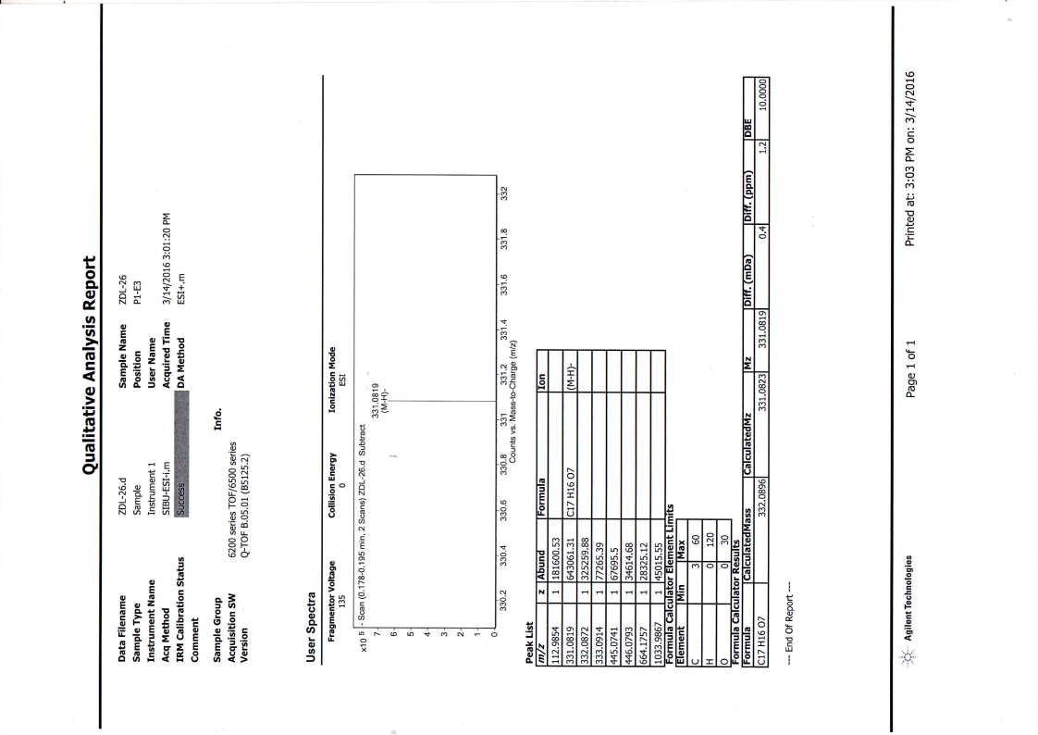
Figure S22. HR-ESI-MS spectrum of 3
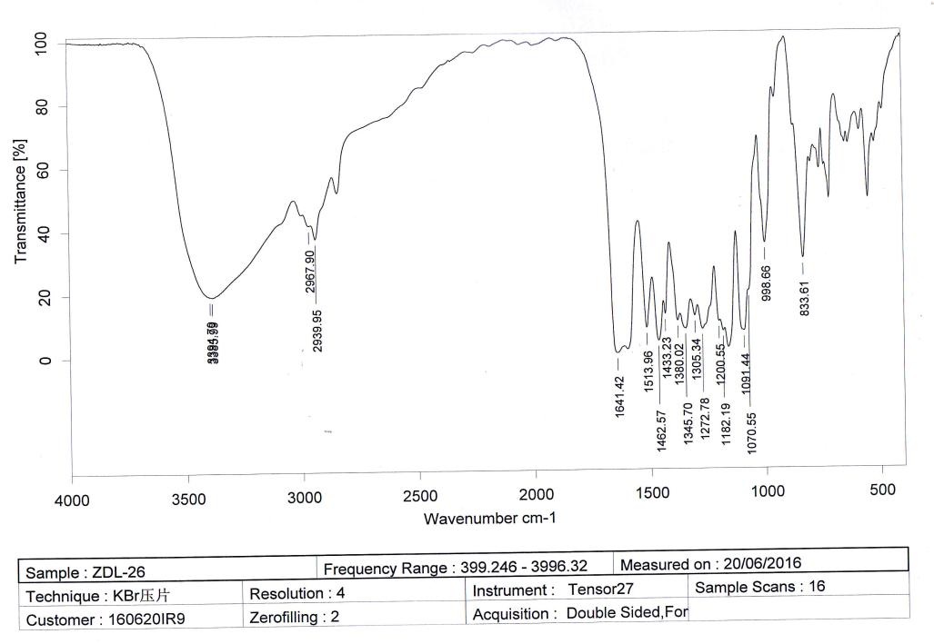
Figure S23. IR spectrum of 3

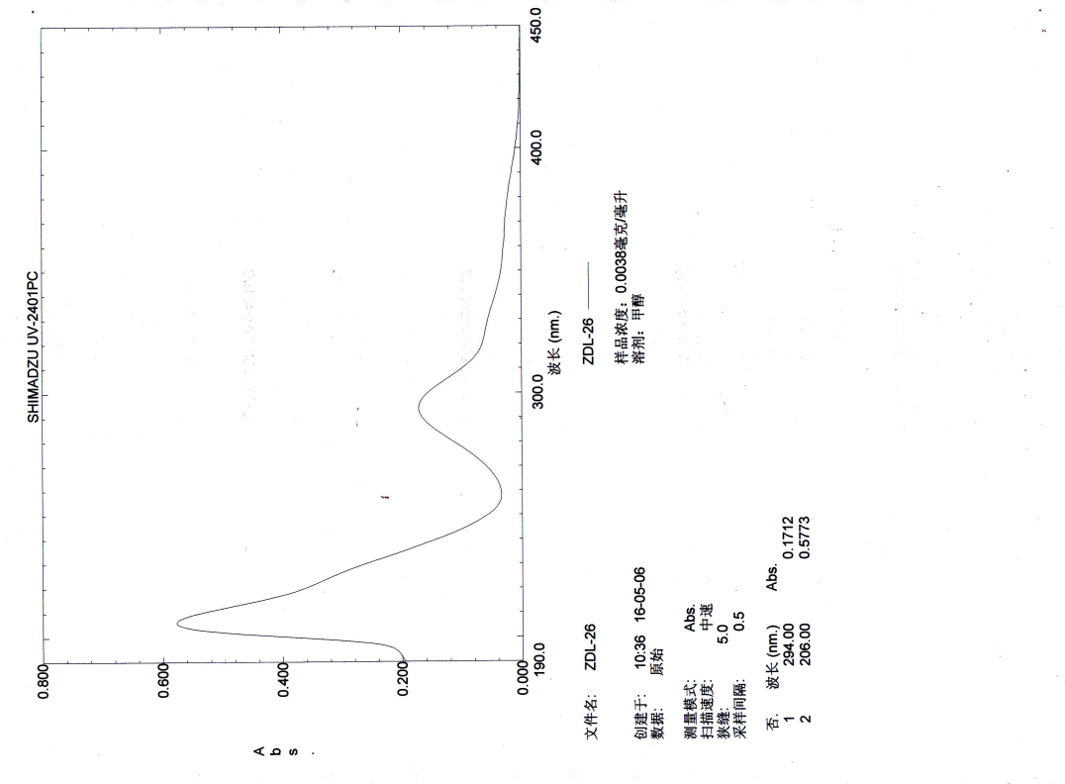
Figure S24. UV spectrum of 3

