Supplementary data for

Alkaloid Constituents of Ficus hispida and Their Antiinflammatory Activity

Xin-Yu Jia¹, Yong-Mei Wu², Jing-Ya Li², Chun Lei^{1*}, Ai-Jun Hou^{1*}

¹School of Pharmacy, State Key Laboratory of Medical Neurobiology, Fudan University, Shanghai 201203, China
²National Center for Drug Screening, Shanghai Institute of Materia Medica, Chinese Academy of Sciences, Shanghai 201203, China

Corresponding authors:
E-mails: chunlei@fudan.edu.cn (C. Lei); ajhou@shmu.edu.cn (A.-J. Hou)

Table of Contents
Fig. S1. ¹H NMR spectrum of compound 1 (in CD₃OD, 400 MHz) 3
Fig. S2. ¹³C NMR and DEPT spectra of compound 1 (in CD₃OD, 150 MHz) 3
Fig. S3. HSQC spectrum of compound 1 (in CD₃OD, 600 MHz) 4
Fig. S4. HMBC spectrum of compound 1 (in CD₃OD, 600 MHz) 4
Fig. S5. HRESIMS spectrum of compound 1 5
Fig. S6. ¹H NMR spectrum of compound 2 (in CD₃OD, 400 MHz) 5
Fig. S7. ¹³C NMR and DEPT spectra of compound 2 (in CD₃OD, 150 MHz) 6
Fig. S8. HSQC spectrum of compound 2 (in CD₃OD, 600 MHz) 6
Fig. S9. HMBC spectrum of compound 2 (in CD₃OD, 600 MHz) 7
Fig. S10. HRESIMS spectrum of compound 2 7
Fig. S11. ¹H NMR spectrum of compound 3 (in CD₃OD, 400 MHz) 8
Fig. S12. ¹³C NMR spectrum of compound 3 (in CD₃OD, 150 MHz) 8
Fig. S13. HSQC spectrum of compound 3 (in CD₃OD, 600 MHz) 9
Fig. S14. HMBC spectrum of compound 3 (in CD₃OD, 600 MHz) 9
Fig. S15. HRESIMS spectrum of compound 3 10
Fig. S16. ¹H NMR spectrum of compound 4 (in CD₃OD, 400 MHz) 10
Fig. S17. ¹³C NMR and DEPT spectra of compound 4 (in CD₃OD, 150 MHz) 11
Fig. S18. HSQC spectrum of compound 4 (in CD₃OD, 600 MHz) 11
Fig. S19. HMBC spectrum of compound 4 (in CD₃OD, 600 MHz) 12
Fig. S20. HRESIMS spectrum of compound 4 12

Fig. S1. ¹H NMR spectrum of compound 1 (in CD₃OD, 400 MHz)
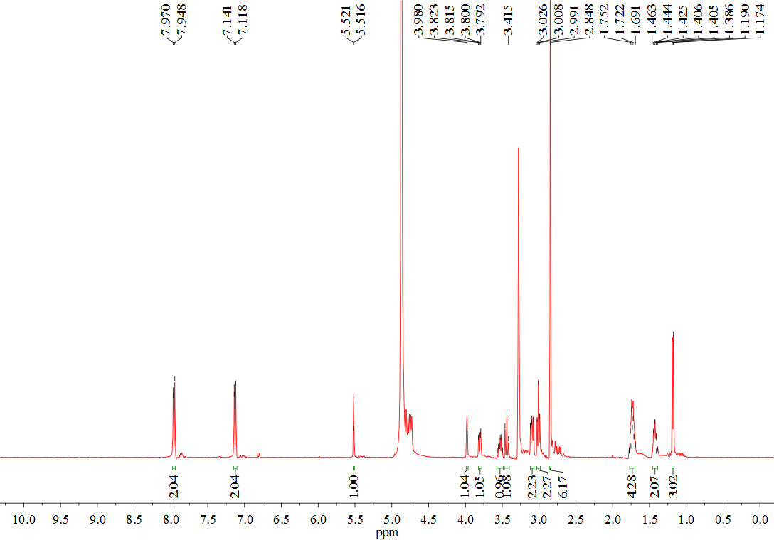

Fig. S2. ¹³C NMR and DEPT spectra of compound 1 (in CD₃OD, 150 MHz)
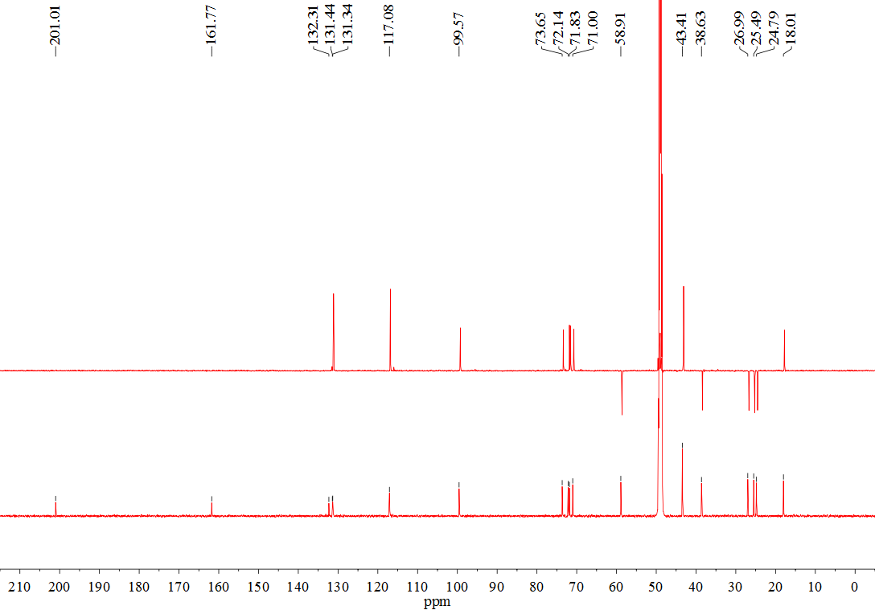

Fig. S3. HSQC spectrum of compound 1 (in CD₃OD, 600 MHz)
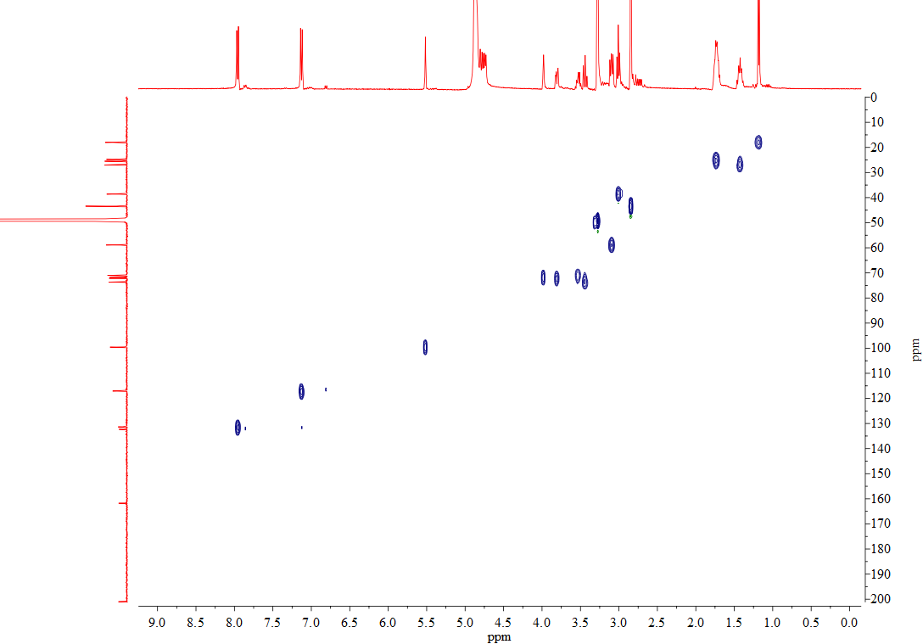

Fig. S4. HMBC spectrum of compound 1 (in CD₃OD, 600 MHz)
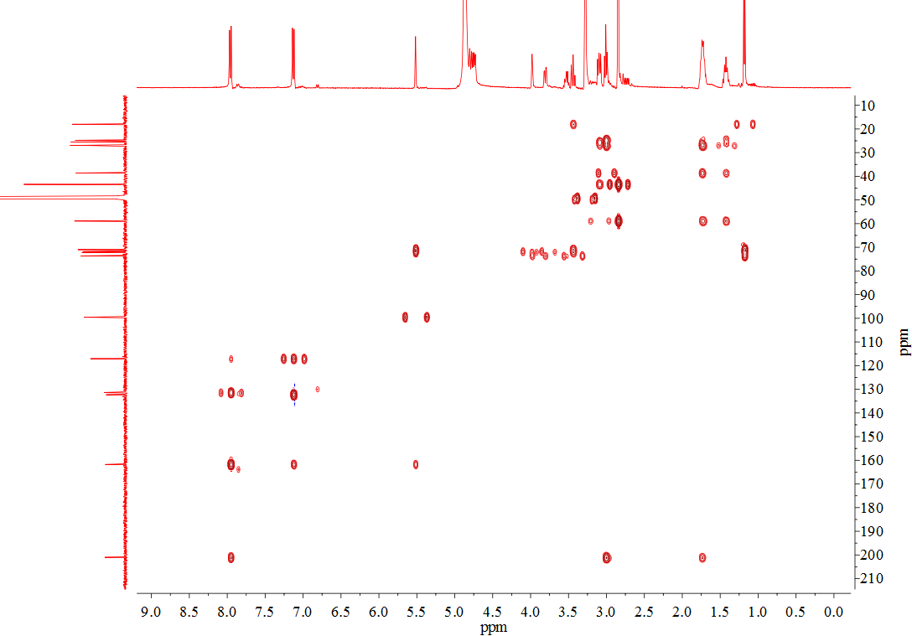

Fig. S5. HRESIMS spectrum of compound 1
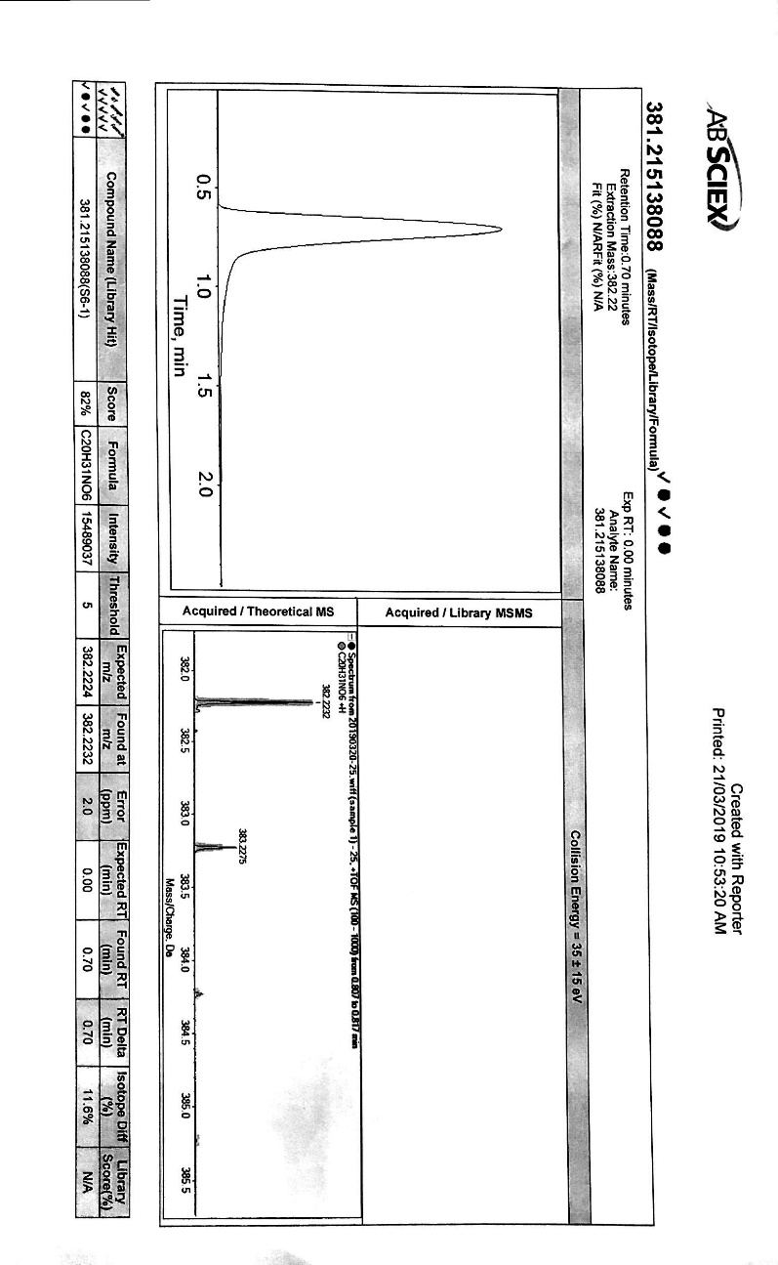

Fig. S6. ¹H NMR spectrum of compound 2 (in CD₃OD, 400 MHz)
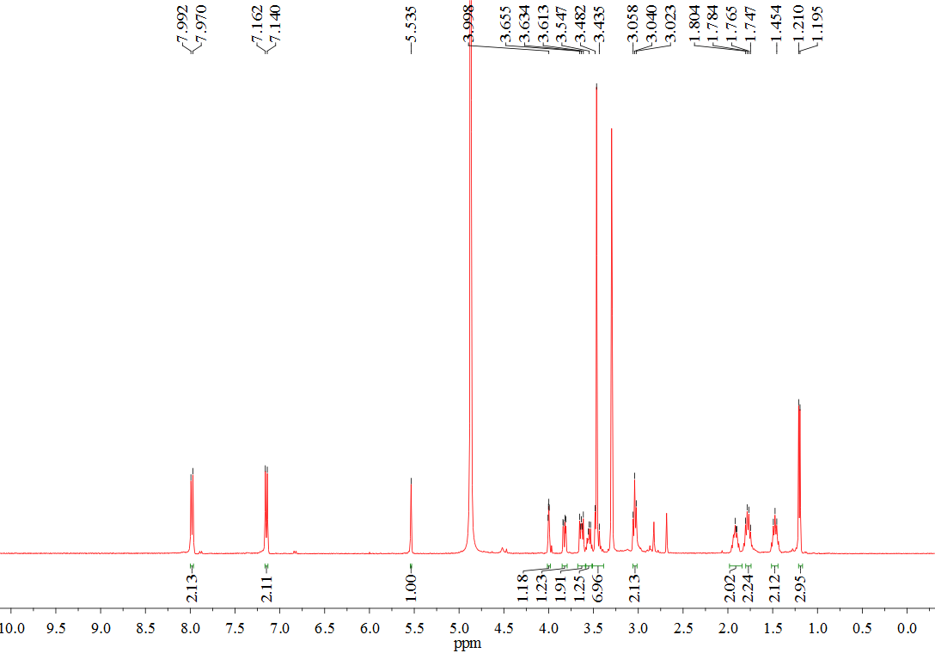

Fig. S7. ¹³C NMR and DEPT spectra of compound 2 (in CD₃OD, 150 MHz)

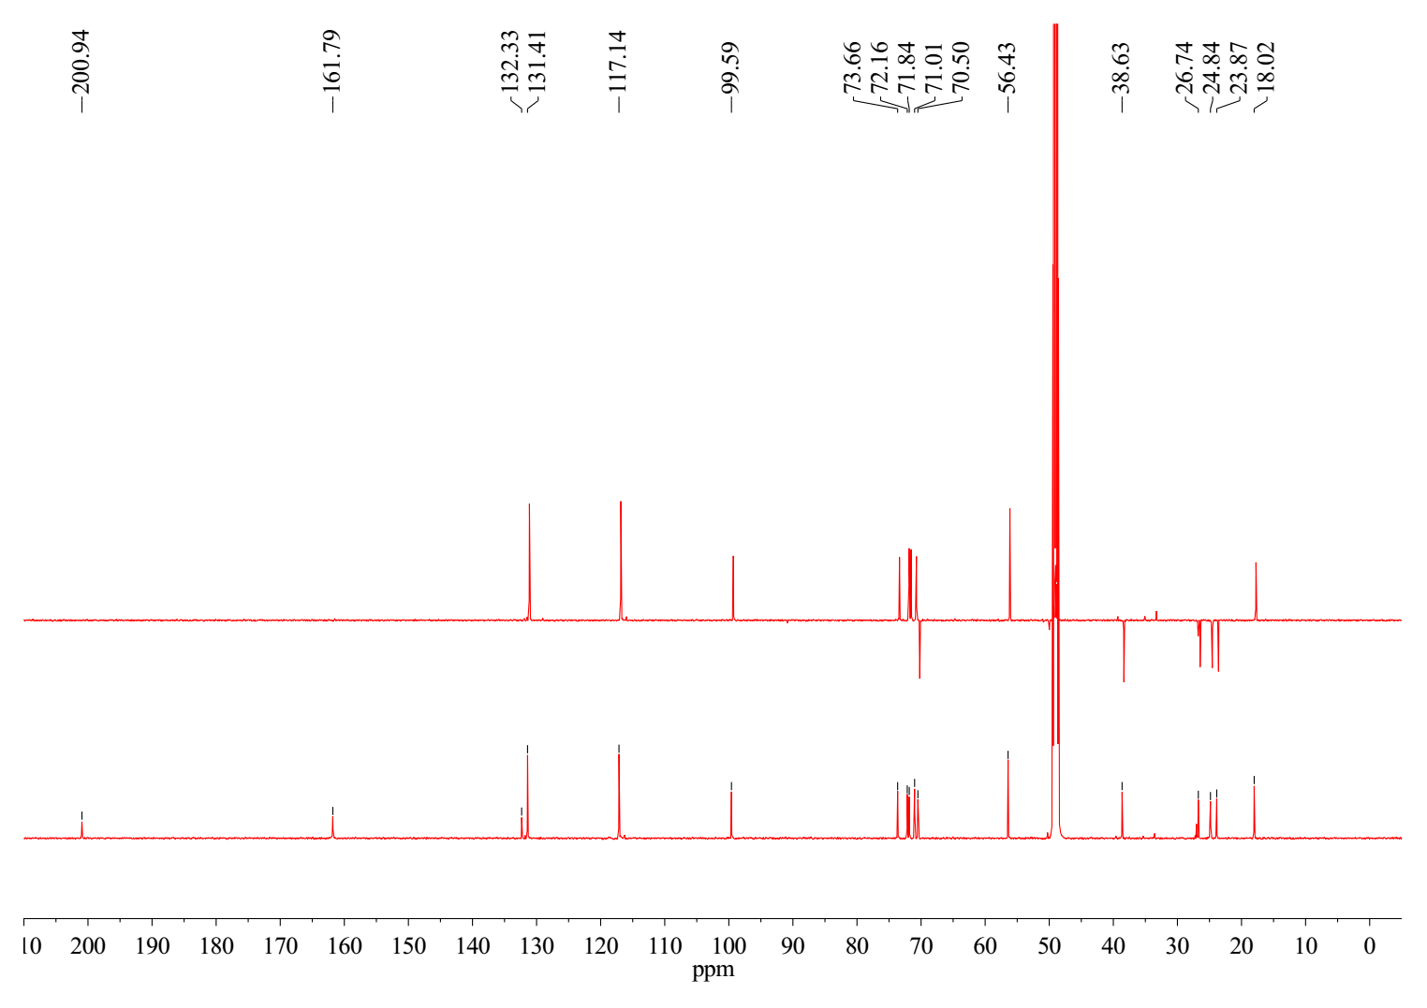

Fig. S8. HSQC spectrum of compound 2 (in CD₃OD, 600 MHz)
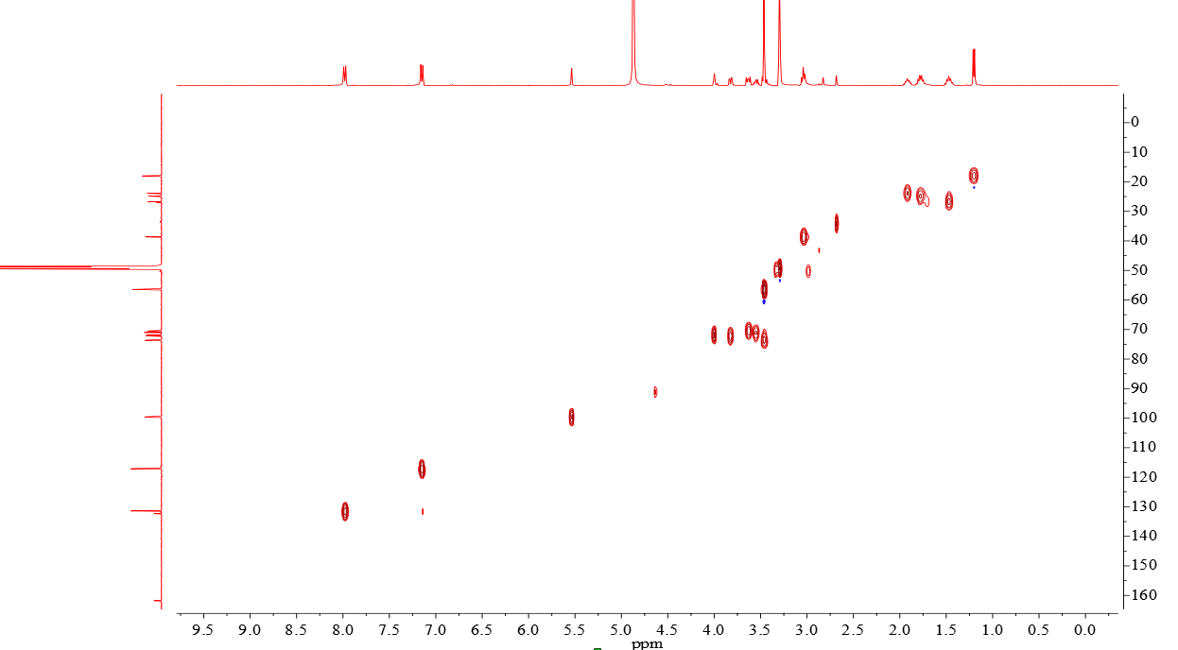

Fig. S9. HMBC spectrum of compound 2 (in CD₃OD, 600 MHz)

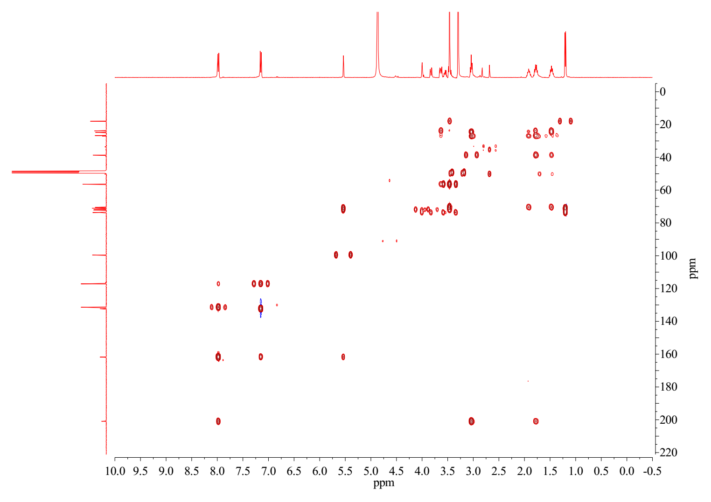

Fig. S10. HRESIMS spectrum of compound 2
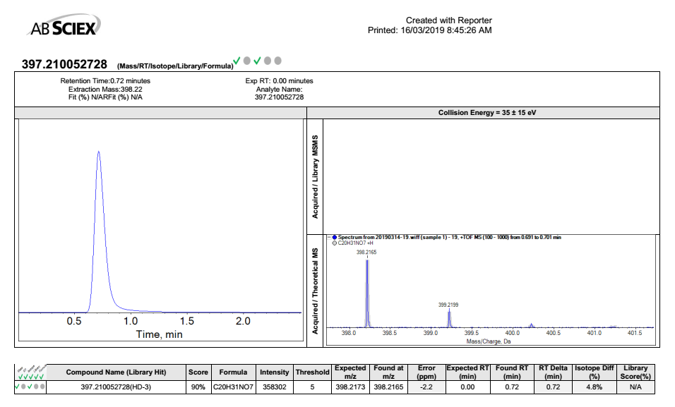

Fig. S11. ¹H NMR spectrum of compound 3 (in CD₃OD, 400 MHz)

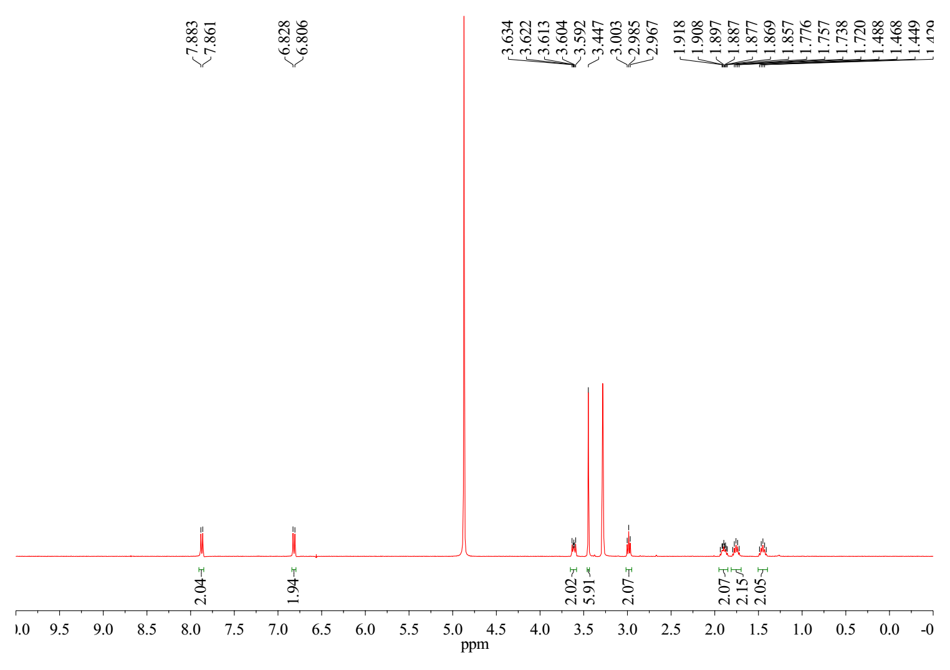

Fig. S12. ¹³C NMR spectrum of compound 3 (in CD₃OD, 150 MHz)
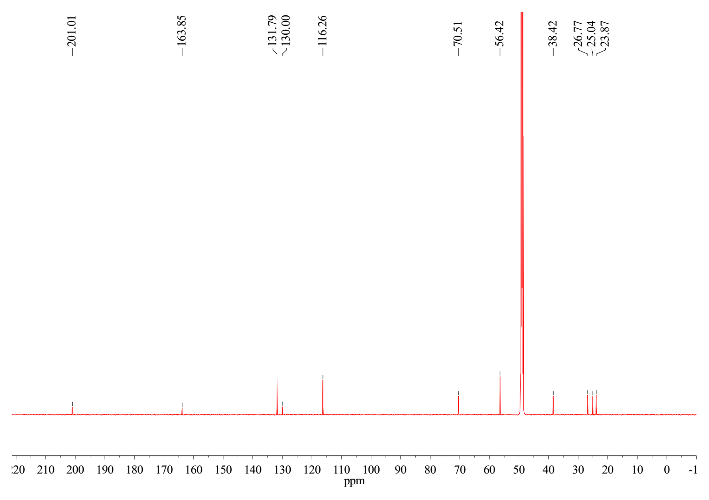

Fig. S13. HSQC spectrum of compound 3 (in CD₃OD, 600 MHz)
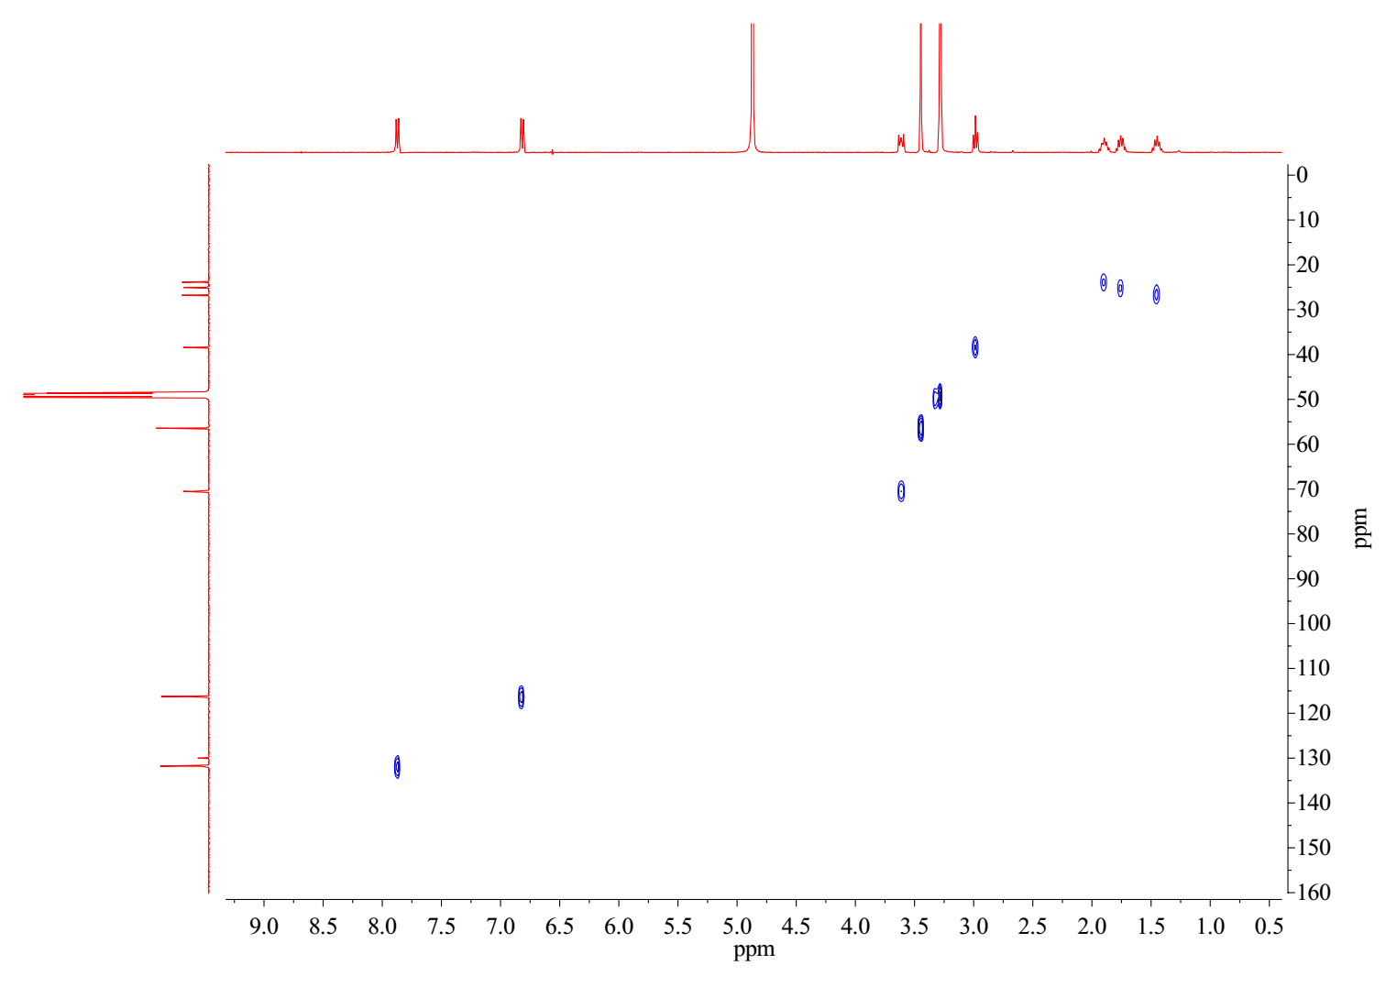

Fig. S14. HMBC spectrum of compound 3 (in CD₃OD, 600 MHz)

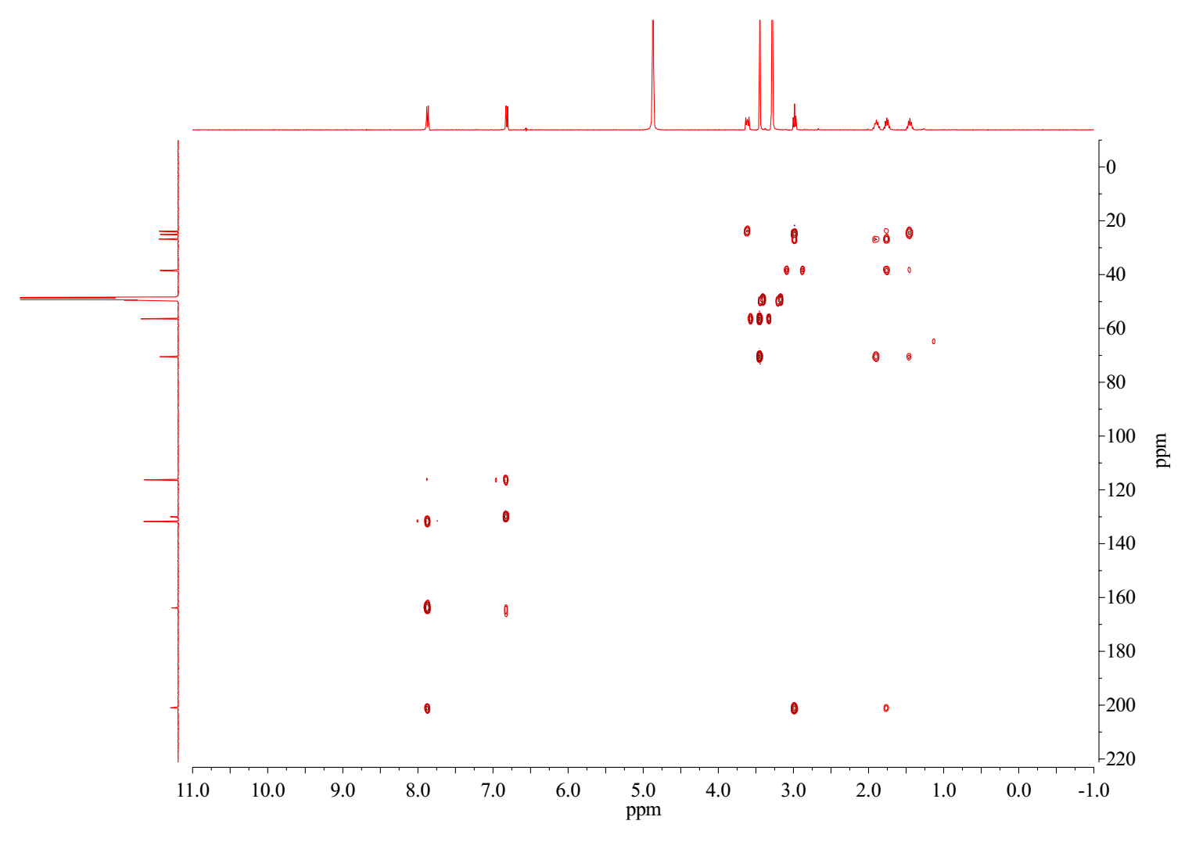

Fig. S15. HRESIMS spectrum of compound 3
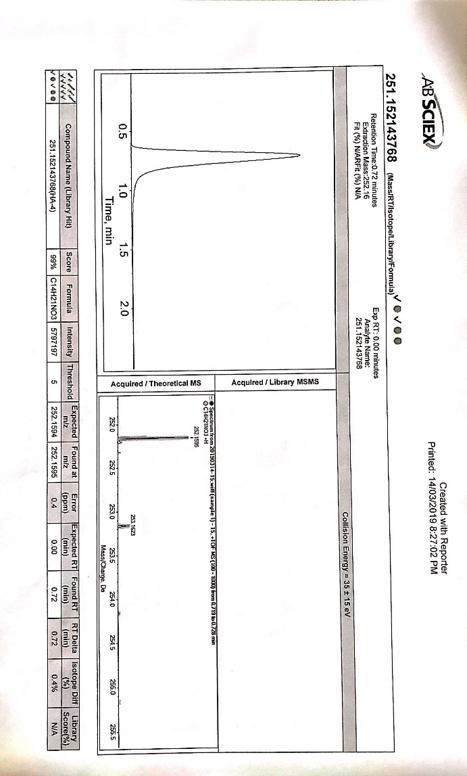

Fig. S16. ¹H NMR spectrum of compound 4 (in CD₃OD, 400 MHz)

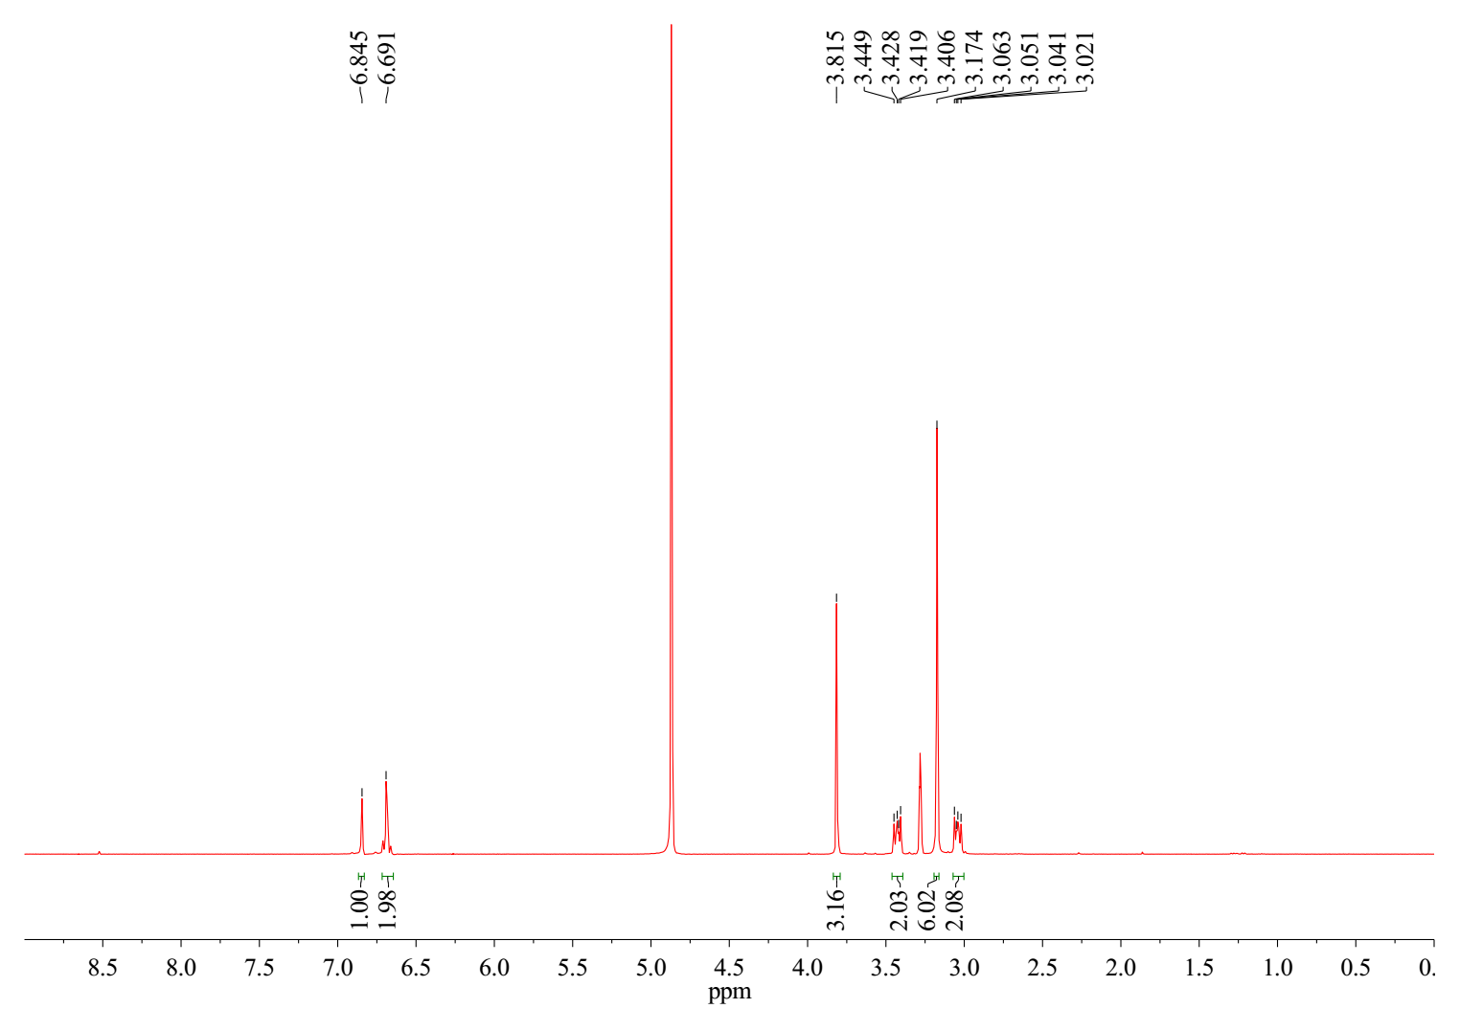

Fig. S17. ¹³C NMR and DEPT spectra of compound 4 (in CD₃OD, 150 MHz)
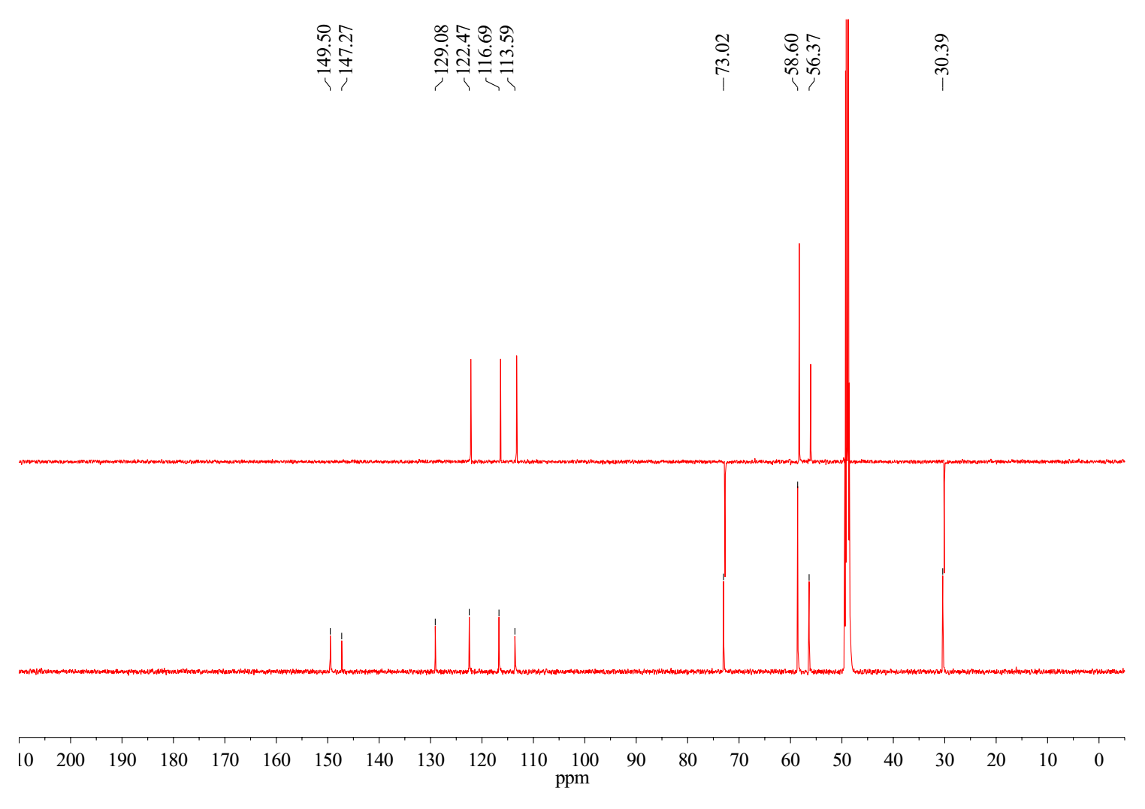

Fig. S18. HSQC spectrum of compound 4 (in CD₃OD, 600 MHz)
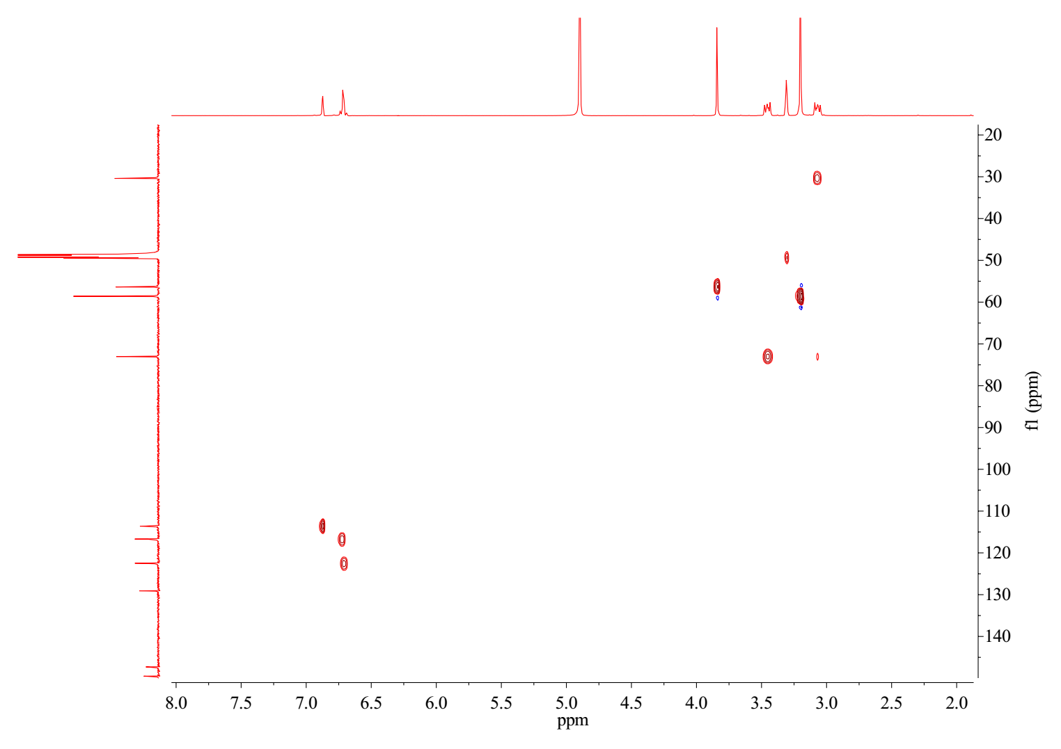

Fig. S19. HMBC spectrum of compound 4 (in CD₃OD, 600 MHz)
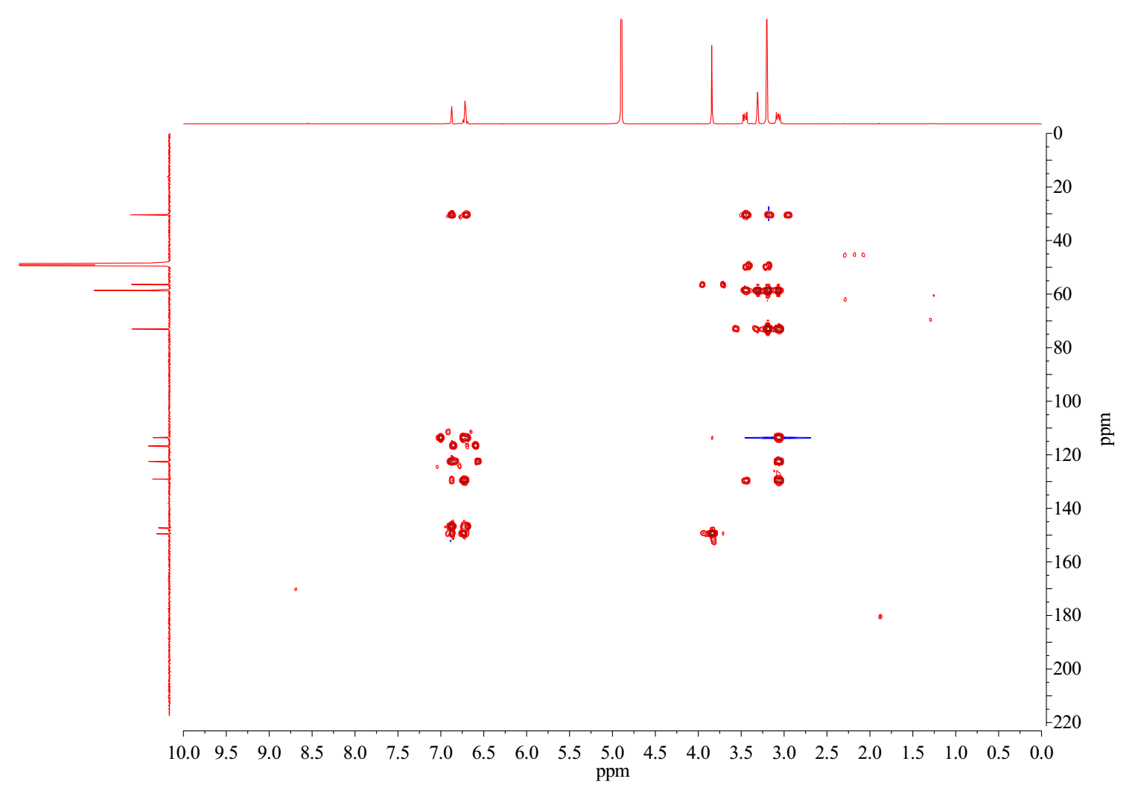

Fig. S20. HRESIMS spectrum of compound 4

