Supplementary data for
Irlactane and Tremulane Sesquiterpenoids from the Cultures of the Medicinal Fungus Irpex lacteus HFG1102
He-Ping Chen,ª Xu Ji,^{b} Zheng-Hui Li,ª Tao Feng,ª Ji-Kai Liu^{a,}*

ªSchool of Pharmaceutical Sciences, South-Central University for Nationalities, Wuhan 430074, People’s Republic of China
^{b}School of Chemical Science and Technology, Yunnan University, Kunming 650091, People’s Republic of China

Corresponding authors
*E-mails: jkliu@mail.kib.ac.cn; liujikai@mail.scuec.edu.cn (J.-K. Liu)

Contents
Figure 1S. ¹H NMR spectrum of 1 (600 MHz, CDCl₃). 4
Figure 2S. ¹³C NMR and DEPT spectra of 1 (150 MHz, CDCl₃). 4
Figure 3S. HSQC spectrum of 1. 5
Figure 4S. ¹H-¹H COSY spectrum of 1. 5
Figure 5S. HMBC spectrum of 1. 6
Figure 6S. ROESY spectrum of 1. 6
Figure 7S. ¹H NMR spectrum of 2 (600 MHz, CDCl₃). 7
Figure 8S. ¹³C NMR and DEPT spectra of 2 (150 MHz, CDCl₃). 7
Figure 9S. HSQC spectrum of 2. 8
Figure 10S. ¹H-¹H COSY spectrum of 2. 8
Figure 11S. HMBC spectrum of 2. 9
Figure 12S. ROESY spectrum of 2. 9
Figure 13S. (+)-HRESIMS report of 2. 10
Figure 14S. ¹H NMR spectrum of 3 (600 MHz, CDCl₃). 11
Figure 15S. ¹³C NMR spectrum of 3 (150 MHz, CDCl₃). 11
Figure 16S. HSQC spectrum of 3. 12
Figure 17S. ¹H-¹H COSY spectrum of 3. 12
Figure 18S. HMBC spectrum of 3. 13
Figure 19S. ROESY spectrum of 3. 13
Figure 20S. (+)-HRESIMS report of 3. 14
Figure 21S. ¹H NMR spectrum of 4 (600 MHz, CDCl₃). 15
Figure 22S. ¹³C NMR and DEPT spectra of 4 (150 MHz, CDCl₃). 15
Figure 23S. HSQC spectrum of 4. 16
Figure 24S. ¹H-¹H COSY spectrum of 4. 16
Figure 25S. HMBC spectrum of 4. 17
Figure 26S. ROESY spectrum of 4. 17
Figure 27S. (+)-HRESIMS report of 4. 18
Figure 28S. ¹H NMR spectrum of 5 (600 MHz, CDCl₃). 19
Figure 29S. ¹³C NMR and DEPT spectra of 5 (150 MHz, CDCl₃). 19
Figure 30S. HSQC spectrum of 5. 20
Figure 31S. ¹H-¹H COSY spectrum of 5. 20
Figure 32S. HMBC spectrum of 5. 21
Figure 33S. ROESY spectrum of 5. 21
Figure 34S. (+)-HRESIMS report of 5. 22
Figure 35S. ¹H NMR spectrum of 6/7 (600 MHz, CDCl₃). 23
Figure 36S. ¹³C NMR and DEPT spectra of 6/7 (150 MHz, CDCl₃). 23
Figure 37S. HSQC spectrum of 6/7. 24
Figure 38S. ¹H-¹H COSY spectrum of 6/7. 24
Figure 39S. HMBC spectrum of 6/7. 25
Figure 40S. ROESY spectrum of 6/7. 25
Figure 41S. (+)-HRESIMS report of 6/7. 26
Figure 42S. ¹H NMR spectrum of 8 (600 MHz, CDCl₃). 27
Figure 43S. ¹³C NMR and DEPT spectra of 8 (150 MHz, CDCl₃). 27
Figure 44S. HSQC spectrum of 8. 28
Figure 45S. HMBC spectrum of 8. 28
Figure 46S. ROESY spectrum of 8. 29
Figure 47S. (+)-HRESIMS report of 8. 30
Figure 48S. ¹H NMR spectrum of 9 (600 MHz, CDCl₃). 31
Figure 49S. ¹³C NMR and DEPT spectra of 9 (150 MHz, CDCl₃). 31
Figure 50S. HSQC spectrum of 9. 32
Figure 51S. ¹H-¹H COSY spectrum of 9. 32
Figure 52S. HMBC spectrum of 9. 33
Figure 53S. ROESY spectrum of 9. 33
Figure 54S. (+)-HRESIMS report of 9. 34
Figure 55S. ¹H NMR spectrum of 10 (600 MHz, CDCl₃). 35
Figure 56S. ¹³C NMR spectrum of 10 (150 MHz, CDCl₃). 35
Figure 57S. HMBC spectrum of 10. 36
Figure 58S. ROESY spectrum of 10. 36
Figure 59S. (+)-HRESIMS report of 10. 37
Figure 60S. ¹H NMR spectrum of 11 (600 MHz, CDCl₃). 38
Figure 61S. ¹³C NMR and DEPT spectra of 11 (150 MHz, CDCl₃). 38
Figure 62S. HSQC spectrum of 11. 39
Figure 63S. ¹H-¹H COSY spectrum of 11. 39
Figure 64S. HMBC spectrum of 11. 40
Figure 65S. ROESY spectrum of 11. 40
Figure 66S. (+)-HRESIMS report of 11. 41
Figure 67S. ¹H NMR spectrum of 12 (600 MHz, CDCl₃). 42
Figure 68S. ¹³C NMR and DEPT spectra of 12 (150 MHz, CDCl₃). 42
Figure 69S. HSQC spectrum of 12. 43
Figure 70S. ¹H-¹H COSY spectrum of 12. 43
Figure 71S. HMBC spectrum of 12. 44
Figure 72S. ROESY spectrum of 12. 44
Figure 73S. (+)-HRESIMS report of 12. 45
Figure 74S. ¹H NMR spectrum of 13 (600 MHz, CDCl₃). 46
Figure 75S. ¹³C NMR and DEPT spectra of 13 (150 MHz, CDCl₃). 46
Figure 76S. HSQC spectrum of 13. 47
Figure 77S. ¹H-¹H COSY spectrum of 13. 47
Figure 78S. HMBC spectrum of 13. 48
Figure 79S. ROESY spectrum of 13. 48
Figure 80S. (+)-HRESIMS report of 13. 49
Figure 84S. ¹H NMR spectrum of 14 (600 MHz, CDCl₃). 50
Figure 85S. ¹³C NMR and DEPT spectra of 14 (150 MHz, CDCl₃). 50
Figure 86S. HSQC spectrum of 14. 51
Figure 87S. ¹H-¹H COSY spectrum of 14. 51
Figure 88S. HMBC spectrum of 14. 52
Figure 89S. ROESY spectrum of 14. 52
Figure 90S. (+)-HRESIMS report of 14. 53
Figure 81S. ¹H NMR spectrum of 15 (600 MHz, CDCl₃). 54
Figure 82S. ¹³C NMR spectrum of 15 (150 MHz, CDCl₃). 54
Figure 83S. HSQC spectrum of 15. 55
Figure 84S. ¹H-¹H COSY spectrum of 15. 55
Figure 85S. HMBC spectrum of 15. 56
Figure 86S. ROESY spectrum of 15. 56
Figure 87S. (+)-HRESIMS report of 15. 57

Figure 1S. ¹H NMR spectrum of 1 (600 MHz, CDCl₃).

Figure 2S. ¹³C NMR and DEPT spectra of 1 (150 MHz, CDCl₃).

Figure 3S. HSQC spectrum of 1.

Figure 4S. ¹H-¹H COSY spectrum of 1.

Figure 5S. HMBC spectrum of 1.

Figure 6S. ROESY spectrum of 1.

Figure 7S. ¹H NMR spectrum of 2 (600 MHz, CDCl₃).

Figure 8S. ¹³C NMR and DEPT spectra of 2 (150 MHz, CDCl₃).

Figure 9S. HSQC spectrum of 2.

Figure 10S. ¹H-¹H COSY spectrum of 2.

Figure 11S. HMBC spectrum of 2.

Figure 12S. ROESY spectrum of 2.

Figure 13S. (+)-HRESIMS report of 2.
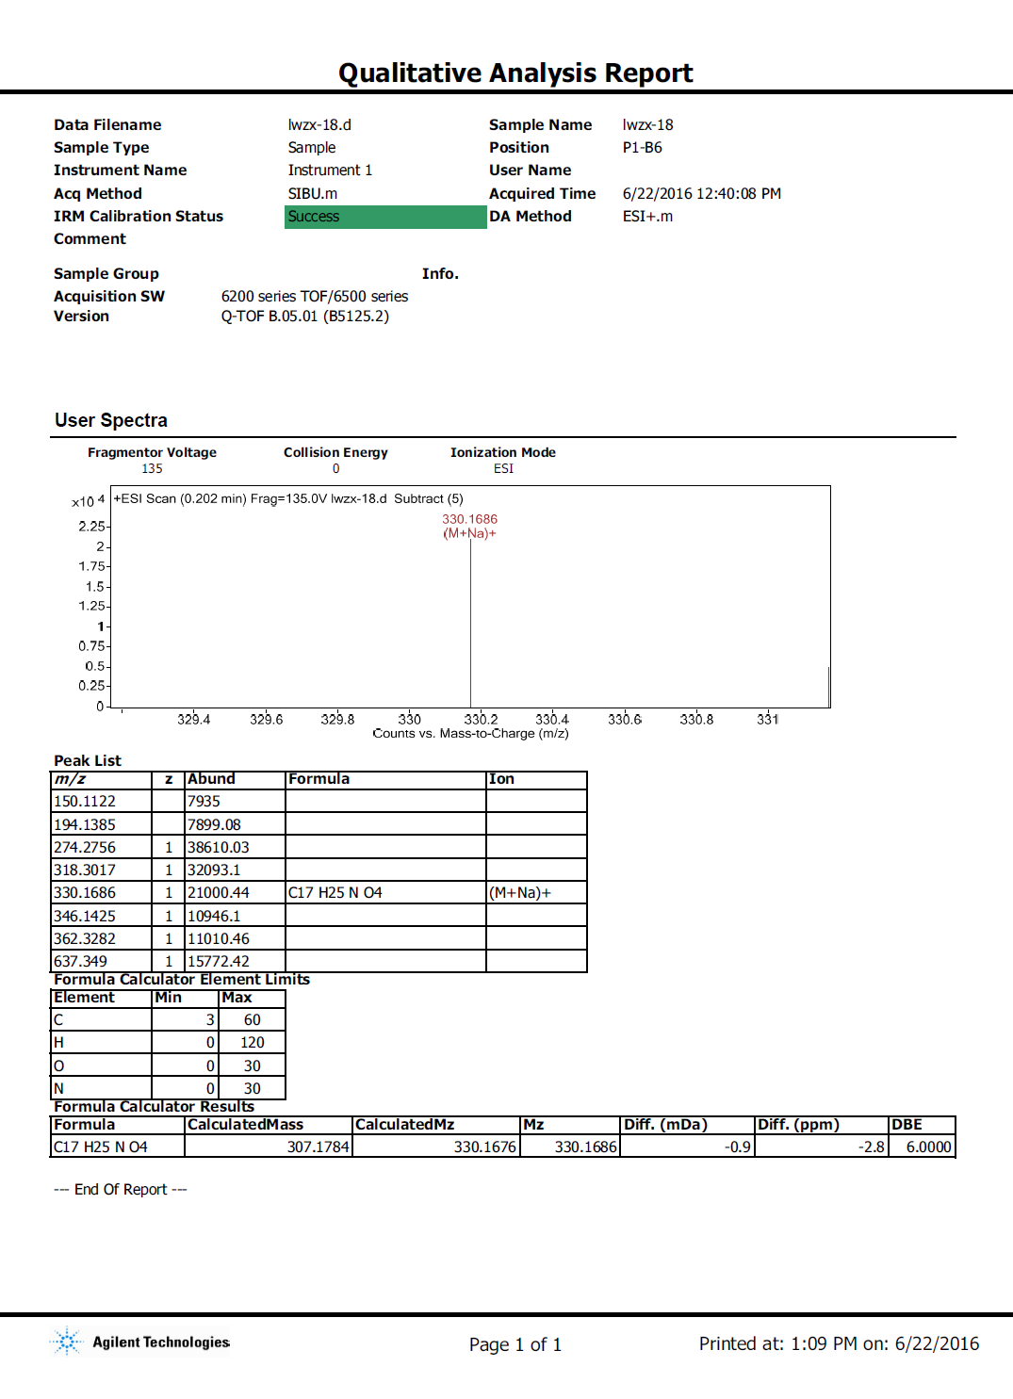

Figure 14S. ¹H NMR spectrum of 3 (600 MHz, CDCl₃).

Figure 15S. ¹³C NMR spectrum of 3 (150 MHz, CDCl₃).

Figure 16S. HSQC spectrum of 3.

Figure 17S. ¹H-¹H COSY spectrum of 3.

Figure 18S. HMBC spectrum of 3.

Figure 19S. ROESY spectrum of 3.

Figure 20S. (+)-HRESIMS report of 3.
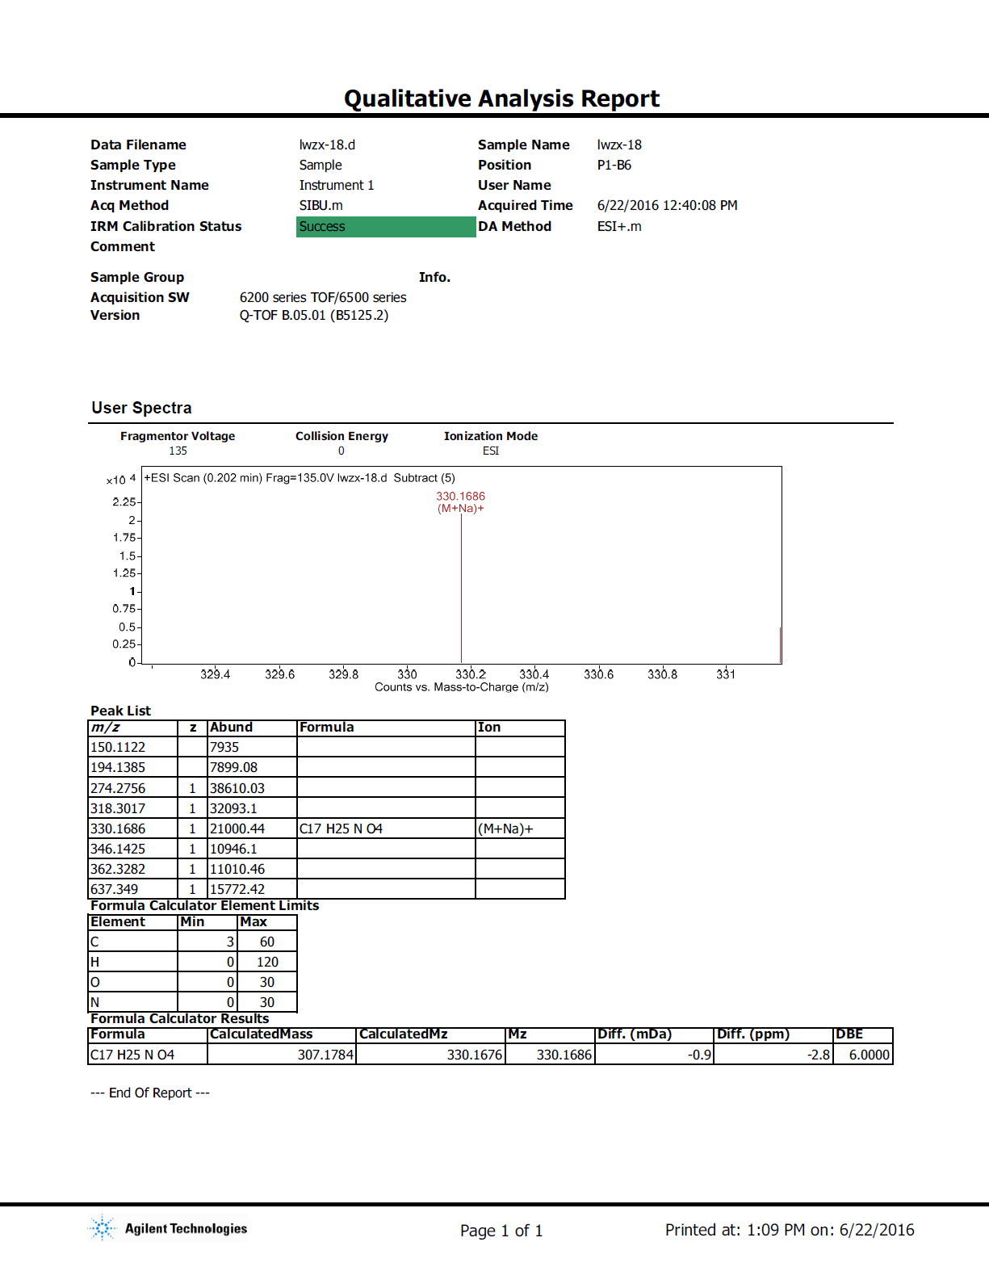

Figure 21S. ¹H NMR spectrum of 4 (600 MHz, CDCl₃).

Figure 22S. ¹³C NMR and DEPT spectra of 4 (150 MHz, CDCl₃).

Figure 23S. HSQC spectrum of 4.

Figure 24S. ¹H-¹H COSY spectrum of 4.

Figure 25S. HMBC spectrum of 4.

Figure 26S. ROESY spectrum of 4.

Figure 27S. (+)-HRESIMS report of 4.
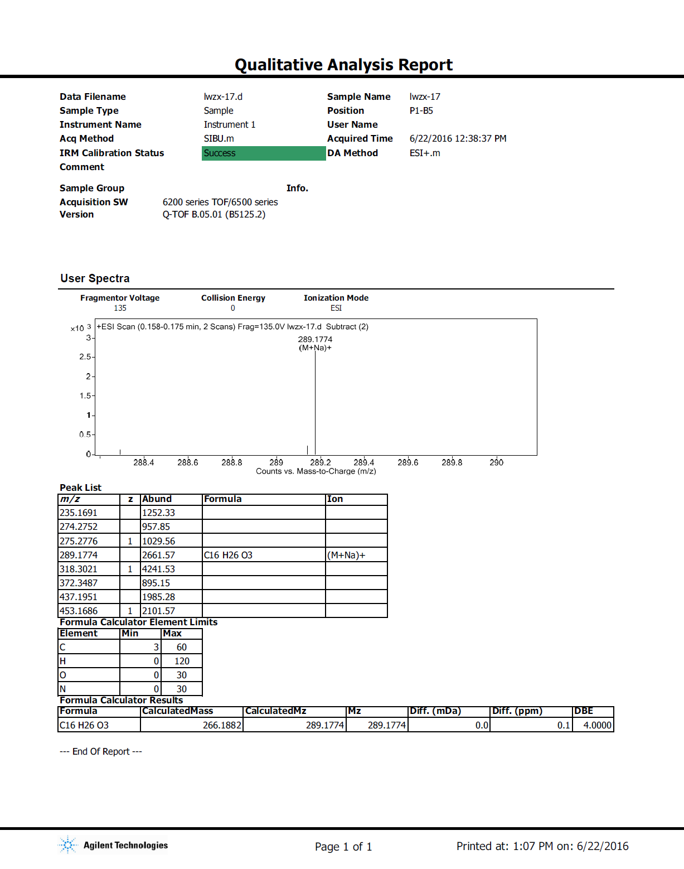

Figure 28S. ¹H NMR spectrum of 5 (600 MHz, CDCl₃).

Figure 29S. ¹³C NMR and DEPT spectra of 5 (150 MHz, CDCl₃).

Figure 30S. HSQC spectrum of 5.

Figure 31S. ¹H-¹H COSY spectrum of 5.

Figure 32S. HMBC spectrum of 5.

Figure 33S. ROESY spectrum of 5.

Figure 34S. (+)-HRESIMS report of 5.
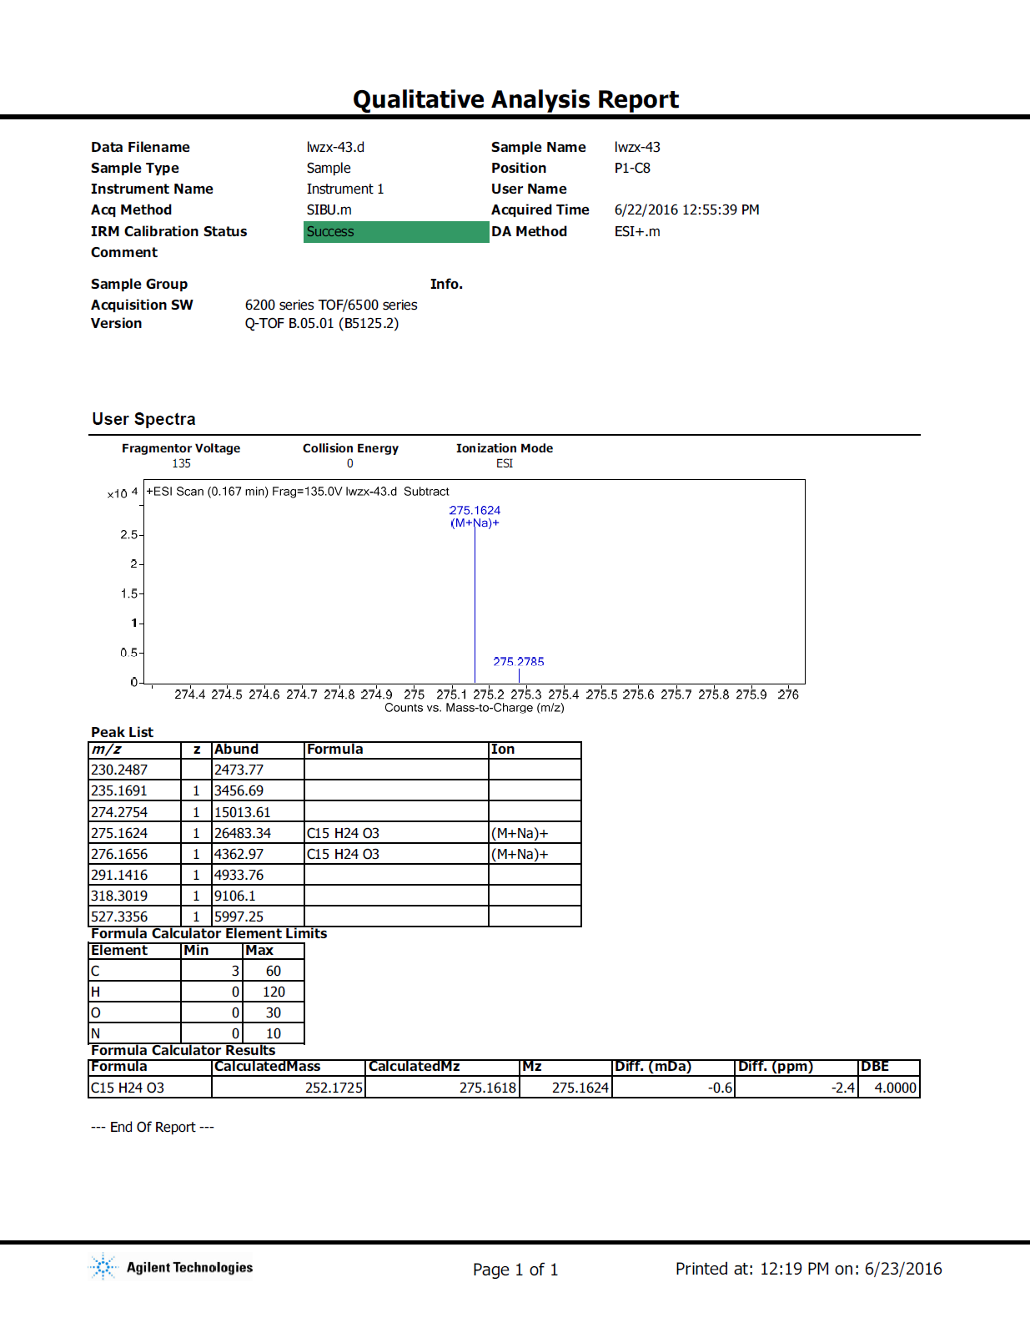

Figure 35S. ¹H NMR spectrum of 6/7 (600 MHz, CDCl₃).

Figure 36S. ¹³C NMR and DEPT spectra of 6/7 (150 MHz, CDCl₃).

Figure 37S. HSQC spectrum of 6/7.

Figure 38S. ¹H-¹H COSY spectrum of 6/7.

Figure 39S. HMBC spectrum of 6/7.

Figure 40S. ROESY spectrum of 6/7.

Figure 41S. (+)-HRESIMS report of 6/7.
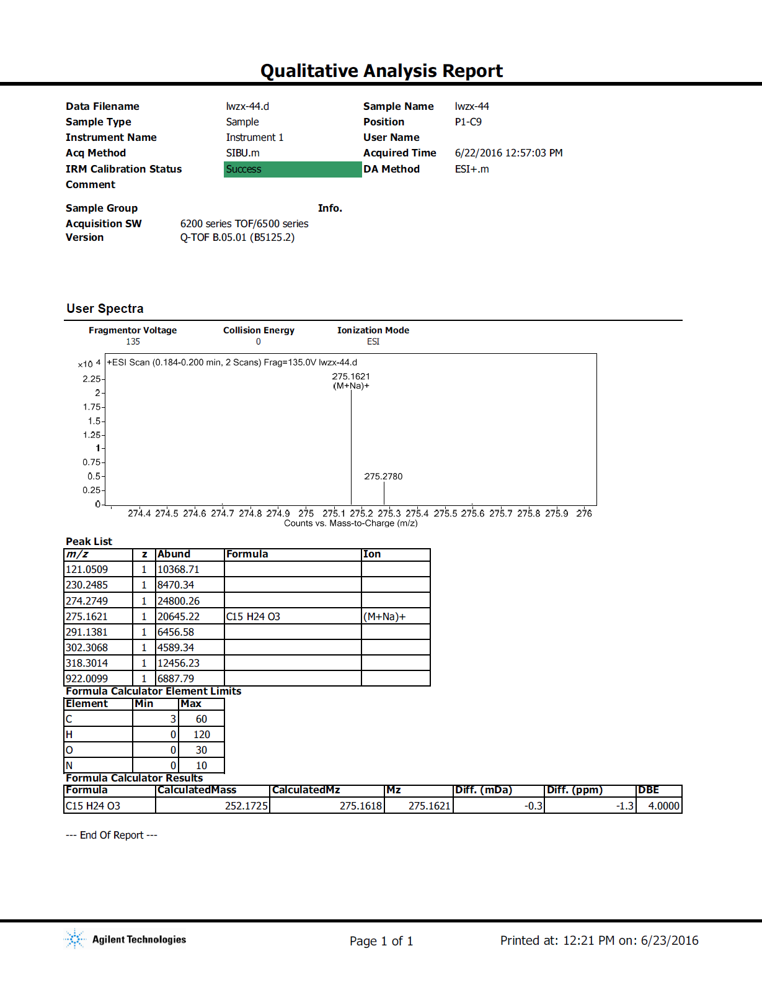

Figure 42S. ¹H NMR spectrum of 8 (600 MHz, CDCl₃).

Figure 43S. ¹³C NMR and DEPT spectra of 8 (150 MHz, CDCl₃).

Figure 44S. HSQC spectrum of 8.

Figure 45S. HMBC spectrum of 8.

Figure 46S. ROESY spectrum of 8.

Figure 47S. (+)-HRESIMS report of 8.
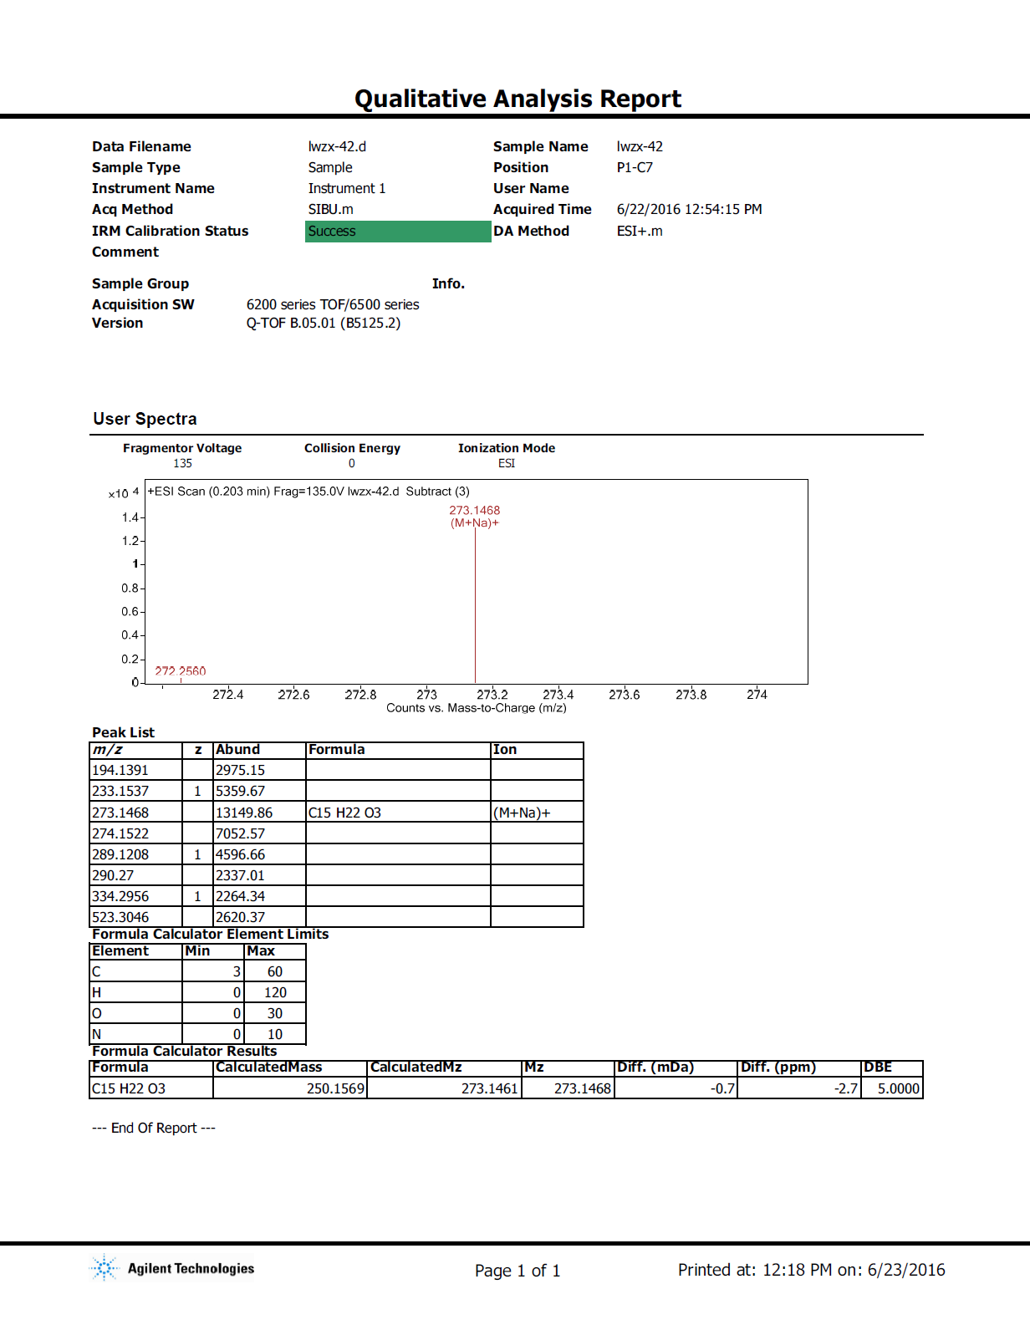

Figure 48S. ¹H NMR spectrum of 9 (600 MHz, CDCl₃).

Figure 49S. ¹³C NMR and DEPT spectra of 9 (150 MHz, CDCl₃).

Figure 50S. HSQC spectrum of 9.

Figure 51S. ¹H-¹H COSY spectrum of 9.

Figure 52S. HMBC spectrum of 9.

Figure 53S. ROESY spectrum of 9.

Figure 54S. (+)-HRESIMS report of 9.
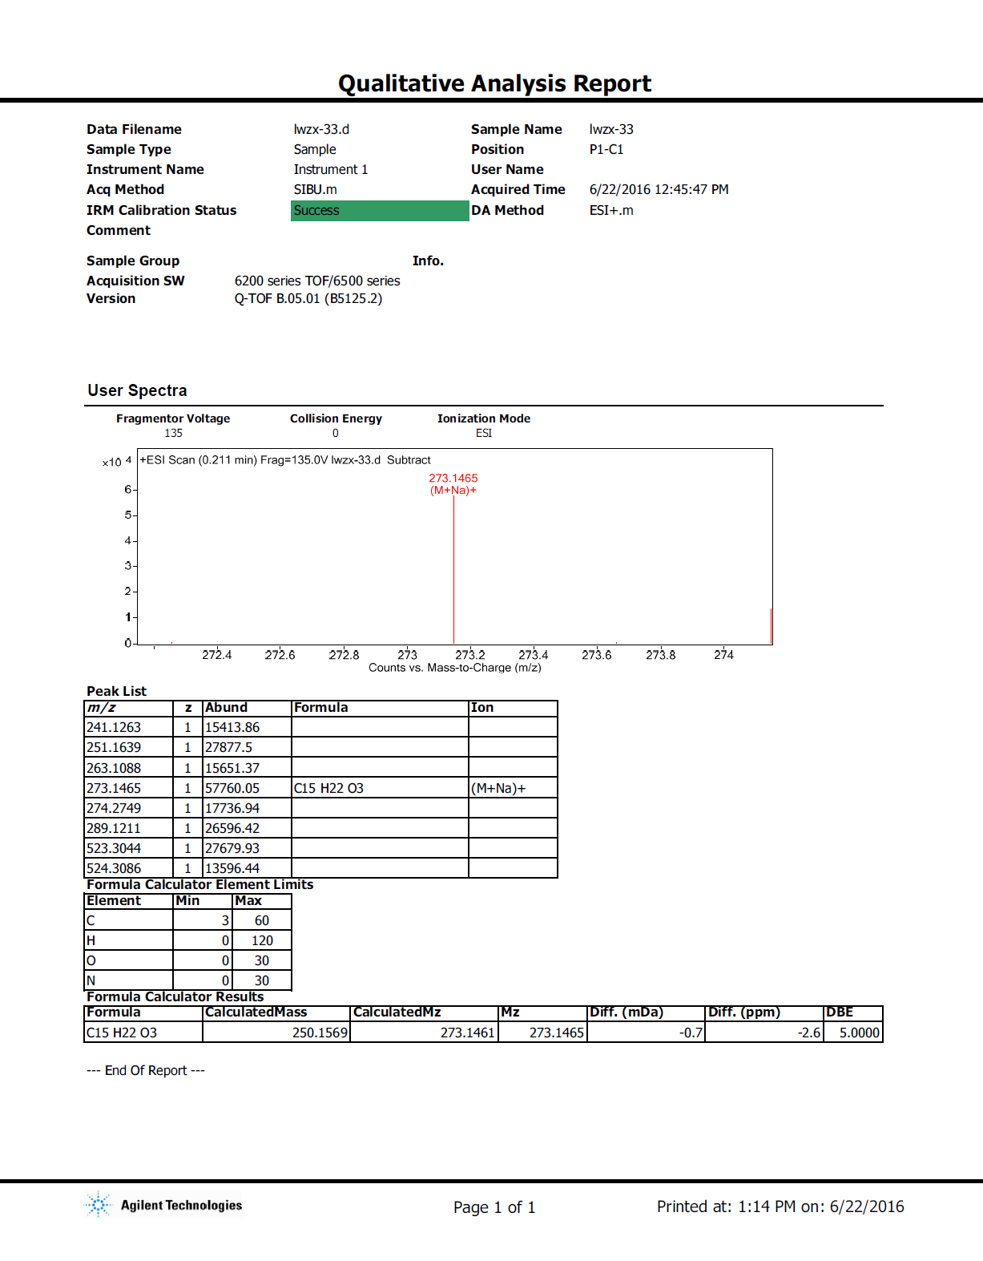

Figure 55S. ¹H NMR spectrum of 10 (600 MHz, CDCl₃).

Figure 56S. ¹³C NMR spectrum of 10 (150 MHz, CDCl₃).

Figure 57S. HMBC spectrum of 10.

Figure 58S. ROESY spectrum of 10.

Figure 59S. (+)-HRESIMS report of 10.
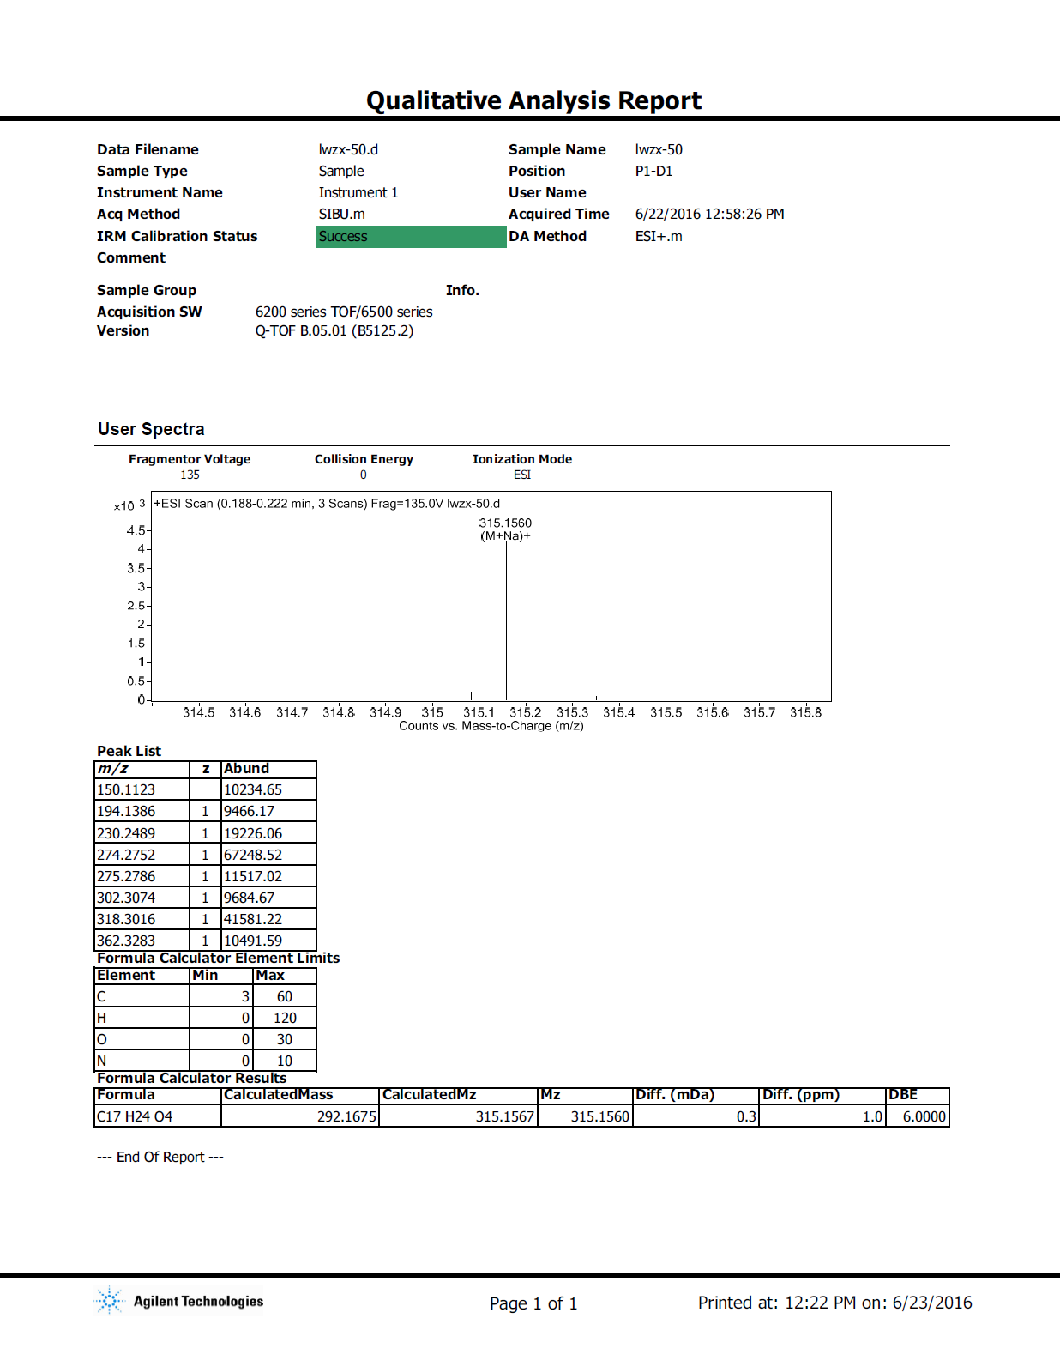

Figure 60S. ¹H NMR spectrum of 11 (600 MHz, CDCl₃).

Figure 61S. ¹³C NMR and DEPT spectra of 11 (150 MHz, CDCl₃).

Figure 62S. HSQC spectrum of 11.

Figure 63S. ¹H-¹H COSY spectrum of 11.

Figure 64S. HMBC spectrum of 11.

Figure 65S. ROESY spectrum of 11.

Figure 66S. (+)-HRESIMS report of 11.
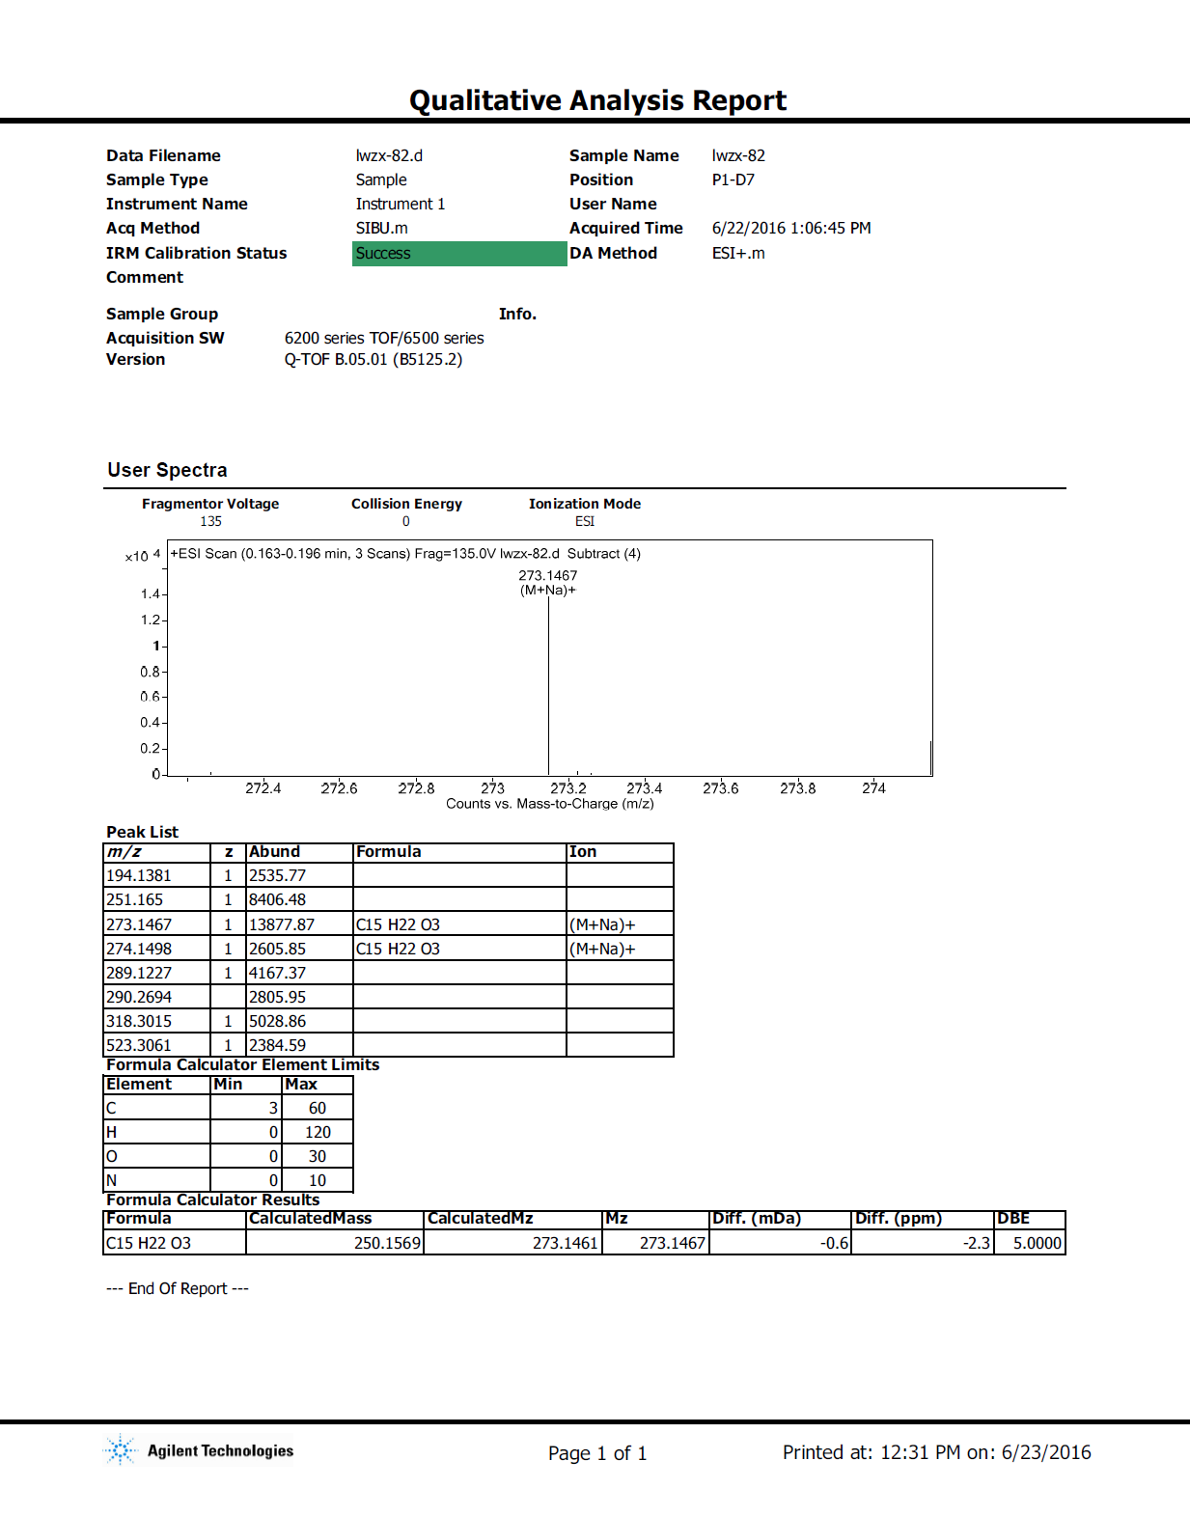

Figure 67S. ¹H NMR spectrum of 12 (600 MHz, CDCl₃).

Figure 68S. ¹³C NMR and DEPT spectra of 12 (150 MHz, CDCl₃).

Figure 69S. HSQC spectrum of 12.

Figure 70S. ¹H-¹H COSY spectrum of 12.

Figure 71S. HMBC spectrum of 12.

Figure 72S. ROESY spectrum of 12.

Figure 73S. (+)-HRESIMS report of 12.
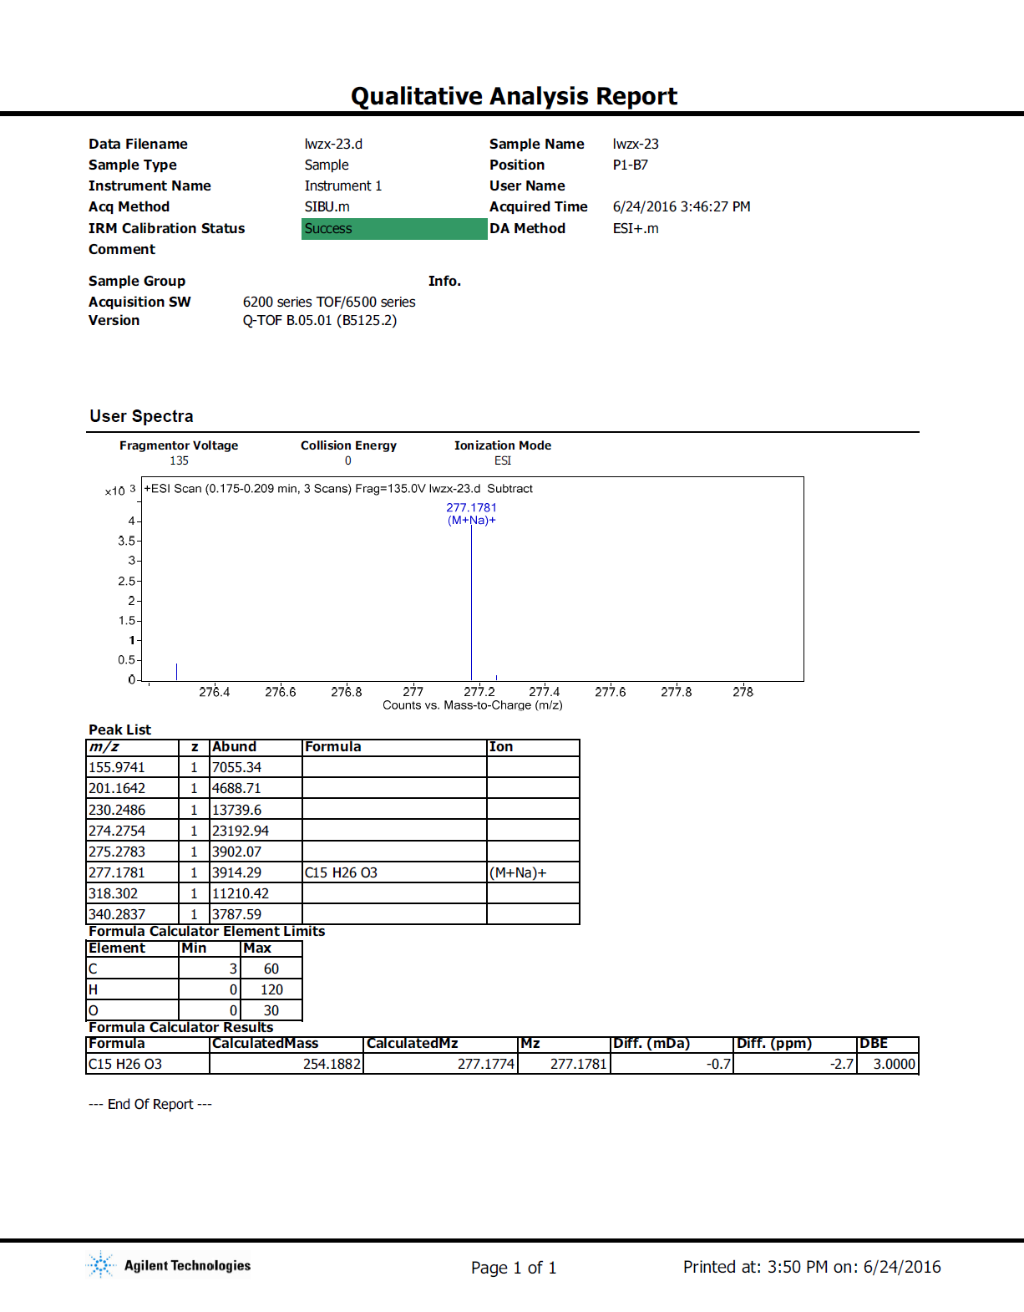

Figure 74S. ¹H NMR spectrum of 13 (600 MHz, CDCl₃).

Figure 75S. ¹³C NMR and DEPT spectra of 13 (150 MHz, CDCl₃).

Figure 76S. HSQC spectrum of 13.

Figure 77S. ¹H-¹H COSY spectrum of 13.

Figure 78S. HMBC spectrum of 13.

Figure 79S. ROESY spectrum of 13.
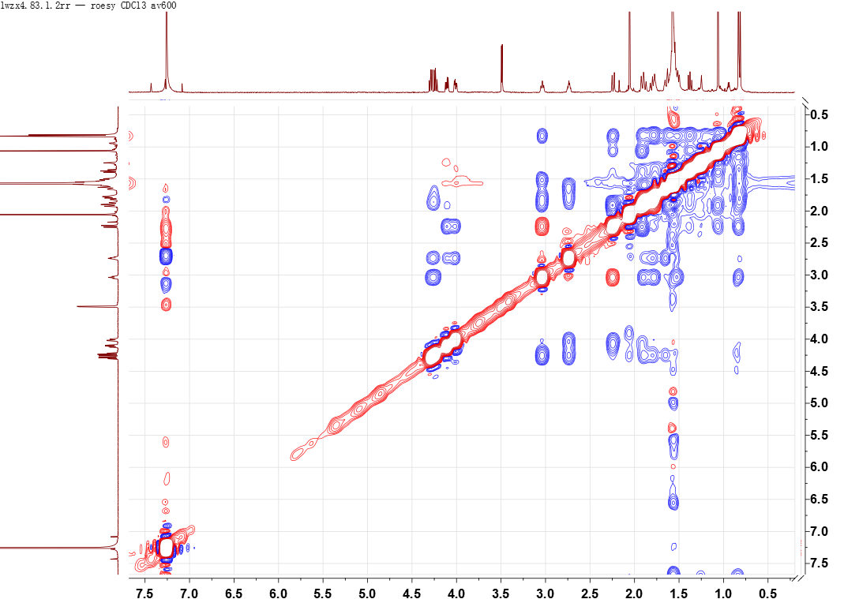

Figure 80S. (+)-HRESIMS report of 13.
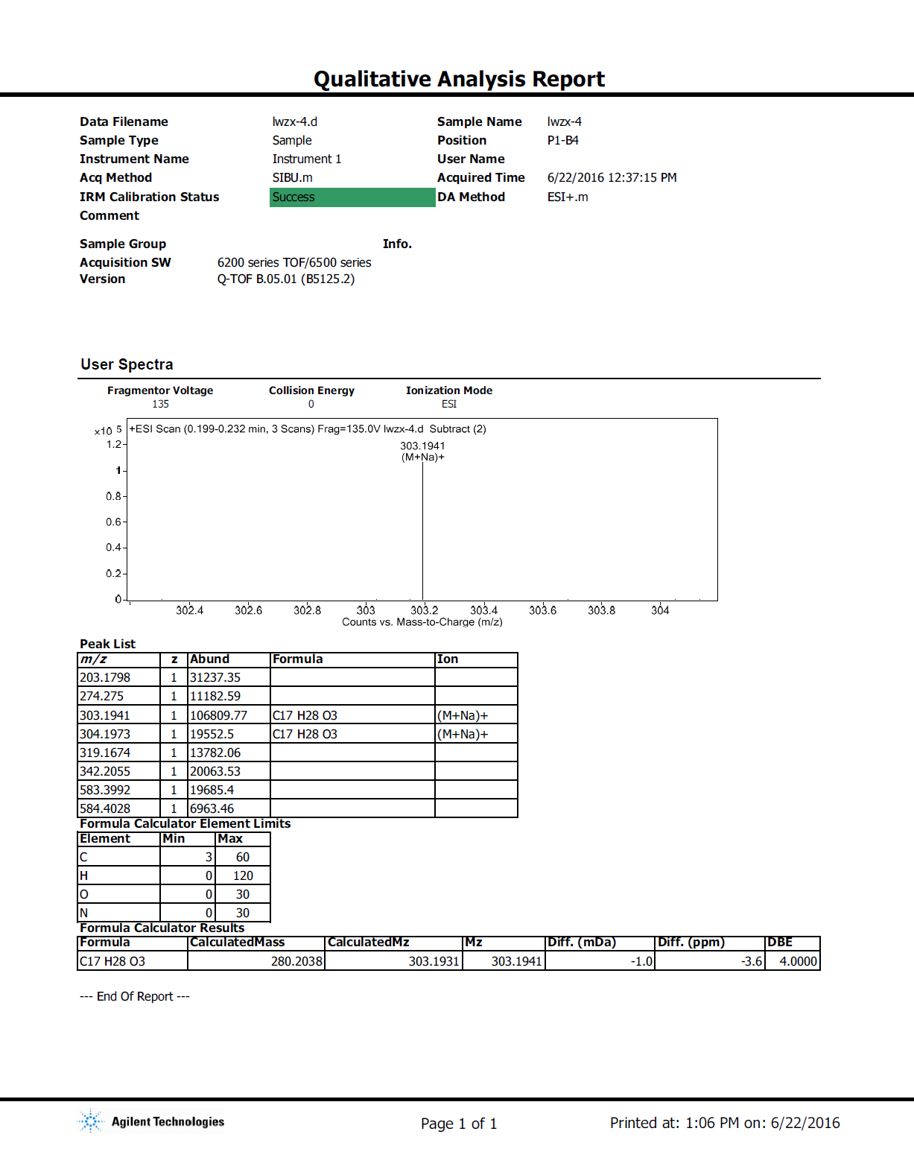

Figure 84S. ¹H NMR spectrum of 14 (600 MHz, CDCl₃).

Figure 85S. ¹³C NMR and DEPT spectra of 14 (150 MHz, CDCl₃).

Figure 86S. HSQC spectrum of 14.

Figure 87S. ¹H-¹H COSY spectrum of 14.

Figure 88S. HMBC spectrum of 14.

Figure 89S. ROESY spectrum of 14.

Figure 90S. (+)-HRESIMS report of 14.
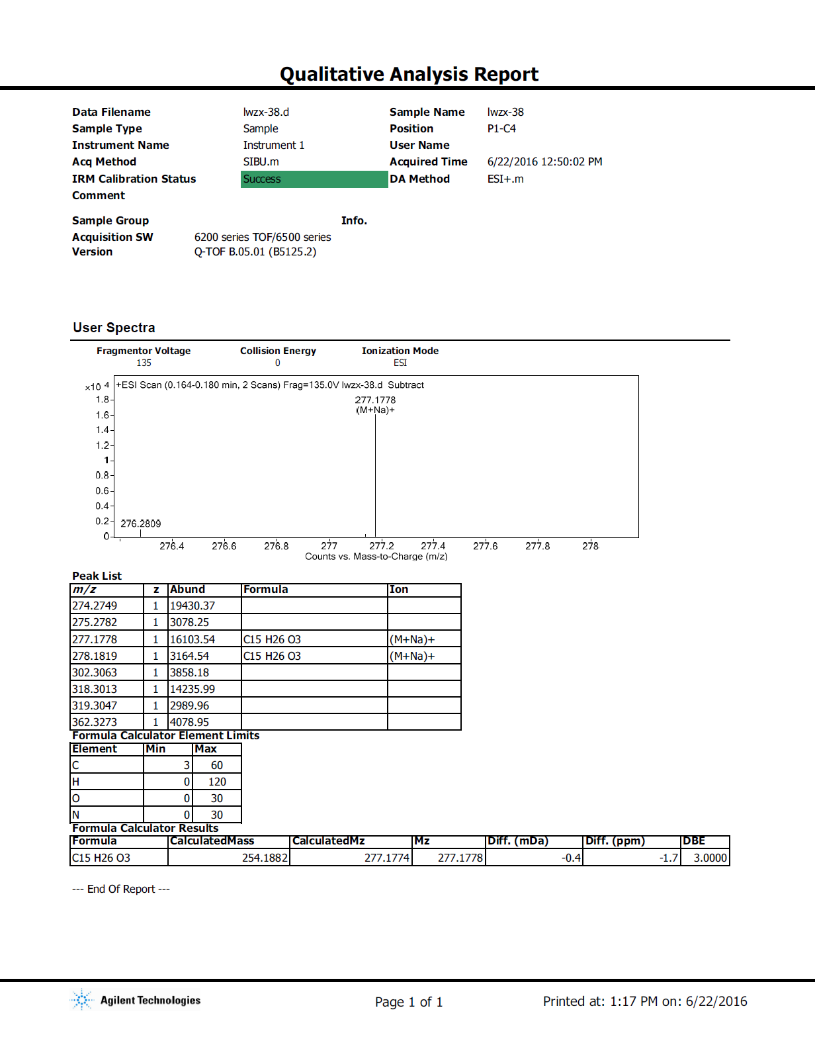

Figure 81S. ¹H NMR spectrum of 15 (600 MHz, CDCl₃).

Figure 82S. ¹³C NMR spectrum of 15 (150 MHz, CDCl₃).

Figure 83S. HSQC spectrum of 15.

Figure 84S. ¹H-¹H COSY spectrum of 15.

Figure 85S. HMBC spectrum of 15.

Figure 86S. ROESY spectrum of 15.

Figure 87S. (+)-HRESIMS report of 15.
