Supporting Information

Artemyrianins A−G from Artemisia myriantha and Their Cytotoxicity against HepG2 Cells

Shuang Tang^{1,2} ‧ Yun-Bao Ma¹ ‧ Chang-An Geng¹ ‧ Cheng Shen^{1,2} ‧ Tian-Ze Li¹ ‧ Xue-Mei Zhang¹ ‧ Li-Hua Su^{1,2} ‧ Zhen Gao^{1,2} ‧ Jing Hu¹ ‧ Ji-Jun Chen ⃰ ^{,1,2}

¹State Key Laboratory of Phytochemistry and Plant Resources in West China, Yunnan Key Laboratory of Natural Medicinal Chemistry, Kunming Institute of Botany, Chinese Academy of Sciences, Kunming 650201, People's Republic of China
²University of Chinese Academy of Sciences, Beijing 100049, People's Republic of China

*Corresponding author. Kunming Institute of Botany, Chinese Academy of Sciences, Kunming 650201, People's Republic of China. Tel.: +86 871 65223265; Fax: +86-871-65227197. E-mail address: chenjj@mail.kib.ac.cn (Ji-Jun Chen).

Contents
Computational details‧‧‧‧‧‧‧‧‧‧‧‧‧‧‧‧‧‧‧‧‧‧‧‧‧‧‧‧‧‧‧‧‧‧‧‧‧‧‧‧‧‧‧‧‧‧‧‧‧‧‧‧‧‧‧‧‧‧‧‧‧‧‧‧‧‧‧‧‧‧‧‧‧‧‧‧‧‧‧‧‧‧‧‧‧‧‧‧‧‧‧‧‧‧‧‧‧‧‧‧‧‧‧‧‧‧‧‧‧‧‧P3
Figures S1−10, the spectroscopic data of artemyrianin A (1)‧‧‧‧‧‧‧‧‧‧‧‧‧‧‧‧‧‧‧‧‧‧‧‧‧‧‧‧‧‧‧‧‧‧‧‧‧‧‧‧‧‧‧‧‧‧P4−8
Figures S11−20, the spectroscopic data of artemyrianin B (2)‧‧‧‧‧‧‧‧‧‧‧‧‧‧‧‧‧‧‧‧‧‧‧‧‧‧‧‧‧‧‧‧‧‧‧‧‧‧‧‧‧‧P9−13
Figures S21−30, the spectroscopic data of artemyrianin C (3)‧‧‧‧‧‧‧‧‧‧‧‧‧‧‧‧‧‧‧‧‧‧‧‧‧‧‧‧‧‧‧‧‧‧‧‧‧‧‧‧P14−18
Figures S31−40, the spectroscopic data of artemyrianin D (4)‧‧‧‧‧‧‧‧‧‧‧‧‧‧‧‧‧‧‧‧‧‧‧‧‧‧‧‧‧‧‧‧‧‧‧‧‧‧‧‧P19−23
Figures S41−51, the spectroscopic data of artemyrianin E (5)‧‧‧‧‧‧‧‧‧‧‧‧‧‧‧‧‧‧‧‧‧‧‧‧‧‧‧‧‧‧‧‧‧‧‧‧‧‧‧‧P24−28
Figures S52−62, the spectroscopic data of artemyrianin F (6)‧‧‧‧‧‧‧‧‧‧‧‧‧‧‧‧‧‧‧‧‧‧‧‧‧‧‧‧‧‧‧‧‧‧‧‧‧‧‧‧P29−33
Figures S63−73, the spectroscopic data of artemyrianin G (7)‧‧‧‧‧‧‧‧‧‧‧‧‧‧‧‧‧‧‧‧‧‧‧‧‧‧‧‧‧‧‧‧‧‧‧‧‧‧‧‧P34−38
X-ray crystallographic data for artemyrianin A (1)‧‧‧‧‧‧‧‧‧‧‧‧‧‧‧‧‧‧‧‧‧‧‧‧‧‧‧‧‧‧‧‧‧‧‧‧‧‧‧‧‧‧‧‧‧‧‧‧‧‧‧‧‧‧‧‧P39−40

Computational details
The ECD calculations for compounds 2−7 were achieved by Gaussian 09 program. The configurations of compounds 2−4 and 7 were initially established on the basis of their ROESY data, and further optimized by means of the DFT calculation at b3lyp/6-31G(d,p) level in the gas phase. The imaginary frequencies were excluded by the aid of frequency calculations at the same level. Taking the solvent effects into consideration, ECD calculations were carried out using the TDDFT methodology at b3lyp/6-311+g(d,p) level. The ECD curves were plotted by the Origin Pro 9 program (OriginLab Corporation, Northampton, USA).

1. Frisch, M. J.; Trucks, G. W.; Schlegel, H. B.; Scuseria, G. E.; Robb, M. A.; Cheeseman, J. R.; Scalmani, G.; Barone, V.; Mennucci, B.; Petersson, G. A.; Nakatsuji, H.; Caricato, M.; Li, X.; Hratchian, H. P.; Izmaylov, A. F.; Bloino, J.; Zheng, G.; Sonnenberg, J. L.; Hada, M.; Ehara, M.; Toyota, K.; Fukuda, R.; Hasegawa, J.; Ishida, M.; Nakajima, T.; Honda, Y.; Kitao, O.; Nakai, H.; Vreven, T.; Montgomery, J. A.; Peralta, J. J. E.; Ogliaro, F.; Bearpark, M.; Heyd, J. J.; Brothers, E.; Kudin, K. N.; Staroverov, V. N.; Keith, T.; Kobayashi, R.; Normand, J.; Raghavachari, K.; Rendell, A.; Burant, J. C.; Iyengar, S. S.; Tomasi, J.; Cossi, M.; Rega, N.; Millam, J. M.; Klene, M.; Knox, J. E.; Cross, J. B.; Bakken, V.; Adamo, C.; Jaramillo, J.; Gomperts, R.; Stratmann, R. E.; Yazyev, O.; Austin, A. J.; Cammi, R.; Pomelli, C.; Ochterski, J. W.; Martin, R. L.; Morokuma, K.; Zakrzewski, V. G.; Voth, G. A.; Salvador, P.; Dannenberg, J. J.; Dapprich, S.; Daniels, A. D.; Farkas, O.; Foresman, J. B.; Ortiz, J. V.; Cioslowski, J.; Fox, D. J. Gaussian 09, Revision C.01; Gaussian, Inc., Wallingford CT: 2010.

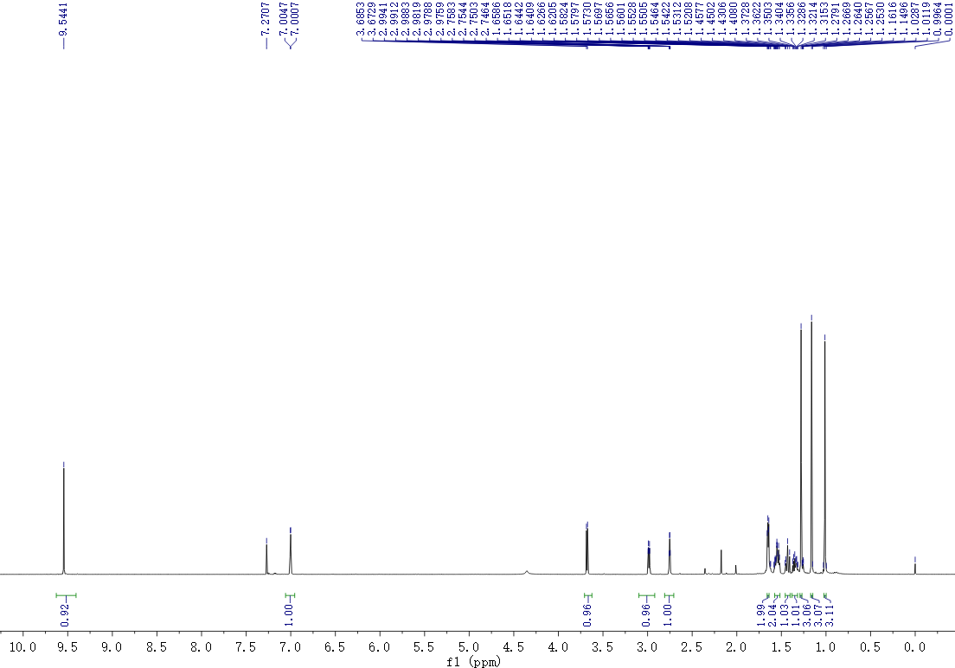
Figure S1. ¹H NMR spectrum of artemyrianin A (1) recorded in CDCl₃ at 600 MHz

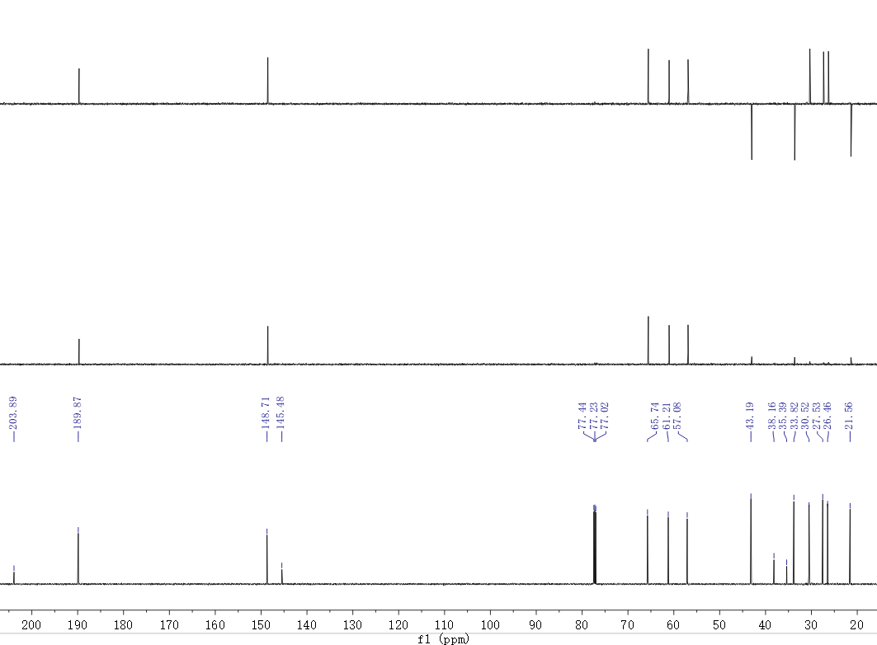
Figure S2. ¹³C NMR (DEPT) spectrum of artemyrianin A (1) recorded in CDCl₃ at 150 MHz
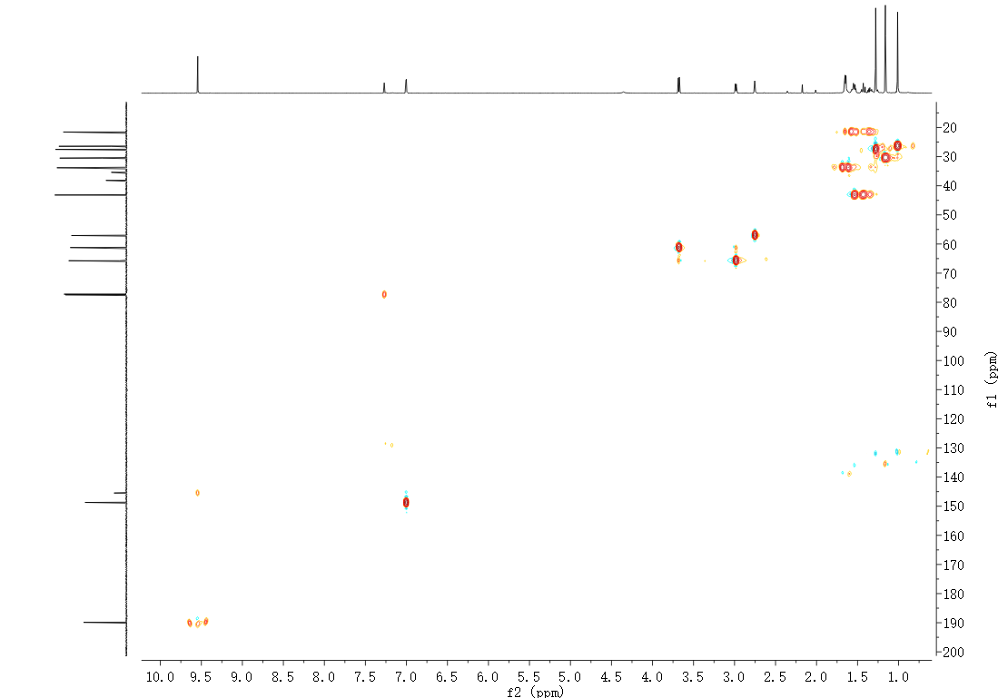
Figure S3. HSQC spectrum of artemyrianin A (1) recorded in CDCl₃

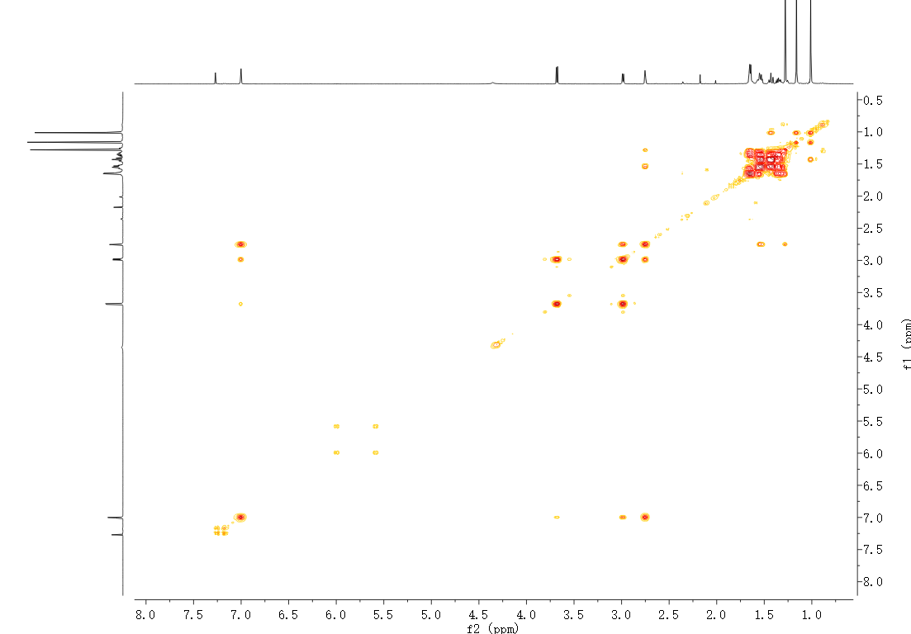
Figure S4. ¹H−¹H COSY spectrum of artemyrianin A (1) recorded in CDCl₃
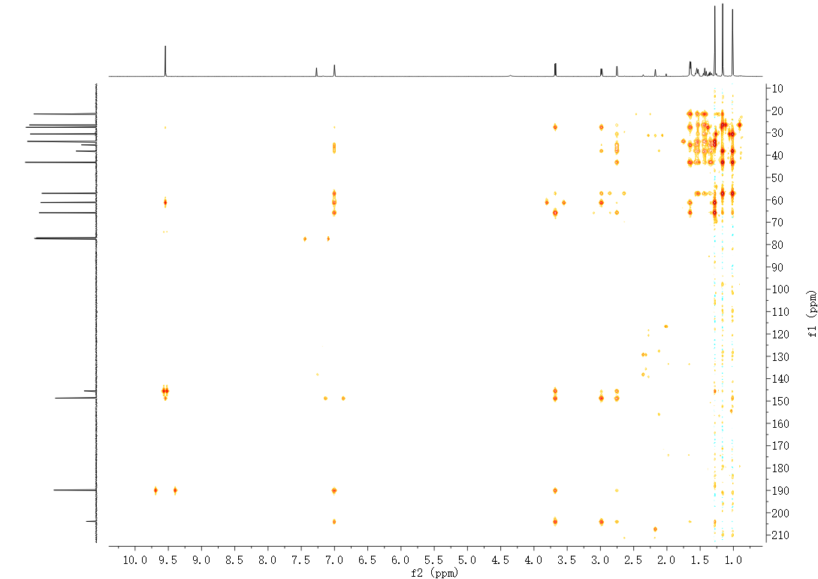
Figure S5. HMBC spectrum of artemyrianin A (1) recorded in CDCl₃

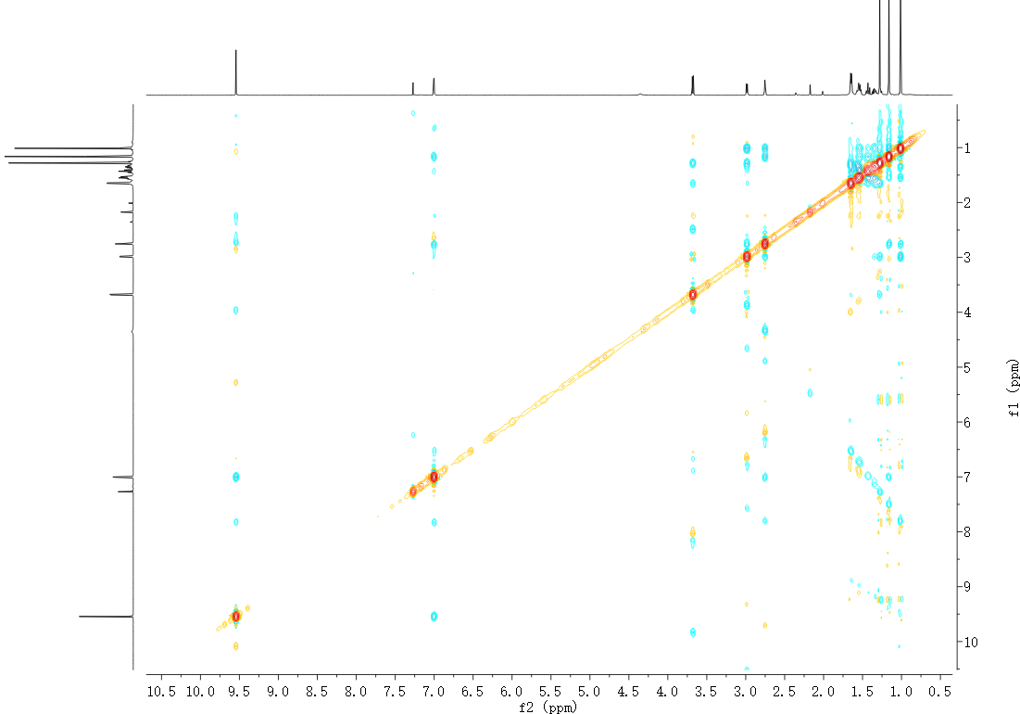
Figure S6. ROESY spectrum of artemyrianin A (1) recorded in CDCl₃
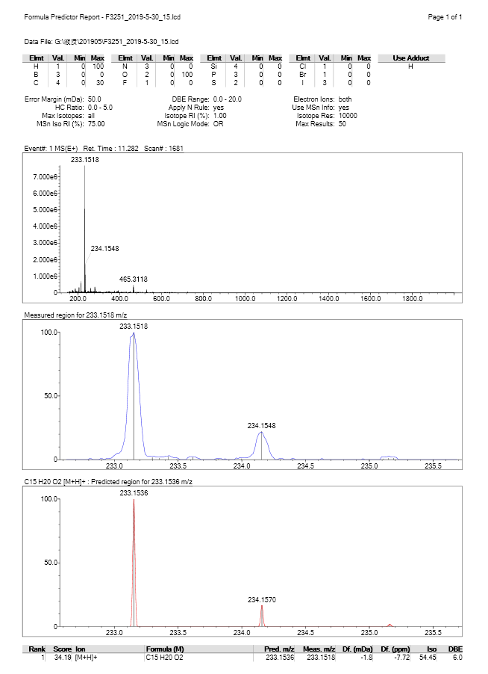
Figure S7. (+)-HRESIMS spectrum of artemyrianin A (1)

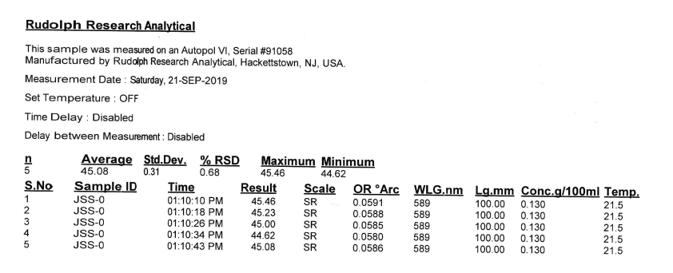
Figure S8. [α]_{D} spectrum of artemyrianin A (1) in MeOH
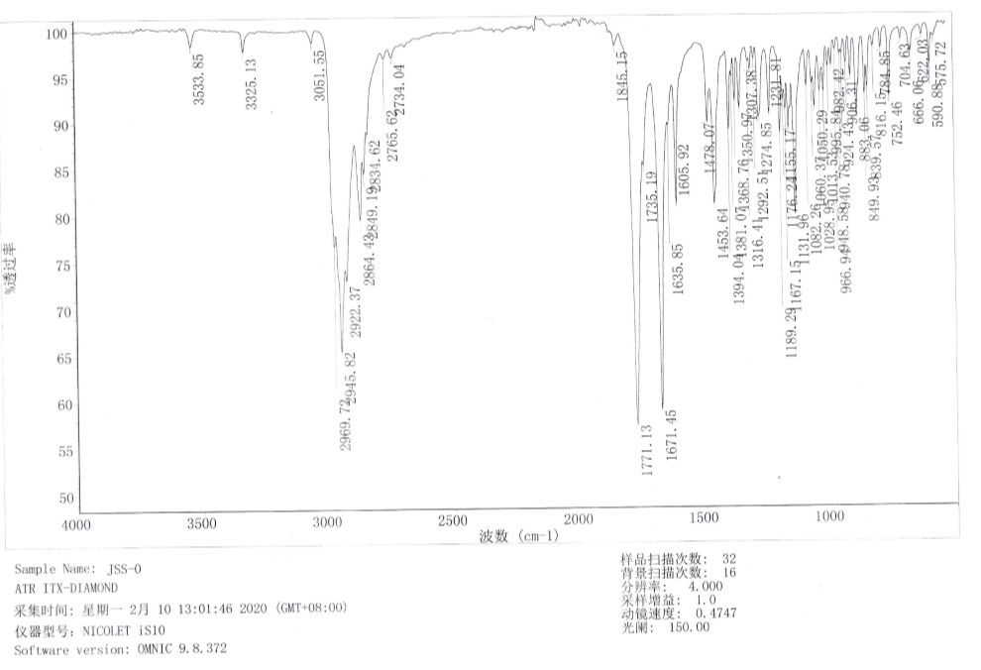
Figure S9. IR spectrum of artemyrianin A (1)

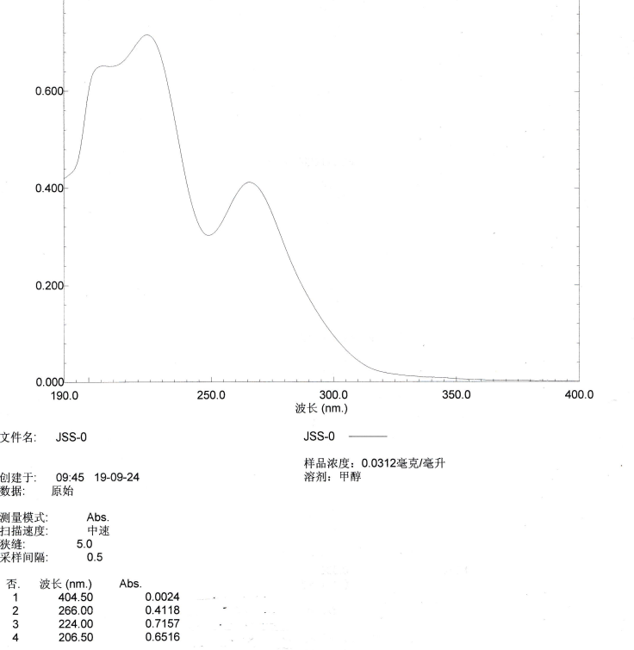
Figure S10. UV spectrum of artemyrianin A (1) in MeOH
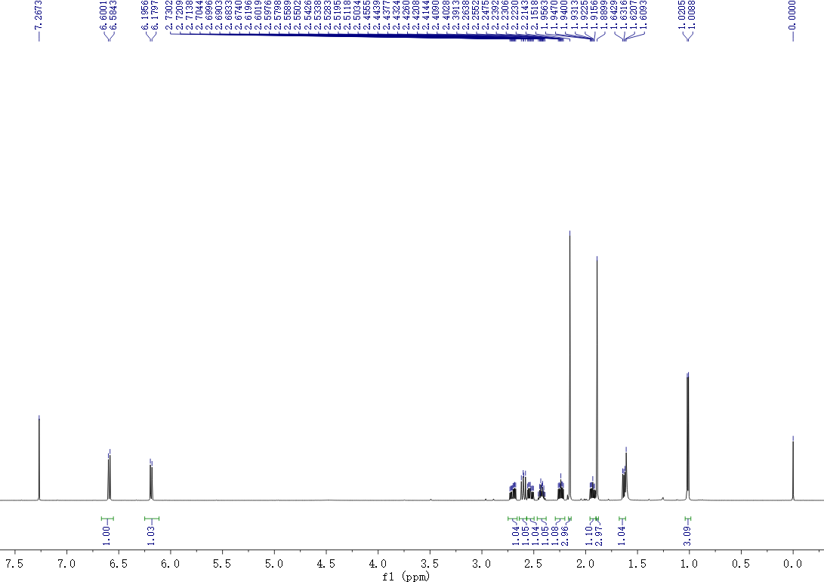
Figure S11. ¹H NMR spectrum of artemyrianin B (2) recorded in CDCl₃ at 600 MHz

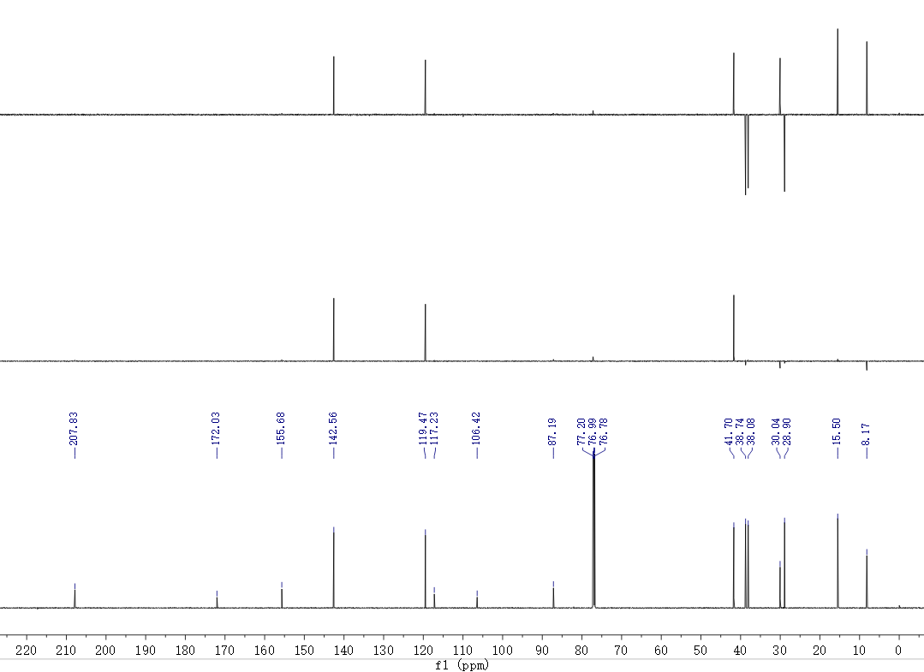
Figure S12. ¹³C NMR (DEPT) spectrum of artemyrianin B (2) recorded in CDCl₃ at 150 MHz
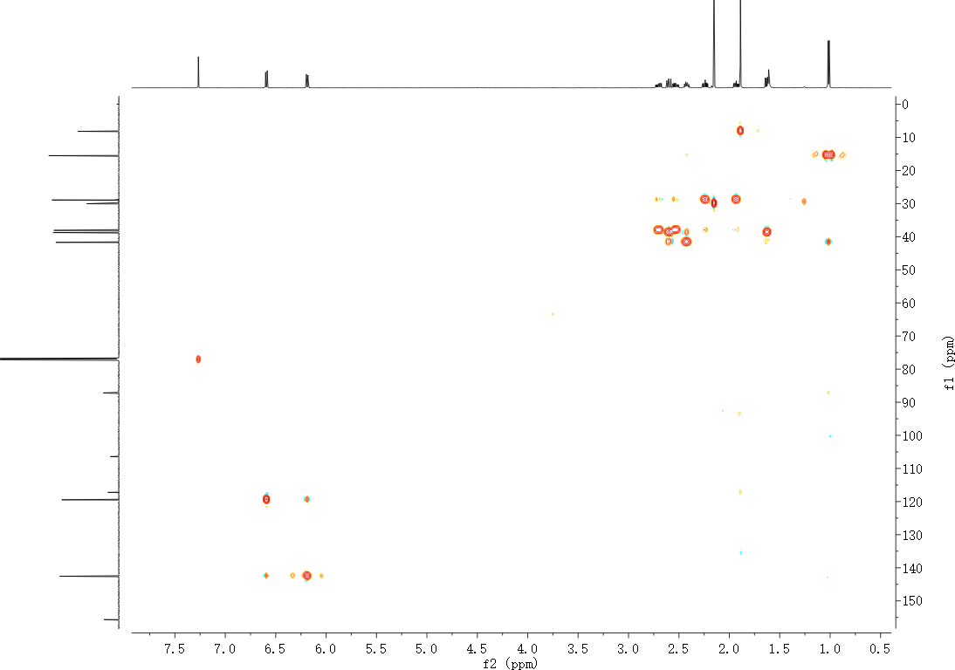
Figure S13. HSQC spectrum of artemyrianin B (2) recorded in CDCl₃

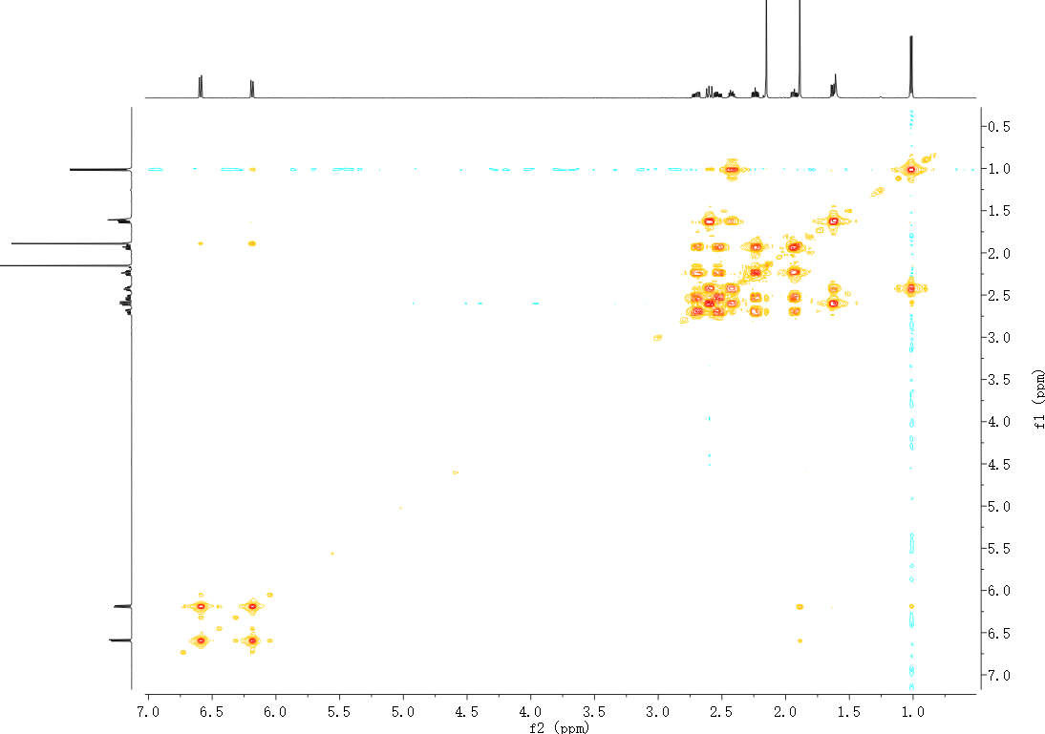
Figure S14. ¹H−¹H COSY spectrum of artemyrianin B (2) recorded in CDCl₃
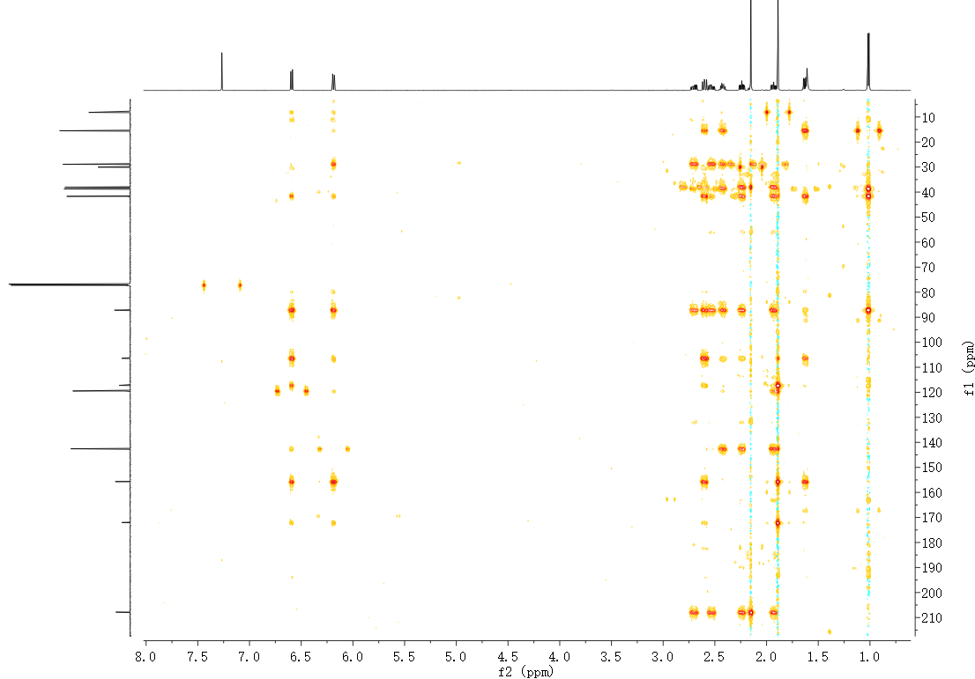
Figure S15. HMBC spectrum of artemyrianin B (2) recorded in CDCl₃

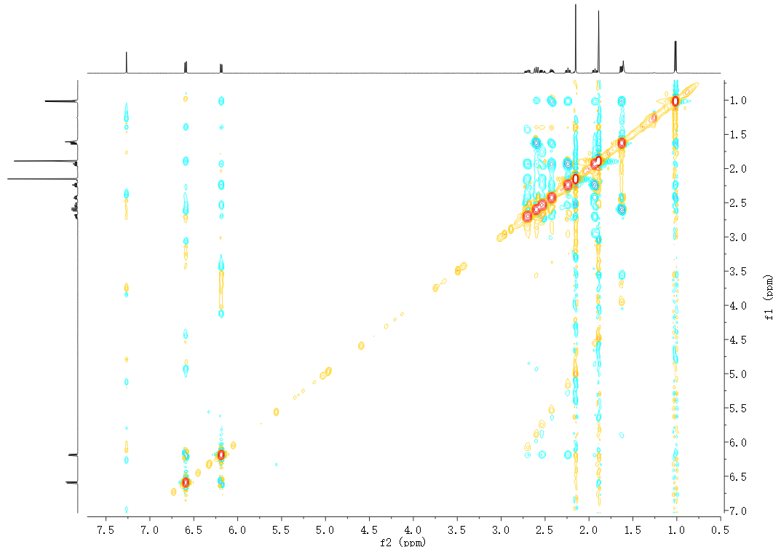
H₃-13
H-6
Figure S16. ROESY spectrum of artemyrianin B (2) recorded in CDCl₃
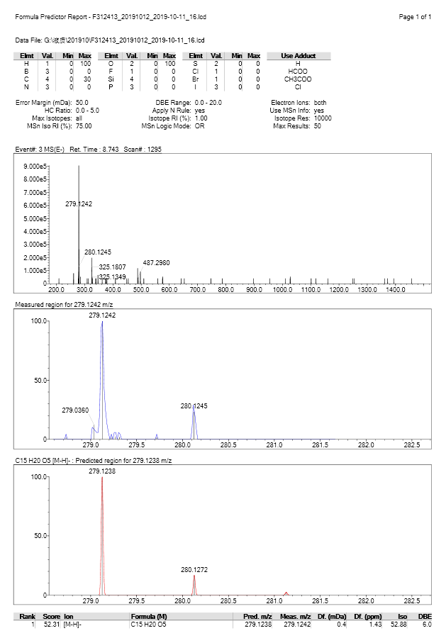
Figure S17. (−)-HRESIMS spectrum of artemyrianin B (2)

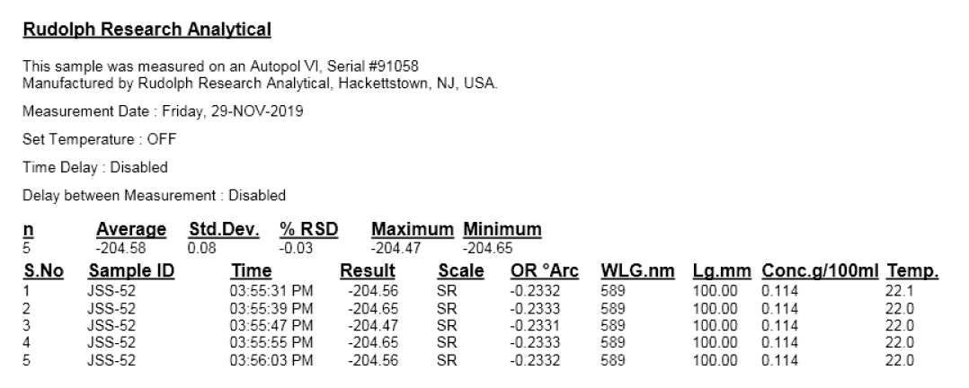
Figure S18. [α]_{D} spectrum of artemyrianin B (2) in MeOH
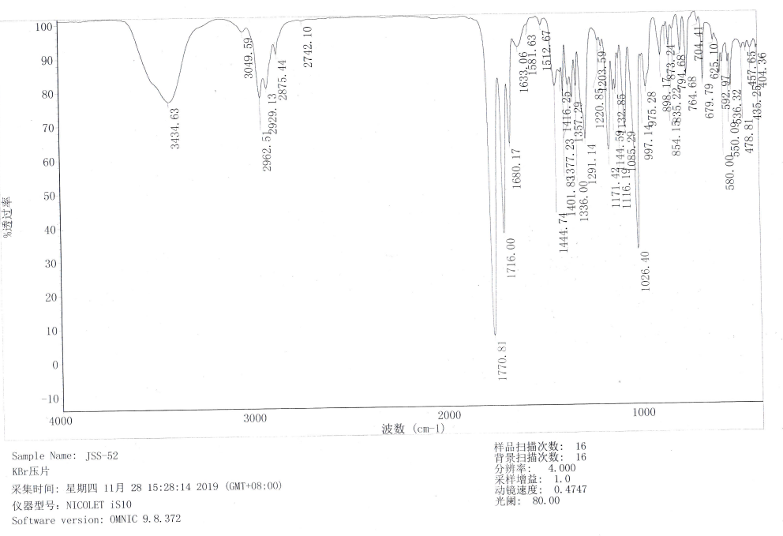
Figure S19. IR spectrum of artemyrianin B (2)

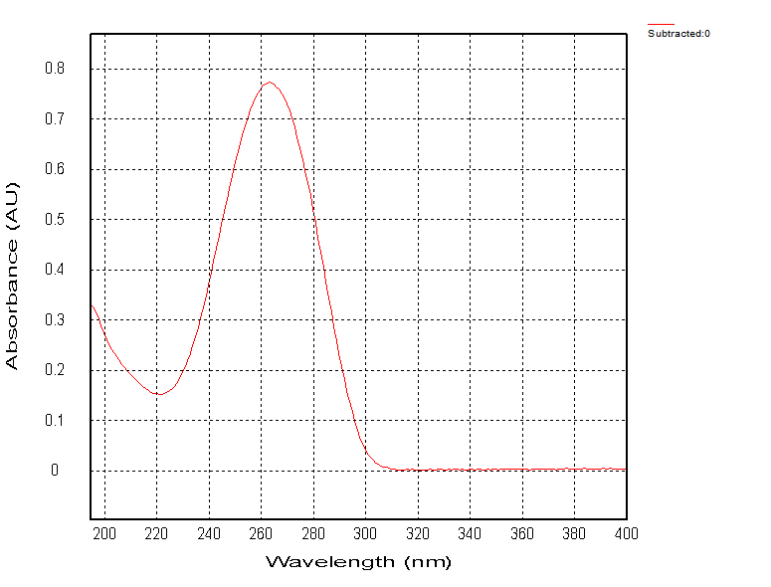
Figure S20. UV spectrum of artemyrianin B (2) in MeOH
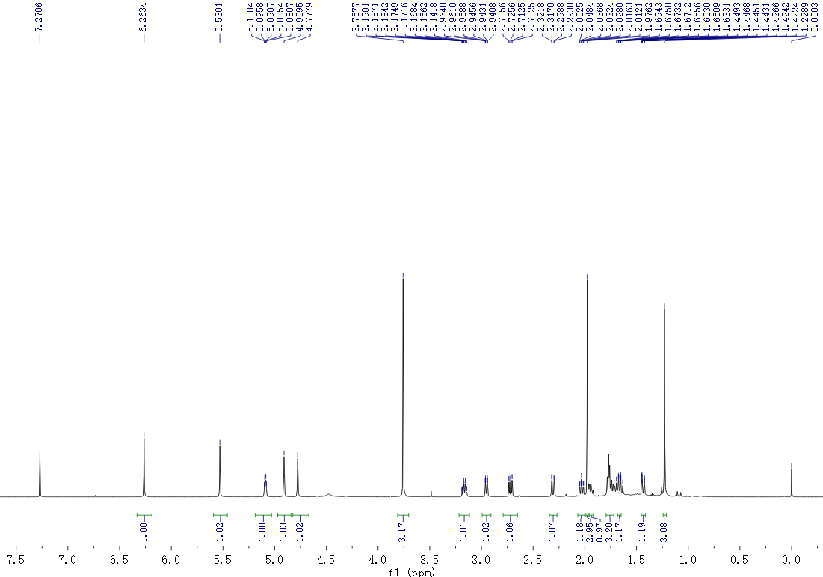
Figure S21. ¹H NMR spectrum of artemyrianin C (3) recorded in CDCl₃ at 600 MHz

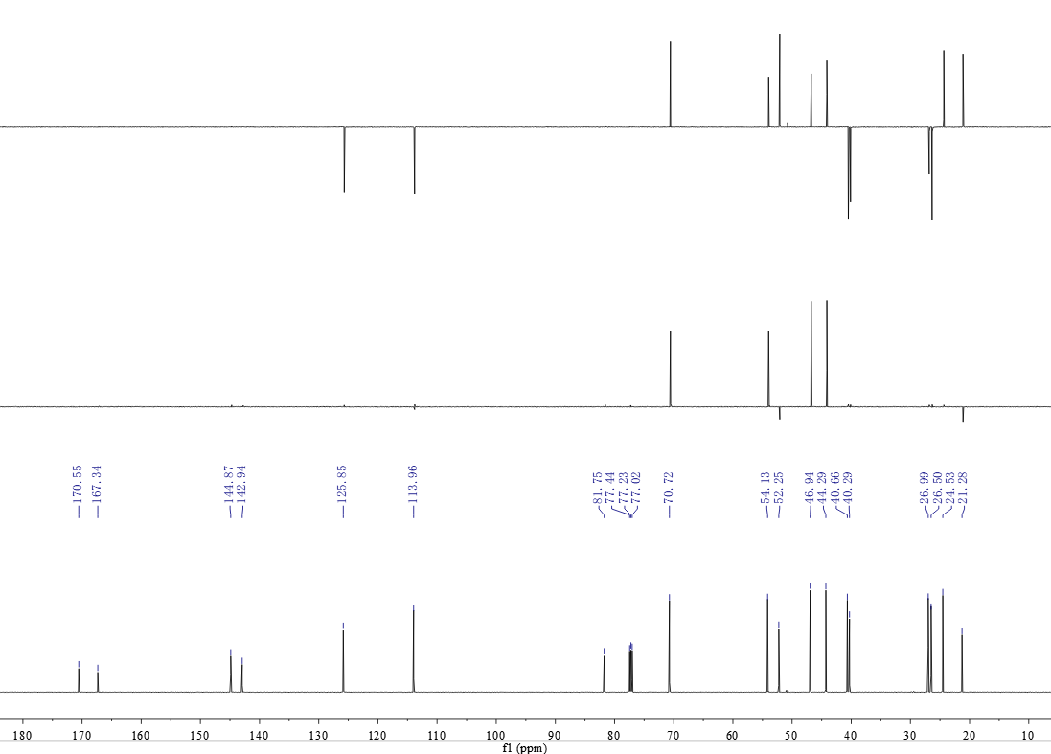
Figure S22. ¹³C NMR (DEPT) spectrum of artemyrianin C (3) recorded in CDCl₃ at 150 MHz
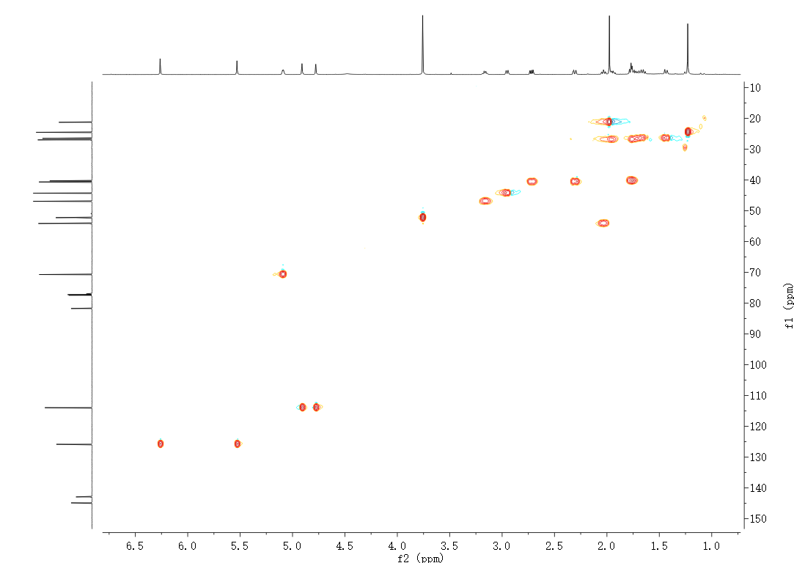
Figure S23. HSQC spectrum of artemyrianin C (3) recorded in CDCl₃

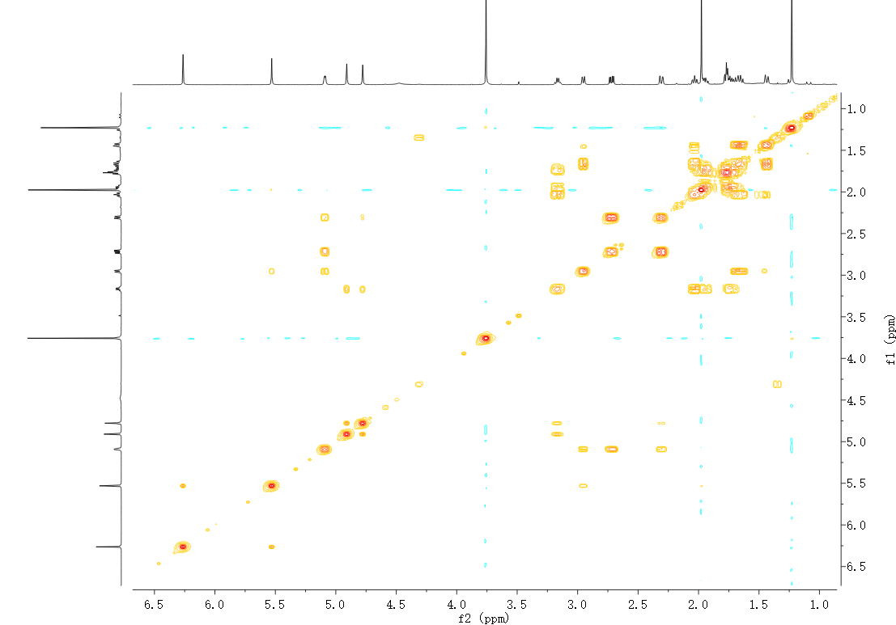
Figure S24. ¹H−¹H COSY spectrum of artemyrianin C (3) recorded in CDCl₃
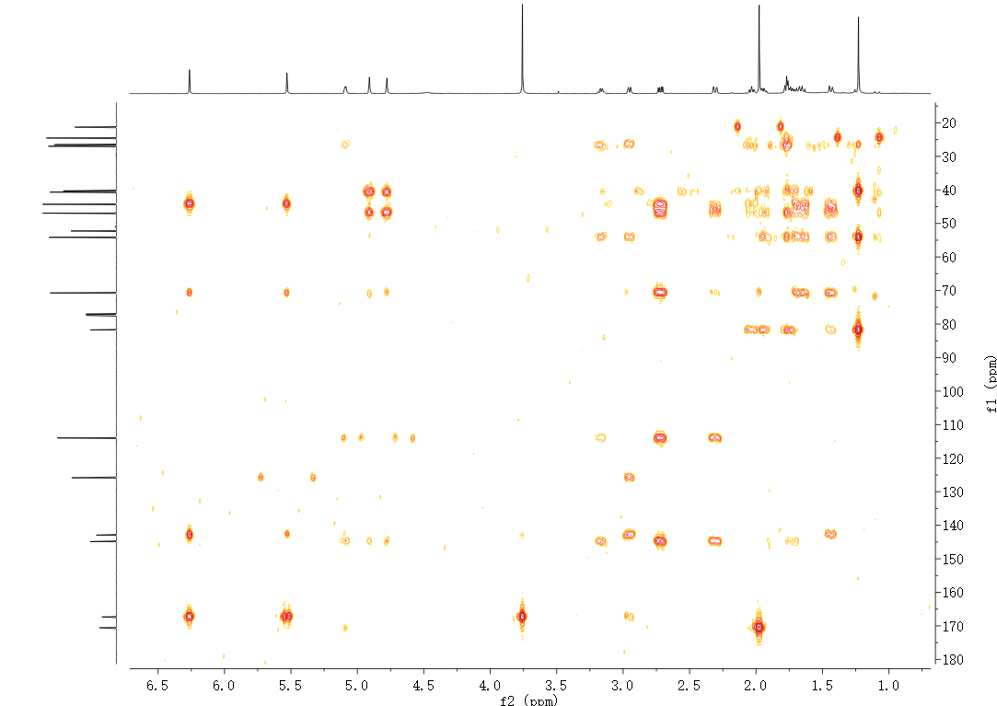
Figure S25. HMBC spectrum of artemyrianin C (3) recorded in CDCl₃

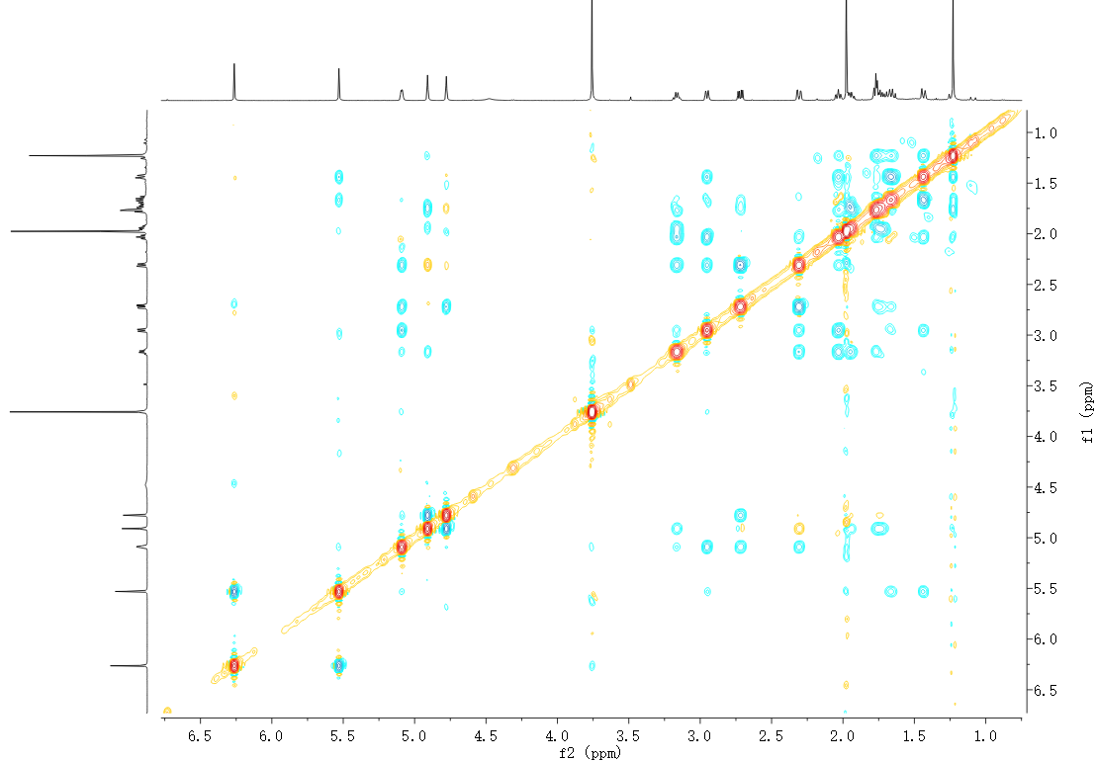
Figure S26. ROESY spectrum of artemyrianin C (3) recorded in CDCl₃
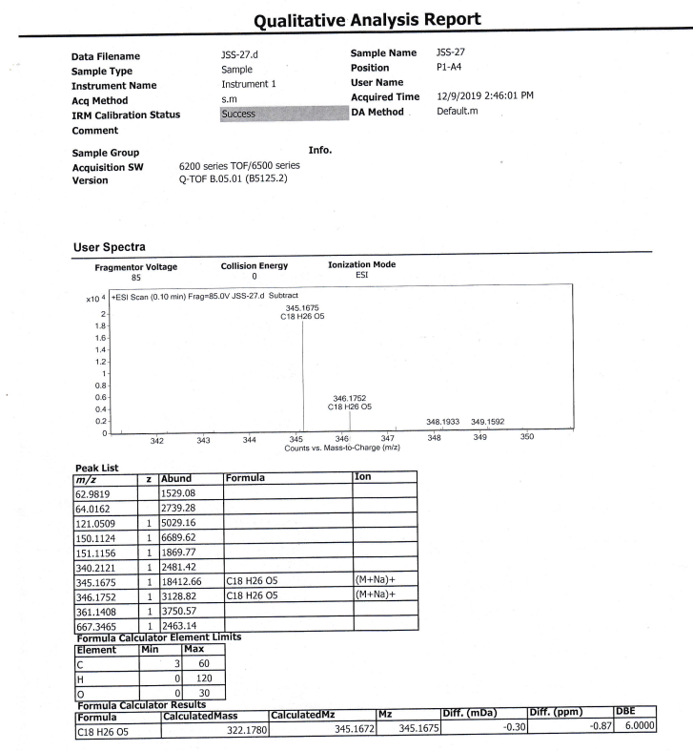
Figure S27. (+)-HRESIMS spectrum of artemyrianin C (3)

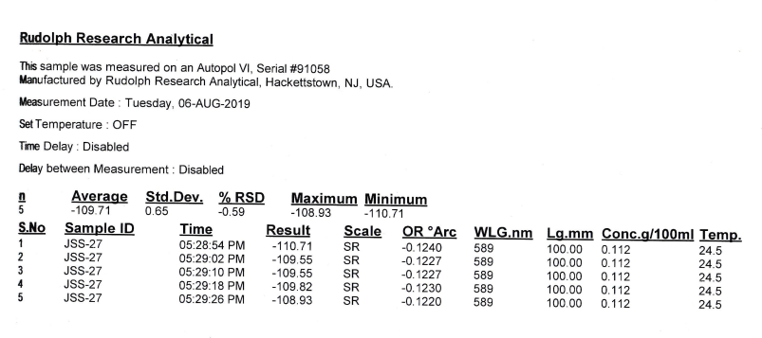
Figure S28. [α]_{D} spectrum of artemyrianin C (3) in MeOH
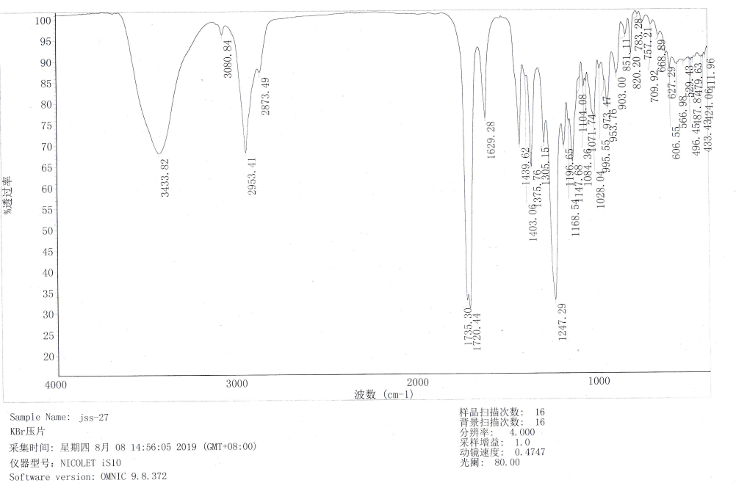
Figure S29. IR spectrum of artemyrianin C (3)

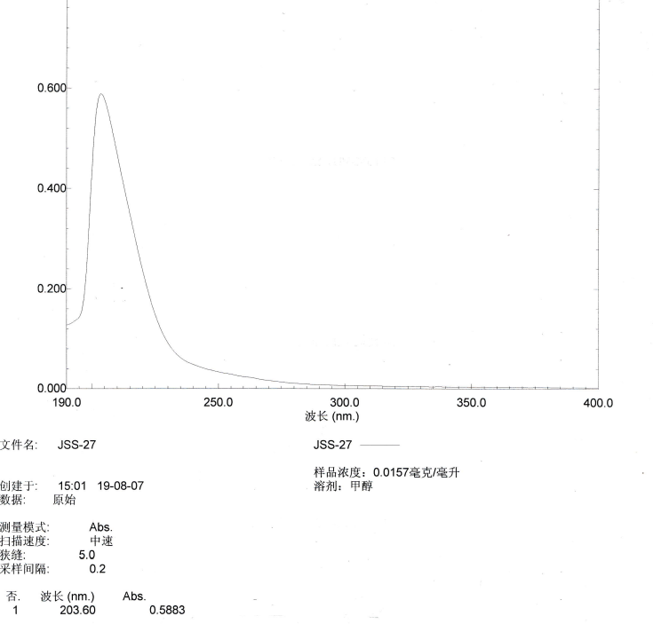
Figure S30. UV spectrum of artemyrianin C (3) in MeOH
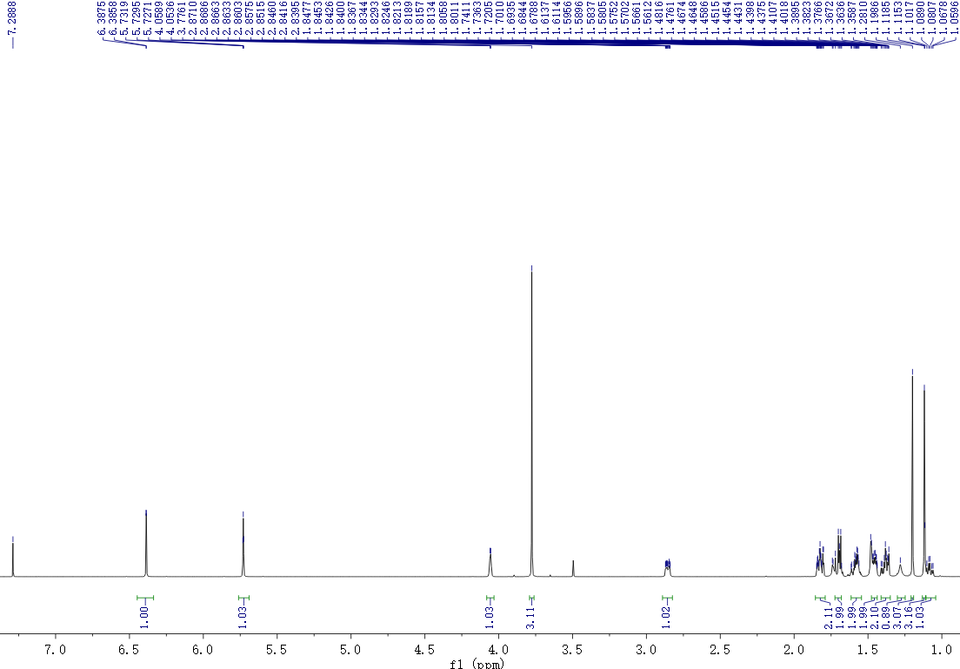
Figure S31. ¹H NMR spectrum of artemyrianin D (4) recorded in CDCl₃ at 600 MHz

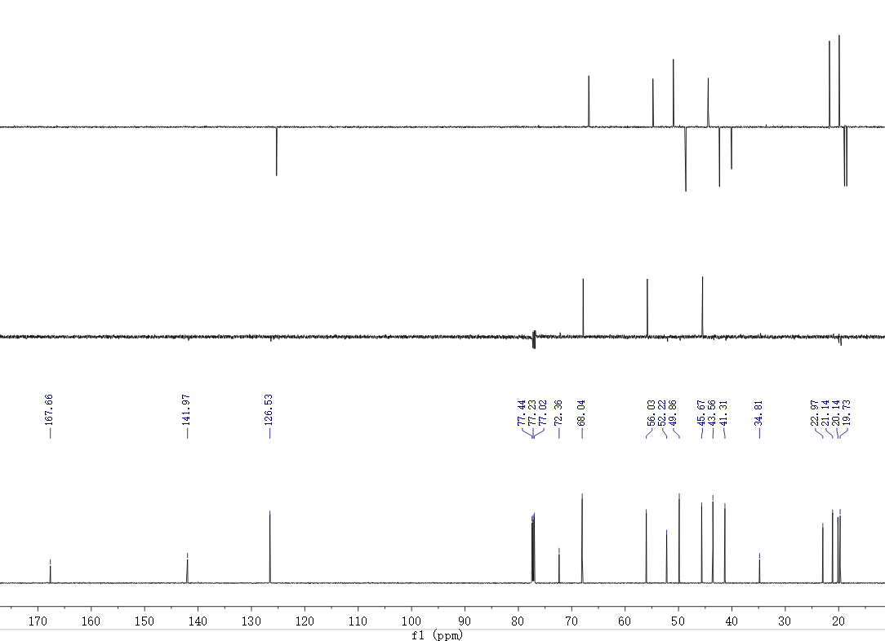
Figure S32. ¹³C NMR (DEPT) spectrum of artemyrianin D (4) recorded in CDCl₃ at 150 MHz
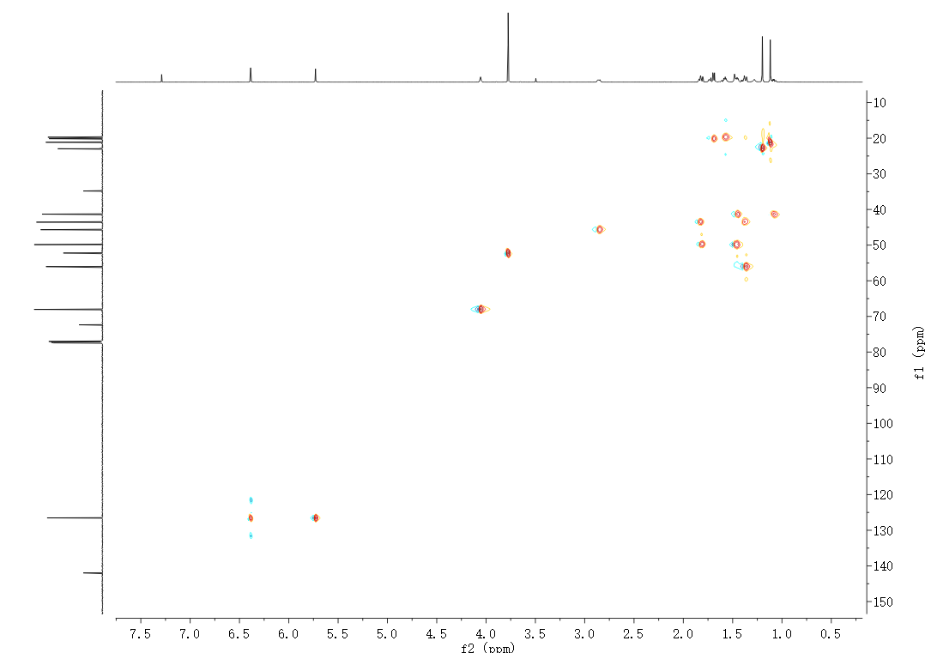
Figure S33. HSQC spectrum of artemyrianin D (4) recorded in CDCl₃

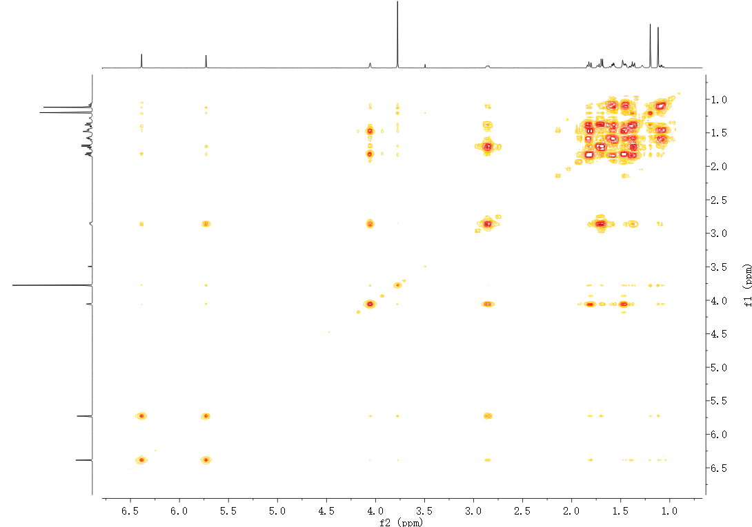
Figure S34. ¹H−¹H COSY spectrum of artemyrianin D (4) recorded in CDCl₃
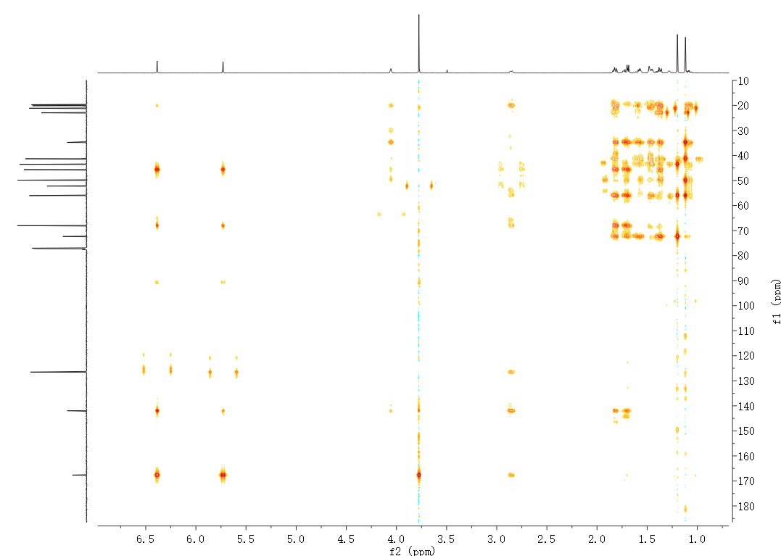
Figure S35. HMBC spectrum of artemyrianin D (4) recorded in CDCl₃

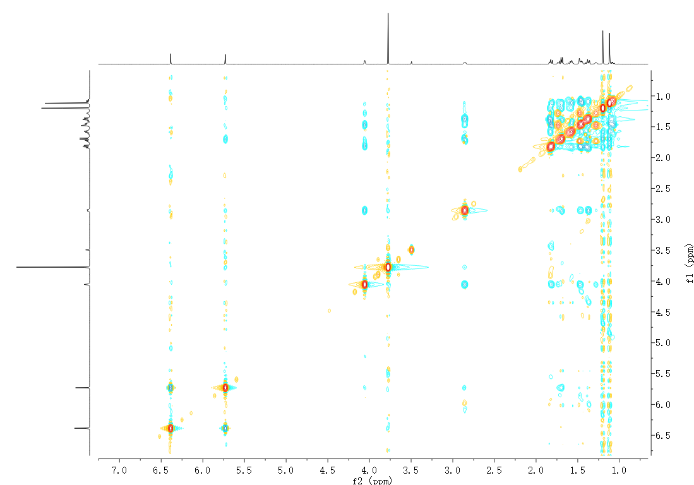
Figure S36. ROESY spectrum of artemyrianin D (4) recorded in CDCl₃
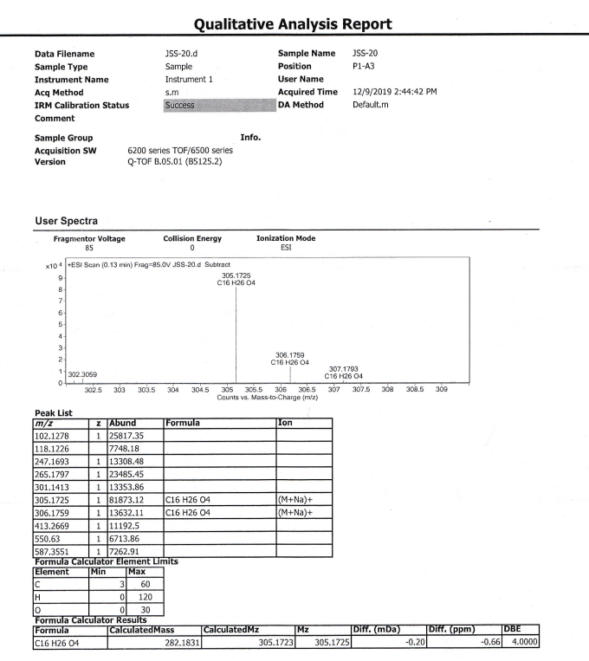
Figure S37. (+)-HRESIMS spectrum of artemyrianin D (4)

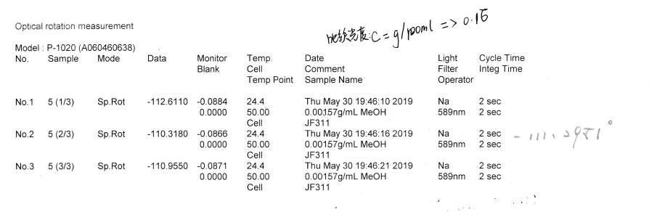
Figure S38. [α]_{D} spectrum of artemyrianin D (4) in MeOH
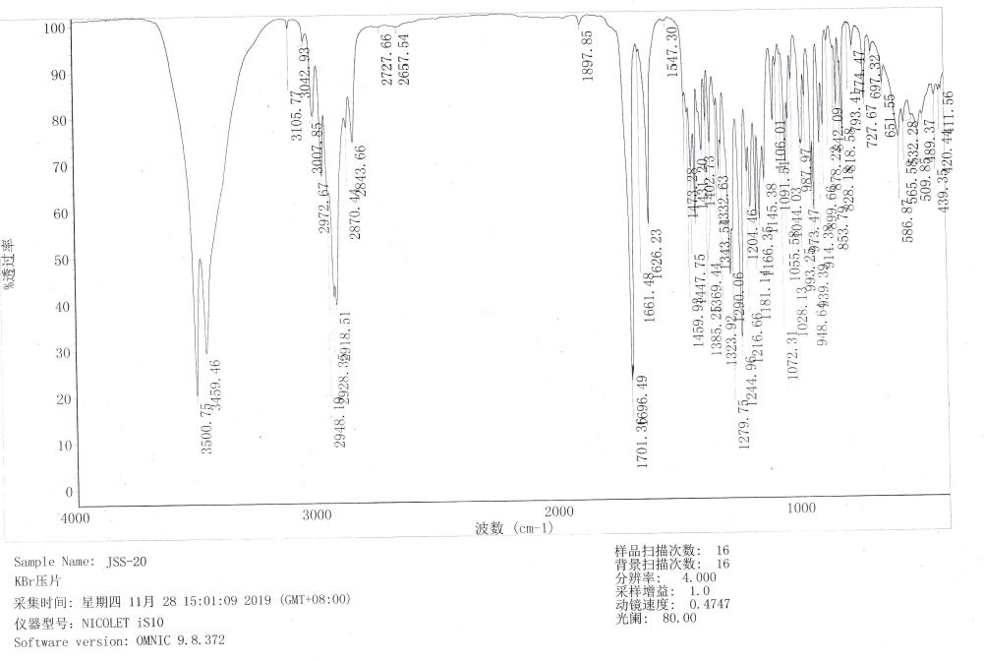
Figure S39. IR spectrum of artemyrianin D (4)

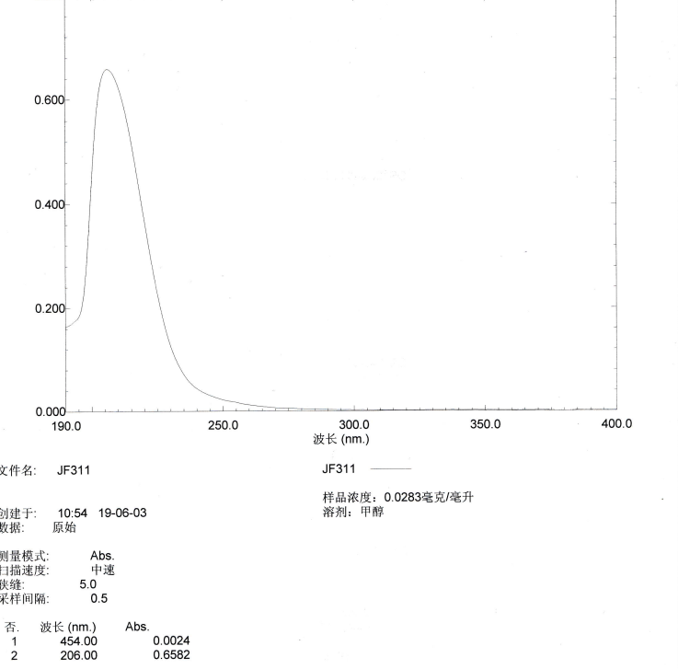
Figure S40. UV spectrum of artemyrianin D (4) in MeOH
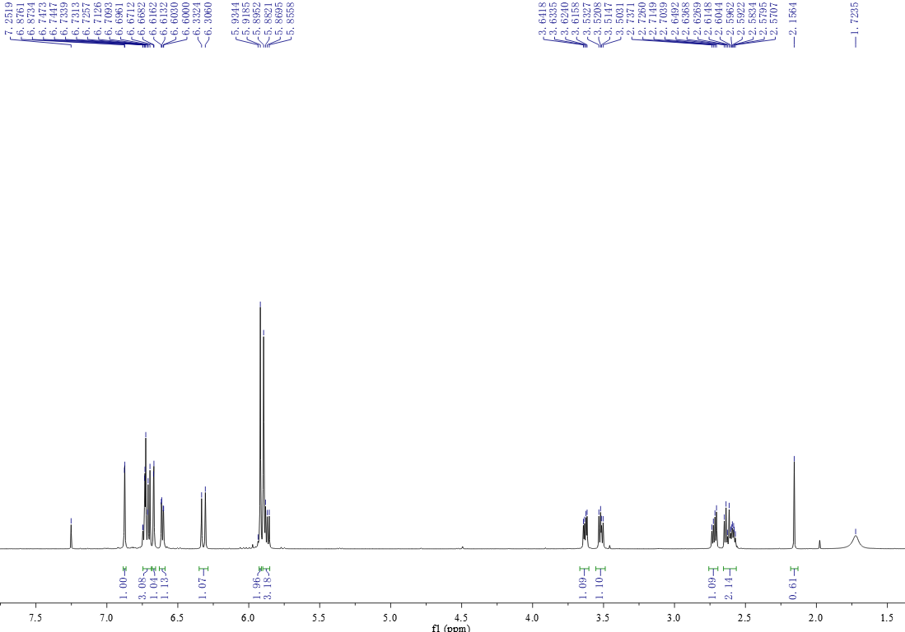
Figure S41. ¹H NMR spectrum of artemyrianin E (5) recorded in CDCl₃ at 600 MHz

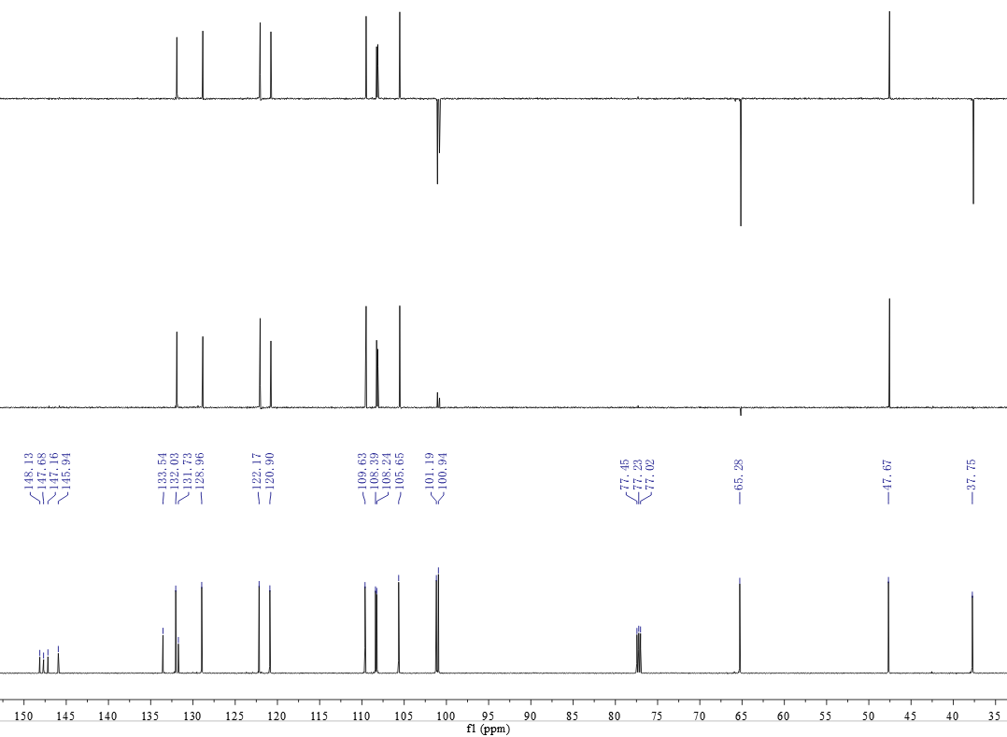
Figure S42. ¹³C NMR (DEPT) spectrum of artemyrianin E (5) recorded in CDCl₃ at 150 MHz
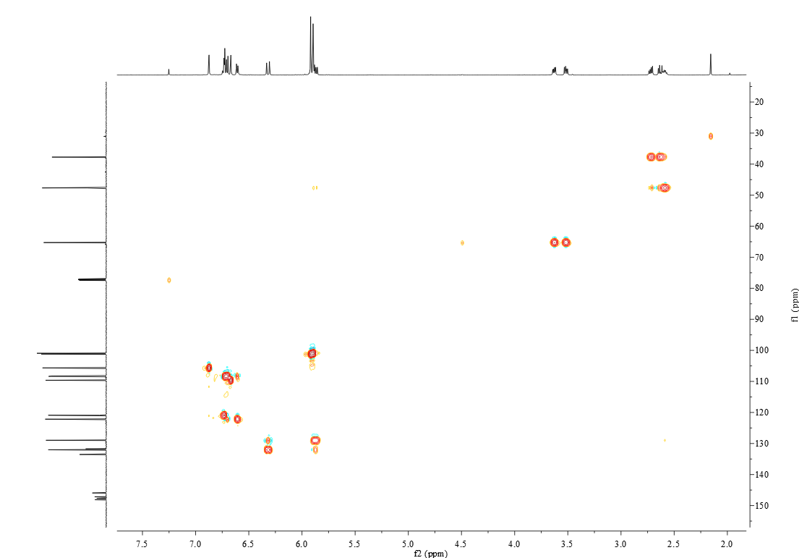
Figure S43. HSQC spectrum of artemyrianin E (5) recorded in CDCl₃

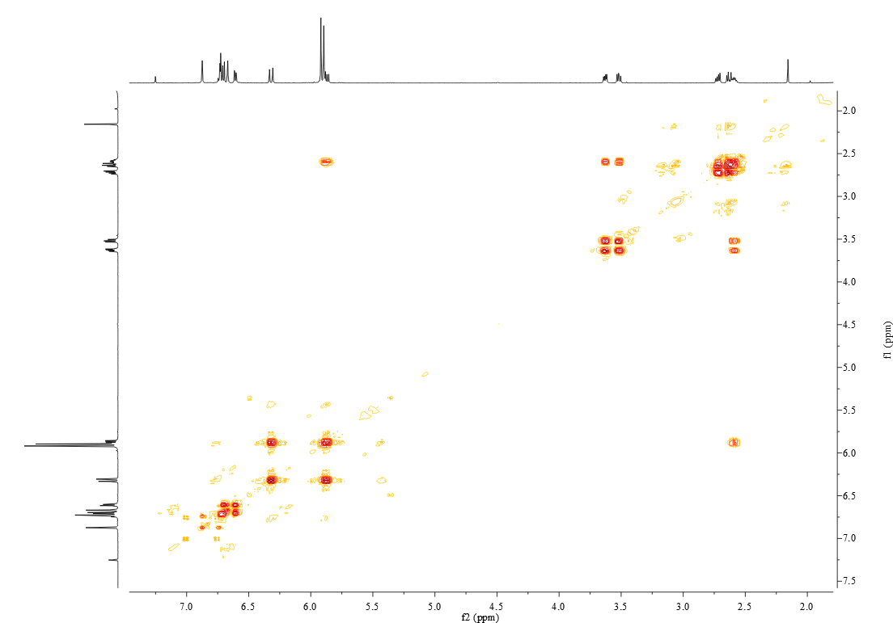
Figure S44. ¹H−¹H COSY spectrum of artemyrianin E (5) recorded in CDCl₃

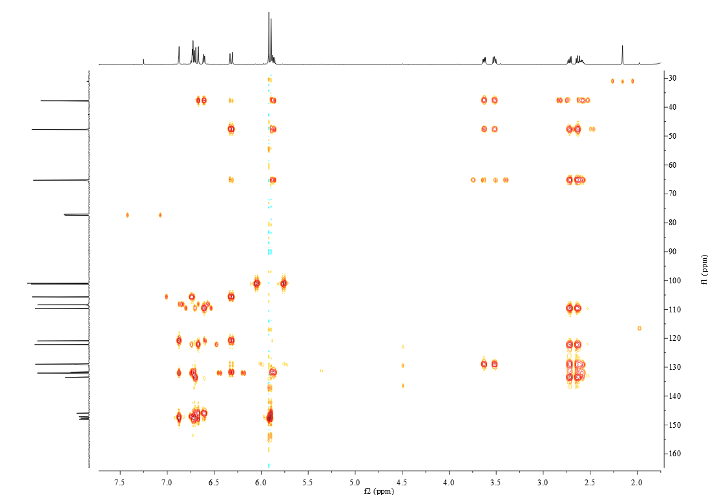
Figure S45. HMBC spectrum of artemyrianin E (5) recorded in CDCl₃

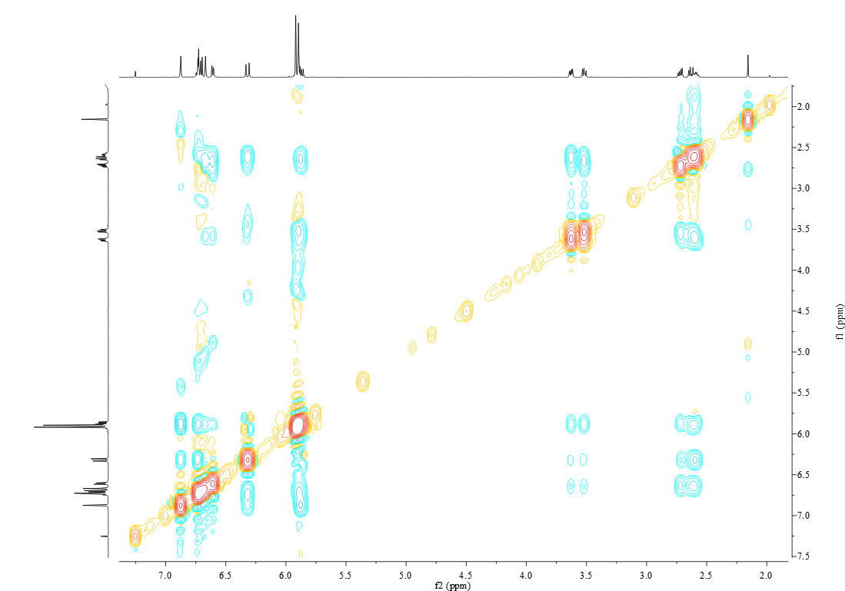
Figure S46. ROESY spectrum of artemyrianin E (5) recorded in CDCl₃
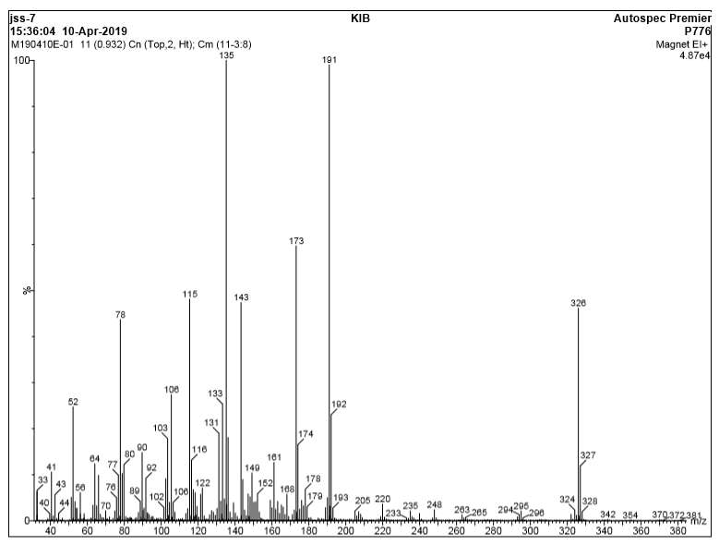
Figure S47. EIMS spectrum of artemyrianin E (5)

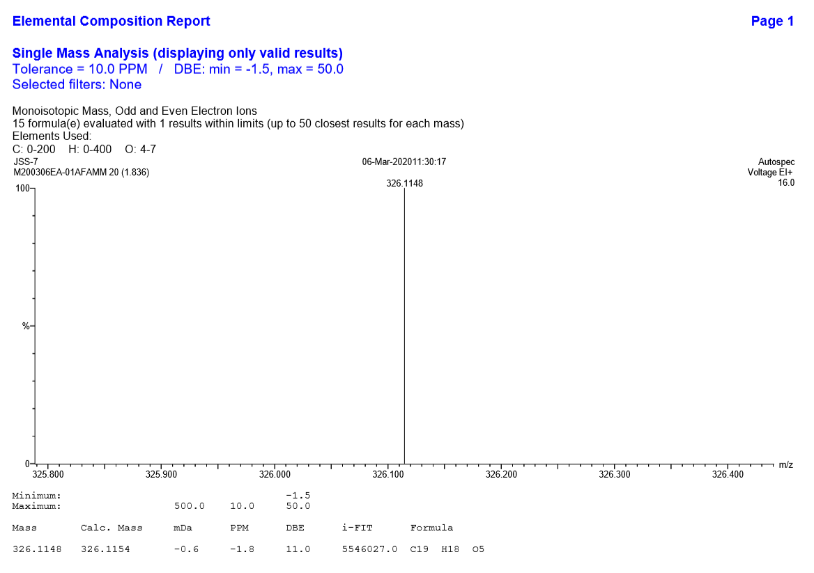
Figure S48. HREIMS spectrum of artemyrianin E (5)

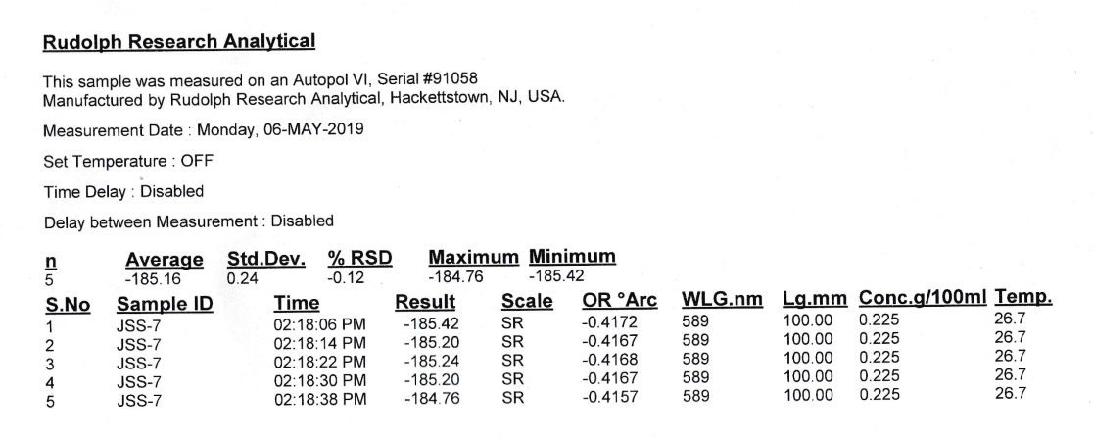
Figure S49. [α]_{D} spectrum of artemyrianin E (5) in MeOH
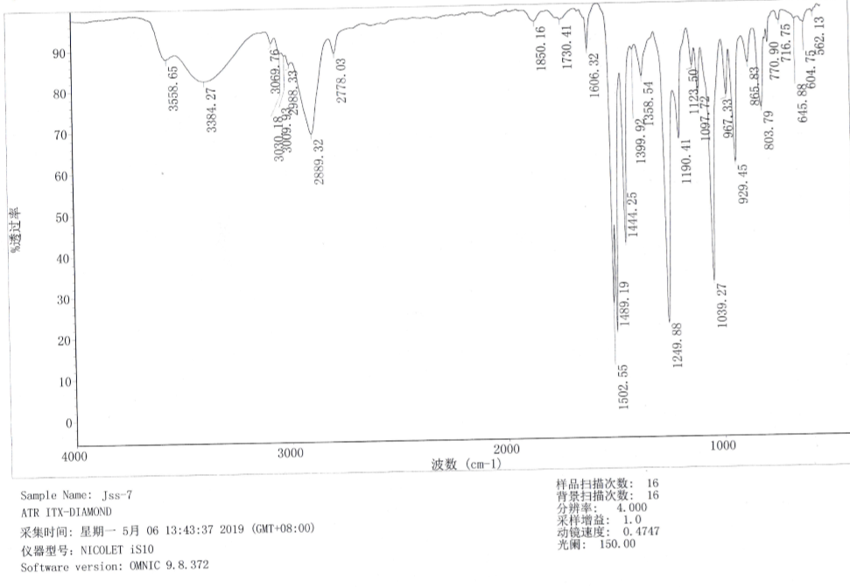
Figure S50. IR spectrum of artemyrianin E (5)

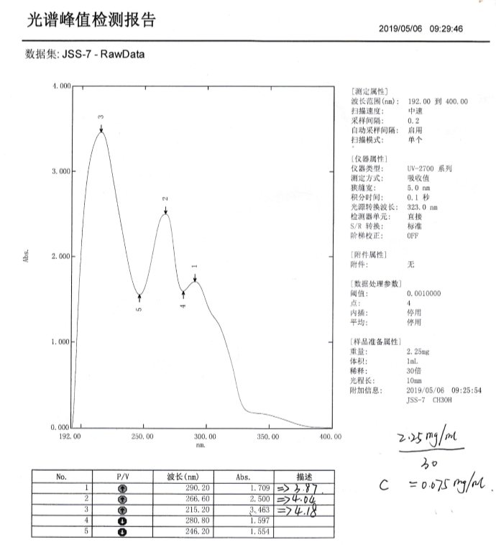
Figure S51. UV spectrum of artemyrianin E (5) in MeOH
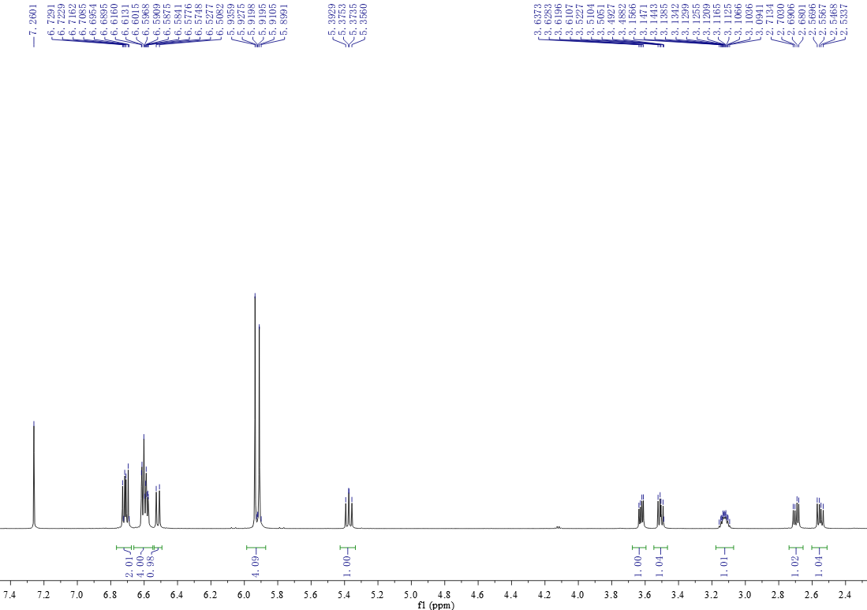
Figure S52. ¹H NMR spectrum of artemyrianin F (6) recorded in CDCl₃ at 600 MHz

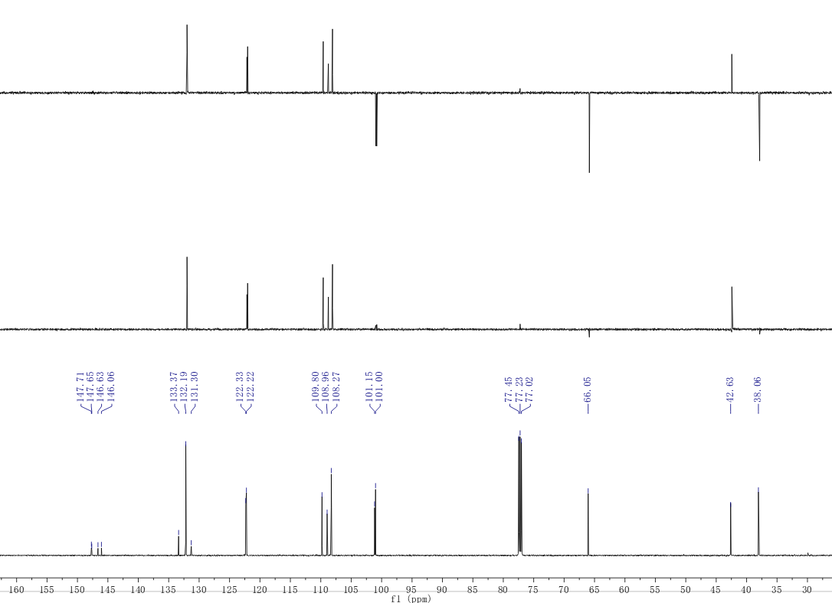
Figure S53. ¹³C NMR (DEPT) spectrum of artemyrianin F (6) recorded in CDCl₃ at 150 MHz

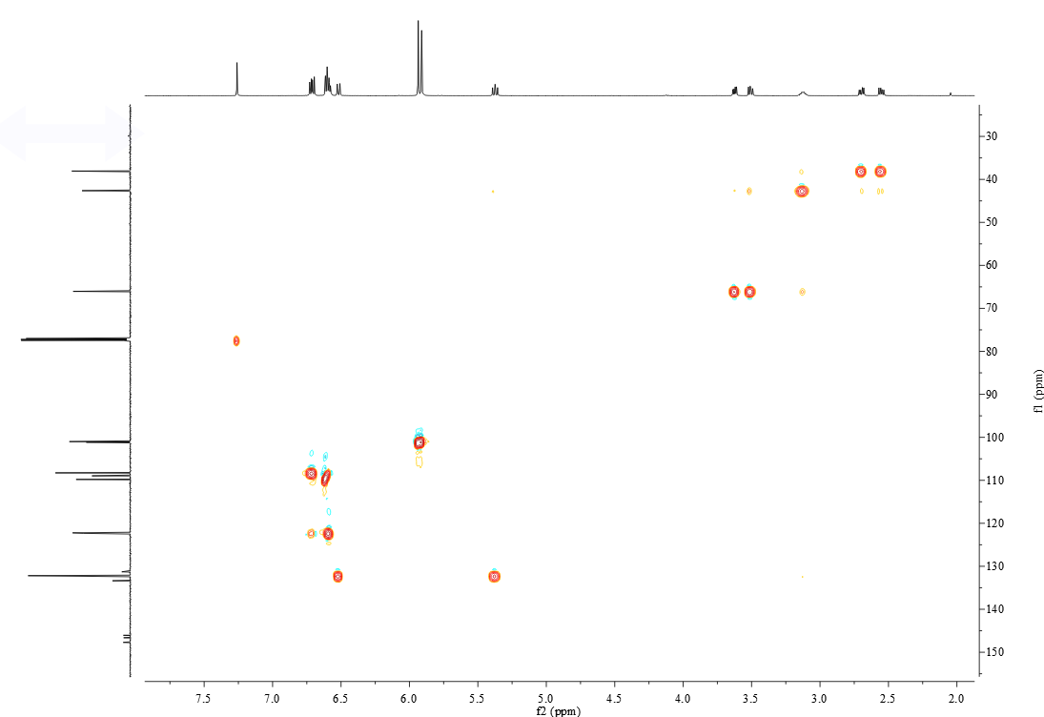
Figure S54. HSQC spectrum of artemyrianin F (6) recorded in CDCl₃

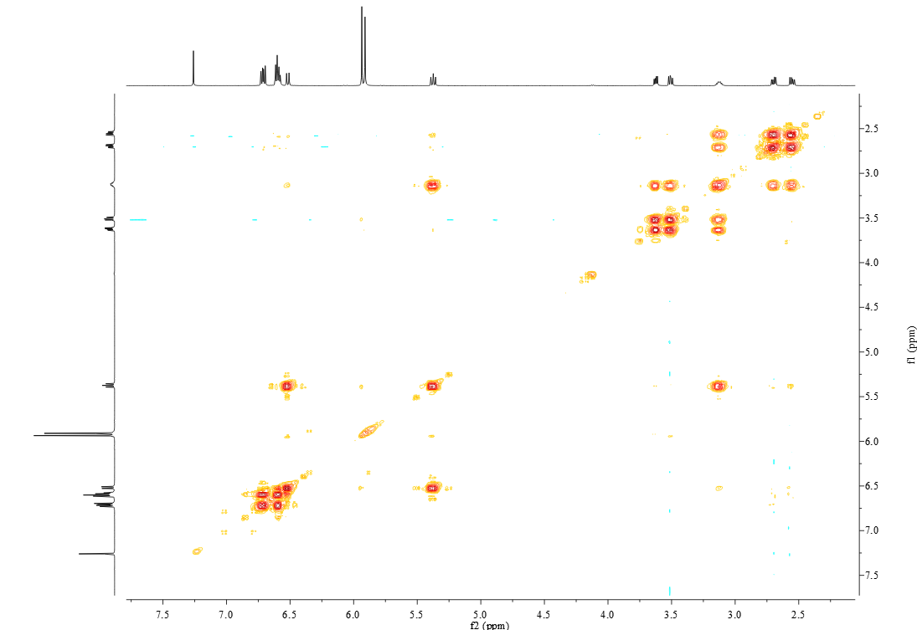
Figure S55. ¹H−¹H COSY spectrum of artemyrianin F (6) recorded in CDCl₃

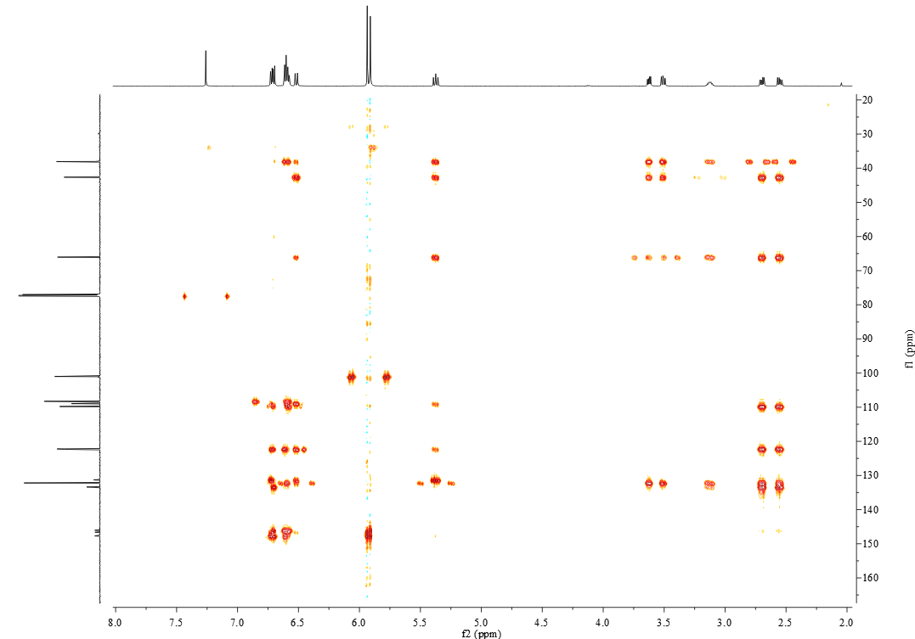
Figure S56. HMBC spectrum of artemyrianin F (6) recorded in CDCl₃

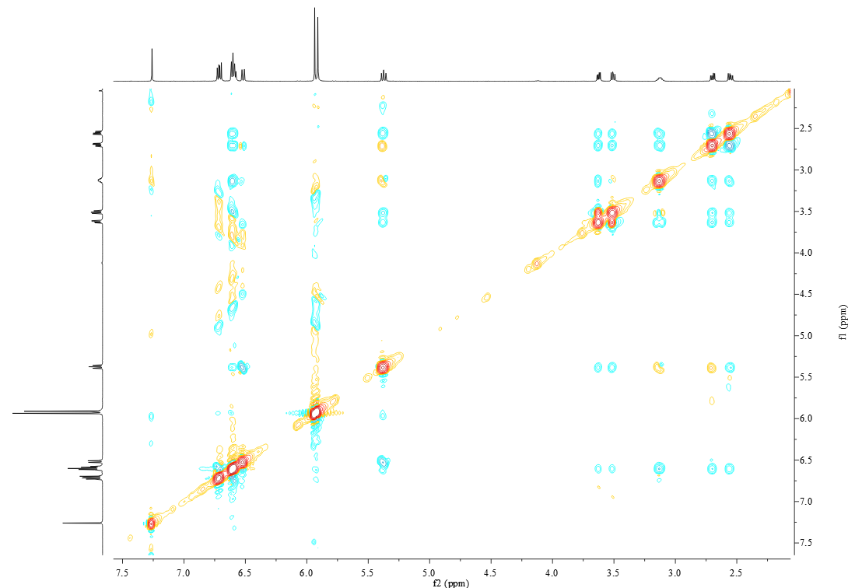
Figure S57. ROESY spectrum of artemyrianin F (6) recorded in CDCl₃

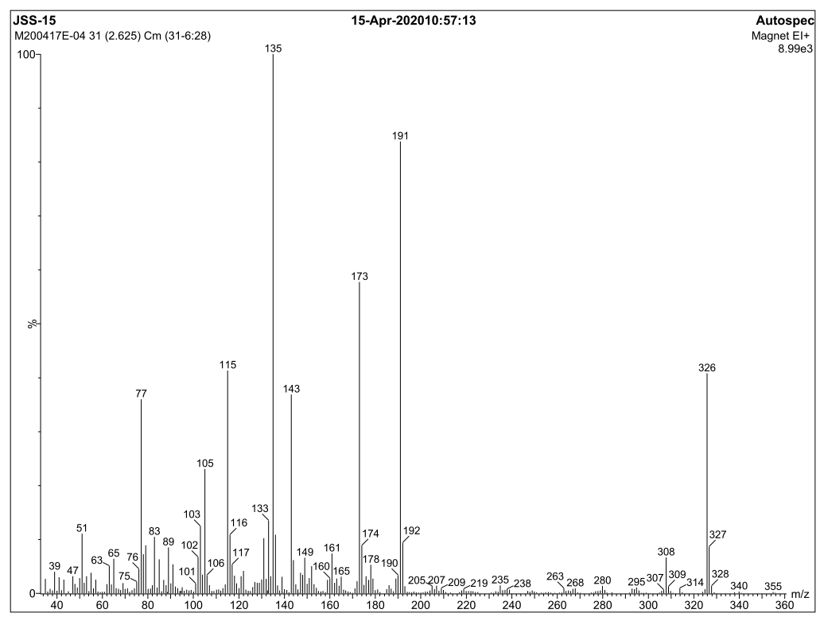
Figure S58. EIMS spectrum of artemyrianin F (6)

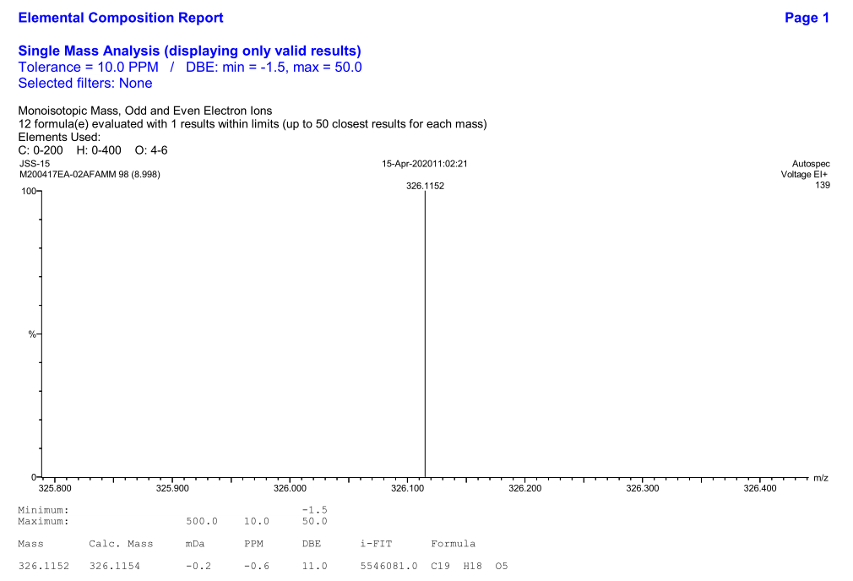
Figure S59. HREIMS spectrum of artemyrianin F (6)

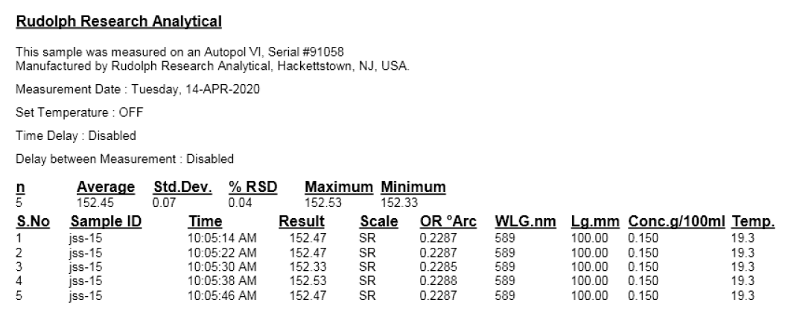
Figure S60. [α]_{D} spectrum of artemyrianin F (6) in MeOH
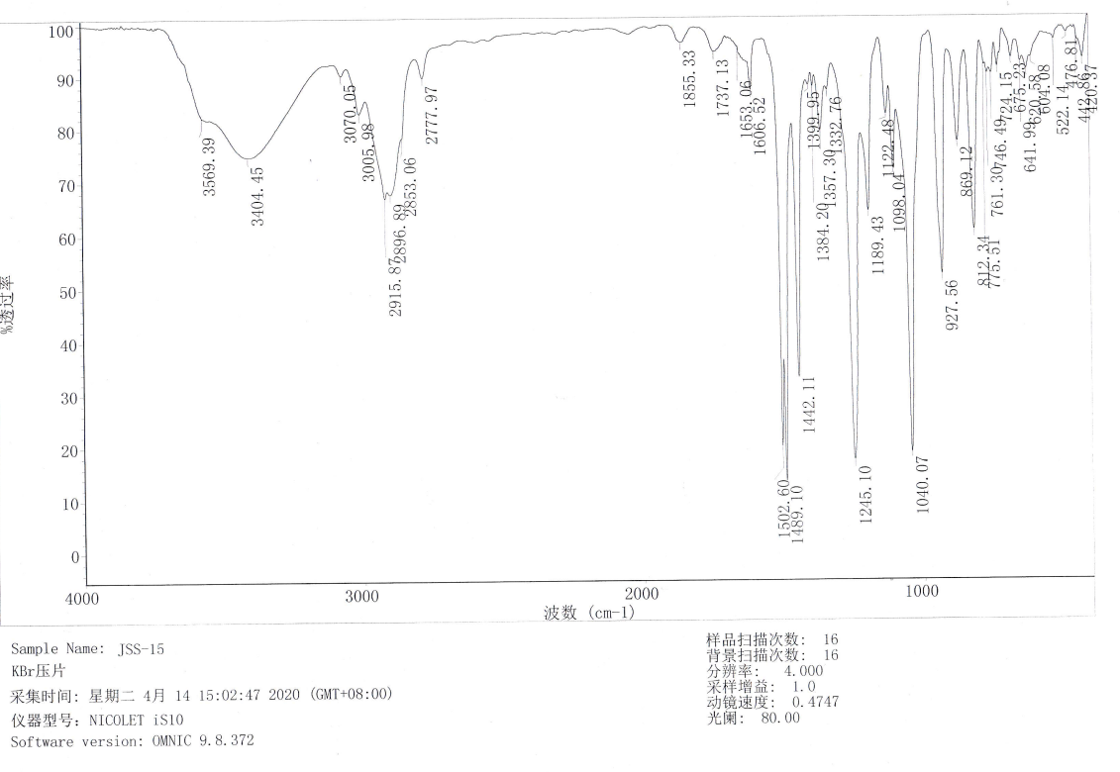
Figure S61. IR spectrum of artemyrianin F (6)

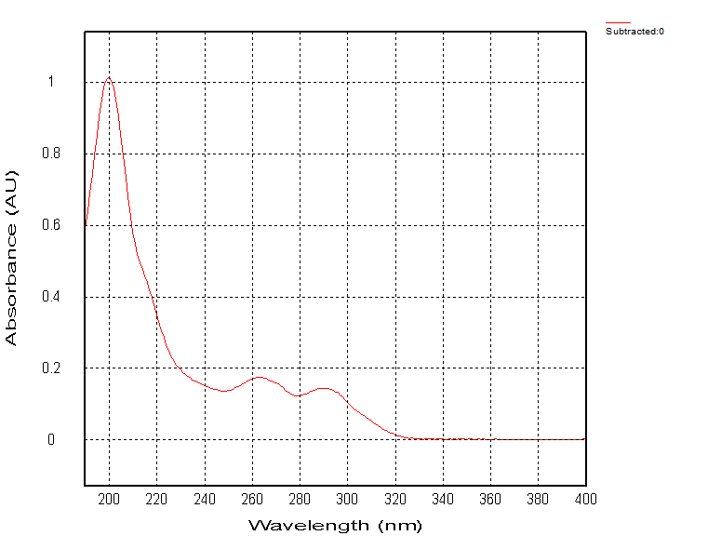
Figure S62. UV spectrum of artemyrianin F (6) in MeCN

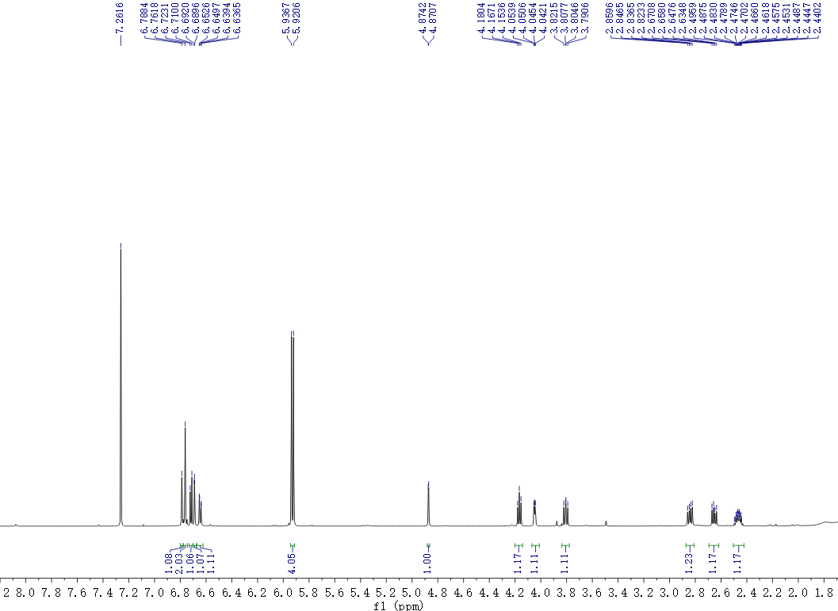
Figure S63. ¹H NMR spectrum of artemyrianin G (7) recorded in CDCl₃ at 600 MHz

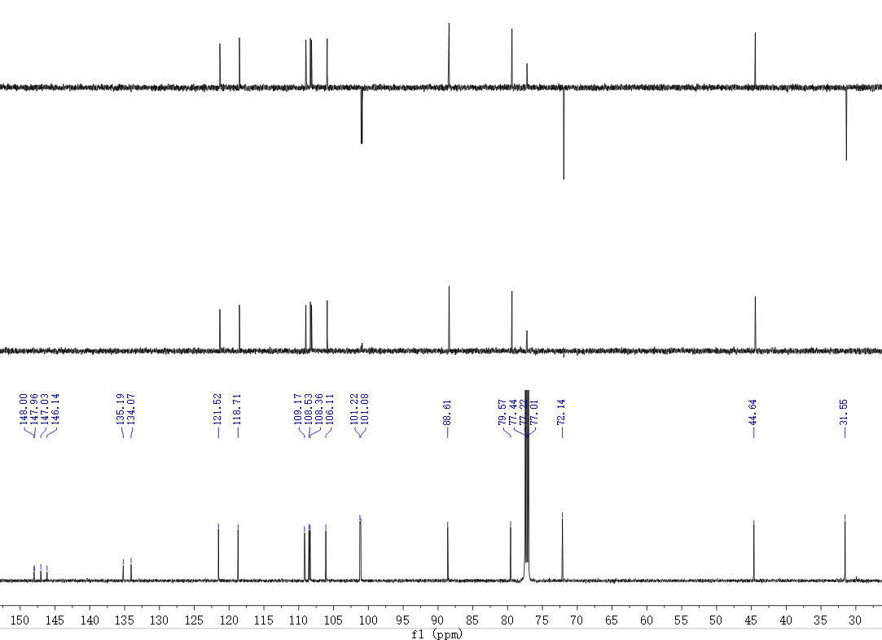
Figure S64. ¹³C NMR (DEPT) spectrum of artemyrianin G (7) recorded in CDCl₃ at 150 MHz
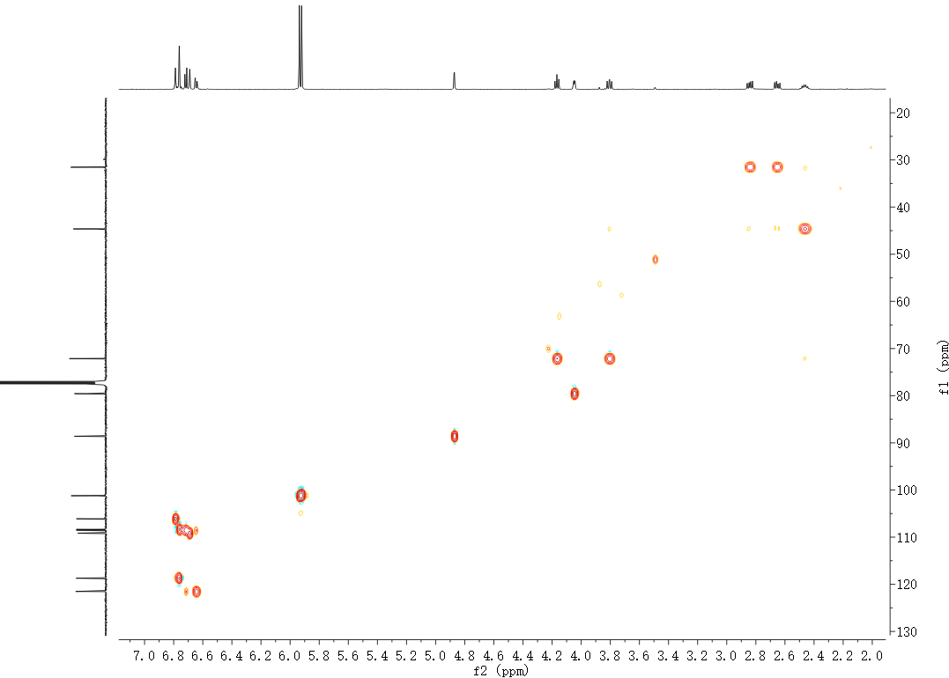
Figure S65. HSQC spectrum of artemyrianin G (7) recorded in CDCl₃

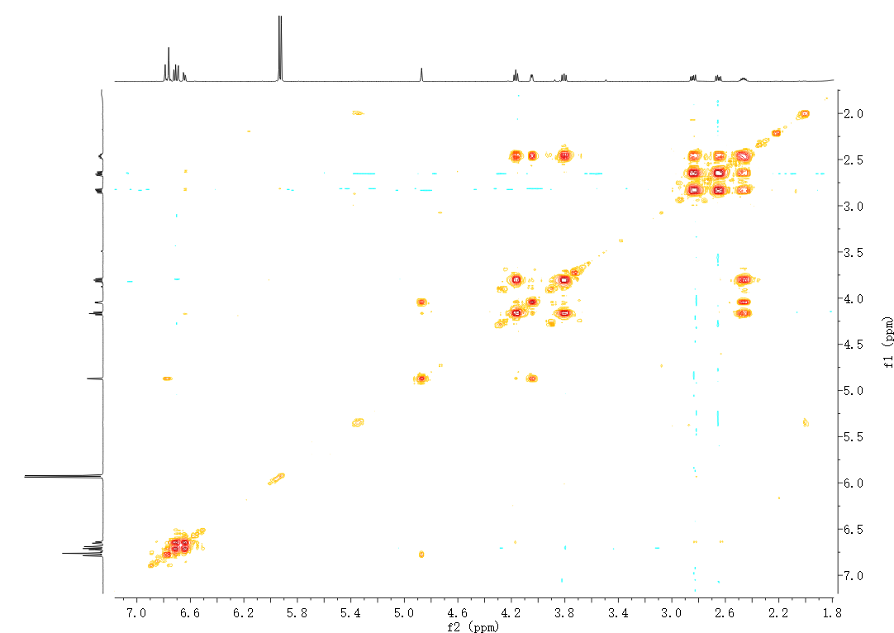
Figure S66. ¹H−¹H COSY spectrum of artemyrianin G (7) recorded in CDCl₃
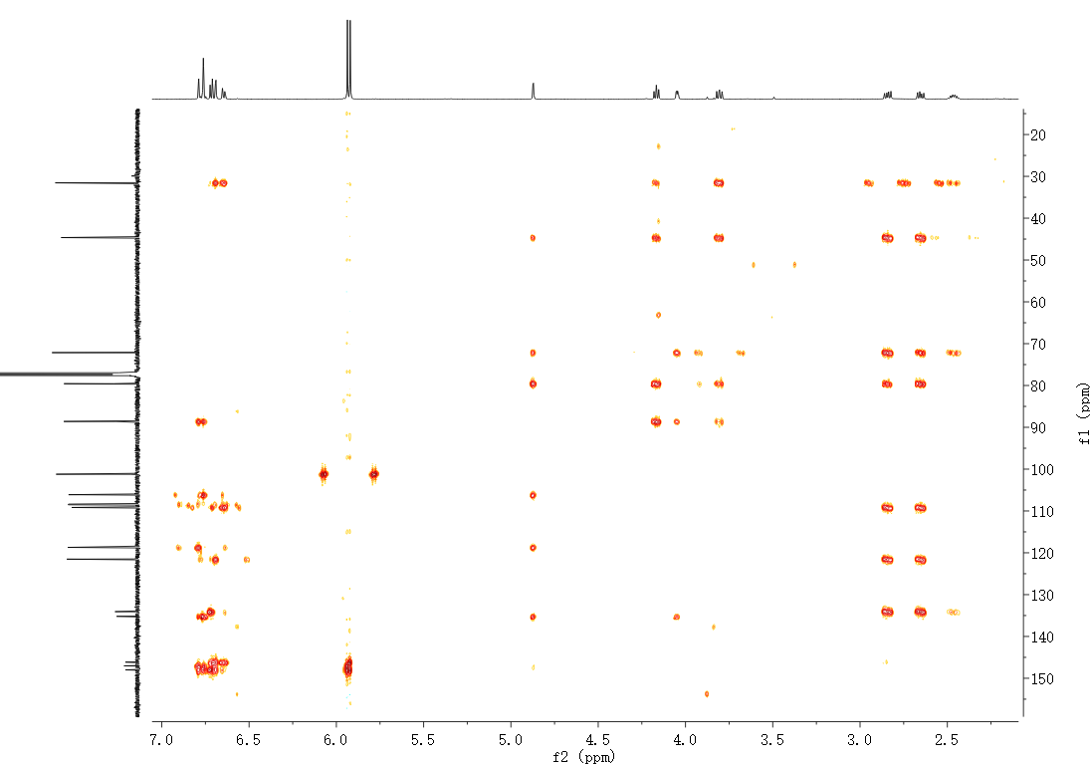
Figure S67. HMBC spectrum of artemyrianin G (7) recorded in CDCl₃

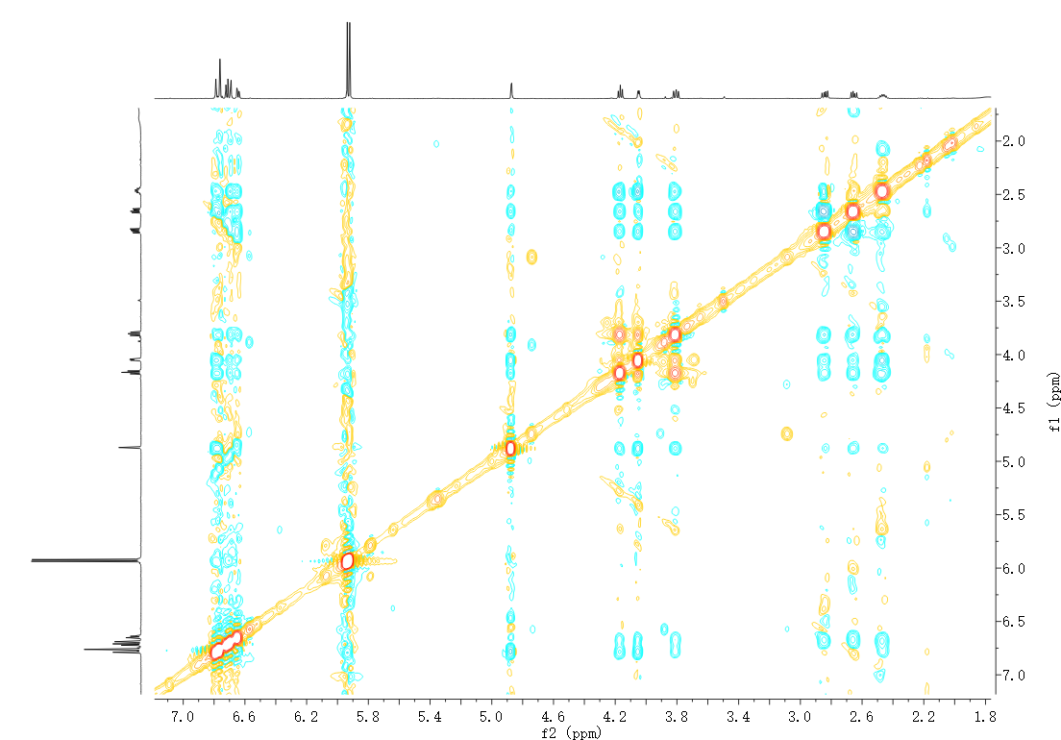
Figure S68. ROESY spectrum of artemyrianin G (7) recorded in CDCl₃
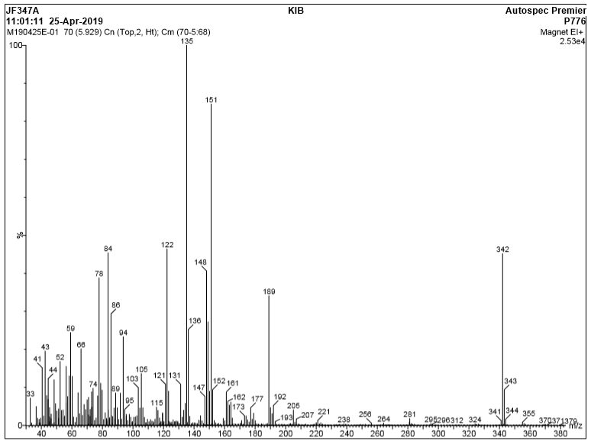
Figure S69. EIMS spectrum of artemyrianin G (7)

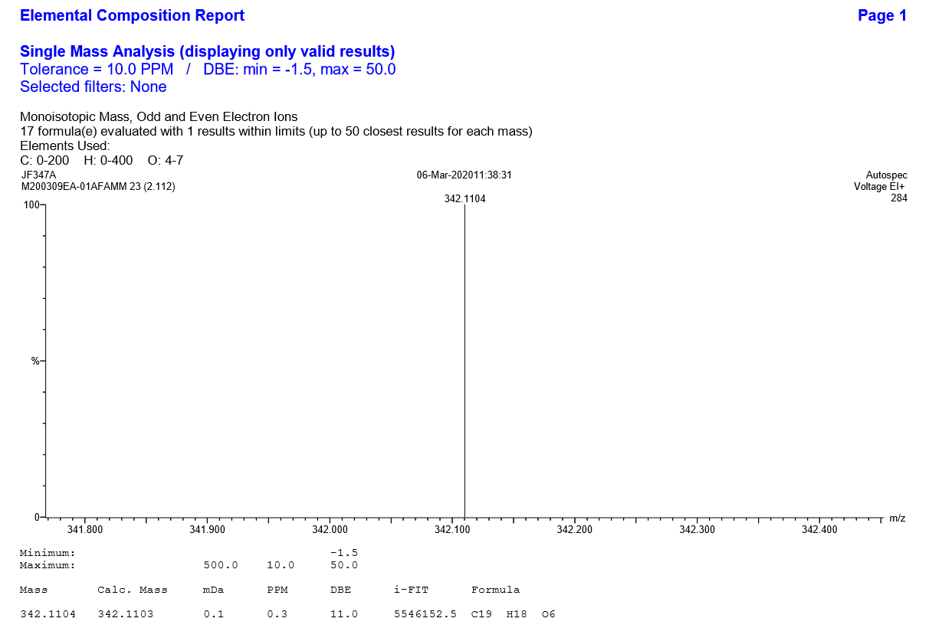
Figure S70. HREIMS spectrum of artemyrianin G (7)

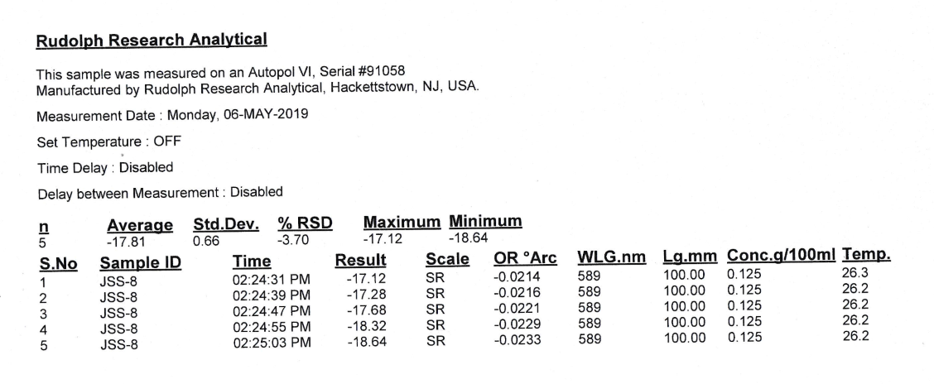
Figure S71. [α]_{D} spectrum of artemyrianin G (7) in MeOH
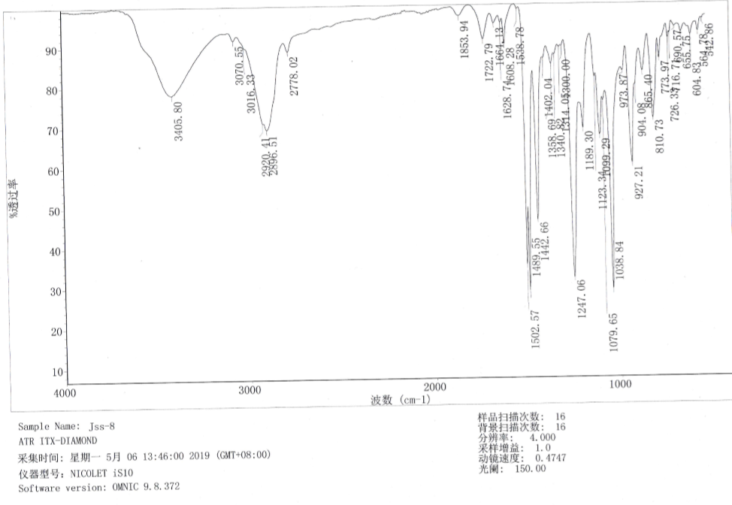
Figure S72. IR spectrum of artemyrianin G (7)

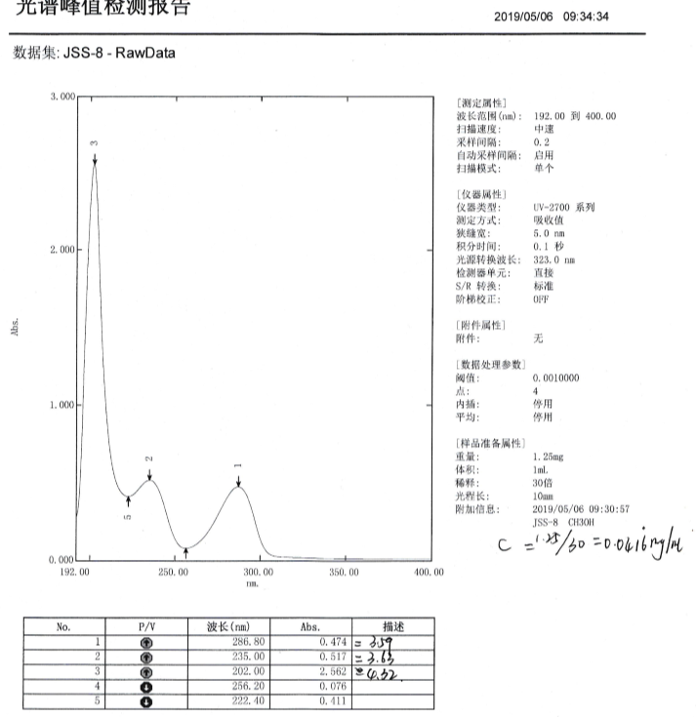
Figure S73. UV spectrum of artemyrianin G (7) in MeOH
X-ray crystallographic data for artemyrianin A (1)
C₁₅H₂₀O₂, M = 232.31, a = 6.7424(3) Å, b = 6.9858(3) Å, c = 7.7309(3) Å, α = 105.3440(10)°, β = 101.9110(10)°, γ = 106.6430(10)°, V = 320.37(2) Å³, T = 100.(2) K, space group P1, Z = 1, μ(Cu Kα) = 0.615 mm⁻¹, 4616 reflections measured, 2090 independent reflections (R_{int} = 0.0519). The final R₁ values were 0.0484 (I > 2σ(I)). The final wR(F²) values were 0.1244 (I > 2σ(I)). The final R₁ values were 0.0485 (all data). The final wR(F²) values were 0.1245 (all data). The goodness of fit on F² was 1.040. Flack parameter = 0.18(14).
View of a molecule of 1 with the atom-labelling scheme
Displacement ellipsoids are drawn at the 30% probability level
View of the pack drawing of 1
Hydrogen-bonds are shown as dashed lines

Crystal data and structure refinement for 1
Identification code global
Empirical formula C15 H20 O2
Formula weight 232.31
Temperature 100(2) K
Wavelength 1.54178 Å
Crystal system Triclinic
Space group P1
Unit cell dimensions a = 6.7424(3) Å = 105.3440(10)°.
b = 6.9858(3) Å = 101.9110(10)°.
c = 7.7309(3) Å  = 106.6430(10)°.
Volume 320.37(2) Å3
Z 1
Density (calculated) 1.204 Mg/m3
Absorption coefficient 0.615 mm-1
F(000) 126
Crystal size 0.700 x 0.400 x 0.200 mm3
Theta range for data collection 10.95 to 72.29°.
Index ranges -7<=h<=8, -8<=k<=8, -9<=l<=9
Reflections collected 4616
Independent reflections 2090 [R(int) = 0.0519]
Completeness to theta = 72.29° 97.1 %
Absorption correction Semi-empirical from equivalents
Max. and min. transmission 0.89 and 0.58
Refinement method Full-matrix least-squares on F2
Data / restraints / parameters 2090 / 3 / 157
Goodness-of-fit on F2 1.040
Final R indices [I>2sigma(I)] R1 = 0.0484, wR2 = 0.1244
R indices (all data) R1 = 0.0485, wR2 = 0.1245
Absolute structure parameter 0.18(14)
Largest diff. peak and hole 0.352 and -0.250 e.Å-3

