Supplementary material
Neolignans and norlignans from insect medicine Polyphaga plancyi and their biological activities**
Hong-Jie Zhu^{b,1}, Te Xu^{a,1}, Yong-Ming Yanª, Zheng-chao Tu^{c,d}, Yong-Xian Chengª*
ªSchool of Pharmaceutical Sciences, Shenzhen University Health Science Center, Shenzhen 518060, People’s Republic of China
^{b}State Key Laboratory of Phytochemistry and Plant Resources in West China, Kunming Institute of Botany, Chinese Academy of Sciences, Kunming 650201, People’s Republic of China
^{c}International Cooperative Laboratory of Traditional Chinese Medicine Modernization and Innovative Drug Development of Chinese Ministry of Education (MOE), College of Pharmacy, Jinan University, Guangzhou 510632, People’s Republic of China
^{d}Drug Discovery Pipeline & Guangdong Provincial Key Laboratory of Biocomputing, Guangzhou Institutes of Biomedicine and Health, Guangzhou 510530, People’s Republic of China
¹ These authors contributed equally to this work.
* Corresponding author
Email address: yxcheng@szu.edu.cn.
** In honor of Professor Jun Zhou.

Content
Figure S1. ¹H NMR spectrum of 1 in methanol-d₄
Figure S2. ¹³C NMR and DEPT spectra of 1 in methanol-d₄
Figure S3. ¹H-¹H COSY spectrum of 1 in methanol-d₄
Figure S4. HSQC spectrum of 1 in methanol-d₄
Figure S5. HMBC spectrum of 1 in methanol-d₄
Figure S6. HRESIMS of 1
Figure S7. ¹H NMR spectrum of 2 in methanol-d₄
Figure S8. ¹³C NMR and DEPT spectra of 2 in methanol-d₄
Figure S9. ¹H-¹H COSY spectrum of 2 in methanol-d₄
Figure S10. HSQC spectrum of 2 in methanol-d₄
Figure S11. HMBC spectrum of 2 in methanol-d₄
Figure S12. HRESIMS of 2
Figure S13. ¹H NMR spectrum of 3 in Methanol-d₄
Figure S14. ¹³C NMR and DEPT spectra of 3 in methanol-d₄
Figure S15. ¹H-¹H COSY spectrum of 3 in methanol-d₄
Figure S16. HSQC spectrum of 3 in methanol-d₄
Figure S17. HMBC spectrum of 3 in methanol-d₄
Figure S18. HRESIMS of 3
Figure S19. ECD comparison between 3 and 4
Figure S20. ¹H NMR spectrum of 4 in methanol-d4
Figure S21. ¹³C NMR and DEPT spectra of 4 in methanol-d₄
Figure S22. ¹H-¹H COSY spectrum of 4 in methanol-d₄
Figure S23. HSQC spectrum of 4 in methanol-d₄
Figure S24. HMBC spectrum of 4 in methanol-d₄
Figure S25. HRESIMS of 4
Figure S26. ¹H NMR spectrum of 5 in methanol-d₄
Figure S27. ¹³C NMR and DEPT spectra of 5 in methanol-d₄
Figure S28. ¹H-¹H COSY spectrum of 5 in methanol-d₄
Figure S29. HSQC spectrum of 5 in methanol-d₄
Figure S30. HMBC spectrum of 5 in methanol-d₄
Figure S31. HRESIMS of 5
Figure S32. ¹H NMR spectrum of 6 in methanol-d₄
Figure S33. ¹³C NMR and DEPT spectra of 6 in methanol-d₄
Figure S34. ¹H-¹H COSY spectrum of 6 in methanol-d₄
Figure S35. HSQC spectrum of 6 in methanol-d₄
Figure S36. HMBC spectrum of 6 in methanol-d₄
Figure S37. HRESIMS of 6
Figure S38. ¹H NMR spectrum of 7 in methanol-d₄
Figure S39. ¹³C NMR and DEPT spectra of 7 in methanol-d₄
Figure S40. ¹H-¹H COSY spectrum of 7 in methanol-d₄
Figure S41. HSQC spectrum of 7 in methanol-d₄
Figure S42. HMBC spectrum of 7 in methanol-d₄
Figure S43. ROESY spectrum of 7 in methanol-d₄
Figure S44. HRESIMS of 7
Figure S45. ¹H NMR spectrum of 8 in methanol-d₄
Figure S46. ¹³C NMR and DEPT spectra of 8 in methanol-d₄
Figure S47. ¹H-¹H COSY spectrum of 8 in methanol-d₄
Figure S48. HSQC spectrum of 8 in methanol-d₄
Figure S49. HMBC spectrum of 8 in methanol-d₄
Figure S50. ¹H NMR spectrum of 8 in pyridine-d₅
Figure S51. ¹³C NMR spectrum of 8 in pyridine-d₅
Figure S52. ¹H-¹H COSY spectrum of 8 in pyridine-d₅
Figure S53. HSQC spectrum of 8 in pyridine-d₅
Figure S54. HMBC spectrum of 8 in pyridine-d₅
Figure S55. ROESY spectrum of 8 in pyridine-d₅
Figure S56. HRESIMS of 8
Figure S57. ¹H NMR spectrum of 9 in methanol-d₄
Figure S58. ¹³C NMR and DEPT spectra of 9 in methanol-d₄
Figure S59. ¹H-¹H COSY spectrum of 9 in methanol-d₄
Figure S60. HSQC spectrum of 9 in methanol-d₄
Figure S61. HMBC spectrum of 9 in methanol-d₄
Figure S62. ROESY spectrum of 9 in methanol-d₄
Figure S63. HRESIMS of 9

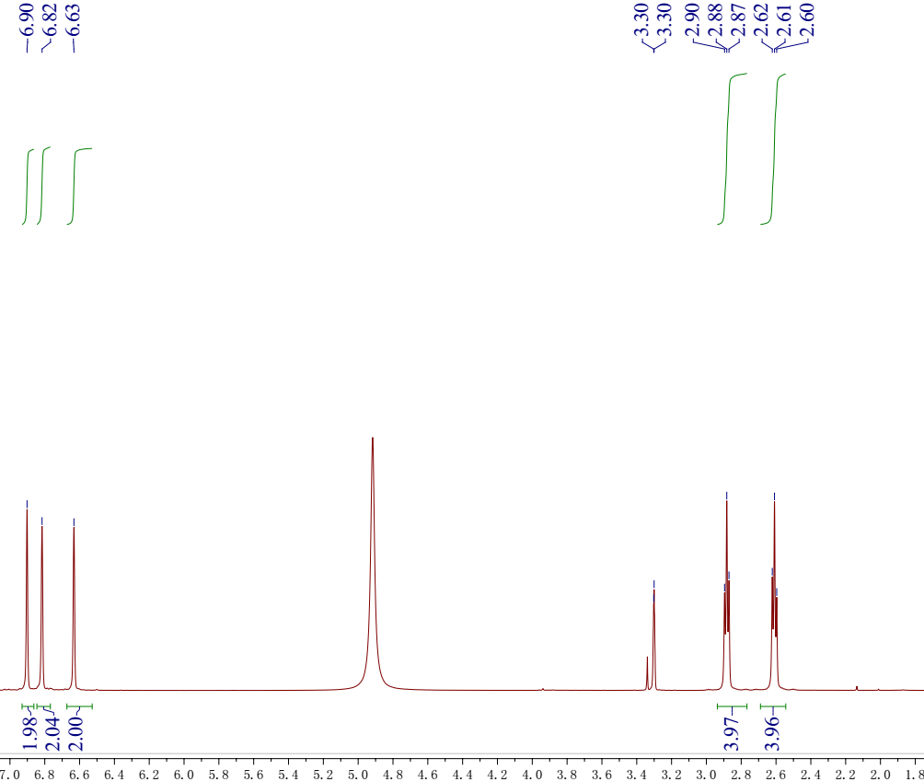
Figure S1. ¹H NMR spectrum of 1 in methanol-d₄
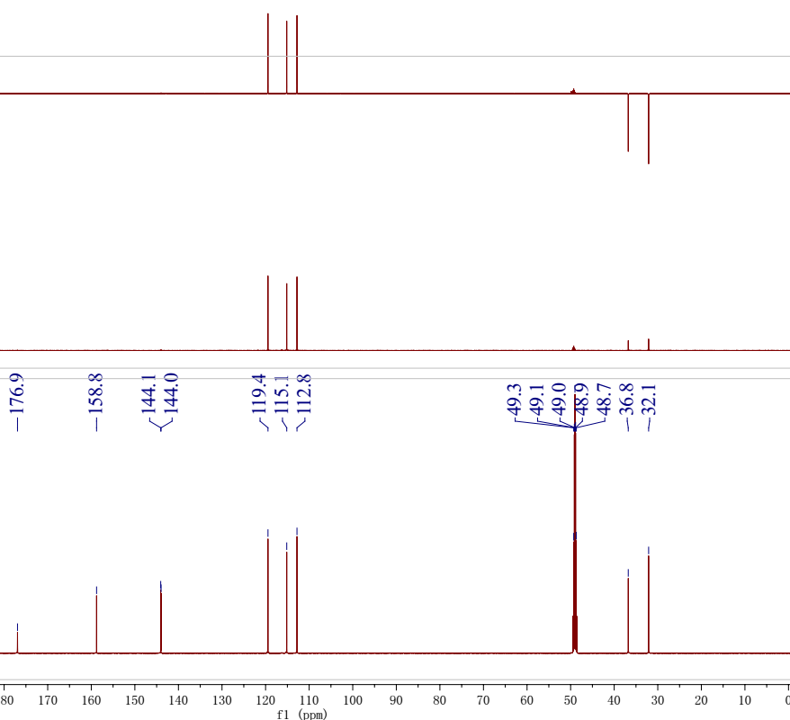
Figure S2. ¹³C NMR and DEPT spectra of 1 in methanol-d₄
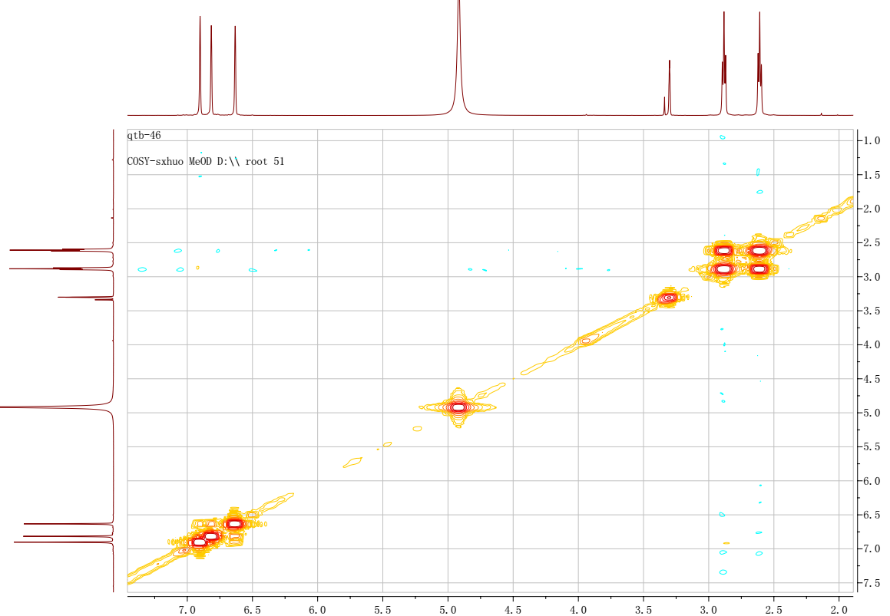
Figure S3. ¹H-¹H COSY spectrum of 1 in methanol-d₄
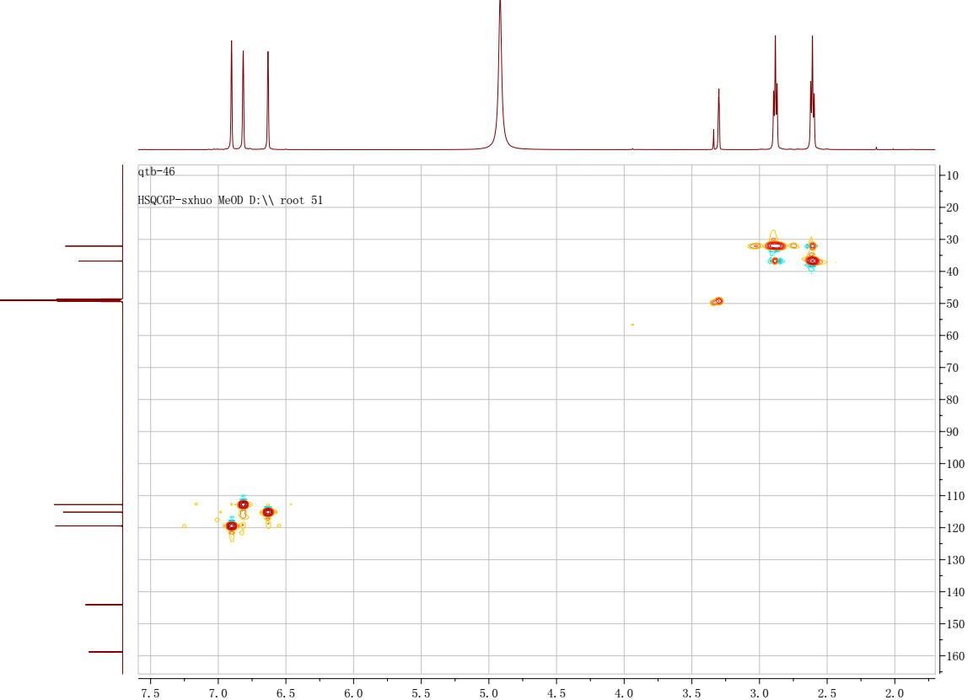
Figure S4. HSQC spectrum of 1 in methanol-d₄

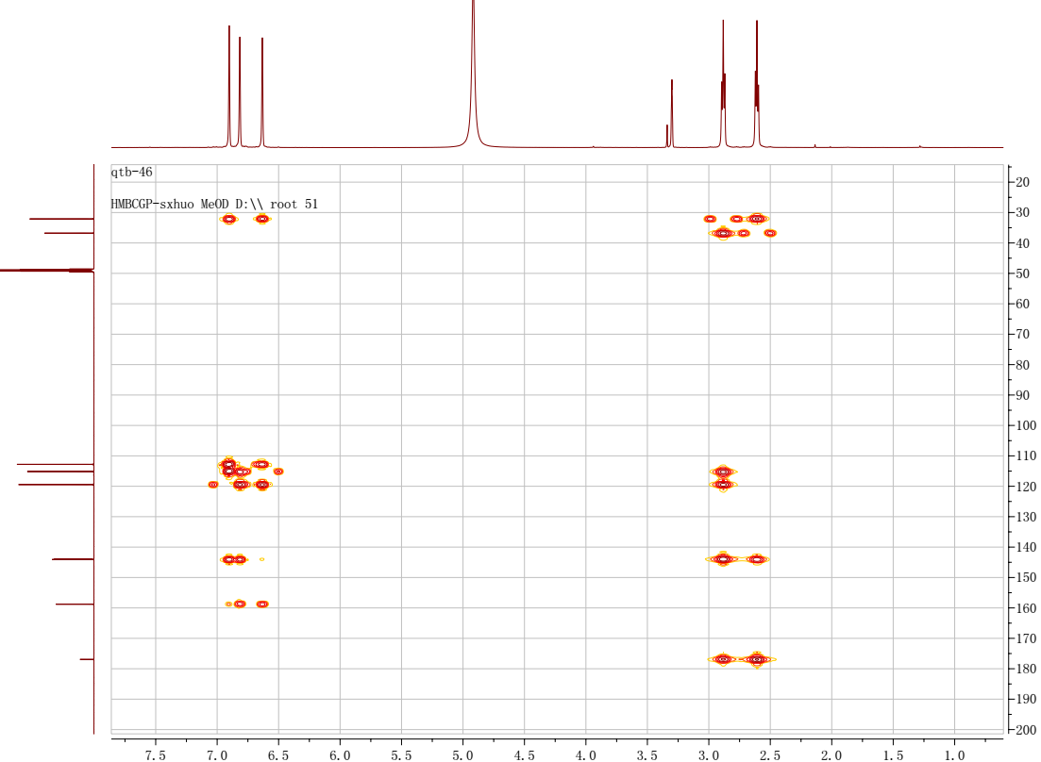
Figure S5. HMBC spectrum of 1 in methanol-d₄

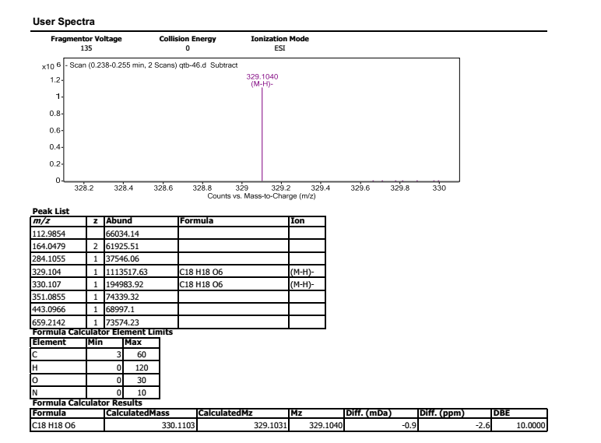
Figure S6. HREIMS of 1
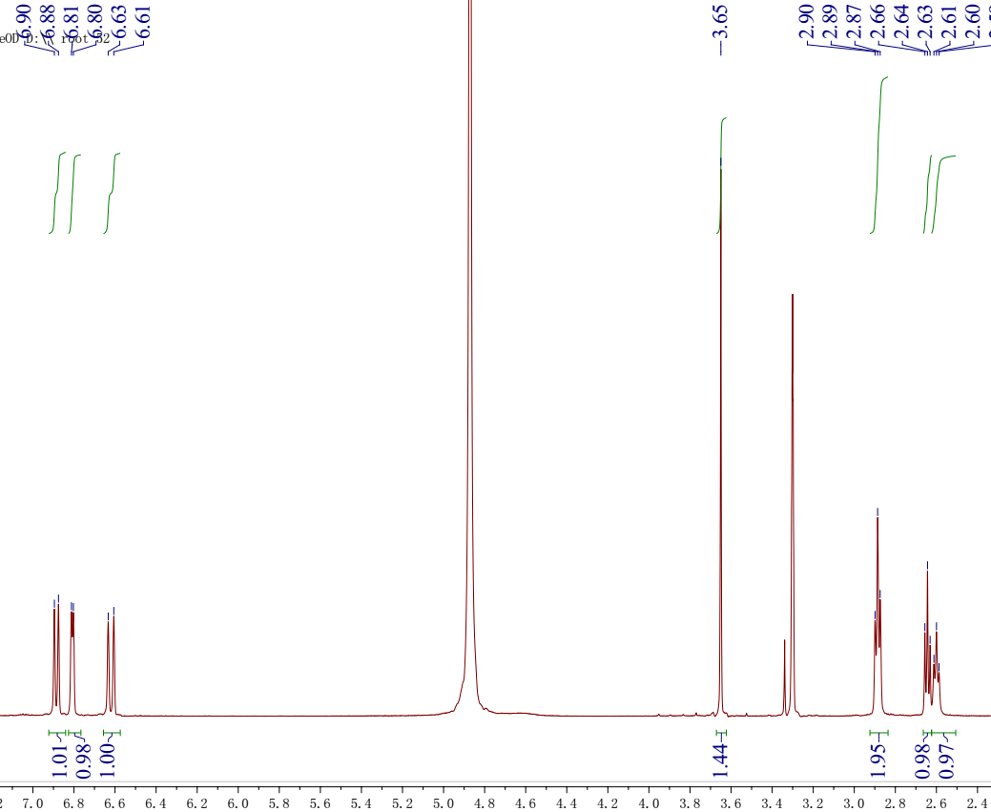
Figure S7. ¹H NMR spectrum of 2 in methanol-d₄
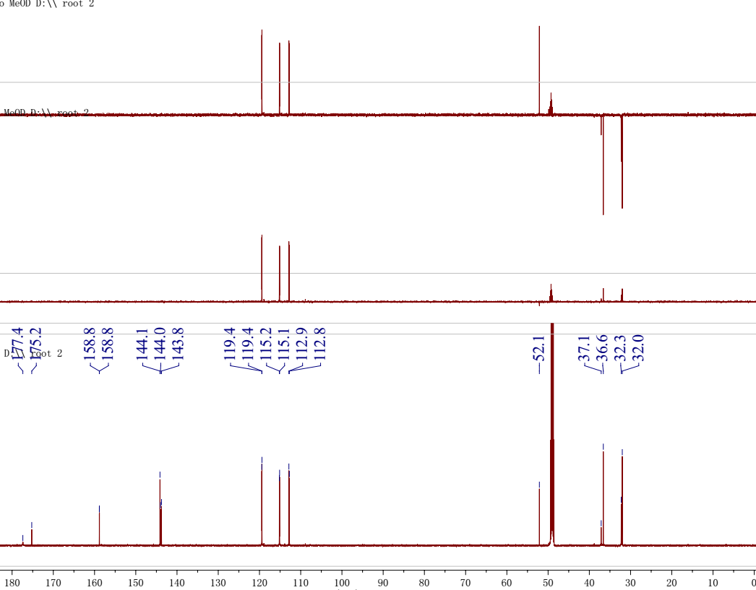
Figure S8. ¹³C NMR and DEPT spectra of 2 in methanol-d₄
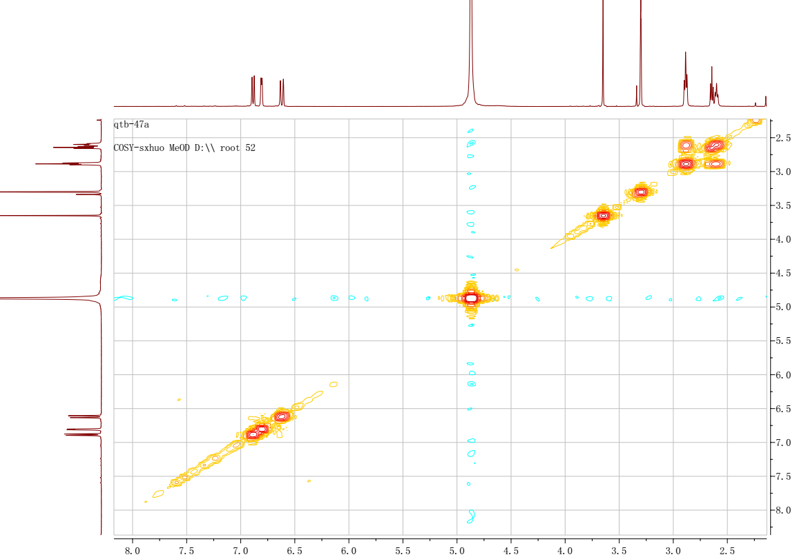
Figure S9. ¹H-¹H COSY spectrum of 2 in methanol-d₄
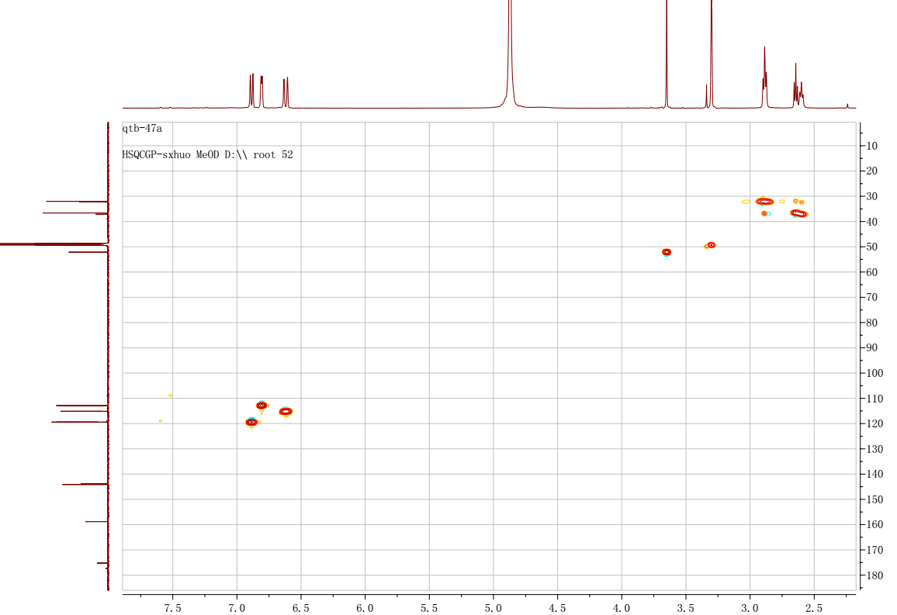
Figure S10. HSQC spectrum of 2 in methanol-d₄
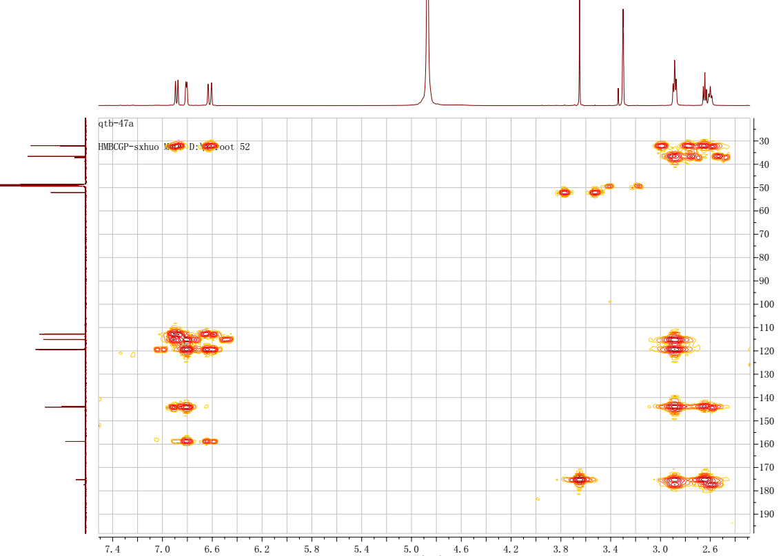
Figure S11. HMBC spectrum of 2 in methanol-d₄
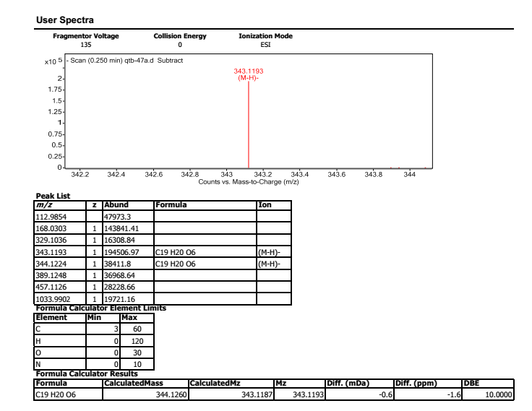
Figure S12. HREIMS of 2

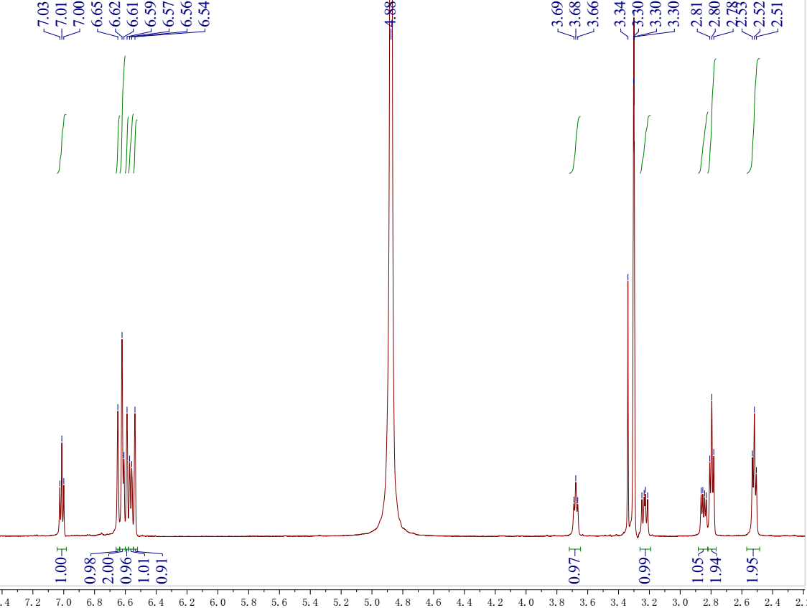
Figure S13. ¹H NMR spectrum of 3 in methanol-d₄
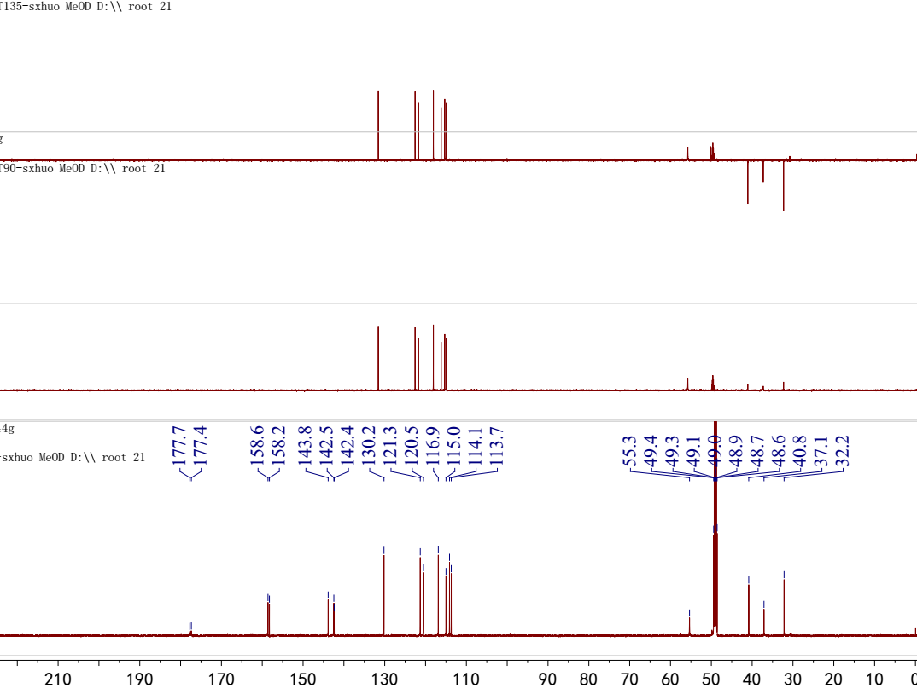
Figure S14. ¹³C NMR and DEPT spectra of 3 in methanol-d₄
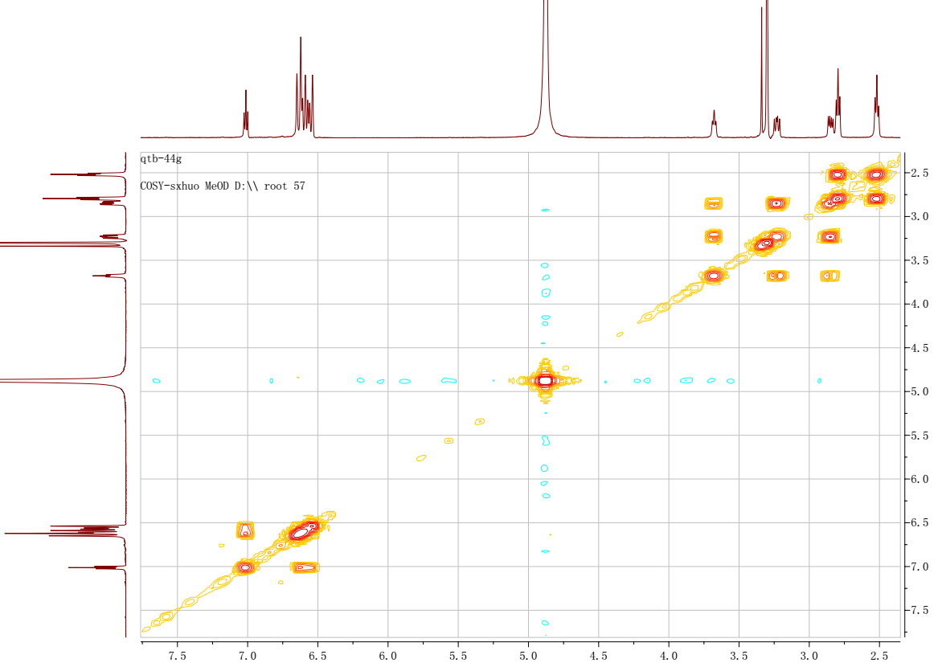
Figure S15. ¹H-¹H COSY spectrum of 3 in methanol-d₄
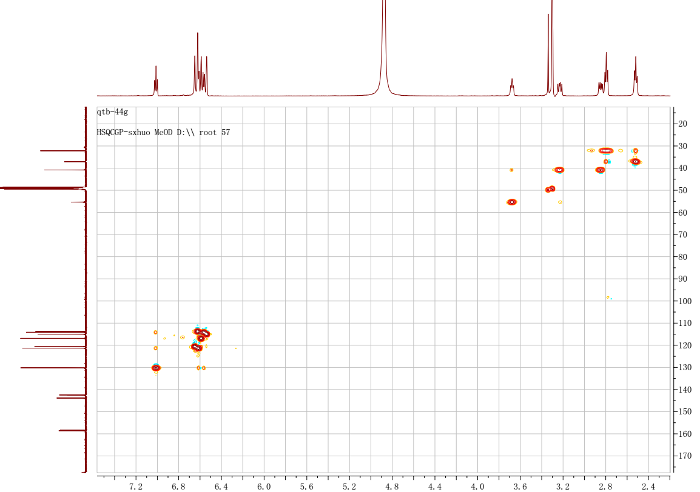
Figure S16. HSQC spectrum of 3 in methanol-d₄
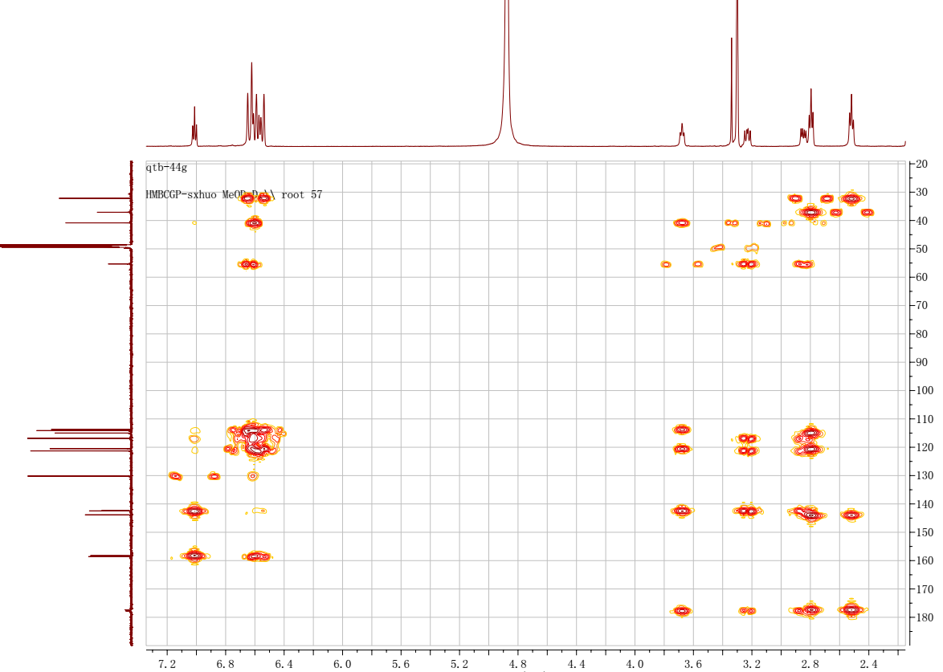
Figure S17. HMBC spectrum of 3 in methanol-d₄
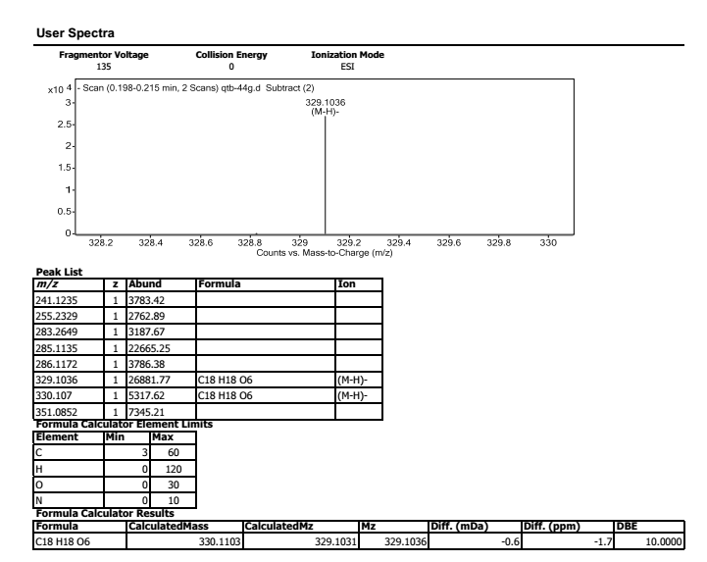
Figure S18. HREIMS of 3
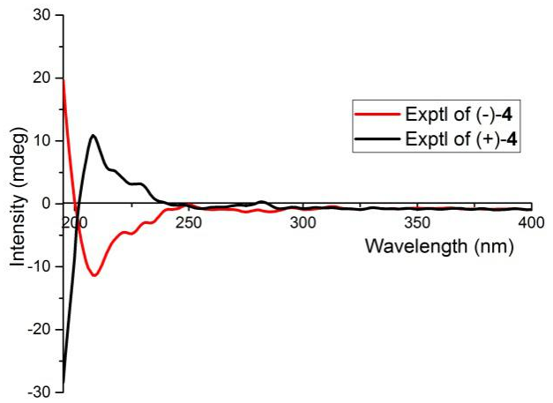
Figure S19. ECD comparison between 3 and 4

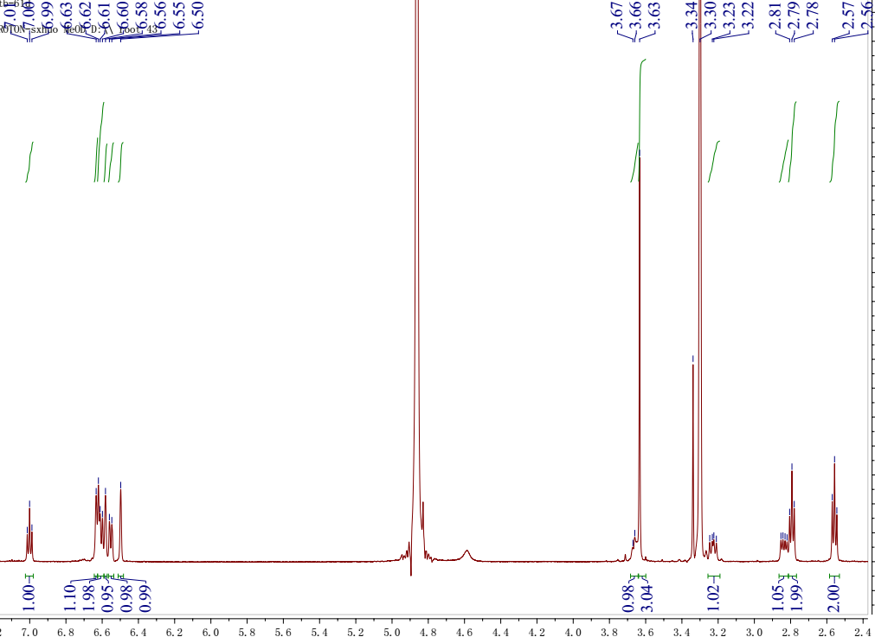
Figure S20. ¹H NMR spectrum of 4 in methanol-d₄
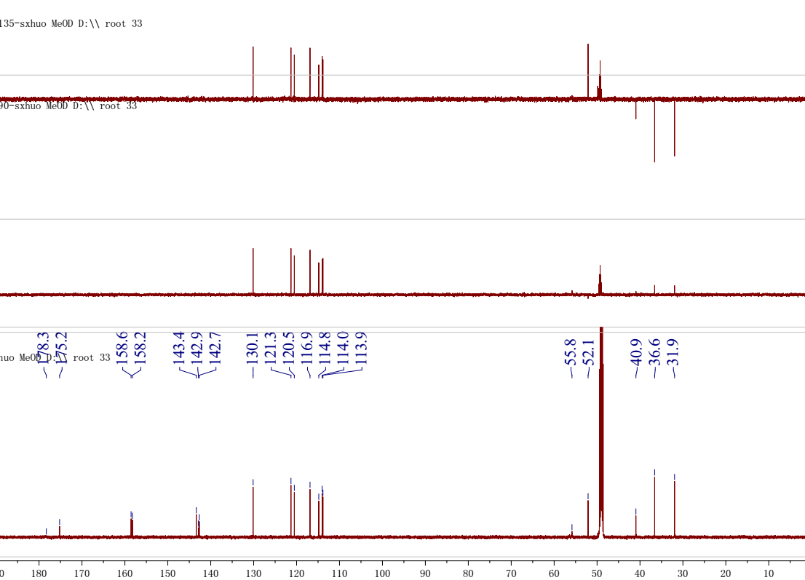
Figure S21. ¹³C NMR and DEPT spectra of 4 in methanol-d₄

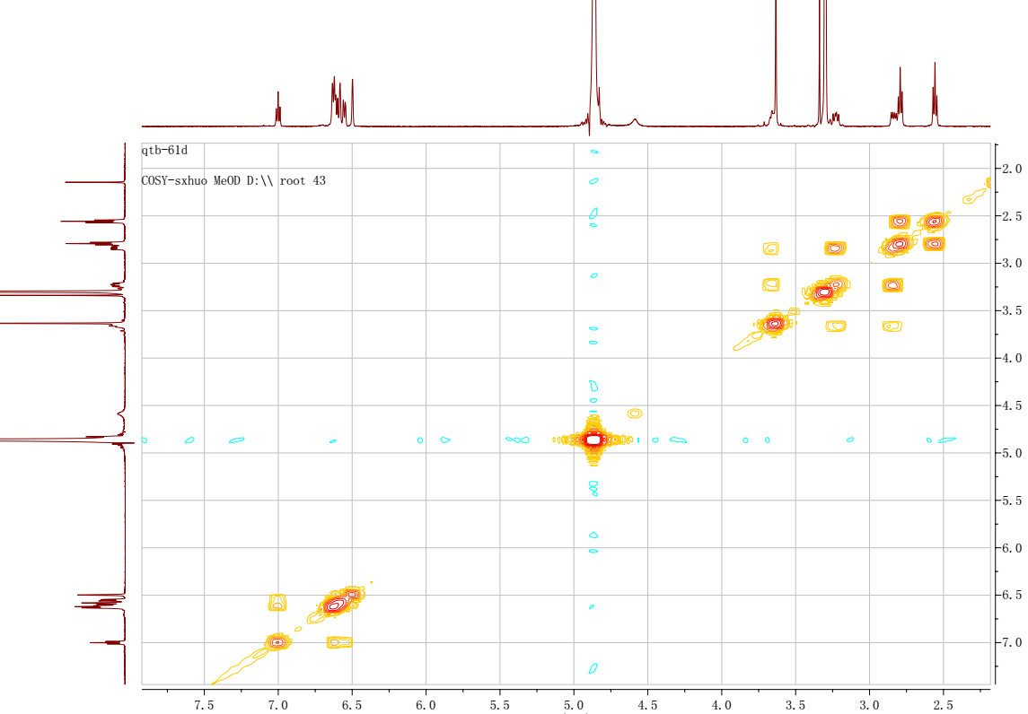
Figure S22. ¹H-¹H COSY spectrum of 4 in methanol-d₄
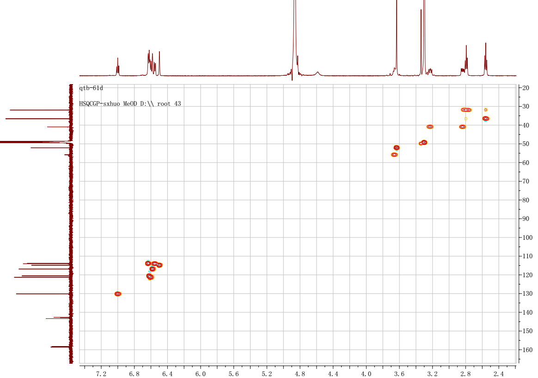
Figure S23. HSQC spectrum of 4 in methanol-d₄

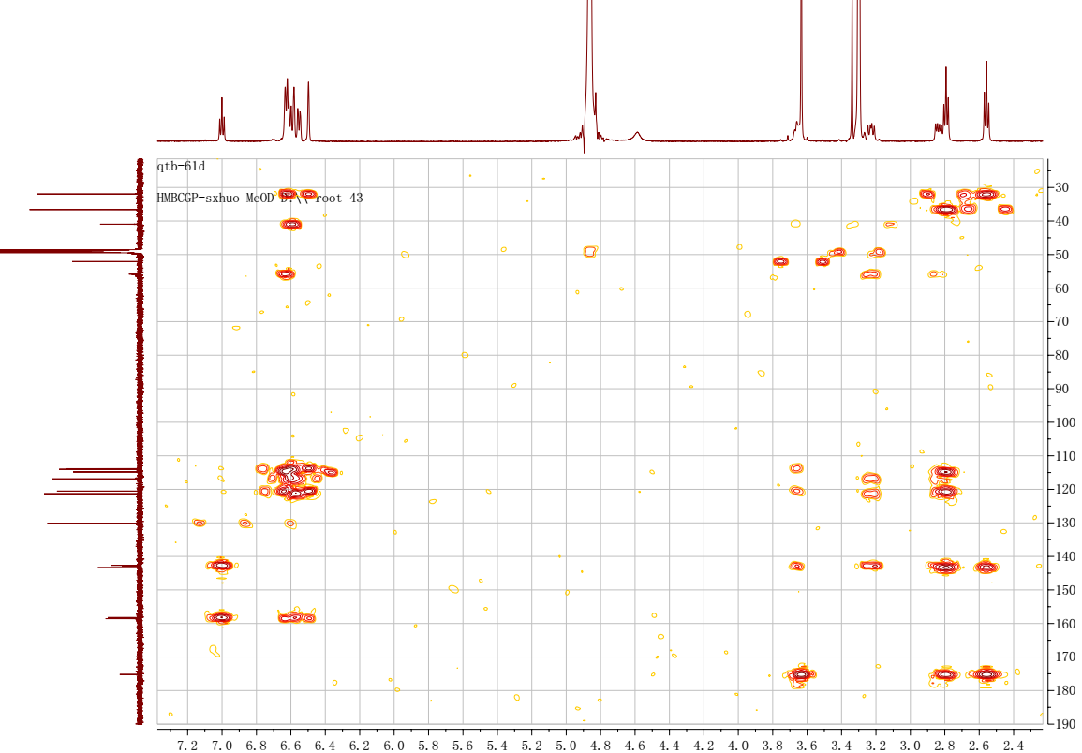
Figure S24. HMBC spectrum of 4 in methanol-d₄
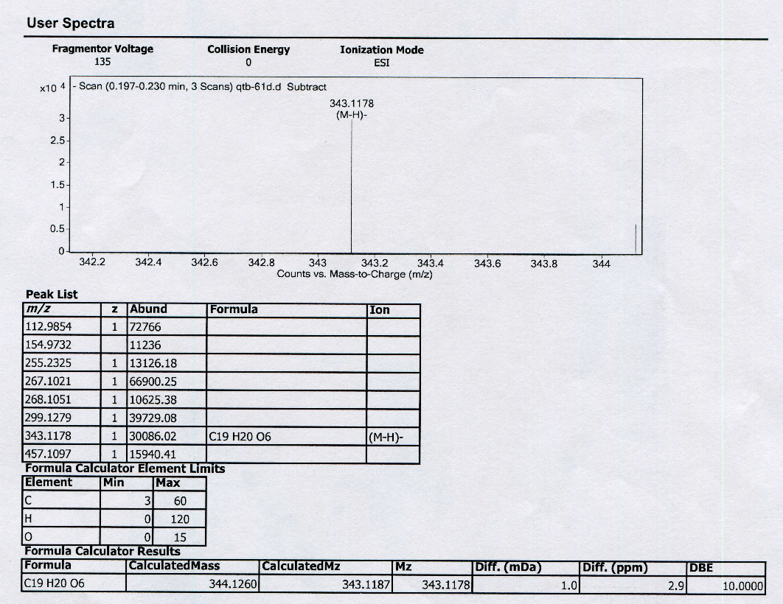
Figure S25. HREIMS of 4

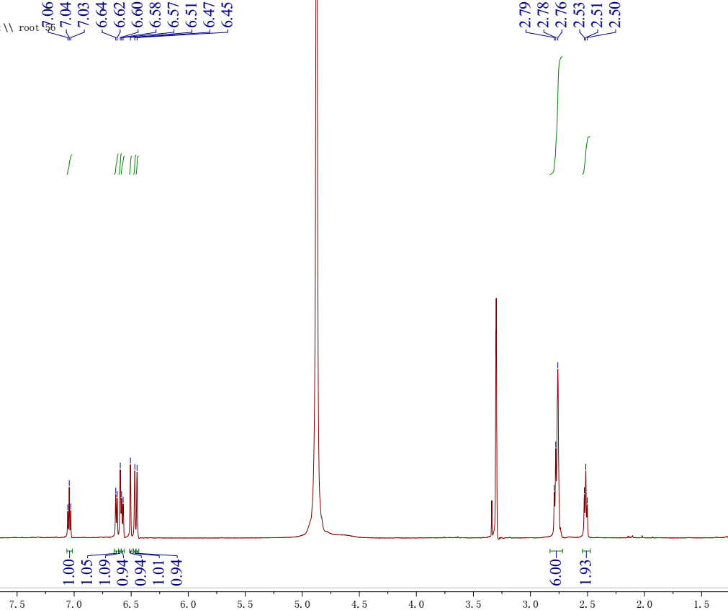
Figure S26. ¹H NMR spectrum of 5 in methanol-d₄
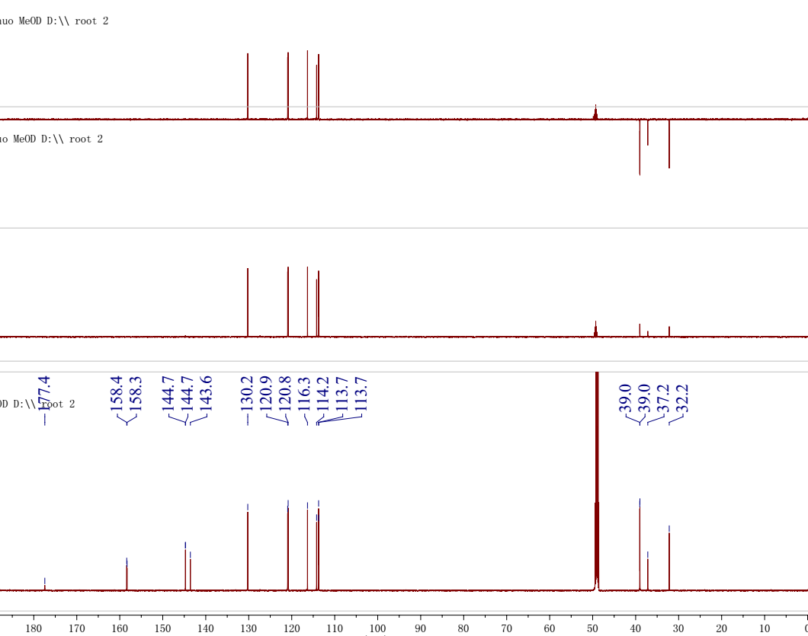
Figure S27. ¹³C NMR and DEPT spectra of 5 in methanol-d₄
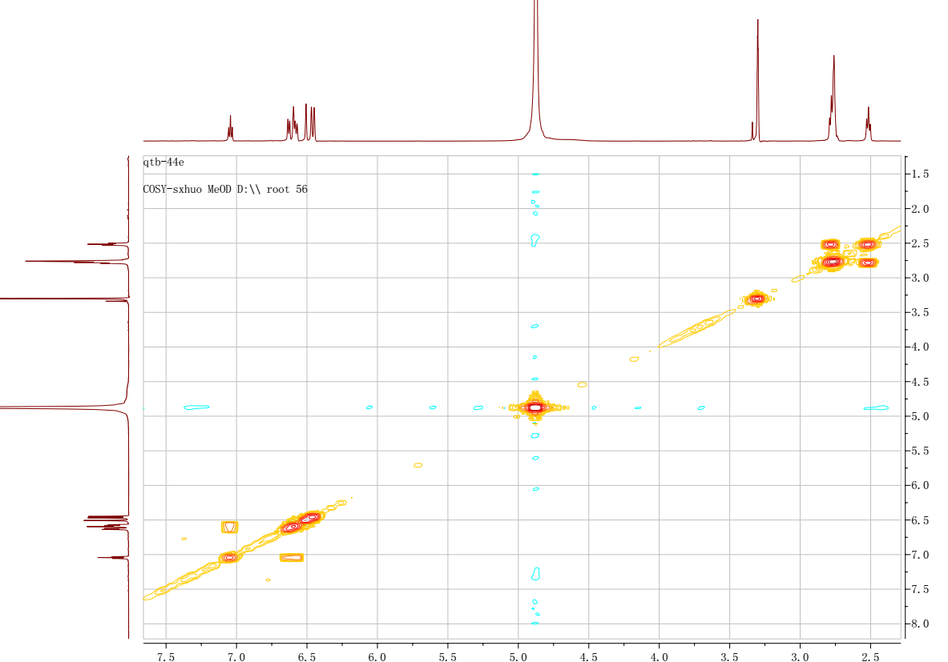
Figure S28. ¹H-¹H COSY spectrum of 5 in methanol-d₄
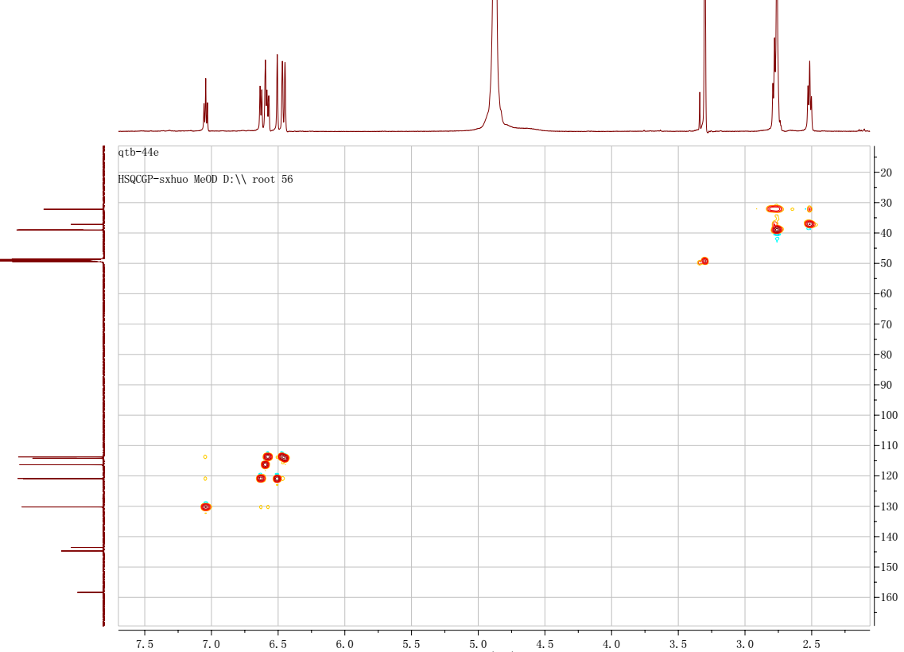
Figure S29. HSQC spectrum of 5 in methanol-d₄
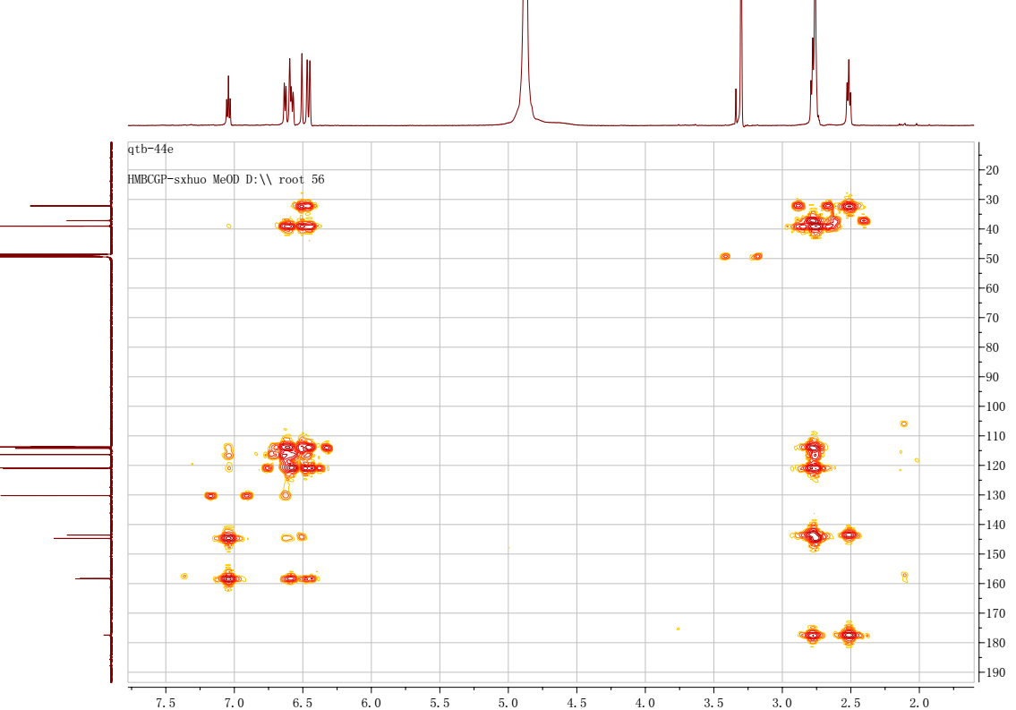
Figure S30. HMBC spectrum of 5 in methanol-d₄
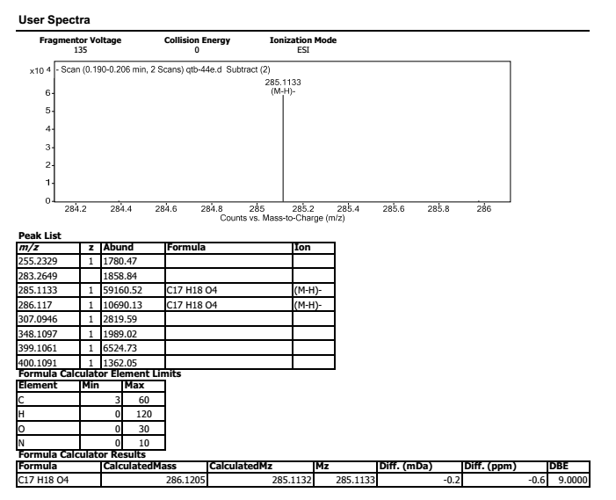
Figure S31. HREIMS of 5
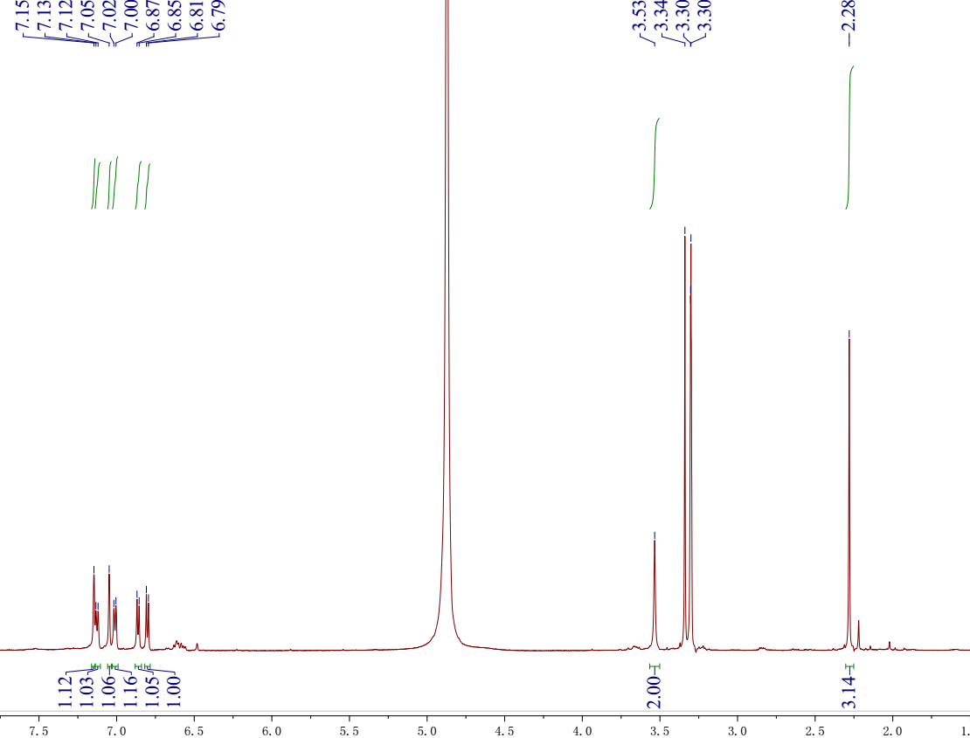
Figure S32. ¹H NMR spectrum of 6 in methanol-d₄
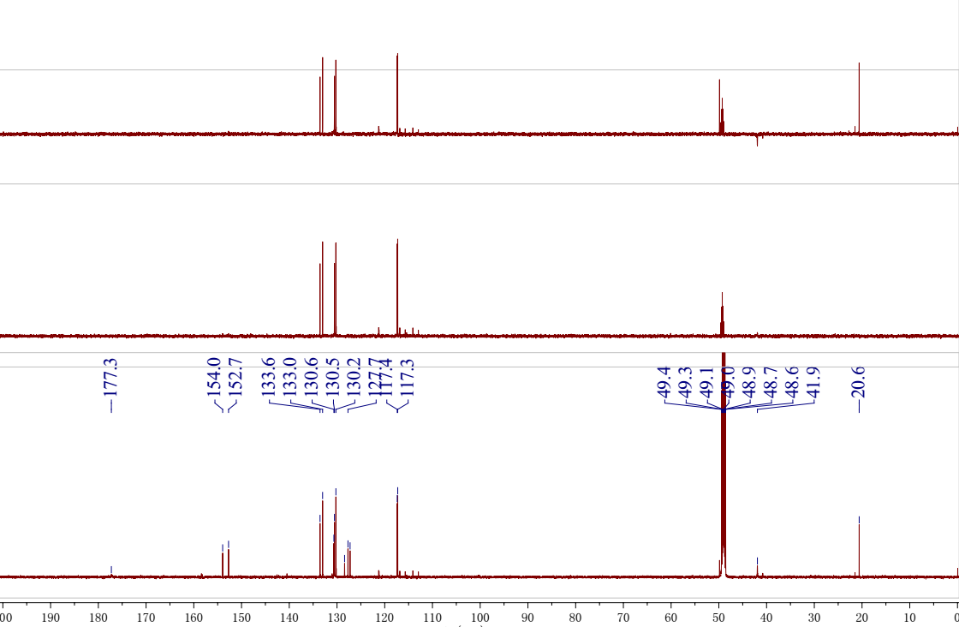
Figure S33. ¹³C NMR and DEPT spectra of 6 in methanol-d₄
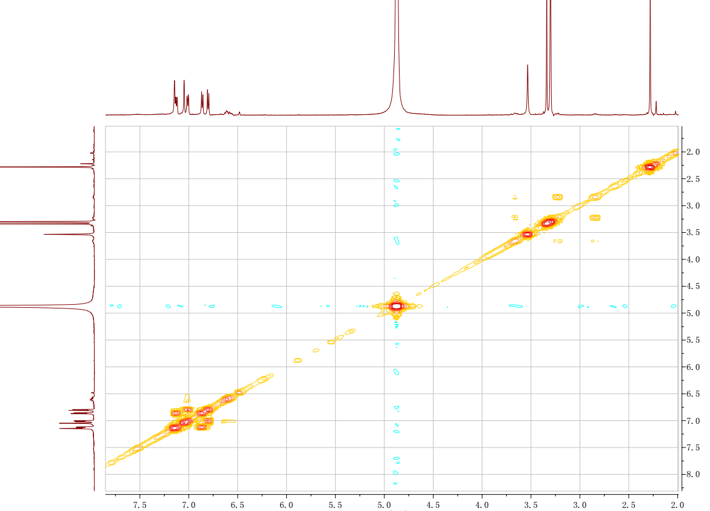
Figure S34. ¹H-¹H COSY spectrum of 6 in methanol-d₄
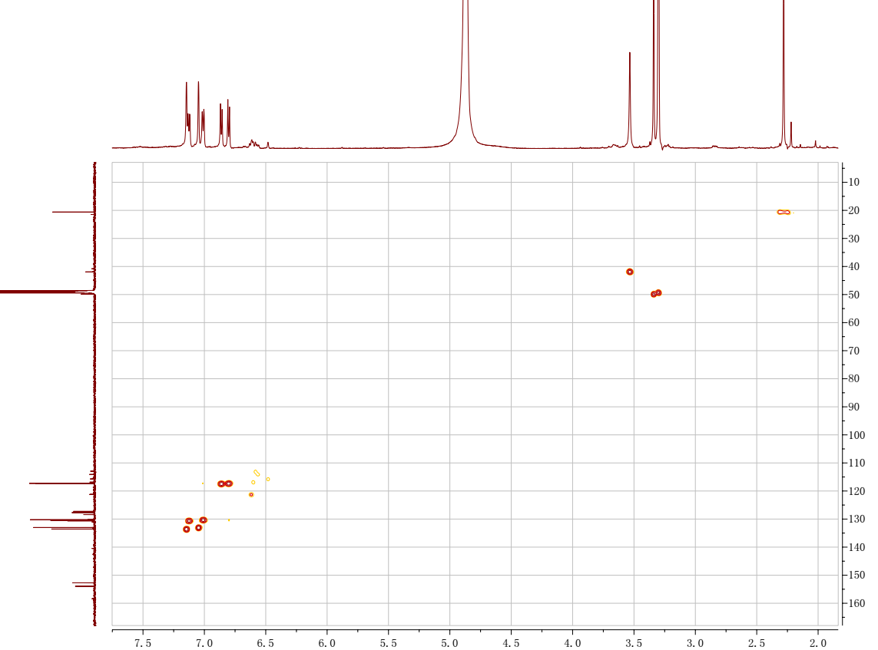
Figure S35. HSQC spectrum of 6 in methanol-d₄

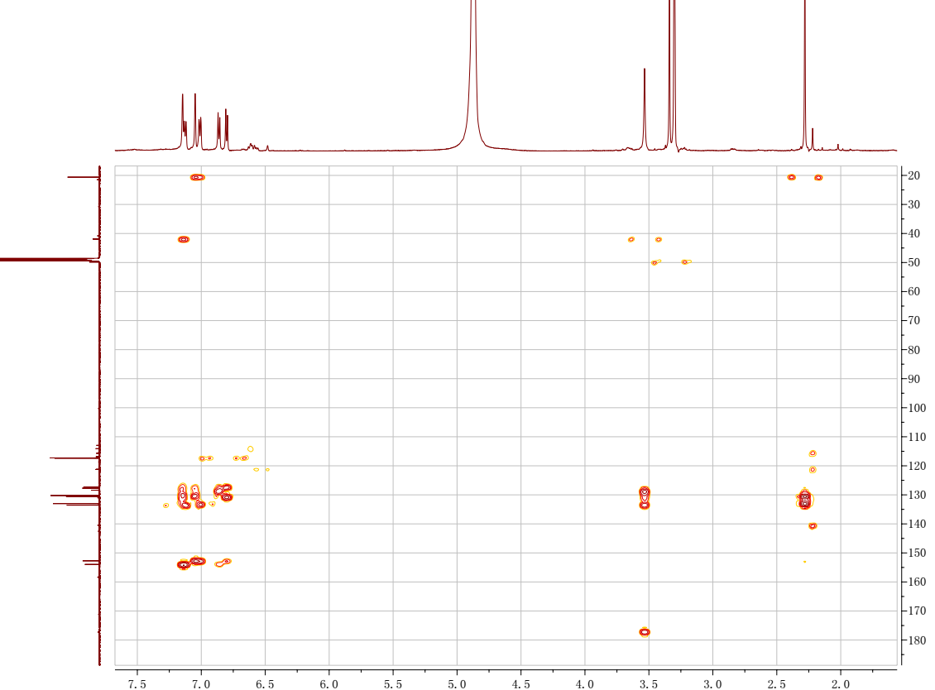
Figure S36. HMBC spectrum of 6 in methanol-d₄
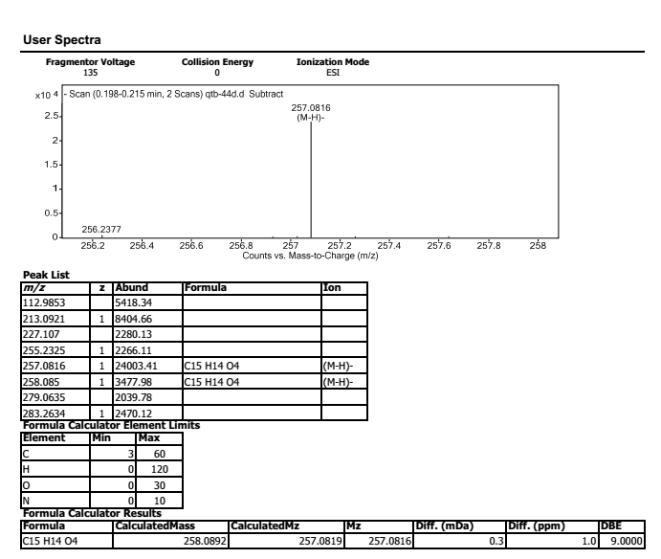
Figure S37. HREIMS of 6
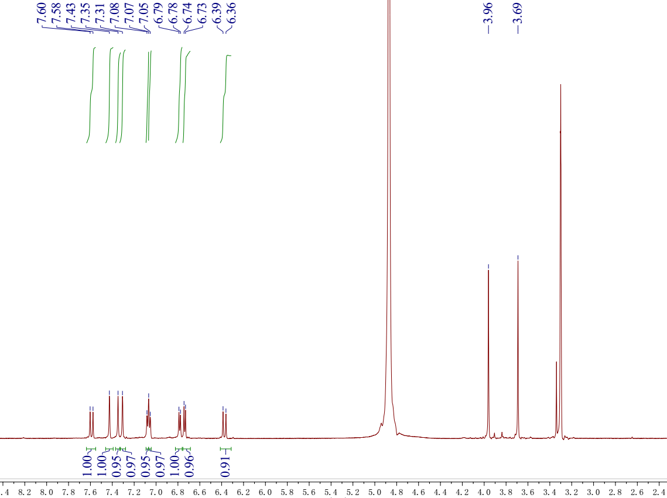
Figure S38. ¹H NMR spectrum of 7 in methanol-d₄
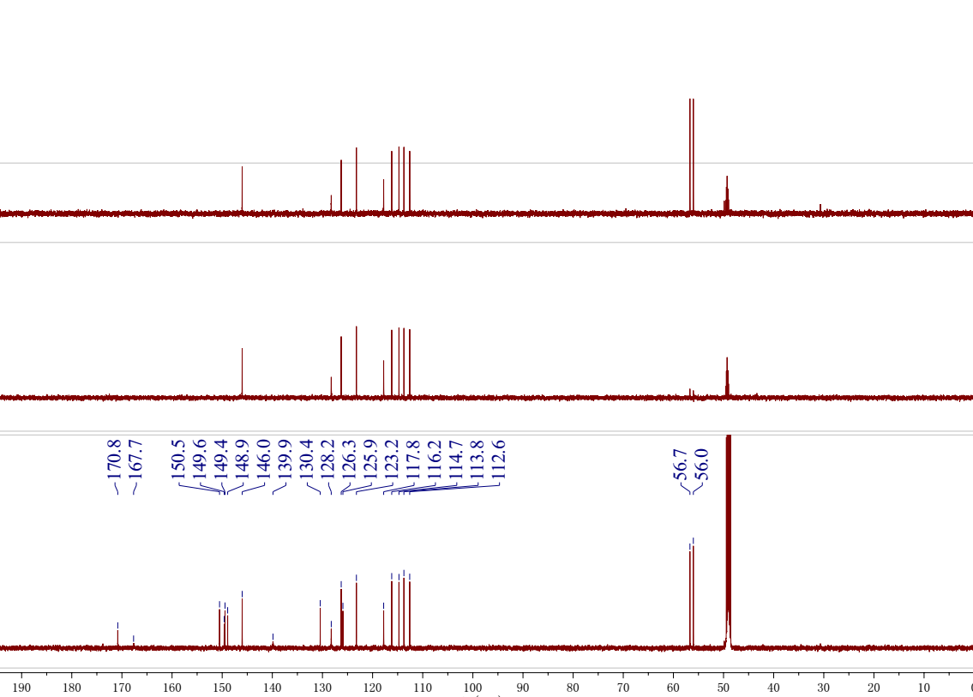
Figure S39. ¹³C NMR and DEPT spectra of 7 in methanol-d₄
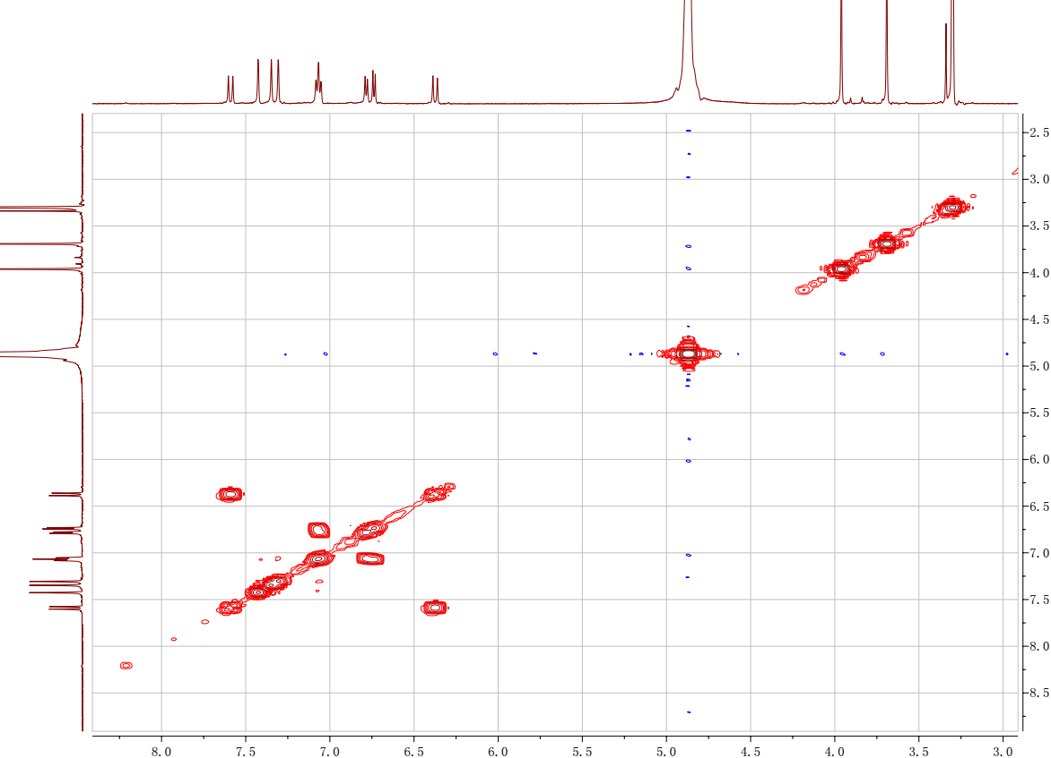
Figure S40. ¹H-¹H COSY spectrum of 7 in methanol-d₄
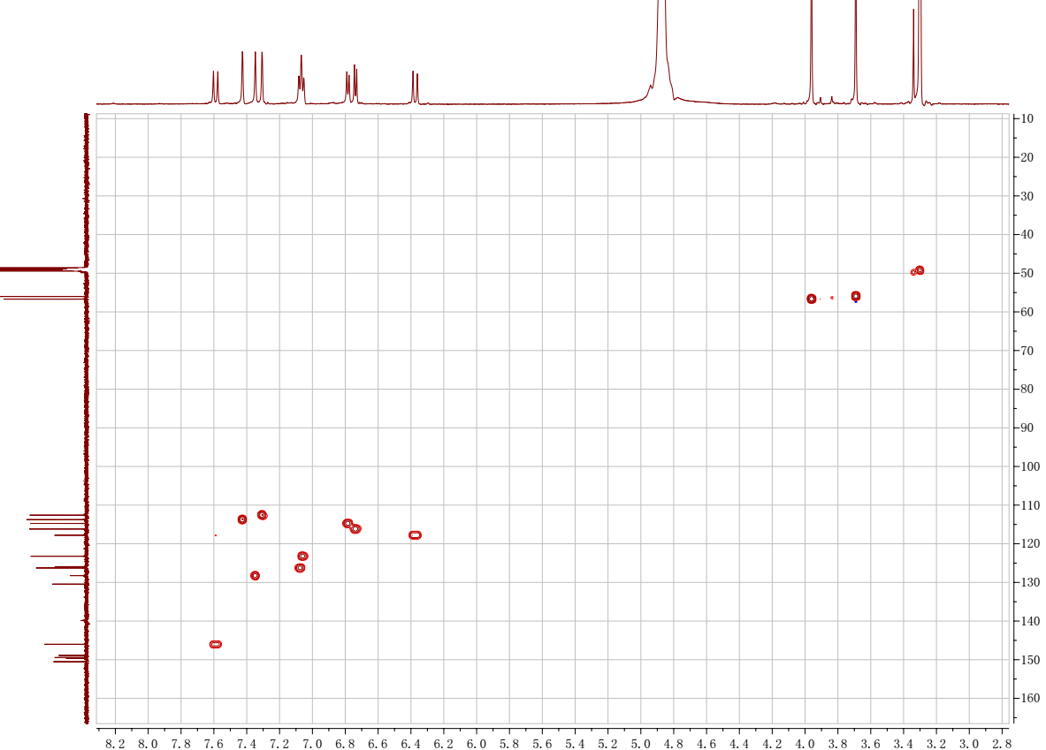
Figure S41. HSQC spectrum of 7 in methanol-d₄
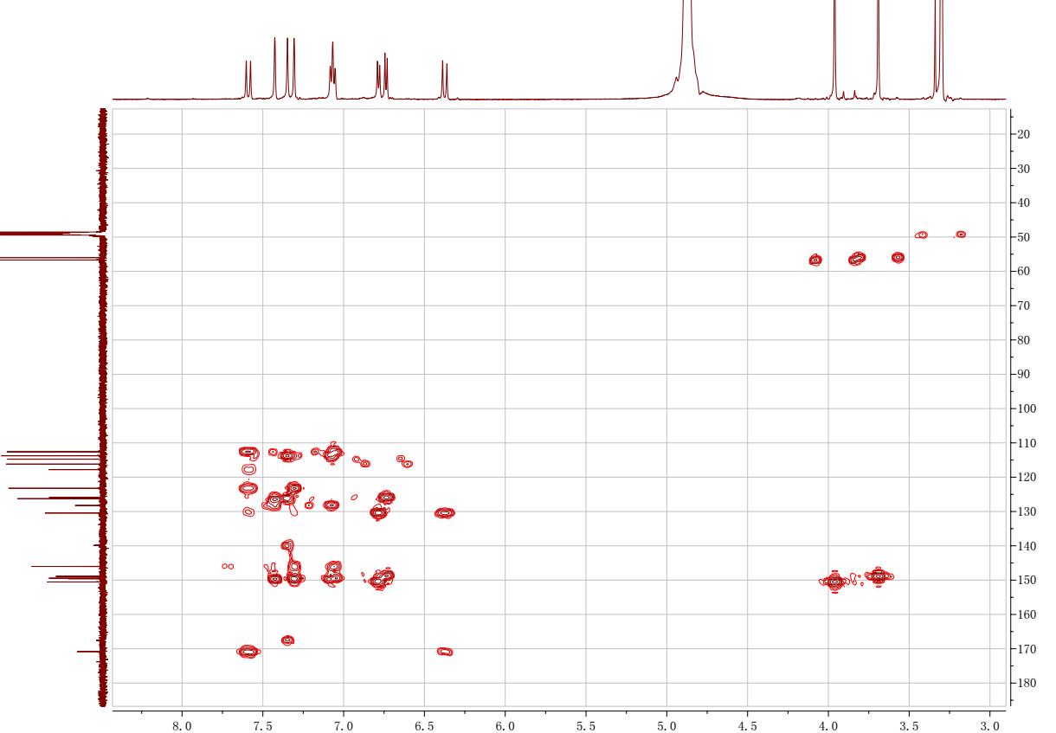
Figure S42. HMBC spectrum of 7 in methanol-d₄
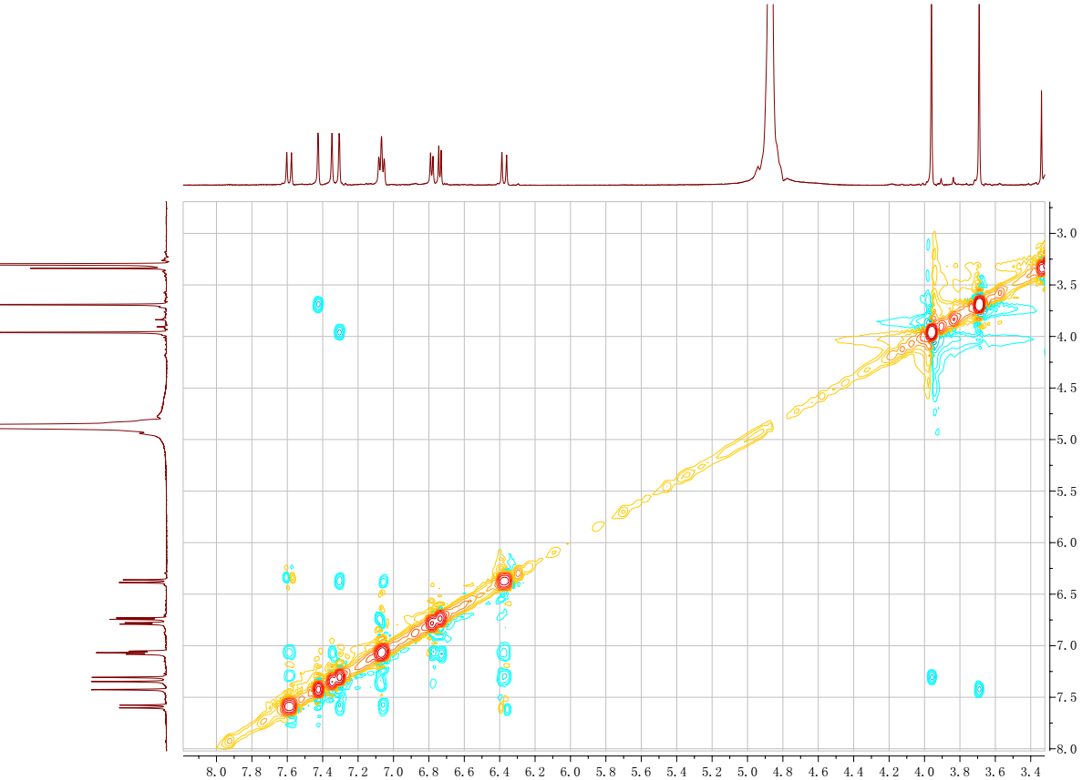
Figure S43. ROESY spectrum of 7 in methanol-d₄

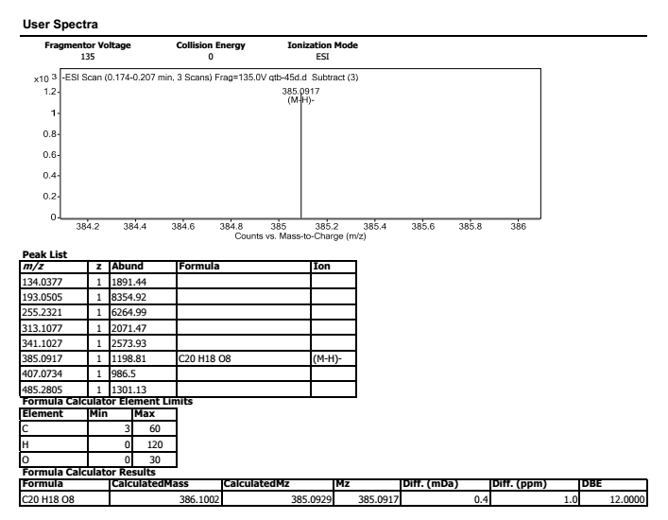
Figure S44. HREIMS of 7

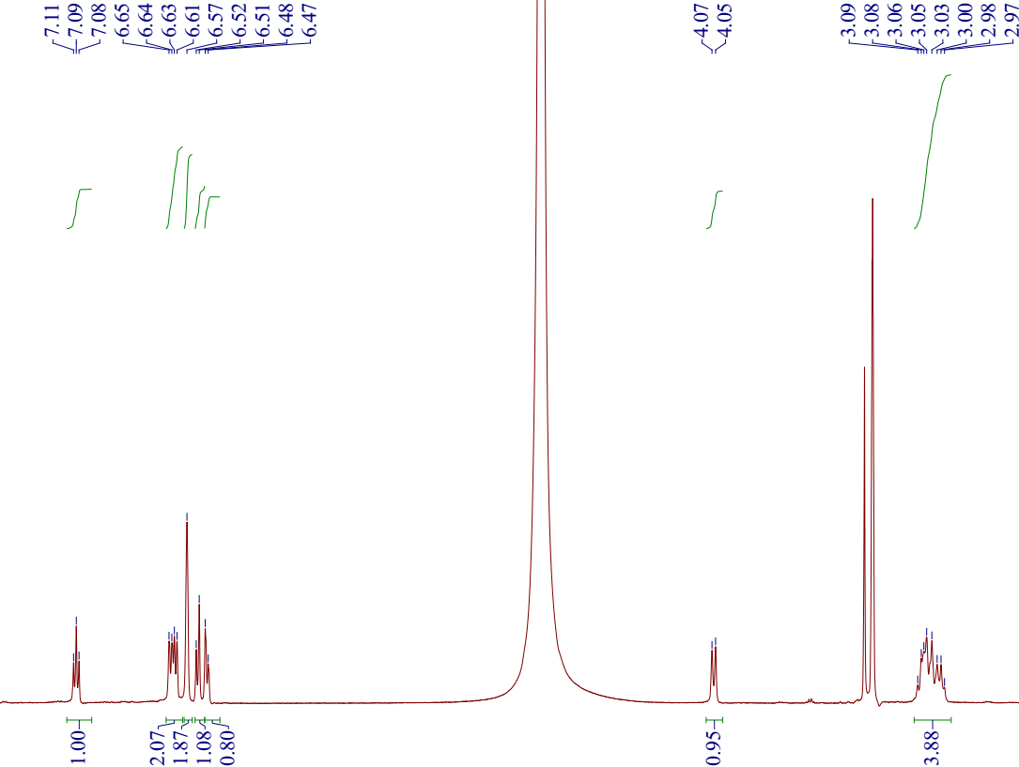
Figure S45. ¹H NMR spectrum of 8 in methanol-d₄
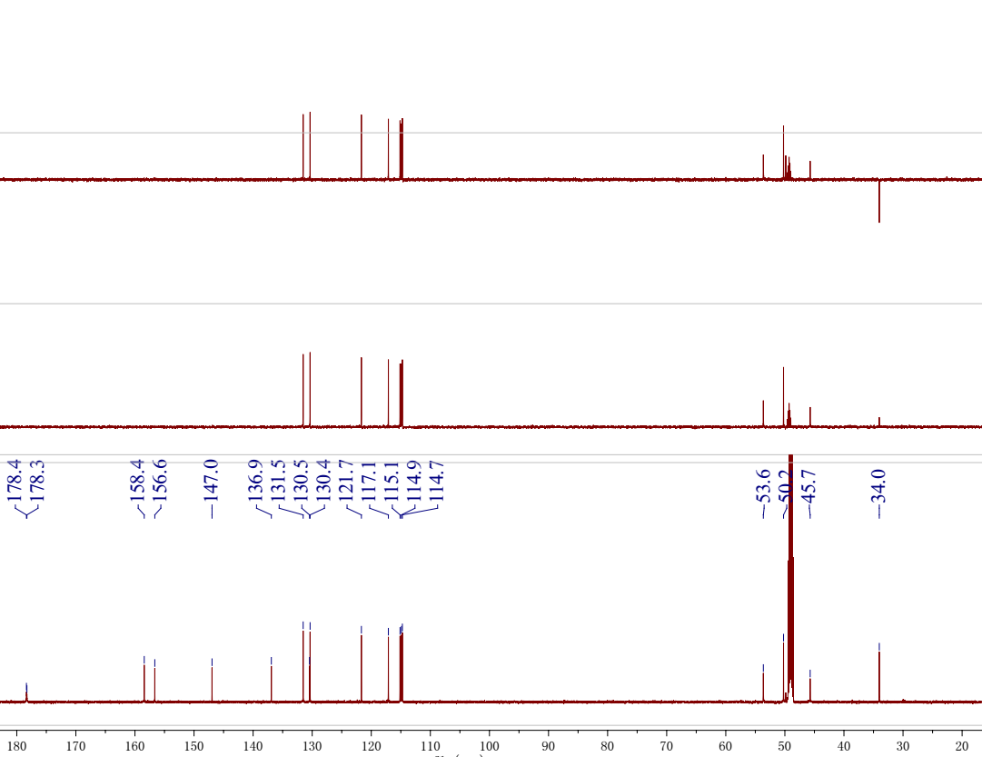
Figure S46. ¹³C NMR and DEPT spectra of 8 in methanol-d₄
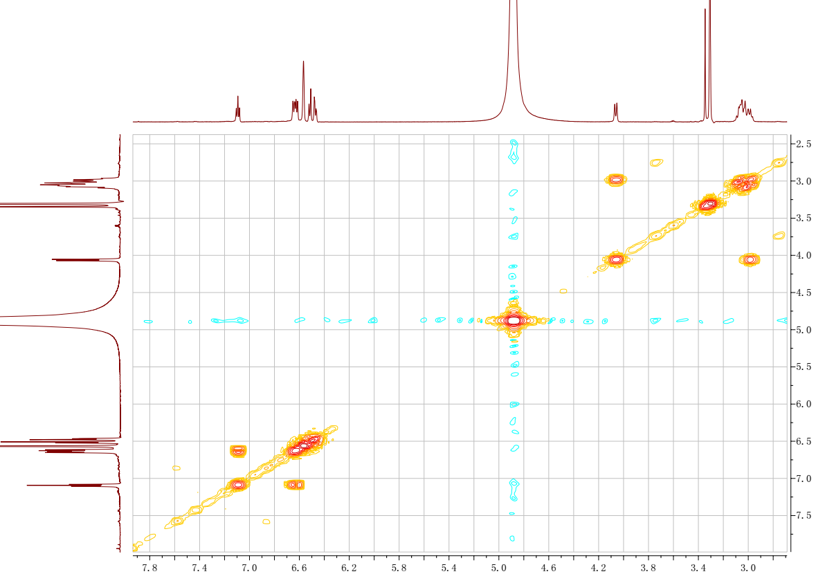
Figure S47. ¹H-¹H COSY spectrum of 8 in methanol-d₄
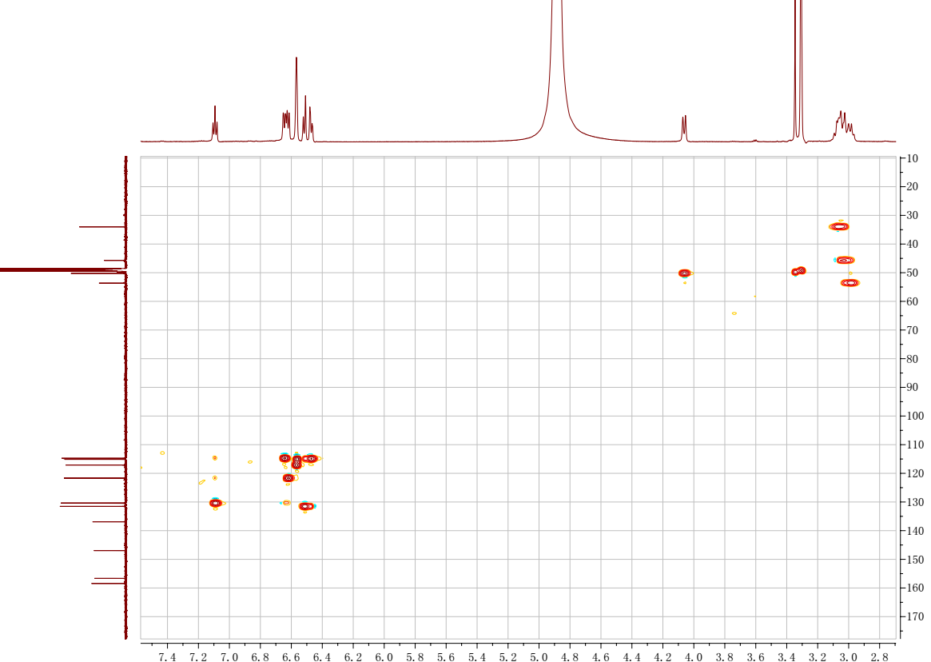
Figure S48. HSQC spectrum of 8 in methanol-d₄
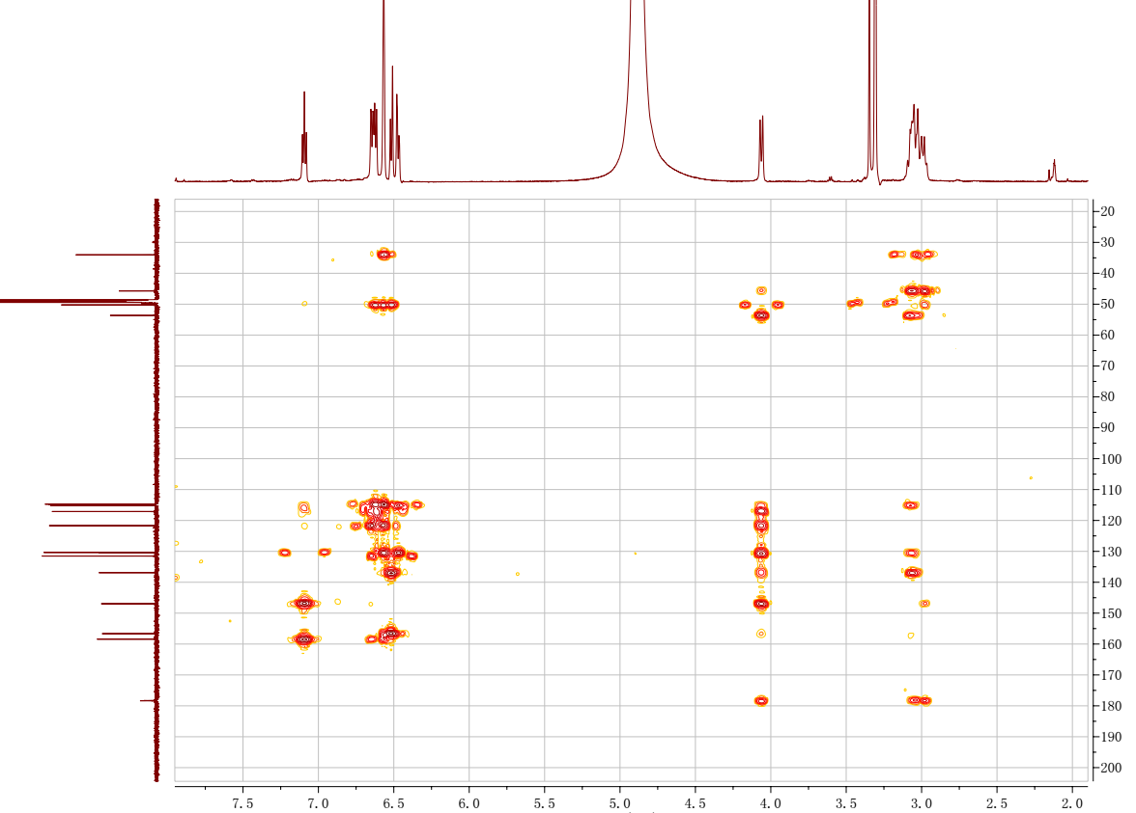
Figure S49. HMBC spectrum of 8 in methanol-d₄
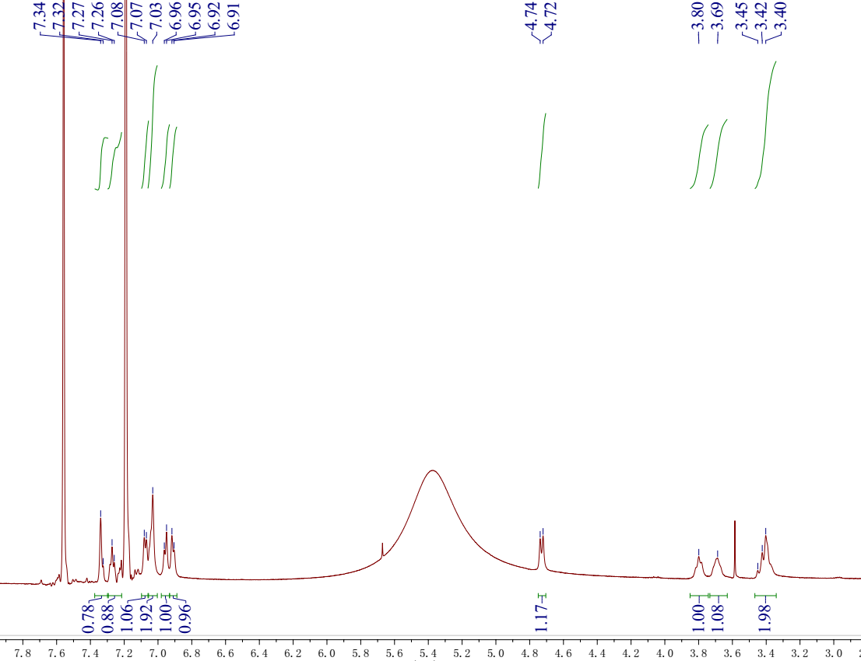
Figure S50. ¹H NMR spectrum of 8 in pyridine-d₅
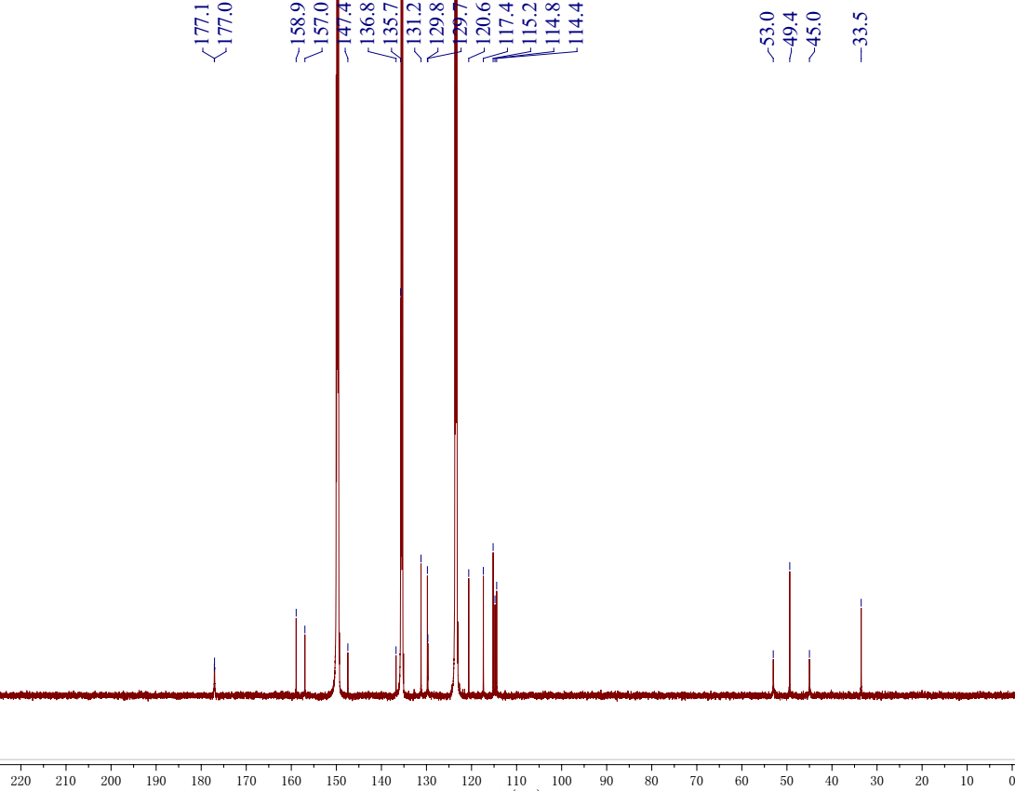
Figure S51. ¹³C NMR spectrum of 8 in pyridine-d₅
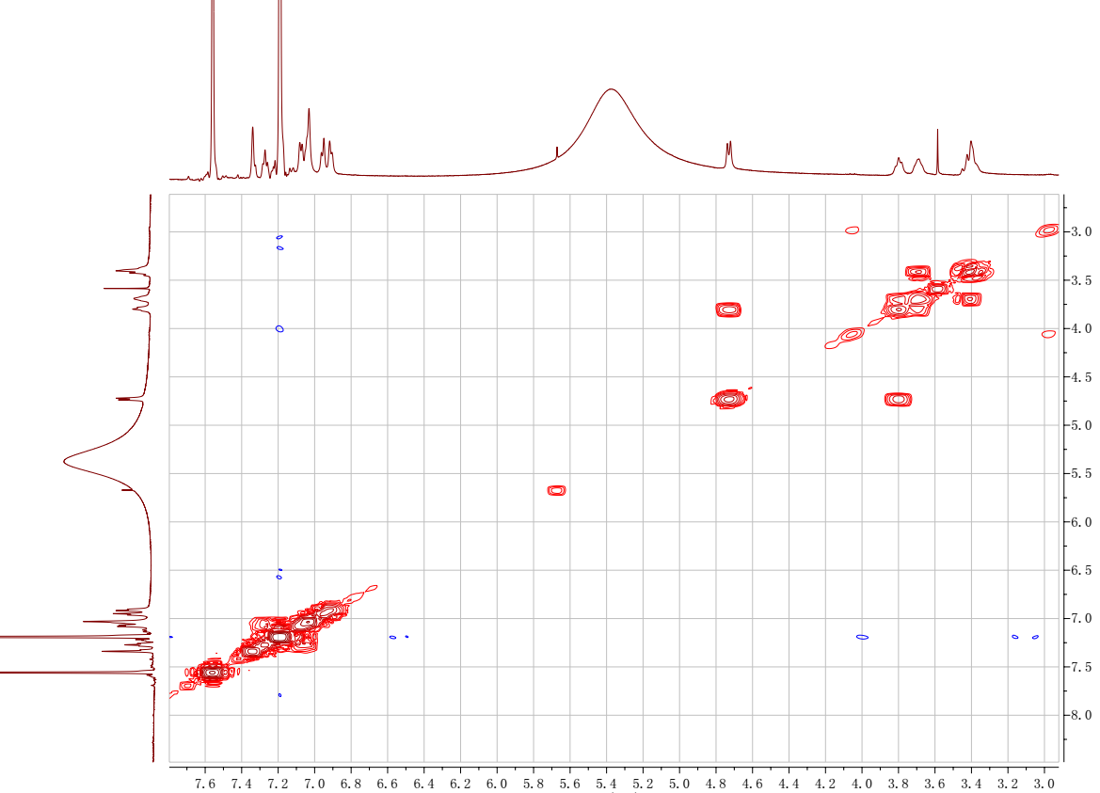
Figure S52. ¹H-¹H COSY spectrum of 8 in pyridine-d₅
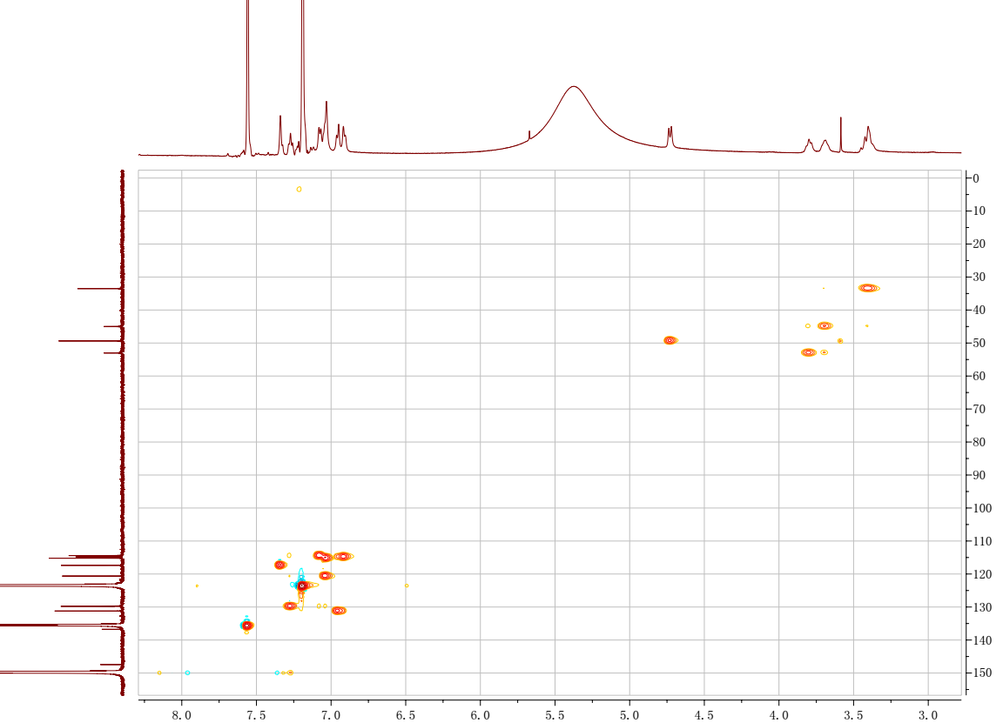
Figure S53. HSQC spectrum of 8 in pyridine-d₅
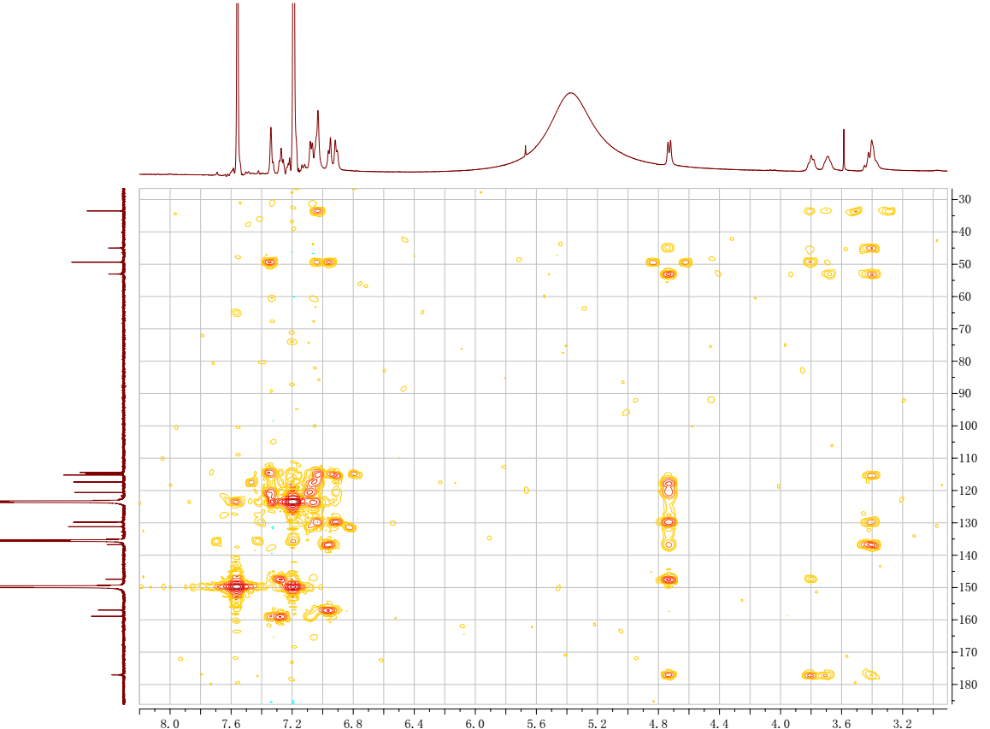
Figure S54. HMBC spectrum of 8 in pyridine-d₅
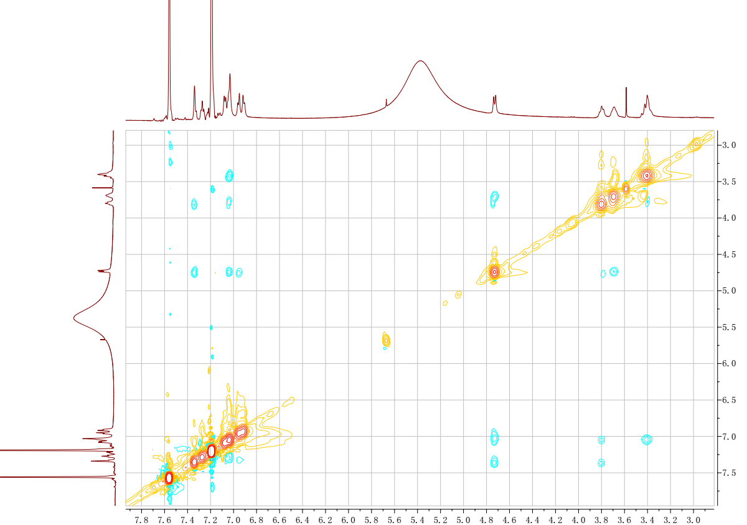
Figure S55. ROESY spectrum of 8 in pyridine-d₅
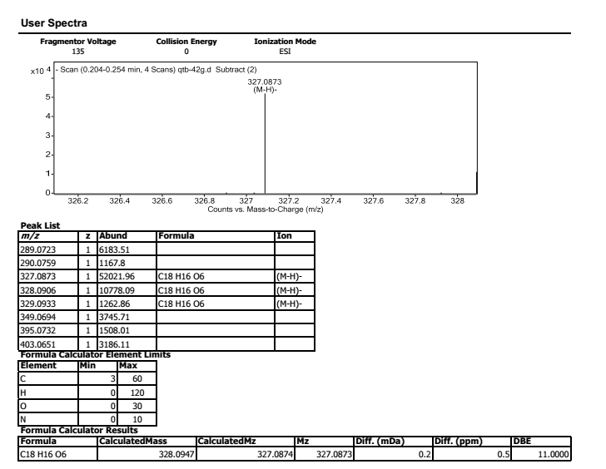
Figure S56. HREIMS of 8

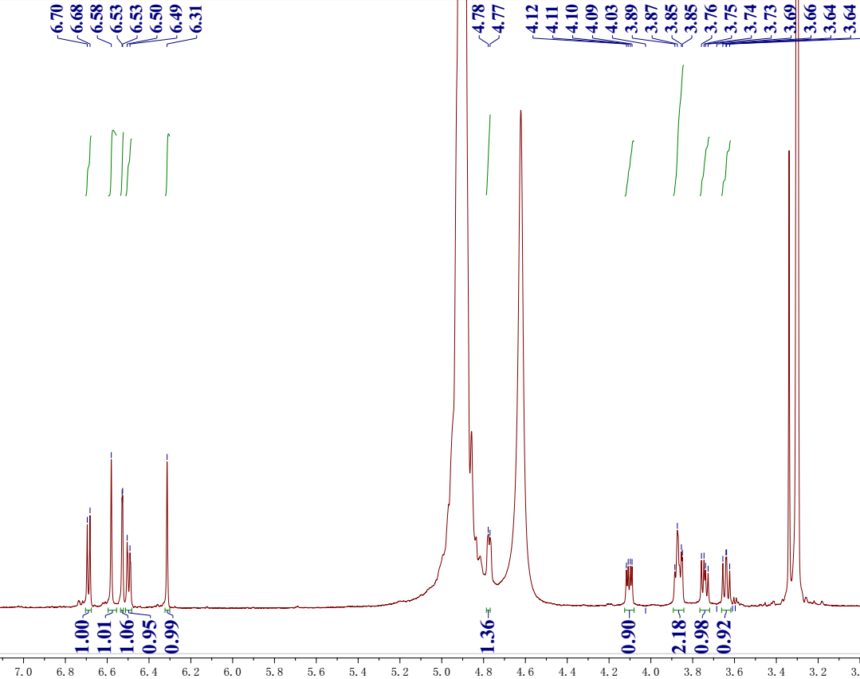
Figure S57. ¹H NMR spectrum of 9 in methanol-d₄
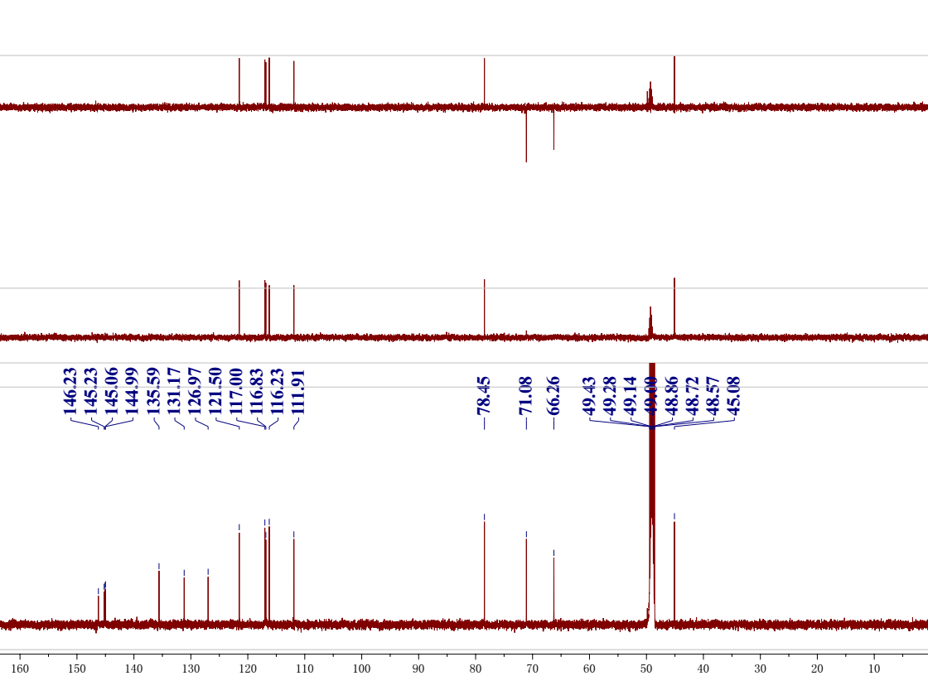
Figure S58. ¹³C NMR and DEPT spectra of 9 in methanol-d₄
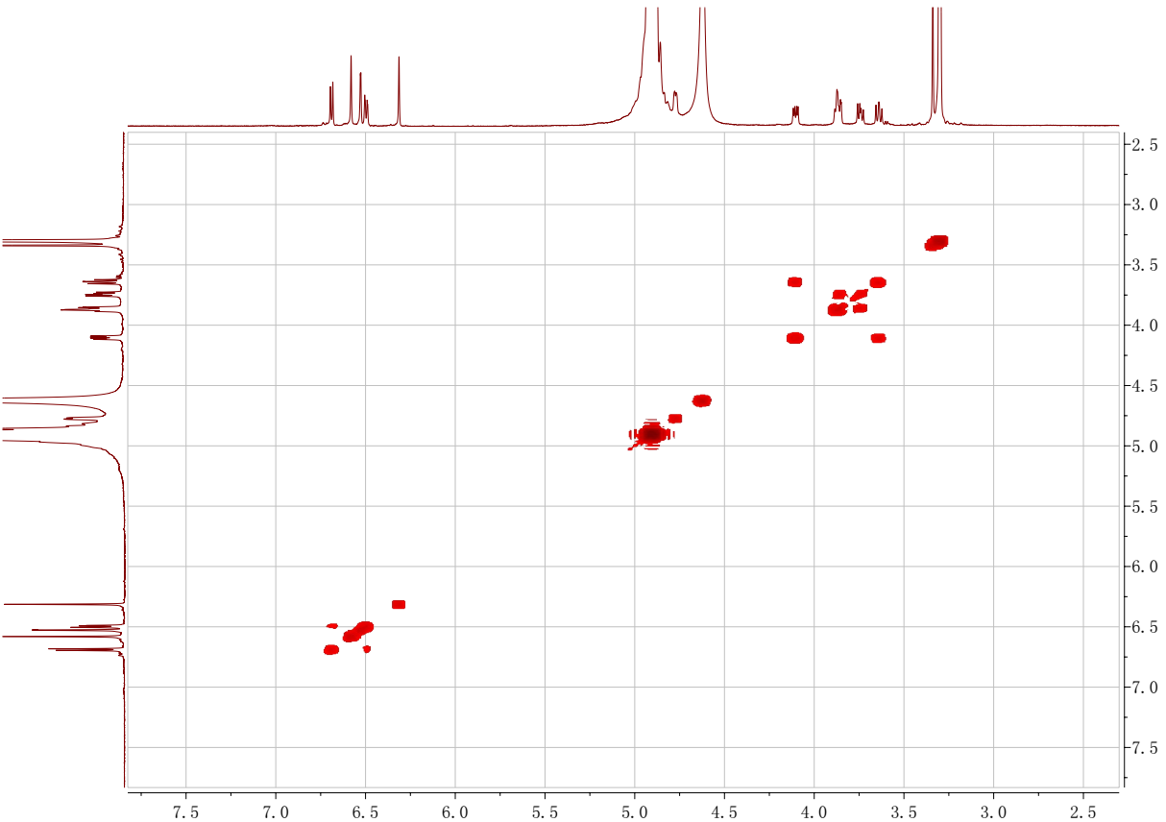
Figure S59. ¹H-¹H COSY spectrum of 9 in methanol-d₄
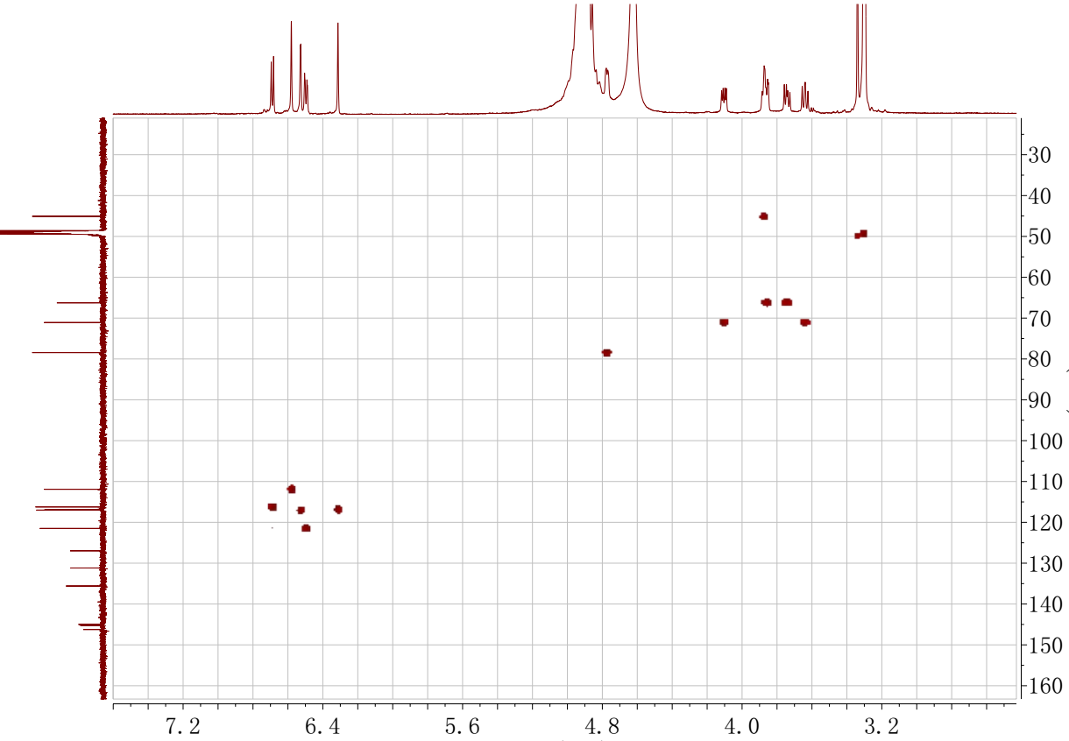
Figure S60. HSQC spectrum of 9 in methanol-d₄
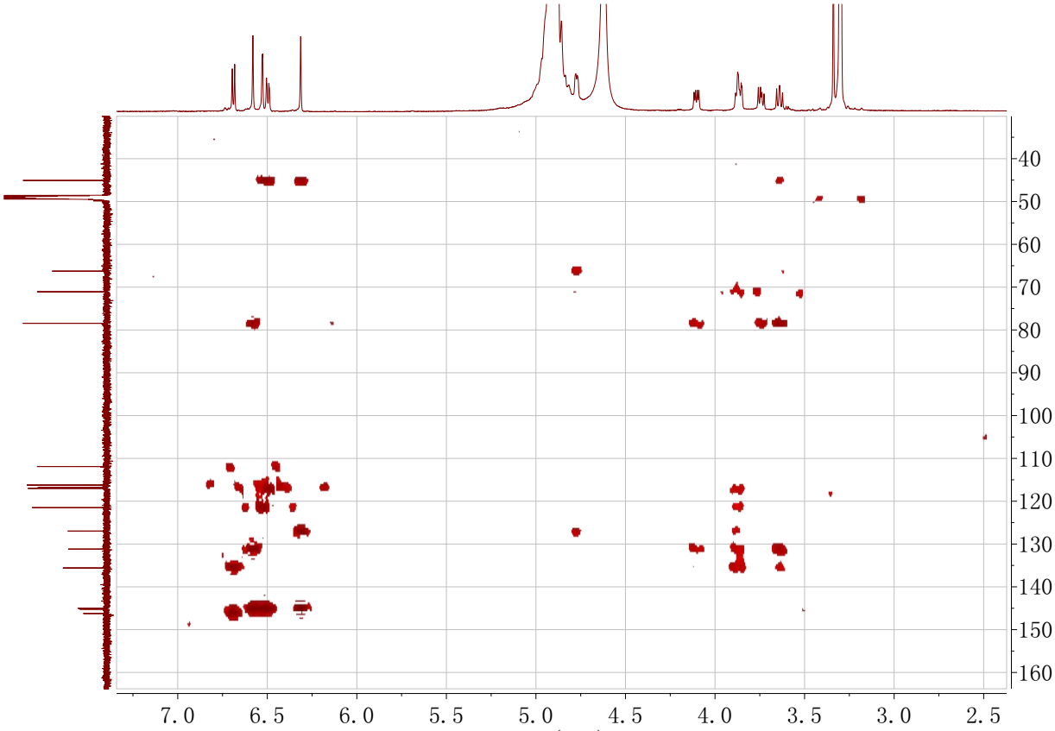
Figure S61. HMBC spectrum of 9 in methanol-d₄
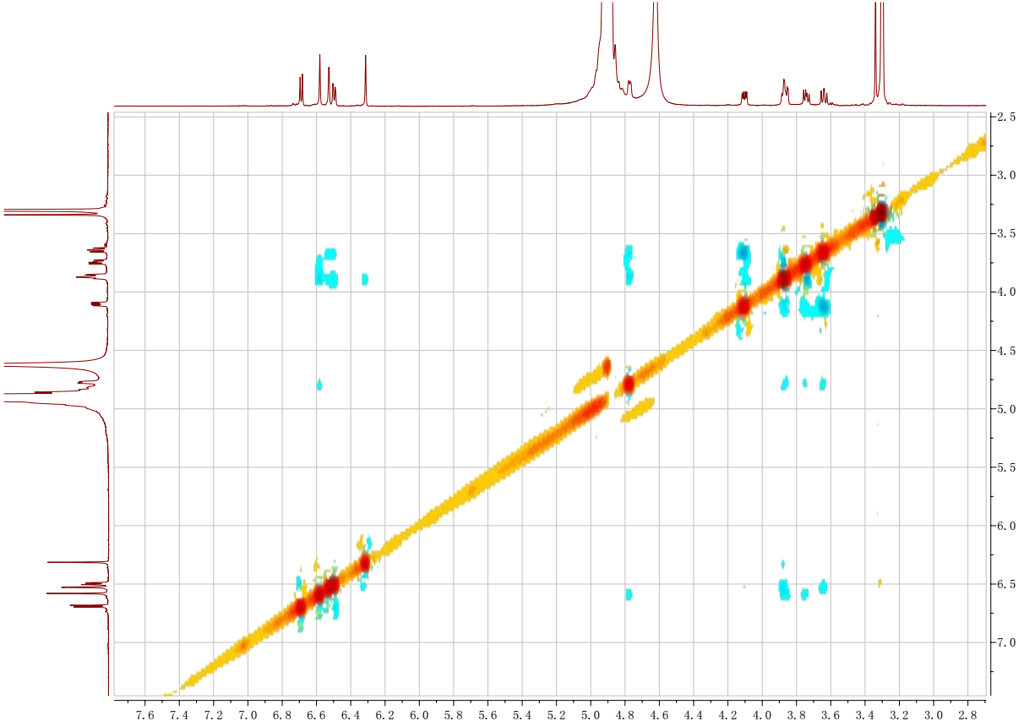
Figure S62. ROESY spectrum of 9 in methanol-d₄
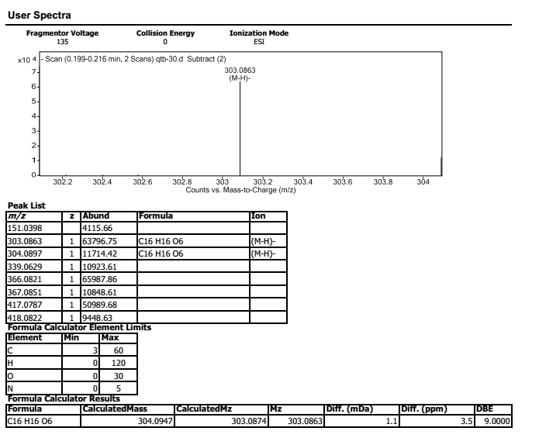
Figure S63. HREIMS of 9

