New Polychlorinated Bibenzyls from Rhododendron minutiflorum Hu
Yang-Li Zhu^{1#}, Li Deng^{1#}, Yu Tang¹, Xian-Zhe Fan¹, Yang Han², Mei Pan³,
Li-Jun Zhang^{1*} and Hai-Bing Liao^{1*}

¹State Key Laboratory for Chemistry and Molecular Engineering of Medicinal Resources, Collaborative Innovation Center for Guangxi Ethnic Medicine, School of Chemistry and Pharmaceutical Sciences, Guangxi Normal University, Guilin 541004, People’s Republic of China
² Guangxi Key Laboratory of Citrus Biology, Guangxi Academy of Specialty Crops, Guilin 541004, People’s Republic of China
³ Guilin Pharma Company, Guilin 541007, People’s Republic of China
Correspondence: ajun840618@mailbox.gxnu.edu.cn (L.-J. Zhang); lhbing188@163.com (H.-B. Liao)

Contents of Additional Information
NO | Content | Page
Figure S1 | Chemical structures of compounds 1-8 isolated from R. minutiflorum Hu | 4
Figure S2 | Comparison of HPLC-MS of compound 2 and the EtOH extract from R. minutiflorum Hu | 5
Figure S3 | Comparison of HPLC-MS of compounds 1-5 and the EtOH extract from R. minutiflorum Hu | 6
Table S1 | X-ray Crystallographic Data for Compound 1 | 7
Table S2 | X-ray Crystallographic Data for Compound 2 | 8
Figure S4 | ¹H NMR Spectrum of Compound 1 in CDCl₃ | 9
Figure S5 | ¹³C NMR Spectrum of Compound 1 in CDCl₃ | 10
Figure S6 | HSQC Spectrum of Compound 1 in CDCl₃ | 11
Figure S7 | HMBC Spectrum of Compound 1 in CDCl₃ | 12
Figure S8 | (-) Total HRESIMS Spectrum of Compound 1 | 13
Figure S9 | (-) Partial HRESIMS Spectrum of Compound 1 | 14
Figure S10 | UV Spectrum of Compound 1 | 15
Figure S11 | IR (KBr disc) Spectrum of Compound 1 | 16
Figure S12 | ¹H NMR Spectrum of Compound 2 in CDCl₃ | 17
Figure S13 | ¹³C NMR Spectrum of Compound 2 in CDCl₃ | 18
Figure S14 | ¹H-¹H COSY Spectrum of Compound 2 in CDCl₃ | 19
Figure S15 | HSQC Spectrum of Compound 2 in CDCl₃ | 20
Figure S16 | HMBC Spectrum of Compound 2 in CDCl₃ | 21
Figure S17 | (-) Total HRESIMS Spectrum of Compound 2 | 22
Figure S18 | (-) Partial HRESIMS Spectrum of Compound 2 | 23
Figure S19 | UV Spectrum of Compound 2 | 24
Figure S20 | IR (KBr disc) Spectrum of Compound 2 | 25
Figure S21 | ¹H NMR Spectrum of Compound 3 in CDCl₃ | 26
Figure S22 | ¹³C NMR Spectrum of Compound 3 in CDCl₃ | 27
Figure S23 | HSQC Spectrum of Compound 3 in CDCl₃ | 28
Figure S24 | HMBC Spectrum of Compound 3 in CDCl₃ | 29
Figure S25 | (-) Total HRESIMS Spectrum of Compound 3 | 30
Figure S26 | (-) Partial HRESIMS Spectrum of Compound 3 | 31
Figure S27 | UV Spectrum of Compound 3 | 32
Figure S28 | IR (KBr disc) Spectrum of Compound 3 | 33
Figure S29 | ¹H NMR Spectrum of Compound 4 in CDCl₃ | 34
Figure S30 | ¹³C NMR Spectrum of Compound 4 in CDCl₃ | 35
Figure S31 | ¹H-¹H COSY Spectrum of Compound 4 in CDCl₃ | 36
Figure S32 | HSQC Spectrum of Compound 4 in CDCl₃ | 37
Figure S33 | HMBC Spectrum of Compound 4 in CDCl₃ | 38
Figure S34 | (-) Total HRESIMS Spectrum of Compound 4 | 39
Figure S35 | (-) Partial HRESIMS Spectrum of Compound 4 | 40
Figure S36 | UV Spectrum of Compound 4 | 41
Figure S37 | IR (KBr disc) Spectrum of Compound 4 | 42
Figure S38 | ¹H NMR Spectrum of Compound 5 in CDCl₃ | 43
Figure S39 | ¹³C NMR Spectrum of Compound 5 in CDCl₃ | 44
Figure S40 | ¹H-¹H COSY Spectrum of Compound 5 in CDCl₃ | 45
Figure S41 | HSQC Spectrum of Compound 5 in CDCl₃ | 46
Figure S42 | HMBC Spectrum of Compound 5 in CDCl₃ | 47
Figure S43 | (-) Total HRESIMS Spectrum of Compound 5 | 48
Figure S44 | (-) Partial HRESIMS Spectrum of Compound 5 | 49
Figure S45 | UV Spectrum of Compound 5 | 50
Figure S46 | IR (KBr disc) Spectrum of Compound 5 | 51
Figure S47 | ¹H NMR Spectrum of Compound 6 in CDCl₃ | 52
Figure S48 | ¹³C NMR Spectrum of Compound6 in CDCl₃ | 53
Figure S49 | (+) HRESIMS Spectrum of Compound 6 | 54
Figure S50 | ¹H NMR Spectrum of Compound 7 in CDCl₃ | 55
Figure S51 | ¹³C NMR Spectrum of Compound 7 in CDCl₃ | 56
Figure S52 | (+) HRESIMS Spectrum of Compound 7 | 57
Figure S53 | ¹H NMR Spectrum of Compound 8 in MeOH-d₄ | 58
Figure S54 | ¹³C NMR Spectrum of Compound 8 in MeOH-d₄ | 59
Figure S55 | ¹H-¹H COSY Spectrum of Compound 8 in MeOH-d₄ | 60
Figure S56 | HSQC Spectrum of Compound 8 in MeOH-d₄ | 61
Figure S57 | HMBC Spectrum of Compound 8 in MeOH-d₄ | 62
Figure S58 | (+) HRESIMS Spectrum of Compound 8 | 63
Table S3 | ¹H and ¹³C NMR Data of Compound 8 | 64

Figure S1. Chemical structures of compounds 1-8 isolated from R. minutiflorum Hu

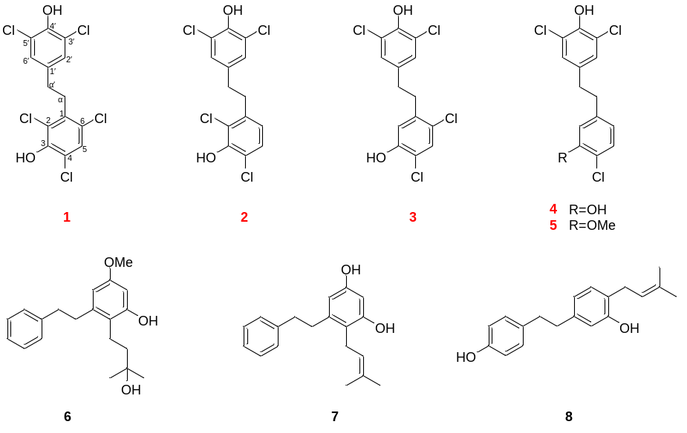

Figure S2. Comparison of HPLC-MS of compound 2 and the EtOH extract from R. minutiflorum Hu
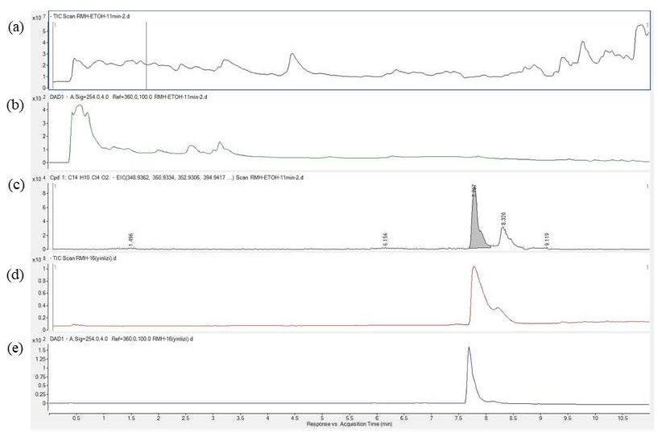
Note: (a) The TIC scan of the EtOH extract of R. minutiflorum Hu; (b) The HPLC of the EtOH extract of R. minutiflorum Hu under 254 nm; (c) The distribution of compound 2 in the TIC scan of the EtOH extract of R. minutiflorum Hu; (d) The TIC scan of compound 2; (e) The HPLC of compound 2 under 254 nm.

Figure S3. Comparison of HPLC-MS of compounds 1-5 and the EtOH extract from R. minutiflorum Hu
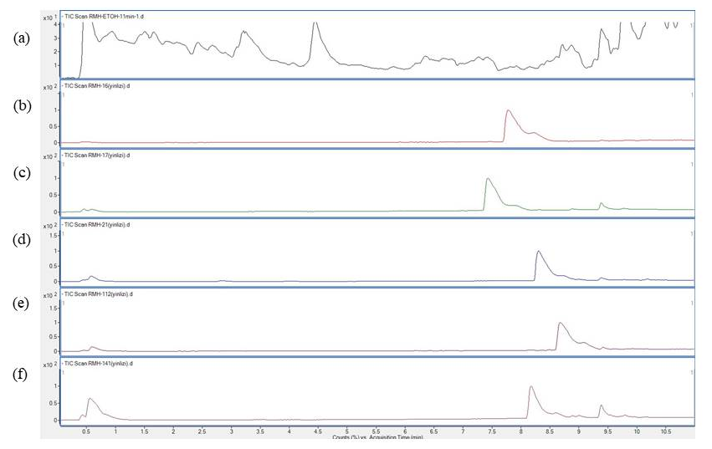
Note: (a) The TIC scan of the EtOH extract of R. minutiflorum Hu; (b) The TIC scan of compound 2; (c) The TIC scan of compound 4; (d) The TIC scan of compound 3; (e) The TIC scan of compound 1; (e) The TIC scan of compound 5.

Table S1. X-ray Crystallographic Data for Compound 1
Empirical formula | C₁₄H₁₃Cl₅O₄
Moiety formula | C₁₄ H₉ Cl₅O₂, 2(H₂O)
Formula weight | 422.49
Temperature/K | 293
Crystal system | monoclinic
Space group | I2/a
a/Å | 27.1575(11)
b/Å | 4.3189(3)
c/Å | 30.0170(12)
α/° | 90
β/° | 91.182(4)
γ/° | 90
Volume/Å³ | 3519.9(3)
Z | 8
ρ_{calc}g/cm³ | 1.594
μ/mm⁻¹ | 7.655
F(000) | 1712.0
Crystal size/mm³ | 0.1 × 0.05 × 0.03
Radiation | Cu Kα (λ = 1.54184)
2Θ range for data collection/° | 5.89 to 134.15
Index ranges | -32 ≤ h ≤ 32, -4≤ k ≤ 5, -35 ≤ l ≤ 35
Reflections collected | 24050
Independent reflections | 3111 [R_{int} = 0.1191, R_{sigma} = 0.0689]
Data/restraints/parameters | 3111/6/222
Goodness-of-fit on F² | 1.125
Final R indexes [I>=2σ (I)] | R₁ = 0.0710 wR₂ = 0.1946
Final R indexes [all data] | R₁ = 0.1132, wR₂ = 0.2257
Largest diff. peak/hole / e Å⁻³ | 0.64/-0.43

Table S2. X-ray Crystallographic Data for Compound 2
Empirical formula | C₁₄H₁₀Cl₄O₂
Formula weight | 352.02
Temperature/K | 293
Crystal system | orthorhombic
Space group | P2₁2₁2₁
a/Å | 4.74049(13)
b/Å | 12.6052(5)
c/Å | 24.1973(7)
α/° | 90
β/° | 90
γ/° | 90
Volume/Å³ | 1445.91(8)
Z | 4
ρ_{calc}g/cm³ | 1.617
μ/mm⁻¹ | 7.423
F(000) | 712.0
Crystal size/mm³ | 0.15 × 0.03 × 0.03
Radiation | Cu Kα (λ = 1.54184)
2Θ range for data collection/° | 7.306 to 134.126
Index ranges | -5 ≤ h ≤ 3, -15 ≤ k ≤ 14, -26 ≤ l ≤ 28
Reflections collected | 6362
Independent reflections | 2567 [R_{int} = 0.0471, R_{sigma} = 0.0556]
Data/restraints/parameters | 2567/0/182
Goodness-of-fit on F² | 0.991
Final R indexes [I>=2σ (I)] | R₁ = 0.0330, wR₂ = 0.0744
Final R indexes [all data] | R₁ = 0.0386, wR₂ = 0.0768
Largest diff. peak/hole / e Å⁻³ | 0.21/-0.21
Flack parameter | -0.008(14)

Figure S4. ¹H NMR Spectrum of Compound 1 in CDCl₃
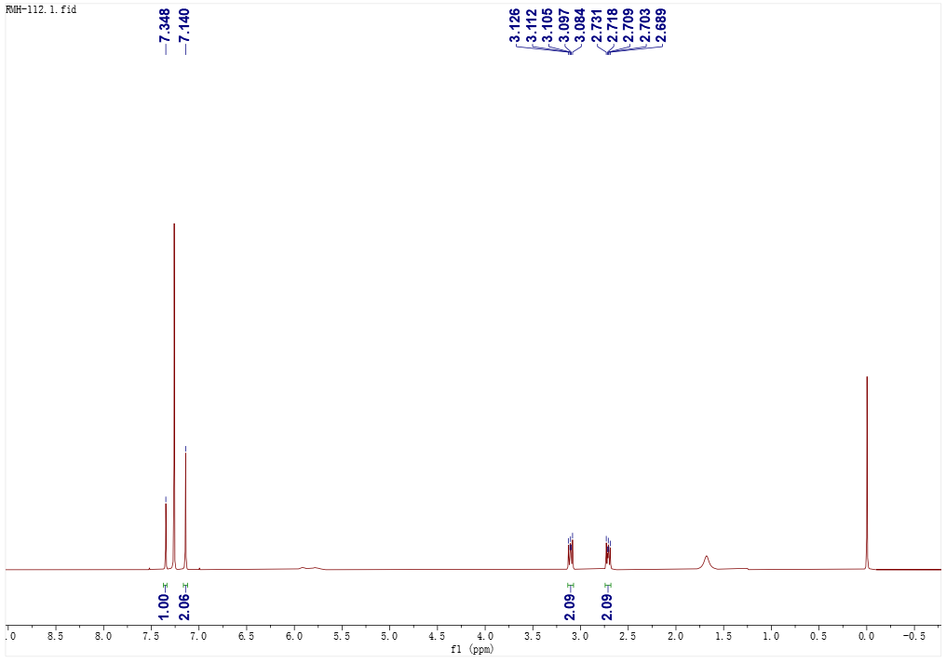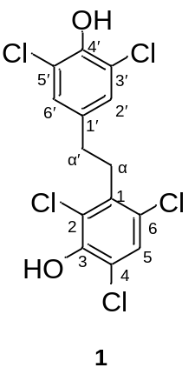

Figure S5. ¹³C NMR Spectrum of Compound 1 in CDCl₃
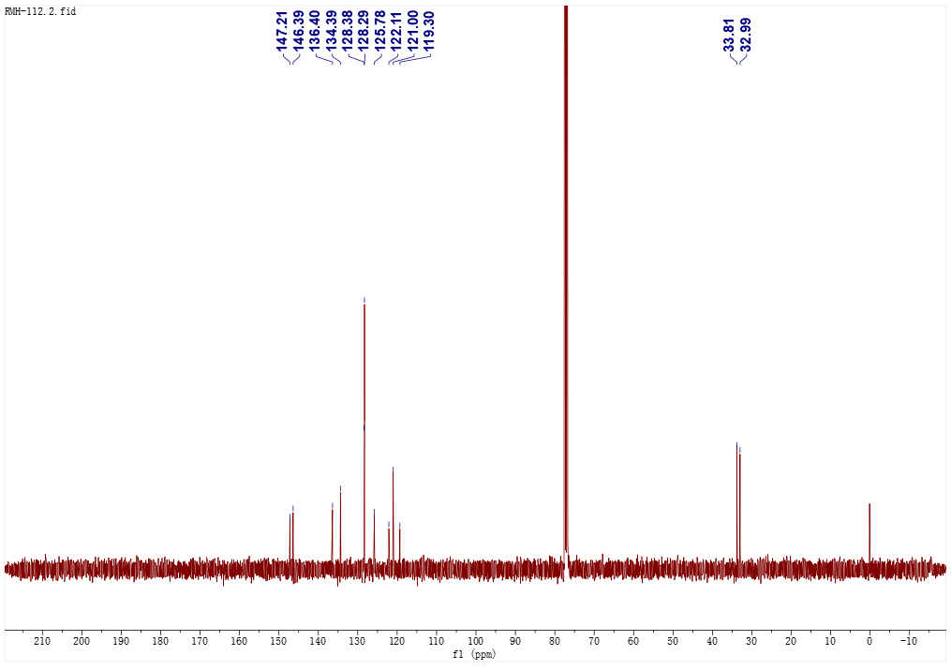

Figure S6. HSQC Spectrum of Compound 1 in CDCl₃
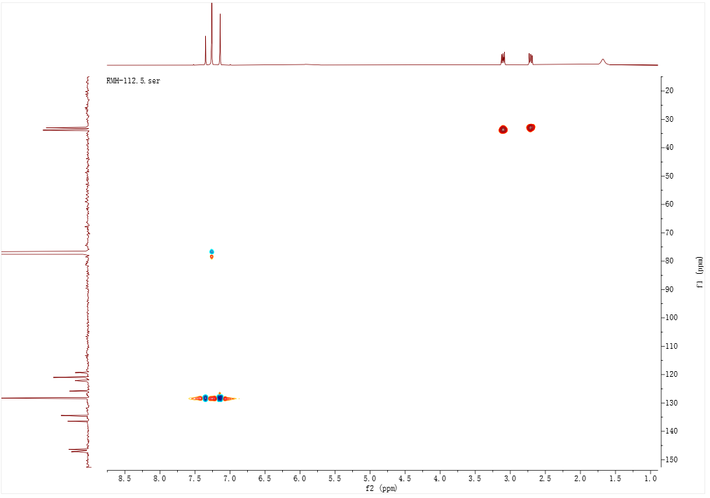
Figure S7. HMBC Spectrum of Compound 1 in CDCl₃
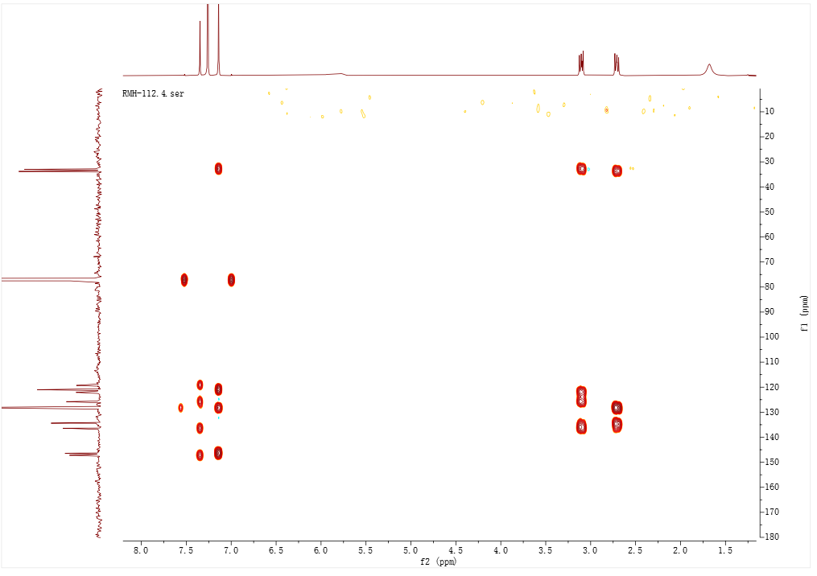

Figure S8. (-) Total HRESIMS Spectrum of Compound 1
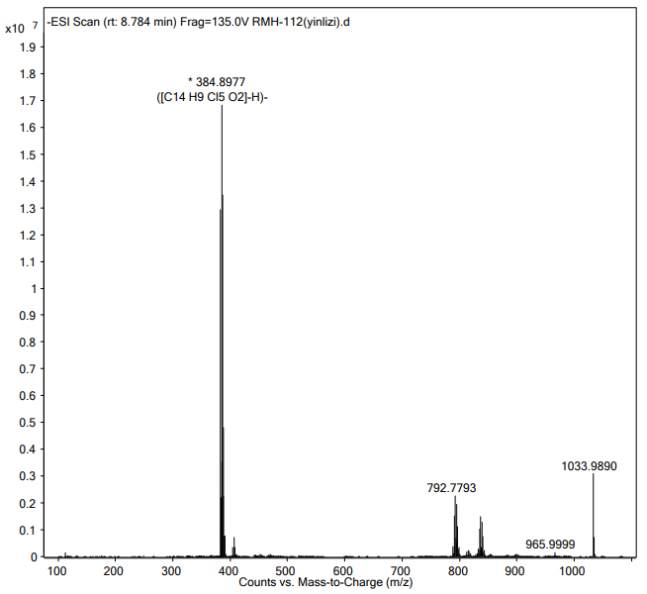

Figure S9 (-) Partial HRESIMS Spectrum of Compound 1
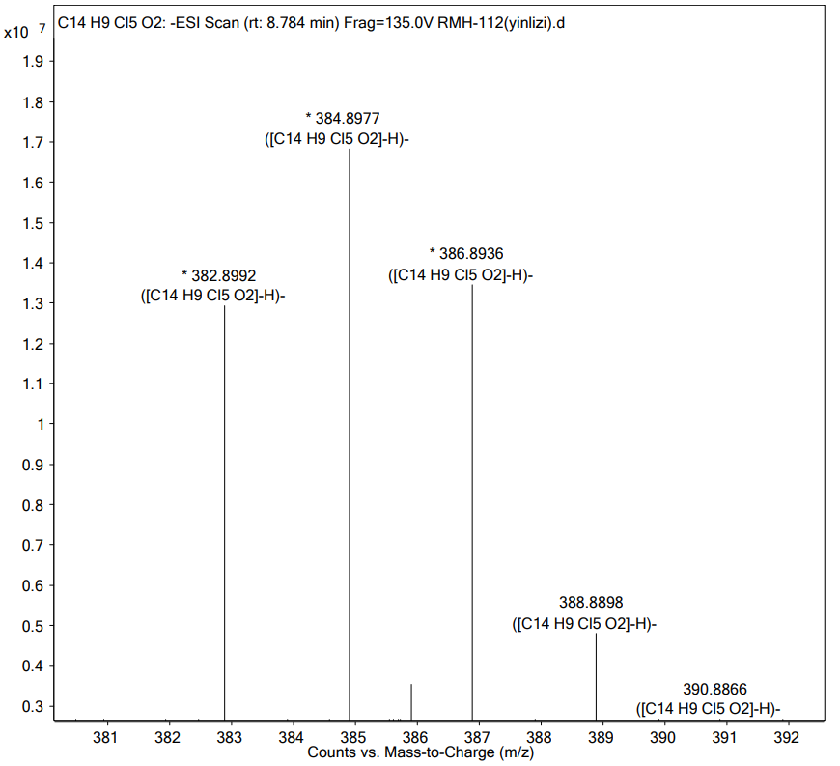

Figure S10. UV Spectrum of Compound 1
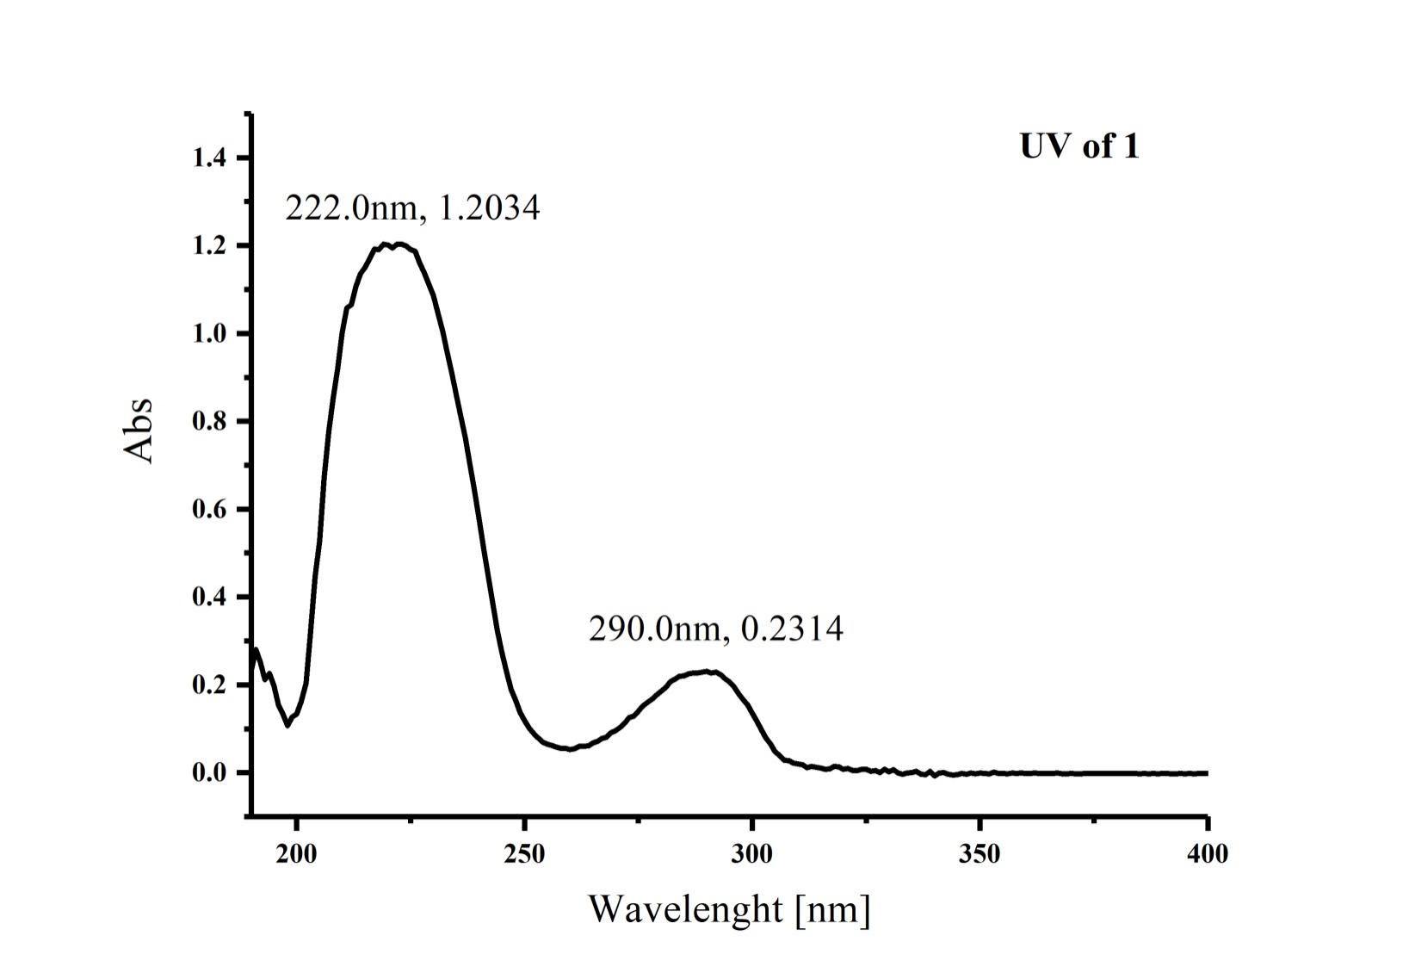

Figure S11. IR (KBr disc) Spectrum of Compound 1
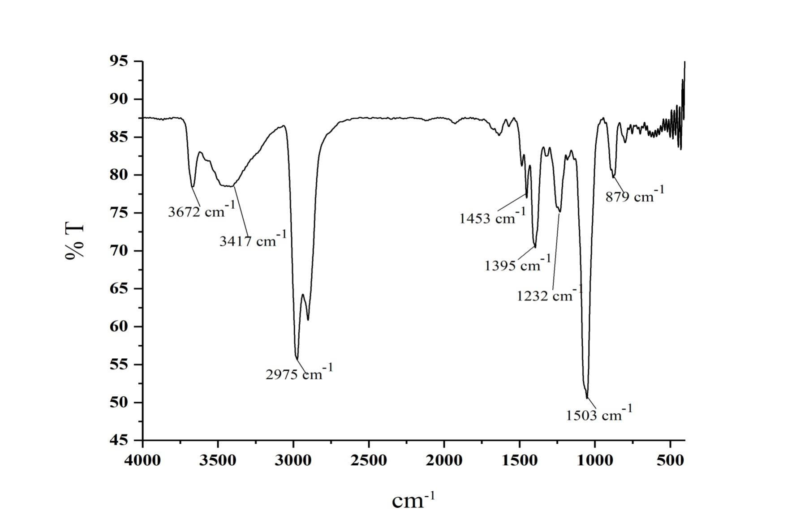
Figure S12. ¹H NMR Spectrum of Compound 2 in CDCl₃
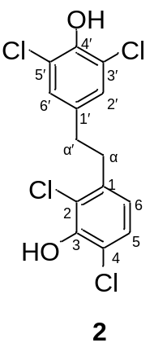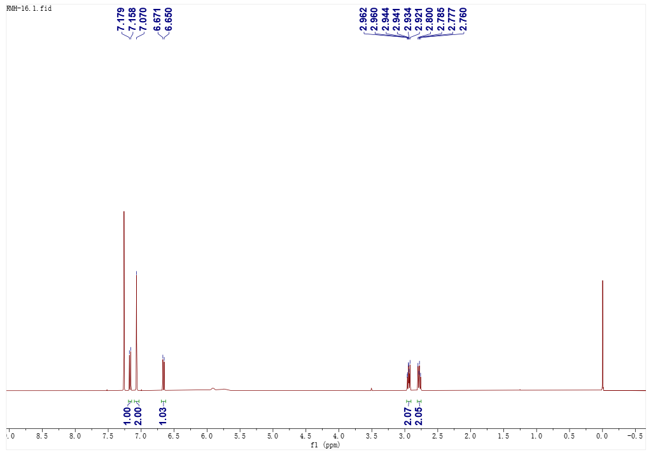

Figure S13. ¹³C NMR Spectrum of Compound 2 in CDCl₃
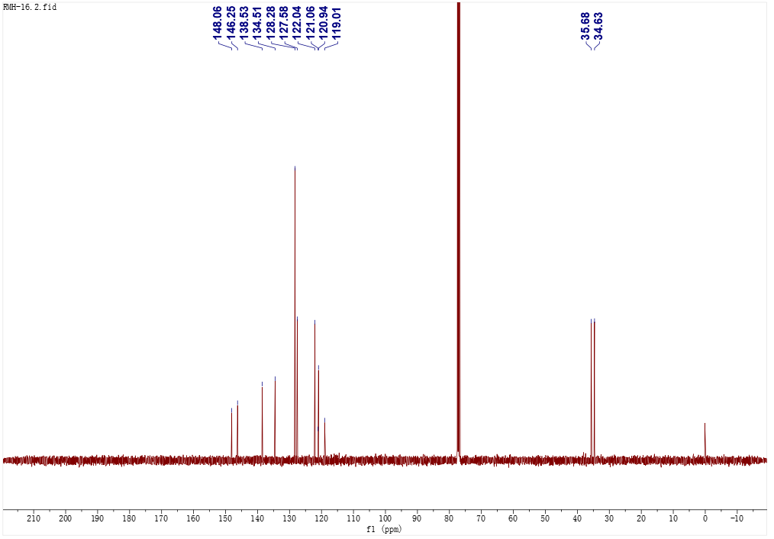

Figure S14. ¹H-¹H COSY Spectrum of Compound 2 in CDCl₃
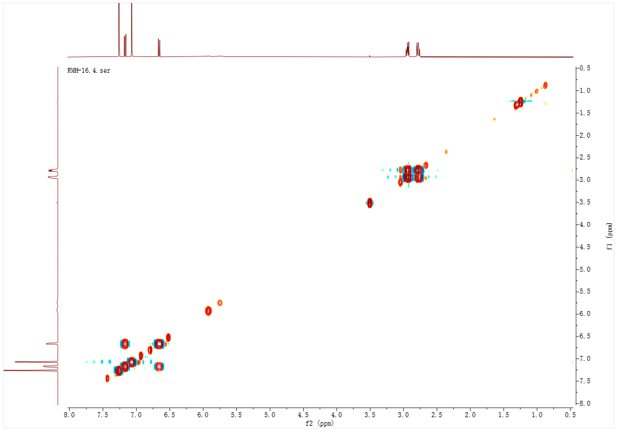

Figure S15. HSQC Spectrum of Compound 2 in CDCl₃
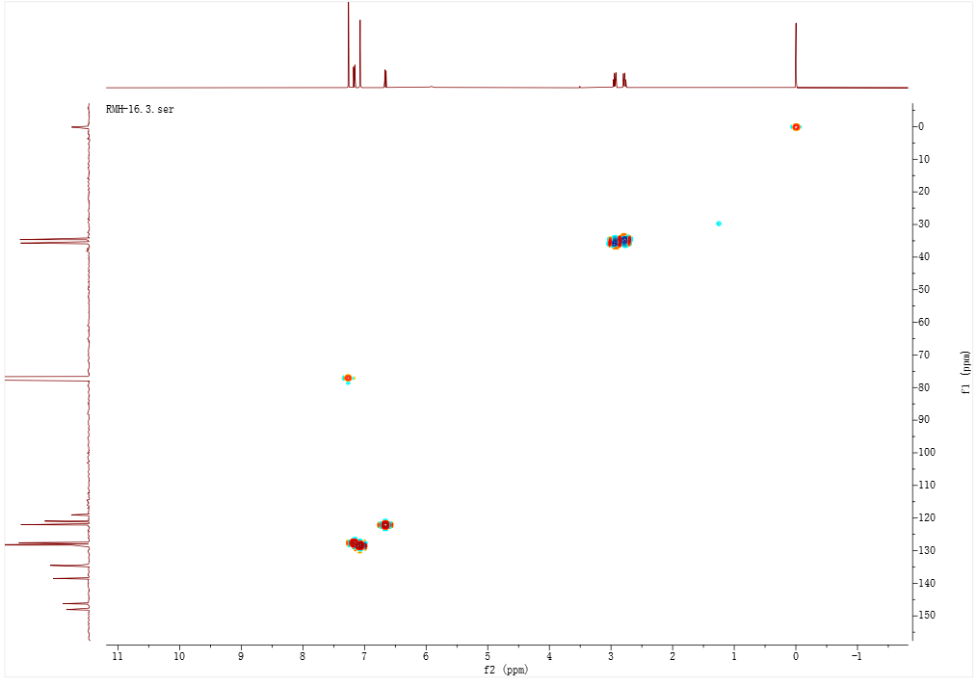

Figure S16.HMBC Spectrum of Compound 2 in CDCl₃
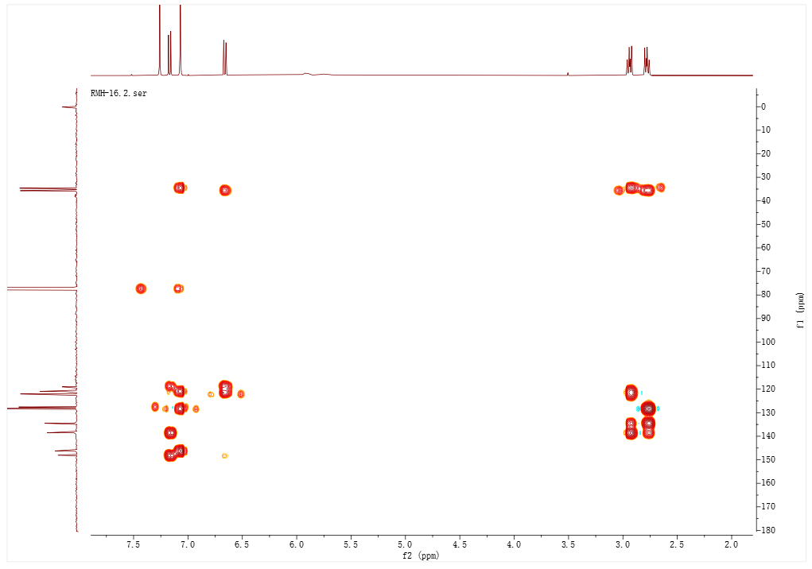

Figure S17. (-) Total HRESIMS Spectrum of Compound 2
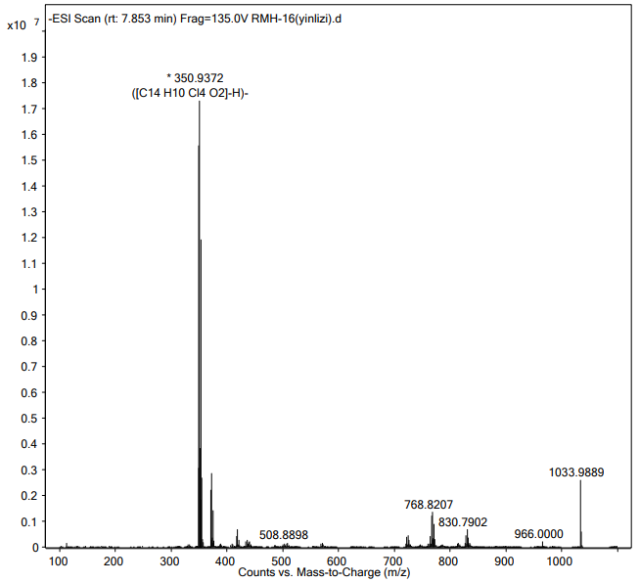

Figure S18. (-) Partial HRESIMS Spectrum of Compound 2
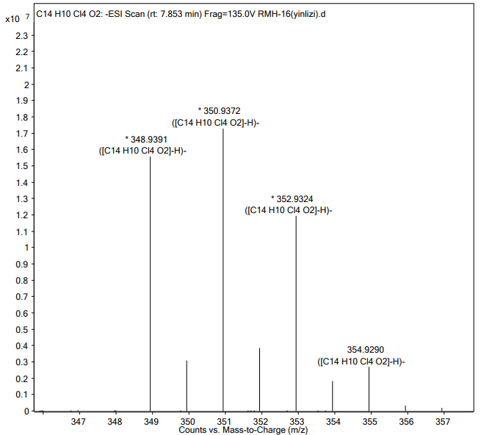

Figure S19. UV Spectrum of Compound 2
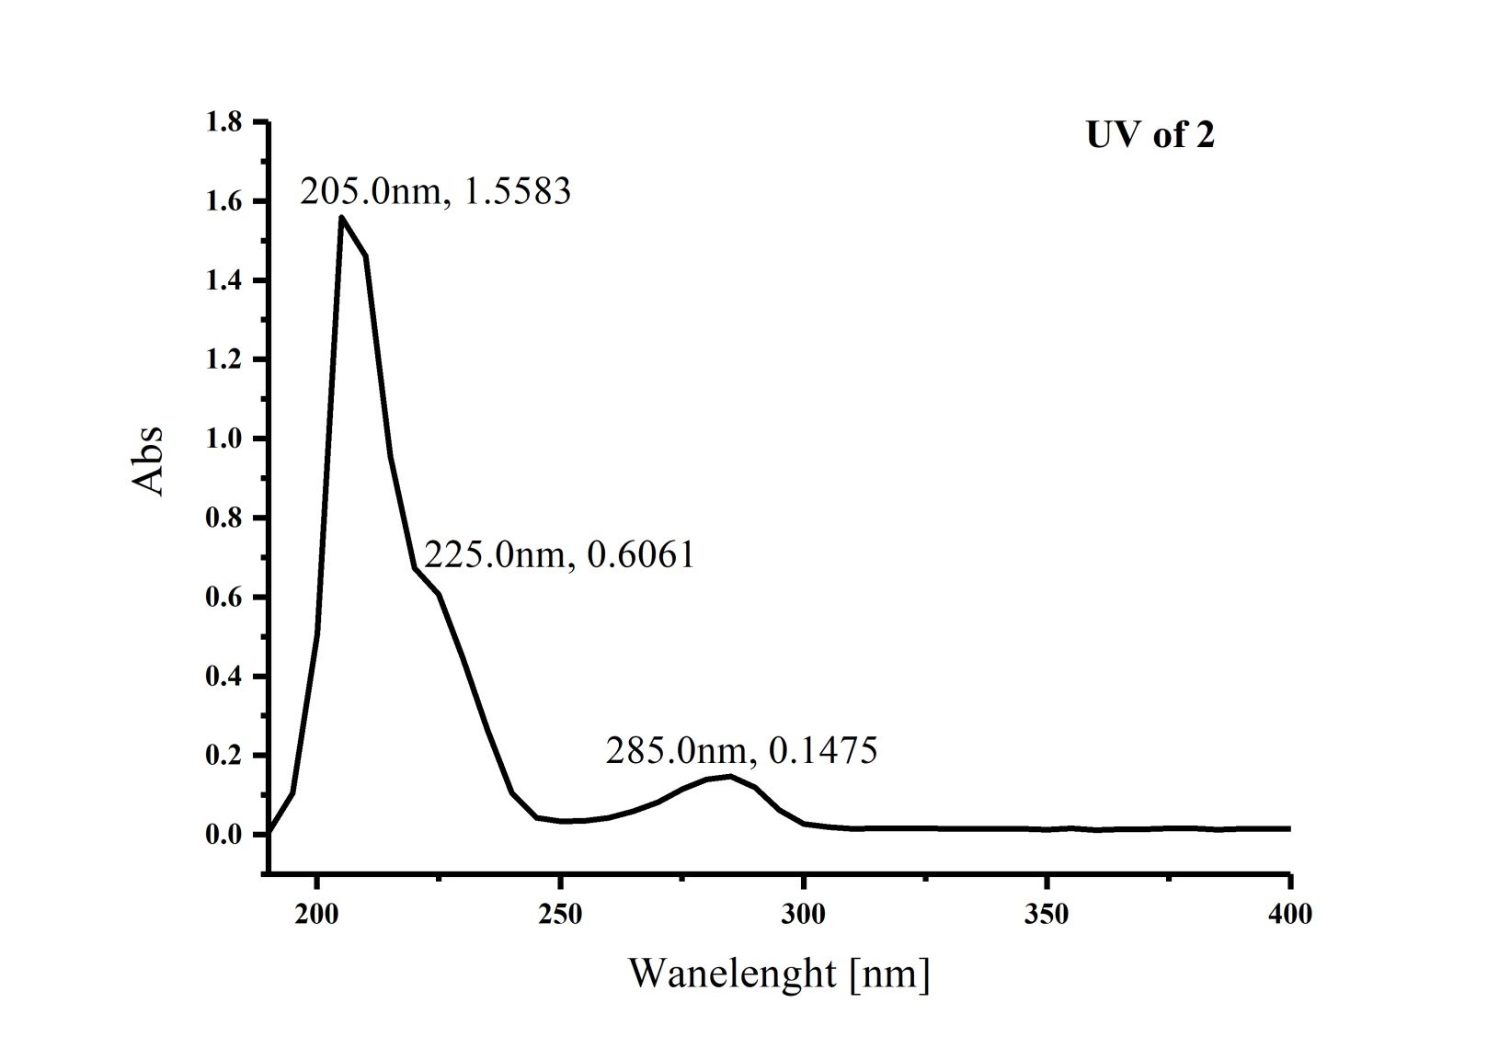

Figure S20. IR (KBr disc) Spectrum of Compound 2
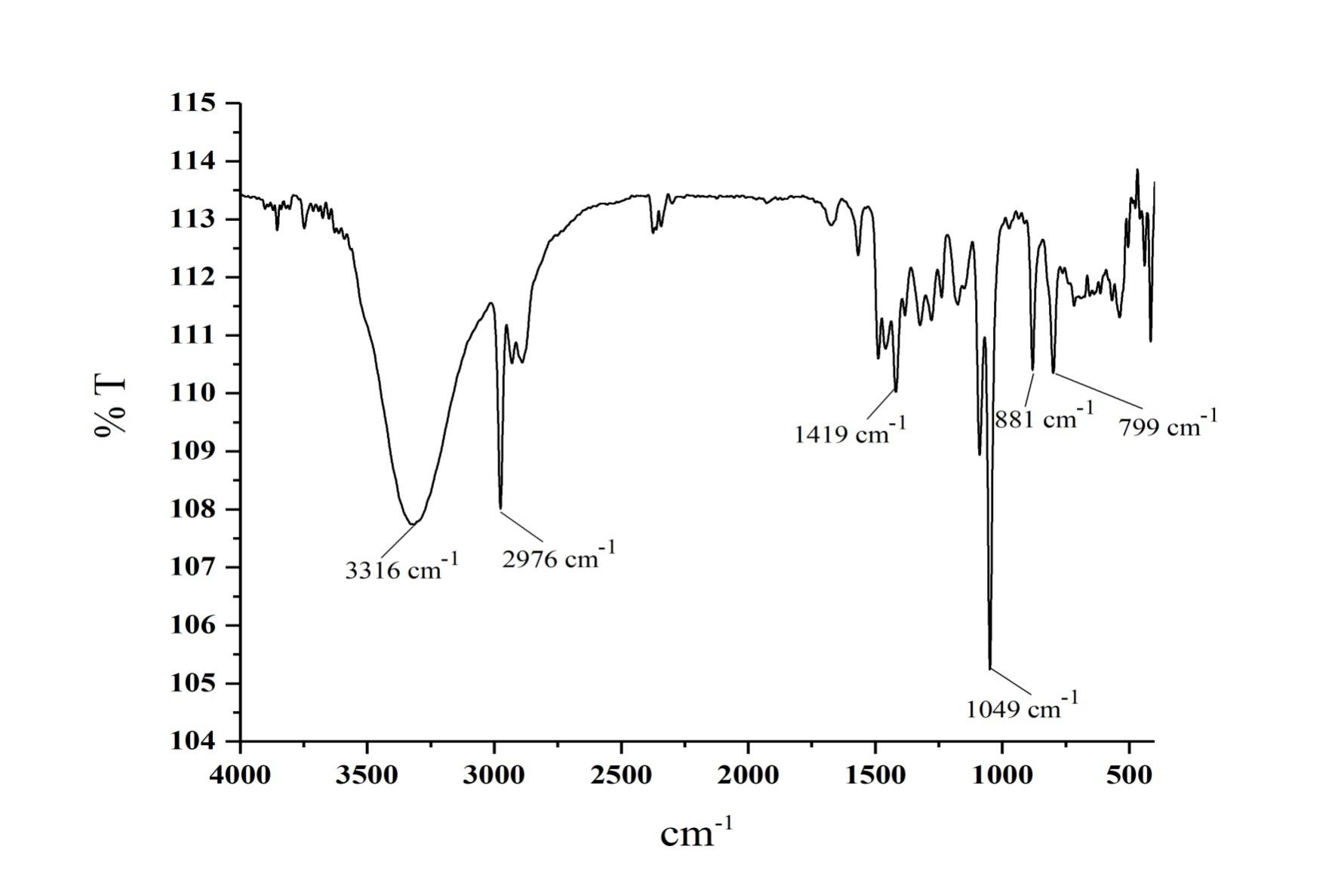
Figure S21. ¹H NMR Spectrum of Compound 3 in CDCl₃
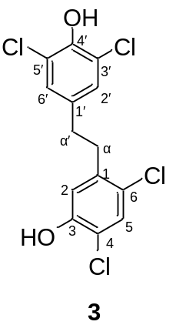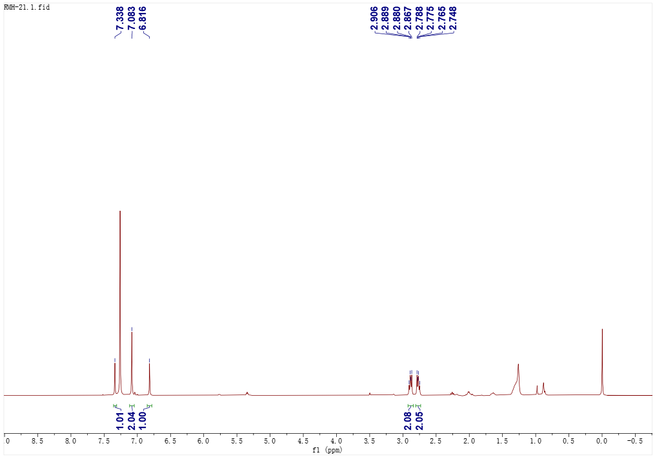

Figure S22. ¹³C NMR Spectrum of Compound 3 in CDCl₃
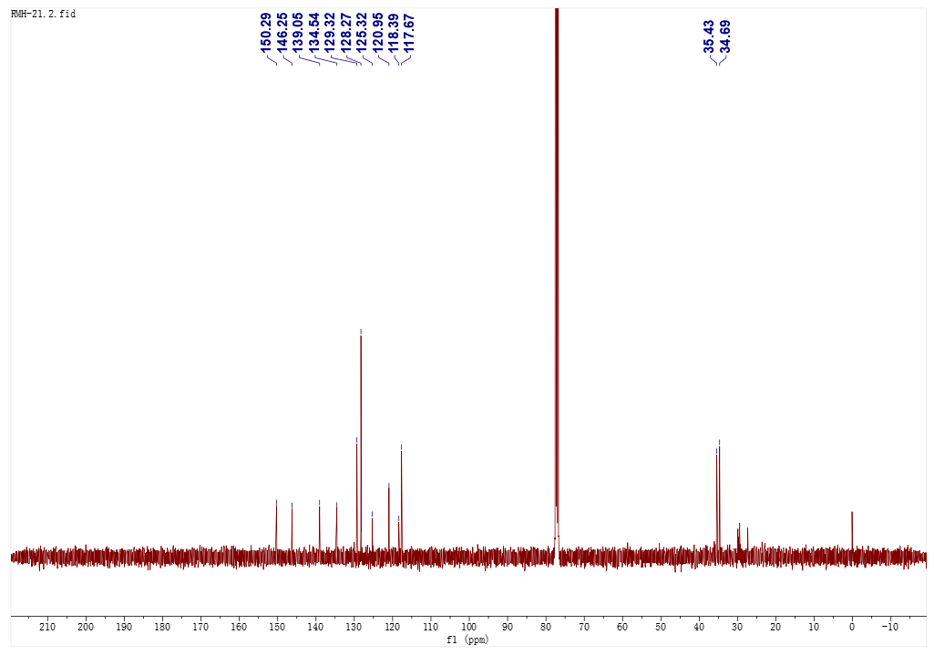

Figure S23. HSQC Spectrum of Compound 3 in CDCl₃
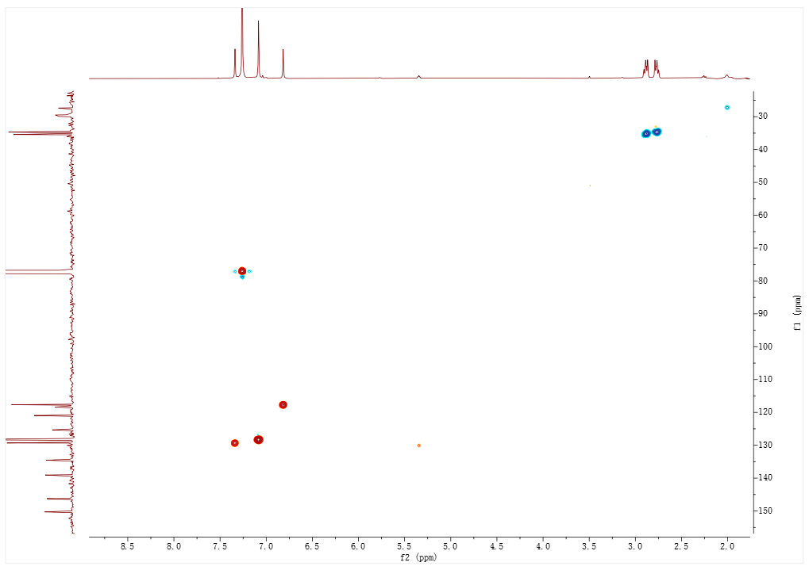

Figure S24. HMBC Spectrum of Compound 3 in CDCl₃
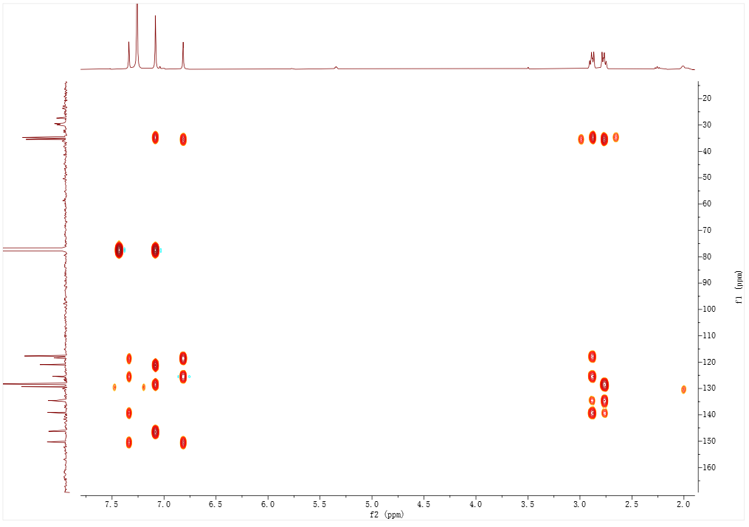

Figure S25. (-) Total HRESIMS Spectrum of Compound 3
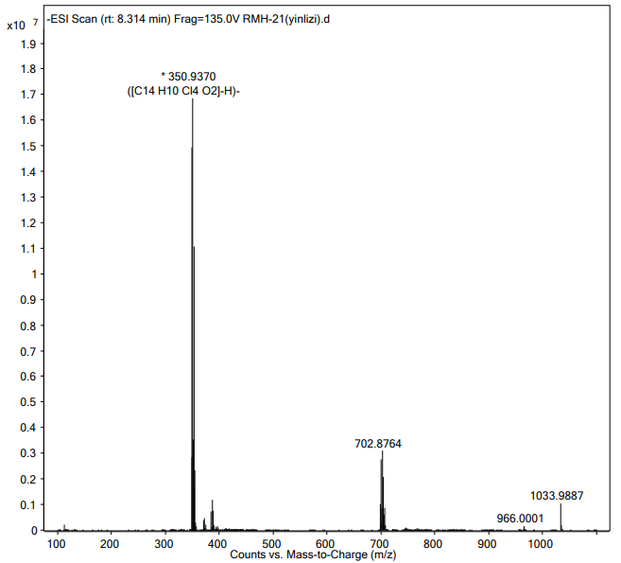

Figure S26. (-) Partial HRESIMS Spectrum of Compound 3
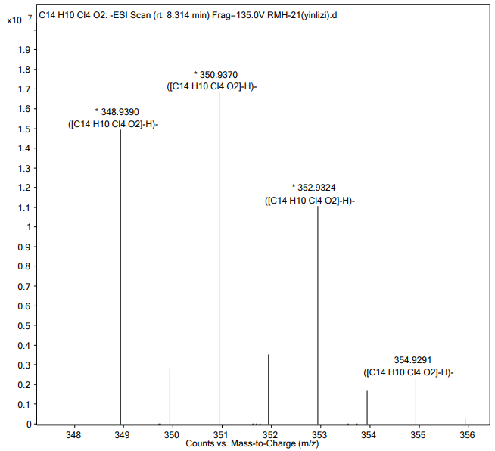

Figure S27. UV Spectrum of Compound 3
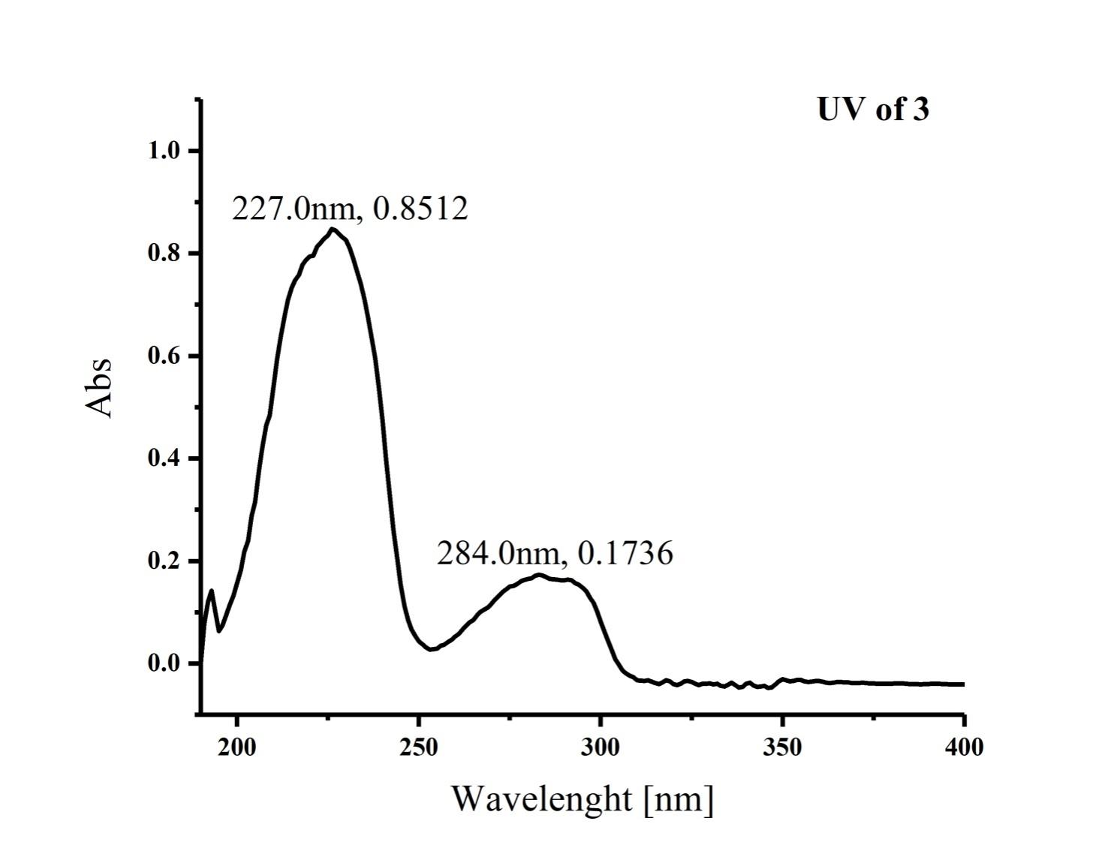

Figure S28. IR (KBr disc) Spectrum of Compound 3
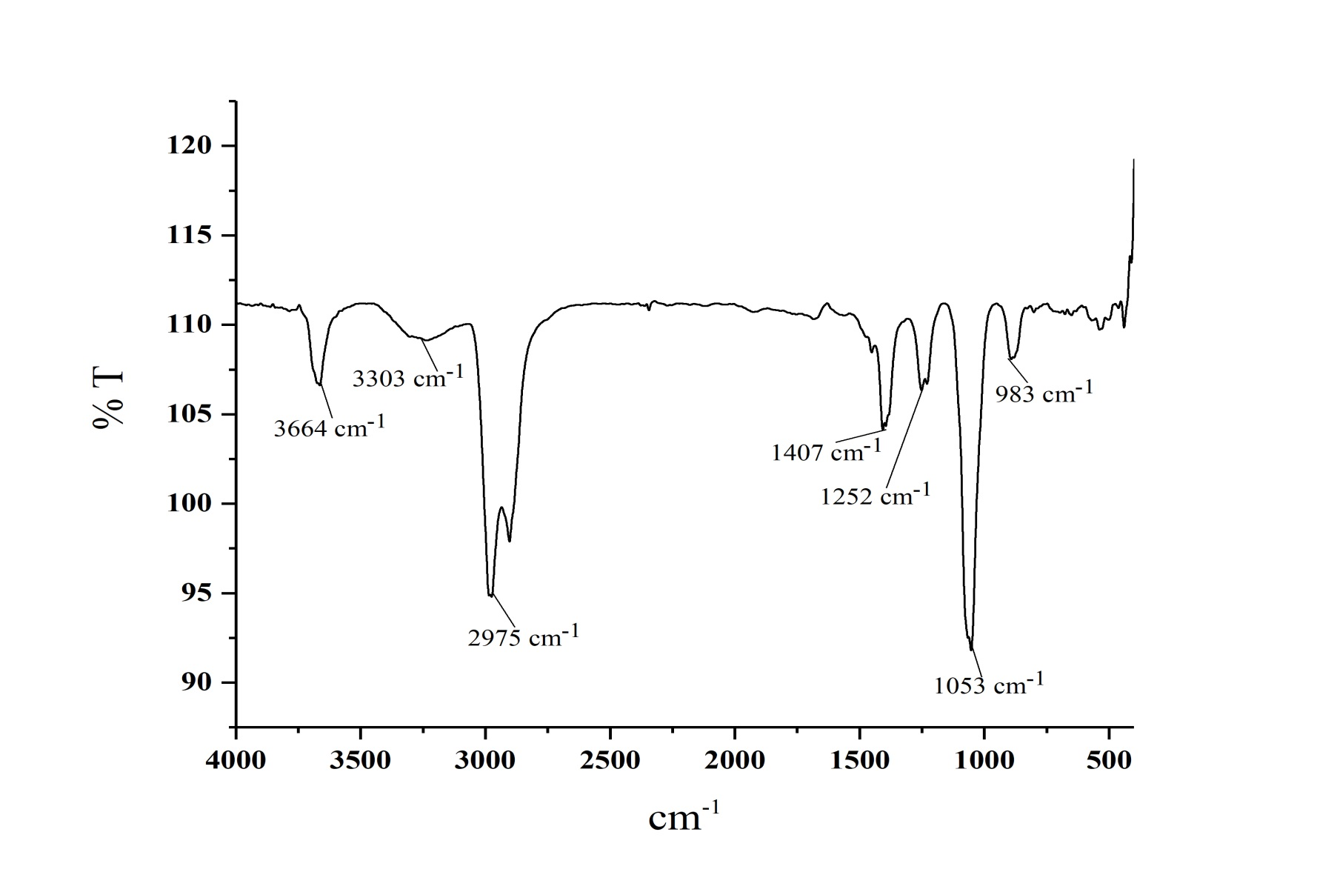
Figure S29. ¹H NMR Spectrum of Compound 4 in CDCl₃
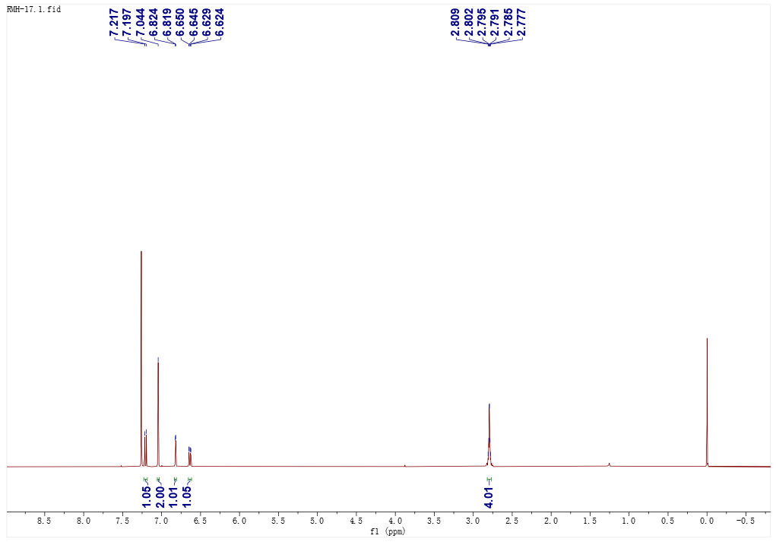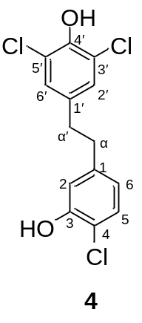

Figure S30. ¹³C NMR Spectrum of Compound 4 in CDCl₃
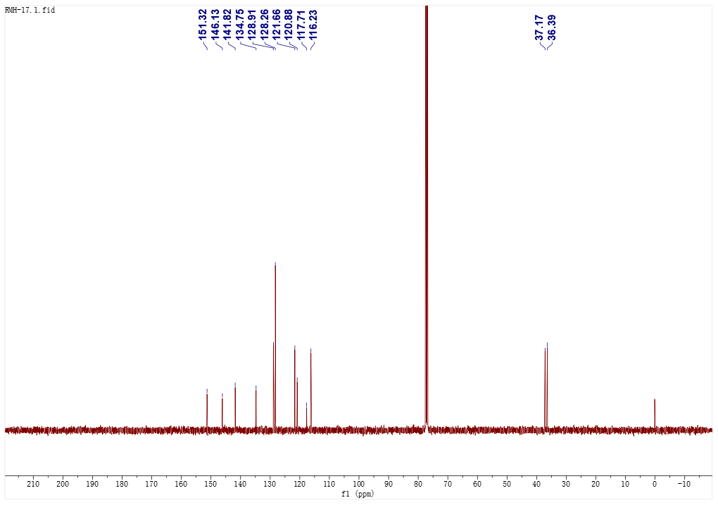

Figure S31. ¹H-¹H COSY Spectrum of Compound 4 in CDCl₃
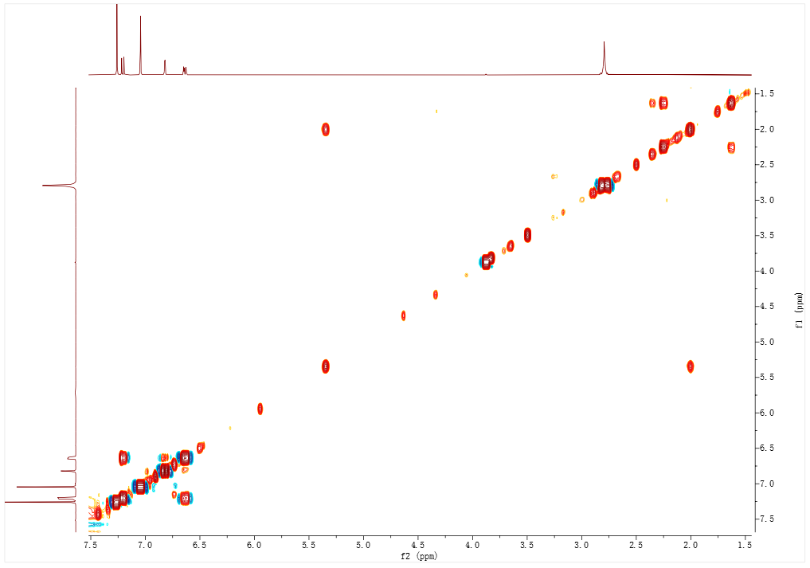

Figure S32. HSQC Spectrum of Compound 4 in CDCl₃
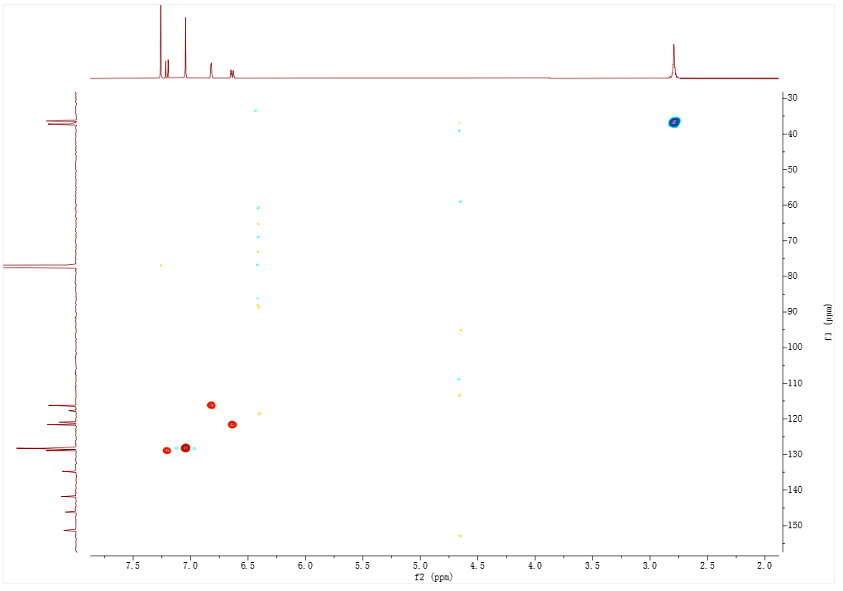

Figure S33. HMBC Spectrum of Compound 4 in CDCl₃
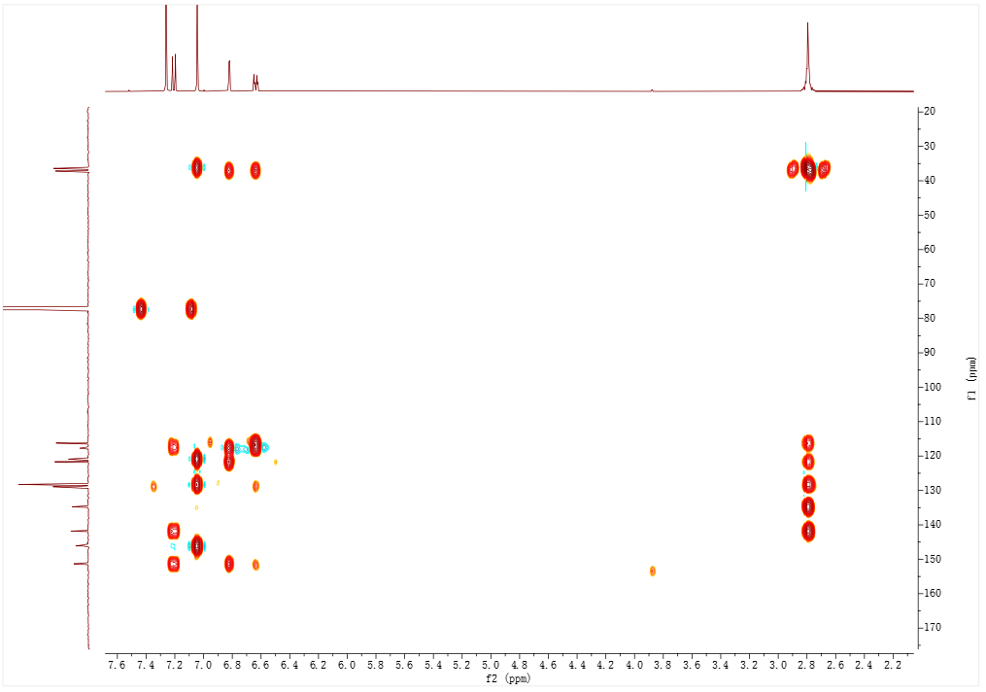

Figure S34. (-) Total HRESIMS Spectrum of Compound 4
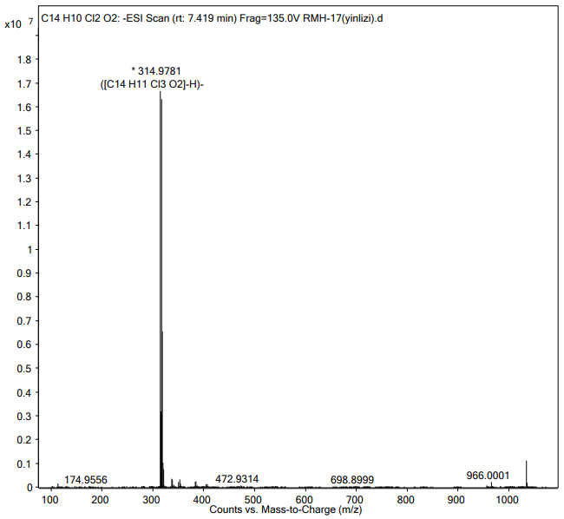

Figure S35. (-) Partial HRESIMS Spectrum of Compound 4
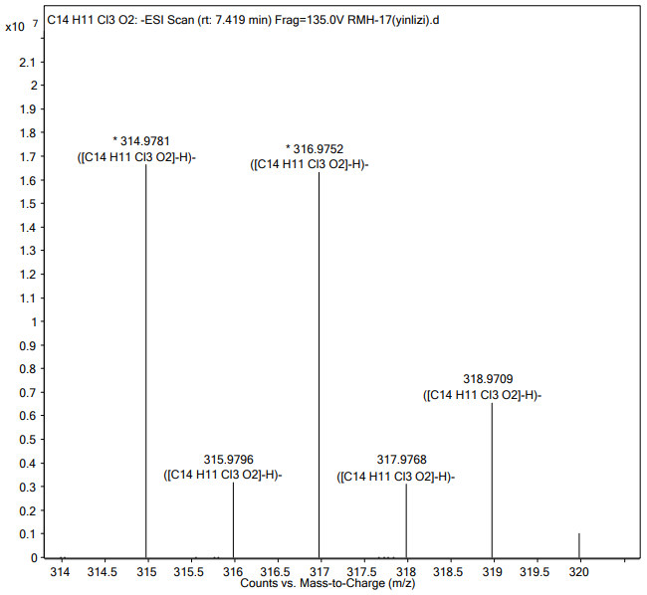

Figure S36. UV Spectrum of Compound 4
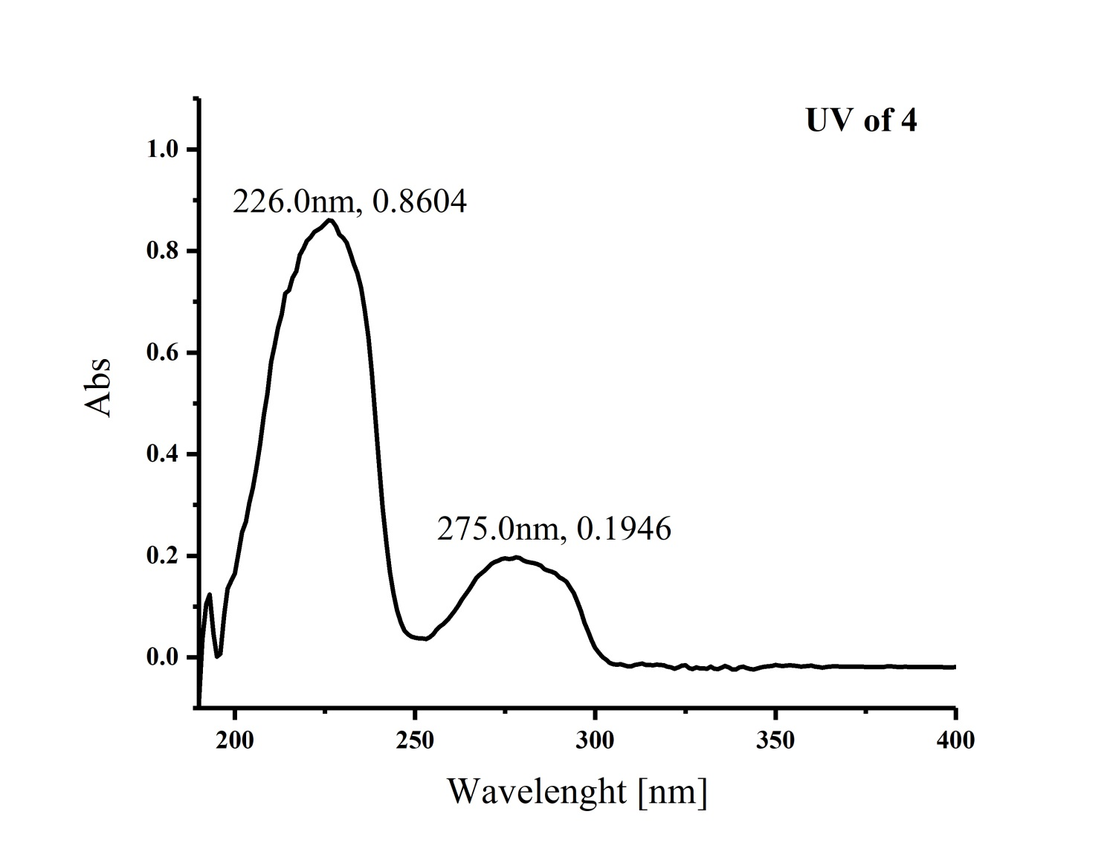

Figure S37. IR (KBr disc) Spectrum of Compound 4
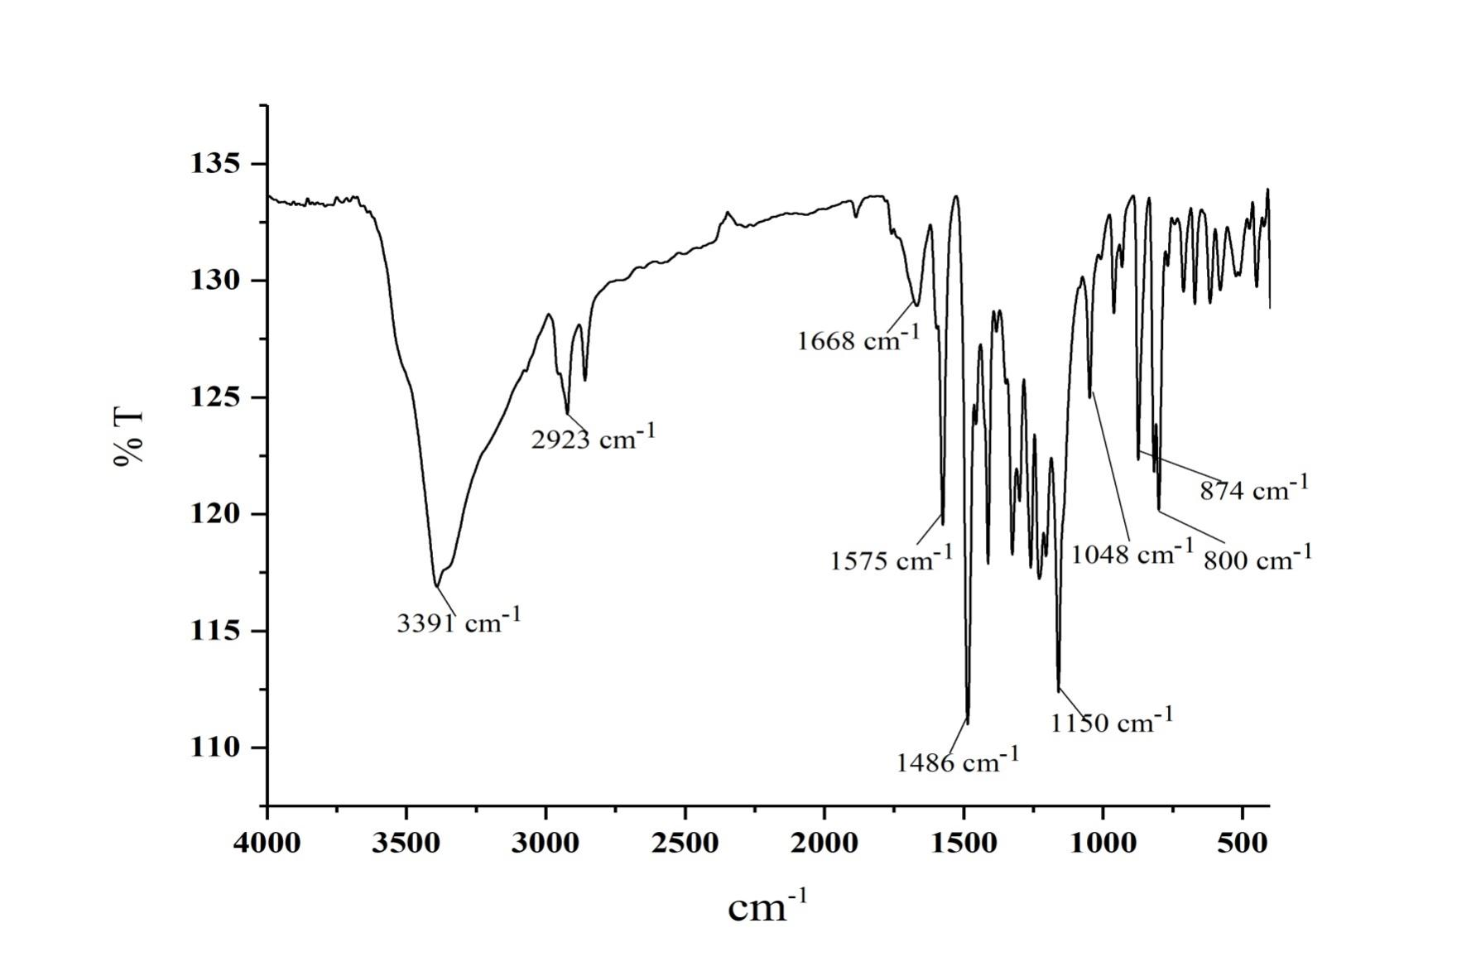
Figure S38. ¹H NMR Spectrum of Compound 5 CDCl₃
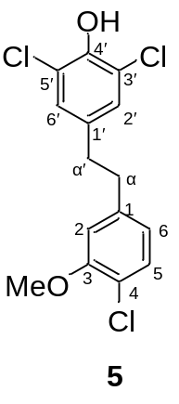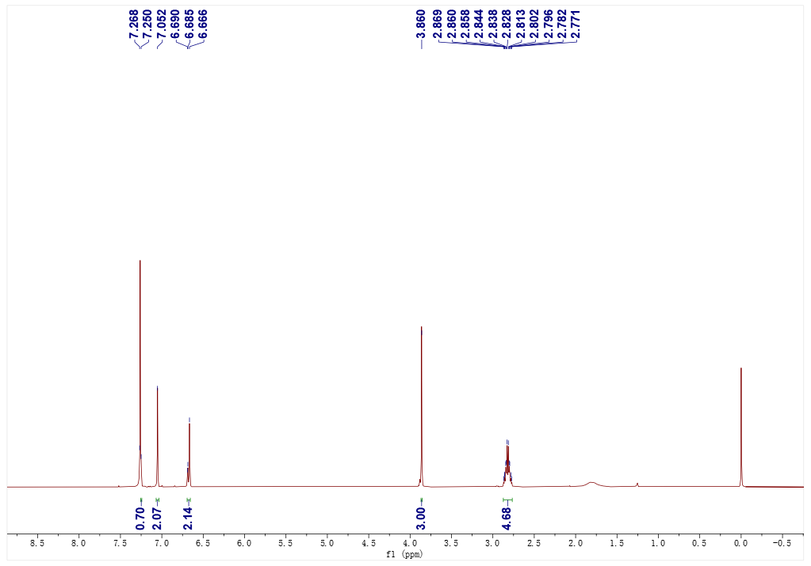

Figure S39. ¹³C NMR Spectrum of Compound 5 in CDCl₃
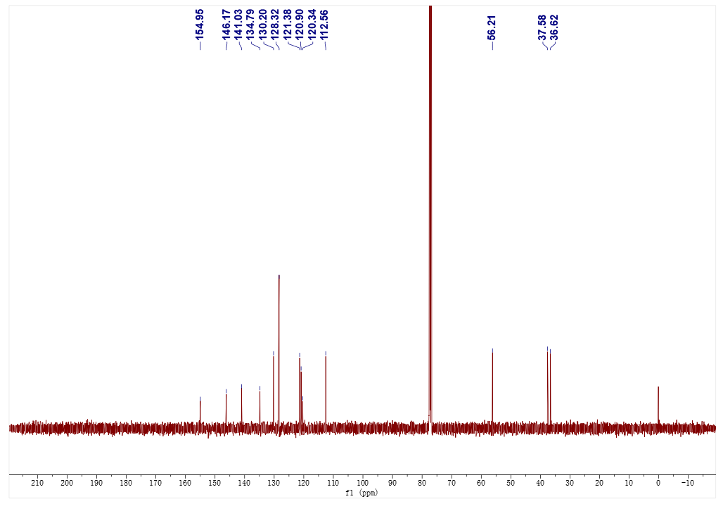

Figure S40. ¹H-¹H COSY Spectrum of Compound 5 in CDCl₃
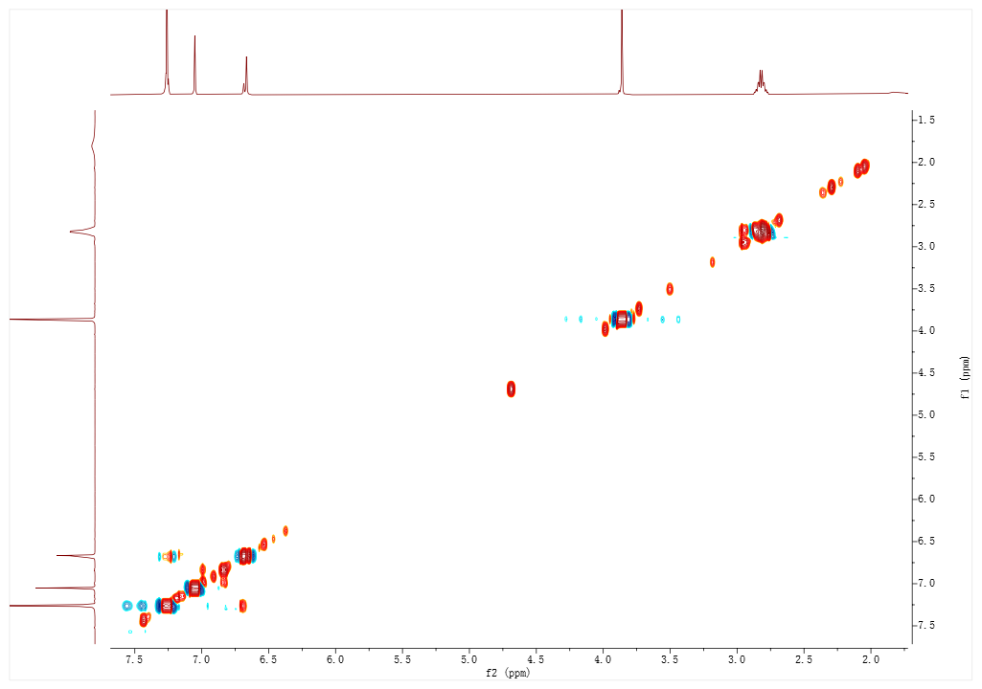

Figure S41. HSQC Spectrum of Compound 5 in CDCl₃
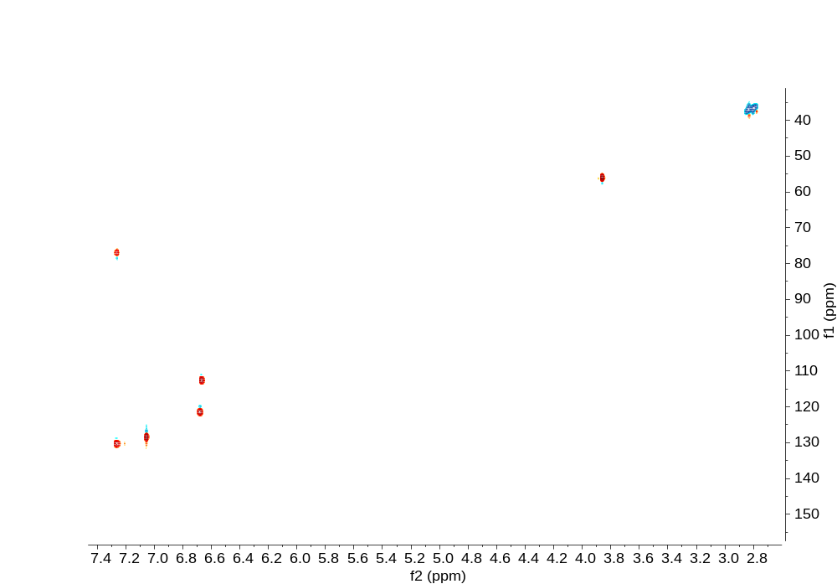

Figure S42. HMBC Spectrum of Compound 5 in CDCl₃
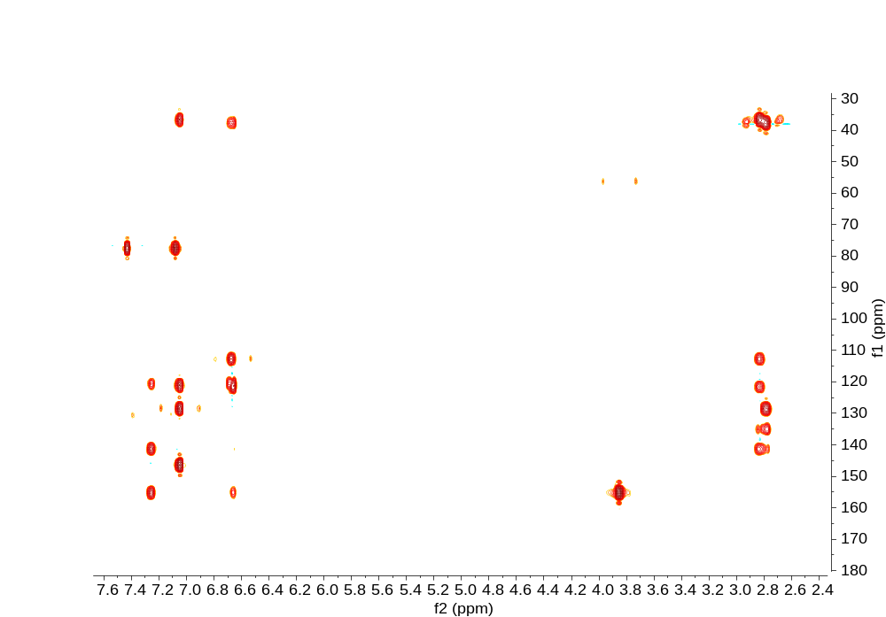

Figure S43. (-) Total HRESIMS Spectrum of Compound 5
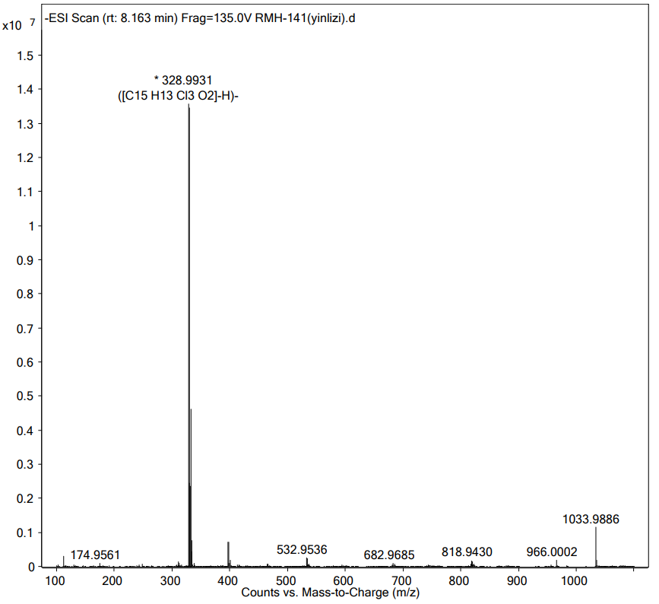

Figure S44. (-) Partial HRESIMS Spectrum of Compound 5
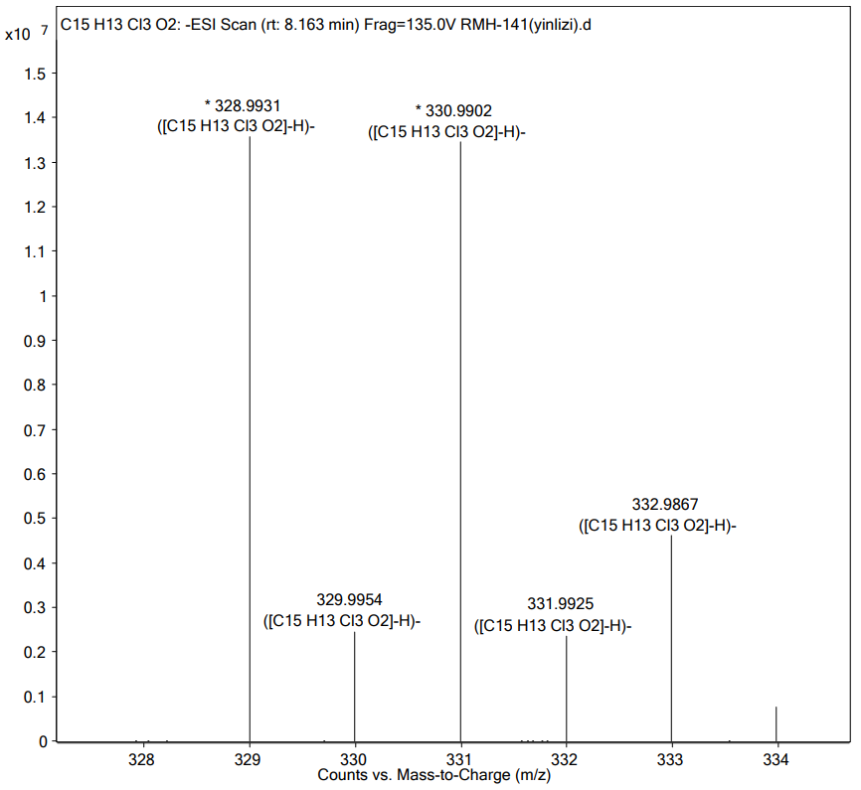

Figure S45. UV Spectrum of Compound 5
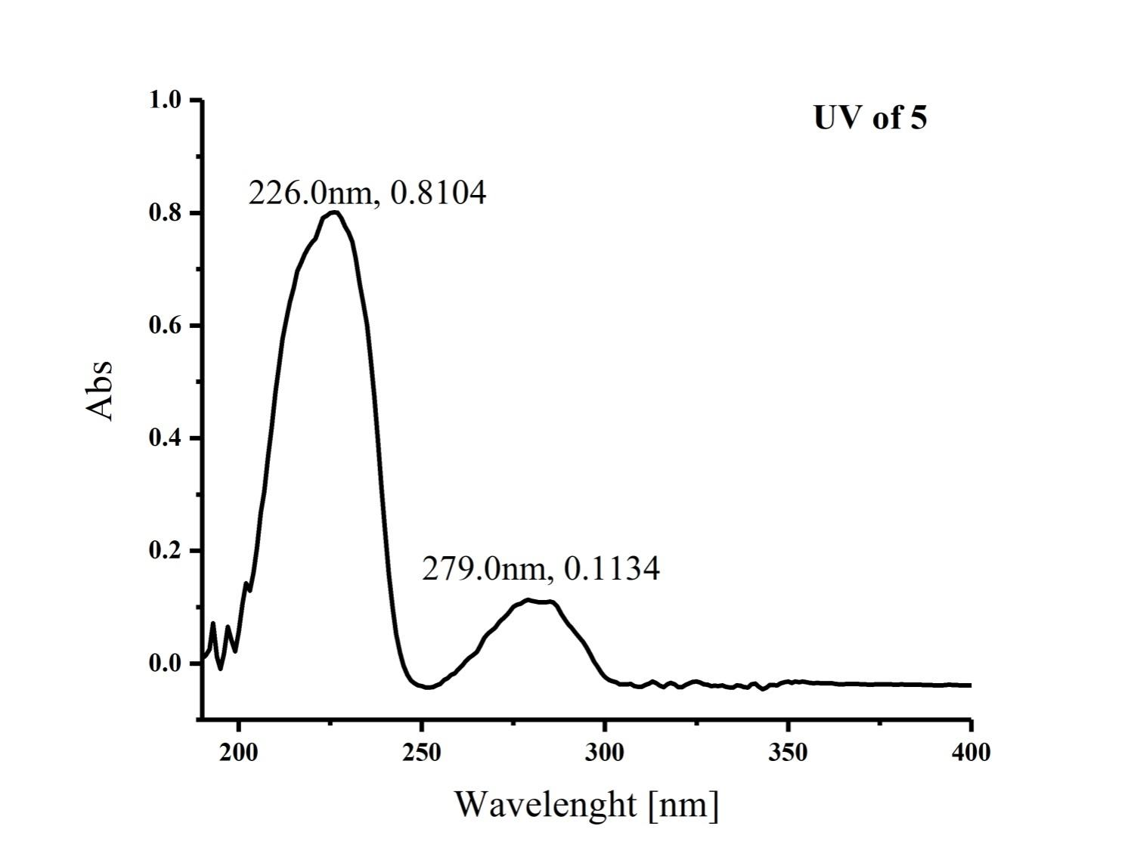

Figure S46. IR (KBr disc) Spectrum of Compound 5
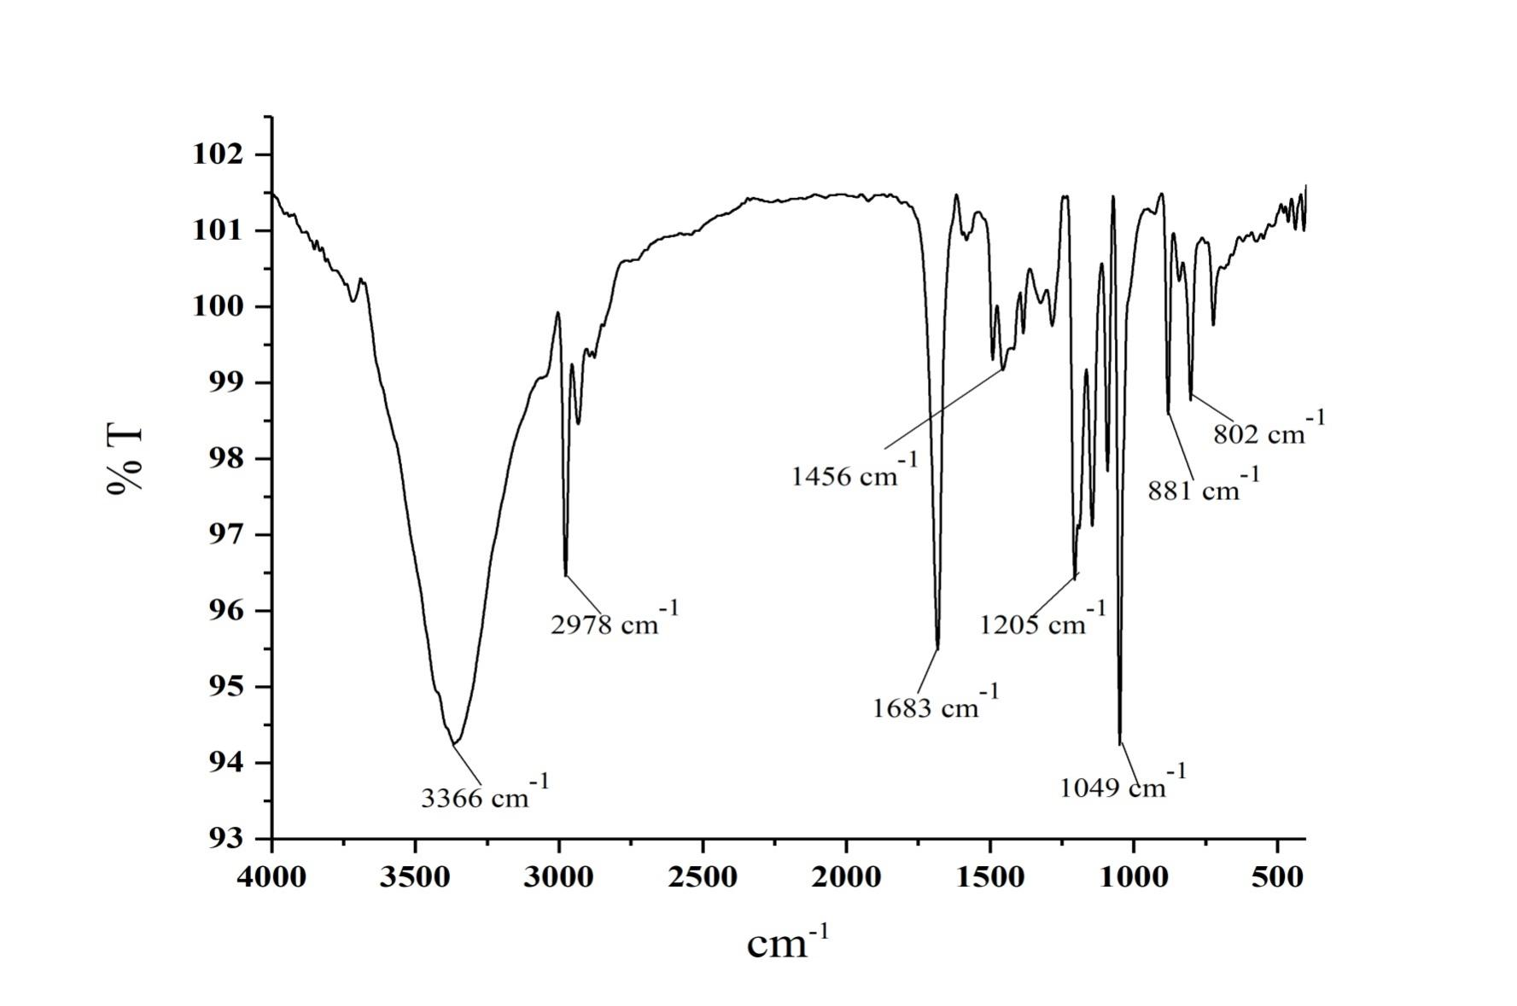
Figure S47. ¹H NMR Spectrum of Compound 6 in CDCl₃
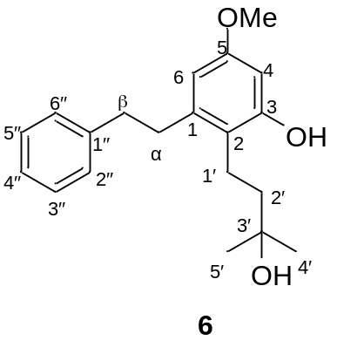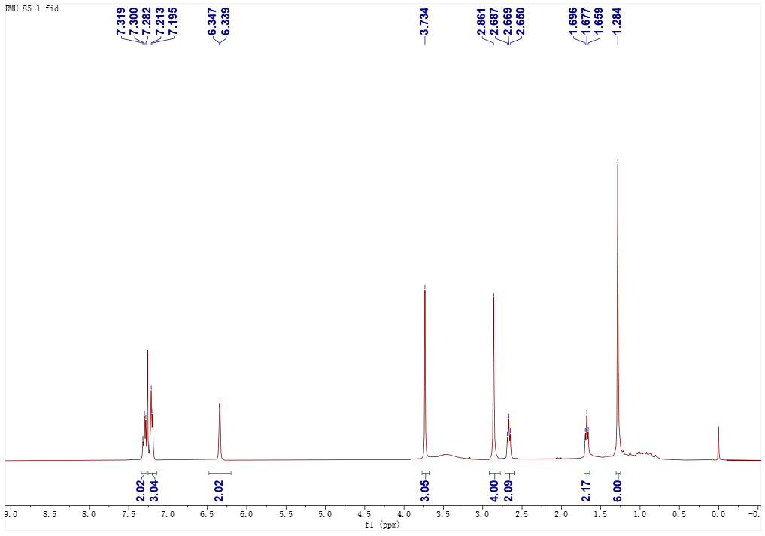

Figure S48. ¹³C NMR Spectrum of Compound 6 in CDCl₃
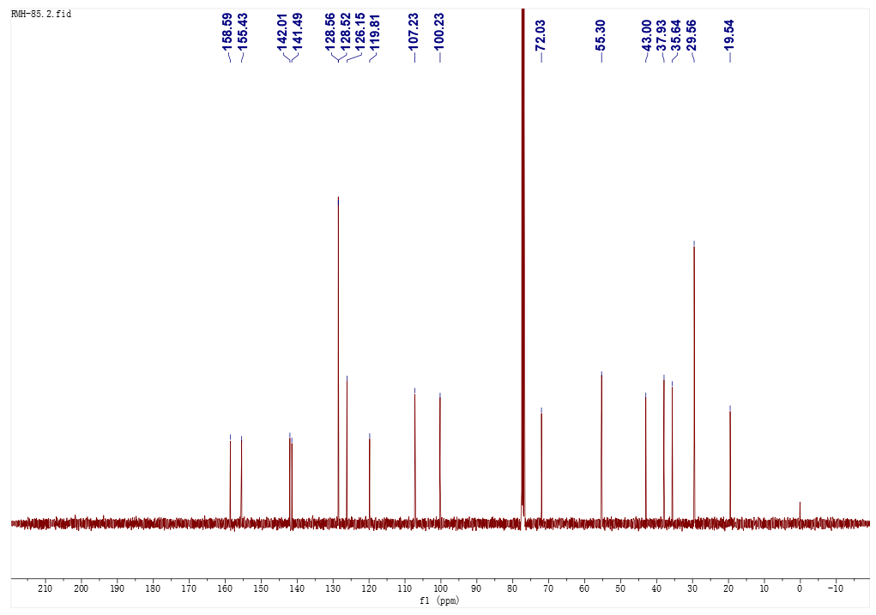

Figure S49. (+) HRESIMS Spectrum of Compound 6
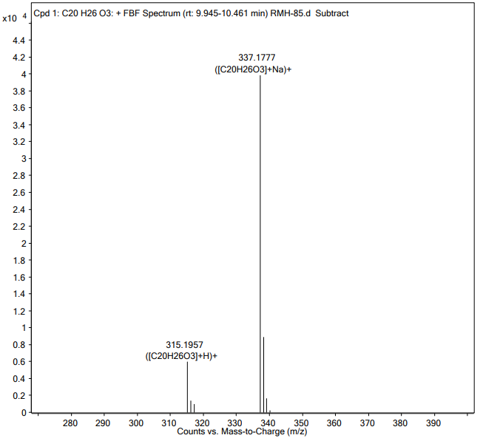

Figure S50. ¹H NMR Spectrum of Compound 7 in CDCl₃
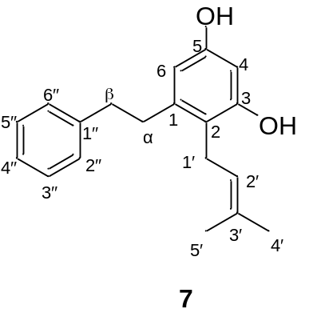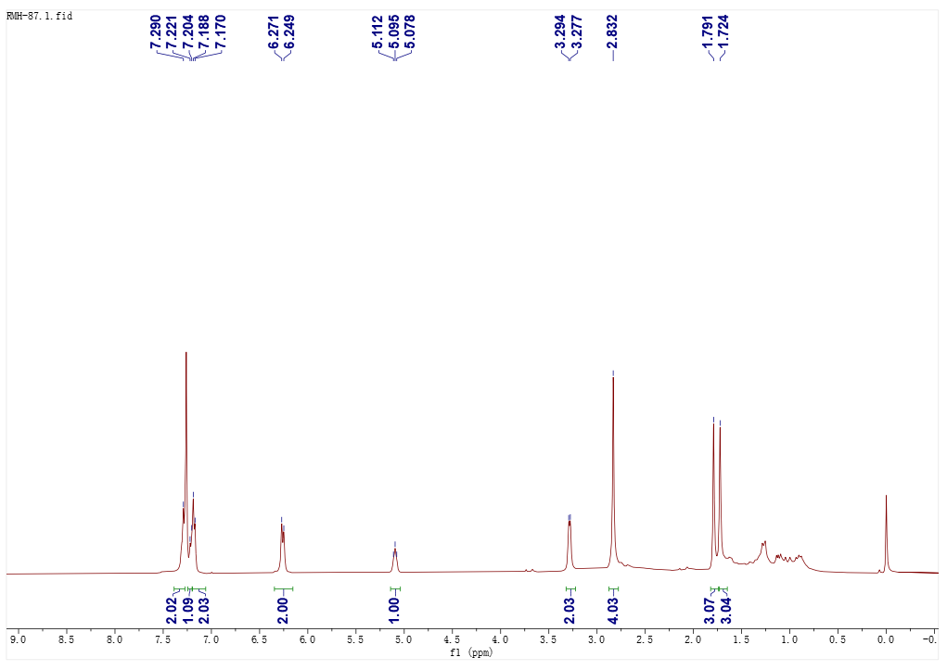
Figure S51. ¹³C NMR Spectrum of Compound 7 in CDCl₃
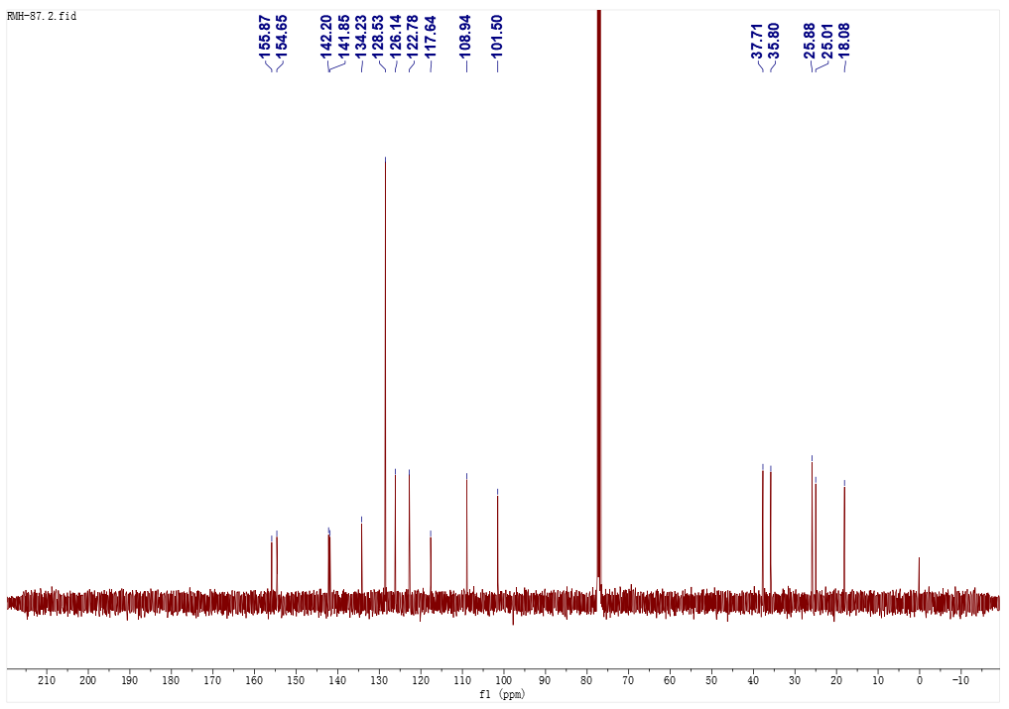

Figure S52. (+) HRESIMS Spectrum of Compound 7
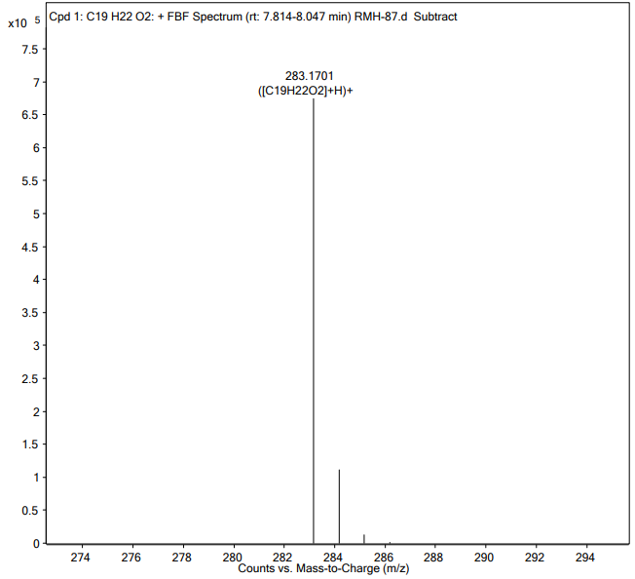

Figure S53. ¹H NMR Spectrum of Compound 8 in MeOH-d₄
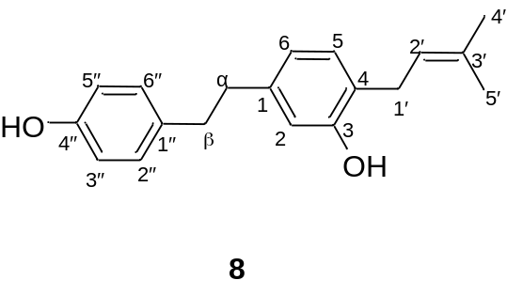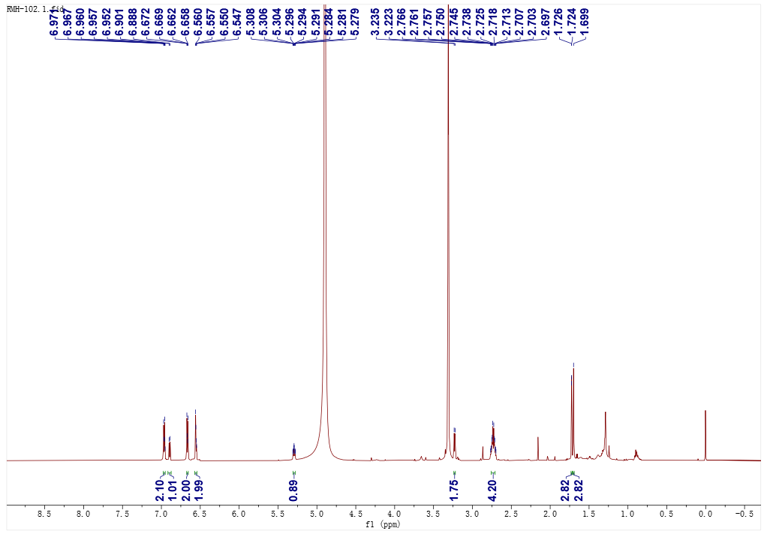
Figure S54. ¹³C NMR Spectrum of Compound 8 in MeOH-d₄
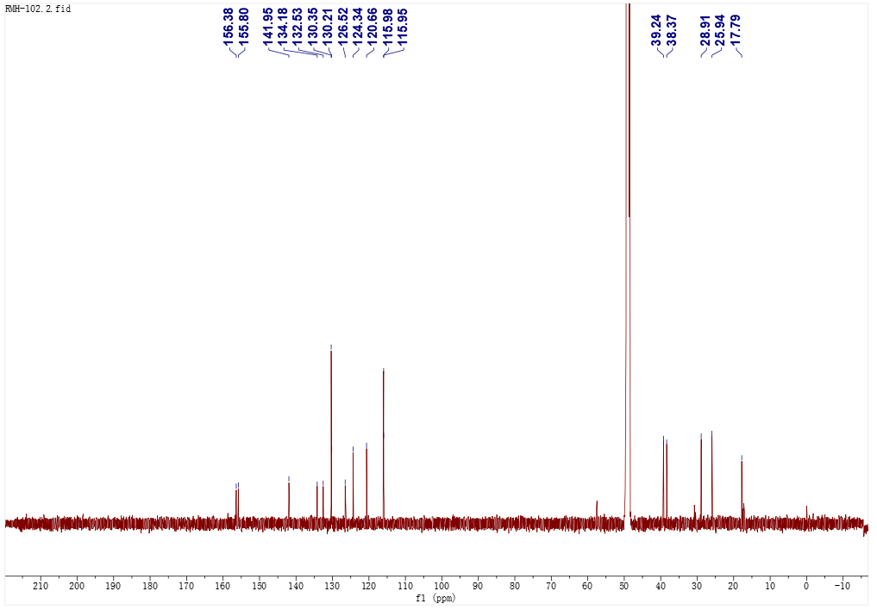

Figure S55. ¹H-¹H COSY Spectrum of Compound 8 in MeOH-d₄

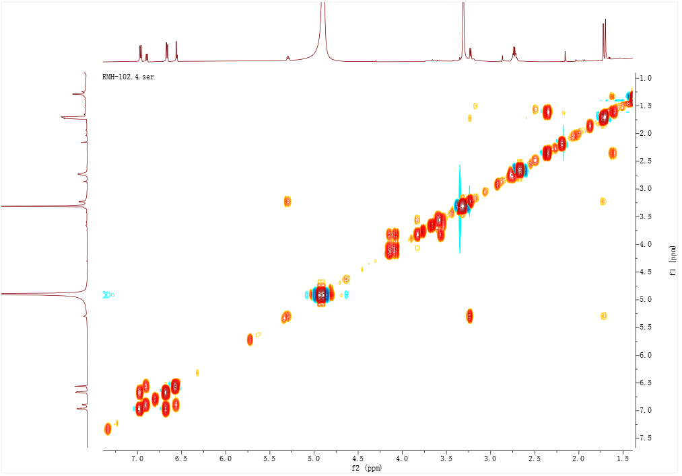
Figure S56. HSQC Spectrum of Compound 8 in MeOH-d₄
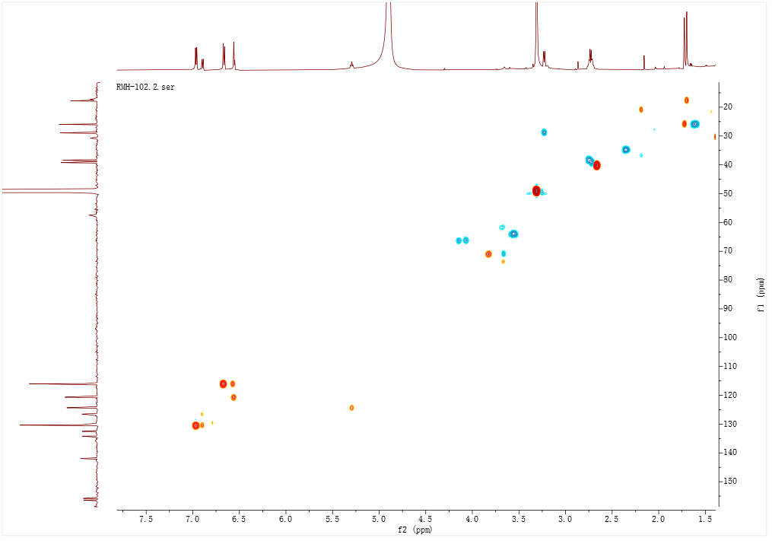

Figure S57. HMBC Spectrum of Compound 8 in MeOH-d₄

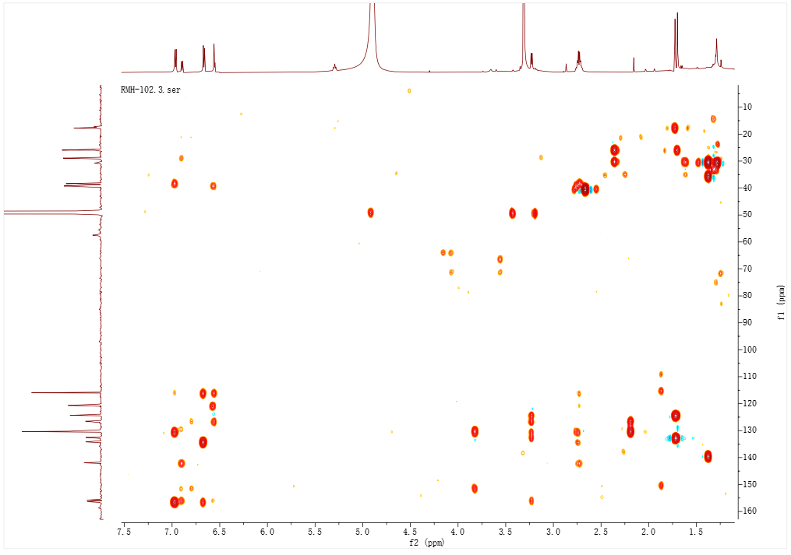
Figure S58. (+) HRESIMS Spectrum of Compound 8
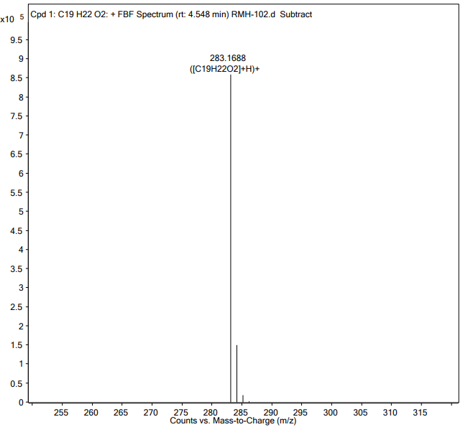

Table S3.¹H and ¹³C NMR Data of Compound 8
No | δ_{H}, mult. (J) | δ_{C}, type
1 |  | 142.0, s
2 | 6.56, m^{b} | 116.0, d
3 |  | 155.8, s
4 |  | 126.5, s
5 | 6.89, d (7.8) | 130.2, d
6 | 6.55, m^{b} | 120.7, d
1′ | 3.23, d (7.2) | 28.9, t
2′ | 5.29, m | 124.3, d
3′ |  | 132.6, s
4′ | 1.72, s | 25.9, q
5′ | 1.70, s | 17.8, q
α | 2.74, m^{b} | 39.2, t
β | 2.74, m^{b} | 38.4, t
1′′ |  | 134.2, s
2′′ | 6.96, m | 130.4, d
3′′ | 6.66, m | 116.0, d
4′′ |  | 156.4, s
5′′ | 6.66, m | 116.0, d
6′′ | 6.96, m | 130.4, d
^{b}Overlapped signals are reported without designating multiplicity.