Electronic Supplementary Material
Chemically engineered essential oils prepared through thiocyanation under solvent-free conditions: chemical and bioactivity alteration
Liz E. Lescano,ª Mario O. Salazar ^{a,b} * and Ricardo L. E. Furlan ^{a,b}
ª Farmacognosia, Facultad de Ciencias Bioquímicas y Farmacéuticas, Universidad Nacional de Rosario (UNR), Suipacha 531, 2000 Rosario, Argentina
^{b} Consejo Nacional de Investigaciones Científicas y Técnicas (CONICET)
E-mail address: msalazar@fbioyf.unr.edu.ar (M.O. Salazar).

Contents
Fig. S1: GC-MS traces of F0.2A......................................................................................................S2
Fig. S2: GC-MS traces of F0.2B......................................................................................................S2
Fig. S3: GC-MS traces of F0.4A......................................................................................................S3
Fig. S4: GC-MS traces of F0.4B......................................................................................................S3
Table 1: Comparing the AChE inhibition properties of each CEEO/EO pair.........................................S4
Fig. S5: GC-MS traces of a) carvacrol, b) EO of OV and c) CEEO of OV.......................................S4
Mass spectrum of compounds 1 to 4...................................................................................................S5
¹H NMR (300 MHz) of compounds 1 to 4...........................................................................................S6
¹³C NMR (300 MHz) of compounds 1 to 4..........................................................................................S8
Plots of % of inhibition of AChE versus log [I] of compounds 1-4 .....................................................S9

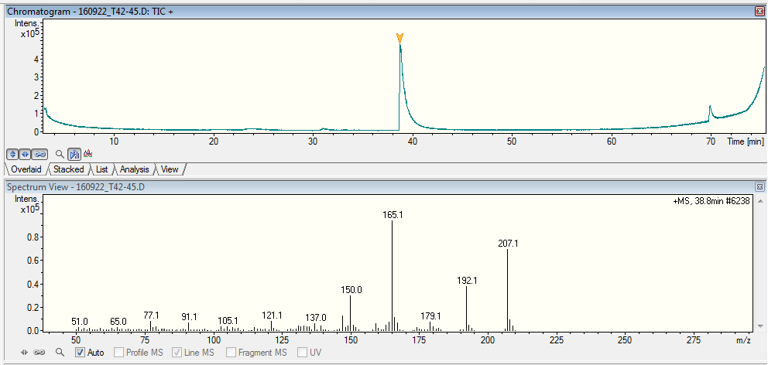
Fig. S1: Representative GC- MS traces of F0.2A (up) and mass spectrum of compound at rt 38.8 min (down).
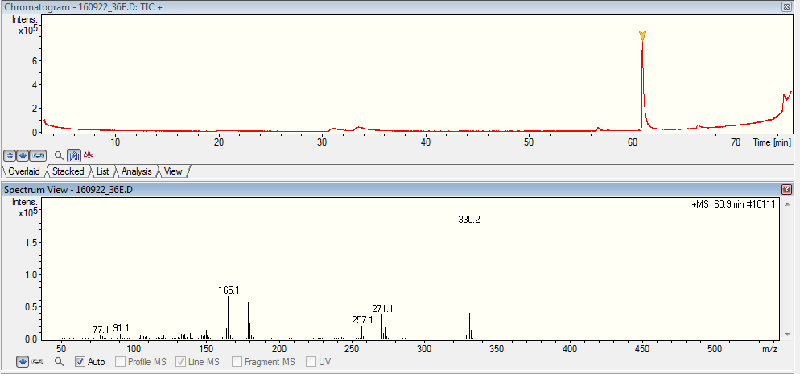
Fig. S2: Representative GC- MS traces of F0.2B (up) and mass spectrum of compound at rt 60.9 min (down).
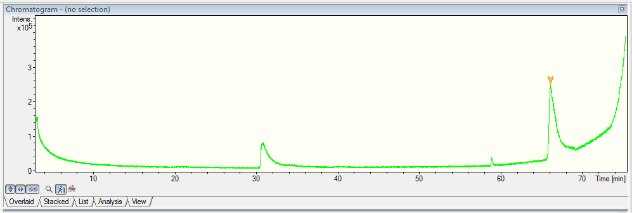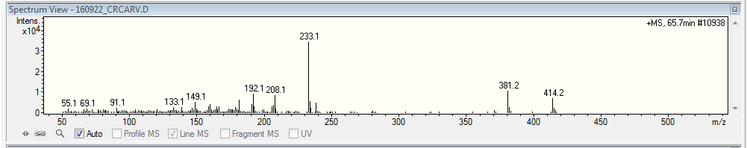
Fig. S3: Representative GC- MS traces of F0.4A (up) and mass spectrum of compound at rt 65.7 min (down).
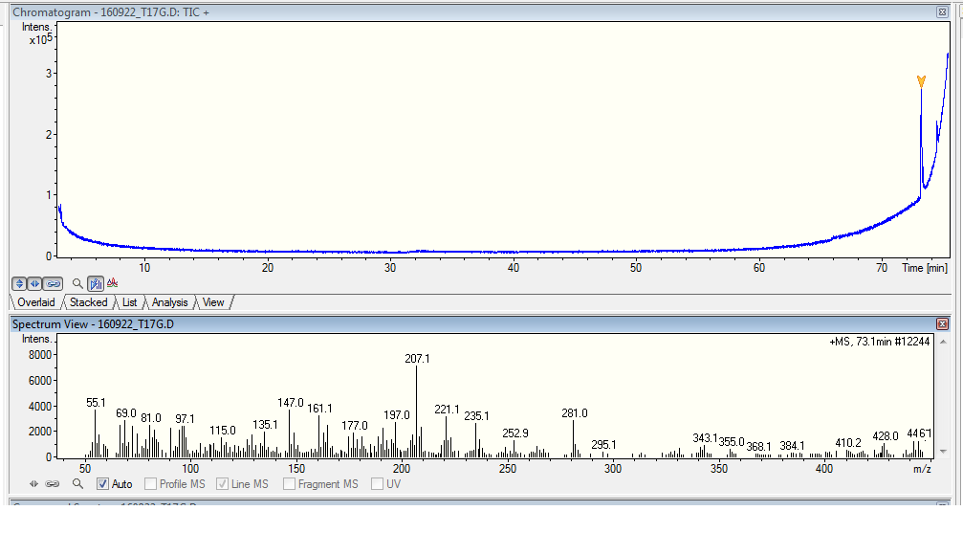
Fig. S4: Representative GC- MS traces of F0.4B (up) and mass spectrum of compound at rt 73.1 min (down).

Table S1. Comparing the AChE inhibition properties of each CEEO/EO pair.
 | Inhibition halos
Samples | EOs | CEEOs | New | Total
Pimenta racemosa (Mill.) J.W.Moore. | 0 | 0 | 0 | 0
Thuya occidentalis L. | 0 | 2 | 2 | 2
Coriandrum sativum L. | 2 | 1 | 0 | 2
Foeniculum vulgare Mill | 0 | 0 | 0 | 0
Lavandula angustifolia Mill. | 0 | 1 | 1 | 1
Cymbopogom citratus (DC.) Stapf | 0 | 0 | 0 | 1
Litsea cubeba (Lour.) Pers. | 0 | 0 | 0 | 1
Menta arvensis L. | 1 | 2 | 1 | 2
Origanum vulgare L. | 0 | 2 | 2 | 2
Pogostemon cablin Benth. | 2 | 0 | 0 | 2
Salvia officinalis L. | 0 | 2 | 2 | 2

Fig. S5: GC-MS traces of a) carvacrol, b) EO of OV and c) CEEO of OV.

Mass spectrum

Compound 1 | Compound 2
Compound 3 | Compound 4

¹ H NMR (300 MHz) of compounds 1 to 4

Compound 1
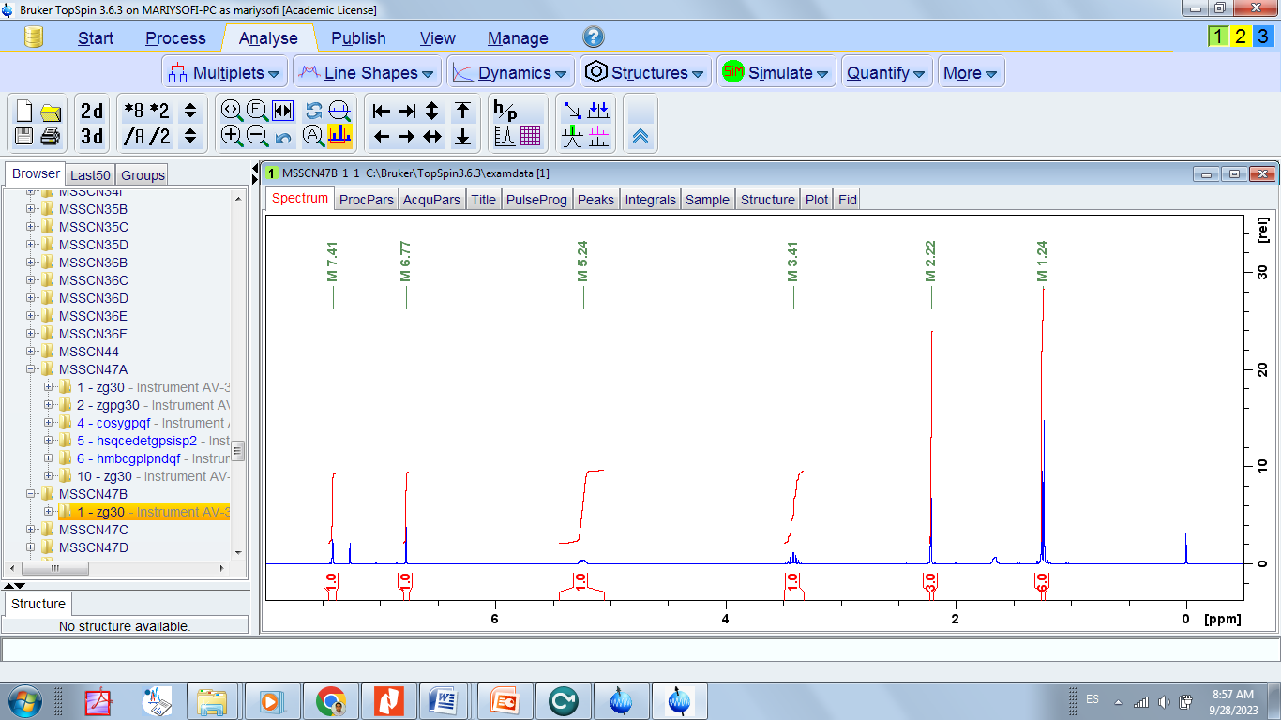
Compound 2
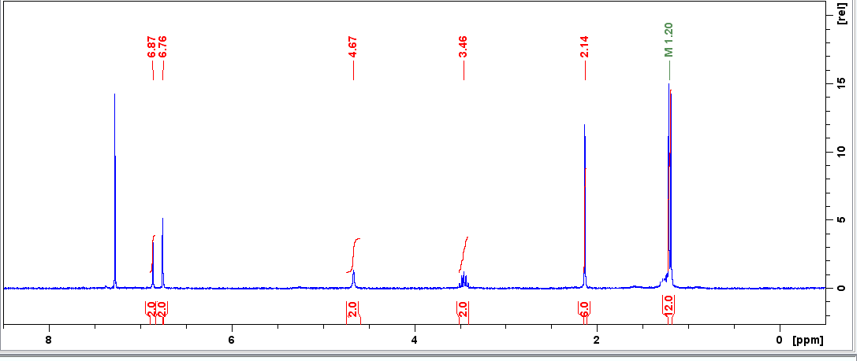

Compound 3
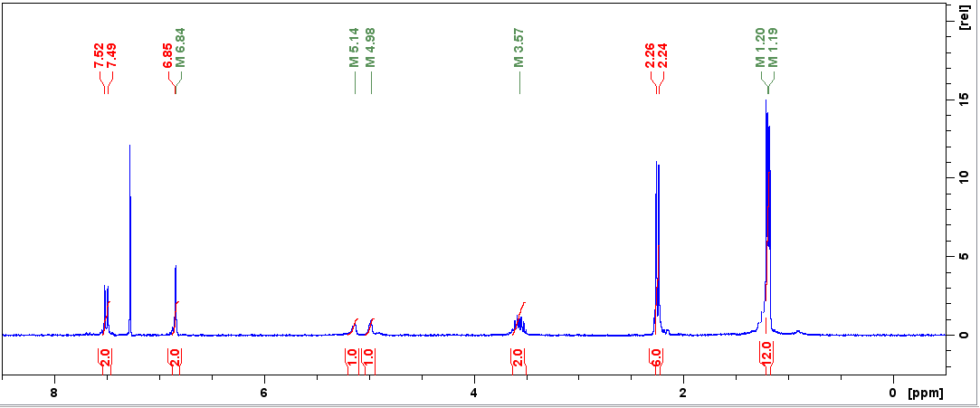

Compound 4
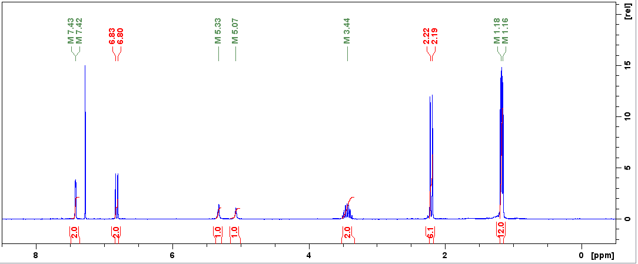

¹ ³C NMR(75 MHz) of compounds 1 to 4

Compound 1
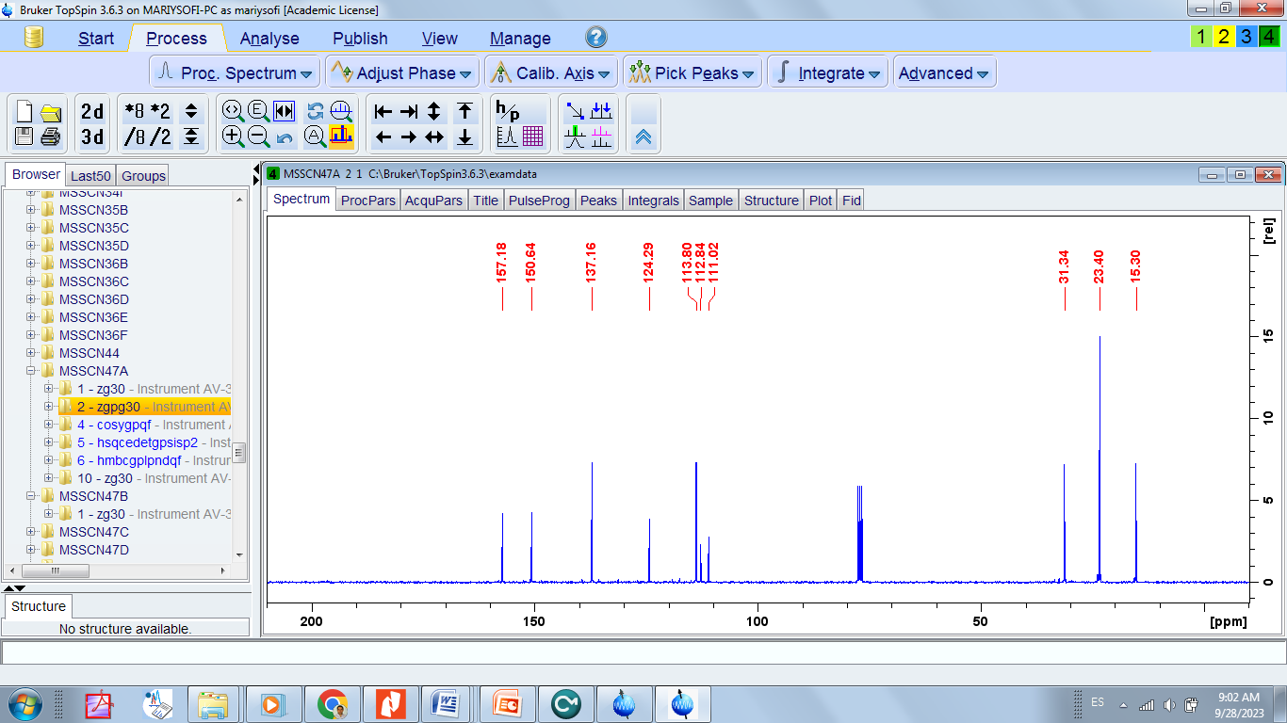
Compound 2
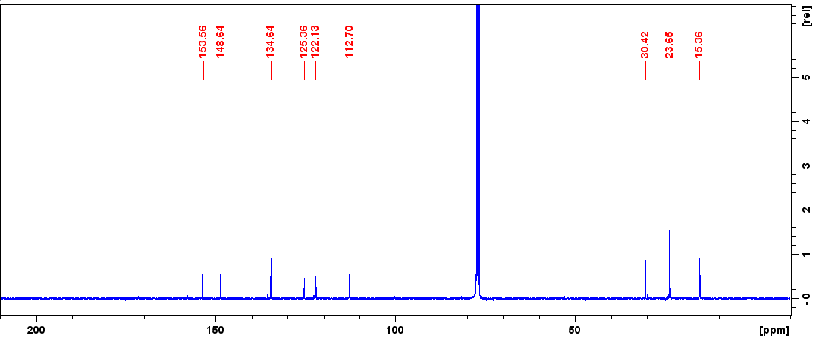

Compound 3
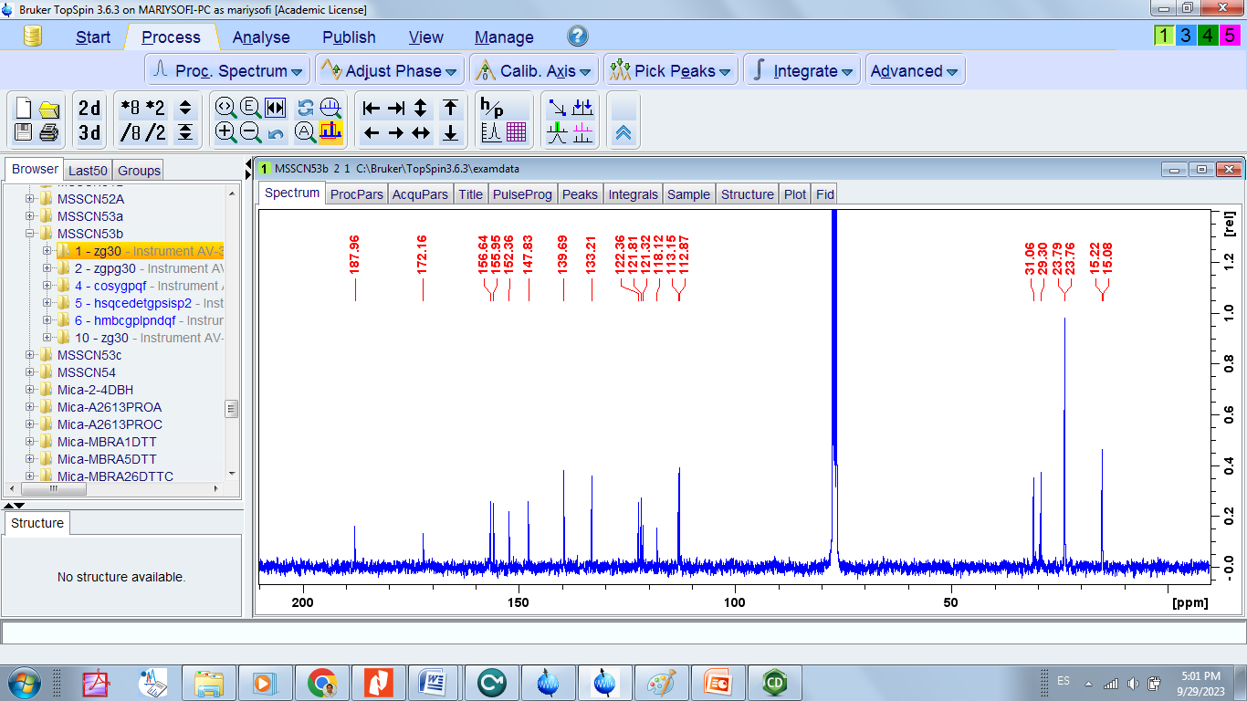
Compound 4
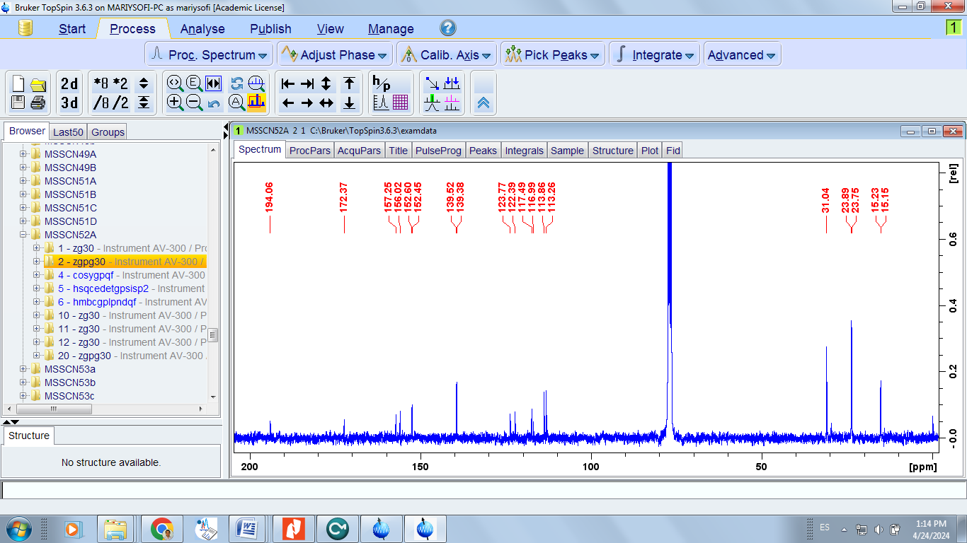

Plots of % of inhibition of AChE versus log [I] of compounds 1 to 4

Compound 1
Compound 2

Compound 3
Compound 4

