Supplementary Material
Silvaticusins A–D: ent-kaurane diterpenoids and a cyclobutane-containing ent-kaurane dimer from Isodon silvaticus
Qi-Xiu Hai^{1,2}, Kun Hu², Su-Ping Chen², Yang-Yang Fu², Xiao-Nian Li², Han-Dong Sun², Hong-Ping He^{1,*}, Pema-Tenzin Puno^{2,*}
¹College of Chinese Materia Medica and Yunnan Key Laboratory of Southern Medicinal Utilization, Yunnan University of Chinese Medicine, Kunming 650500, People’s Republic of China
²Key Laboratory of Phytochemistry and Natural Medicines, Kunming Institute of Botany, Chinese Academy of Sciences, Kunming 650201, People’s Republic of China

*Correspondence:
Hong-Ping He
95431111@qq.com
Pema-Tenzin Puno
punopematenzin@mail.kib.ac.cn

Contents of Supplementary Material

1. General experimental procedures 1
2. Plant material 1
3. Extraction and isolation 1
4. X-ray crystal structure analysis 2
5. NMR, MS, UV, ECD, IR spectra, and OR of silvaticusin A (1) 3
6. NMR, MS, UV, ECD, IR spectra, and OR of silvaticusin B (2) 9
7. NMR, MS, UV, ECD spectra, and OR of silvaticusin C (3) 15
8. NMR, MS, UV, ECD spectra, and OR of silvaticusin D (4) 21
9. Computational data of silvaticusin D (4) 27
10. Information of known compounds 54

- General experimental procedures
Melting points were obtained on an XRC-1 apparatus and are uncorrected; Optical rotations were measured in MeOH with Horiba SEPA-300 and JASCO P-1020 polarimeters. UV spectra were obtained on a Shimadzu UV-2401A UV spectrometer; IR spectra were obtained on a Tenor27 infrared spectrometer. ESIMS and HRESIM were measured using an API-QSTAR-TOF mass spectrometer; NMR spectra were recorded on Bruker DRX-500, DRX-600, and DRX-800 spectrometers using TMS as the internal standard. All chemical shifts (δ) are expressed in ppm relative to the solvent signals; X-ray diffraction data were collected utilizing a Bruker APEX DUO instrument; The analytical and semi preparative HPLC were Agilent 1100, 1200 and 1260 HPLC, with a Zorbax SB-C18 column (Agilent, 4.6 mm x 250 mm, 1 mL/min; 9.4 mm x 250 mm, 3 mL/min) and a diode array detector (DAD) as the detector; The preparative HPLC is Agilent 1260 HPLC, with a Zorbax SB-C18 (21.2 mm x 250 mm) column. The normal phase silica gel plate for thin-layer chromatography, silica gel for sample mixing, and silica gel for column chromatography are all produced by Qingdao Marine Chemical, Inc.; The solvents used include petroleum ether, chloroform, acetone, ethyl acetate, and methanol, all of which are industrial grade solvents and are used after redistillation; Lichoprep RP-18 (40-63 um) is produced by Merk Company; MCI (75-150 um) is produced by Mitsubishi Chemical Company in Japan; Thin-layer chromatography was performed on precoated TLC plates (200−250 μm thickness, silica gel 60 F254, Qingdao Marine Chemical, Inc.), and spots were visualized by UV light (254 nm) or by spraying heated silica gel plates with 10% H₂SO₄ in ethanol.

- Plant material
The aerial parts of Isodon silvaticus were collected in the Changdu of the Tibetan Autonomous Region, People’s Republic of China, in August 2020 and identified by Prof. Chun-Lei Xiang at the Kunming Institute of Botany. A specimen (KIB 2020081713) has been deposited in in our laboratory.

- Extraction and isolation
The aerial parts of I. silvaticus (13.5 kg) were extracted with 70% aqueous acetone three times (for three days each time) at room temperature and filtered. The filtrate was concentrated under reduced pressure to a volume of 5 L and then partitioned between ethyl acetate and n-butanol. The ethyl acetate-soluble portion (750 g) was subjected to silica gel column chromatography (CC) (6.75 kg, 80~100 mesh), eluting with dichloromethane/acetone (1:0~0:1 gradient system). Seven fractions (A–E) were obtained from the silica gel column. Fraction B (chloroform/acetone, 9:1; 242 g) which was a brown gum, individually decolorized on MCI gel, after which they were eluted with methanol/water (30%, 60%, 90%, 100% and 100% acetone) to yield fractions B1–B5. Fraction B2 (161 g) was separated into six subfractions (B2-1–B2-6) using silica gel CC (petroleum ether/acetone, 10:1 to 0:1 gradient). B2-2 (2.04 g) was subjected to semipreparative HPLC (acetonitrile/water) to obtain 3 (1.6 mg). Fraction C (chloroform/acetone, 8:2; 142 g) which was a brown gum, individually decolorized on MCI gel, after which they were eluted with methanol/water (20%, 40%, 60%, 100%) to yield fractions C1–C4. Fraction C2 (48 g) was subjected to RP-18 CC (methanol/water, 25:75 to 90:10 gradient) and then semipreparative HPLC (acetonitrile/water) to yield 2 (4.2 mg), and C3 (36 g) was submitted to semipreparative HPLC (methanol/water) to obtain 1 (801.2 mg) and 4 (1.1 mg).

- X-ray crystal structure analysis
The intensity data for silvaticusin A (1) was collected at 100 K on a Bruker APEX DUO diffractometer equipped with an APEX II CCD using Cu Kα radiation. Cell refinement and data reduction were performed with Bruker SAINT. The structures were solved by direct methods using SHELXS-97, expanded using difference Fourier techniques, and refined by the program and full-matrix least-squares calculations. The non-hydrogen atoms were refined anisotropically, and hydrogen atoms were fixed at calculated positions.

- NMR, MS, UV, ECD, IR spectra, and OR of silvaticusin A (1)
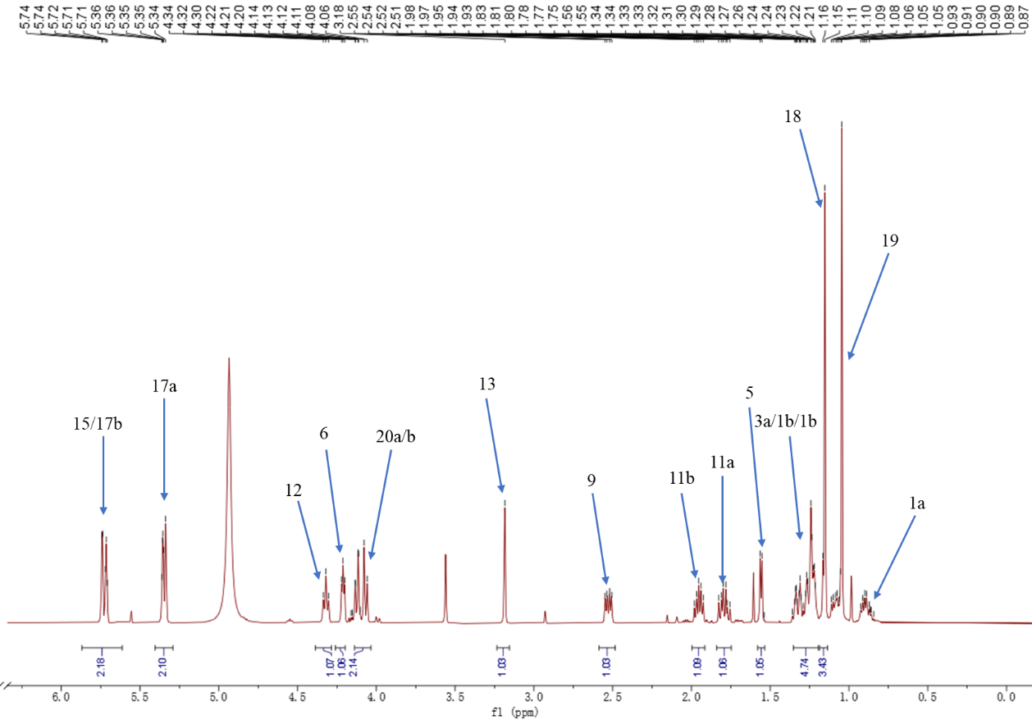
Fig. S1 ¹H NMR spectrum of silvaticusin A (1) (pyridine-d₅, 500 MHz).
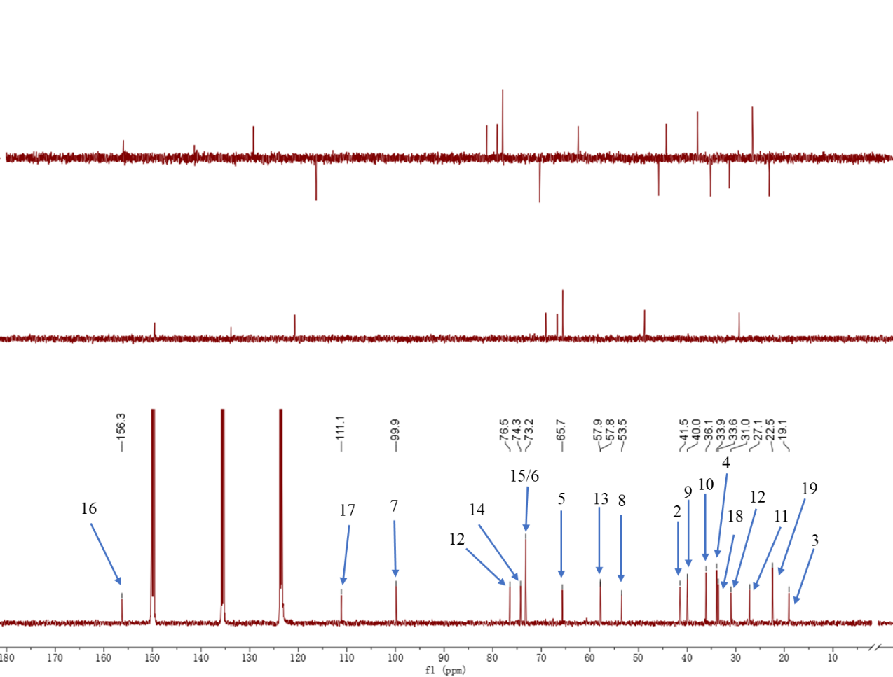
Fig. S2 ¹³C NMR spectrum of silvaticusin A (1) (pyridine-d₅, 125 MHz).
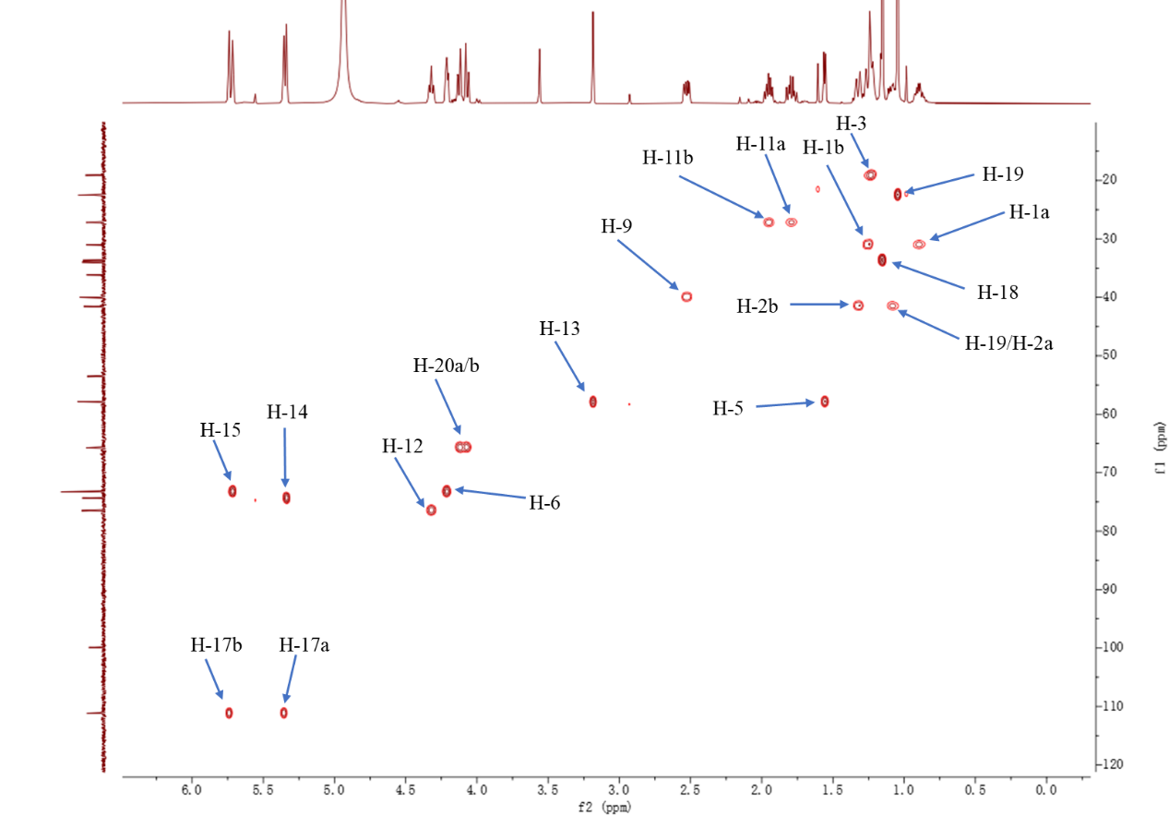
Fig. S3 HSQC spectrum of silvaticusin A (1) (pyridine-d₅, 500 MHz).
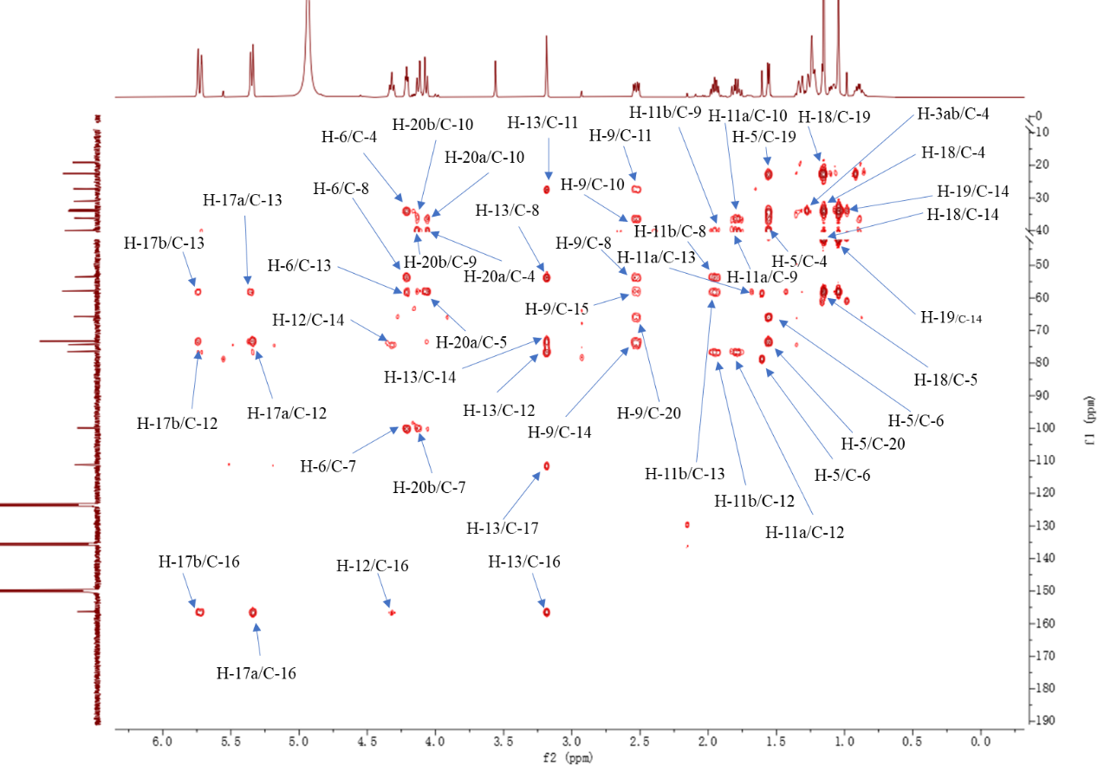
Fig. S4 HMBC spectrum of silvaticusin A (1) (pyridine-d₅, 500 MHz).
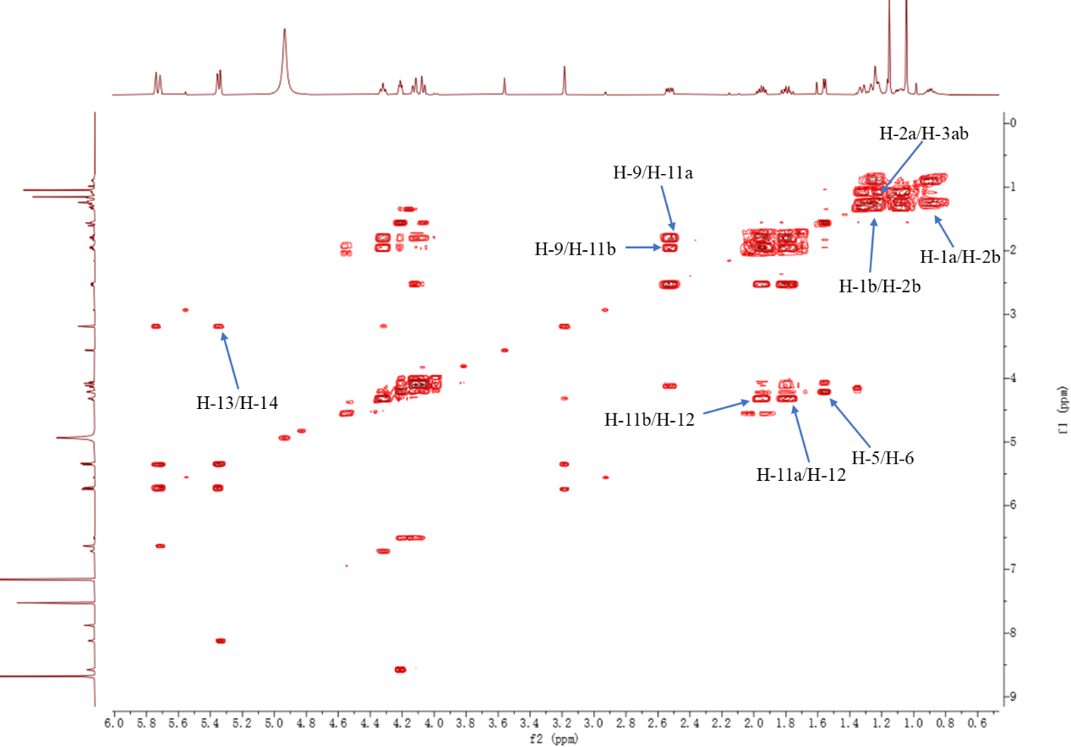
Fig. S5 ¹H–¹H COSY spectrum of silvaticusin A (1) (pyridine-d₅, 500 MHz).
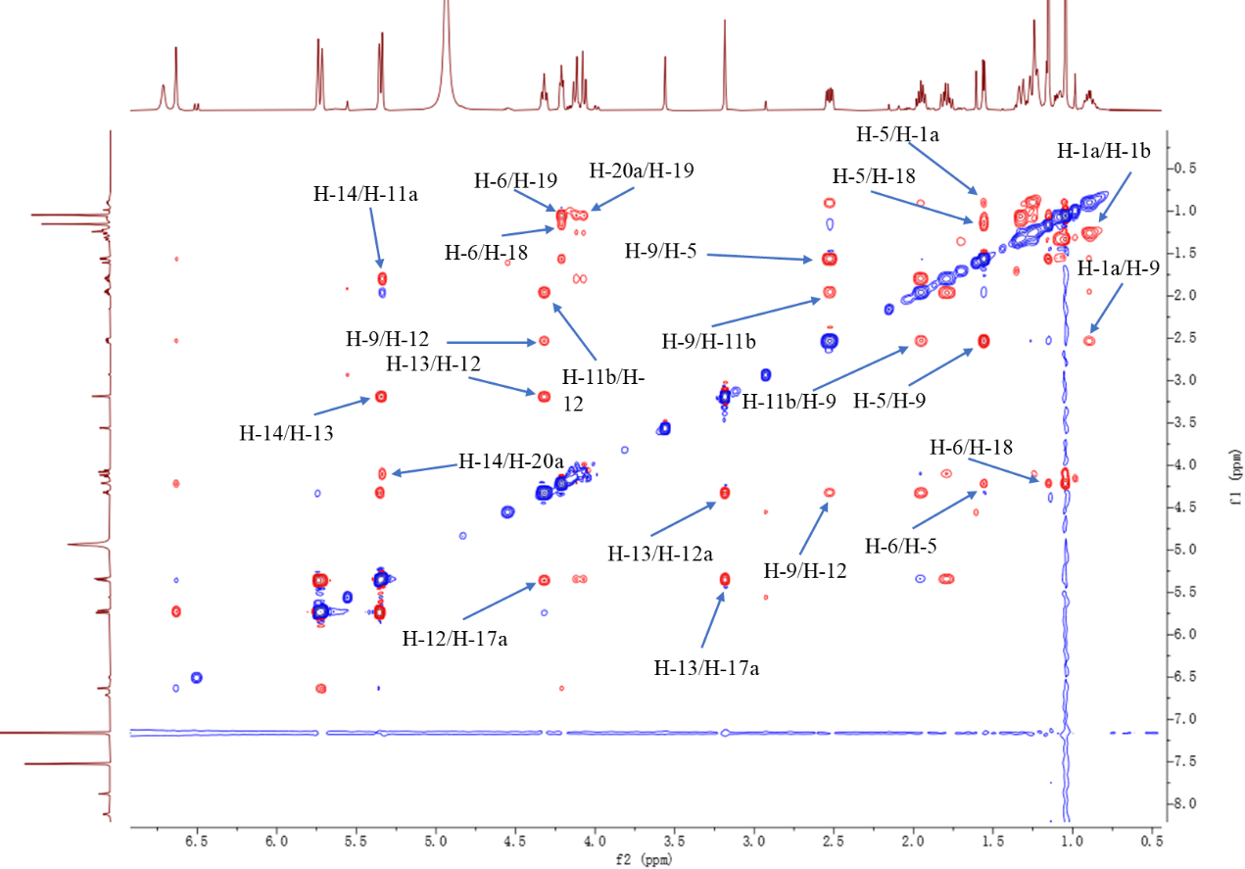
Fig. S6 ROESY spectrum of silvaticusin A (1) (pyridine-d₅, 500 MHz).
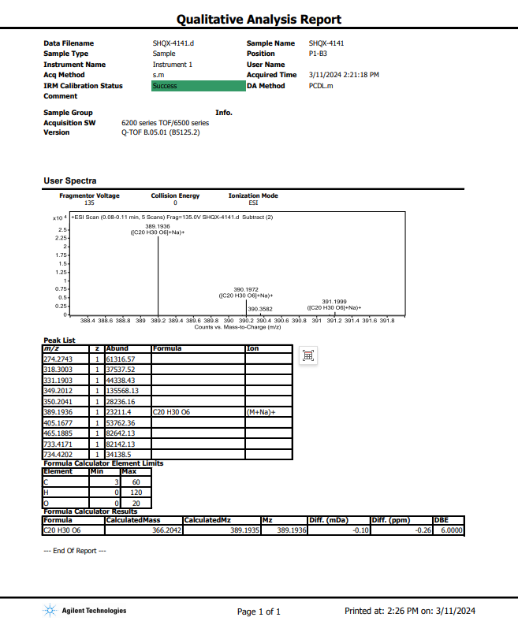
Fig. S7 HRESIMS spectrum of silvaticusin A (1).

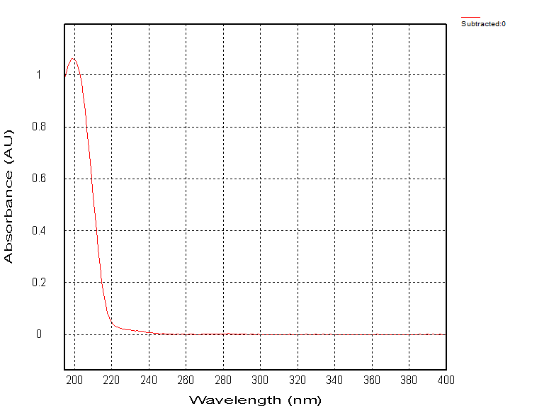
Fig. S8 UV spectrum of silvaticusin A (1).
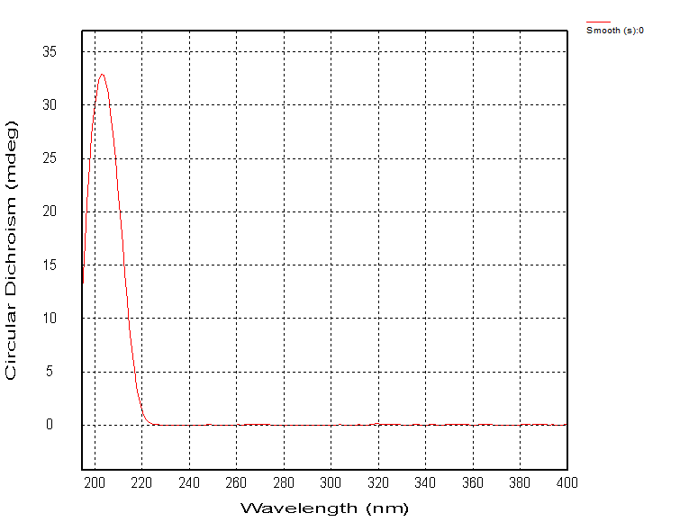
Fig. S9 ECD spectrum of silvaticusin A (1).
Fig. S10 IR spectrum of silvaticusin A (1).
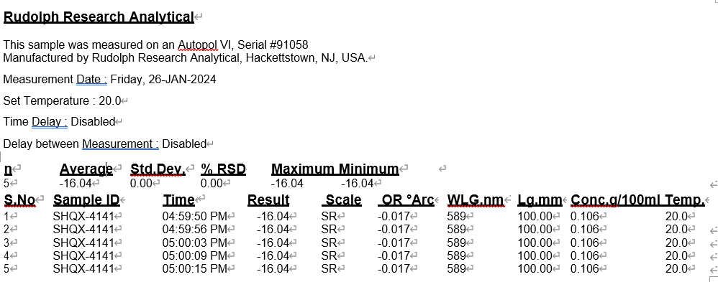
Fig. S11 OR of silvaticusin A (1).
- NMR, MS, UV, ECD, IR spectra, and OR of silvaticusin B (2)
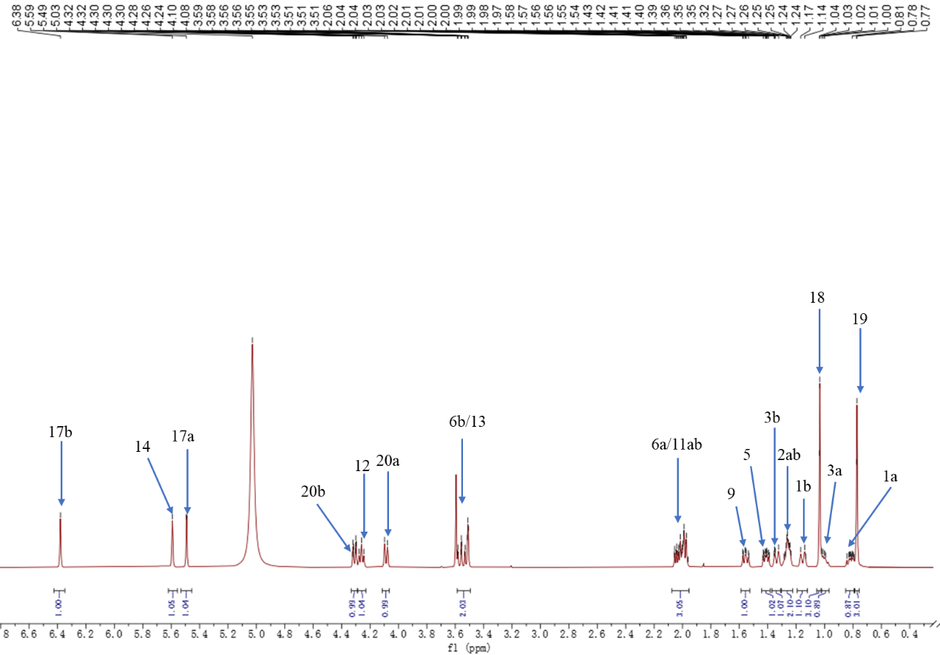
Fig. S12 ¹H NMR spectrum of silvaticusin B (2) (pyridine-d₅, 500 MHz).
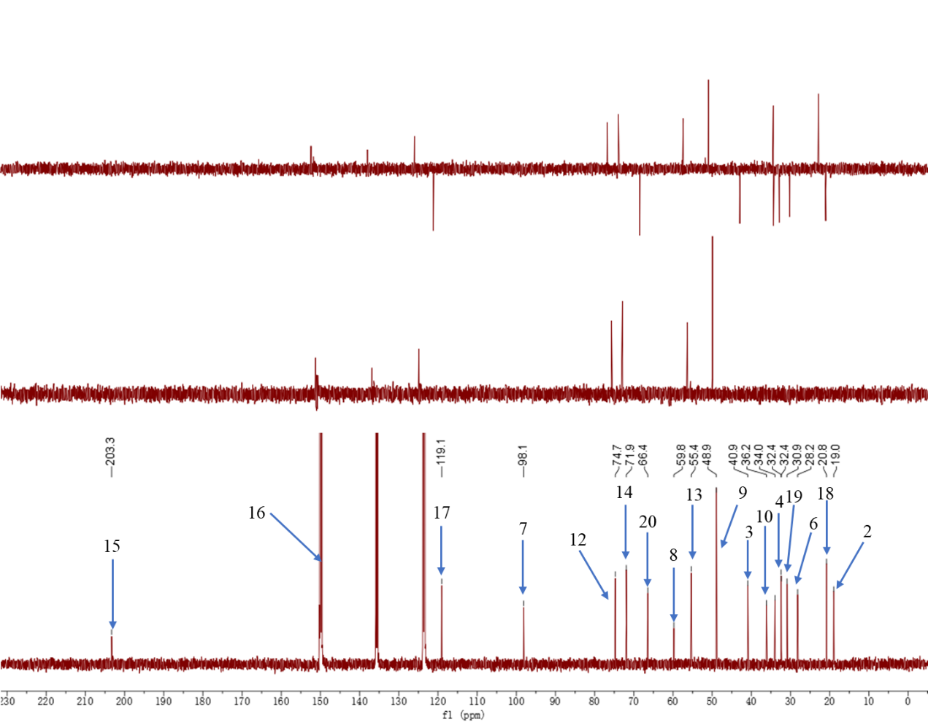
Fig. S13 ¹³C NMR spectrum of silvaticusin B (2) (pyridine-d₅, 125 MHz).
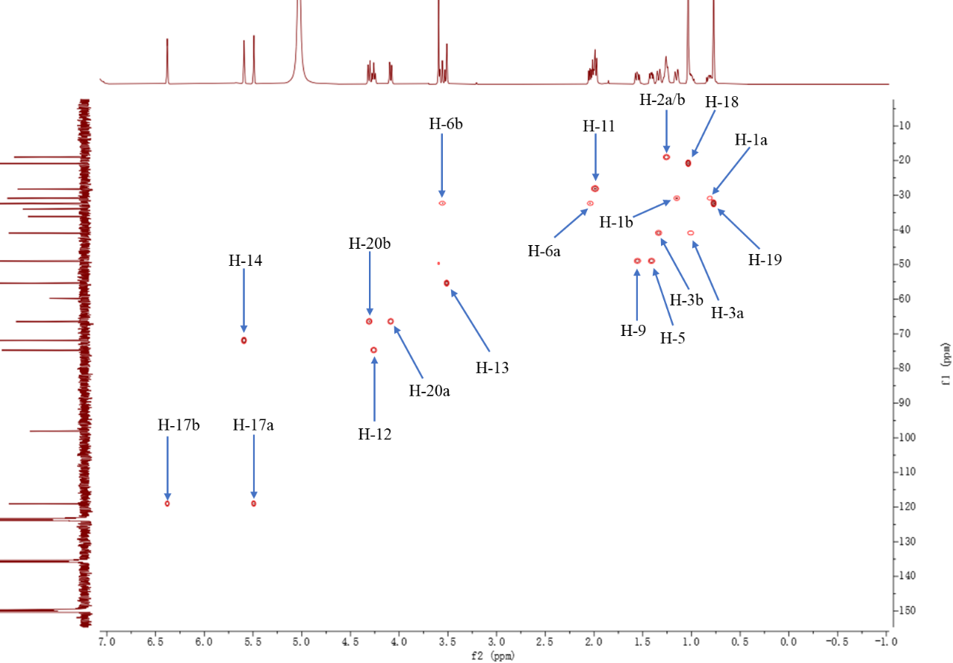
Fig. S14 HSQC spectrum of silvaticusin B (2) (pyridine-d₅, 500 MHz).
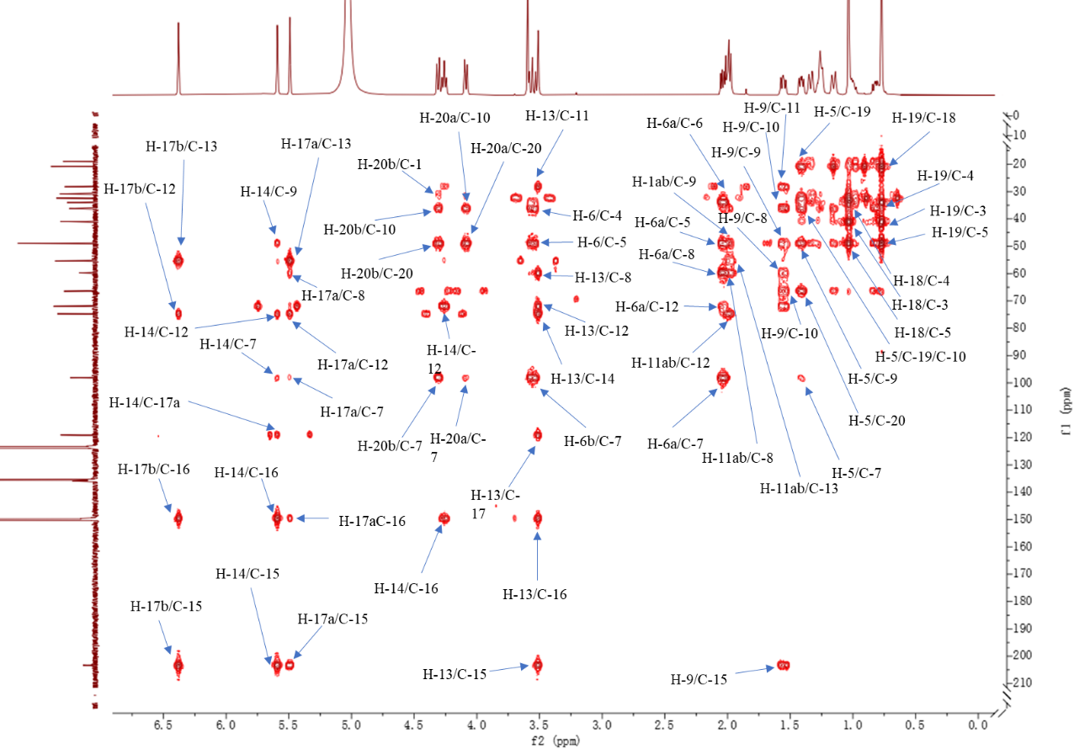
Fig. S15 HMBC spectrum of silvaticusin B (2) (pyridine-d₅, 500 MHz).
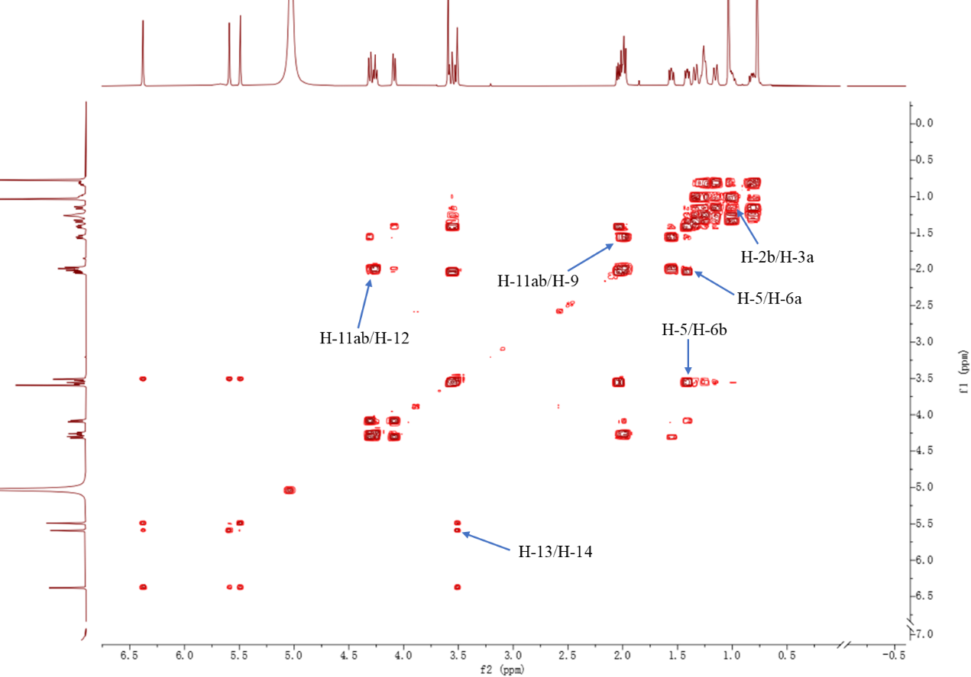
Fig. S16 ¹H-¹H COSY spectrum of silvaticusin B (2) (pyridine-d₅, 500 MHz).
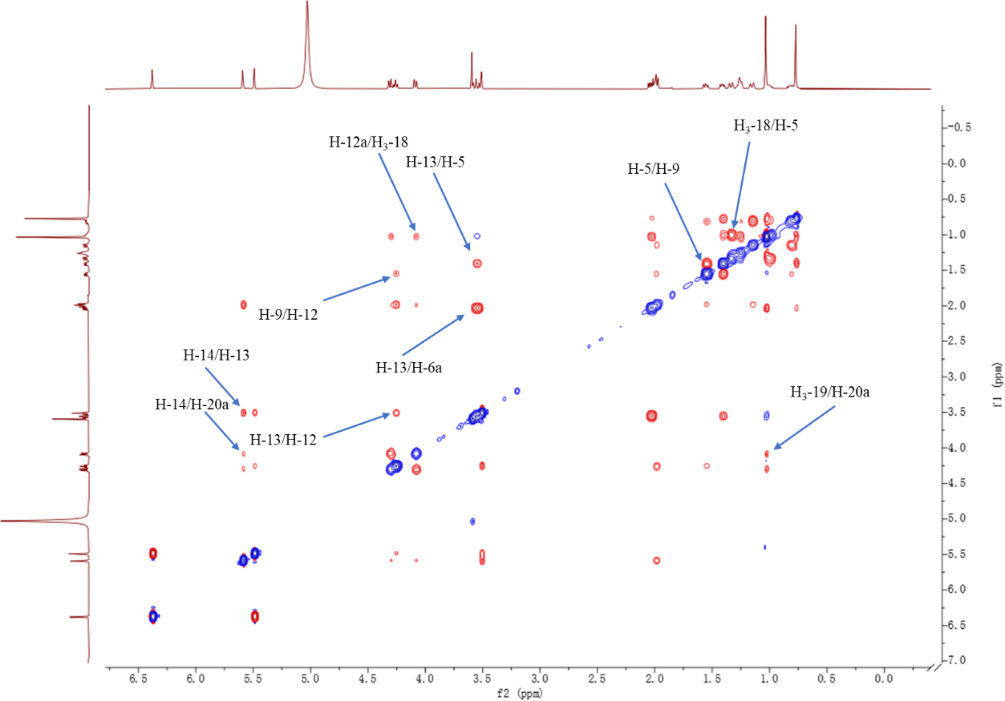
Fig. S17 ROESY spectrum of silvaticusin B (2) (pyridine-d₅, 500 MHz).

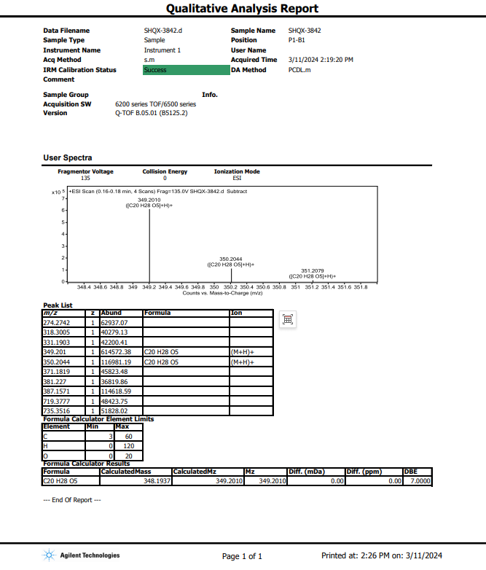
Fig. S18 HRESIMS spectrum of silvaticusin B (2).

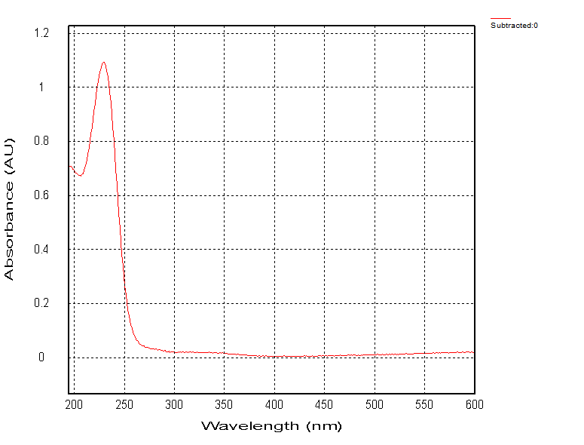
Fig. S19 UV spectrum of silvaticusin B (2).
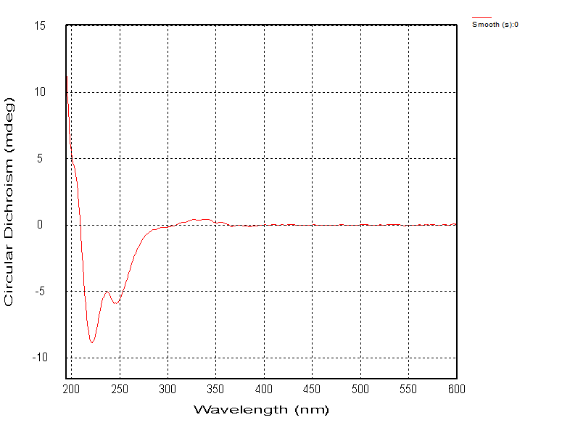
Fig. S20 ECD spectrum of silvaticusin B (2).

Fig. S21 IR spectrum of silvaticusin B (2).
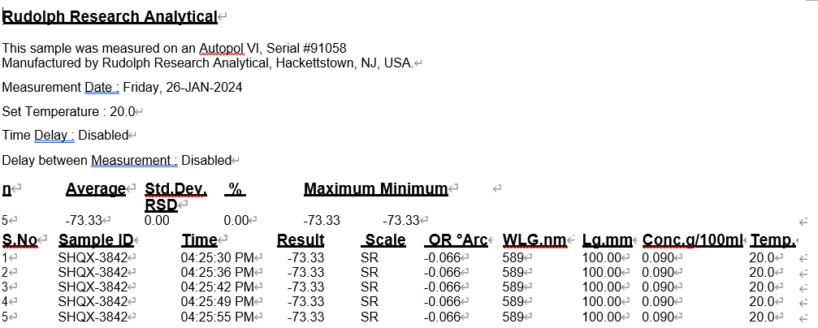
Fig. S22 OR of silvaticusin B (2).
- NMR, MS, UV, ECD spectra, and OR of silvaticusin C (3)
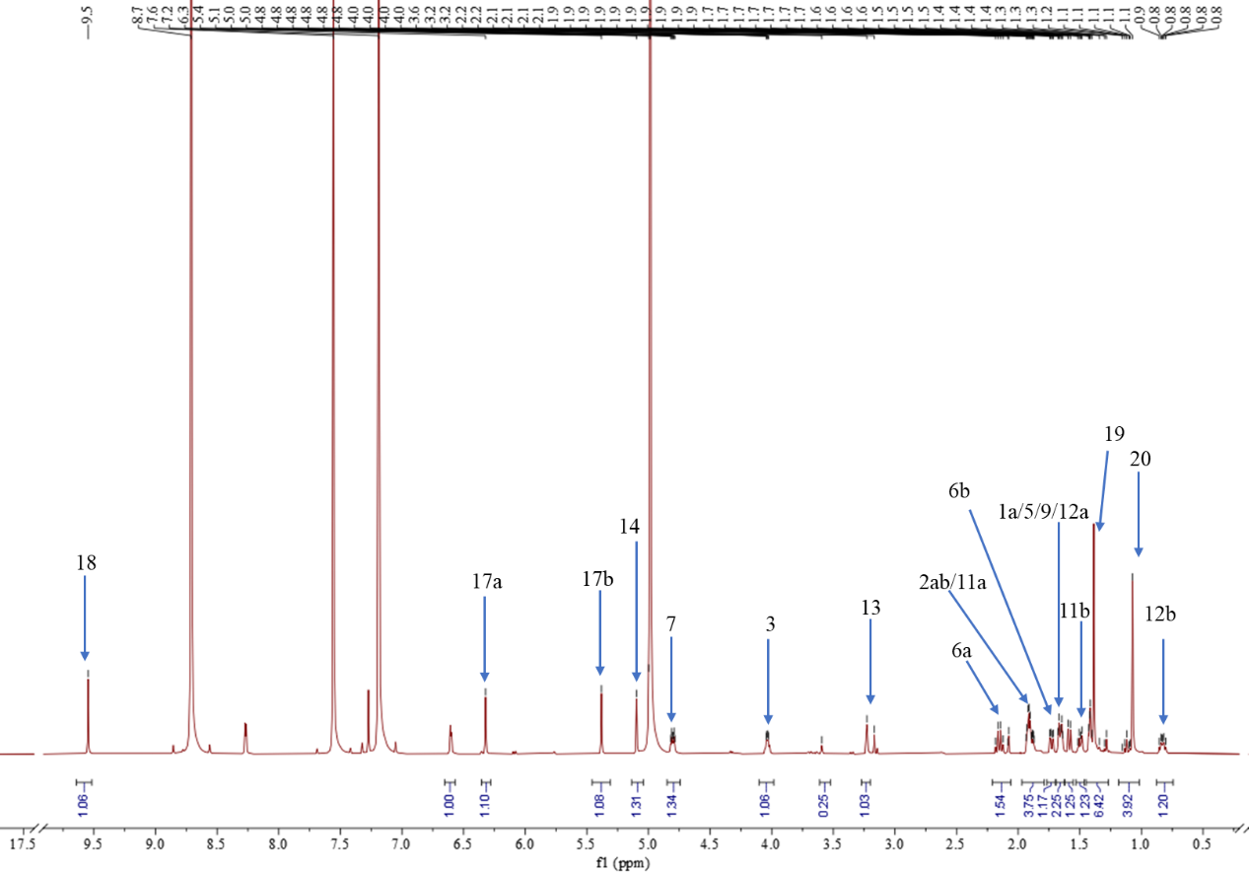
Fig. S23 ¹H NMR spectrum of silvaticusin C (3) (pyridine-d₅, 600 MHz).
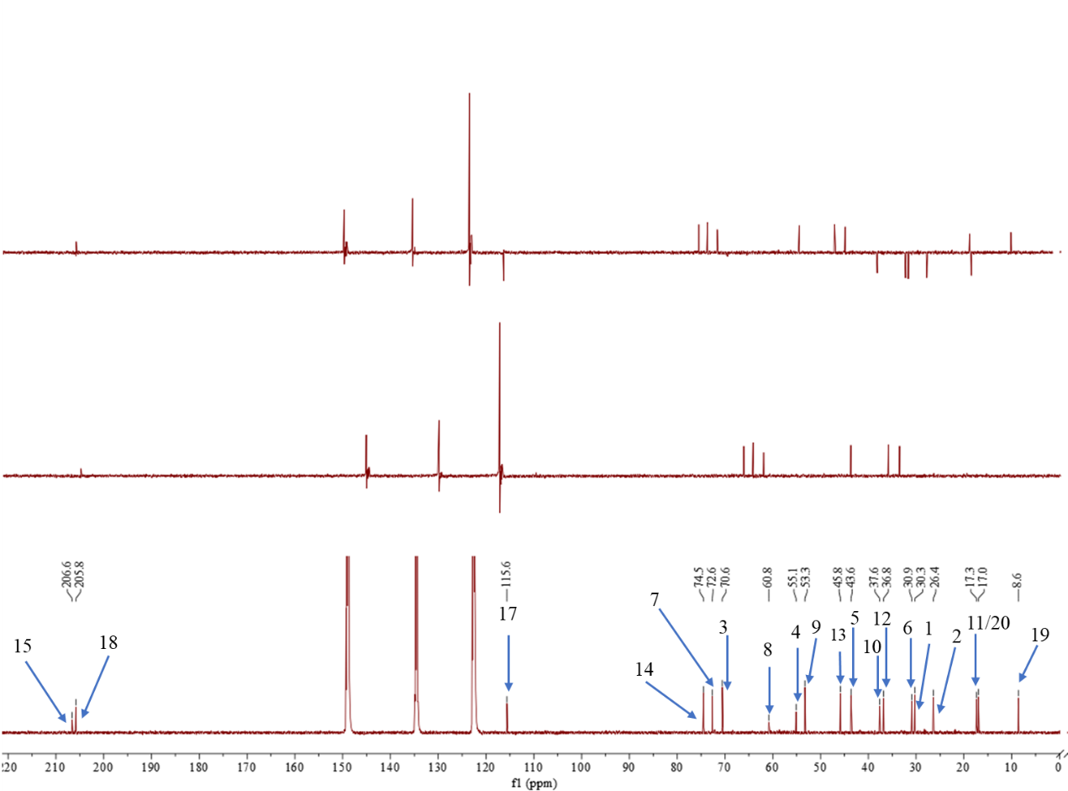
Fig. S24 ¹³C NMR spectrum of silvaticusin C (3) (pyridine-d₅, 150 MHz).
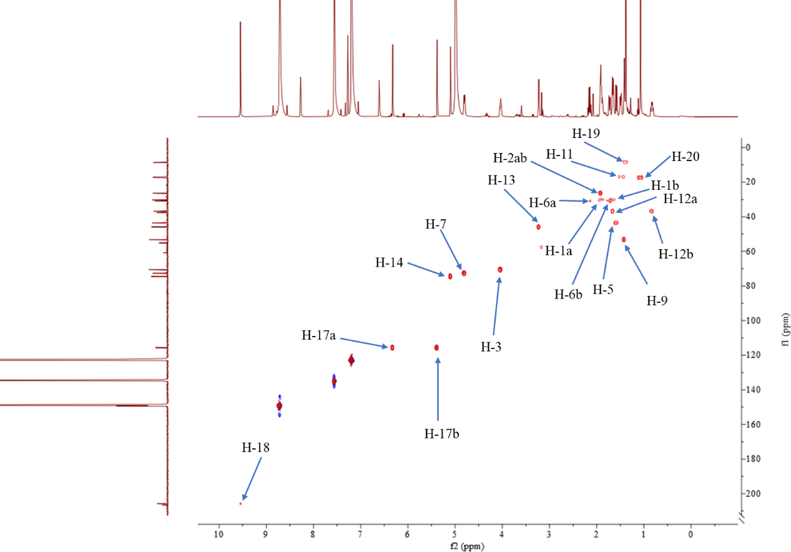
Fig. S25 HSQC spectrum of silvaticusin C (3) (pyridine-d₅, 600 MHz).
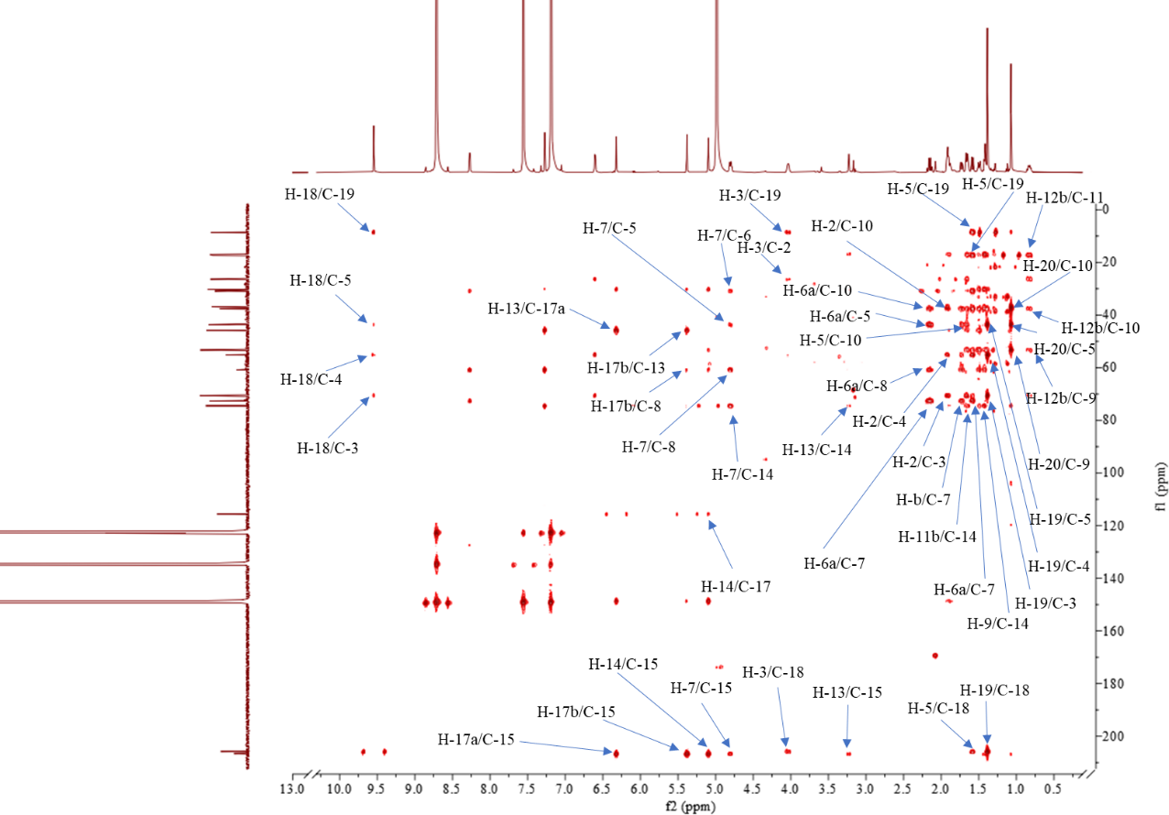
Fig. S26 HMBC spectrum of silvaticusin C (3) (pyridine-d₅, 600 MHz).
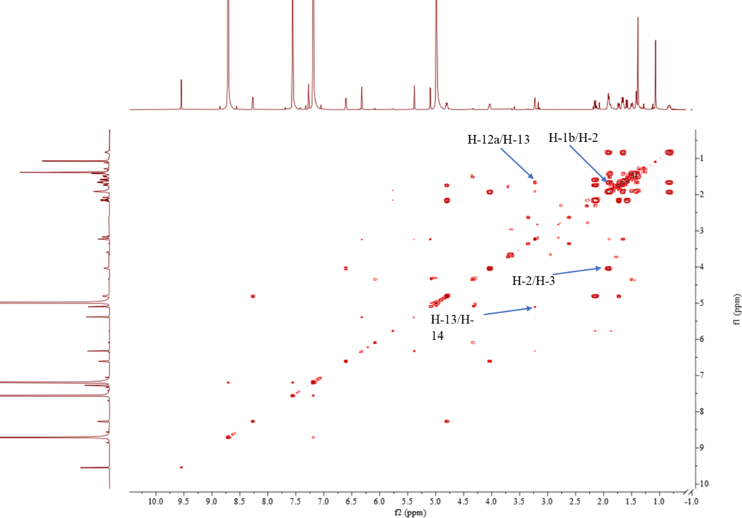
Fig. S27 ¹H-¹H COSY spectrum of silvaticusin C (3) (pyridine-d₅, 600 MHz).
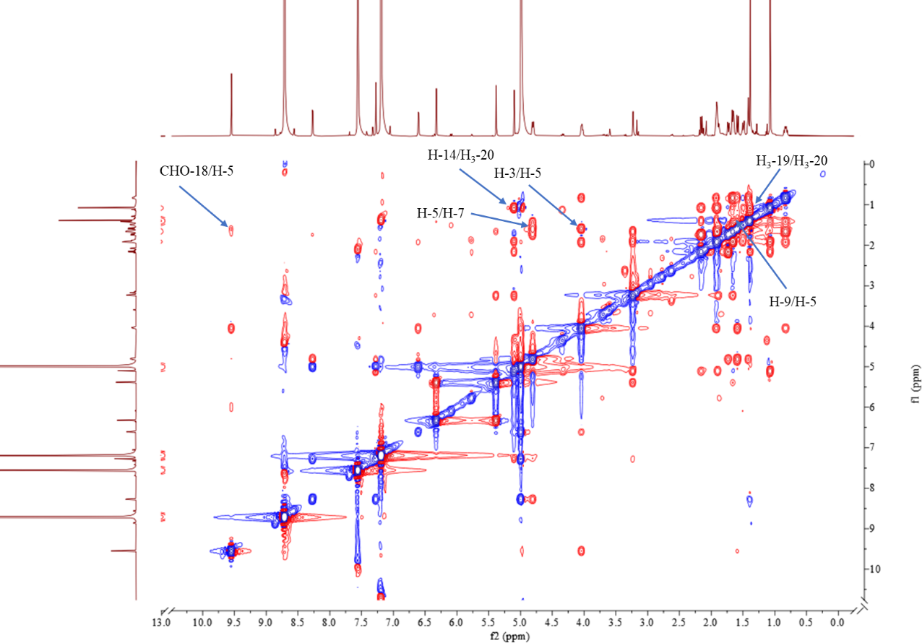
Fig. S28 ROESY spectrum of silvaticusin C (3) (pyridine-d₅, 600 MHz).
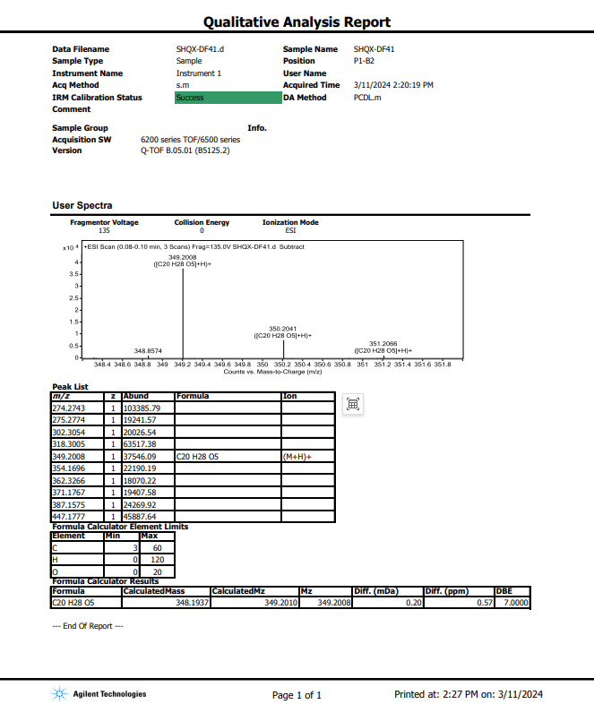
Fig. S29 HRESIMS spectrum of silvaticusin C (3).
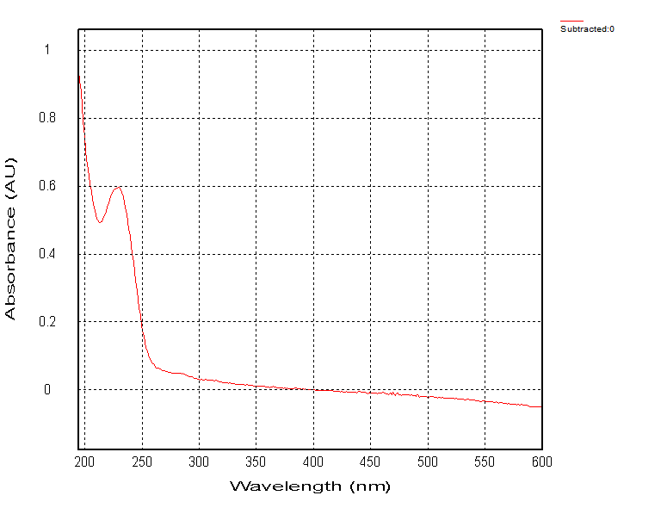
Fig. S30 UV spectrum of silvaticusin C (3).
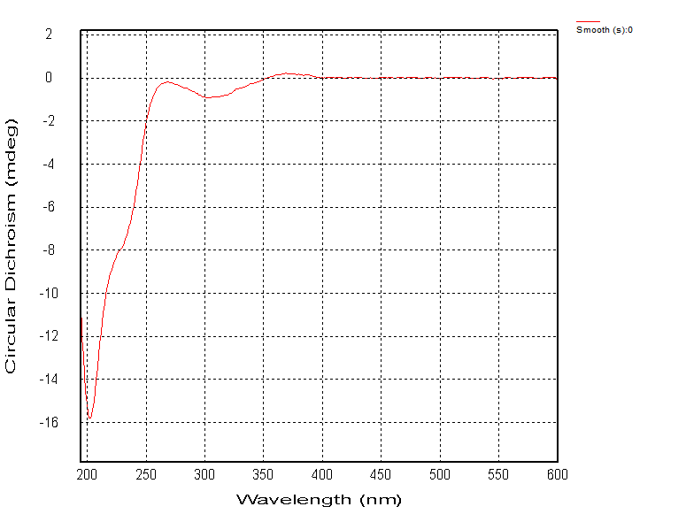
Fig. S31 ECD spectrum of silvaticusin C (3).
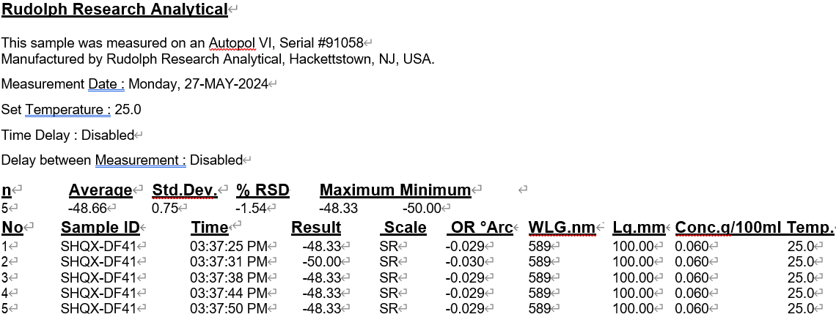
Fig. S32 OR spectrum of silvaticusin C (3).
- NMR, MS, UV, ECD spectra, and OR of silvaticusin D (4)
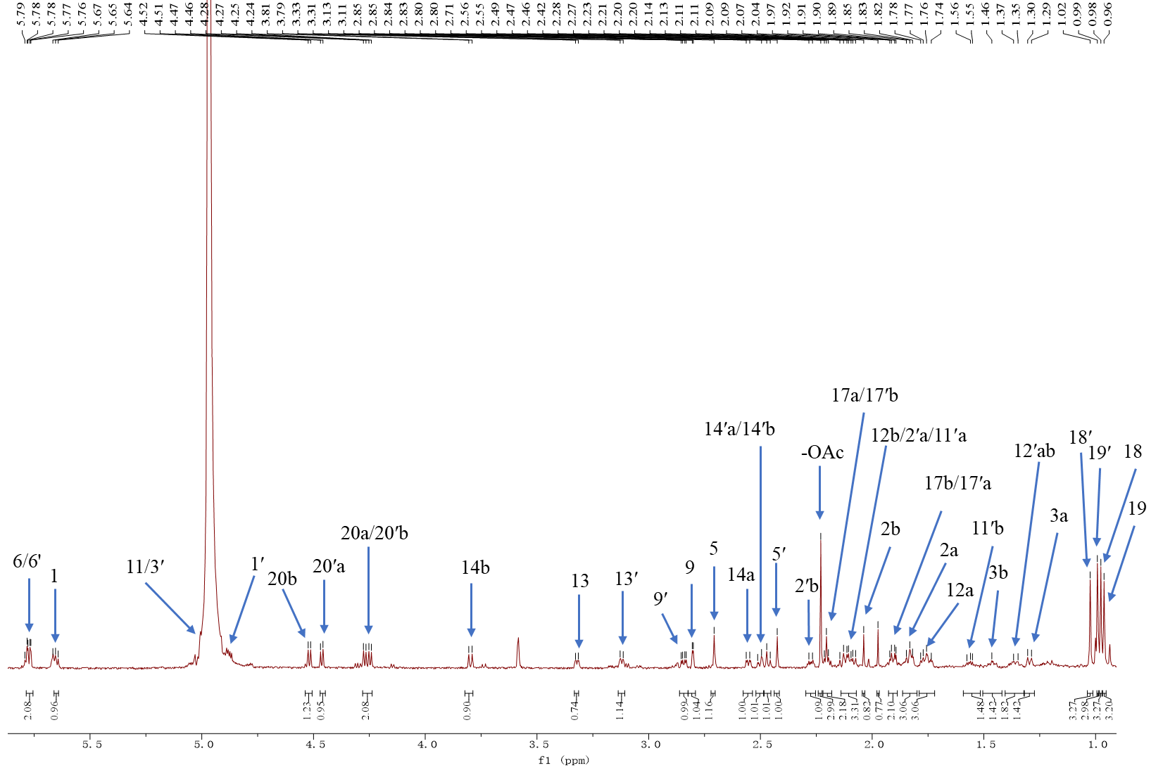
Fig. S33 ¹H NMR spectrum of silvaticusin D (4) (pyridine-d₅, 800 MHz).
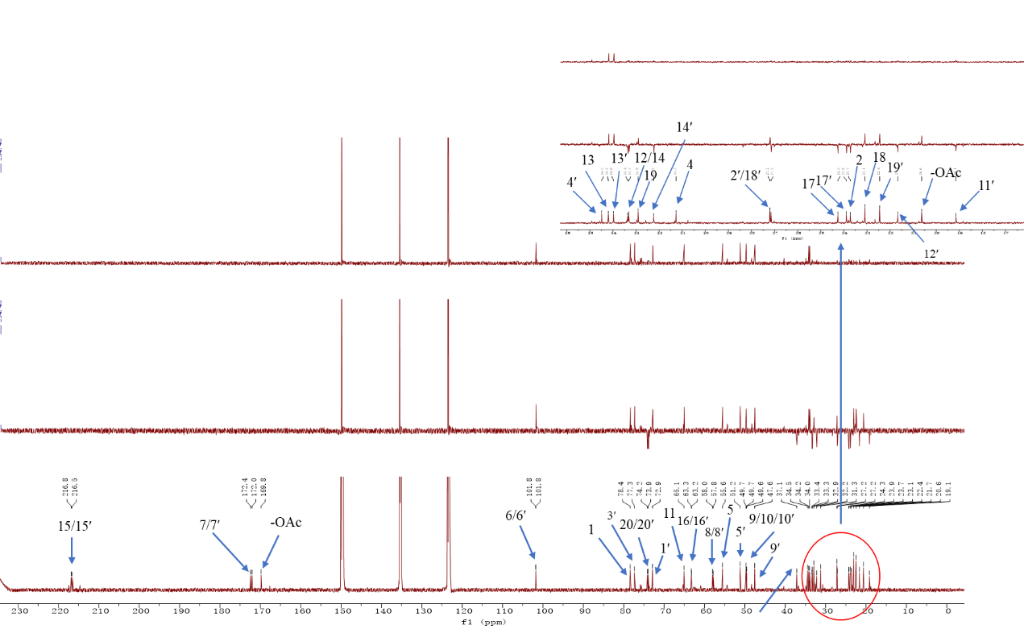
Fig. S34 ¹³C NMR spectrum of silvaticusin D (4) (pyridine-d₅, 200 MHz).
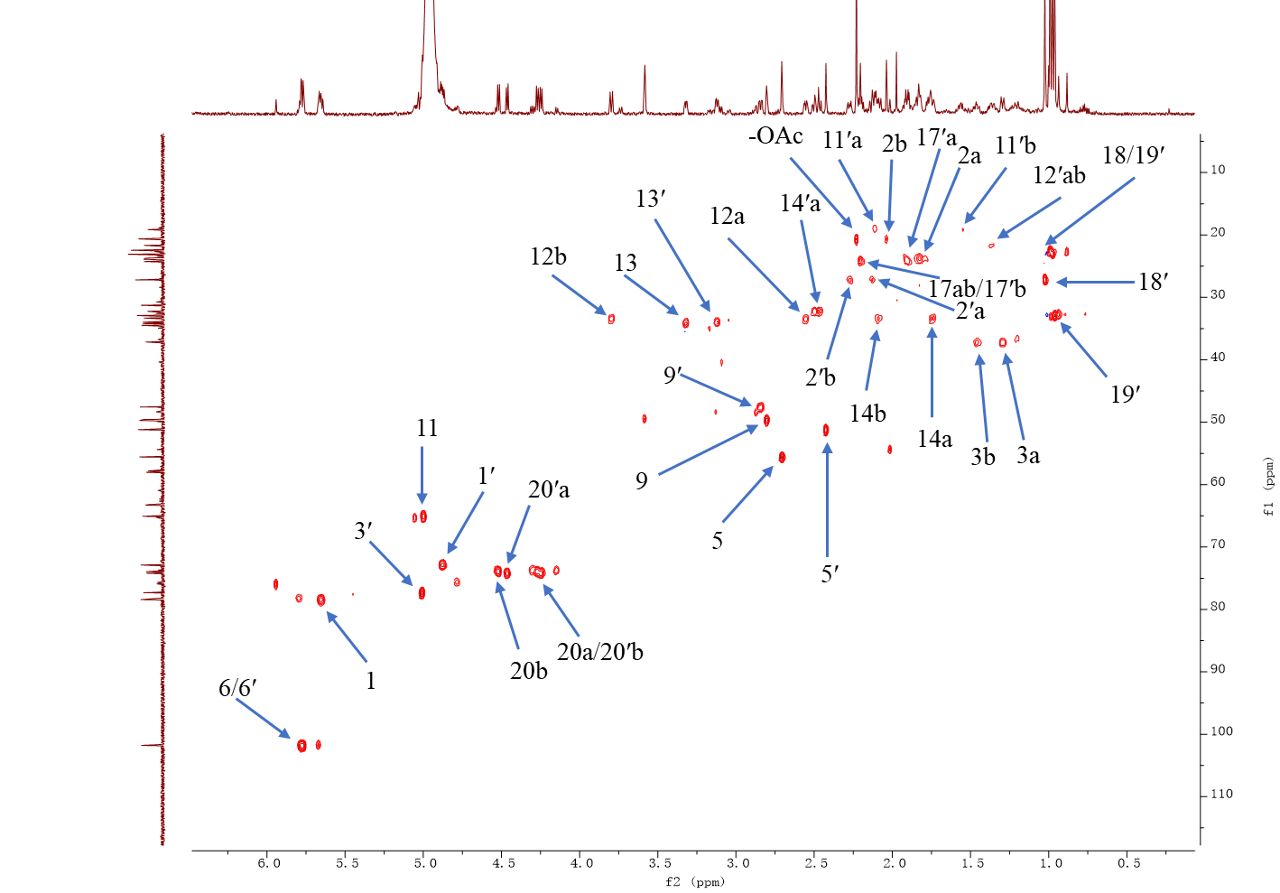
Fig. S35 HSQC spectrum of silvaticusin D (4) (pyridine-d₅, 800 MHz).
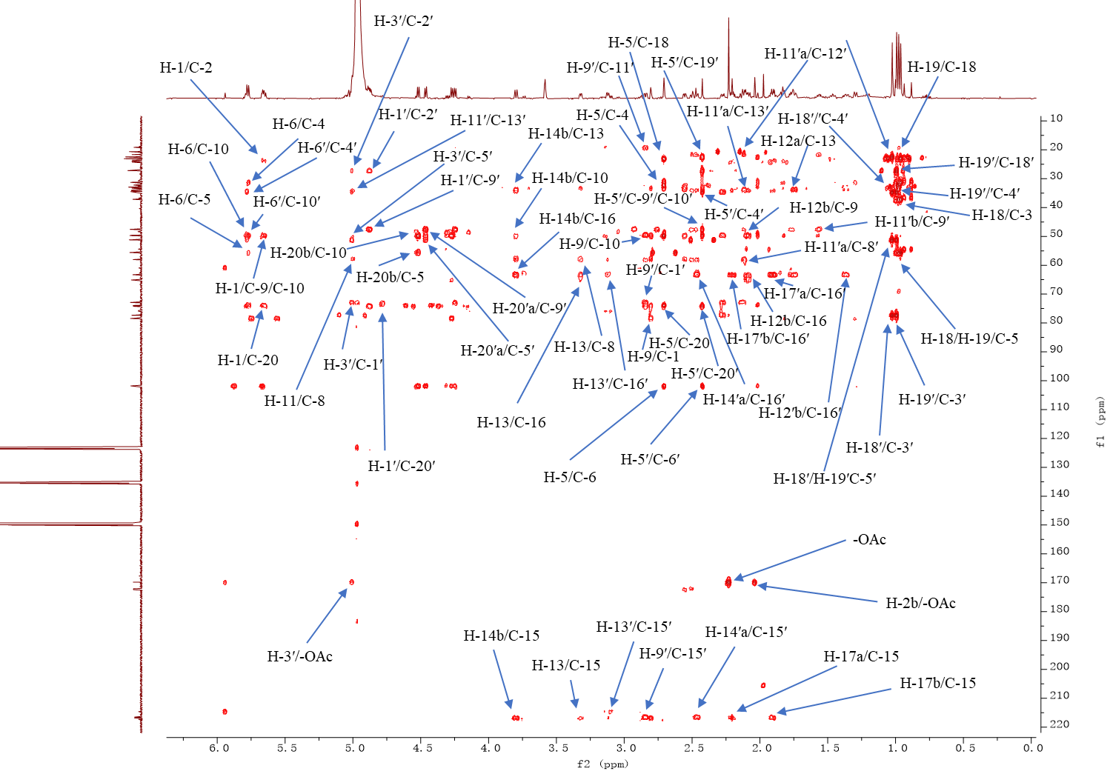
Fig. S36 HMBC spectrum of silvaticusin D (4) (pyridine-d₅, 800 MHz).
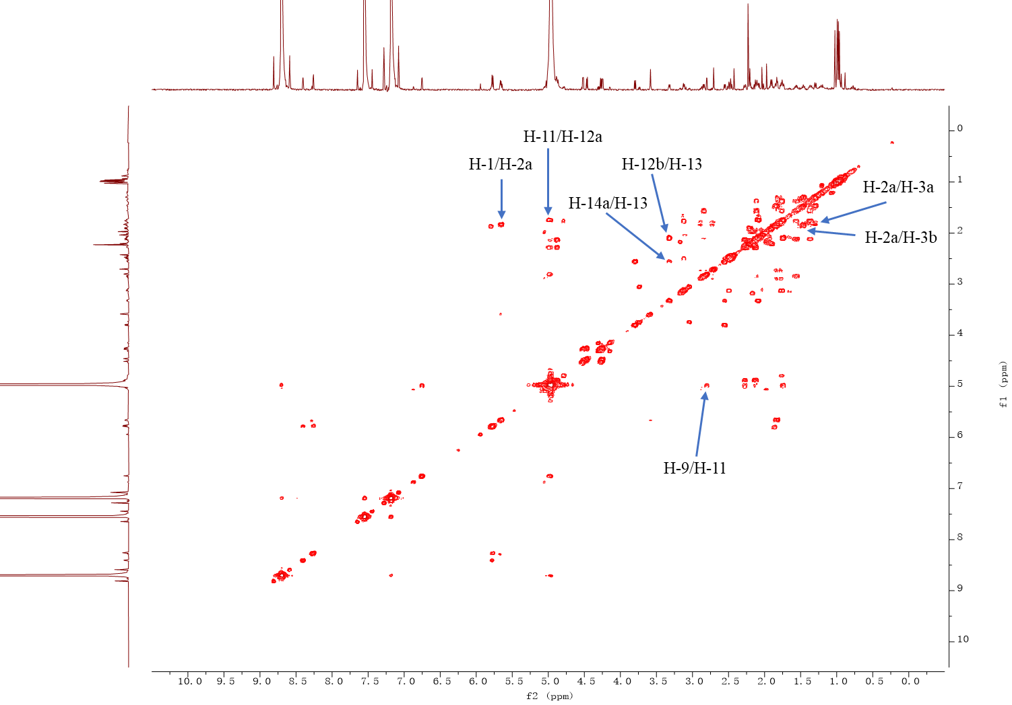
Fig. S37 ¹H–¹H COSY spectrum of silvaticusin D (4) (pyridine-d₅, 800 MHz).
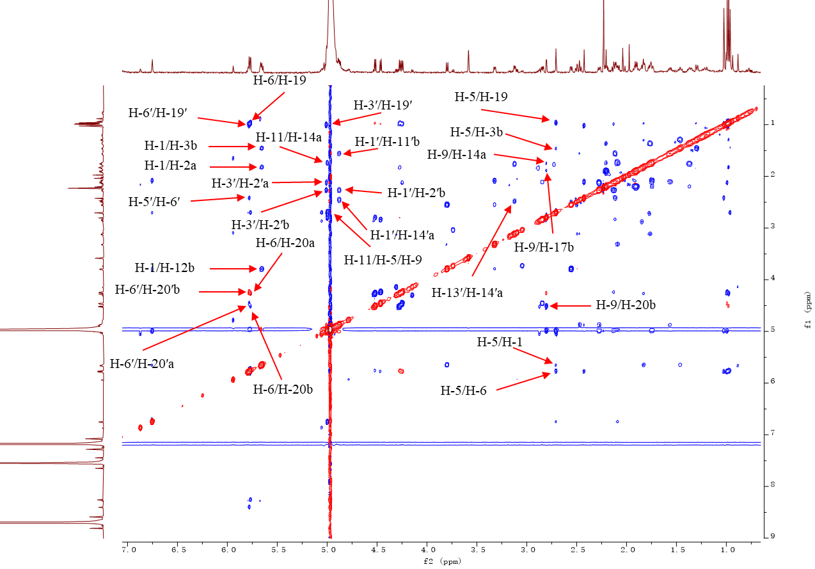
Fig. S38 ROESY spectrum of silvaticusin D (4) (pyridine-d₅, 800 MHz).
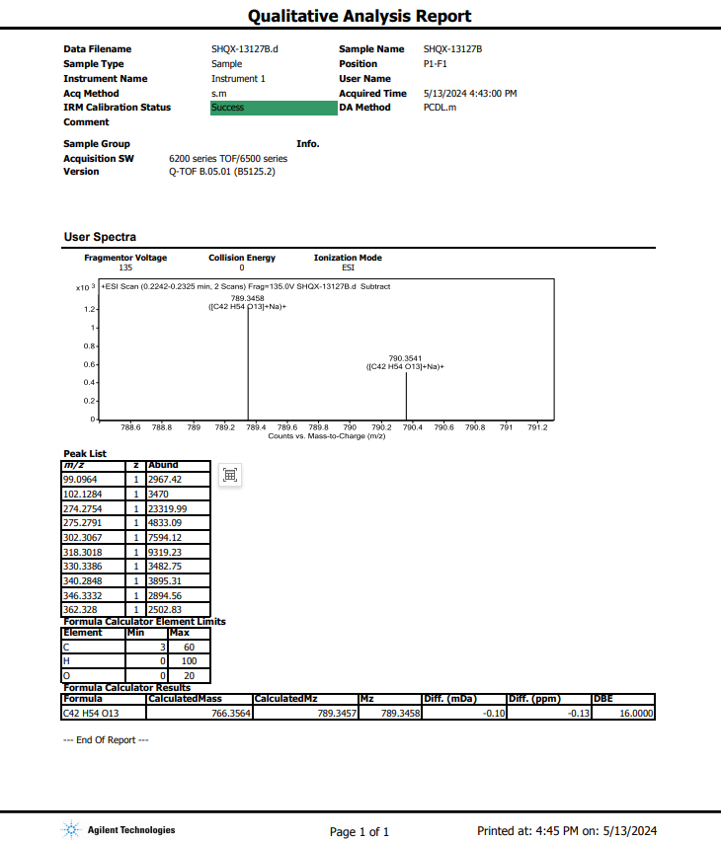
Fig. S39 HRESIMS spectrum of silvaticusin D (4).
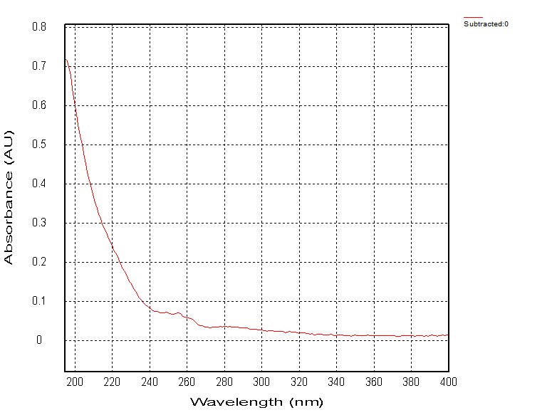
Fig. S40 UV spectrum of silvaticusin D (4).
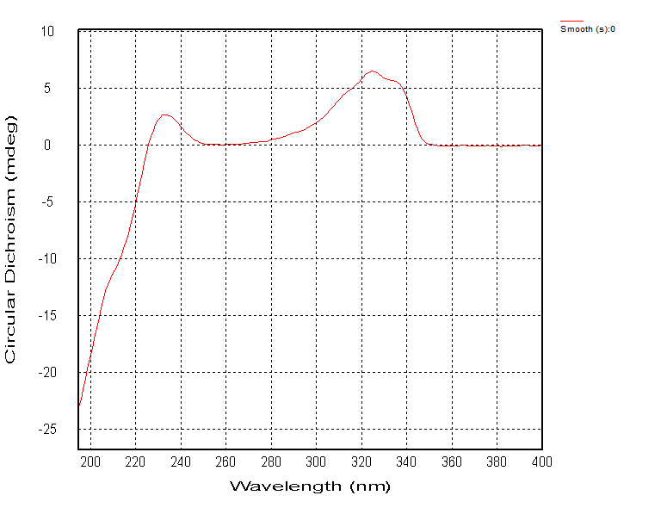
Fig. S41 ECD spectrum of silvaticusin D (4).
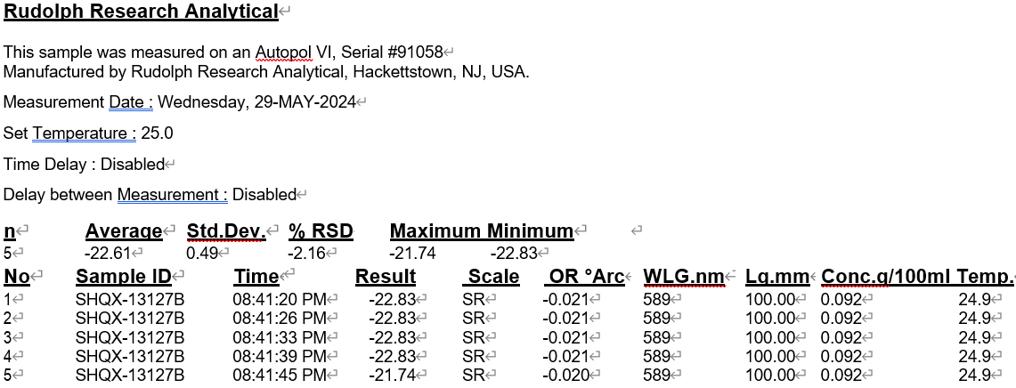
Fig. S42 OR spectrum of silvaticusin D (4).

- Computational data of silvaticusin D (4)
9.1 Methods for NMR and ECD calculation
Conformational searching of 4a and 4b (Fig. S43) were performed with the Crest code (version 3.0.1) using the default procedure [1]. Those conformers within an energy cut-off of 4 kcal/mol were subjected to DFT geometry optimizations at B3LYP-D3BJ/6-31G(d) level of theory in the gas phase. Frequency analysis of all optimized conformers were undertaken at the same level of theory to ensure that no imaginary frequency exists. More accurate energies of optimized conformers were evaluated at M06-2X-D3/6-311+G(2d,p) level of theory in the gas phase, and were then added to “thermal correction to Gibbs free energies” obtained by frequency analysis to get the Gibbs free energy of each conformer. Those two B3LYP geometries with RMSD below 0.15 Å and energy difference below 0.15 kcal were regarded as duplicate conformers, and the one with higher energy was removed. Subsequently, Room-temperature (298.15 K) equilibrium populations were calculated according to Boltzmann distribution law:
$$p_{i}= \frac{n_{i}}{\sum_{j}{n_{j}}}= \frac{e^{-ΔG_{i}/RT}}{\sum_{j}{e^{-ΔG_{j}/RT}}}$$
Where P_{i} is the population of the i^{th} conformer; n_{i} the number of molecules in i^{th} conformer; ΔG is the relative Gibbs free energy (kcal/mol); T is room temperature (298.15 K); R is the ideal gas constant (0.0019858995).
NMR shielding tensors of all dereplicated conformers were calculated with the GIAO method at mPW1PW91-SCRF/6-31+G(d,p) level (pyridine, IEFPCM solvent model). The shielding constants obtained were converted into chemical shifts by referencing to TMS at 0 ppm (δ_{cal} = σ_{TMS} – σ_{cal}), where the σ_{TMS} was the shielding constant of TMS calculated at the same level. For 4a and 4b, the parameters a and b of the linear regression δ_{cal} = aδ_{exp} + b; the correlation coefficient, R²; the mean absolute error (MAE) defined as Σn |δ_{cal} – δ_{exp}|/n; the corrected mean absolute error, CMAE, defined as Σn |δ_{corr} – δ_{exp}|/n, where δ_{corr} = (δ_{cal} – b)/a, were calculated. Then, DP4+ probability analysis [2] were undertaken using the calculated NMR chemical shifts and scripts provided by Sarotti, et al, and DP4+ probabilities of 4a and 4b were obtained (Fig. S46).
For ECD calculation, those conformers with a population over 2% were subjected to TDDFT calculations at PBE0/6-311+G(2d,p) and CAM-B3LYP/6-311+G(2d,p) level of theory (MeOH, IEFPCM solvent model), and 36 excited states were calculated for each conformer. The coordinates for calculated ECD curves were generated using the Multiwfn software (version 3.8) [3].
The geometry optimization, single-point energy calculation, NMR shielding constant calculation, TDDFT ECD calculation were all completed in Gaussian 16 program [4].

[1] P. Pracht, S. Grimme, C. Bannwarth, F. Bohle, S. Ehlert, G. Feldmann, J. Gorges, M. Müller, T. Neudecker, C. Plett, S. Spicher, P. Steinbach, P.A. Wesołowski, F. Zeller, CREST—A program for the exploration of low-energy molecular chemical space. J. Chem. Phys. 21 (2024) 14110.
[2] N. Grimblat, M.M. Zanardi, A.M. Sarotti, Beyond DP4: an Improved Probability for the Stereochemical Assignment of Isomeric Compounds using Quantum Chemical Calculations of NMR Shifts, J. Org. Chem. 80 (2015), 12526–12534.
[3] T. Lu, F. Chen, Multiwfn: A multifunctional wavefunction analyzer, J. Comput. Chem. 33 (2012) 580–592.
[4] M.J. Frisch, G.W. Trucks, H.B. Schlegel, G.E. Scuseria, M.A. Robb, J.R. Cheeseman, G. Scalmani, V. Barone, B. Mennucci, G.A. Petersson, H. Nakatsuji, M. Caricato, X. Li, H.P. Hratchian, A.F. Izmaylov, J. Bloino, G. Zheng, J.L. Sonnenberg, M. Hada, M. Ehara, K. Toyota, R. Fukuda, J. Hasegawa, M. Ishida, T. Nakajima, Y. Honda, O. Kitao, H. Nakai, T. Vreven, J.A. Montgomery, J.E.P. Jr., F. Ogliaro, M. Bearpark, J.J. Heyd, E. Brothers, K.N. Kudin, V.N. Staroverov, T. Keith, R. Kobayashi, J. Normand, K. Raghavachari, A. Rendell, J.C. Burant, S.S. Iyengar, J. Tomasi, M. Cossi, N. Rega, J.M. Millam, M. Klene, J.E. Knox, J.B. Cross, V. Bakken, C. Adamo, J. Jaramillo, R. Gomperts, R.E. Stratmann, O. Yazyev, A.J. Austin, R. Cammi, C. Pomelli, J.W. Ochterski, R.L. Martin, K. Morokuma, V.G. Zakrzewski, G.A. Voth, P. Salvador, J.J. Dannenberg, S. Dapprich, A.D. Daniels, O. Farkas, J.B. Foresman, J.V. Ortiz, J. Cioslowski, D.J. Fox, Gaussian 16, Revision C.01; Gaussian, Inc., Wallingford CT: 2016.

9.2 General results for NMR calculation
Fig. S43 Chemical structures of (1S*, 5R*, 6R*, 8S*, 9S*, 10S*, 11S*, 13S*, 16R*, 1'S*, 3'S*, 5'R*, 6'R*, 8'S*, 9'S*, 10'S*, 13'R*, 16'R*)-4 (4a) and (1S*, 5R*, 6R*, 8S*, 9S*, 10S*, 11S*, 13S*, 16R*, 1'S*, 3'R*, 5'R*, 6'R*, 8'S*, 9'S*, 10'S*, 13'R*, 16'R*)-4 (4b).

Table S1 Experimental and calculated ¹³C NMR chemical shifts of 4a and 4b.
No. | δ_{exptl.} (ppm) | δ_{calcd.} (ppm) |  | No. | δ_{exptl.} (ppm) | δ_{calcd.} (ppm)
No. | δ_{exptl.} (ppm) | 4a | 4b | No. | δ_{exptl.} (ppm) | 4a | 4b
1 | 78.5 | 75.9 | 77.6 | 4' | 34.5 | 37.9 | 38.7
2 | 23.7 | 25.7 | 26.1 | 5' | 51.2 | 51.9 | 53.6
3 | 37.1 | 37.8 | 37.9 | 6' | 101.8 | 103.5 | 103
4 | 31.3 | 33.4 | 34.1 | 7' | 172 | 171.1 | 170.9
5 | 55.6 | 52.3 | 53.4 | 8' | 58 | 62 | 62.1
6 | 101.8 | 103.2 | 104.1 | 9' | 47.6 | 50.5 | 49.5
7 | 172.4 | 170.5 | 170.2 | 10' | 49.7 | 52.3 | 52.1
8 | 57.8 | 62.1 | 61.5 | 11' | 19.1 | 22.2 | 22
9 | 49.7 | 53.3 | 54.8 | 12' | 21.6 | 23.7 | 24.3
10 | 49.6 | 53.3 | 51.9 | 13' | 33.9 | 37.8 | 39.1
11 | 65.1 | 65.7 | 65.5 | 14' | 32.2 | 34.8 | 35.9
12 | 33.4 | 36 | 36.5 | 15' | 216.5 | 218.1 | 220
13 | 34.2 | 37.5 | 38.9 | 16' | 63.2 | 65.8 | 66
14 | 33.3 | 34.8 | 36.1 | 17' | 23.9 | 26 | 27.6
15 | 216.8 | 218 | 220 | 18' | 27.3 | 27 | 27.8
16 | 63.3 | 66.3 | 67 | 19' | 22.5 | 23.9 | 18.5
17 | 24.3 | 26.4 | 27.5 | 20' | 74.3 | 75.3 | 75.1
18 | 32.9 | 31.6 | 31.7 | 21' | 169.8 | 168.7 | 169.5
19 | 23.1 | 24.1 | 24.3 | 22' | 20.6 | 22.1 | 22.1
20 | 73.9 | 74.8 | 74.7
1' | 72.9 | 72.5 | 74.5 | R² | - | 0.9989 | 0.9983
2' | 27.2 | 30.1 | 30.5 | MAE | - | 2.1 | 2.5
3' | 77.3 | 76.7 | 74.7 | CMAE | - | 1.4 | 1.7

Table S2 Experimental and calculated ¹H NMR chemical shifts of 4a and 4b.
No. | δ_{exptl.} (ppm) | δ_{calcd.} (ppm) |  | No. | δ_{exptl.} (ppm) | δ_{calcd.} (ppm)
No. | δ_{exptl.} (ppm) | 4a | 4b | No. | δ_{exptl.} (ppm) | 4a | 4a
1 | 5.65 | 4.41 | 4.4 | 2'a | 2.13 | 1.74 | 1.79
2b | 2.04 | 1.7 | 1.72 | 3' | 5.01 | 5.12 | 4.48
2a | 1.83 | 1.69 | 1.7 | 5' | 2.42 | 2 | 1.82
3a | 1.3 | 1.23 | 1.23 | 6' | 5.78 | 5.28 | 5.28
3b | 1.46 | 1.24 | 1.28 | 9' | 2.84 | 2.34 | 2.36
5 | 2.71 | 3.5 | 3.48 | 11'b | 1.56 | 1.47 | 1.28
6 | 5.77 | 5.28 | 5.29 | 11'a | 2.11 | 1.66 | 1.64
9 | 2.8 | 2.21 | 2.26 | 12'a | 1.36 | 1.3 | 1.24
11 | 5 | 3.98 | 3.96 | 12'b | 1.37 | 1.81 | 1.75
12a | 2.55 | 0.93 | 0.88 | 13' | 3.12 | 2.62 | 2.48
12b | 3.8 | 2.16 | 2.17 | 14a' | 2.47 | 2.2 | 1.95
13 | 3.32 | 2.66 | 2.5 | 14b' | 2.5 | 2.28 | 2.29
14a | 1.75 | 2.11 | 1.87 | 17'a | 1.91 | 1.86 | 1.67
14b | 2.09 | 2.24 | 2.25 | 17'b | 2.21 | 2.09 | 2.33
17b | 1.89 | 1.87 | 1.71 | 18' | 1.33 | 0.7 | 0.78
17a | 2.2 | 2.1 | 2.32 | 19' | 0.99 | 0.82 | 0.87
18 | 0.98 | 0.8 | 0.8 | 20'b | 4.25 | 4.01 | 4.06
19 | 0.96 | 0.78 | 0.78 | 20'a | 4.46 | 4.08 | 4.06
20a | 4.27 | 4 | 4.01 | 22' | 2.23 | 2.03 | 1.98
20b | 4.52 | 4.05 | 4.07 | R² | - | 0.8945 | 0.8969
1' | 4.88 | 4.71 | 4.34 | MAE | - | 0.41 | 0.45
2'b | 2.27 | 1.91 | 1.79 | CMAE | - | 0.33 | 0.33

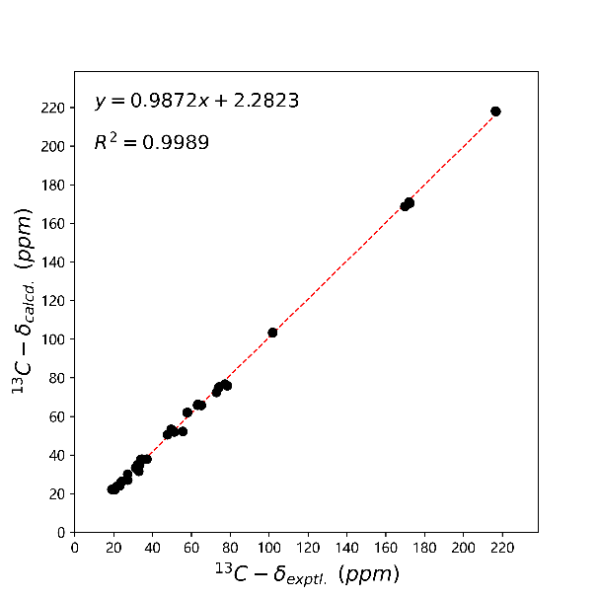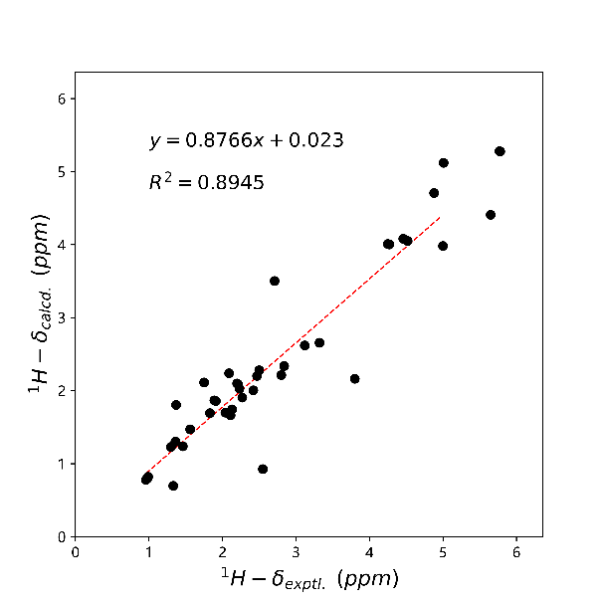
Fig. S44 Linear regression analysis between the experimental and calculated NMR chemical shifts of 4a.
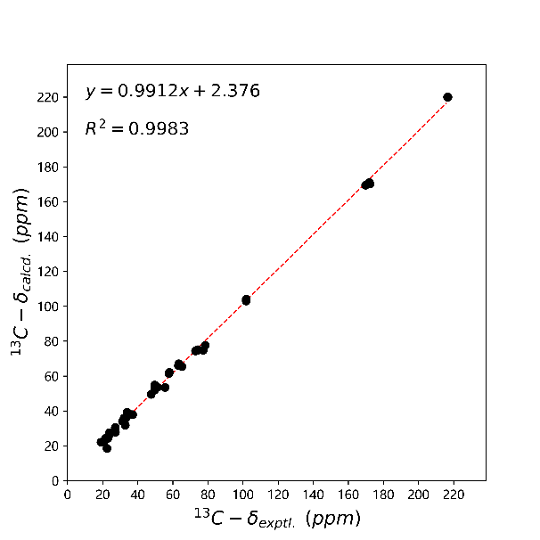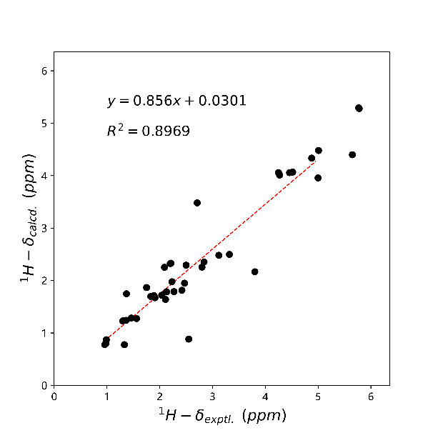
Fig. S45 Linear regression analysis between the experimental and calculated NMR chemical shifts of 4b.

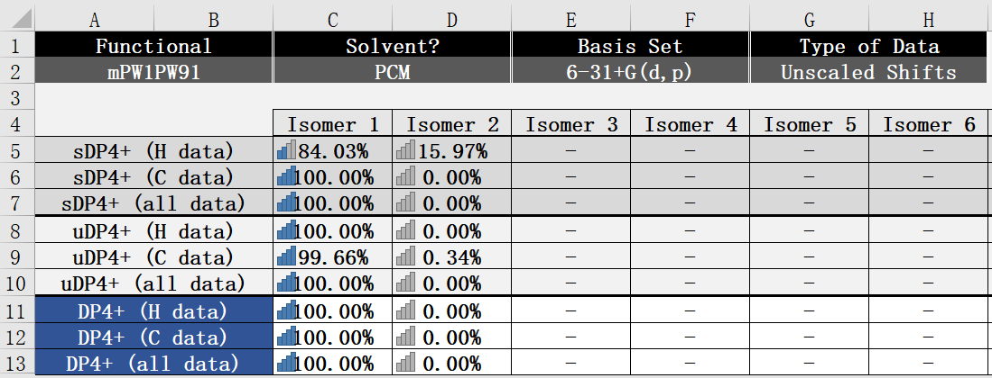
Fig. S46 DP4+ analysis of 4a and 4b.

9.3 Computational data of 4a
Table S3 Conformational analysis of the B3LYP-D3BJ/6-31G(d) optimized conformers of 4a in the gas phase (T=298.15 K)
Conformer | E (Hartree)ª | C (Hartree)^{b} | G (kcal/mol)^{c} | ΔG (kcal/mol)^{d} | Population^{e}
4a-1 | -2610.714755 | 0.836925 | -1637698.338275 | 0.0 | 64.58%
4a-2 | -2610.715307 | 0.838044 | -1637697.982765 | 0.35551 | 35.42%
ªElectronic energy obtained at M06-2X-D3/6-311+G(2d,p) level of theory; ^{b}Thermal correction to Gibbs free energy obtained at B3LYP-D3BJ/6-31G(d) level of theory; ^{c}Gibbs free energy (E + C); ^{d}The relative Gibbs free energy; ^{e}The Boltzmann distribution of each conformer.

Table S4 Atomic coordinates (Å) of 4a-1 obtained at the B3LYP-D3BJ/6-31G(d) level of theory in the gas phase.
C | -5.215283 | 1.826997 | 0.691743 | O | 1.264506 | -2.697893 | 0.741388
C | -6.360408 | 2.789802 | 0.939062 | H | 5.312635 | -3.452780 | -1.893812
C | -7.528420 | 2.027458 | 1.565185 | H | -5.649357 | -2.465704 | 0.608965
C | -8.098180 | 0.948391 | 0.622183 | H | -6.582866 | -2.464360 | -1.858013
C | -6.954660 | -0.056237 | 0.259392 | H | 7.785403 | 1.765922 | 1.289744
C | -7.253836 | -0.838130 | -1.019082 | O | 6.327683 | 2.246368 | -0.093407
C | -3.104471 | 1.867759 | -0.451422 | H | 1.843504 | 0.914976 | -3.062708
C | -3.008013 | 0.400023 | -0.075395 | H | 1.781854 | -0.829518 | -2.938614
C | -4.359055 | -0.416304 | 0.086514 | H | 5.614840 | 2.030789 | 2.453143
C | -5.563979 | 0.560388 | -0.095785 | H | 6.187388 | 0.382799 | 2.683886
C | -4.285880 | -1.277190 | 1.370640 | H | 1.968440 | 1.671969 | -0.178070
C | -2.944664 | -2.047641 | 1.448429 | H | 0.592380 | 1.038209 | 0.717227
C | -1.693416 | -1.201202 | 1.096122 | H | 9.157356 | 0.821235 | -0.613548
C | -2.098867 | 0.278338 | 1.173447 | H | 7.809505 | 0.977344 | -1.752083
C | -2.212188 | -0.399084 | -1.121340 | H | 8.578039 | -0.595079 | -1.508291
C | -1.289602 | -1.368151 | -0.386081 | H | -2.858415 | -2.451104 | 2.461712
C | -1.253876 | -2.759027 | -1.071759 | H | -3.026931 | -2.914918 | 0.783687
C | -9.184138 | 0.159487 | 1.376592 | H | 5.353816 | -1.802785 | 2.164644
C | -8.769369 | 1.633732 | -0.587995 | H | 3.941672 | -2.486126 | 1.344949
C | -5.727960 | 0.831224 | -1.613525 | H | -2.590288 | 0.549155 | 2.110316
C | 4.553558 | 0.576543 | 1.286981 | H | -1.245748 | 0.946646 | 1.049197
C | 5.825838 | 1.090810 | 1.933691 | H | -7.190478 | 1.549706 | 2.496378
C | 6.891073 | 1.307065 | 0.864796 | H | -8.328065 | 2.723336 | 1.845172
C | 7.276240 | 0.002919 | 0.136687 | H | -4.369736 | -0.623102 | 2.246925
C | 5.999223 | -0.641627 | -0.493760 | H | -6.011031 | 3.591350 | 1.598510
C | 6.169454 | -2.135543 | -0.769679 | H | -6.657092 | 3.264096 | -0.001388
C | 2.426265 | -0.260197 | 1.987751 | H | 3.632649 | 1.123559 | -1.506915
C | 2.162225 | -0.437912 | 0.503300 | H | 7.203460 | -2.444983 | -0.958527
C | 3.397667 | -0.756102 | -0.439896 | H | -0.866596 | -1.438303 | 1.767568
C | 4.713700 | -0.650290 | 0.386174 | H | -4.808408 | 1.530501 | 1.667823
C | 3.321164 | 0.092841 | -1.718040 | H | -0.304249 | -1.914793 | -2.858973
C | 1.910636 | 0.085612 | -2.350684 | H | 0.786714 | -3.045006 | -1.994178
C | 0.760911 | 0.210018 | -1.310600 | H | 4.130127 | 1.393234 | 0.694654
C | 1.358981 | 0.780143 | -0.015054 | H | -8.318910 | -0.988792 | -1.218657
C | 1.193052 | -1.597993 | 0.236936 | H | -1.004548 | -3.538438 | -0.349356
C | 0.227498 | -1.171983 | -0.868104 | H | -2.145892 | -3.037660 | -1.638823
C | -0.021325 | -2.317270 | -1.884398 | H | 8.445602 | -1.772104 | 0.667919
C | 8.262907 | 0.323437 | -1.001656 | H | 8.848633 | -0.328434 | 1.595164
C | 8.018389 | -0.892405 | 1.154895 | H | 7.386640 | -1.249728 | 1.968521
C | 4.890954 | -1.964985 | 1.185866 | H | -0.038547 | 0.839232 | -1.705424
C | 7.059601 | 3.344332 | -0.414946 | H | -4.806721 | 0.657732 | -2.177697
C | 6.316836 | 4.185959 | -1.423060 | H | -6.065951 | 1.850859 | -1.820613
O | -6.731348 | -0.087412 | -2.084097 | H | -9.517706 | 2.347556 | -0.224592
O | 5.757234 | -2.802841 | 0.402460 | H | -8.070869 | 2.181579 | -1.222288
O | -6.630929 | -2.127654 | -0.948414 | H | -9.289673 | 0.914870 | -1.226647
H | 4.031903 | -0.305818 | -2.445038 | H | -10.015668 | 0.817005 | 1.655581
O | -5.352800 | -2.205889 | 1.502494 | H | -9.593745 | -0.649055 | 0.760039
O | -4.183134 | 2.557356 | -0.017247 | H | -8.782910 | -0.289194 | 2.292232
H | -4.412183 | -1.127055 | -0.743204 | O | -2.215538 | 2.445224 | -1.034351
H | 3.315466 | -1.797743 | -0.757152 | O | 1.589608 | -0.487406 | 2.830441
H | -6.850033 | -0.741895 | 1.099041 | O | 8.149112 | 3.595381 | 0.046758
H | 5.813565 | -0.113838 | -1.427767 | H | 6.904880 | 5.071800 | -1.663242
O | 5.367396 | -2.483145 | -1.886905 | H | 6.132718 | 3.603148 | -2.331659
O | 3.621628 | 0.265205 | 2.350046 | H | 5.342093 | 4.480948 | -1.021573
O | -2.382187 | -0.339202 | -2.320278 | - | - | - | -

Table S5 Atomic coordinates (Å) of 4a-2 obtained at the B3LYP-D3BJ/6-31G(d) level of theory in the gas phase.
C | 4.641360 | 1.574628 | -1.125503 | O | -1.102176 | -2.530722 | -1.405229
C | 5.563625 | 2.662214 | -1.641168 | H | -5.659740 | -3.768071 | -0.299206
C | 6.915567 | 2.042943 | -1.995300 | H | 5.987205 | -2.268689 | 0.265511
C | 7.629868 | 1.448969 | -0.764209 | H | 6.683277 | -1.335561 | 2.619454
C | 6.708199 | 0.357142 | -0.124926 | H | -7.096658 | 2.653671 | -0.722528
C | 7.069202 | 0.075874 | 1.332879 | O | -5.947042 | 2.162144 | 0.922269
C | 2.507067 | 1.464673 | -0.030563 | H | -2.315973 | -1.145945 | 3.468660
C | 2.734942 | -0.037330 | 0.005139 | H | -2.302548 | -2.565071 | 2.447833
C | 4.243978 | -0.524910 | 0.119107 | H | -4.713686 | 3.105112 | -1.228841
C | 5.192740 | 0.711141 | 0.012958 | H | -5.315243 | 1.892739 | -2.353936
C | 4.473225 | -1.705679 | -0.851463 | H | -1.791080 | 0.974349 | 1.369886
C | 3.337149 | -2.745711 | -0.728621 | H | -0.265661 | 0.682088 | 0.555575
C | 1.907077 | -2.145135 | -0.718394 | H | -8.608883 | -0.610693 | 0.317419
C | 1.999981 | -0.687962 | -1.197639 | H | -8.898563 | 1.133410 | 0.188540
C | 2.023235 | -0.702658 | 1.199520 | H | -7.823169 | 0.500010 | 1.445282
C | 1.338711 | -1.973764 | 0.713800 | H | 3.447930 | -3.450206 | -1.558540
C | 1.356101 | -3.199590 | 1.655398 | H | 3.535898 | -3.321559 | 0.181593
C | 8.918201 | 0.748680 | -1.233928 | H | -4.737213 | -0.372968 | -2.896769
C | 8.036781 | 2.593991 | 0.188646 | H | -3.581379 | -1.584480 | -2.322432
C | 5.172448 | 1.442291 | 1.380053 | H | 2.527526 | -0.577508 | -2.147267
C | -4.015430 | 1.119942 | -0.813689 | H | 1.014654 | -0.237034 | -1.333417
C | -5.085372 | 2.078271 | -1.301552 | H | 6.765093 | 1.249454 | -2.741846
C | -6.342477 | 1.911382 | -0.455686 | H | 7.564451 | 2.791987 | -2.464355
C | -6.949289 | 0.497357 | -0.564075 | H | 4.501288 | -1.327456 | -1.880210
C | -5.877944 | -0.565745 | -0.155897 | H | 5.100744 | 3.131252 | -2.515832
C | -6.188788 | -1.956090 | -0.709298 | H | 5.673522 | 3.446273 | -0.885720
C | -1.854081 | 0.377624 | -1.520750 | H | -3.698676 | 0.095898 | 1.963873
C | -1.903724 | -0.506662 | -0.286072 | H | -7.255226 | -2.151102 | -0.868662
C | -3.334099 | -1.045203 | 0.149261 | H | 1.236090 | -2.738065 | -1.340244
C | -4.435188 | -0.347369 | -0.702547 | H | 4.387372 | 0.921032 | -1.970175
C | -3.494676 | -0.941634 | 1.671753 | H | -0.767357 | -3.818125 | 2.117062
C | -2.256857 | -1.471525 | 2.424467 | H | -0.218273 | -4.163476 | 0.458632
C | -0.905350 | -0.995744 | 1.817837 | H | -3.683976 | 1.466383 | 0.169230
C | -1.185260 | 0.200203 | 0.893757 | H | 8.122323 | 0.241335 | 1.578649
C | -1.058786 | -1.780870 | -0.452637 | H | 2.086787 | -3.980845 | 1.432690
C | -0.280434 | -2.020409 | 0.835379 | H | 1.484464 | -2.873318 | 2.691696
C | -0.113903 | -3.482505 | 1.308380 | H | -8.075470 | -0.583568 | -2.101269
C | -8.139513 | 0.375009 | 0.405754 | H | -8.182965 | 1.171939 | -2.217047
C | -7.502479 | 0.340950 | -1.998751 | H | -6.730467 | 0.328272 | -2.768513
C | -4.510397 | -1.060658 | -2.075794 | H | -0.204556 | -0.740552 | 2.613432
C | -6.663477 | 3.068065 | 1.636245 | H | 4.270496 | 1.227438 | 1.961235
C | -6.100439 | 3.191573 | 3.030607 | H | 5.258665 | 2.527762 | 1.275236
O | 6.312996 | 0.962226 | 2.115555 | H | 8.637079 | 3.324310 | -0.366244
O | -5.574048 | -2.022575 | -1.976679 | H | 7.187030 | 3.124795 | 0.620530
O | 6.750314 | -1.285564 | 1.651930 | H | 8.649302 | 2.234567 | 1.019941
H | -4.364323 | -1.529535 | 1.973133 | H | 8.698379 | -0.027922 | -1.975078
O | 5.715602 | -2.371173 | -0.667114 | H | 9.605386 | 1.470366 | -1.690650
O | 3.425329 | 2.217769 | -0.674944 | H | 9.444587 | 0.273394 | -0.398030
H | 4.377401 | -0.932687 | 1.125189 | O | 1.513920 | 1.994530 | 0.413042
H | -3.377113 | -2.108075 | -0.096823 | O | -0.908435 | 0.417376 | -2.273860
H | 6.823598 | -0.548720 | -0.718402 | O | -7.613644 | 3.678871 | 1.203209
H | -5.869698 | -0.596263 | 0.932304 | H | -6.119858 | 2.217063 | 3.529412
O | -5.665936 | -2.925909 | 0.184507 | H | -5.055312 | 3.514451 | 2.984999
O | -2.897328 | 1.216146 | -1.725308 | H | -6.687861 | 3.912740 | 3.599033
O | 2.103124 | -0.334270 | 2.352765 | - | - | - | -

Table S6 Key transitions, oscillator strengths, and rotatory strengths in the ECD spectrum of conformer 4A-1 at the PBE0/6-311+G(2d,p) level of theory in MeOH with IEFPCM solvent model.
Numª | Transition^{b} | CI-coeff^{b} | ΔE (eV)^{d} | λ (nm)^{e} | f^{f} | R_{vel}^{g} | R_{len}^{h}
1 | 205->206 | 0.66201 | 3.7697 | 328.89 | 0.0015 | 21.8173 | 21.3122
2 | 203->206 | 0.54465 | 4.1186 | 301.03 | 0.0000 | 2.498 | 2.486
2 | 205->207 | 0.39629
3 | 204->206 | 0.67404 | 5.0186 | 247.05 | 0.0028 | 2.6304 | 2.4519
4 | 201->206 | 0.33984 | 5.2755 | 235.02 | 0.0142 | 18.3143 | 18.2925
4 | 202->206 | 0.40964
5 | 203->206 | -0.36886 | 5.3152 | 233.26 | 0.0114 | 5.1566 | 5.0794
5 | 205->207 | 0.50732
6 | 199->206 | 0.51081 | 5.4074 | 229.28 | 0.0172 | 13.4709 | 13.4445
7 | 201->206 | -0.37257 | 5.5752 | 222.38 | 0.0023 | -0.5804 | -0.5884
7 | 202->206 | 0.43624
8 | 201->206 | 0.22932 | 5.6040 | 221.24 | 0.0008 | -4.7431 | -4.7172
8 | 205->208 | 0.33756
9 | 200->206 | -0.38862 | 5.6622 | 218.97 | 0.0287 | 13.8349 | 13.7828
9 | 205->208 | 0.42668
10 | 193->206 | 0.2712 | 5.6668 | 218.79 | 0.0004 | -2.2387 | -2.1707
10 | 194->206 | 0.2791
11 | 199->208 | 0.23238 | 5.6918 | 217.83 | 0.0209 | -38.9914 | -38.797
11 | 203->207 | 0.41424
12 | 193->206 | -0.23238 | 5.6994 | 217.54 | 0.0401 | -35.9207 | -35.7804
12 | 201->206 | 0.24068
12 | 203->207 | 0.25017
13 | 200->206 | 0.37445 | 5.7480 | 215.70 | 0.0232 | -15.7351 | -15.7362
13 | 205->208 | 0.30583
14 | 203->208 | -0.23845 | 5.7822 | 214.43 | 0.0106 | -24.8624 | -24.6445
14 | 205->209 | 0.47576
15 | 198->206 | 0.53528 | 5.8316 | 212.61 | 0.0007 | -2.305 | -2.3226
16 | 196->206 | -0.23726 | 5.8549 | 211.76 | 0.0042 | -8.5324 | -8.5381
16 | 197->206 | 0.59384
17 | 193->206 | 0.48294 | 5.8958 | 210.29 | 0.0404 | 25.0209 | 25.0116
18 | 196->210 | 0.54764 | 5.9913 | 206.94 | 0.0009 | 3.4656 | 2.9898
18 | 198->210 | 0.28584
19 | 204->207 | 0.65987 | 6.0822 | 203.85 | 0.0068 | -2.8344 | -2.7876
20 | 192->206 | 0.28208 | 6.0903 | 203.58 | 0.0132 | -4.2833 | -4.2111
20 | 195->206 | 0.34687
20 | 196->206 | -0.28154
21 | 192->206 | 0.25247 | 6.2246 | 199.18 | 0.0060 | -1.4205 | -1.3212
21 | 195->206 | 0.23104
21 | 196->206 | 0.52006
22 | 191->206 | 0.57965 | 6.2529 | 198.28 | 0.0375 | -5.1099 | -4.8542
23 | 190->206 | 0.39141 | 6.3066 | 196.59 | 0.0023 | 4.0136 | 3.9807
23 | 192->206 | 0.40321
23 | 195->206 | -0.23822
24 | 189->206 | 0.41267 | 6.3415 | 195.51 | 0.0159 | -18.179 | -18.0835
24 | 190->206 | -0.228
24 | 194->206 | 0.24928
25 | 189->206 | 0.32569 | 6.3504 | 195.24 | 0.0310 | -13.1794 | -13.1669
25 | 190->206 | 0.40898
25 | 192->206 | -0.31423
26 | 201->207 | 0.23982 | 6.3987 | 193.76 | 0.0007 | -1.102 | -1.0526
26 | 202->207 | 0.41192
26 | 204->208 | 0.33422
27 | 202->207 | -0.32744 | 6.4070 | 193.51 | 0.0001 | -1.1998 | -1.2036
27 | 204->208 | 0.3933
27 | 204->209 | -0.23568
28 | 185->206 | 0.22367 | 6.4662 | 191.74 | 0.0171 | -14.6744 | -14.7297
28 | 188->206 | 0.53949
29 | 203->208 | 0.53567 | 6.4878 | 191.10 | 0.0044 | 4.5535 | 4.49
29 | 205->209 | 0.23017
30 | 188->206 | 0.35226 | 6.5155 | 190.29 | 0.0061 | 6.2959 | 6.2688
30 | 199->207 | 0.31653
31 | 205->211 | 0.45305 | 6.5538 | 189.18 | 0.0015 | -3.3256 | -3.1787
32 | 185->206 | -0.26502 | 6.5610 | 188.97 | 0.0066 | -2.9151 | -2.8984
32 | 199->207 | -0.27657
32 | 205->211 | 0.31907
33 | 203->209 | 0.50085 | 6.5758 | 188.55 | 0.0017 | -0.2776 | -0.3008
34 | 187->206 | 0.41125 | 6.6077 | 187.64 | 0.0029 | 1.4857 | 1.3918
34 | 201->207 | -0.2839
34 | 202->207 | 0.22829
35 | 187->206 | 0.34587 | 6.6141 | 187.46 | 0.0074 | -1.7744 | -1.677
35 | 201->207 | 0.31946
36 | 205->210 | 0.39375 | 6.6606 | 186.14 | 0.0003 | 1.062 | 0.9955
36 | 205->213 | 0.47263
ªNumber of the excited states; ^{b}Only transitions with contribution over 10.0% were listed; ^{c}Configuration-interaction coefficient; ^{d}Excitation energy; ^{e}Wavelength; ^{f}Oscillator strength; ^{g}Rotatory strength in velocity form (10⁻⁴⁰ cgs); ^{h}Rotatory strength in length form (10⁻⁴⁰ cgs).

Table S7 Key transitions, oscillator strengths, and rotatory strengths in the ECD spectrum of conformer 4A-2 at the PBE0/6-311+G(2d,p) level of theory in MeOH with IEFPCM solvent model.
Numª | Transition^{b} | CI-coeff^{b} | ΔE (eV)^{d} | λ (nm)^{e} | f^{f} | R_{vel}^{g} | R_{len}^{h}
1 | 203->207 | 0.25374 | 3.8286 | 323.84 | 0.0017 | 19.5013 | 19.563
1 | 205->206 | 0.64069
2 | 203->206 | 0.53858 | 4.0281 | 307.80 | 0.0002 | 4.3356 | 4.2682
2 | 205->207 | 0.41373
3 | 204->206 | 0.65957 | 5.0352 | 246.23 | 0.0084 | -4.3707 | -4.3786
4 | 203->206 | -0.42292 | 5.1261 | 241.87 | 0.0023 | -2.6302 | -2.6422
4 | 205->207 | 0.53983
5 | 201->206 | 0.32367 | 5.2681 | 235.35 | 0.0059 | 6.0606 | 5.9447
5 | 202->206 | 0.49221
6 | 203->207 | 0.58153 | 5.3583 | 231.39 | 0.0395 | -20.4097 | -20.3086
6 | 205->206 | -0.24784
7 | 199->206 | 0.50796 | 5.4169 | 228.88 | 0.0087 | 16.8258 | 16.8233
7 | 201->206 | 0.23873
8 | 201->206 | 0.42409 | 5.6121 | 220.92 | 0.0012 | -1.7258 | -1.7482
8 | 202->206 | -0.41324
9 | 200->206 | 0.43676 | 5.6609 | 219.02 | 0.0565 | -84.9045 | -84.5996
10 | 199->208 | 0.31441 | 5.6825 | 218.18 | 0.0021 | 0.0324 | 0.0084
10 | 201->209 | -0.25049
10 | 202->209 | -0.22513
11 | 199->206 | -0.29862 | 5.7264 | 216.51 | 0.0012 | 14.7708 | 14.5181
11 | 200->206 | 0.41609
12 | 203->209 | -0.25769 | 5.7667 | 215.00 | 0.0183 | -27.4869 | -27.2238
12 | 205->208 | 0.57138
13 | 203->208 | -0.28922 | 5.7764 | 214.64 | 0.0163 | 11.2846 | 11.2137
13 | 205->209 | 0.54186
14 | 204->207 | 0.6283 | 5.8214 | 212.98 | 0.0118 | 10.9658 | 10.9933
15 | 196->206 | 0.25978 | 5.8342 | 212.51 | 0.0010 | 1.3549 | 1.3131
15 | 197->206 | 0.3812
15 | 198->206 | -0.37656
16 | 197->206 | 0.49682 | 5.8625 | 211.49 | 0.0008 | -0.8028 | -0.8111
16 | 198->206 | 0.38976
17 | 194->206 | 0.35395 | 5.9143 | 209.64 | 0.0726 | 13.5818 | 13.658
17 | 195->206 | 0.42734
18 | 196->210 | 0.55378 | 5.9921 | 206.91 | 0.0009 | 3.4893 | 3.2542
18 | 198->210 | 0.32956
19 | 188->206 | -0.3027 | 6.0050 | 206.47 | 0.0031 | 0.022 | 0.0335
19 | 189->206 | 0.37531
19 | 191->206 | 0.29854
20 | 201->207 | 0.29109 | 6.0652 | 204.42 | 0.0096 | -12.8126 | -12.6386
20 | 202->207 | 0.45454
21 | 194->206 | 0.27161 | 6.1468 | 201.70 | 0.0068 | -4.7029 | -4.7297
21 | 202->207 | -0.25382
22 | 192->206 | 0.23346 | 6.2384 | 198.75 | 0.0139 | -3.0677 | -2.8585
22 | 196->206 | 0.42449
22 | 199->207 | 0.25503
23 | 193->206 | 0.39733 | 6.2499 | 198.38 | 0.0406 | -20.7604 | -20.6069
23 | 196->206 | 0.34668
24 | 190->206 | -0.25948 | 6.2677 | 197.82 | 0.0320 | -12.1752 | -12.1956
24 | 199->207 | 0.38984
24 | 201->207 | 0.27234
25 | 190->206 | -0.2969 | 6.3091 | 196.52 | 0.0014 | 0.2903 | 0.2385
25 | 191->206 | 0.22532
25 | 192->206 | 0.36451
26 | 203->208 | 0.42652 | 6.3300 | 195.87 | 0.0031 | 3.1458 | 3.1133
26 | 204->208 | 0.31446
27 | 191->206 | 0.23876 | 6.3442 | 195.43 | 0.0043 | -1.3815 | -1.3987
27 | 193->206 | 0.29213
27 | 194->206 | -0.27727
28 | 192->206 | 0.25399 | 6.3721 | 194.57 | 0.0087 | -0.1192 | -0.1497
28 | 193->206 | 0.31149
28 | 194->206 | -0.22734
28 | 201->207 | -0.25393
29 | 191->206 | -0.29518 | 6.3875 | 194.10 | 0.0094 | 0.2787 | 0.301
29 | 199->207 | -0.27558
29 | 201->207 | 0.3405
29 | 202->207 | -0.25603
30 | 203->208 | 0.32427 | 6.4021 | 193.66 | 0.0029 | 4.7029 | 4.6029
30 | 203->209 | 0.4713
30 | 205->209 | 0.24508
31 | 203->208 | -0.25824 | 6.4348 | 192.68 | 0.0060 | -1.779 | -1.7529
31 | 203->209 | 0.34006
31 | 204->208 | 0.40183
32 | 188->206 | 0.39226 | 6.4658 | 191.75 | 0.0070 | -13.8735 | -13.8023
32 | 189->206 | 0.29976
33 | 188->206 | 0.23562 | 6.5016 | 190.70 | 0.0079 | -3.02 | -3.0058
33 | 199->207 | -0.24025
33 | 200->207 | 0.48966
34 | 183->206 | 0.22845 | 6.5552 | 189.14 | 0.0053 | 6.1504 | 6.0809
34 | 185->206 | 0.2914
34 | 189->206 | -0.2558
34 | 198->207 | -0.28191
35 | 185->206 | 0.3226 | 6.5914 | 188.10 | 0.0033 | 2.3377 | 2.3282
35 | 198->207 | 0.36601
36 | 187->206 | 0.41488 | 6.6259 | 187.12 | 0.0015 | -1.0842 | -1.0603
36 | 197->207 | 0.23547
ªNumber of the excited states; ^{b}Only transitions with contribution over 10.0% were listed; ^{c}Configuration-interaction coefficient; ^{d}Excitation energy; ^{e}Wavelength; ^{f}Oscillator strength; ^{g}Rotatory strength in velocity form (10⁻⁴⁰ cgs); ^{h}Rotatory strength in length form (10⁻⁴⁰ cgs).

Table S8 Key transitions, oscillator strengths, and rotatory strengths in the ECD spectrum of conformer 4A-1 at the CAM-B3LYP/6-311+G(2d,p) level of theory in MeOH with IEFPCM solvent model.
Numª | Transition^{b} | CI-coeff^{b} | ΔE (eV)^{d} | λ (nm)^{e} | f^{f} | R_{vel}^{g} | R_{len}^{h}
1 | 203->207 | 0.28624 | 3.9809 | 311.45 | 0.0004 | 15.1555 | 15.2253
1 | 205->206 | 0.60884
2 | 203->206 | 0.50323 | 4.2145 | 294.19 | 0.0000 | 3.4006 | 3.5737
2 | 205->207 | 0.41466
3 | 198->212 | 0.22273 | 5.6690 | 218.70 | 0.0002 | 4.5483 | 4.5299
3 | 201->212 | -0.19302
3 | 202->212 | 0.22376
4 | 199->206 | -0.16372 | 5.6825 | 218.19 | 0.0005 | 0.6003 | 0.6003
4 | 199->209 | 0.22519
4 | 199->210 | 0.20663
4 | 199->212 | 0.20294
5 | 196->216 | -0.23406 | 6.0156 | 206.10 | 0.0008 | 3.5057 | 3.3207
5 | 196->217 | -0.38383
5 | 196->218 | -0.24505
6 | 193->206 | -0.22327 | 6.0919 | 203.52 | 0.1014 | 2.8514 | 2.9045
6 | 199->206 | -0.18772
6 | 201->206 | 0.22606
6 | 202->206 | -0.21079
6 | 204->206 | 0.41658
7 | 199->206 | 0.34615 | 6.1905 | 200.28 | 0.0365 | -18.4475 | -18.5921
7 | 204->206 | 0.38417
7 | 204->207 | 0.16869
8 | 194->206 | 0.4257 | 6.2320 | 198.95 | 0.0081 | 0.6688 | 0.6653
8 | 195->206 | 0.41647
8 | 203->206 | 0.19212
8 | 205->207 | -0.15848
9 | 198->206 | 0.23105 | 6.3696 | 194.65 | 0.0137 | 17.1738 | 17.0179
9 | 200->206 | 0.19979
9 | 202->206 | 0.26537
9 | 203->206 | 0.1956
9 | 205->212 | -0.16943
10 | 203->212 | 0.30098 | 6.4283 | 192.87 | 0.0377 | -2.8916 | -2.8364
10 | 205->208 | -0.17787
10 | 205->209 | 0.40453
10 | 205->210 | 0.18481
10 | 205->211 | -0.18194
11 | 194->206 | 0.19022 | 6.4810 | 191.30 | 0.0028 | -2.4415 | -2.3995
11 | 203->206 | -0.29869
11 | 203->207 | -0.19424
11 | 205->207 | 0.33251
11 | 205->212 | 0.17584
12 | 203->209 | 0.27568 | 6.4999 | 190.75 | 0.0147 | -26.2352 | -26.0375
12 | 205->207 | -0.2635
12 | 205->210 | 0.16433
12 | 205->212 | 0.41257
13 | 192->206 | -0.16897 | 6.6169 | 187.37 | 0.0106 | -10.1336 | -10.1475
13 | 202->206 | 0.17562
13 | 203->207 | 0.38226
13 | 205->206 | -0.20787
13 | 205->207 | 0.20688
14 | 192->206 | 0.25114 | 6.7327 | 184.15 | 0.0089 | -11.8562 | -11.8814
14 | 193->206 | -0.23901
14 | 194->206 | 0.18129
14 | 199->206 | 0.24873
14 | 203->207 | 0.23765
14 | 204->206 | -0.18668
15 | 194->206 | 0.25855 | 6.8225 | 181.73 | 0.0121 | -7.6891 | -7.5973
15 | 195->206 | -0.16006
15 | 201->206 | 0.29619
15 | 202->206 | 0.20862
16 | 191->206 | 0.19911 | 6.9894 | 177.39 | 0.0127 | -14.8236 | -14.8284
16 | 197->206 | 0.38973
16 | 197->207 | 0.16718
16 | 198->206 | -0.18666
16 | 200->206 | -0.18876
17 | 189->206 | -0.22941 | 7.0370 | 176.19 | 0.0651 | -56.3472 | -56.3971
17 | 198->206 | 0.34633
17 | 200->206 | -0.21107
17 | 202->206 | -0.19524
18 | 183->206 | 0.25495 | 7.0944 | 174.76 | 0.0433 | -10.6733 | -10.6735
18 | 185->206 | -0.17705
18 | 194->207 | -0.17421
18 | 195->207 | -0.21334
18 | 201->206 | 0.19441
18 | 202->206 | 0.25414
19 | 197->206 | 0.28155 | 7.1224 | 174.08 | 0.0089 | -1.1682 | -1.2091
19 | 200->206 | 0.25774
19 | 200->207 | 0.19221
19 | 201->206 | 0.19893
20 | 205->208 | -0.27811 | 7.1331 | 173.82 | 0.0111 | 22.6385 | 22.2223
20 | 205->210 | 0.29381
20 | 205->211 | 0.2123
20 | 205->215 | 0.19833
21 | 191->206 | -0.1815 | 7.2269 | 171.56 | 0.0051 | 18.0069 | 17.928
21 | 194->207 | 0.30033
21 | 200->206 | -0.22089
22 | 191->206 | 0.17517 | 7.2416 | 171.21 | 0.0251 | 7.3068 | 7.3081
22 | 192->206 | 0.34221
22 | 205->213 | -0.15895
23 | 192->206 | 0.1628 | 7.2538 | 170.92 | 0.0476 | -66.4781 | -66.5075
23 | 200->206 | -0.17529
23 | 205->213 | 0.31422
23 | 205->218 | 0.18272
24 | 189->207 | 0.18719 | 7.2753 | 170.42 | 0.0121 | -13.2232 | -13.2243
24 | 193->207 | 0.23516
24 | 194->206 | -0.15997
24 | 199->207 | 0.16148
24 | 201->206 | 0.18624
24 | 201->207 | -0.17922
24 | 204->207 | -0.21987
25 | 204->209 | 0.28507 | 7.3015 | 169.81 | 0.0186 | 16.7801 | 16.5836
25 | 204->210 | -0.24421
25 | 204->211 | 0.15844
25 | 204->216 | -0.25215
26 | 204->209 | 0.26868 | 7.4036 | 167.46 | 0.0508 | 10.2122 | 9.8747
26 | 204->210 | 0.22931
26 | 204->212 | 0.20114
27 | 180->206 | 0.16138 | 7.4113 | 167.29 | 0.0040 | -12.303 | -12.2611
27 | 187->206 | 0.28672
27 | 193->206 | 0.16149
28 | 185->206 | 0.1823 | 7.4325 | 166.81 | 0.0172 | 3.1031 | 4.3055
28 | 201->208 | -0.16156
29 | 201->206 | 0.1795 | 7.4752 | 165.86 | 0.0119 | -57.0486 | -56.7308
30 | 181->206 | 0.19145 | 7.4799 | 165.76 | 0.0256 | 2.8176 | 2.8579
30 | 183->206 | 0.26391
30 | 194->207 | 0.24883
30 | 195->207 | 0.29711
31 | 205->208 | 0.33782 | 7.5082 | 165.13 | 0.0167 | -33.2907 | -33.3183
31 | 205->210 | 0.2302
31 | 205->211 | 0.23804
31 | 205->219 | 0.15813
32 | 200->209 | 0.16484 | 7.5309 | 164.63 | 0.0094 | -28.0285 | -27.8944
32 | 204->213 | -0.17849
32 | 205->208 | 0.17315
32 | 205->211 | 0.21325
33 | 204->210 | 0.17058 | 7.5398 | 164.44 | 0.2092 | 65.4984 | 65.0476
34 | 199->207 | 0.16087 | 7.5558 | 164.09 | 0.0204 | 60.3733 | 59.8827
34 | 204->207 | 0.3576
35 | 205->210 | 0.15863 | 7.5752 | 163.67 | 0.0093 | -6.1713 | -6.348
35 | 205->211 | -0.26725
35 | 205->214 | 0.34789
35 | 205->215 | 0.17034
35 | 205->220 | 0.17386
36 | 202->208 | 0.15836 | 7.6076 | 162.97 | 0.0171 | -10.6281 | -11.1295
ªNumber of the excited states; ^{b}Only transitions with contribution over 5.0% were listed; ^{c}Configuration-interaction coefficient; ^{d}Excitation energy; ^{e}Wavelength; ^{f}Oscillator strength; ^{g}Rotatory strength in velocity form (10⁻⁴⁰ cgs); ^{h}Rotatory strength in length form (10⁻⁴⁰ cgs).

Table S9 Key transitions, oscillator strengths, and rotatory strengths in the ECD spectrum of conformer 4A-2 at the CAM-B3LYP/6-311+G(2d,p) level of theory in MeOH with IEFPCM solvent model.
Numª | Transition^{b} | CI-coeff^{b} | ΔE (eV)^{d} | λ (nm)^{e} | f^{f} | R_{vel}^{g} | R_{len}^{h}
1 | 203->207 | 0.31705 | 4.0038 | 309.66 | 0.0006 | 13.5504 | 13.7871
1 | 205->206 | 0.58253
2 | 203->206 | 0.48366 | 4.1315 | 300.10 | 0.0002 | 4.1257 | 4.1262
2 | 204->206 | 0.14732
2 | 205->207 | 0.43341
3 | 198->210 | 0.15749 | 5.6715 | 218.61 | 0.0007 | -5.3426 | -5.3162
3 | 198->213 | 0.17156
3 | 201->210 | -0.15024
3 | 201->213 | -0.15608
3 | 202->206 | 0.15966
3 | 202->210 | 0.21167
3 | 202->211 | -0.14596
3 | 202->213 | 0.22875
4 | 199->206 | -0.1515 | 5.6817 | 218.22 | 0.0018 | -10.5782 | -10.5551
4 | 199->209 | -0.24595
4 | 199->210 | 0.25942
4 | 199->213 | -0.17833
5 | 196->215 | 0.17255 | 6.0164 | 206.08 | 0.0008 | 3.2452 | 2.992
5 | 196->216 | 0.14449
5 | 196->217 | -0.43051
5 | 196->219 | -0.16842
5 | 196->220 | 0.14539
5 | 196->222 | -0.1638
5 | 198->217 | -0.16898
6 | 203->206 | -0.40395 | 6.1148 | 202.76 | 0.0076 | -0.5611 | -0.5705
6 | 204->206 | -0.14503
6 | 205->207 | 0.45013
7 | 203->206 | -0.17401 | 6.1319 | 202.20 | 0.0349 | 4.359 | 4.3473
7 | 204->206 | 0.49184
7 | 204->207 | 0.22878
8 | 199->206 | 0.30078 | 6.1916 | 200.24 | 0.1221 | -65.5928 | -65.9472
8 | 200->206 | 0.16445
8 | 202->206 | -0.27014
8 | 203->207 | 0.29585
8 | 205->206 | -0.1875
9 | 198->206 | 0.14673 | 6.3086 | 196.53 | 0.0124 | 0.572 | 0.6292
9 | 202->206 | 0.29713
9 | 202->207 | -0.15125
9 | 203->207 | 0.37866
9 | 205->206 | -0.23274
10 | 190->206 | -0.16154 | 6.3671 | 194.73 | 0.0438 | 16.3503 | 16.3982
10 | 195->206 | -0.17238
10 | 199->206 | 0.2832
10 | 200->206 | 0.2402
10 | 201->206 | -0.23404
10 | 202->206 | 0.14842
10 | 203->207 | -0.1474
10 | 204->206 | 0.20266
11 | 203->210 | -0.20998 | 6.4989 | 190.78 | 0.0136 | -7.8795 | -7.8507
11 | 203->211 | 0.1425
11 | 203->213 | -0.22395
11 | 205->210 | 0.30543
11 | 205->211 | -0.22055
11 | 205->213 | 0.32879
12 | 203->209 | -0.2289 | 6.5167 | 190.25 | 0.0211 | 0.1445 | 0.1913
12 | 203->210 | 0.22731
12 | 203->213 | -0.16512
12 | 205->209 | -0.31452
12 | 205->210 | 0.32435
12 | 205->213 | -0.20376
13 | 188->206 | 0.15363 | 6.6550 | 186.30 | 0.0077 | -0.1409 | -0.1214
13 | 189->206 | 0.28073
13 | 191->206 | -0.14939
13 | 195->206 | 0.29656
13 | 201->206 | -0.25847
13 | 205->207 | 0.18254
14 | 189->206 | 0.24654 | 6.6922 | 185.27 | 0.0150 | -5.0525 | -5.0452
14 | 191->206 | -0.14696
14 | 192->206 | 0.23604
14 | 193->206 | 0.20588
14 | 194->206 | -0.15302
14 | 195->206 | -0.2115
14 | 199->206 | -0.1725
14 | 199->207 | -0.16023
14 | 204->206 | -0.16431
15 | 185->206 | -0.16718 | 6.8211 | 181.77 | 0.0163 | -17.3617 | -17.1246
15 | 189->206 | -0.18008
15 | 194->206 | -0.14451
15 | 195->206 | 0.1561
15 | 201->206 | -0.23086
15 | 201->207 | 0.24678
15 | 202->206 | -0.15427
16 | 189->206 | -0.1985 | 6.9593 | 178.16 | 0.0026 | 3.7139 | 3.779
16 | 191->206 | -0.17413
16 | 195->207 | 0.15906
16 | 197->206 | 0.3789
16 | 200->206 | -0.16534
16 | 200->207 | -0.14771
16 | 204->207 | -0.17674
17 | 189->207 | 0.15588 | 7.0233 | 176.53 | 0.0923 | -54.7441 | -54.7041
17 | 190->206 | 0.26417
17 | 194->206 | -0.16316
17 | 198->206 | -0.24569
17 | 198->207 | 0.14375
17 | 204->207 | -0.1936
18 | 197->206 | -0.16138 | 7.0614 | 175.58 | 0.0049 | 3.7127 | 3.8322
18 | 198->206 | 0.27974
18 | 201->206 | -0.15577
18 | 202->206 | -0.24255
18 | 202->207 | 0.22818
19 | 183->206 | -0.22186 | 7.1194 | 174.15 | 0.0352 | -8.3149 | -8.2408
19 | 185->206 | 0.21242
19 | 189->207 | 0.15226
19 | 192->207 | 0.1509
19 | 195->207 | -0.14659
19 | 197->206 | 0.24524
19 | 200->207 | 0.14269
20 | 193->206 | 0.18467 | 7.1430 | 173.57 | 0.0066 | 2.2334 | 2.2508
20 | 194->206 | 0.1449
20 | 195->206 | 0.20554
20 | 195->207 | 0.16027
20 | 200->206 | 0.3014
20 | 204->207 | -0.21547
21 | 205->208 | 0.26158 | 7.1956 | 172.30 | 0.0176 | 16.6381 | 16.0901
21 | 205->210 | -0.18203
21 | 205->211 | -0.17247
21 | 205->212 | 0.22014
21 | 205->215 | -0.14182
22 | 184->206 | 0.14443 | 7.2077 | 172.02 | 0.0016 | 7.8892 | 7.9505
22 | 193->206 | -0.15078
22 | 198->207 | 0.14659
22 | 199->206 | -0.14441
22 | 200->206 | 0.31256
22 | 200->207 | 0.1514
22 | 202->207 | 0.19225
22 | 205->211 | 0.14147
23 | 200->206 | -0.16072 | 7.2397 | 171.26 | 0.0435 | -37.4792 | -38.0794
23 | 203->211 | 0.15399
23 | 205->208 | 0.1984
23 | 205->211 | 0.31036
24 | 183->206 | 0.16619 | 7.2419 | 171.20 | 0.0182 | -25.0096 | -25.2439
24 | 190->207 | -0.1533
24 | 199->206 | -0.17619
24 | 199->207 | 0.27706
24 | 201->206 | -0.16429
24 | 203->207 | 0.14245
25 | 195->206 | 0.16424 | 7.2874 | 170.14 | 0.0089 | 11.0281 | 10.8821
25 | 201->206 | 0.17496
25 | 204->207 | -0.17397
25 | 204->209 | -0.15825
25 | 204->210 | -0.15395
25 | 204->216 | 0.18261
26 | 176->206 | 0.20166 | 7.3054 | 169.72 | 0.0102 | 20.0629 | 19.7928
26 | 189->207 | 0.17327
26 | 204->209 | 0.21287
26 | 204->216 | -0.20161
27 | 189->207 | 0.15 | 7.3451 | 168.80 | 0.0065 | -21.3013 | -20.9709
27 | 193->206 | 0.24576
27 | 195->207 | 0.15154
27 | 201->206 | -0.14418
27 | 202->207 | 0.17997
27 | 204->207 | 0.21306
28 | 204->209 | 0.32181 | 7.4079 | 167.37 | 0.0332 | -11.3791 | -11.6249
28 | 204->210 | -0.31823
28 | 204->213 | 0.22069
29 | 185->206 | 0.1455 | 7.4254 | 166.97 | 0.0548 | -9.6687 | -9.6303
29 | 187->206 | 0.2136
29 | 204->207 | -0.15372
30 | 201->208 | -0.1531 | 7.4447 | 166.54 | 0.0266 | -33.7448 | -33.5875
30 | 202->207 | 0.19467
31 | 195->207 | -0.14508 | 7.4493 | 166.44 | 0.0077 | 24.5555 | 25.2312
31 | 201->208 | 0.18023
31 | 202->206 | 0.15004
31 | 204->207 | -0.16546
32 | 180->206 | -0.18475 | 7.5095 | 165.10 | 0.2350 | 101.7137 | 101.1236
33 | 187->206 | 0.15259 | 7.5281 | 164.70 | 0.0272 | -53.5006 | -53.5662
34 | 200->209 | 0.22619 | 7.5327 | 164.60 | 0.0102 | 41.6205 | 41.3879
34 | 204->211 | 0.24848
34 | 204->213 | 0.14231
34 | 204->214 | -0.15712
35 | 198->208 | -0.14404 | 7.5867 | 163.42 | 0.0098 | -19.453 | -20.1019
35 | 202->208 | 0.16793
35 | 202->211 | -0.16028
36 | 180->206 | 0.15094 | 7.6256 | 162.59 | 0.0116 | 9.8658 | 9.8863
36 | 184->206 | 0.14608
36 | 188->206 | 0.25616
36 | 199->206 | 0.17042
36 | 199->207 | -0.14957
ªNumber of the excited states; ^{b}Only transitions with contribution over 4.0% were listed; ^{c}Configuration-interaction coefficient; ^{d}Excitation energy; ^{e}Wavelength; ^{f}Oscillator strength; ^{g}Rotatory strength in velocity form (10⁻⁴⁰ cgs); ^{h}Rotatory strength in length form (10⁻⁴⁰ cgs).

9.4 Computational data of 4b
Table S10 Conformational analysis of the B3LYP-D3BJ/6-31G(d) optimized conformers of 4b in the gas phase (T=298.15 K)
Conformer | E (Hartree)ª | C (Hartree)^{b} | G (kcal/mol)^{c} | ΔG (kcal/mol)^{d} | Population^{e}
4b-1 | -2610.713652 | 0.836689 | -1637697.794339 | 0.0 | 61.54%
4b-2 | -2610.712975 | 0.836455 | -1637697.516024 | 0.278315 | 38.46%
ªElectronic energy obtained at M06-2X-D3/6-311+G(2d,p) level of theory; ^{b}Thermal correction to Gibbs free energy obtained at B3LYP-D3BJ/6-31G(d) level of theory; ^{c}Gibbs free energy (E + C); ^{d}The relative Gibbs free energy; ^{e}The Boltzmann distribution of each conformer.

Table S11 Atomic coordinates (Å) of 4b-1 obtained at the B3LYP-D3BJ/6-31G(d) level of theory in the gas phase.
C | -5.270894 | 2.035214 | 0.052879 | O | 1.176754 | -2.307526 | 1.454549
C | -6.395281 | 3.050331 | -0.012378 | H | 5.035320 | -4.047267 | -0.976494
C | -7.539380 | 2.587847 | 0.889784 | H | -5.743716 | -1.999116 | 1.510814
C | -8.161073 | 1.258851 | 0.414451 | H | -6.786418 | -2.844360 | -0.756009
C | -7.043933 | 0.163118 | 0.386024 | H | 6.400968 | 1.682228 | -0.988608
C | -7.408240 | -1.012688 | -0.519664 | O | 8.055710 | 2.004653 | 0.191409
C | -3.214646 | 1.618282 | -1.113296 | H | 1.596015 | -0.270259 | -3.404043
C | -3.112614 | 0.378291 | -0.243135 | H | 1.537088 | -1.860548 | -2.674983
C | -4.461439 | -0.296905 | 0.249076 | H | 5.691565 | 2.557461 | 1.240471
C | -5.665685 | 0.580490 | -0.219449 | H | 6.231695 | 1.059078 | 2.006075
C | -4.337529 | -0.651011 | 1.750603 | H | 1.857069 | 1.445267 | -0.972614
C | -2.999356 | -1.373824 | 2.043052 | H | 0.524620 | 1.186730 | 0.146592
C | -1.758567 | -0.731141 | 1.369237 | H | 8.322659 | -1.366693 | -1.751042
C | -2.151824 | 0.688074 | 0.932253 | H | 9.071625 | 0.179987 | -1.323791
C | -2.367997 | -0.756788 | -0.966227 | H | 7.658202 | 0.144142 | -2.394147
C | -1.417016 | -1.418544 | 0.028273 | H | -2.872658 | -1.398709 | 3.129464
C | -1.412138 | -2.962100 | -0.122911 | H | -3.115788 | -2.417084 | 1.728309
C | -9.218069 | 0.814856 | 1.442223 | H | 5.328320 | -1.127833 | 2.289390
C | -8.880794 | 1.487725 | -0.932511 | H | 3.848701 | -1.979923 | 1.820268
C | -5.895741 | 0.300248 | -1.726868 | H | -2.601096 | 1.283222 | 1.730042
C | 4.532461 | 0.845066 | 0.687025 | H | -1.300722 | 1.251182 | 0.547106
C | 5.848766 | 1.488252 | 1.076493 | H | -7.162938 | 2.462865 | 1.915600
C | 6.833865 | 1.276620 | -0.067511 | H | -8.319451 | 3.356880 | 0.936464
C | 7.194024 | -0.204816 | -0.283108 | H | -4.377768 | 0.271744 | 2.341912
C | 5.862235 | -0.960135 | -0.617411 | H | -6.009321 | 4.024974 | 0.304657
C | 5.974735 | -2.467537 | -0.381459 | H | -6.730808 | 3.167235 | -1.047323
C | 2.416825 | 0.381029 | 1.706643 | H | 3.448155 | 0.438926 | -2.092734
C | 2.078228 | -0.299233 | 0.392888 | H | 6.990307 | -2.864345 | -0.486243
C | 3.261629 | -0.957260 | -0.433448 | H | -0.906250 | -0.732333 | 2.050612
C | 4.617243 | -0.620836 | 0.256123 | H | -4.822117 | 2.094070 | 1.053570
C | 3.132449 | -0.598103 | -1.921111 | H | -0.538607 | -2.816127 | -2.128982
C | 1.694237 | -0.799997 | -2.450793 | H | 0.587040 | -3.587430 | -0.965711
C | 0.595312 | -0.298933 | -1.470650 | H | 4.108500 | 1.430042 | -0.139655
C | 1.255028 | 0.676393 | -0.483048 | H | -8.482670 | -1.197431 | -0.610890
C | 1.089936 | -1.456705 | 0.595485 | H | -1.133415 | -3.440967 | 0.817558
C | 0.078827 | -1.428806 | -0.549933 | H | -2.327577 | -3.408253 | -0.520144
C | -0.214702 | -2.854551 | -1.087147 | H | 8.817315 | -0.106774 | 1.143010
C | 8.116287 | -0.317930 | -1.511645 | H | 7.352309 | -0.798061 | 1.847396
C | 7.958167 | -0.751804 | 0.941782 | H | 8.335323 | -1.759855 | 0.753407
C | 4.801649 | -1.590656 | 1.448851 | H | -0.219789 | 0.168417 | -2.025684
C | 8.071050 | 3.312667 | -0.165825 | H | -5.002411 | -0.084015 | -2.228279
C | 9.407343 | 3.933079 | 0.157988 | H | -6.233888 | 1.188100 | -2.269198
O | -6.927259 | -0.701163 | -1.801061 | H | -9.604804 | 2.302643 | -0.816870
O | 5.590916 | -2.686949 | 0.957445 | H | -8.207174 | 1.757557 | -1.747299
O | -6.795284 | -2.209472 | -0.021185 | H | -9.436842 | 0.602655 | -1.253172
H | 3.809749 | -1.232821 | -2.496365 | H | -9.663022 | -0.149090 | 1.169271
O | -5.403781 | -1.449826 | 2.243391 | H | -8.778975 | 0.709321 | 2.440605
O | -4.266810 | 2.442192 | -0.909935 | H | -10.029858 | 1.548977 | 1.503045
H | -4.557149 | -1.253142 | -0.273428 | O | -2.349229 | 1.929426 | -1.899116
H | 3.148496 | -2.041604 | -0.371889 | O | 1.617156 | 0.493161 | 2.606173
H | -6.906845 | -0.183944 | 1.409234 | O | 7.131160 | 3.883959 | -0.672801
H | 5.650434 | -0.770425 | -1.670232 | H | 10.207999 | 3.392076 | -0.356447
O | 5.117881 | -3.133380 | -1.294691 | H | 9.406487 | 4.979229 | -0.148491
O | 3.637754 | 0.959534 | 1.816916 | H | 9.601739 | 3.859463 | 1.232953
O | -2.591956 | -1.124960 | -2.099430 | - | - | - | -

Table S12 Atomic coordinates (Å) of 4b-2 obtained at the B3LYP-D3BJ/6-31G(d) level of theory in the gas phase.
C | -5.308356 | 2.027758 | 0.196009 | O | 1.142299 | -2.389303 | 1.314318
C | -6.436771 | 3.040633 | 0.201194 | H | 5.042933 | -3.913209 | -1.204120
C | -7.589054 | 2.501001 | 1.048439 | H | -5.778908 | -2.113819 | 1.312366
C | -8.198680 | 1.213199 | 0.458108 | H | -6.792885 | -2.775607 | -1.027950
C | -7.076099 | 0.127785 | 0.353424 | H | 6.380288 | 1.802210 | -0.736531
C | -7.424247 | -0.970930 | -0.649992 | O | 7.982936 | 2.073041 | 0.523148
C | -3.236288 | 1.716335 | -0.975308 | H | 1.611124 | 0.040579 | -3.356341
C | -3.138671 | 0.409101 | -0.209480 | H | 1.550434 | -1.604485 | -2.761604
C | -4.489893 | -0.309424 | 0.209675 | H | 5.641018 | 2.489309 | 1.566507
C | -5.692890 | 0.598777 | -0.199558 | H | 6.176137 | 0.935497 | 2.202696
C | -4.381446 | -0.785230 | 1.678420 | H | 1.834432 | 1.551145 | -0.790606
C | -3.043522 | -1.525076 | 1.925779 | H | 0.489906 | 1.197398 | 0.287808
C | -1.798065 | -0.824359 | 1.322030 | H | 7.688635 | 0.422594 | -2.227988
C | -2.192741 | 0.624471 | 0.998813 | H | 8.290360 | -1.171273 | -1.730385
C | -2.380283 | -0.659774 | -1.014650 | H | 9.079973 | 0.294061 | -1.140060
C | -1.437591 | -1.397584 | -0.066870 | H | -2.929158 | -1.639476 | 3.007800
C | -1.423286 | -2.923409 | -0.344307 | H | -3.151594 | -2.539021 | 1.524292
C | -9.265377 | 0.682438 | 1.433410 | H | 5.275218 | -1.268876 | 2.294322
C | -8.903841 | 1.549265 | -0.874010 | H | 3.808319 | -2.087216 | 1.734770
C | -5.904614 | 0.442433 | -1.727468 | H | -2.653631 | 1.150388 | 1.837548
C | 4.493601 | 0.825197 | 0.849263 | H | -1.339896 | 1.220325 | 0.671076
C | 5.803078 | 1.438671 | 1.306805 | H | -7.224218 | 2.293484 | 2.065022
C | 6.797615 | 1.330975 | 0.158644 | H | -8.373352 | 3.260562 | 1.148639
C | 7.169668 | -0.129746 | -0.171586 | H | -4.432457 | 0.085594 | 2.343097
C | 5.846712 | -0.860918 | -0.584084 | H | -6.059017 | 3.987197 | 0.602105
C | 5.964401 | -2.381947 | -0.470040 | H | -6.760949 | 3.241316 | -0.824479
C | 2.367000 | 0.273276 | 1.799960 | H | 3.444935 | 0.645493 | -1.969281
C | 2.047598 | -0.298205 | 0.430906 | H | 6.983136 | -2.764500 | -0.594845
C | 3.243861 | -0.882260 | -0.432038 | H | -0.953762 | -0.878682 | 2.011159
C | 4.589882 | -0.599600 | 0.299295 | H | -4.871711 | 2.005741 | 1.203499
C | 3.131004 | -0.402891 | -1.886738 | H | -0.526583 | -2.609759 | -2.320722
C | 1.700174 | -0.565530 | -2.448805 | H | 0.588850 | -3.469533 | -1.210963
C | 0.587076 | -0.150859 | -1.444614 | H | 4.077004 | 1.473786 | 0.067251
C | 1.230185 | 0.742836 | -0.372386 | H | -8.496618 | -1.152366 | -0.768319
C | 1.062265 | -1.472005 | 0.525956 | H | -1.153463 | -3.476805 | 0.557045
C | 0.065042 | -1.354268 | -0.625778 | H | -2.331744 | -3.338992 | -0.787981
C | -0.215007 | -2.732344 | -1.281643 | H | 8.319360 | -1.749718 | 0.748552
C | 8.109822 | -0.145265 | -1.391935 | H | 8.762232 | -0.128666 | 1.290256
C | 7.919190 | -0.768781 | 1.016722 | H | 7.298824 | -0.905080 | 1.903137
C | 4.763926 | -1.663661 | 1.410618 | H | -0.223549 | 0.357196 | -1.969613
C | 8.422181 | 3.025620 | -0.339648 | H | -5.004007 | 0.103348 | -2.248039
C | 9.669336 | 3.680315 | 0.200286 | H | -6.239930 | 1.370783 | -2.199043
O | -6.931263 | -0.552441 | -1.895865 | H | -8.222241 | 1.889044 | -1.655388
O | 5.567360 | -2.711061 | 0.842568 | H | -9.450865 | 0.691147 | -1.273663
O | -6.810180 | -2.201732 | -0.244722 | H | -9.633854 | 2.348299 | -0.700028
H | 3.817926 | -0.985941 | -2.503663 | H | -10.081180 | 1.406114 | 1.544588
O | -5.449708 | -1.625511 | 2.091514 | H | -9.702714 | -0.257465 | 1.077136
O | -4.294857 | 2.516565 | -0.717759 | H | -8.837319 | 0.496978 | 2.424912
H | -4.574700 | -1.220022 | -0.390437 | O | -2.362878 | 2.094831 | -1.721782
H | 3.134772 | -1.968392 | -0.460904 | O | 1.555995 | 0.310124 | 2.695454
H | -6.949313 | -0.301469 | 1.346322 | O | 7.883824 | 3.297244 | -1.389138
H | 5.647286 | -0.585963 | -1.620390 | H | 9.985804 | 4.474844 | -0.475666
O | 5.120593 | -2.975161 | -1.443374 | H | 9.479730 | 4.086949 | 1.198461
O | 3.584627 | 0.844378 | 1.972941 | H | 10.466587 | 2.935851 | 0.297529
O | -2.589620 | -0.934349 | -2.176778 | - | - | - | -

- Information of known compounds

Fig. S44 Chemical structures of known diterpenoids (5−41) isolated from Isodon silvaticus.

Table S13 Compound names and references of known diterpenoids (5−41) isolated from Isodon silvaticus.
No. | Compound name | Reference
5 | effusanin E | Fujita T, Takeda Y, Shingu T and Ueno A. Structures of effusanins, antibacterial diterpenoids from Rabdosia effusa. Chem Lett. 2006;9(12):1635–8.
6 | nervosanin B | Feng C, Guo LQ, Yan FL, Cui JM and Di XM. 1α,6β,7β,11α,15β-Penta-hydr-oxy-7α,20-ep-oxy-ent-kaur-16-ene. Acta Crystallogr Sect E Struct Rep Online. 2010;66(Pt 2):o334.
7 | taibaihenryiin A | Li BL, Pan YJ and Pan WJ. Two New C(20)-Oxygenated ent-Kaurene Diterpenoids from Isodon henryi. Helvetica Chimica Acta. 2001;84(11):3418–22.
8 | effusanin C | Fujita T, Takeda Y, Shingu T and Ueno A. Structures of effusanins, antibacterial diterpenoids from Rabdosia effusa. Chem Lett. 2006;9(12):1635–8.
9 | longikaurin D | Fujita T, Takeda Y and Shingu T. Longikaurin C, D, E and F; New Antibacterial Diterpenoids from Rabdosia longituba. Heterocycles. 1981;16:227.
10 | wikstroemioidin A | Wu SH, Zang HJ, Chen YP, Lin ZW and Sun HD. Diterpenoids from Isodon wikstroemioides. Phytochemistry. 1993;34(4):1099–102.
11 | oreskaurin B | Xiang W, Li RT, Wang ZY, Li SH, Zhao QS, Zhang HJ, et al. ent-Kaurene diterpenoids from Isodon oresbius. Phytochemistry. 2004;65(8):1173–7.
12 | longikaurin A | Fujita T, Takeda Y and Shingu T. Longikaurin A and B; new, biologically active diterpenoids from Rabdosia longituba. J Chem Soc Chem Commun. 1980;(5):205–7.
13 | phyllostacin C | Sun HD, Li X, Pu JX, Li SH, Huang SX, Weng ZY, et al. Three new ent-kauranoids from Isodon phyllostachys. Heterocycles. 2007;71(11):2441.
14 | enmenol | Mori S, Shudo K, Ageta T, Koizumi T and Okamoto T. Studies on the Constituents of Isodon trichocarpus KUDO. I. Isolation of the Constituents and the Structures of Isodonol, Enmedol, and Enmenol. Chem Pharm Bull. 1970;18(5):871–83.
15 | oridonin | Fujita E, Fujita T, Katayama H, Shibuya M and Shingu T. Terpenoids. Part XV. Structure and absolute configuration of oridonin isolated from Isodon japonicus and Isodon trichocarpus. J Chem Soc C. 1970;(12):1674–81.
16 | rubluanin D | Zhang HB, Pu JX, Wang YY, He F, Zhao Y, Li XN, et al. Four New ent-Kauranoids from Isodon rubescens var. lushanensis and Data Reassignment of Dayecrystal B. Chem Pharm Bull. 2010;58(1):56–60.
17 | dayecrystal B | Zhang HB, Pu JX, Wang YY, He F, Zhao Y, Li XN, et al. Four New ent-Kauranoids from Isodon rubescens var. lushanensis and Data Reassignment of Dayecrystal B. Chem Pharm Bull. 2010;58(1):56–60.
18 | lasiokaurin | Fujita E and Taoka M. Terpenoids. XX. The Structure and Absolute Configuration of Lasiokaurin and Lasiodonin, New Diterpenoids from Isodon lasiocarpus (HAYATA) KUDO. Chem Pharm Bull. 1972;20:1752–4.
19 | isojiangrubesin D | Zhang YY, Jiang HY, Liu M, Hu K, Wang WG, Du X, et al. Bioactive ent-kaurane diterpenoids from Isodon rubescens. Phytochemistry. 2017;143:199–207.
20 | 6β,7β,11α-Trihydroxy-7α,20-epoxy-ent-kaur-16-en-15-one | Fujita, E.; Fuji, K.; Noide, M.; Takashima, J.; Furui, M.; Abe, T.; Egawa, M. JP07173147A, 1995.
21 | excisanin C | Chang R, Kim D, U Z, Xiaoyu S, Yiping C and Handong S. A diterpenoid from Rabdosia excisa. Phytochemistry. 1992;31(1):342–3.
22 | excisanin J | Gui MY, Aoyagi Y, Jin Y, Li XW, Hasuda T and Takeya K. Excisanin H, a novel cytotoxic 14,20-epoxy-ent-kaurene diterpenoid, and three new ent-kaurene diterpenoids from Rabdosia excisa. J Nat Prod. 2004;(673):373–6.
23 | isorosthornin G | Zhan R, Li XN, Du X, Wang WG, Dong K, Su J, et al. ent-Atisane and ent-kaurane diterpenoids from Isodon rosthornii. Fitoterapia. 2013;(88):76–81.
24 | sculponeatin F | Jiang B, Hou AJ, Li ML, Li SH, Han QB, Wang SJ, et al. Cytotoxic ent-kaurane diterpenoids from Isodon sculponeata. Planta Med. 2002;68(10):921–5.
25 | nodosin | Fujita E, Fujita T and Shibuya M. Terpenoids. VII. The Structure and Absolute Configuration of nodosin, a New Diterpenoid from Isodon Species. Chem Pharm Bull. 1968;16(3):509–15.
26 | epinodosinol | Fujita E, Fujita T, Taoka M, Katayama H and Shibuya M. The structure and absolute configuration of sodoponin and epinodosinol, new minor diterpenoids of Isodon japonicus. Tetrahedron Lett. 1970;11(6):421–4.
27 | longirabdolide C | Takeda Y, Matsumoto T and Otsuka H. Longirabdolide C, a new diterpenoid from Rabdosia longituba. J Nat Prod. 1994;57(5):650–3.
28 | carpalasionin | Zhang YY, Jiang HY, Liu M, Hu K, Wang WG, Du X, et al. Bioactive ent-kaurane diterpenoids from Isodon rubescens. Phytochemistry. 2017;143:199–207.
29 | dihydrorugosanin | Fang L and Xu XJ. Studies on the chemical constituents of Rabdosia rubescens. J Chin Med Mater. 2008;31(9):1340–3.
30 | sculponeatin A | Sun H, Lin Z, Xu Y, Minami Y, Marunaka T, Togo T, et al. structures of sculponeatin A, sculponeatin B, and sculponeatin C, 3 new diterpenoids having unique acetal structures from Rabdosia sculponeata. Heterocycles. 1986;24(1):1–4.
31 | 15β-hydroxy-6,7-seco-6,11β:6,20-diepoxy-1α,7-olide-ent-kaur-16-one | Yan FL, Guo LQ, Zhang JX, Bai SP and Sun HD. New ent-kaurane-type diterpenoids from Isodon nervosus. Chin Chem Lett. 2008;19(4):441–3.
32 | enmein-type diterpenoid analogs 11 | Li DH, Xu ST, Cai H, Pei LL, Zhang HY, Wang L, et al. Enmein-type diterpenoid analogs from natural kaurene-type oridonin: Synthesis and their antitumor biological evaluation. Eur J Med Chem. 2013;64:215–21.
33 | enmein-type diterpenoid analogs 10 | Li DH, Xu ST, Cai H, Pei LL, Zhang HY, Wang L, et al. Enmein-type diterpenoid analogs from natural kaurene-type oridonin: Synthesis and their antitumor biological evaluation. Eur J Med Chem. 2013;64:215–21.
34 | δ-lactone hemiacetal | Mori S, Shudo K, Ageta T, Koizumi T and Okamoto T. Studies on the constituents of Isodon trichocarpus KUDO. I. Isolation of the constituents and the structures of isodonol, enmedol, and enmenol. Chem Pharm Bull. 1970;18(5):871–83.
35 | enmein-3-acetate | 藤田 栄, 藤多 哲 and 渋谷 雅. Terpenoids(第6報) : ヒキオコシ Isodon japonicus Hara から Enmein および Enmein 3-acetate の分離について. 藥學雜誌. 1967;87(9):1076–8.
36 | dihydroisodocarpin | Fang L and Xu XJ. Studies on the chemical constituents of Rabdosia rubescens. J Chin Med Mater. 2008;31(9):1340–3.
37 | isodocarpin | Fujita E, Fujita T and Shibuya M. Terpenoids. IX. The structure and absolute configuration of isodocarpin, a New Diterpenoid from Isodon trichocarpus KUDO and I. japonicus Hara. Chem Pharm Bull. 1968;16(8):1573–5.
38 | dihydroenmein | 池田 鉄 and 金友 昭. クロバナヒキオコシ成分の研究 (第1報). 藥學雜誌. 1958;78(10):1128–32.  Fujita E, Fujita T and Shibuya M. Diterpenoid constituents of Isodon trichocarpus and Isodon japonicus (terpenoids IV). Tetrahedron Lett. 1966;7(27):3153–62.
39 | enmein | 池田 鉄 and 金友 昭. クロバナヒキオコシ成分の研究 (第1報). 藥學雜誌. 1958;78(10):1128–32.  Fujita E, Fujita T and Shibuya M. Diterpenoid constituents of Isodon trichocarpus and Isodon japonicus (terpenoids IV). Tetrahedron Lett. 1966;7(27):3153–62.
40 | bisjaponin B | Yang LB, Yang J, Li LM, Lei C, Zhao Y, Huang SX, et al. Symmetric and asymmetric ent-kaurane dimers isolated from Isodon japonicus. Tetrahedron Lett. 2008;49(22):3574–7.
41 | lushanrubescensin J | Han QB, Lu Y, Wu L, He ZD, Qiao CF, Xu HX, et al. An asymmetric ent-kauranoid dimer from Isodon rubescens var. lushanensis. Tetrahedron Lett. 2005;46(32):5373–5.

