Supporting Information for
Chemical constituents of Lycium barbarum leaves and their anti-rheumatoid arthritis activity in vitro
Zi-Jiao Wang^{a,c}, Bang-Yin Tan^{a,c}, Yun Zhao^{a,c}, Chang-Bin Wang^{a,c}, Yun-Li Zhao^{b,*}, and Xiao-Dong Luo^{a,b,*}
ª State Key Laboratory of Phytochemistry and Natural Medicine, Kunming Institute of Botany, Chinese Academy of Sciences, Kunming 650201, P. R. China
b Yunnan Characteristic Plant Extraction Laboratory Co. Ltd; Key Laboratory of Medicinal Chemistry for Natural Resource, Ministry of Education; Yunnan Key Laboratory of Research and Development for Natural Products; School of Pharmacy; School of Chemical Science and Technology, Yunnan University, Southwest United Graduate School, Kunming, 650091, P. R. China
^{c} University of Chinese Academy of Sciences, Beijing 100049, P. R. China
__________________________________________________
* Corresponding author.
Tel.: +86-0871-6522317;
E-mail address: xdluo@mail.kib.ac.cn
Contents
The identification data for known compounds 3
Figure S1. ¹H NMR spectrum (600 MHz, CDCl₃) of 1 11
Figure S2. ¹³C NMR and DEPT spectrum (150 MHz, CDCl₃) of 1 11
Figure S3. HSQC spectrum (600 MHz, CDCl₃) of 1 12
Figure S4. HMBC spectrum (600 MHz, CDCl₃) of 1 12
Figure S5. ¹H-¹H COSY spectrum (600 MHz, CDCl₃) of 1 13
Figure S6. NOESY spectrum (600 MHz, CDCl₃) of 1 13
Figure S7. IR spectrum of 1 14
Figure S8. HR-ESIMS spectrum of 1 14
Figure S9. UV spectrum of compound 1 15
Figure S10. Circular dichroism spectrum of 1 15
Figure S11. ¹H NMR spectrum (600 MHz, CD₃OD) of 2 16
Figure S12. ¹³C NMR and DEPT spectrum (150 MHz, CD₃OD) of 2 16
Figure S13. HSQC spectrum (600 MHz, CD₃OD) of 2 17
Figure S14. HMBC spectrum (600 MHz, CD₃OD) of 2 17
Figure S15. ¹H-¹H COSY spectrum (600 MHz, CD₃OD) of 2 18
Figure S16. NOESY spectrum (600 MHz, CD₃OD) of 2 18
Figure S17. IR spectrum of 2 19
Figure S18. HRESIMS spectrum of 2 19
Figure S19. UV spectrum of compound 2 20
Figure S20. Circular dichroism spectrum of 2 20
ECD Calculation Details. 21
Plant material 21
Extraction and purification 21
Table S1. The cell viabilities of 34 compounds on MH7A by LPS induction 24
Table S2. The effect of 24 compounds on the production of NO in LPS-induced MH7A 25
Table S3. The effect of 24 compounds on the release of LDH in LPS-induced MH7A 27
Table S4. The summary of effective compounds on both NO and LDH 28

The identification data for known compounds
(-)-(3S,4S)-eucomegastigmane B (3): C₁₃H₂₀O₃; white amorphous powder; ¹H NMR (400 MHz, DMSO-d₆) δ_{H}: 1.02 (3H, s, H-13), 1.08 (3H, s, H-12), 1.42 (1H, t, J = 12.2 Hz, H-2α), 1.60 (1H, dd, J = 12.8, 3.5 Hz, H-2β), 1.74 (3H, s, H-11), 2.27 (3H, s, H-10), 3.55 (1H, ddd, J = 11.2, 7.4, 3.6 Hz, H-3), 3.63 (1H, d, J = 7.4 Hz, H-4), 6.04 (1H, d, J = 16.5 Hz, H-8), 7.16 (1H, d, J = 16.5 Hz, H-7); ¹³C NMR (100 MHz, DMSO-d₆) δ_{C}: 17.3 (q, C-11), 27.7 (q, C-10), 28.4 (q, C-12), 30.5 (q, C-13), 36.4 (s, C-1), 45.7 (t, C-2), 69.4 (d, C-3), 76.6 (d, C-4), 132.8 (d, C-8), 136.2 (s, C-5), 136.8 (s, C-6), 142.5 (d, C-7), 198.4 (s, C-9); positive ESI-MS m/z 247 [M+Na]⁺.
cis-3,6-dihydroxy-α-ionone (4): C₁₃H₂₀O₃; colorless oil; ¹H NMR (600 MHz, DMSO-d₆) δ_{H}: 0.84 (3H, s, H-11), 0.85 (3H, s, H-12), 1.54 (3H, s, H-13), 1.57 (1H, dd, J = 13.1, 5.4 Hz, H-2α), 1.63 (1H, dd, J = 13.1, 7.2 Hz, H-2β), 2.22 (3H, s, H-10), 4.76 (1H, br s, H-3), 5.49 (1H, s, H-4), 6.22 (1H, d, J = 16.4 Hz, H-8), 6.72 (1H, d, J = 16.4 Hz, H-7); ¹³C NMR (150 MHz, DMSO-d₆) δ_{C}: 19.0 (q, C-13), 24.4 (q, C-12), 24.6 (q, C-11), 27.2 (q, C-10), 37.7 (s, C-1), 63.1 (d, C-3), 76.2 (s, C-6), 128.8 (d, C-4), 129.9 (d, C-8), 135.1 (d, C-5), 150.4 (s, C-7), 198.6 (s, C-9); positive ESI-MS m/z 247 [M+Na]⁺.
(+)-dehydrovomifoliol (5): C₁₃H₁₈O₃; yellow oil; ¹H NMR (400 MHz, DMSO-d₆) δ_{H}: 0.92 (3H, s, H-12), 0.96 (3H, s, H-11), 1.81 (3H, s, H-13), 2.17 (1H, d, J =17.6 Hz, H-2β), 2.27 (3H, s, H-10), 2.64 (1H, d, J =17.6 Hz, H-2α), 5.86 (1H, s, H-4), 6.28 (1H, d, J = 16.0 Hz, H-8), 6.98 (1H, d, J = 16.0 Hz, H-7); ¹³C NMR (100 MHz, DMSO-d₆) δ_{C}: 19.0 (q, C-13), 23.6 (q, C-12), 24.6 (q, C-11), 27.8 (q, C-10), 49.6 (t, C-2), 78.6 (s, C-6), 127.0 (d, C-4), 131.0 (d, C-8), 147.6 (d, C-7), 162.1 (s, C-5), 197.5 (s, C-3), 198.7 (s, C-9); positive ESI-MS m/z 245 [M+Na]⁺.
vomifoliol (6): C₁₃H₂₀O₃; colorless needles; ¹H NMR (400 MHz, DMSO-d₆) δ_{H}: 1.01 (3H, s, H-11), 1.08 (3H, s, H-12), 1.30 (3H, d, J = 6.8 Hz, H-10), 1.89 (3H, s, H-13), 2.23 (1H, d, J = 17.2 Hz, H-2α), 2.45 (1H, d, J = 17.2 Hz, H-2β), 4.41 (1H, m, H-9), 5.81 (2H, m, H-7, 8), 5.90 (1H, s, H-4); ¹³C NMR (100 MHz, DMSO-d₆) δ_{C}: 19.0 (q, C-13), 23.9 (q, C-12), 24.1 (q, C-11), 24.1 (q, C-10), 40.9 (s, C-1), 49.4 (t, C-2), 66.1 (d, C-9), 77.8 (s, C-6), 125.5 (d, C-4), 127.8 (d, C-8), 135.8 (d, C-7), 164.4 (s, C-5), 197.4 (s, C-3); positive ESI-MS m/z 247 [M+Na]⁺.
trans, trans-abscisic acid (7): C₁₅H₂₀O₄; colorless oil; ¹H NMR (400 MHz, DMSO-d₆) δ_{H}: 0.90 (3H, s, H-13), 0.95 (3H, s, H-12), 1.80 (3H, s, H-14), 2.12 (1H, d, J = 17.1 Hz, H-2α), 2.19 (3H, br s, H-15), 2.55 (1H, d, J = 17.1 Hz, H-2β), 5.80 (2H, s, H-4, 10), 6.20 (1H, d, J = 15.6 Hz, H-7), 6.40 (1H, d, J = 15.6 Hz, H-8); ¹³C NMR (100 MHz, DMSO-d₆) δ_{C}: 13.7 (q, C-15), 18.8 (q, C-14), 23.2 (q, C-12), 24.2 (q, C-13), 41.3 (s, C-1), 49.4 (t, C-2), 78.3 (s, C-6), 120.0 (d, C-10), 125.9 (d, C-4), 133.3 (d, C-8), 135.2 (d, C-7), 149.6 (s, C-5), 163.1 (s, C-9), 168.5 (s, C-11), 197.3 (s, C-3); positive ESI-MS m/z 287 [M+Na]⁺.
(3S,5R,6S,7E)-5,6-epoxy-3-hydroxy-7-megastigmen-9-one (8): C₁₃H₂₀O₃; red oil; ¹H NMR (400 MHz, DMSO-d₆) δ_{H}: 0.86 (3H, s, H-12), 1.11 (3H, s, H-11), 1.12 (3H, s, H-13), 1.19 (1H, m, H-2α), 1.46 (1H, m, H-2β), 1.57 (1H, m, H-4β), 2.19 (1H, dd, J = 14.4, 4.8 Hz, H-4α), 2.24 (3H, s, H-10), 3.60 (1H, m, H-3), 6.01 (1H, d, J = 15.6 Hz, H-7), 7.07 (1H, d, J = 15.6 Hz, H-8); ¹³C NMR (100 MHz, DMSO-d₆) δ_{C}: 20.1 (q, C-13), 25.2 (q, C-12), 27.6 (q, C-11), 29.5 (q, C-10), 35.0 (s, C-1), 40.8 (t, C-2), 47.0 (t, C-4), 63.2 (d, C-3), 67.4 (s, C-5), 69.4 (s, C-6), 132.7 (d, C-8), 143.8 (d, C-7), 197.8 (s, C-9); positive ESI-MS m/z 247 [M+Na]⁺.
3-hydroxy-7,8-dehydro-β-ionol (9): C₁₃H₂₀O₂; white amorphous powder; ¹H NMR (400 MHz, DMSO-d₆) δ_{H}: 1.04 (3H, s, H-11), 1.08 (3H, s, H-12), 1.25 (1H, t, J = 12.0 Hz, H-2β), 1.33 (3H, d, J = 6.5 Hz, H-10), 1.69 (1H, m, H-2α), 1.80 (3H, s, H-13), 1.89 (1H, dd, J = 17.6, 9.6 Hz, H-4β), 2.24 (1H, dd, J = 17.5, 4.9 Hz, H-4α), 3.72 (1H, m, H-3), 4.52 (1H, q, J = 6.0 Hz, H-9); ¹³C NMR (100 MHz, DMSO-d₆) δ_{C}: 22.6 (q, C-13), 25.6 (q, C-10), 28.9 (q, C-11), 30.8 (q, C-12), 36.4 (s, C-1), 41.6 (t, C-4), 47.0 (t, C-2), 57.2 (d, C-9), 63.0 (d, C-3), 80.8 (s, C-8), 97.4 (s, C-7), 123.3 (s, C-6), 137.7 (s, C-5); positive ESI-MS m/z 209 [M+H]⁺.
phaseic acid (10): C₁₅H₂₀O₅; colorless crystals; ¹H NMR (400 MHz, DMSO-d₆) δ_{H}: 0.88 (3H, s, H-9'), 1.08 (3H, s, H-7'), 2.23-2.35 (2H, m, H-5), 2.69 (1H, dd, J = 18.0, 2.0 Hz, H-3'α),2.79 (1H, d, J = 18.0 Hz, H-3'β), 3.52 (1H, d, J = 7.6 Hz, H-8'α), 3.78 (1H, dd, J = 7.6, 2.8 Hz, H-8'β), 5.69 (1H, s, H-2), 6.44 (1H, d, J = 16.0 Hz, H-5), 7.98 (1H, d, J = 16.0 Hz, H-4); ¹³C NMR (100 MHz, DMSO-d₆) δ_{C}: 15.8 (q, C-9'), 19.6 (q, C-7'), 21.3 (q, C-6), 48.7 (s, C-6'), 52.4 (t, C-5'), 53.5 (t, C-3'), 77.1 (t, C-8'), 86.5 (s, C-2'), 119.2 (d, C-2), 131.1 (d, C-4), 134.0 (d, C-5), 149.6 (d, C-3), 167.5 (s, C-1); positive ESI-MS m/z 281 [M+H]⁺.
loliolida (11): C₁₁H₁₆O_{3;} amorphous powder (MeOH); ¹H NMR (400 MHz, DMSO-d₆) δ_{H}: 1.19 (3H, s, H-10), 1.37 (3H, s, H-9), 1.41 (1H, dd, J = 14, 3.6 Hz, H-2α), 1.63 (1H, dd, J = 13.6, 4 Hz, H-4α), 1.66 (3H, s, H-11), 1.86 (1H, dt, J = 14, 2.4 Hz, H-2β), 2.29 (1H, dt, J = 13.6, 2 Hz, H-4β), 4.08 (1H, m, H-3), 5.78 (1H, s, H-7); ¹³C NMR (100 MHz, DMSO-d₆) δ_{C}: 26.7 (q, C-9), 27.3 (q, C-11), 30.9 (q, C-10), 36.1 (s, C-1), 45.7 (t, C-4), 47.1 (t, C-2), 65.3 (d, C-3), 86.8 (s, C-5), 112.6 (d, C-7), 171.5 (s, C-8), 183.5 (s, C-6); positive ESI-MS m/z 197 [M+H]⁺.
(+)-syringaresinol (12): colorless needles, C₂₂H₂₆O₈, ¹H NMR (400 MHz, DMSO-d₆) δ_{H}: 3.05 (2H, m, H-9β, 9'β ), 3.77 (12H, s, 3, 3', 5, 5'-OCH₃), 3.78 (2H, overlapped, H-9α, 9'α), 4.61 (2H, d, J = 3.6 Hz, H-7, 7'), 6.60 (4H, s, H-2, 2', 6, 6'), 8.30 (2H, s, 4, 4'-OH); ¹³C NMR (100 MHz, DMSO-d₆) δ_{C}: 54.1 (d, C-8, 8'), 56.5 (q, 3', 3', 5, 5'-OCH₃ ), 71.5 (d, C-9, 9'), 85.8 (d, C-7, 7'), 104.1 (d, C-2', 2', 6, 6'), 131.9 (s, C-1, 1'), 135.3 (s, C-4, 4'), 148.4 (s, C-3, 3', 5, 5'); positive ESI-MS m/z 419 [M+H]⁺.
medioresinol (13): white amorphous powder; C₂₁H₂₄O₇, ¹H NMR (400 MHz, DMSO-d₆) δ_{H}: 3.05 (2H, s, H-8, 8'), 3.75 (2H, m, H-9β, H-9'β), 3.76 (9H, s, 3-OCH₃, 3'-OCH₃, 5'-OCH₃), 4.14 (2H, m, H-9α, 9'α), 4.61 (2H, br s, H-7, 7'), 6.60 (2H, s, H-2', 6'), 6.72 (1H, m, H-5), 6.76 (1H, m, H-6), 6.89 (1H, d, J = 1.2 Hz, H-2), 8.70 (1H, s, 4-OH), 8.80 (1H, s, 4'-OH); ¹³C NMR (100 MHz, DMSO-d₆) δ_{C}: 53.5 (d, C-8'), 54.1 (d, C-8), 56.1 (q, 3-OCH₃), 56.5 (q, 3'-OCH₃, 5'-OCH₃), 71.4 (t, C-9'), 71.5 (t, C-9), 85.6 (d, C-7), 85.8 (d, C-7), 104.1 (d, C-2', C-6'), 110.9 (d, C-2), 115.6 (d, C-5), 119.1 (d, C-6), 131.9 (s, C-1'), 132.7 (s, C-1), 135.3 (s, C-4'), 145.9 (s, C-4), 146.4 (s, C-3), 147.8 (s, C-3'), 147.9 (s, C-3); positive ESI-MS m/z 389 [M+H]⁺.
(-)-pinoresinol (14): C₂₀H₂₂O₆, yellow amorphous powder, ¹H NMR (400 MHz, DMSO-d₆) δ_{H}: 3.03 (2H, m, H-8, 8'), 3.75 (2H, m, H-9β, H-9'β), 3.76 (6H, s, 3-OCH₃, 3'-OCH₃), 4.12 (2H, m, H-9α, 9'α), 4.61 (2H, d, J = 4.1 Hz, H-7, 7'), 6.72 (2H, m, H-6, 6'), 6.89 (2H, br s, H-2, 2'), 8.9 (2H, br s, 4', 4''-OH); ¹³C NMR (100 MHz, DMSO-d₆) δ_{C}: 54.1 (d, C-8'), 56.1 (q, 3, 3'-OCH₃), 71.4 (t, C-9, 9'), 85.6 (d, C-7, 7'), 110.9 (d, C-5, 5'), 115.6 (d, C-2, 2′), 119.1 (d, C-6, 6'), 132.7 (s, C-1, 1'), 146.4 (s, C-4, C-4'), 148.0 (s, C-3, 3'); positive ESI-MS m/z 359 [M+H]⁺.
(1R*,2R*,5R*,6S*)-6-(4-hydroxy-3-methoxyphenyl)-3,7-dioxabicyclo[3.3.0] octan-2-ol (15): C₁₃H₁₆O₅; white amorphous powder; ¹H NMR (400 MHz, DMSO-d₆) δ_{H}: 2.86 (1H, m, H-7), 3.06 (1H, m, H-3), 3.40 (1H, m, H-4β), 3.77 (1H, m, H-8β), 3.83 (3H, s, 5'-OCH₃), 3.95 (1H, dd, J = 8.8, 6.0 Hz, H-4α), 4.23 (2H, m, H-6, 8α), 5.19 (1H, d, J = 3.8 Hz, H-2), 6.72 (2H, m, H-3', 6′), 6.86 (1H, m, H-2'); ¹³C NMR (150 MHz, DMSO-d₆) δ_{C}: 52.3 (d, C-3), 53.5 (d, C-7), 55.5 (q, 5'-OCH₃), 68.0 (t, C-4), 70.8 (t, C-8), 86.3 (d, C-6), 101.1 (d, C-2), 110.2 (d, C-6'), 115.1 (d, C-2'), 118.7 (d, C-3'), 132.1 (s, C-1'), 146.0 (s, C-4'), 147.5 (s, C-5'); positive ESI-MS m/z 253 [M+H]⁺.
(+)-lariciresinol (16): white amorphous powder; C₂₀H₂₄O₆, ¹H NMR (400 MHz, DMSO-d₆) δ_{H}: 2.17 (1H, m, H-8'), 2.40 (1H, m, H-7α), 2.57 (1H, m, H-8), 2.82 (1H, dd, J = 13.2, 4.8 Hz, H-7β) , 3.45 (1H, m, H-9'β), 3.55 (1H, dd, J = 8.0, 6.8 Hz, H-9α), 3.65 (1H, m, H-9'α), 3.74 (3H, s, 3'-OCH₃), 3.74 (3H, s, 3-OCH₃), 3.86 (1H, dd, J = 8.0, 6.4 Hz, H-9β), 4.64 (1H, d, J = 6.4 Hz, H-7'), 4.68 (1H, overlapped, 9'-OH), 6.56 (1H, dd, J = 8.0, 1.6 Hz, H-6), 6.67 (2H, m, H-5, 5'), 6.69 (1H, br s, H-6'), 6.74 (1H, d, J = 0.9 Hz, H-2), 6.82 (1H, d, J = 1.7 Hz, H-2'), 8.70 (1H, s, 4-OH), 8.80 (1H, s, 4'-OH); ¹³C NMR (100 MHz, DMSO-d₆) δ_{C}: 32.7 (d, C-7), 42.4 (d, C-8), 52.4 (d, C-8'), 56.0 (q, 3'-OCH₃), 56.0 (q, 3-OCH₃), 59.0 (t, C-9'), 72.3 (t, C-9), 82.2 (d, C-7'), 110.4( d, C-2), 113.2 (d, C-2), 115.5 (d, C-5), 115.8 (C-5'), 118.6 (d, C-6'), 121.0 (d, C-6), 132.2 (s, C-1), 135.2 (s, C-1'), 145.0 (s, C-4), 146.0 (s, C-4'), 147.8 (s, C-3), 147.9 (s, C-3'); positive ESI-MS m/z 361 [M+H]⁺.
(+)-isolariciresinol (17): C₂₀H₂₄O₆; white amorphous powder; ¹H NMR (400 MHz, DMSO-d₆) δ_{H}: 1.61 (1H, m, H-8), 1.83 (1H, m, H-8'), 2.67 (2H, m, H-7'), 3.16 (1H, m, H-9β), 3.43 (1H, m, H-9'β), 3.45 (1H, m, H-9α), 3.56 (1H, m, H-9'α), 3.69 (3H, s, 4'-OCH₃), 3.70 (3H, s, 3-OCH₃), 3.74 (1H, d, J = 10.4 Hz, H-7), 6.08 (1H, s, H-5'), 6.48 (1H, dd, J = 8.4, 1.6 Hz, H-5), 6.63 (1H, d, J = 1.6 Hz, H-2), 6.68 (1H, d, J = 8.1 Hz, H-6); ¹³C NMR (100 MHz, DMSO-d₆) δ_{C}: 32.7 (t, C-7'), 38.5 (d, C-8'), 46.4 (d, C-7, 8), 56.0 (q, 4'-OCH₃), 56.1 (q, 3-OCH₃), 60.2 (t, C-9), 64.0 (t, C-9'), 112.5 (d, C-2'), 113.7 (d, C-2), 115.7 (d, C-5), 116.7 (d, C-5') 121.9 (d, C-6), 127.6 (s, C-1'), 137.6 (s, C-1), 144.6 (s, C-4'), 145.1 (s, C-4), 146.0 (s, C-3'), 147.8 (s, C-3); positive ESI-MS m/z 383 [M+Na]⁺.
meliasendanin B (18): C₂₀H₂₄O₈; white amorphous powder; ¹H NMR (400 MHz, DMSO-d₆) δ_{H}: 3.22 (1H, m, H-8), 3.36 (1H, m, H-9β), 3.44 (1H, m, H-9α), 3.48 (1H, m, H-8'), 3.61 (1H, m, H-9'β), 3.69 (1H, m, H-9'α), 3.75 (3H, s, 3-OCH₃), 3.77 (3H, s, 3'-OCH₃), 4.44 (2H, brs, H-9), 4.51 (1H, s, H-8), 4.97 (1H, m, H-8'), 5.02 (1H, m, H-7), 5.43 (1H, d, J = 6.8 Hz, H-7'), 6.76 (2H, br s, H-5', 6'), 6.83 (1H, s, H-6), 6.86 (1H, s, H-2), 6.92 (1H, s, H-2'), 9.01 (1H, s, 4'-OH); ¹³C NMR (100 MHz, DMSO-d₆) δ_{C}: 53.4 (d, C-8'), 56.0 (q, 3-OCH₃), 56.1 (q, 3'-OCH₃), 63.1 (t, C-9'), 63.6 (t, C-9), 73.4 (d, C-7), 76.3 (d, C-8), 87.0 (d, C-7'), 110.3 (d, C-2'), 111.4 (d, C-2), 115.6 (d, C-5'), 115.7 (d, C-6), 118.9 (d, C-6'), 128.9 (s, C-5), 133.0 (s, C-1), 137.0 (s, C-1'), 143.5 (s, C-3), 146.7 (s, C-4'), 146.8 (s, C-3'), 148.0 (s, C-4); positive ESI-MS m/z 415 [M+Na]⁺.
evofolin B (19): C₁₇H₁₈O₆; yellow oil; ¹H NMR (400 MHz, DMSO-d₆) δ_{H}: 3.49 (1H, m, H-9β), 3.71 (3H, s, 3'-OCH₃), 3.78 (3H, s, 3-OCH₃), 4.09 (1H, m, H-9α), 4.73 (1H, dd, J = 7.6, 4.0 Hz, H-8), 6.65 (2H, m, H-5', H-6'), 6.80 (1H, d, J = 8.4 Hz, H-5), 6.90 (1H, d, J = 1.8 Hz, H-2'), 7.47 (1H, d, J = 2.0 Hz, H-2), 7.58 (1H, dd, J = 8.3, 2.0 Hz, H-6); ¹³C NMR (100 MHz, DMSO-d₆) δ_{C}: 53.9 (d, C-8), 55.5 (s, 3'-OCH₃), 55.6 (s, 3-OCH₃), 111.6 (d, C-2), 112.4 (d, C-2'), 114.9 (d, C-5), 115.8 (d, C-5'), 120.5 (d, C-6'), 123.6 (d, C-6), 128.3 (s, C-1'), 128.6 (s, C-1), 145.6 (s, C-4'), 147.5 (s, C-3), 147.6 (s, C-3'), 151.6 (s, C-4), 197.1 (s, C-7); positive ESI-MS m/z 341 [M+Na]⁺.
vanillic acid (20): C₈H₈O₄; white powder; ¹H NMR (400 MHz, DMSO-d₆) δ_{H}: 3.81 (3H, s, 3-OCH₃), 6.85 (1H, d, J = 8.0 Hz, H-5), 7.45 (1H, s, H-2), 7.47 (2H, m, H-6); ¹³C NMR (100 MHz, DMSO-d₆), δ_{C}: 56.0 (q, 3-OCH₃), 113.2 (d, C-5), 115.5 (d, C-2), 122.1 (s, C-1), 147.7 (s, C-3), 151.6 (s, C-4), 167.7 (s, COOH); positive ESI-MS m/z 169 [M+H]⁺.
4-hydroxybenzoic acid (21): C₇H₆O₃; white amorphous powder; ¹H NMR (400 MHz, MSO-d₆) δ_{H}: 6.83 (2H, d, J = 8.7 Hz, H-3, 5), 7.81 (1H, d, J = 8.7 Hz, H-2, 6); ¹³C NMR (100 MHz, DMSO-d₆) δ_{C}: 115.6 (d, C-3, 5), 121.8 (s, C-1), 132.0 (d, C-2, 6), 162.0 (s, C-4), 167.8 (s, COOH); positive ESI-MS m/z 139 [M+H]⁺.
syringic acid (22): C₉H₁₀O₅; colorless needles; ¹H NMR (400 MHz, DMSO-d₆), δ_{H}: 3.83 (6H, s, 3, 5-OCH₃), 7.30 (2H, s, H-2, 6), 9.16 (1H, br s, 4-OH), 12.51 (1H, br s, COOH); ¹³C NMR (100 MHz, DMSO-d₆) δ_{C}: 56.0 (q, 3, 5-OCH₃), 106.8 (d, C-2, 6), 120.4 (s, C-1), 140.2 (s, C-4), 147.4 (s, C-3, 5), 167.3 (s, COOH); positive ESI-MS m/z 199 [M+H]⁺.
4-hydroxyacetophenone (23): C₈H₈O₂；yellow powder；¹H NMR (400 MHz, DMSO-d₆) δ_{H}: 2.45 (3H, s, H-8), 6.86 (2H, d, J = 8.4 Hz, H-3, 5), 7.82 (1H, d, J = 8.2 Hz, H-2, 6); ¹³C NMR (100MHz, DMSO-d₆) δ_{C}: 26.5 (q, C-8), 115.2 (d, C-3, 5), 129.0 (s, C-1), 131.1 (d, C-2, 6 ), 162.5 (s, C-4), 196.5 (s, C-7); positive ESI-MS m/z 137 [M+H]⁺.
ferulic acid (24): C₁₀H₁₀O₄; colorless needles; ¹H NMR (400 MHz, DMSO-d₆) δ_{H}: 3.81 (3H, s, 3-OCH₃), 6.36 (1H, d, J = 15.6 Hz, H-8), 6.79 (1H, d, J = 8.0 Hz, H-5), 7.08 (1H, d, J = 8.0 Hz, H-6), 7.28 (1H, br s, H-2), 7.49 (1H, d, J = 16.0 Hz, H-7); ¹³C NMR (100 MHz, DMSO-d₆) δ_{C}: 56.1 (q, 3-OCH₃), 111.6 (d, C-2), 116.0 (d, C-8), 116.1 (d, C-5), 123.3 (d, C-6), 126.2 (d, C-5), 145.0 (d, C-7), 148.3 (s, C-3), 149.5 (s, C-4), 168.5 (s, COOH); positive ESI-MS m/z 217 [M+Na]⁺.
p-coumaric acid (25): C₉H₈O₃; colorless needles; ¹H NMR (400 MHz, DMSO-d₆) δ_{H}: 6.29 (1H, d, J = 15.9 Hz, H-8), 6.79 (2H, d, J = 8.4 Hz, H-3, 5), 7.49 (1H, d, J = 15.9 Hz, H-7), 7.51 (2H, d, J = 8.4 Hz, H-2, 6); ¹³C NMR (100 MHz, DMSO-d₆) δ_{C}: 115.8 (d, C-3, 5), 116.0 (d, C-8), 125.7 (s, C-1), 130.7 (d, C-2, 6), 144.6 (d, C-7), 160.1 (s, C-4), 168.4 (s, COOH); positive ESI-MS m/z 165 [M+H]⁺.
caffeic acid methyl ester (26): C₁₀H₁₀O₄; yellow amorphous powder; ¹H NMR (400 MHz, DMSO-d₆) δ_{H}: 3.68 (3H, s, H-10), 6.27 (1H, d, J = 15.6 Hz, H-8), 6.79 (1H, d, J = 8.0 Hz, H-5), 7.00 (1H, d, J = 8.0, 1.6 Hz, H-6), 7.06 (1H, br s, H-2), 7.49 (1H, d, J = 15.6 Hz, H-7), 9.36 (2H, br s, 3, 4-OH); ¹³C NMR (100 MHz, DMSO-d₆) δ_{C}: 51.7 (q, C-10), 114.1 (d, C-8), 115.2 (d, C-2), 116.1 (d, C-5), 121.8 (d, C-6), 125.9 (s, C-1), 145.6 (d, C-7), 146.0 (s, C-3), 148.9 (s, C-4), 167.5 (s, C-9); positive ESI-MS m/z 217 [M+Na]⁺.
tyrosol (27): C₈H₁₀O₂; brown oil; ¹H NMR (400 MHz, DMSO- d₆) δ_{H}: 2.59 (2H, t, J =7.6 Hz, H-7), 3.51 (2H, t, J = 7.2 Hz, H-8), 6.65 (2H, m, H-2, 6), 6.98 (2H, m, H-3, 5); ¹³C NMR (100 MHz, DMSO-d₆) δ_{C}: 38.3 (t, C-7), 63.1 (t, C-8), 115.4 (d, C-3,5), 130.1 (d, C-2,6), 130.1 (s, C-4), 155.1 (s, C-1); positive ESI-MS m/z 139 [M+H]⁺.
ethyl 3,4-dihydroxybenzoate (28): C₉H₁₀O₄; white amorphous powder; ¹H NMR (400 MHz, DMSO-d₆) δ_{H}: 1.28 (3H, t, J = 7.2 Hz, H-9), 4.22 (2H, q, J = 7.2 Hz, H-8), 6.78 (1H, br s, H-5), 7.36 (1H, br s, H-6), 7.31 (1H, br s, H-2); ¹³C NMR (100 MHz, DMSO-d₆) δ_{C}: 14.3 (t, C-9), 60.0 (q, C-8), 115.2 (d, C-5), 120.7 (s, C-1), 121.7 (d, C-6), 145.0 (s, C-3), 150.3 (s, C-4), 165.6 (s, C-7); positive ESI-MS m/z 183 [M+H]⁺.
β-hydroxy propiovanillone (29): C₁₀H₁₂O₄; yellow oil; ¹H NMR (400 MHz, DMSO-d₆) δ_{H}: 3.04 (2H, t, J = 6.4 Hz, H-2), 3.75 (2H, t, J = 6.4 Hz, H-3), 3.82 (3H, s, 3'-OCH₃), 6.86 (1H, d, J = 8.0 Hz, H-5'), 7.43 (1H, br s, H-2'), 7.51 (1H, dd, J = 8.0, 1.2 Hz, H-6'); ¹³C NMR (100 MHz, DMSO-d₆) δ_{C}: 41.3 (t, C-2), 56.0 (q, 3-OCH₃), 57.3 (t, C-3), 111.5 (d, C-2), 115.4 (d, C-5'), 123.6 (d, C-6'), 129.0 (s, C-1'), 148.0 (s, C-3'), 151.8 (s, C-4'), 197.4 (s, C-1); positive ESI-MS m/z 197 [M+H]⁺.
6,7-dimethoxy-4-hydroxy-1-naphthoic acid (30): C₁₃H₁₂O₅; white needles, ¹H NMR (400 MHz, DMSO-d₆) δ_{H}: 3.81 (3H, s, 7-OCH₃), 3.81 (3H, s, 6-OCH₃), 6.84 (1H, d, J = 8.4 Hz, H-3), 7.20 (1H, s, H-8), 7.43 (1H, br s, H-2), 7.44 (1H, s, H-5), 9.20 (1H, br s, 4-OH), 12.53 (1H, br s, COOH); ¹³C NMR (100 MHz, DMSO-d₆) δ_{C}: 56.0 (q, 7-OCH₃), 56.4 (q, 6-OCH₃), 107.3 (d, C-5), 113.3 (d, C-8), 115.5 (s, C-3), 120.8 (s, C-8α), 122.1 (s, C-4α), 123.9 (d, C-2), 140.6 (s, C-1), 147.7 (s, C-7), 147.9 (s, C-6), 151.5 (s, C-4), 167.6 (s, COOH); positive ESI-MS m/z 271 [M+Na]⁺.
chrysoeriol (31): C₁₆H₁₂O₆; yellow solid; ¹H NMR (400 MHz, DMSO-d₆) δ_{H}: 3.89 (3H, s, 3'-OCH₃), 6.19 (1H, d, J =1.6 Hz, H-6), 6.51 (1H, d, J = 2.0 Hz, H-8), 6.90 (1H, s, H-3), 6.93 (1H, d, J = 8.8 Hz, H-5'), 7.55 (1H, s, H-2'), 7.57 (1H, d, J = 9.2 Hz, H-6'), 9.96 (1H, s, 4'-OH), 10.82 (1H, s, 7-OH), 12.97 (1H, s, 5-OH); ¹³C NMR (100 MHz, DMSO-d₆) δ_{C}: 56.4 (q, 3'-OCH₃), 94.5 (d, C-8), 99.3 (d, C-6), 103.7 (d, C-3), 104.1 (s, C-10), 110.7 (d, C-2'), 116.2 (d, C-5'), 120.8 (d, C-6'), 122.0 (s, C-1'), 148.6 (s, C-3'), 151.2 (s, C-4'), 157.8 (s, C-9), 161.9 (s, C-5), 164.1 (s, C-2), 164.6 (s, C-7), 182.3 (s, C-4); positive ESI-MS m/z 323 [M+Na]⁺.
scopoletin (32): C₁₀H₈O₄; yellow needles; ¹H NMR (400 MHz, DMSO-d₆) δ_{H}: 3.81 (3H, s, 6-OCH₃), 6.20 (1H, d, J = 9.6 Hz, H-3), 6.77 (1H, s, H-8), 7.20 (1H, s, H-5), 7.87 (1H, d, J = 9.6 Hz, H-4); ¹³C NMR (100 MHz, DMSO-d₆) δ_{C}: 56.4 (q, 6-OCH₃), 103.2 (d, C-8), 109.9 (d, C-5), 112.1 (d, C-3), 144.8 (d, C-4), 145.6 (s, C-6), 150.0 (s, C-9), 151.5 (s, C-7), 161.1 (s, C-2); positive ESI-MS m/z 215 [M+Na]⁺.
5-hydroxy-4-phenyl-5H-furan-2-one (33): C₁₀H₈O₃; colorless oil; ¹H NMR (400 MHz, DMSO-d₆) δ_{H}: 7.80 (2H, m, H-2', 6'), 7.51 (3H, m, H-3', 4', 5'), 6.77 (1H, s, H-4), 6.63 (1H, s, H-2); ¹³C NMR (100 MHz, DMSO-d₆) δ_{C}: 98.4 (d, C-4), 115.3 (d, C-2), 128.5 (d, C-2', 6'), 129.1 (C-1'), 129.3 (d, C-3', 5'), 131.7 (d, C-4'), 163.4 (s, C-3), 172.2 (s, C-1); positive ESI-MS m/z 199 [M+Na]⁺.
4,4-dimethylheptanedioic acid (34): C₉H₁₆O₄; white needles; ¹H NMR (400 MHz, DMSO-d₆) δ_{H}: 1.25 (6H, br s, H-8, 9), 1.48 (4H, t, J = 7.0 Hz, H-2, 6), 2.18 (4H, t, J = 7.0 Hz, H-3, 5). ¹³C NMR (100 MHz, DMSO-d₆) δ_{C}: 24.9 (q, C-8, 9), 28.8 (t, C-2, 6), 28.9 (s, C-4), 34.1 (t, C-3, 5), 175.0 (s, C-1, 7); positive ESI-MS m/z 211 [M+Na]⁺.

Figure S1. ¹H NMR spectrum (600 MHz, CDCl₃) of 1

Figure S2. ¹³C NMR and DEPT spectrum (150 MHz, CDCl₃) of 1

Figure S3. HSQC spectrum (600 MHz, CDCl₃) of 1

Figure S4. HMBC spectrum (600 MHz, CDCl₃) of 1

Figure S5. ¹H-¹H COSY spectrum (600 MHz, CDCl₃) of 1

Figure S6. NOESY spectrum (600 MHz, CDCl₃) of 1

Figure S7. IR spectrum of 1
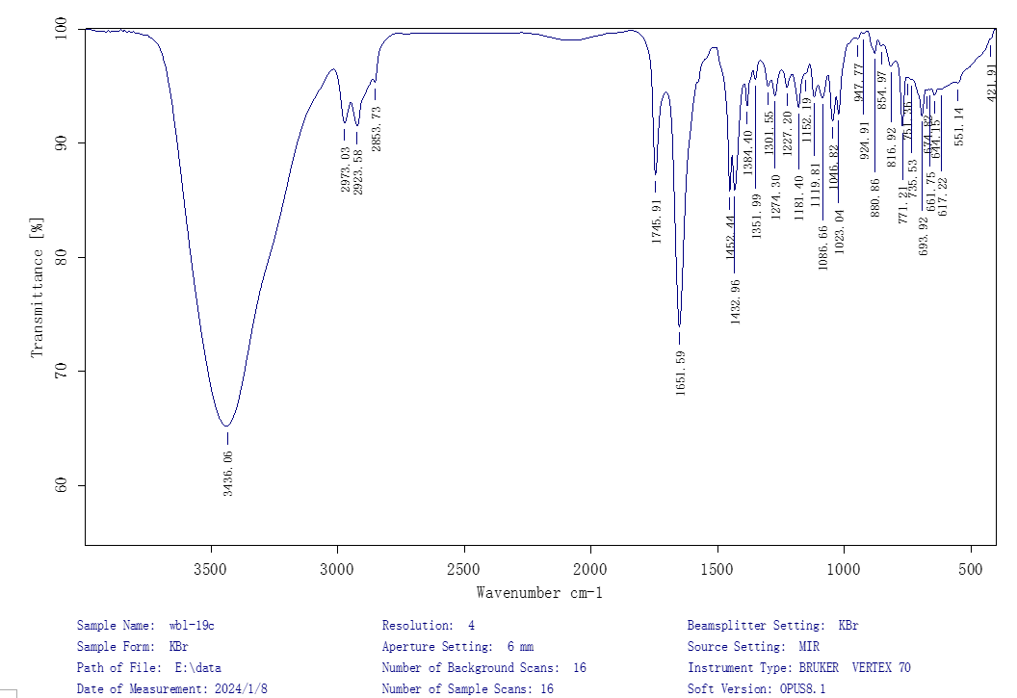

Figure S8. HR-ESIMS spectrum of 1
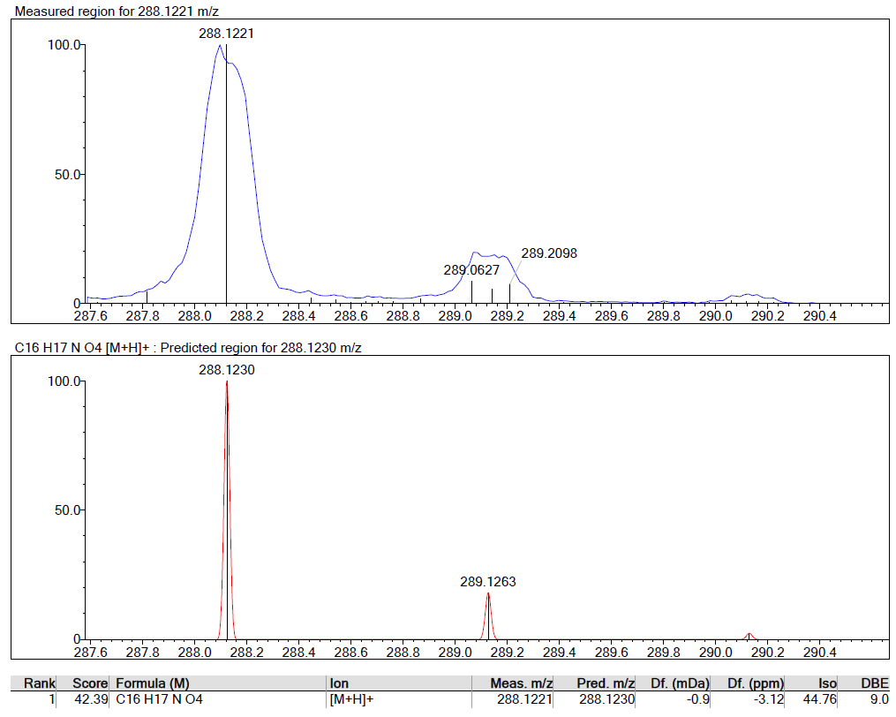

Figure S9. UV spectrum of compound 1
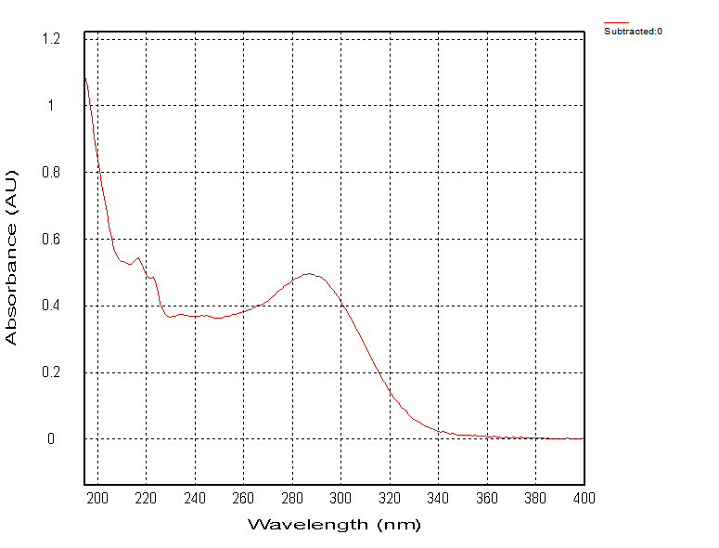

Figure S10. Circular dichroism spectrum of 1
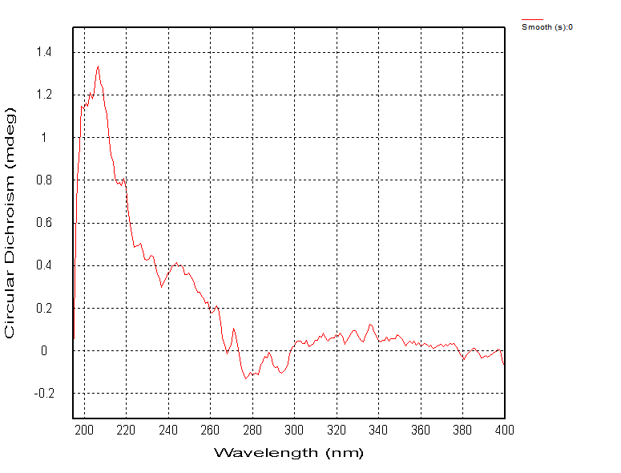

Figure S11. Specific rotation spectrum of 1
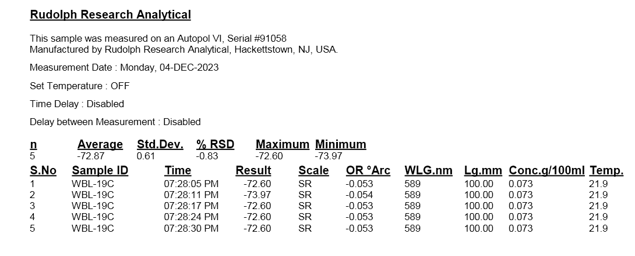

Figure S12. ¹H NMR spectrum (600 MHz, CD₃OD) of 2

Figure S13. ¹³C NMR and DEPT spectrum (150 MHz, CD₃OD) of 2

Figure S14. HSQC spectrum (600 MHz, CD₃OD) of 2

Figure S15. HMBC spectrum (600 MHz, CD₃OD) of 2

Figure S16. ¹H-¹H COSY spectrum (600 MHz, CD₃OD) of 2
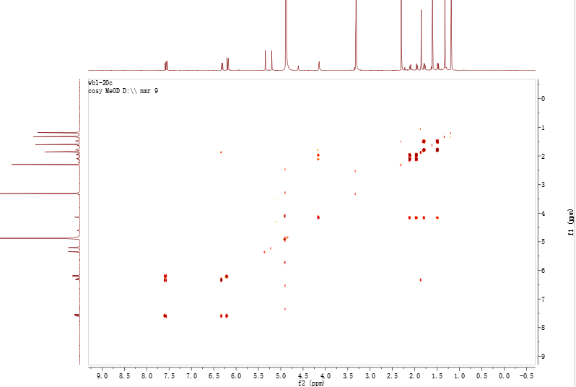

Figure S17. NOESY spectrum (600 MHz, CD₃OD) of 2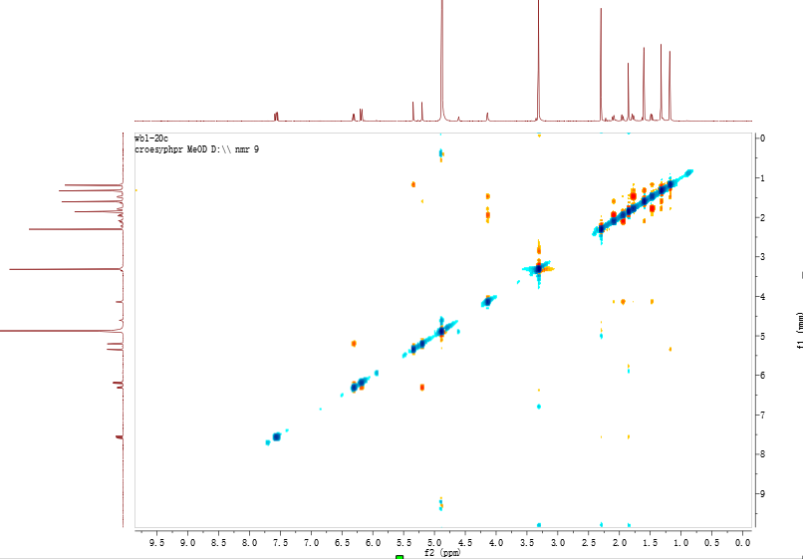

Figure S18. IR spectrum of 2
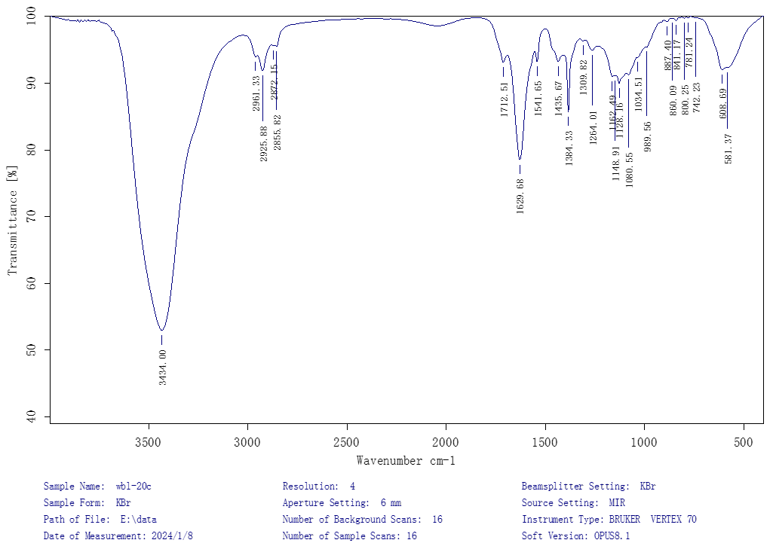

Figure S19. HRESIMS spectrum of 2
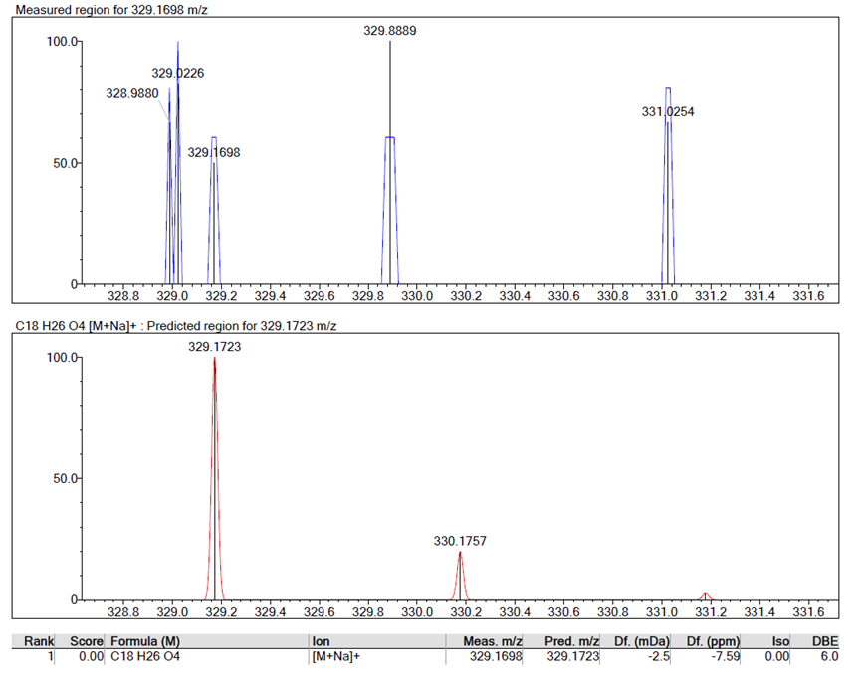

Figure S20. UV spectrum of compound 2
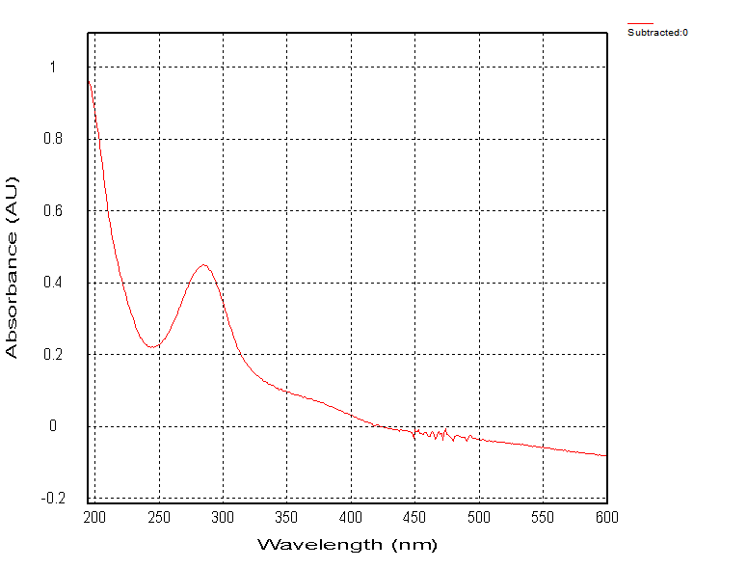

Figure S21. Circular dichroism spectrum of 2
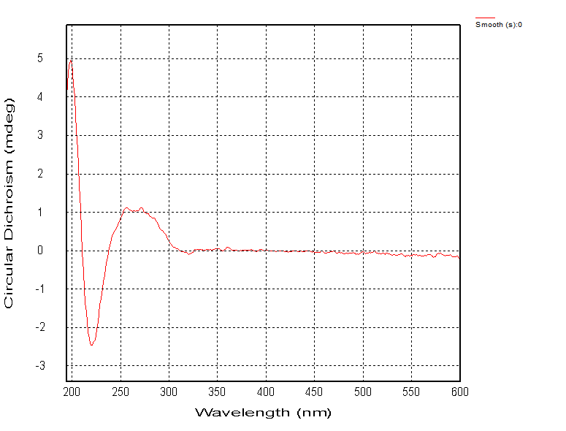

ECD Calculation Details.
The conformation search was performed by Spartan 14.0 software using Molecular Merck force field (MMFF). The appropriate low-energy conformers were selected and optimized in the gas phase using the Gaussian 16 program package. Further optimization and frequency analysis were carried out using density functional theory (DFT) at the B3LYP/6-31G(d,p) level. Solvent effects were accounted for by employing the conductor polarizable continuum model (CPCM). All conformers were utilized for calculating electronic circular dichroism (ECD) through the time-dependent density functional theory (TDDFT) method at the B3LYP/6-31G(d, p) level with the CPCM model in MeOH. The overall calculated ECD curves were generated by Boltzmann weighting the selected low-energy conformers using SpecDis 1.62 with σ ≈ 0.3 eV

Plant material
L. barbarum leaves were gathered from Zhongning country in P. R. China on May 10, 2016, kept dry, and ventilated. And the material was discerned by Dr. Jian-Fei Liu from LanZhou Institute of Chemical Physics, CAS. The voucher specimen (No. 20160510) has been stored in a dried environment of Kunming Institute of botany, Chinese Academy of Sciences.

Extraction and purification
The 14.0 kg of air-dried L. barbarum leaves were ground into powder and extracted four times at room temperature using 85% ethanol (each 80 L). A crude residue (3.0 kg) was obtained by concentrating the mixed extracts under lower pressure. After dissolving the crude residue in 5.0 L of water, it was extracted five times using ethyl acetate, yielding 780.0 g of ethyl acetate extract. Six fractions (Frs. A‒F) were obtained by subjecting this to silica gel column chromatography (Si CC) and eluting it gradually using a mixed solvent of MeOH−CHCl₃ (0:100, 10:90, 20:80, 30:70, 40:60 and 50:50, v/v).
Fr. D (87.0 g) was separated via MCI gel CHP 20P CC, eluted with MeOH−H₂O (30:70 to 100:0) to obtain Frs. D₁‒D₄. Fr. D₄ was then purified on an Rp-C18 gel column, eluted with MeOH−H₂O (50:50), yielding compound 32 (10.0 g).
Fr. E (99.0 g) was separated using an MCI gel CHP 20P CC with a MeOH−H₂O (30:70 to 100:0) gradient, resulting in four fractions (Frs. E₁‒E₄). Fr. E₁ (5.0 g) underwent Si CC (CHCl₃−acetone, 20:1 to 10:1), isolating compound 5 (5.0 mg). Further purification involved Si CC (petroleum ether−EtOAc, 3:1 to 2:1) and Sephadex LH-20 (MeOH), yielding compounds 24 (20.0 mg), 13 (5.0 mg), and 14 (20.0 mg).
Fr. E₂ was purified on an Rp-C18 gel column with MeOH−H₂O (30:70 to 100:0), and Sephadex LH-20 (MeOH), producing compounds 28 (1.0 g), 23 (20.0 mg), 25 (100.0 mg), 9 (5.0 mg), 27 (10.0 mg), 28 (5.0 mg), and 33 (4.1 mg). The remaining portion was processed by HPLC to yield compounds 5 (40.0 mg, t_{R} = 24 min; CH₃CN−H₂O, 20:80) and 10 (40.0 mg, t_{R} = 27 min; CH₃CN−H₂O, 20:80). Fr. E₄ was purified via HPLC to yield compounds 2 (4.2 mg, t_{R} = 35 min; CH3CN−H2O, 45:55), 4 (6.8 mg, t_{R} = 31 min; CH₃CN−H₂O, 15:85), and 7 (2.0 mg, t_{R} = 14 min; CH₃CN−H₂O, 12:88).
Fraction F (80.0 g) was separated via MCI gel CHP 20P CC with a MeOH−H₂O (20:80 to 100:0) gradient, resulting in three fractions (Fr. F₁‒F₃). Fr. F_{1.1} (6.5 g) underwent Si CC (petroleum ether−acetone, 4:1 to 1:1) and Sephadex LH-20 (MeOH), isolating compounds 21 (2.0 g), 22 (10.0 mg), and 29 (4.5 mg). Subfraction Fr._{1.2} was further purified using Si CC (CHCl₃−acetone, 30:1) to yield compounds 6 (10.0 mg), 20 (25.0 mg) and compound 3 (13.0 mg). HPLC was used to isolate compounds 1 (5.2 mg, t_{R} = 21 min; CH₃CN−H₂O, 29:71) and 17 (30.0 mg, retention time = 24 min; CH₃CN−H₂O, 20:80) from Fr. F_{1.3}. Fr. F₂ (15.0 g) was chromatographed on Si CC (petroleum ether−EtOAc, 6:1 to 1:1) to obtain compounds 15 (2.0 mg), 16 (4.2 mg), 19 (5.0 mg), 26 (16.0 mg), followed by Sephadex LH-20 (MeOH) to yield compounds and 31 (4.1 mg), 18 (50.0 mg), 8 (2.0 mg), and 34 (100.0 mg).

Table S1. The cell viabilities of 34 compounds on MH7A by LPS induction
No. | Group | Cell viability (%) | P value
Screening 1 | Control | 100.00±0.50 | -
Screening 1 | Model | 123.02±1.35 | 0.000
Screening 1 | Compound 20 | 108.69±1.09 | 0.000
Screening 1 | Compound 21 | 99.58±0.78 | 0.000
Screening 2 | Control | 100.00±0.92 | -
Screening 2 | Model | 129.56±0.87 | 0.000
Screening 2 | Compound 4 | 103.32±2.96 | 0.000
Screening 2 | Compound 8 | 105.86±2.10 | 0.000
Screening 3 | Control | 100.00±0.04 | -
Screening 3 | Model | 115.98±0.94 | 0.000
Screening 3 | Compound 6 | 104.28±1.04 | 0.000
Screening 3 | Compound 29 | 112.46±1.06 | 0.009
Screening 4 | Control | 100.00±0.20
Screening 4 | Model | 118.07±2.32 | 0.000
Screening 4 | Compound 5 | 116.99±2.34 | 0.601
Screening 4 | Compound 30 | 98.69±0.68 | 0.000
Screening 5 | Control | 100.00±0.45 | -
Screening 5 | Model | 116.47±2.64 | 0.000
Screening 5 | Compound 2 | 103.46±0.77 | 0.001
Screening 5 | Compound 9 | 102.50±1.11 | 0.001
Screening 6 | Control | 100.00±0.75 | -
Screening 6 | Model | 117.83±1.61 | 0.000
Screening 6 | Compound 12 | 99.88±0.57 | 0.000
Screening 6 | Compound 13 | 100.51±0.73 | 0.000
Screening 7 | Control | 100.00±0.55 | -
Screening 7 | Model | 115.44±1.06 | 0.000
Screening 7 | Compound 15 | 114.34±1.44 | 0.430
Screening 7 | Compound 23 | 96.54±2.07 | 0.000
Screening 8 | Control | 100.00±0.81 | -
Screening 8 | Model | 115.24±3.68 | 0.011
Screening 8 | Compound 14 | 94.84±1.80 | 0.000
Screening 8 | Compound 17 | 95.57±1.92 | 0.001
Screening 9 | Control | 100.00±1.26 | -
Screening 9 | Model | 114.09±2.18 | 0.003
Screening 9 | Compound 31 | 95.32±2.70 | 0.000
Screening 10 | Control | 100.00±1.05 | -
Screening 10 | Model | 116.92±3.27 | 0.001
Screening 10 | Compound 24 | 107.52±1.33 | 0.009
Screening 10 | Compound 25 | 117.68±1.11 | 0.723
Screening 11 | Control | 100.00±3.14 | -
Screening 11 | Model | 124.72±0.86 | 0.000
Screening 11 | Compound 11 | 98.44±0.78 | 0.000
Screening 11 | Compound 19 | 107.27±2.59 | 0.000
Screening 12 | Control | 100.00±1.67 | -
Screening 12 | Model | 128.68±0.72 | 0.000
Screening 12 | Compound 10 | 105.63±0.66 | 0.000
Screening 12 | Compound 16 | 109.24±1.27 | 0.000
Screening 13 | Control | 100.00±1.04 | -
Screening 13 | Model | 114.36±2.41 | 0.000
Screening 13 | Compound 3 | 106.42±2.83 | 0.014
Screening 13 | Compound 7 | 114.85±1.80 | 0.784
Screening 13 | Compound 18 | 98.47±0.90 | 0.000
Screening 14 | Control | 100.00±1.18 | -
Screening 14 | Model | 121.72±2.51 | 0.000
Screening 14 | Compound 34 | 115.31±6.02 | 0.164
Screening 15 | Control | 100.00±3.47 | -
Screening 15 | Model | 112.91±2.30 | 0.005
Screening 15 | Compound 1 | 98.72±1.62 | 0.000
Screening 16 | Control | 100.00±4.29 | -
Screening 16 | Model | 114.54±0.90 | 0.004
Screening 16 | Compound 27 | 115.66±2.16 | 0.453
Screening 16 | Compound 32 | 96.45±1.74 | 0.000
Screening 16 | Compound 33 | 112.37±1.89 | 0.147
Screening 17 | Control | 100.00±2.07 | -
Screening 17 | Model | 121.01±2.18 | 0.000
Screening 17 | Compound 26 | 116.76±2.30 | 0.420
Screening 17 | Compound 22 | 104.95±4.77 | 0.110
Screening 17 | Compound 28 | 118.49±1.83 | 0.200

Table S2. The effect of 24 compounds on the production of NO in LPS-induced MH7A
NO. | Group | NO (μM) | P value
Screening 1 | Control | 0.92±0.06 | -
Screening 1 | Model | 1.36±0.04 | 0.000
Screening 1 | Compound 2 | 1.00±0.10 | 0.004
Screening 2 | Control | 0.84±0.05 | -
Screening 2 | Model | 1.20±0.04 | 0.000
Screening 2 | Compound 4 | 1.15±0.01 | 0.183
Screening 2 | Compound 12 | 1.07±0.03 | 0.018
Screening 2 | Compound 14 | 0.92±0.07 | 0.004
Screening 3 | Control | 0.72±0.02 | -
Screening 3 | Model | 1.29±0.03 | 0.000
Screening 3 | Compound 19 | 1.01±0.08 | 0.006
Screening 4 | Control | 0.92±0.06 | -
Screening 4 | Model | 1.26±0.04 | 0.001
Screening 4 | Compound 16 | 1.00±0.10 | 0.014
Screening 5 | Control | 0.77±0.03 | -
Screening 5 | Model | 1.31±0.02 | 0.000
Screening 5 | Compound 9 | 1.30±0.03 | 0.590
Screening 5 | Compound 13 | 1.25±0.03 | 0.081
Screening 5 | Compound 21 | 1.14±0.02 | 0.000
Screening 6 | Control | 0.79±0.01 | -
Screening 6 | Model | 1.29±0.03 | 0.000
Screening 6 | Compound 29 | 1.07±0.03 | 0.008
Screening 6 | Compound 30 | 1.24±0.03 | 0.192
Screening 6 | Compound 32 | 1.25±0.05 | 0.367
Screening 7 | Control | 0.79±0.01 | -
Screening 7 | Model | 1.27±0.02 | 0.000
Screening 7 | Compound 6 | 1.16±0.03 | 0.007
Screening 7 | Compound 24 | 1.23±0.02 | 0.093
Screening 8 | Control | 0.75±0.06 | -
Screening 8 | Model | 1.17±0.03 | 0.000
Screening 8 | Compound 3 | 1.01±0.05 | 0.038
Screening 8 | Compound 17 | 0.85±0.01 | 0.000
Screening 8 | Compound 18 | 0.82±0.04 | 0.000
Screening 10 | Control | 0.92±0.02 | -
Screening 10 | Model | 1.34±0.01 | 0.000
Screening 10 | Compound 11 | 1.06±0.07 | 0.003
Screening 10 | Compound 20 | 1.31±0.05 | 0.361
Screening 11 | Control | 0.75±0.04 | -
Screening 11 | Model | 1.20±0.04 | 0.000
Screening 11 | Compound 8 | 0.92±0.04 | 0.001
Screening 11 | Compound 31 | 0.92±0.02 | 0.000
Screening 12 | Control | 0.73±0.03 | -
Screening 12 | Model | 1.40±0.05 | 0.000
Screening 12 | Compound 1 | 0.75±0.04 | 0.000
Screening 12 | Compound 10 | 1.02±0.02 | 0.000
Screening 12 | Compound 23 | 1.38±0.01 | 0.689

Table S3. The effect of 24 compounds on the release of LDH in LPS-induced MH7A
No. | Group | LDH (U/gprot) | P value
Screening 1 | Control | 1.29±0.03 | -
Screening 1 | Model | 1.60±0.02 | 0.000
Screening 1 | Compound 3 | 1.35±0.02 | 0.000
Screening 1 | Compound 17 | 1.38±0.01 | 0.000
Screening 1 | Compound 18 | 1.30±0.01 | 0.000
Screening 2 | Control | 0.92±0.02 | -
Screening 2 | Model | 1.80±0.04 | 0.000
Screening 2 | Compound 8 | 1.28±0.04 | 0.000
Screening 3 | Control | 1.11±0.02 | -
Screening 3 | Model | 1.71±0.02 | 0.000
Screening 3 | Compound 10 | 1.38±0.06 | 0.001
Screening 4 | Control | 1.24±0.02 | -
Screening 4 | Model | 1.44±0.03 | 0.000
Screening 4 | Compound 14 | 1.29±0.02 | 0.002
Screening 5 | Control | 1.13±0.04 | -
Screening 5 | Model | 1.63±0.03 | 0.000
Screening 5 | Compound 1 | 1.10±0.01 | 0.000
Screening 5 | Compound 2 | 1.26±0.05 | 0.000
Screening 5 | Compound 4 | 1.56±0.05 | 0.118
Screening 5 | Compound 19 | 1.34±0.03 | 0.000
Screening 6 | Control | 1.20±0.06 | -
Screening 6 | Model | 1.38±0.01 | 0.010
Screening 6 | Compound 12 | 1.33±0.03 | 0.139
Screening 6 | Compound 16 | 1.35±0.04 | 0.315
Screening 7 | Control | 1.29±0.05 | -
Screening 7 | Model | 1.49±0.04 | 0.005
Screening 7 | Compound 11 | 1.42±0.03 | 0.060
Screening 7 | Compound 30 | 1.42±0.03 | 0.080
Screening 7 | Compound 32 | 1.40±0.01 | 0.021
Screening 8 | Control | 0.92±0.06 | -
Screening 8 | Model | 1.39±0.07 | 0.000
Screening 8 | Compound 6 | 1.26±0.03 | 0.044
Screening 8 | Compound 13 | 1.32±0.03 | 0.217
Screening 8 | Compound 29 | 1.20±0.03 | 0.013
Screening 9 | Control | 1.27±0.03 | -
Screening 9 | Model | 1.62±0.04 | 0.000
Screening 9 | Compound 20 | 1.56±0.01 | 0.056
Screening 9 | Compound 21 | 1.58±0.01 | 0.115
Screening 9 | Compound 23 | 1.57±0.06 | 0.305
Screening 9 | Compound 24 | 1.56±0.03 | 0.100
Screening 10 | Control | 1.28±0.01 | -
Screening 10 | Model | 1.41±0.02 | 0.000
Screening 10 | Compound 9 | 1.28±0.04 | 0.004
Screening 10 | Compound 31 | 1.33±0.01 | 0.002

Table S4. The summary of effective compounds on both NO and LDH
Compounds | NO inhibitory rate (%) | LDH inhibitory rate (%)
1 | 46.7 | 32.8
2 | 26.8 | 22.8
3 | 10.2 | 16.0
6 | 8.8 | 9.5
8 | 23.4 | 28.6
10 | 26.9 | 19.3
14 | 23.6 | 10.4
17 | 26.9 | 14.1
18 | 29.6 | 18.7
19 | 21.6 | 17.6
29 | 16.9 | 13.7
31 | 3.1 | 6.0

