Supplementary Material

Bioprospecting Cultivable Bacteria Associated with Deep Sea (Mesopelagic) Fish of the North Atlantic Ocean

Ernest Oppong-Danquah¹, Jana Heumann¹, Hannah Moosbauer¹, Martina Blümel¹, Arlette Wenzel-Storjohann¹, and Deniz Tasdemir^{1,2*}
¹GEOMAR Centre for Marine Biotechnology (GEOMAR-Biotech), Research Unit Marine Natural Products Chemistry, GEOMAR Helmholtz Centre for Ocean Research Kiel, Kiel, Germany
²Kiel University, Kiel, Germany
* Correspondence:
Deniz Tasdemir
dtasdemir@geomar.de

List of Supplementary Figures Page No.
Fig. S1. Sampling locations along the transect of the IESSNS cruise 2
Fig. S 2. Diversity of isolated bacteria at phylum level at different sampling points 2
Fig. S 3. Distribution of fish isolates based on tissue sampled 3
Fig. S 4. Molecular network derived from positive ion mode MS/MS data 4
Fig. S 5. Molecular network derived from negative ion mode MS/MS data 5

List of Supplementary Tables Page No.
Table S1. Mesopelagic species and tissue types used for microbial isolation 6
Table S3. Test pathogens, their cultivation media and positive controls for bioactivity testing 7
Tables S2, S4 and S5 are on supplementary excel sheet

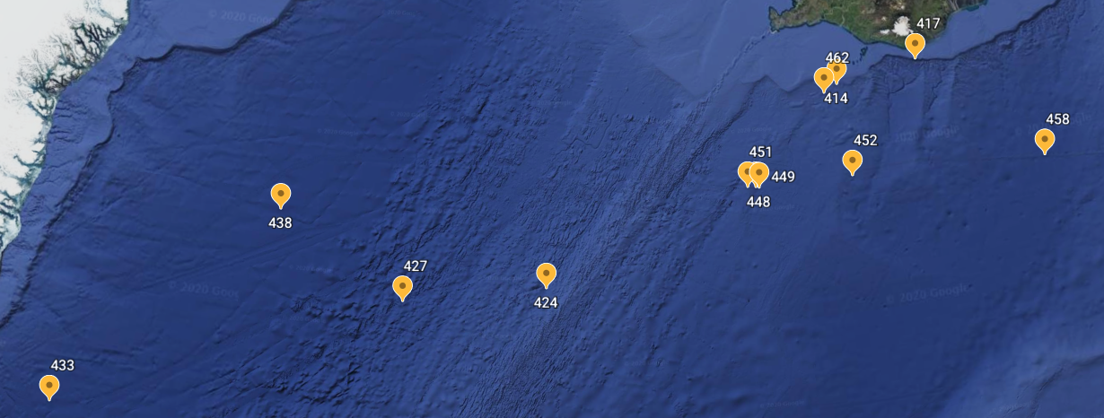
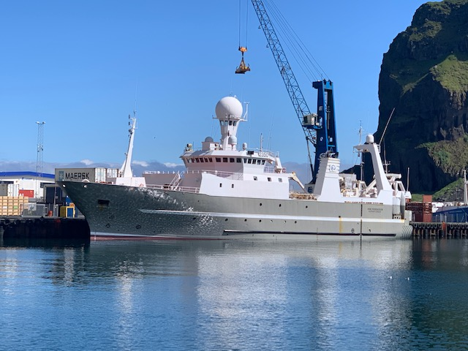
Cruise track IESSNS 13.-30.7.20
Irminger Sea
Greenland
Iceland

Fig. S1 Sampling locations along the transect of the International Ecosystem Summer Survey in the Nordic Seas (IESSNS) cruise.

Fig. S2 Diversity of isolated bacteria at phylum level from mesopelagic animals at different sampling stations. Geographical coordinate for all sampling stations are provided in Table 1.

Fig. S3 Distribution of fish isolates based on tissue sampled.

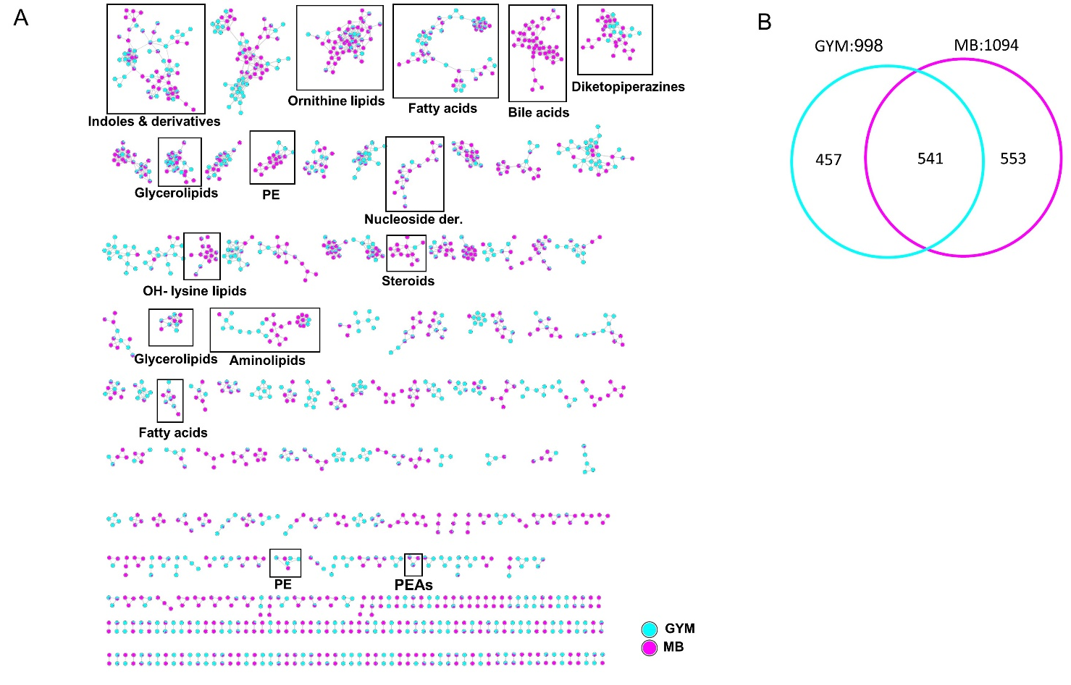
Fig. S4 (A) Molecular network derived from positive ion MS/MS data of the 26 most active extracts (B) Euler diagram displaying the peak ion distribution among the culture media Marine Broth (MB) and Glucose-Yeast-Malt (GYM). PE: phosphatidylethanolamines, PEAs: phenylethylamides.

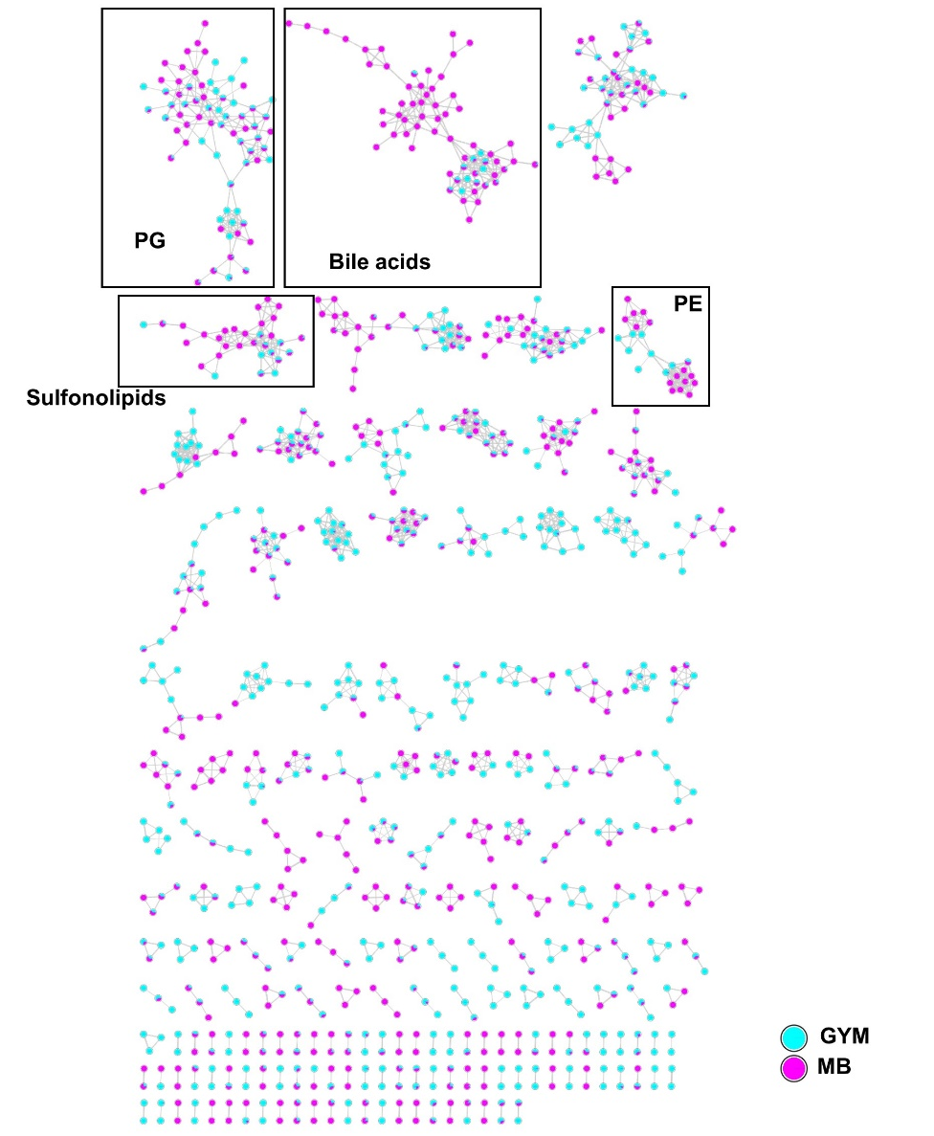
Fig. S5 Molecular network derived from negative ion mode MS/MS data of the 26 most active extracts according to cultivation media Marine Broth (MB) and GYM (Glucose-Yeast-Malt). PE: phosphatidylethanolamines, PG: phosphatidylglycerol.

Table S1 Mesopelagic species and tissue types used for microbial isolation
Sample type | Species | Family | Tissue | Amount plated
Fish | Arctozenus rissoi | Paralepididae | Gill in 500 µl sterile seawater  Gut after stomach | 1:100 dilution plated
Fish | Bathylagus euryops | Bathylagidae | Skin swab, 1:100 dilution plated  Gill in 500 µl sterile seawater  Gut in 500 µl sterile seawater | 1:100 dilution plated
Fish | Benthosema glaciale | Myctophidae | Gill in 500 µl sterile seawater  Gut in 500 µl sterile seawater | 1:100 dilution plated
Fish | Cyclothone microdon | Gonostomatidae | Gill in 500 µl sterile seawater  Gut in 500 µl sterile seawater | 1:100 dilution plated
Fish | Chauliodus sloani | Stomiidae | Gill in 500 µl sterile seawater  Gut in 500 µl sterile seawater | 1:100 dilution plated
Fish | Myctophum punctatum | Myctophidae | Gill in 500 µl sterile seawater  Gut in 500 µl sterile seawater | 1:100 dilution plated
Fish | Maurolicus muelleri | Sternoptychidae | Outer surface of umbrella  Inner surface of umbrella | 1:100 dilution plated
Fish | Notoscopelus kroyeri | Myctophidae | Gill in 500 µl sterile seawater  Gut after stomach | 1:100 dilution plated
Fish | Protomyctophum arcticum | Myctophidae | Outer surface of umbrella  Inner surface of umbrella | 1:100 dilution plated
Fish | Paralepis coregonoides | Paralepididae | Outer surface of umbrella  Inner surface of umbrella | 1:100 dilution plated
Fish | Scopelogadus beanii | Melamphaidae | Gill in 500 µl sterile seawater | 1:100 dilution plated
Fish | Stomias boa ferox | Stomiidae | Gill in 500 µl sterile seawater  Gut in 500 µl sterile seawater | 1:100 dilution plated
Fish | Xenodermichthys copei | Alepocephalidae | Skin swab, 1:100 dilution plated  Gill in 500 µl sterile seawater  Gut in 500 µl sterile seawater | 1:100 dilution plated
Jellyfish | Atolla sp. | Atollidae | Surface swab  Inner hat tissue of jellyfish | 1:100 dilution plated
Krill | Meganyctiphanes norvegica | Euphausiidae | Surface swab | 1:100 dilution plated
Squid | Gonatus sp. | Gonatidae | Surface swab  Inner body, intestines  Inner body, ink sac | 1:100 dilution plated
Seawater | Seawater | Seawater | 100 µl plated | 100 µl plated

Table S3 Test pathogens, their cultivation media and positive controls for bioactivity testing

Test pathogen | Abbreviation | Positive control (conc.) | Medium
Escherichia coli | Ec | 10µM Chloramphenicol | TSB12
Methillicin resistent Staphylococcus aureus | MRSA | 10µM Chloramphenicol | TSB12
Klebsiella pneumoniae | Kp | 10µM Chloramphenicol | TSB12
Acinetobacter baumannii | Ab | 10µM Doxocycline | TSB12
Pseudomonas aeruginosa | Psa | 10µM Polymyxin B | TSB12
Enterococcus faecium | Efm | 10µM Ampicillin | M92
Candida albicans | Ca | 10µM Nystatin | M186/3
Cryptococcus neoformans | Cn | 10µM Amphotericin B | M186
Lactococcus garviae | Lg | 10µM Ampicillin | M92
Vibrio ichthyoenteri | Vi | 10µM Chloramphenicol | MB
Human melanoma | A-375 | 100µg/ml Doxorubicin | RPMI + 10/FBS + 1%PS
Colon cancer | HCT-116 | 100µg/ml Doxorubicin | DMEM + 10%FBS + 1%PS
Human keratinocytes | HaCaT | 100µg/ml Doxorubicin | DMEM + 10%FBS + 1%PS
TSB12: 12g tryptic soy broth, 5g NaCl in 1L H₂O
M92: 30g tryptic soy broth, 3g yeast extract in 1L H₂O (pH 7,0-7,2)
M186: 3g yeast extract, 3g malt extract, 5g peptone from soybeans, 10g Glucose
M186/3: M186 1:3 diluted
DMEM: (Dulbecco's Modified Eagle Medium)
FBS: Fetal bovine serum
PS: Sodium Pyruvate

