Cortinarius mapuveronicae from South America, a chemical and morphological link between European and Australian dermocyboid Cortinarii

Josefine Lange¹⁺, Lesley Huymann²⁺, Sophie Schwarzkopf ³, Dilara Balci¹, Mehdi D. Davari¹, Arijana Turanovic³, Clemens Gotsis², Götz Palfner⁴, Bianka Siewert^{3, 5}, Ursula Peintner^{2*}, and Norbert Arnold^{1*}

¹Department of Bioorganic Chemistry, Leibniz Institute of Plant Biochemistry, Weinberg 3, D-06120 Halle (Saale), Germany
²Department of Microbiology, University Innsbruck, Technikerstr. 25, 6020 Innsbruck, Austria
³Institute of Pharmacy, University of Innsbruck, Innrain 80-82, 6020 Innsbruck, Austria
⁴Departamento de Botanica, Facultad de Ciencias Naturales y Oceanograficas, Universidad de Concepción, Casilla 160-C, Concepción, Chile
⁵current address: Institute of Pharmacy, University of Hamburg, Bundesstr. 45, 20146 Hamburg, Germany

*Corresponding authors Norbert Arnold (Norbert.Arnold@ipb-halle.de); Ursula Peintner (Ursula.Peintner@uibk.ac.at)
⁺first authors (equal contribution)

ORCID
Josefine Lange ORCID 0009-0005-1049-5603
Lesley Huymann ORCID 0000-0002-0483-0031
Dilara Balci ORCID 0009-0008-8159-5443
Sophie Schwarzkopf ORCID 0009-0003-9530-0179
Mehdi D. Davari ORCID 0000-0003-0089-7156
Clemens Gotsis ORCID 0000-0001-6847-7970
Götz Palfner ORCID 0000-0001-6098-728X
Bianka Siewert ORCID 0000-0002-4910-1756
Ursula Peintner ORCID 0000-0001-5388-4266
Norbert Arnold ORCID 0000-0003-2925-2263

Supplementary Information
Table of Contents
Fig. S1 | TLC of ethylacetate extracts and isolated compounds (1-10)
Fig. S2 | Negative ion HRESIMS^{n} spectra of clavorubin-8-O-methylether (1)
Fig. S3 | ¹H NMR spectrum (500 MHz, THF-d₈) of clavorubin-8-O-methylether (1)
Fig. S4 | ¹³C NMR spectrum (125 MHz, THF-d₈) of clavorubin-8-O-methylether (1)
Fig. S5 | HSQC spectrum (500/125 MHz, THF-d₈) of clavorubin-8-O-methylether (1)
Fig. S6 | HMBC spectrum (500/125 MHz, THF-d₈) of clavorubin-8-O-methylether (1)
Fig. S7 | NOESY spectrum (500 MHz, THF-d₈) of clavorubin-8-O-methylether (1)
Fig. S8 | UV spectrum of clavorubin-8-O-methylether (1)
Fig. S9 | Negative ion HRESIMS^{n} spectra of (+)-7,7’-emodinphyscion (2)
Fig. S10 | ¹H NMR spectrum (500 MHz, pyridine-d₅) of (+)-7,7’-emodinphyscion (2)
Fig. S11 | ¹³C NMR spectrum (125 MHz, pyridine-d₅) of (+)-7,7’-emodinphyscion (2)
Fig. S12 | CD spectrum of (+)-7,7-emodinphyscion (2)
Fig. S13 | Negative ion HRESIMS^{n} spectra of emodin (3)
Fig. S14 | ¹H NMR spectrum (500 MHz, CDCl₃) of emodin (3)
Fig. S15 | HSQC spectrum (500/125 MHz, CDCl₃) of emodin (3)
Fig. S16 | HMBC spectrum (500/125 MHz, CDCl₃) of emodin (3)
Fig. S17 | Negative ion HRESIMS^{n} spectra of emodin-6,8-di-O-methylether (4)
Fig. S18 | ¹H NMR spectrum (500 MHz, CDCl₃) of emodin-6,8-di-O-methylether (4)
Fig. S19 | HSQC spectrum (500/125 MHz, CDCl₃) of emodin-6,8-di-O-methylether (4)
Fig. S20 | HMBC spectrum (500/125 MHz, CDCl₃) of emodin-6,8-di-O-methylether (4)
Fig. S21 | Negative ion HRESIMS^{n} spectra of questin (5)
Fig. S22 | ¹H NMR spectrum (500 MHz, CDCl₃) of questin (5)
Fig. S23 | HSQC spectrum (500/125 MHz, CDCl₃) of questin (5)
Fig. S24 | HMBC spectrum (500/125 MHz, CDCl₃) of questin (5)
Fig. S25 | Negative ion HRESIMS^{n} spectra of (+)-(S)-skyrin (6)
Fig. S26 | ¹H NMR spectrum (500 MHz, DMSO-d₆) of (+)-(S)-skyrin (6)
Fig. S27 | ¹³C NMR spectrum (125 MHz, DMSO-d₆) of (+)-(S)-skyrin (6)
Fig. S28 | CD spectrum of (+)-(S)-skyrin (6)
Fig. S29 | Negative ion HRESIMS^{n} spectrum of (+)-(S)-aurantioskyrin (7)
Fig. S30 | ¹H NMR spectrum (500 MHz, CDCl₃) of (+)-(S)-aurantioskyrin (7)
Fig. S31 | HSQC spectrum (500/125 MHz, CDCl₃) of (+)-(S)-aurantioskyrin (7)
Fig. S32 | HMBC spectrum (500/125 MHz, CDCl₃) of (+)-(S)-aurantioskyrin (7)
Fig. S33 | CD spectrum of (+)-aurantioskyrin (7)
Fig. S34 | Negative ion HRESIMS^{n} spectra of hypericin (8)
Fig. S35 | ¹H NMR spectrum (500 MHz, DMSO-d₆) of hypericin (8)
Fig. S36 | HSQC spectrum (500/125 MHz, DMSO-d₆) of hypericin (8)
Fig. S37 | HMBC spectrum (500/125 MHz, DMSO-d₆) of hypericin (8)
Fig. S38 | Negative ion HRESIMS^{n} spectra of dermolutein (9)
Fig. S39 | ¹H NMR spectrum (500 MHz, MeOD) of dermolutein (9)
Fig. S40 | ¹³C NMR spectrum (125 MHz, MeOD) of dermolutein (9)
Fig. S41 | Negative ion HRESIMS^{n} spectra of endocrocin (10)
Fig. S42 | ¹H NMR spectrum (500 MHz, MeOD) of endocrocin (10)
Fig. S43 | HSQC spectrum (500/125 MHz, MeOD) of endocrocin (10)
Fig. S44 | HMBC spectrum (500/125 MHz, MeOD) of endocrocin (10)
Fig. S45 | Negative ion HRESIMS^{n} spectra of clavorubin (11)
Fig. S46 | ¹H spectrum (500 MHz, DMSO-d₆ and THF-d₈) of clavorubin (11)
Fig. S47 | ¹³C NMR spectrum (125 MHz, THF-d₈) of clavorubin (11)
Fig. S48 | HSQC spectrum (500/125 MHz, THF-d₈) of clavorubin (11)
Fig. S49 | HMBC spectrum (500/125 MHz, THF-d₈) of clavorubin (11)
Fig. S50 | Maximum likelihood phylogenetic tree of ITS, LSU, and rpb1 data for the placement of the new species.
Fig. S51 | Isolation scheme.
Fig. S52 | Cell growth inhibition curves of the active anthraquinoid compounds 1, 3, 7, and 8
Fig. S53 | Growth inhibition curves of the active anthraquinoid compounds 3, 7, and 8
Table S1 | Collections examined in this study
Table S2 | Key ions in the negative HRESIMS² (ª) and HRESIMS³ (^{b}) spectra of the anthraquinones (2-11
Table S3 | Collections of C. mapuveronicae used for pigment-chemical studies
Table S4 | Basidiospore sizes of measured C. mapuveronicae collections
Table S5 | EC₅₀ values of the isolated compounds 1-10 tested against A549 and T24 cells under dark (D) and blue light (BL) irradiation conditions. Colchicine was used as positive control

Fig. S1 a TLC (silica gel 60, toluene / ethyl formate / formic acid (10:5:3, (v/v)) overview of ethylacetate extract (5 mg/mL) of C. mapuveronicae and isolated compounds (1-10, 0.5 mg/mL), 366 nm wet; b 366 nm dry; c daylight; d Bornträger reaction induced through ammonia vapor.
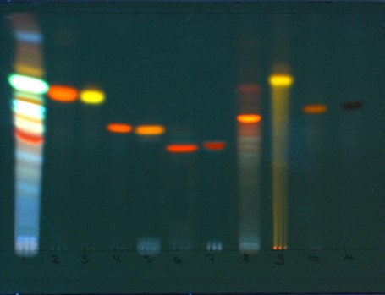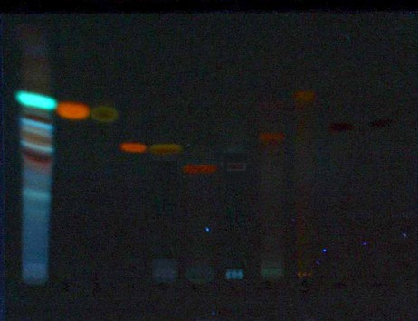
1 2 3 4 5 6 7 8 9 10 11
1 2 3 4 5 6 7 8 9 10 11
b
a
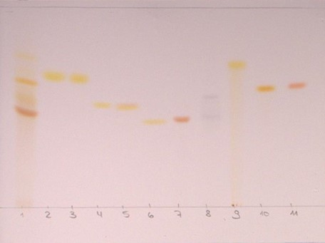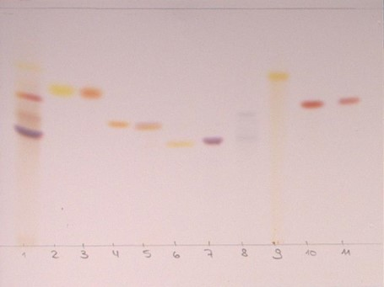
1 2 3 4 5 6 7 8 9 10 11
1 2 3 4 5 6 7 8 9 10 11
d
c

1 Ethylacetate extract of C. mapuveronicae
2 Emodin-6,8-di-O-methylether (4)
3 Emodin (3)
4 Questin (5)
5 Endocrocin (10)
6 Dermolutein (9)
7 Clavorubin-8-O-methylether (1)
8 Hypericin (8)
9 (+)-7,7’-Emodinphyscion (2)
10 (+)-(S)-Skyrin (6)
11 (+)-(S)-Aurantioskyrin (7)

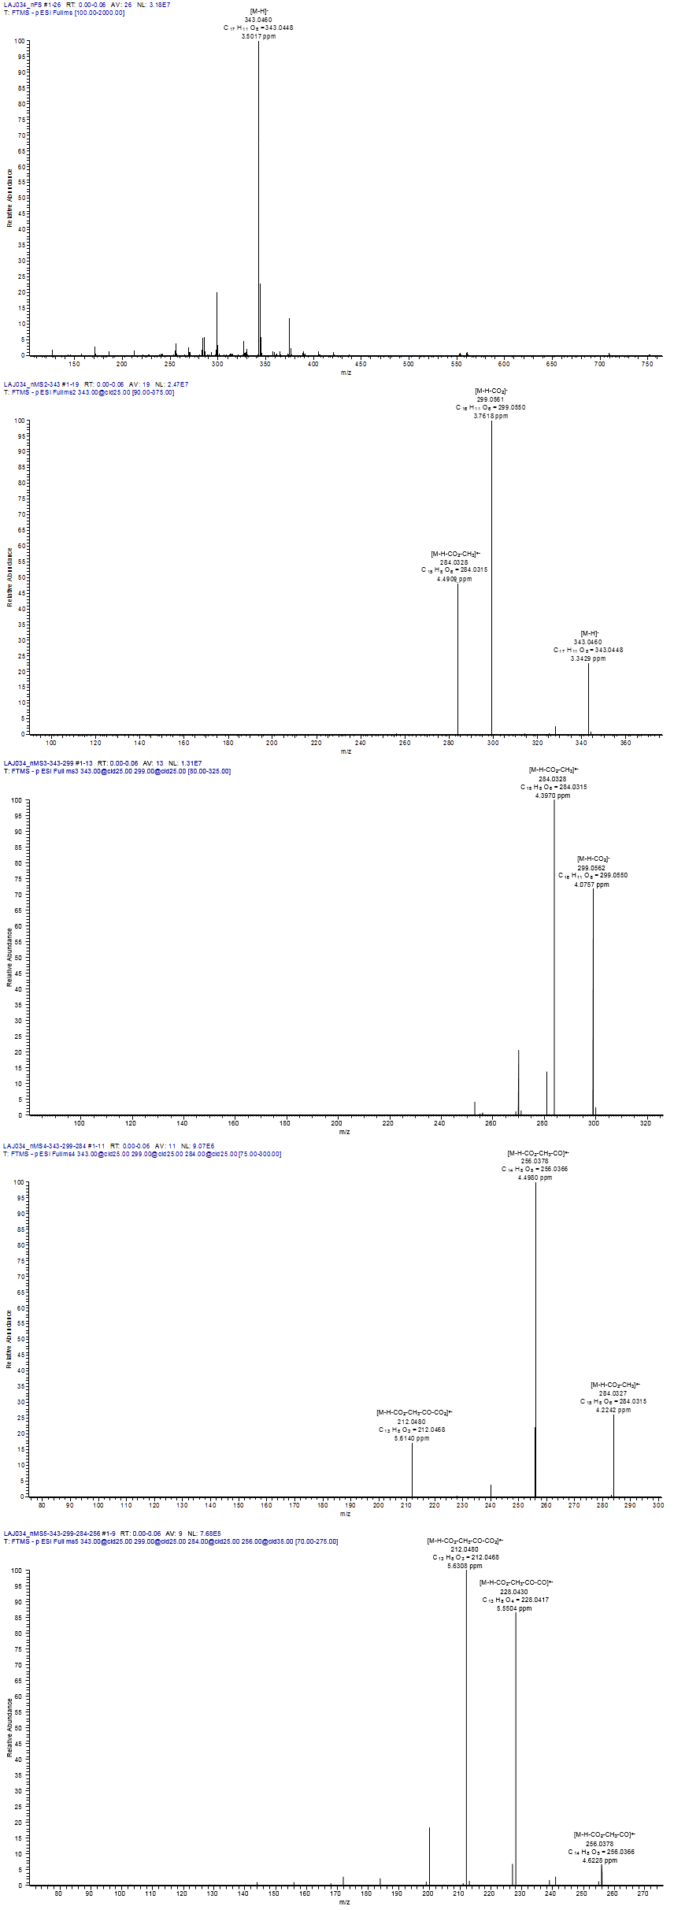
Fig. S2 Negative ion HRESIMS^{n} spectra of clavorubin-8-O-methylether (1).

Fig. S3 ¹H NMR spectrum (500 MHz, THF-d₈) of clavorubin-8-O-methylether (1).
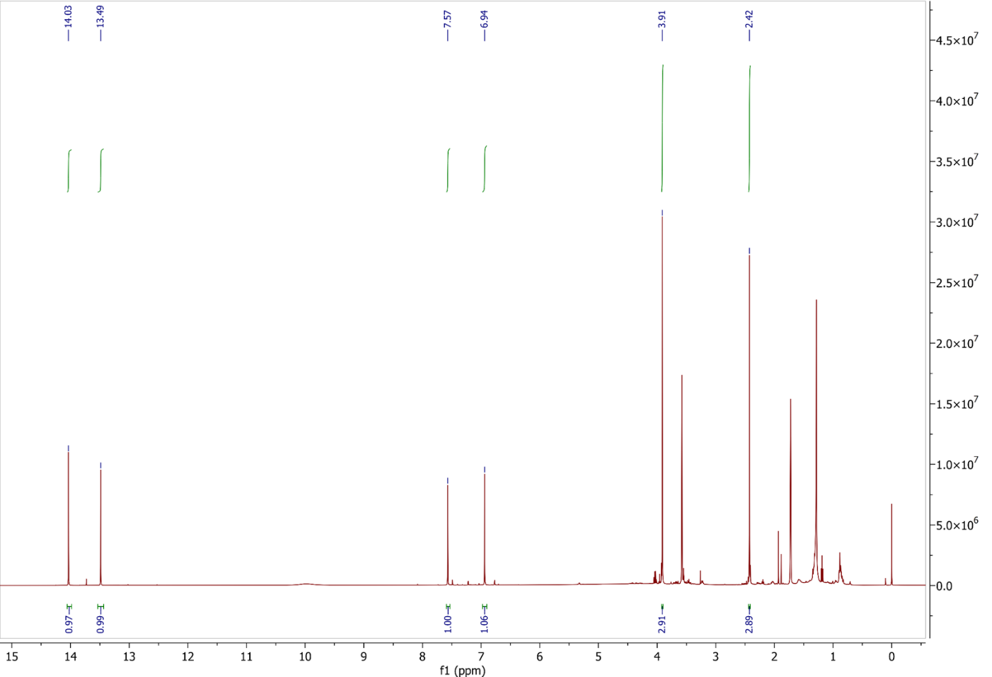

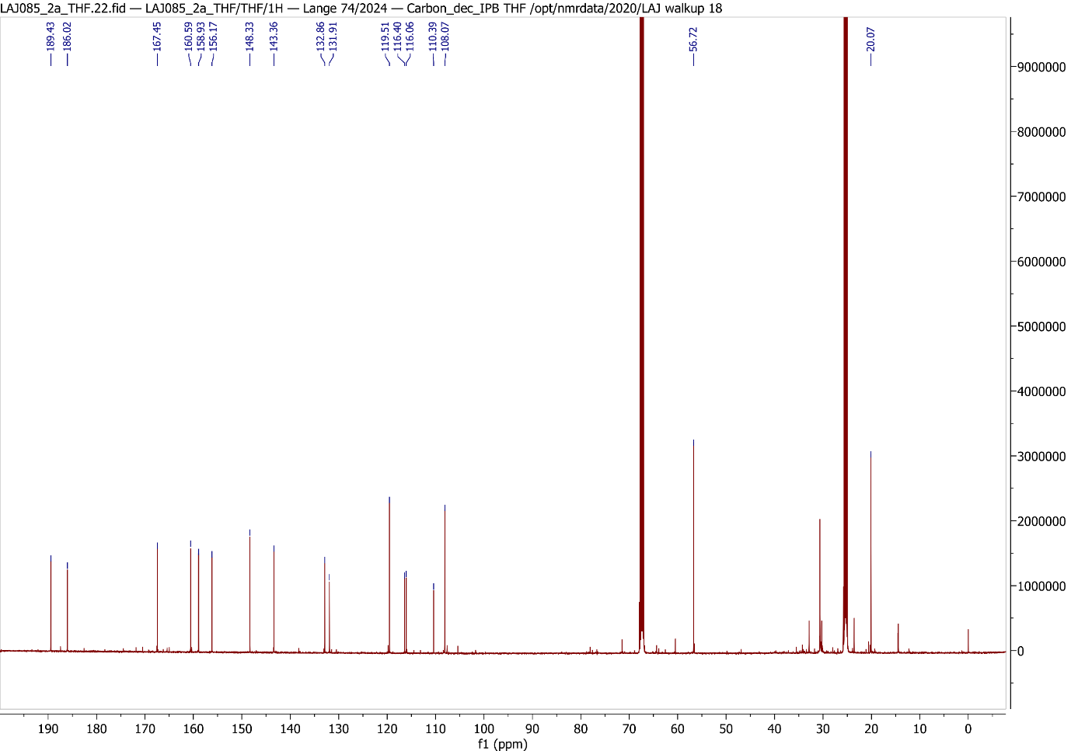
Fig. S4 ¹³C NMR spectrum (125 MHz, THF-d₈) of clavorubin-8-O-methylether (1).

Fig. S5 HSQC spectrum (500/125 MHz, THF-d₈) of clavorubin-8-O-methylether (1).
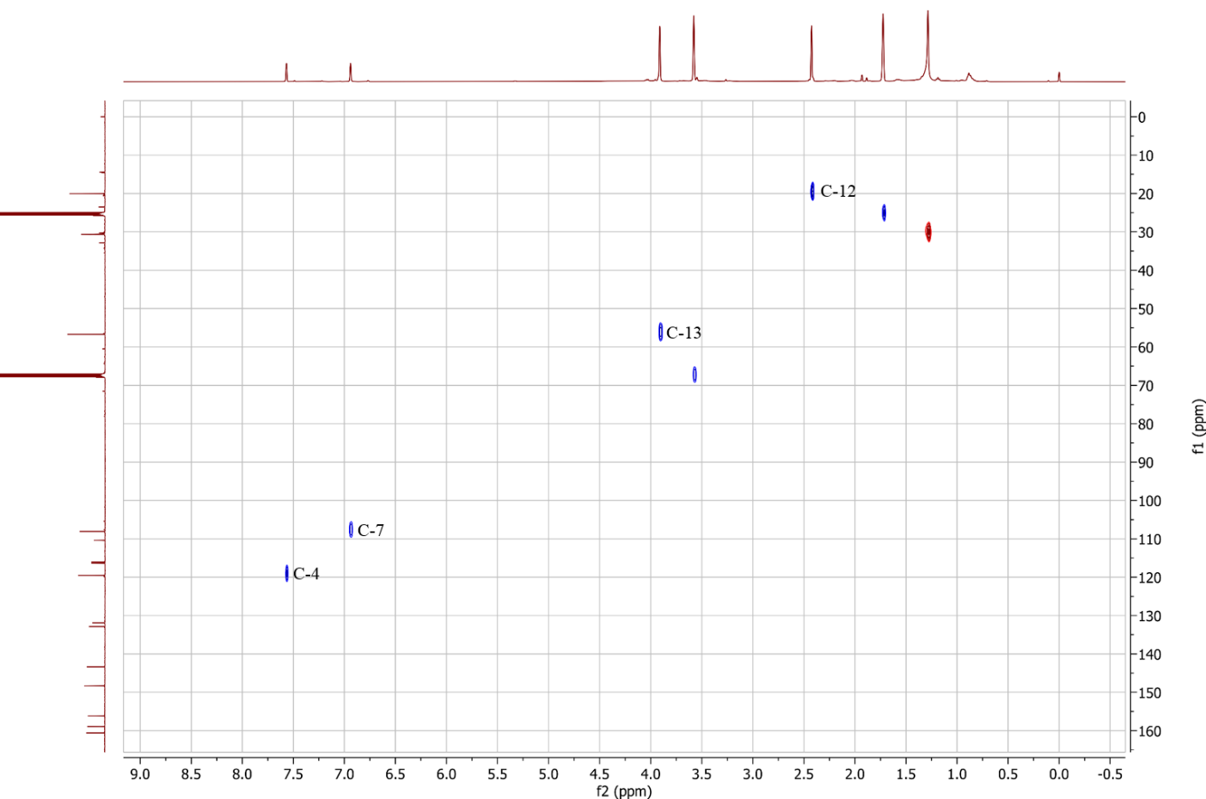

Fig. S6 HMBC spectrum (500/125 MHz, THF-d₈) of clavorubin-8-O-methylether (1).
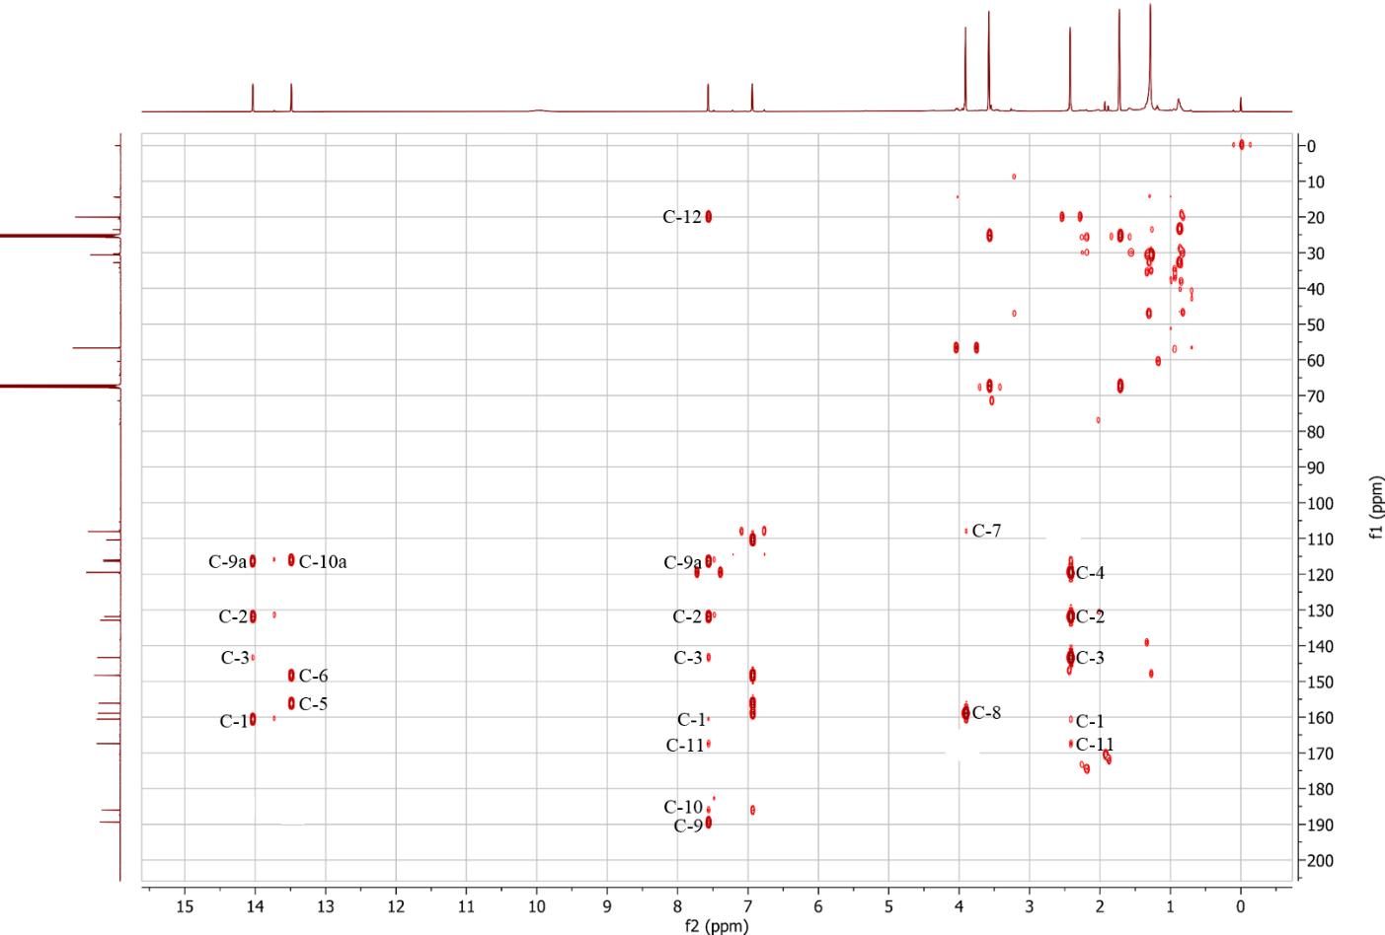

Fig. S7 NOESY spectrum (500/125 MHz, THF-d₈) of clavorubin-8-O-methylether (1).
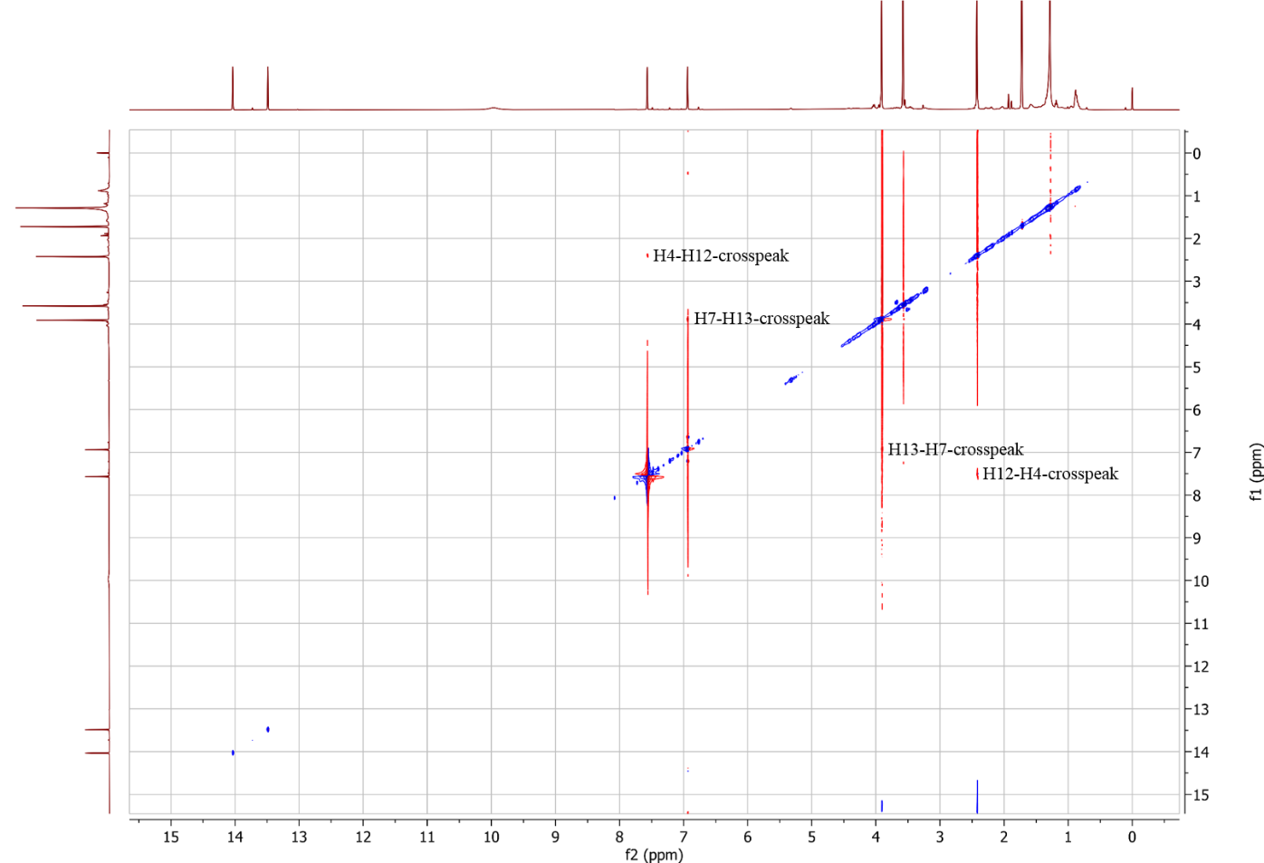

Fig. S8 UV spectrum of clavorubin-8-O-methylether (1).
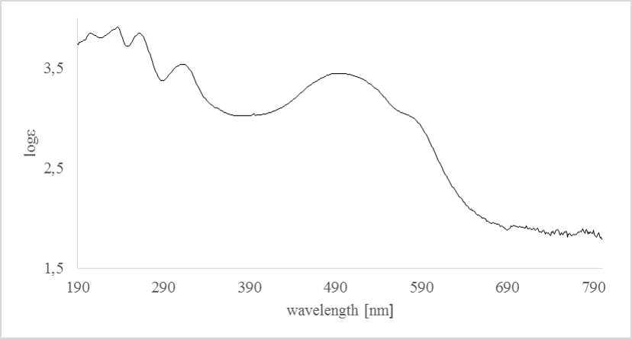

Fig. S9 Negative ion HRESIMS^{n} spectra of (+)-7,7’-emodinphyscion (2).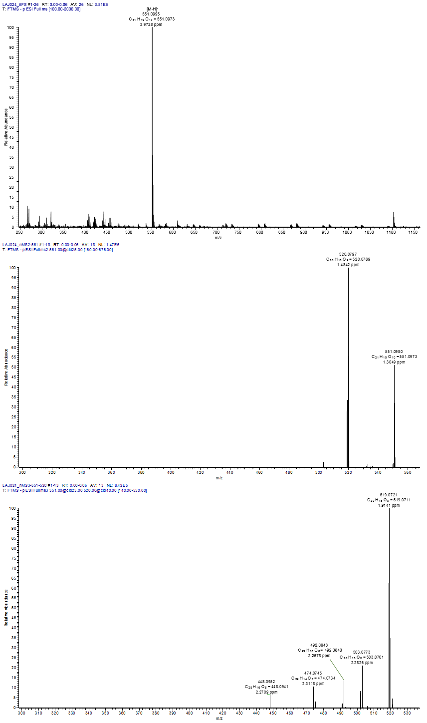
Fig. S10 ¹H NMR spectrum (500 MHz, pyridine-d₅) of (+)-7,7’-emodinphyscion (2).
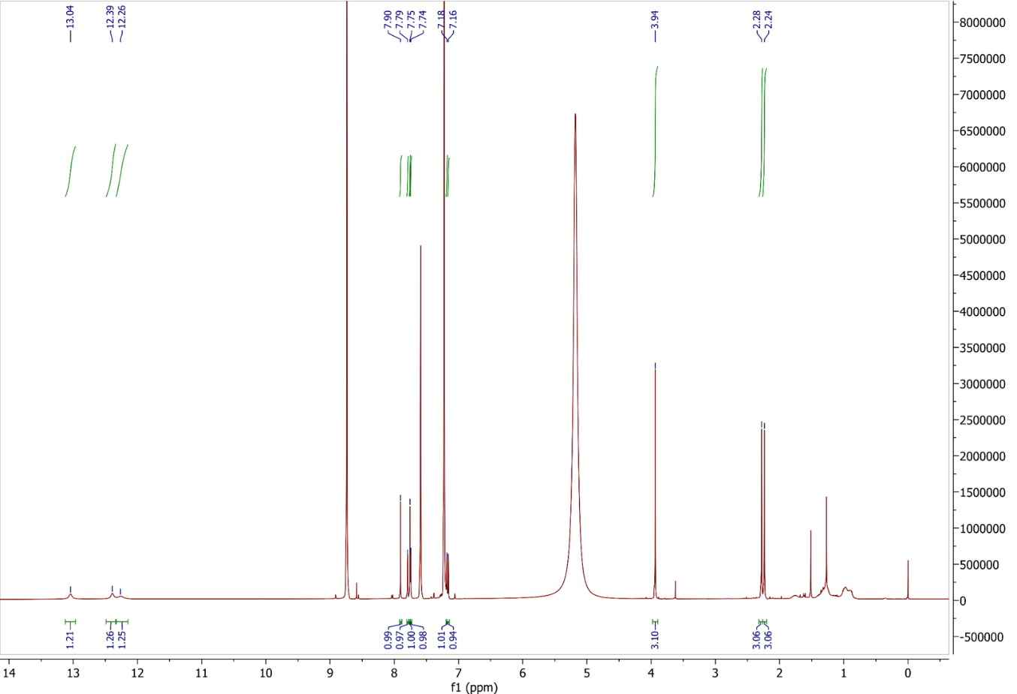

Fig. S11 ¹³C NMR spectrum (125 MHz, pyridine-d₅) of (+)-7,7’-emodinphyscion (2).
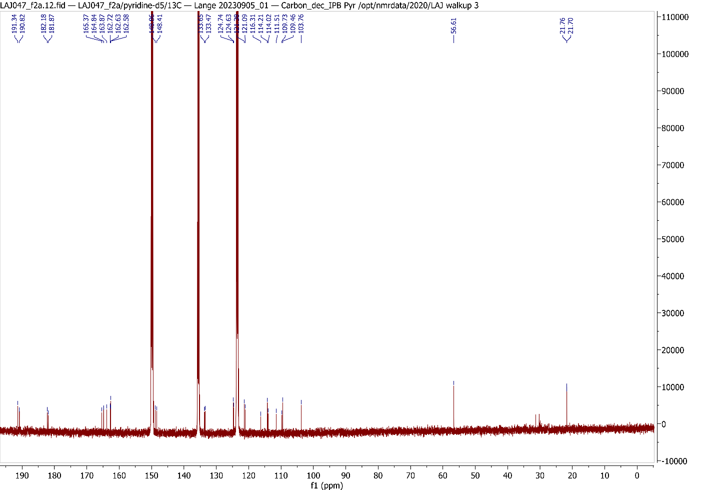

Fig. S12 CD spectrum (MeOH) of (+)-7,7’-emodinphyscion (2).
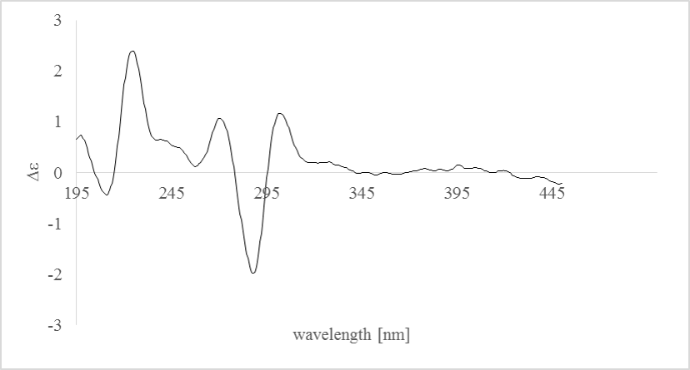

Fig. S13 Negative ion HRESIMS^{n} spectra of emodin (3).
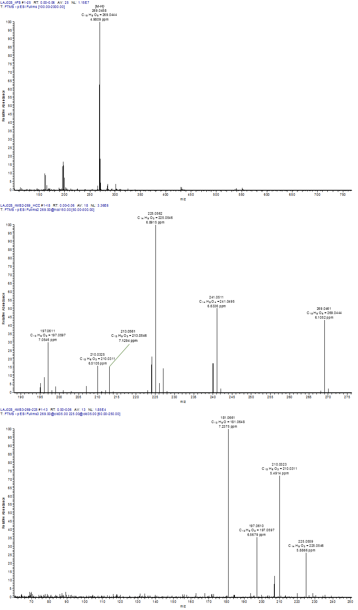

Fig. S14 ¹H NMR spectrum (500 MHz, CDCl₃) of emodin (3).
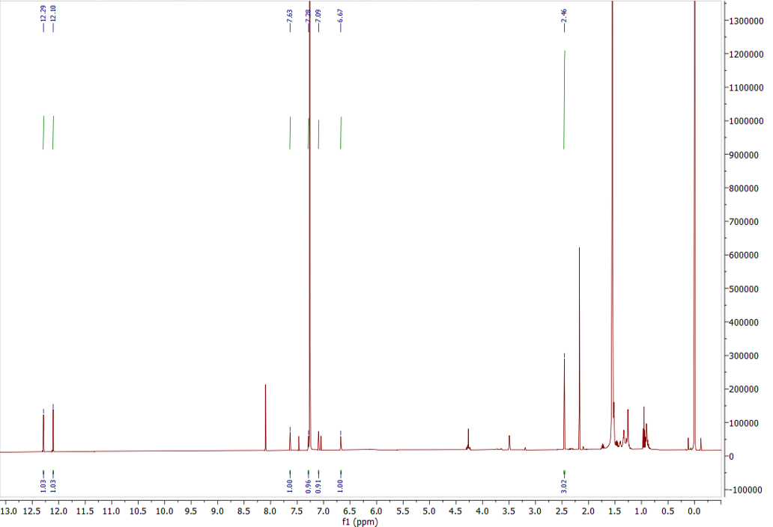

Fig. S15 HSQC spectrum (500/125 MHz, CDCl₃) of emodin (3).
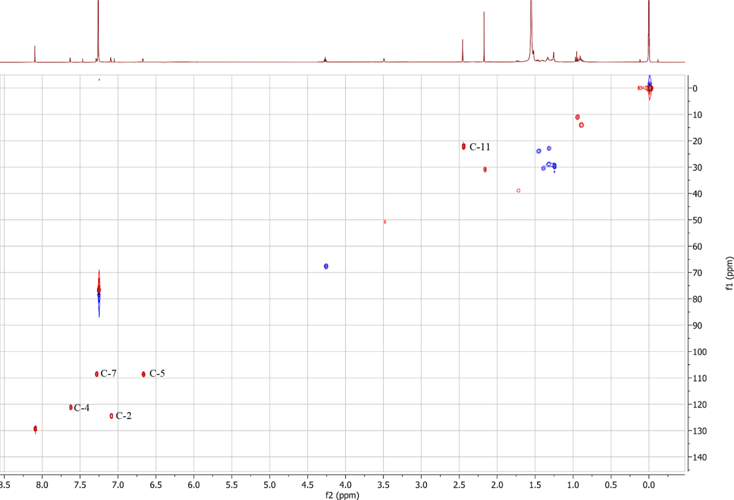
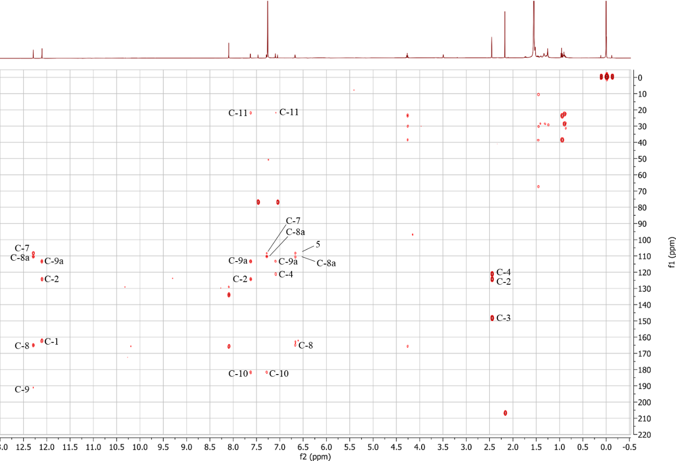
Fig. S16 HMBC spectrum (500/125 MHz, CDCl₃) of emodin (3).

Fig. S17 Negative ion HRESIMS^{n} spectra of emodin-6,8-di-O-methylether (4).
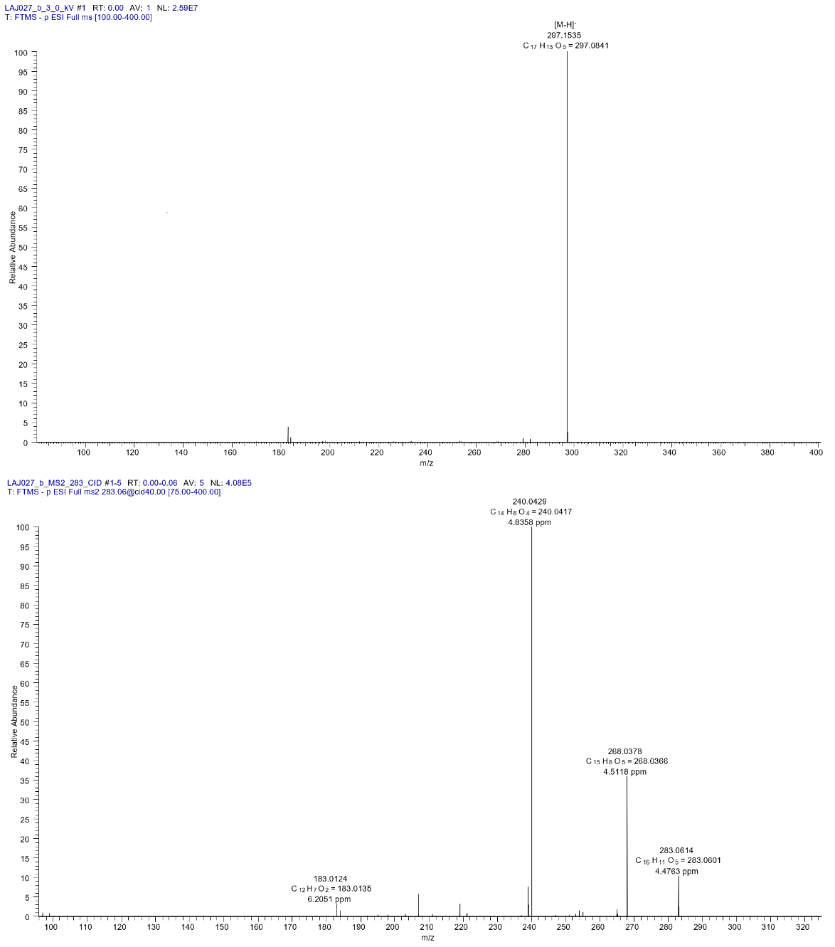

Fig. S18 ¹H NMR spectrum (500 MHz, CDCl₃) of emodin-6,8-di-O-methylether (4).
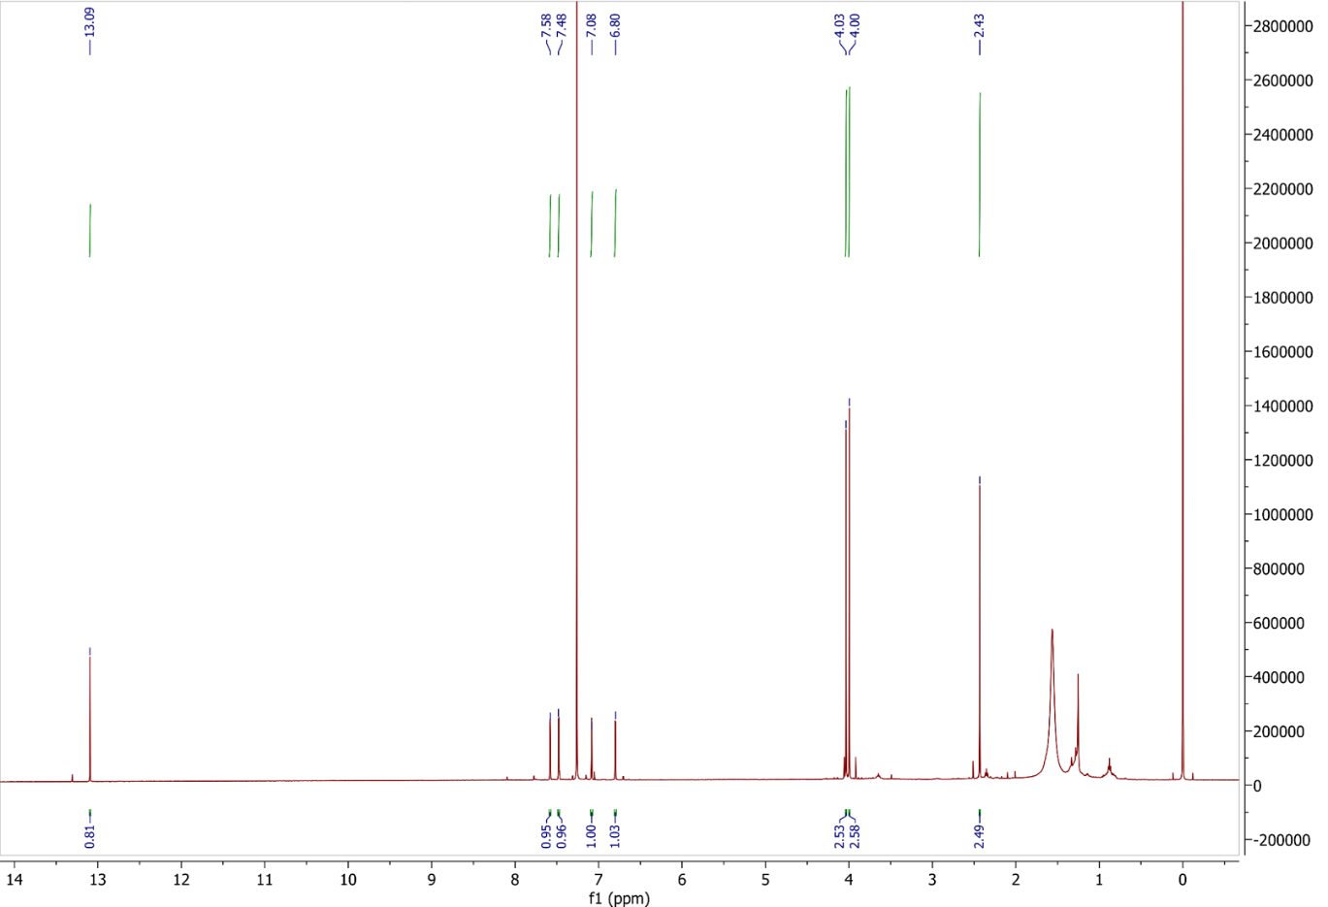

Fig. S19 HSQC spectrum (500/125 MHz, CDCl₃) of emodin-6,8-di-O-methylether (4).
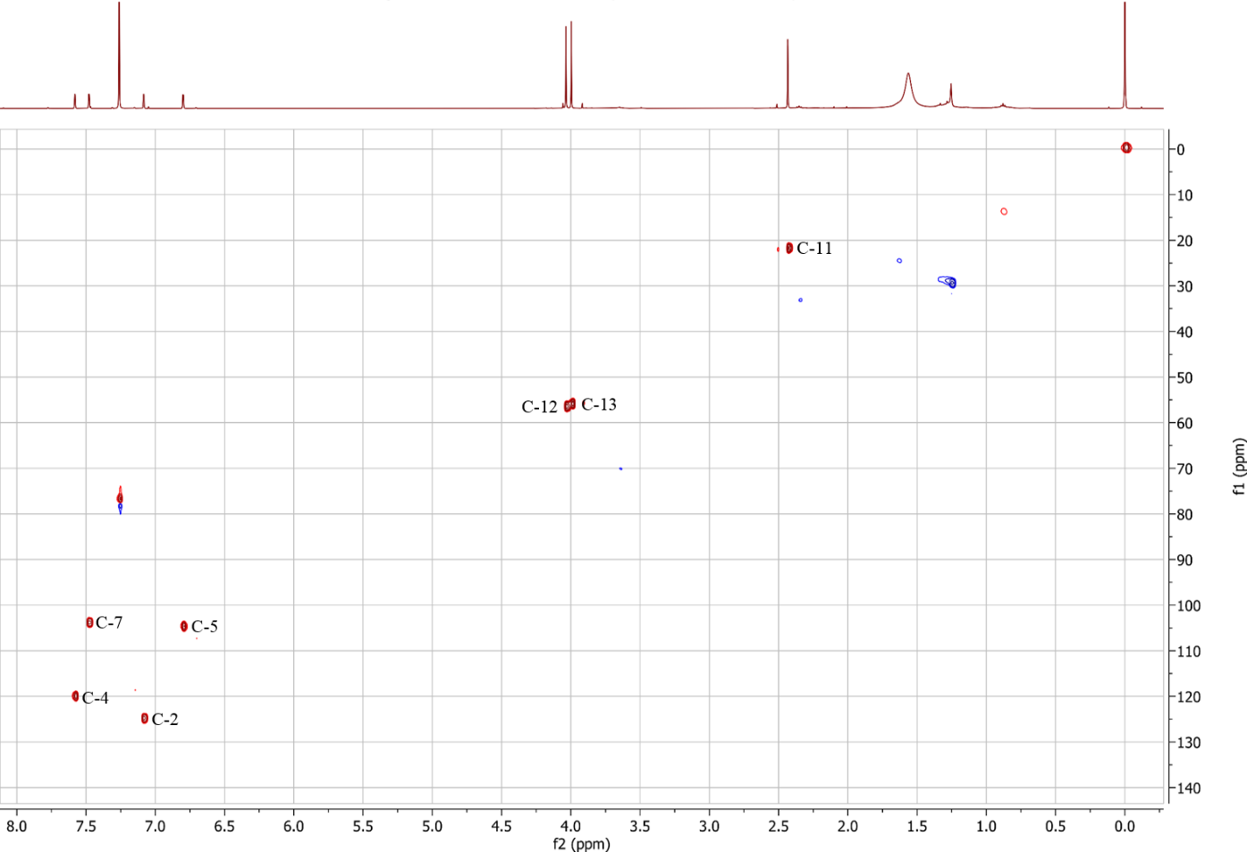

Fig. S20 HMBC spectrum (500/125 MHz, CDCl₃) of emodin-6,8-di-O-methylether (4).
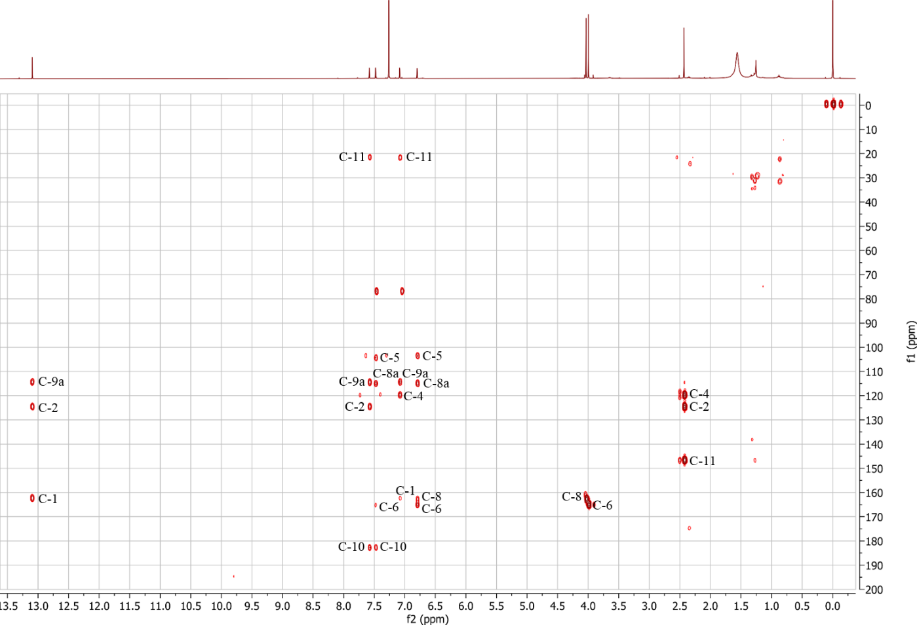

Fig. S21 Negative ion HRESIMS^{n} spectra of questin (5).
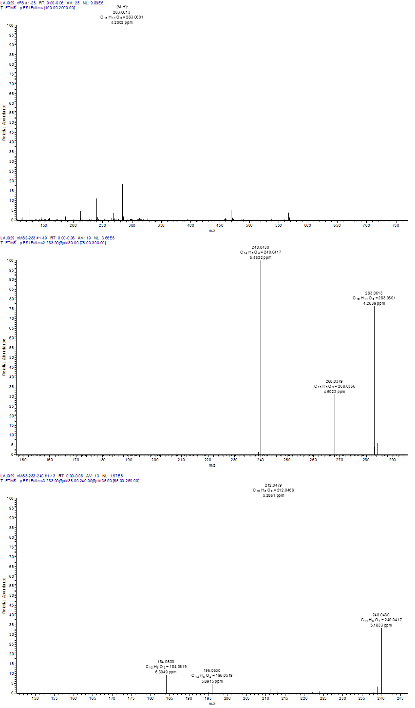

Fig. S22 ¹H NMR spectrum (500 MHz, CDCl₃) of questin (5).
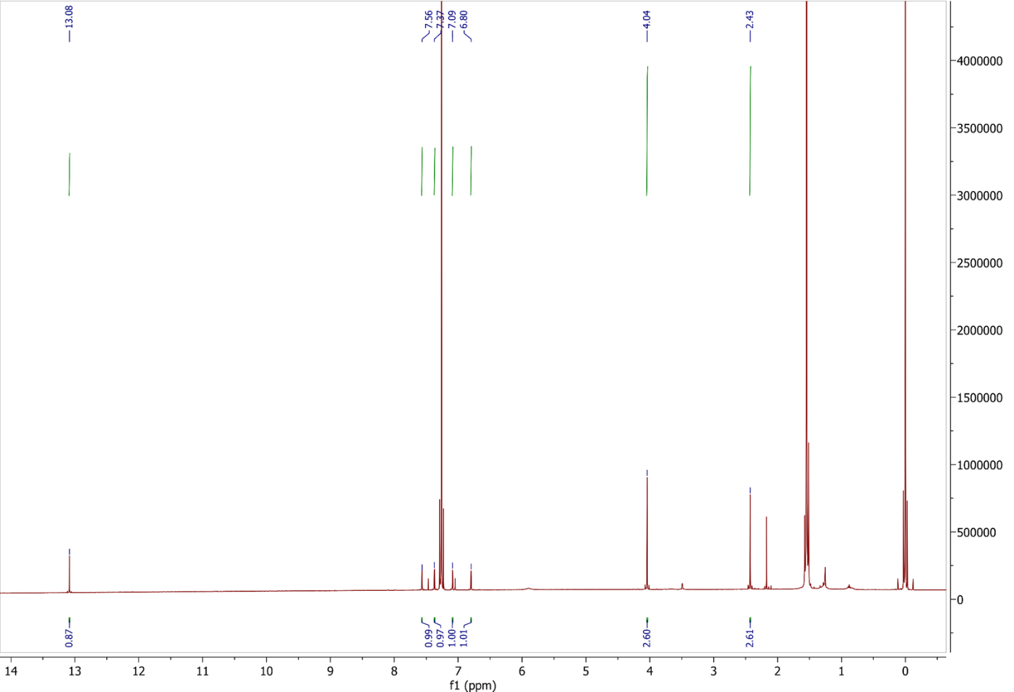

Fig. S23 HSQC spectrum (500/125 MHz, CDCl₃) of questin (5).
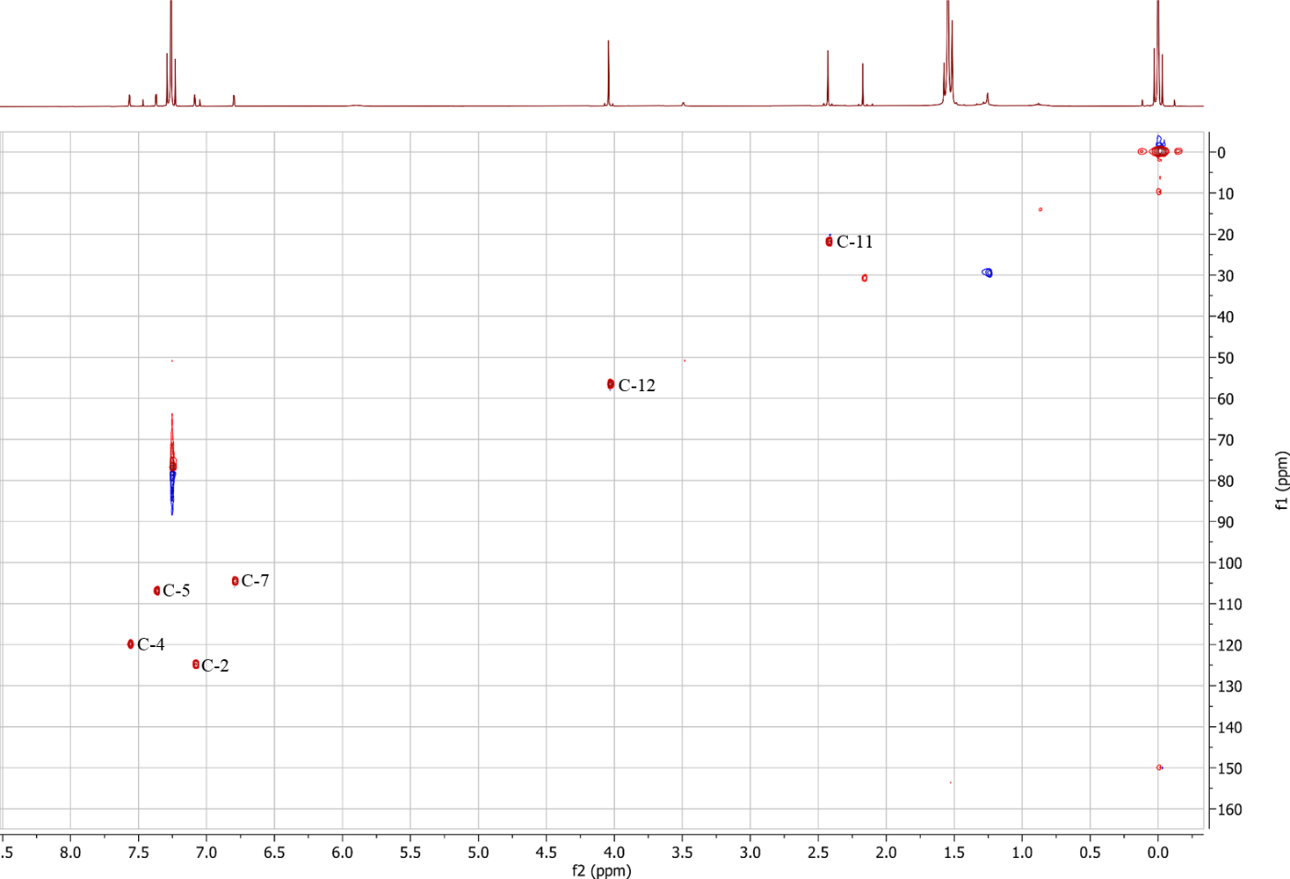
Fig. S24 HMBC spectrum (500/125 MHz, CDCl₃) of questin (5).
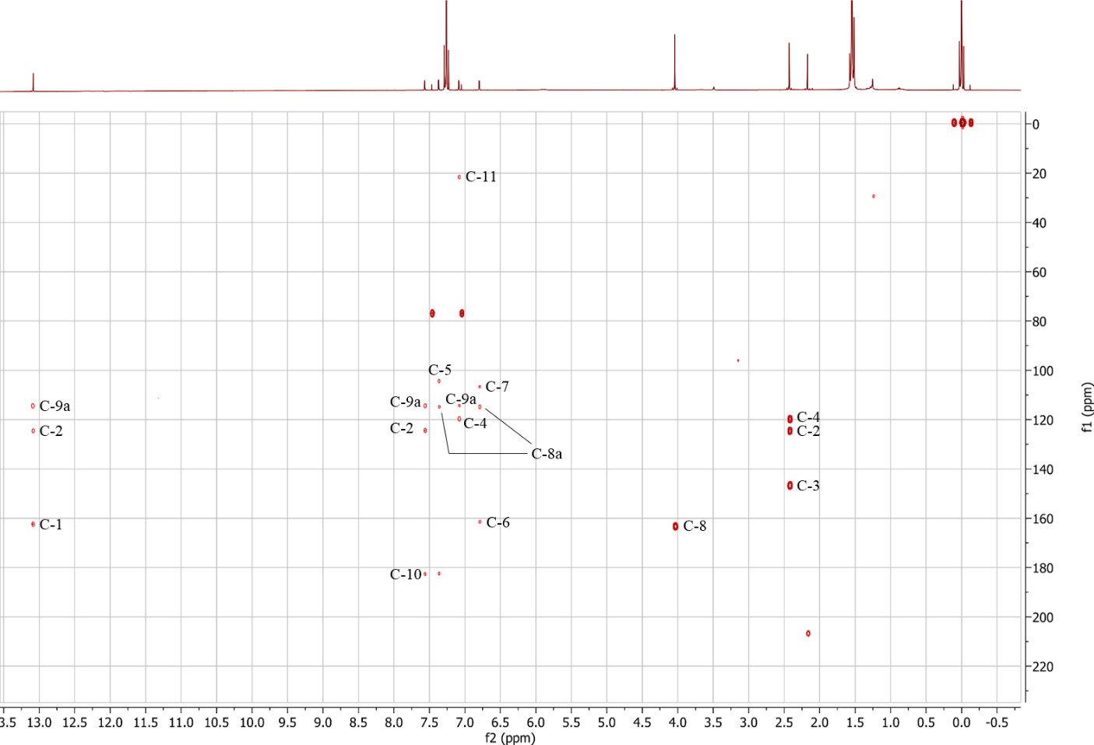

Fig. S25 Negative ion HRESIMS^{n} spectra of (+)-(S)-skyrin (6).
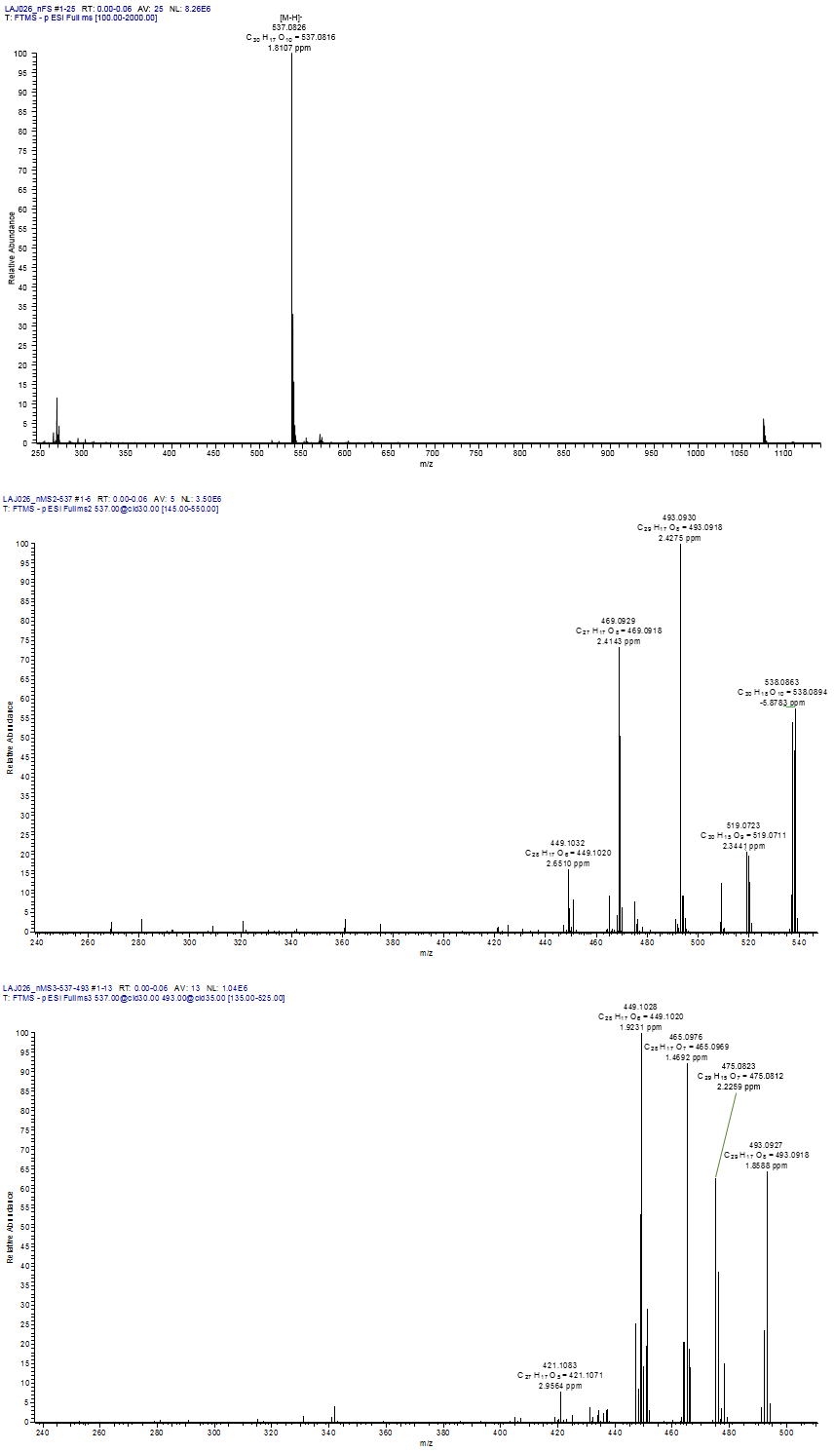

Fig. S26 ¹H NMR spectrum (500 MHz, DMSO-d₆) of (+)-(S)-skyrin (6).
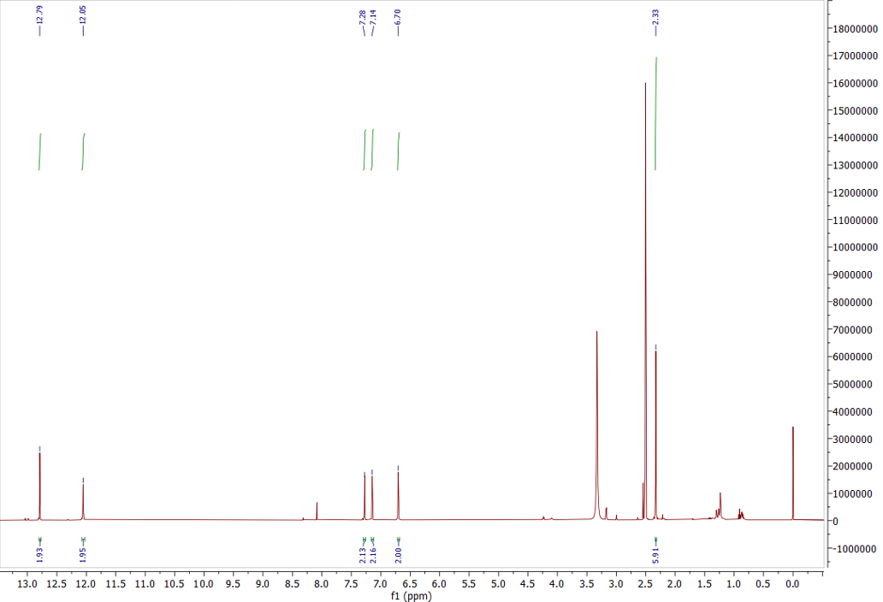

Fig. S27 ¹³C NMR spectrum (500 MHz, DMSO-d₆) of (+)-(S)-skyrin (6).
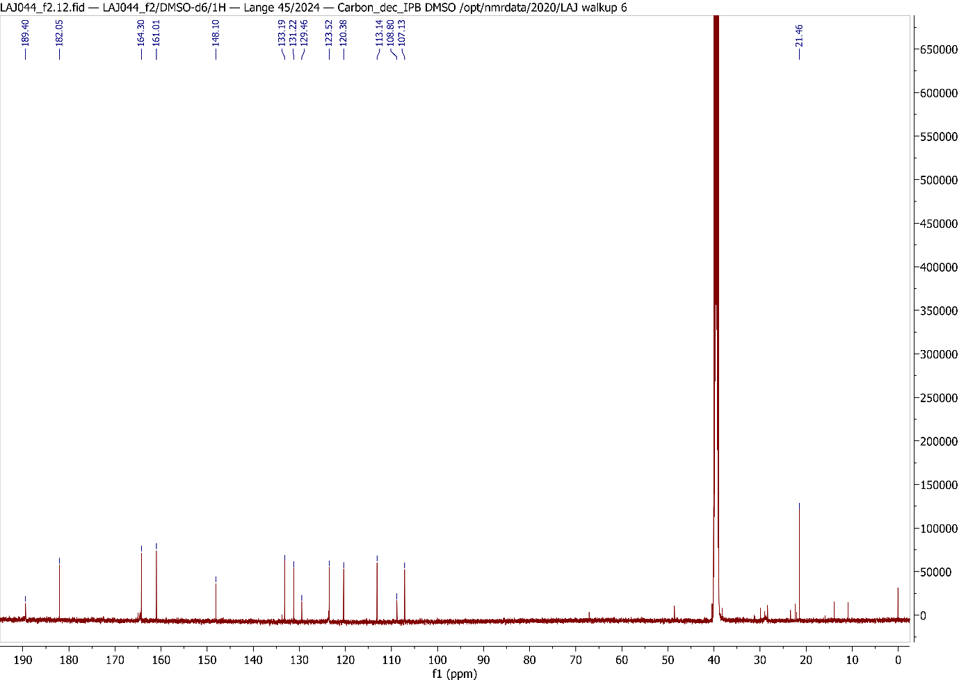

Fig. S28 CD spectrum (MeOH) of (+)-(S)-skyrin (6).
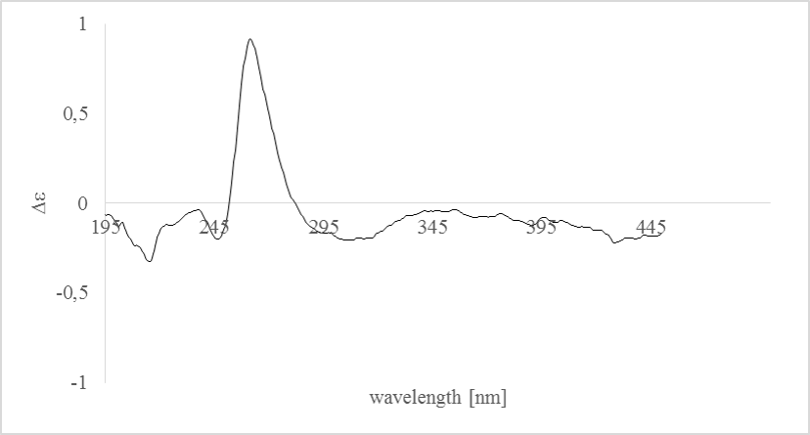

Fig. S29 Negative ion HRESIMS^{n} spectra of (+)-(S)-aurantioskyrin (7).
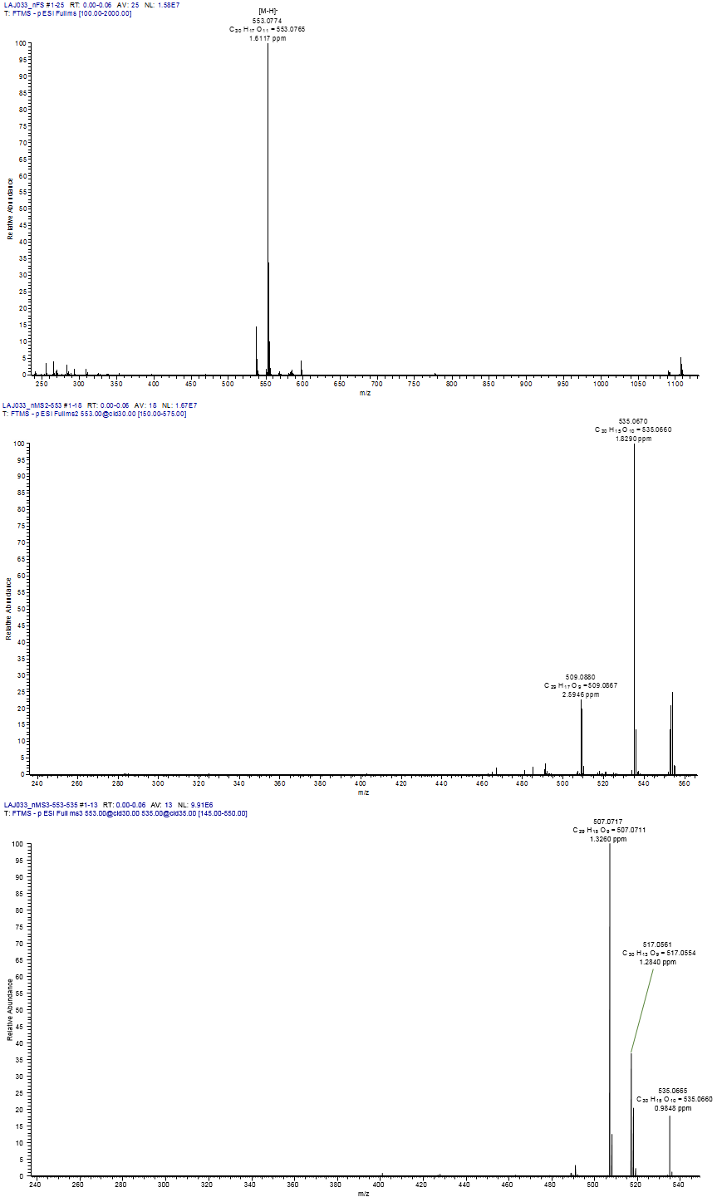

Fig. S30 ¹H NMR spectrum (500 MHz, CDCl₃) of (+)-(S)-aurantioskyrin (7).
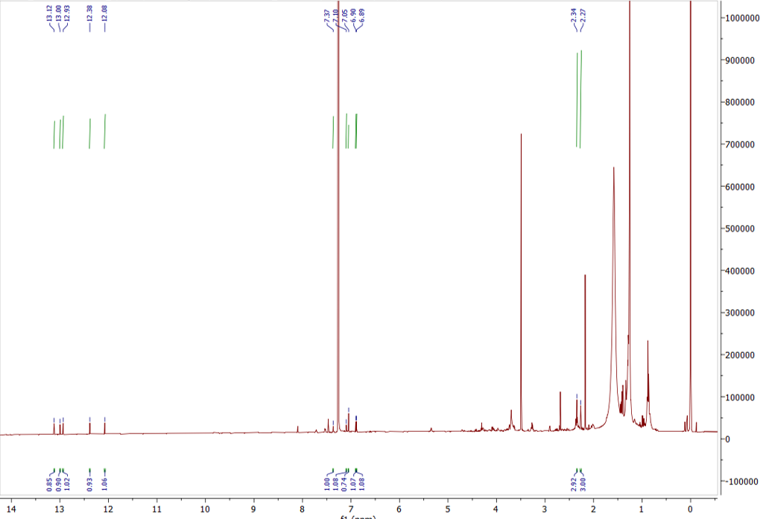

Fig. S31 HSQC spectrum (500/125 MHz, CDCl₃) of (+)-(S)-aurantioskyrin (7).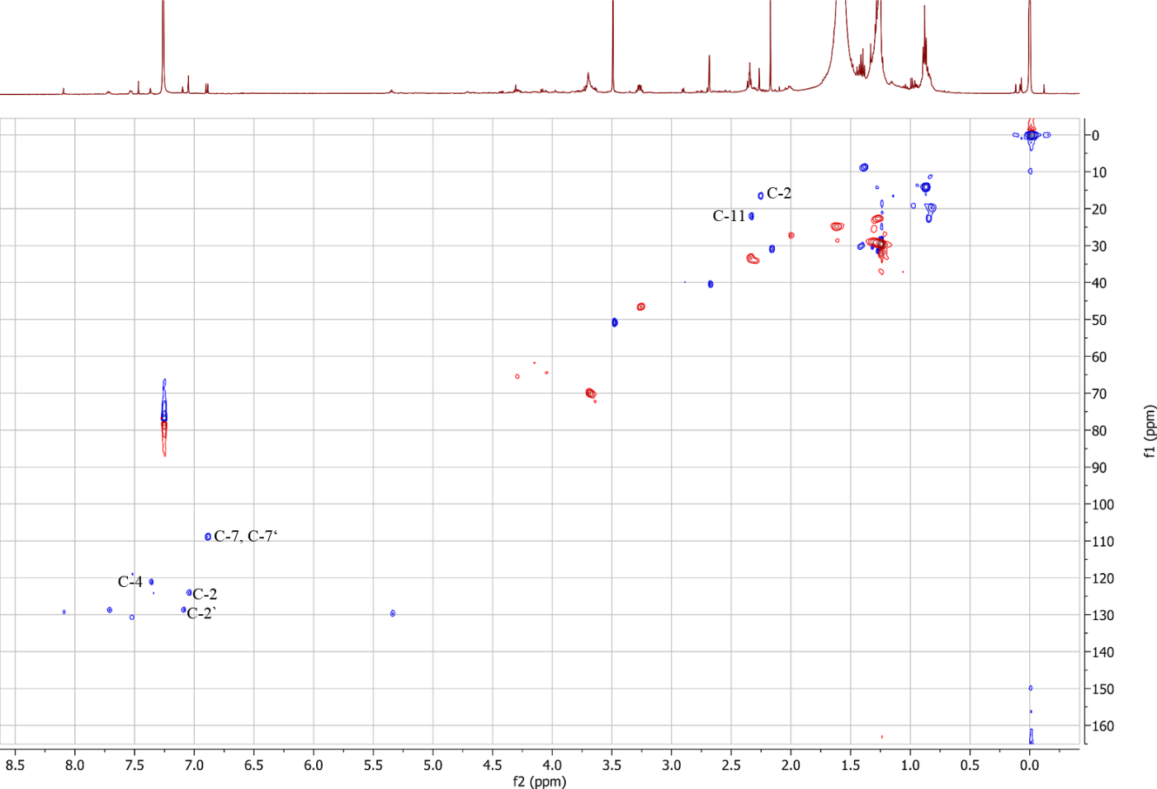

Fig. S32 HMBC spectrum (500/125 MHz, CDCl₃) of (+)-(S)-aurantioskyrin (7).
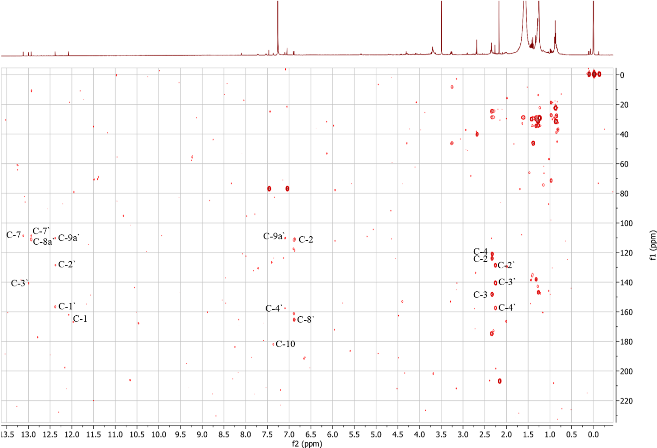

Fig. S33 CD spectrum (MeOH) of (+)-(S)-aurantioskyrin (7).
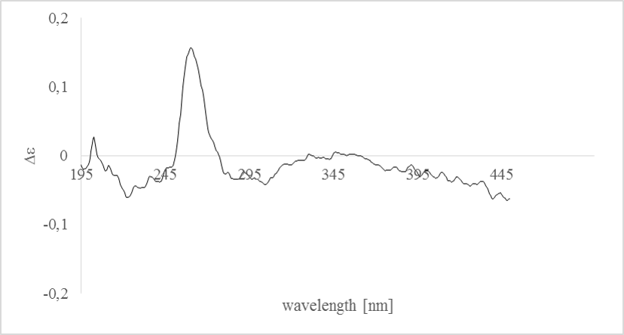

Fig. S34 Negative ion HRESIMS^{n} spectra of hypericin (8).
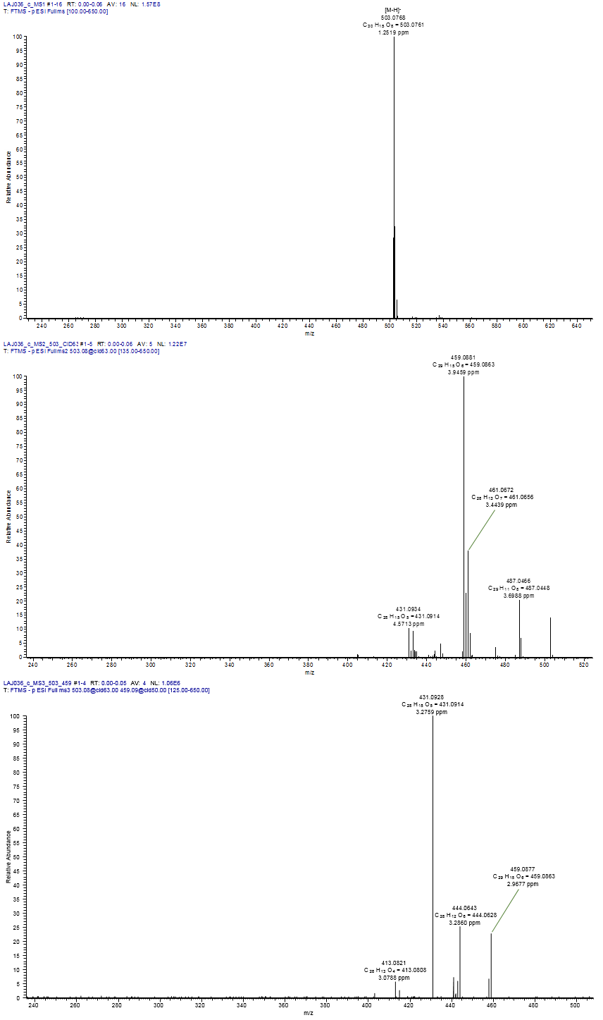
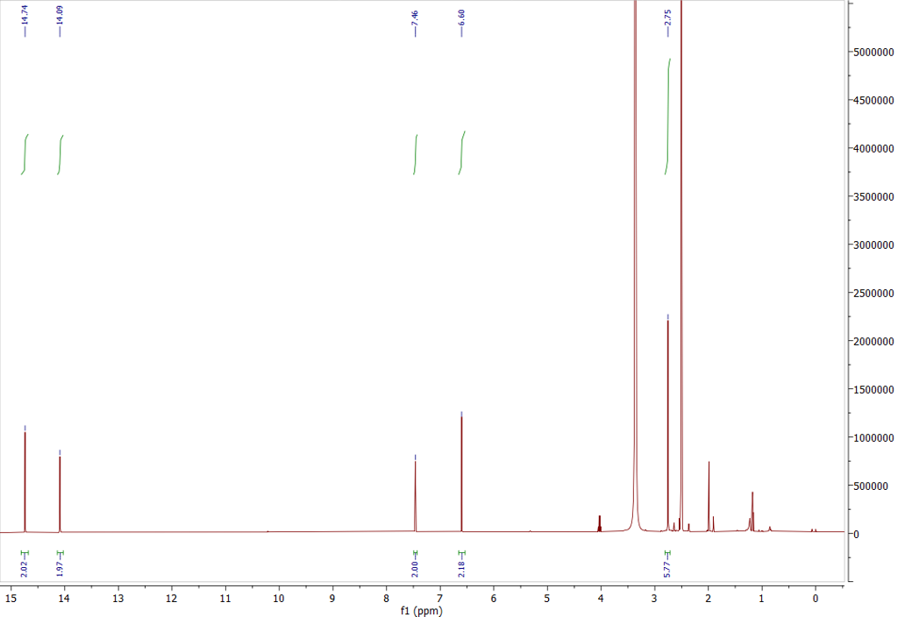
Fig. S35 ¹H NMR spectrum (500 MHz, DMSO-d₆) of hypericin (8).

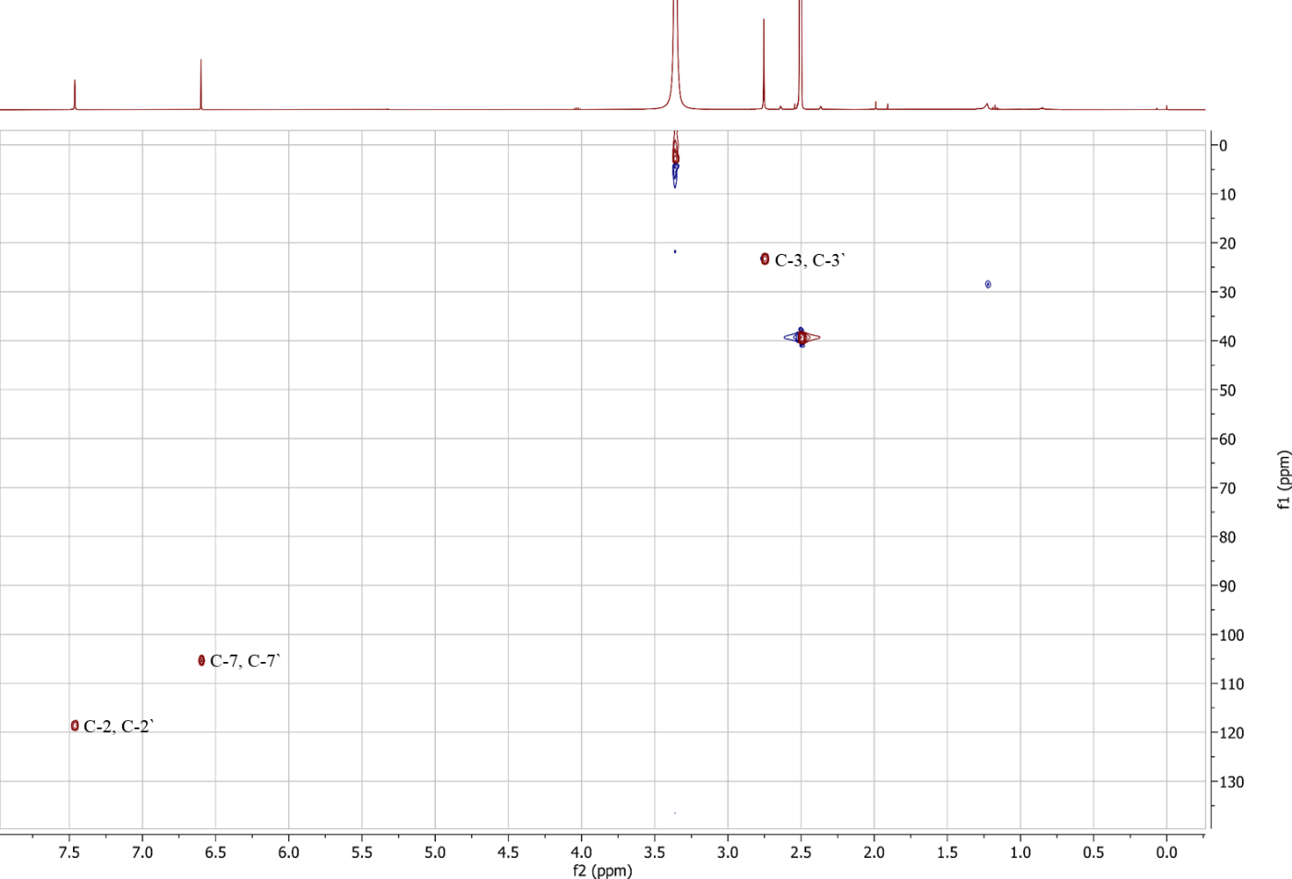
Fig. S36 HSQC spectrum (500 MHz, DMSO-d₆) of hypericin (8).

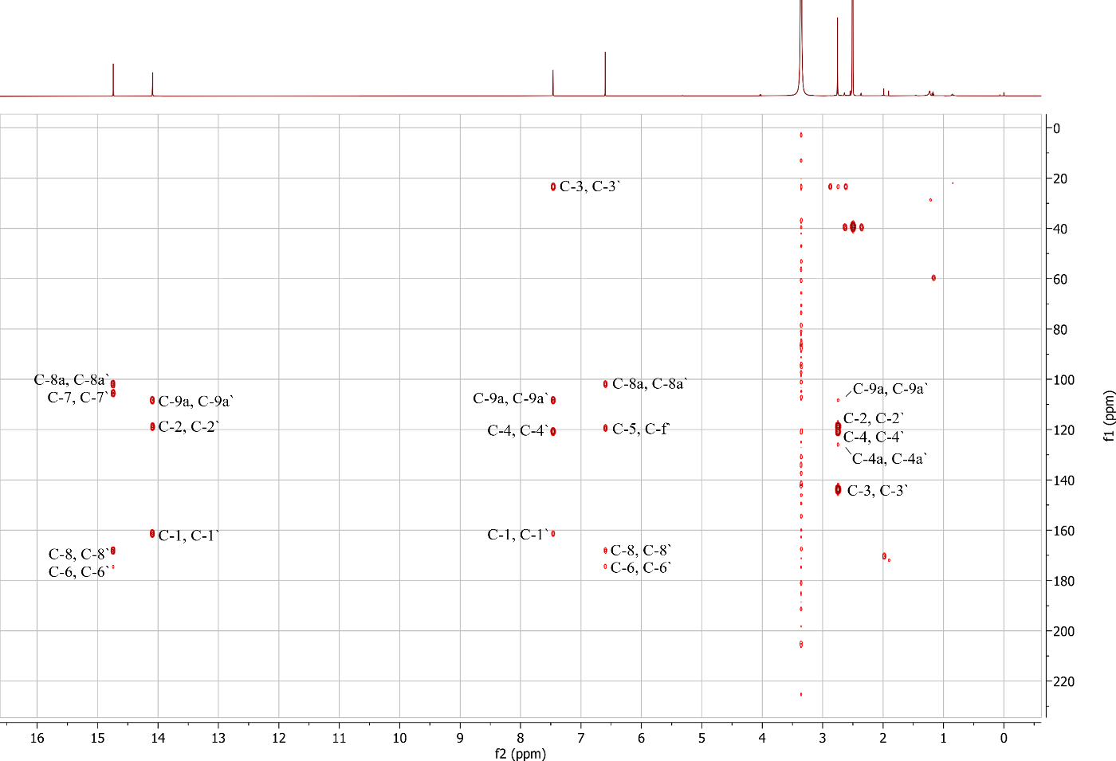
Fig. S37 HMBC spectrum (500 MHz, DMSO-d₆) of hypericin (8).

Fig. S38 Negative ion HRESIMS^{n} spectra of dermolutein (9).
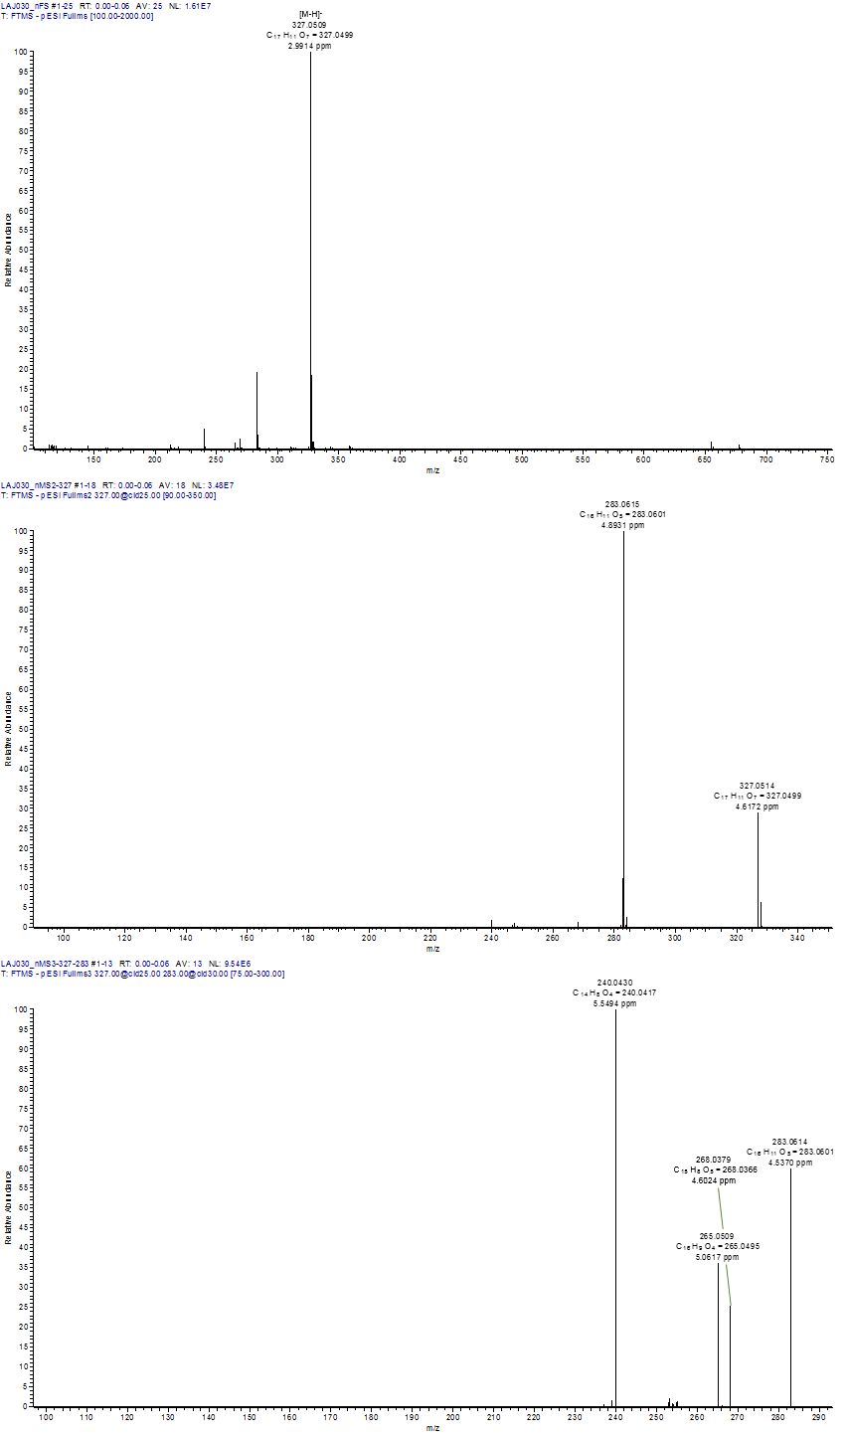

Fig. S39 ¹H NMR spectrum (500 MHz, CD₃OD) of dermolutein (9).
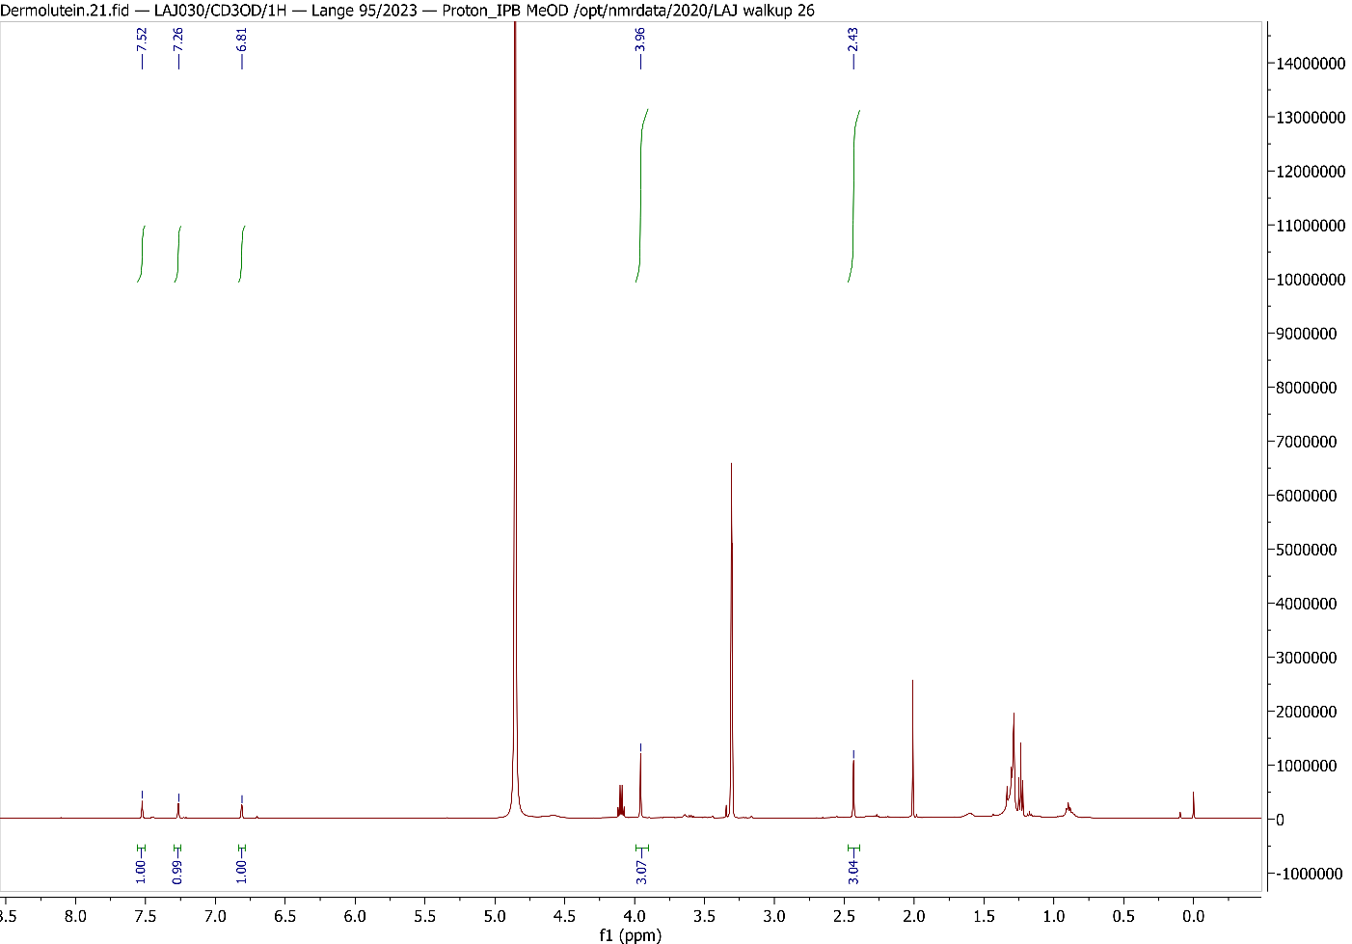

Fig. S40 ¹³C NMR spectrum (125 MHz, CD₃OD) of dermolutein (9).
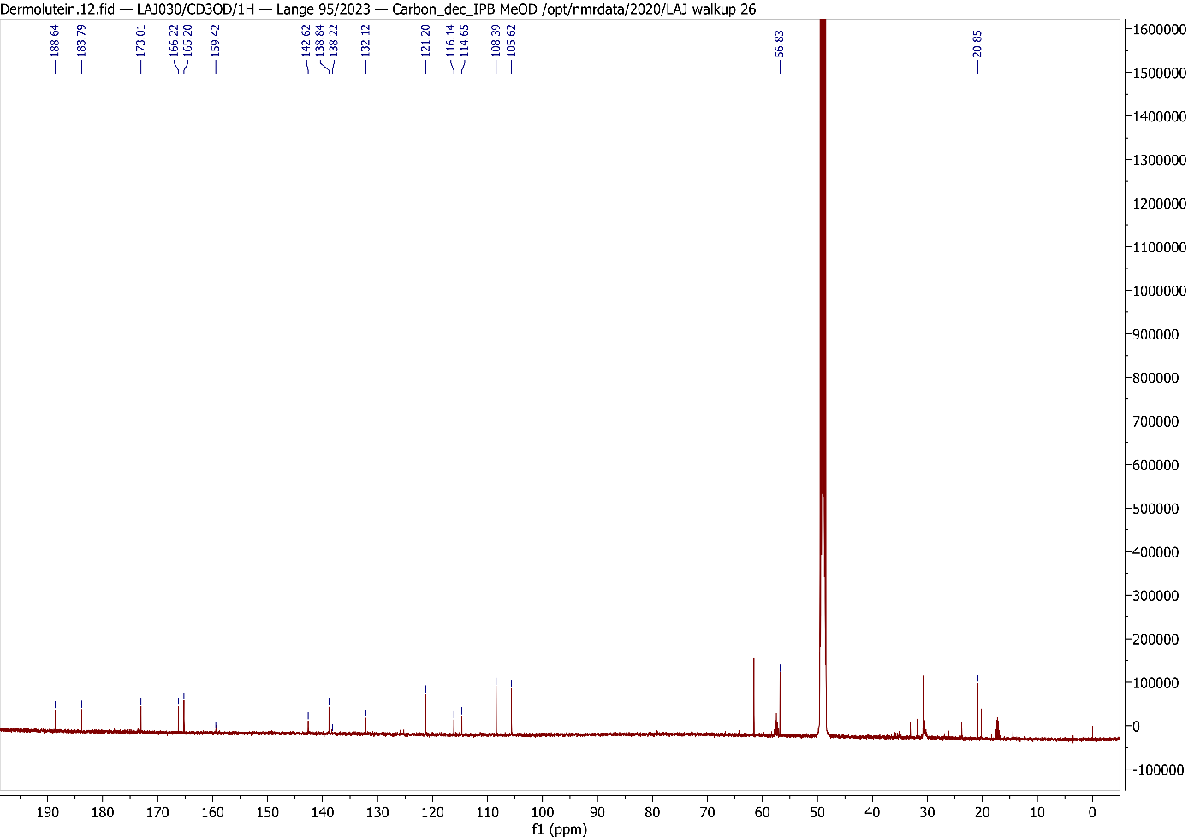
Fig. S41 Negative ion HRESIMS^{n} spectra of endocrocin (10).
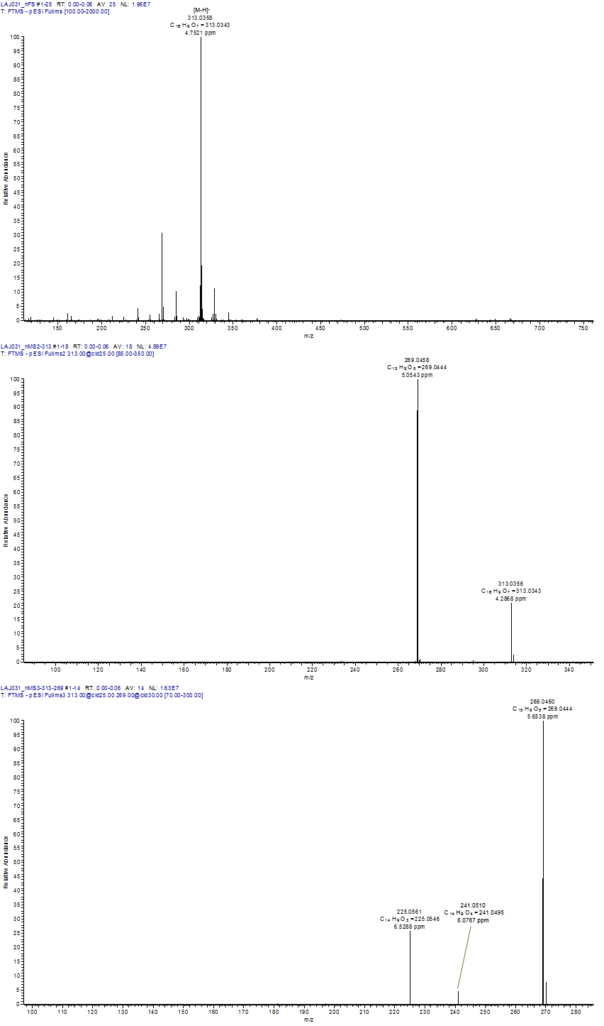

Fig. S42 ¹H NMR spectrum (500 MHz, CD₃OD) of endocrocin (10).
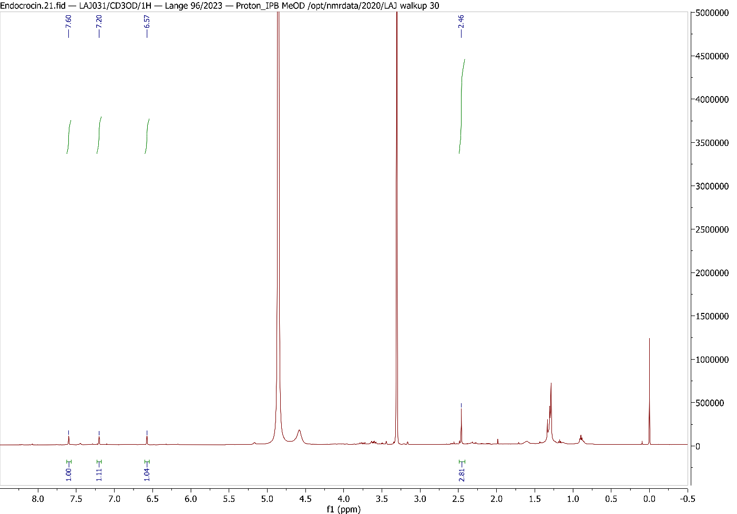

Fig. S43 HSQC spectrum (500/125 MHz, CD₃OD) of endocrocin (10).
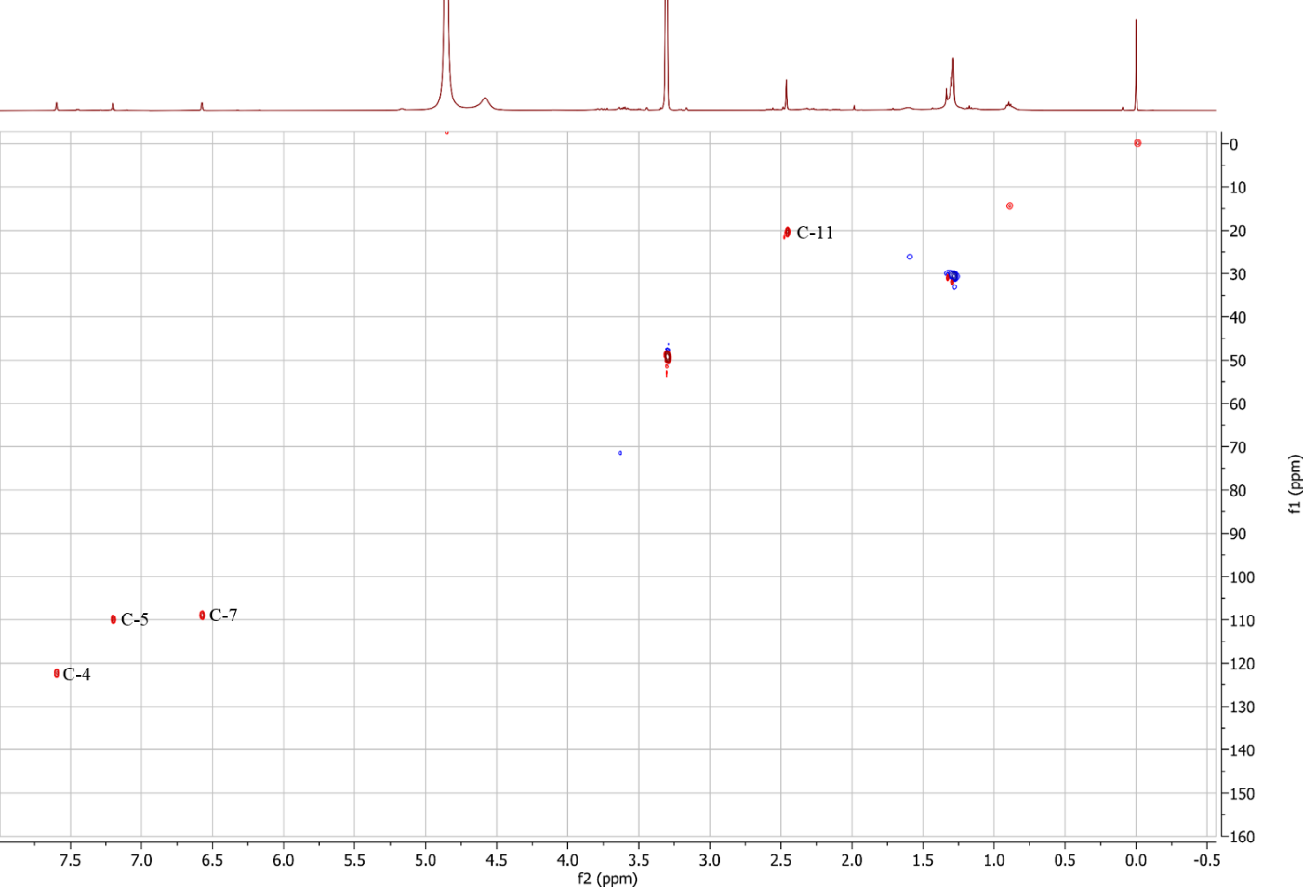
Fig. S44 HMBC spectrum (500/125 MHz, CD₃OD) of endocrocin (10).
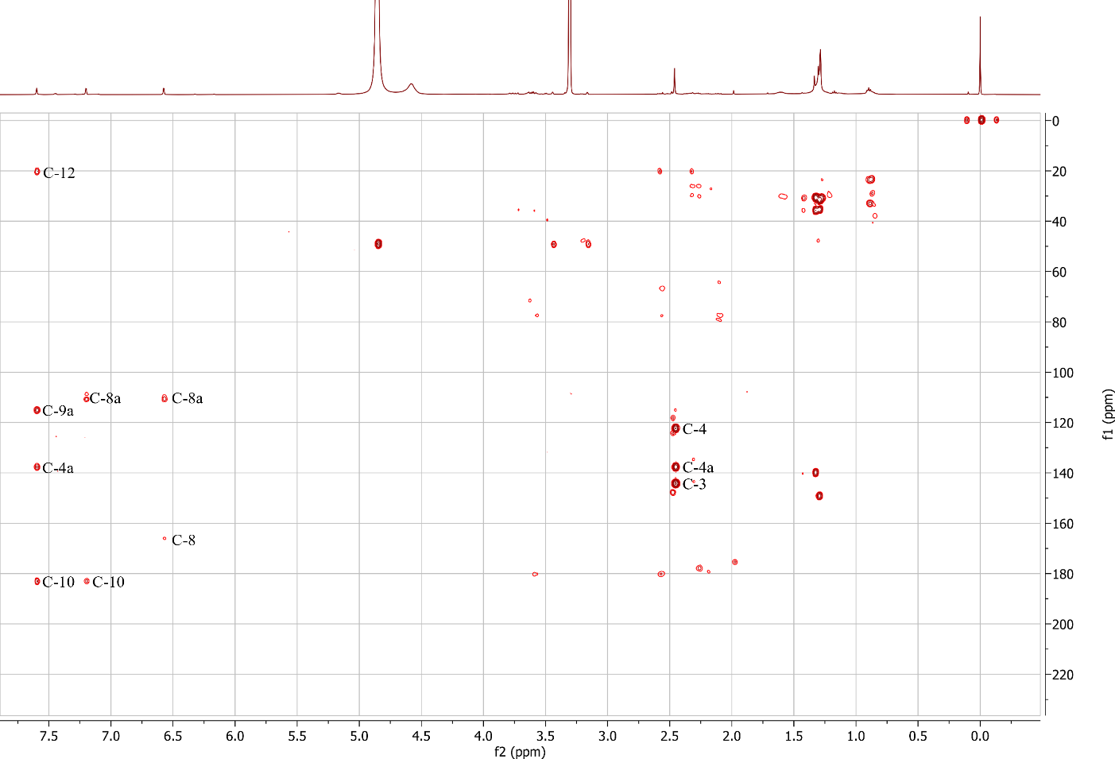

Fig. S45 Negative ion HRESIMS^{n} spectra of clavorubin (11).
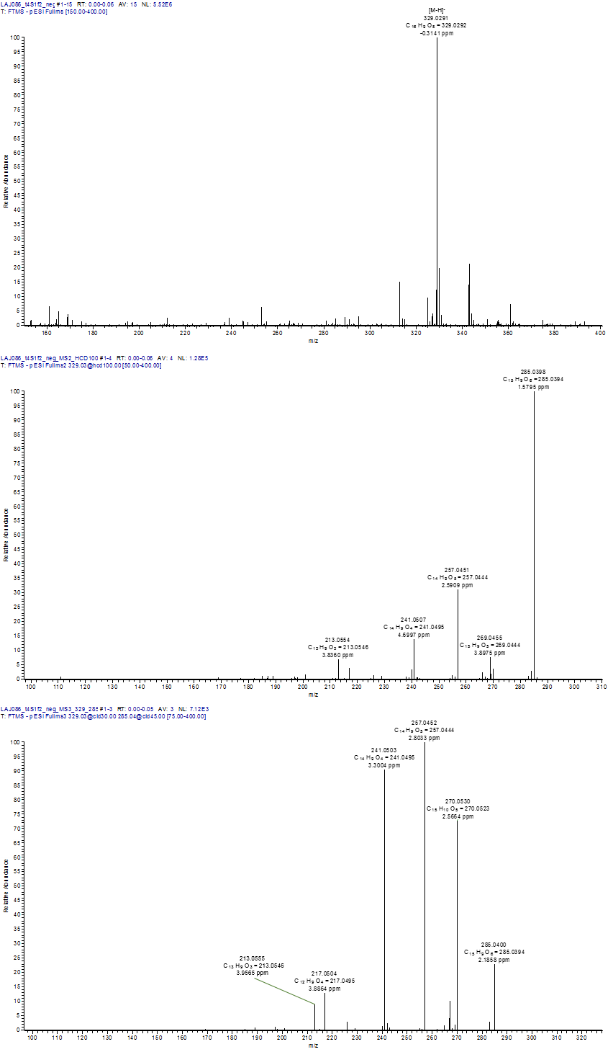

Fig. S46 a ¹H NMR spectrum (500 MHz, DMSO-d₆) of clavorubin (11).
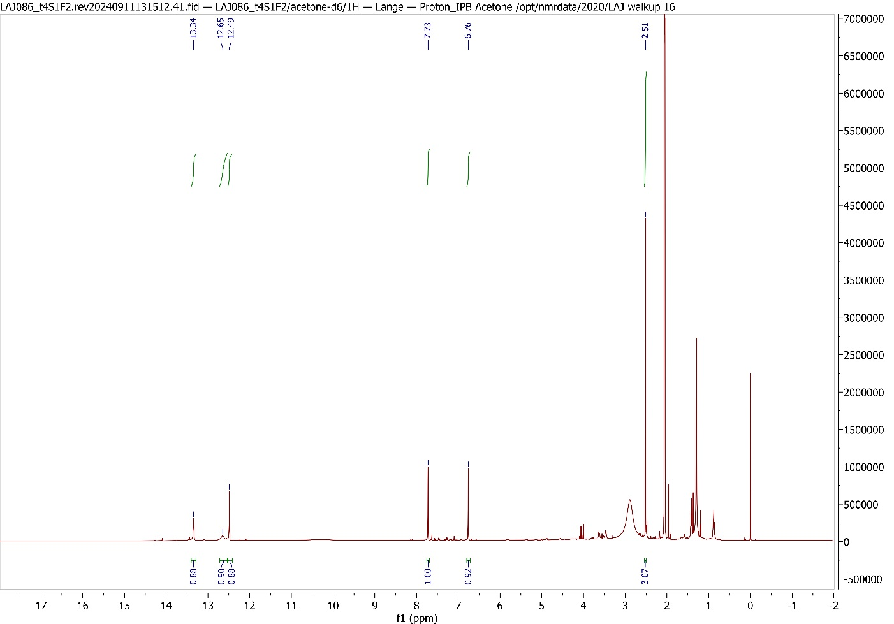

Fig. S46 b ¹H NMR spectrum (500 MHz, THF-d₈) of clavorubin (11).
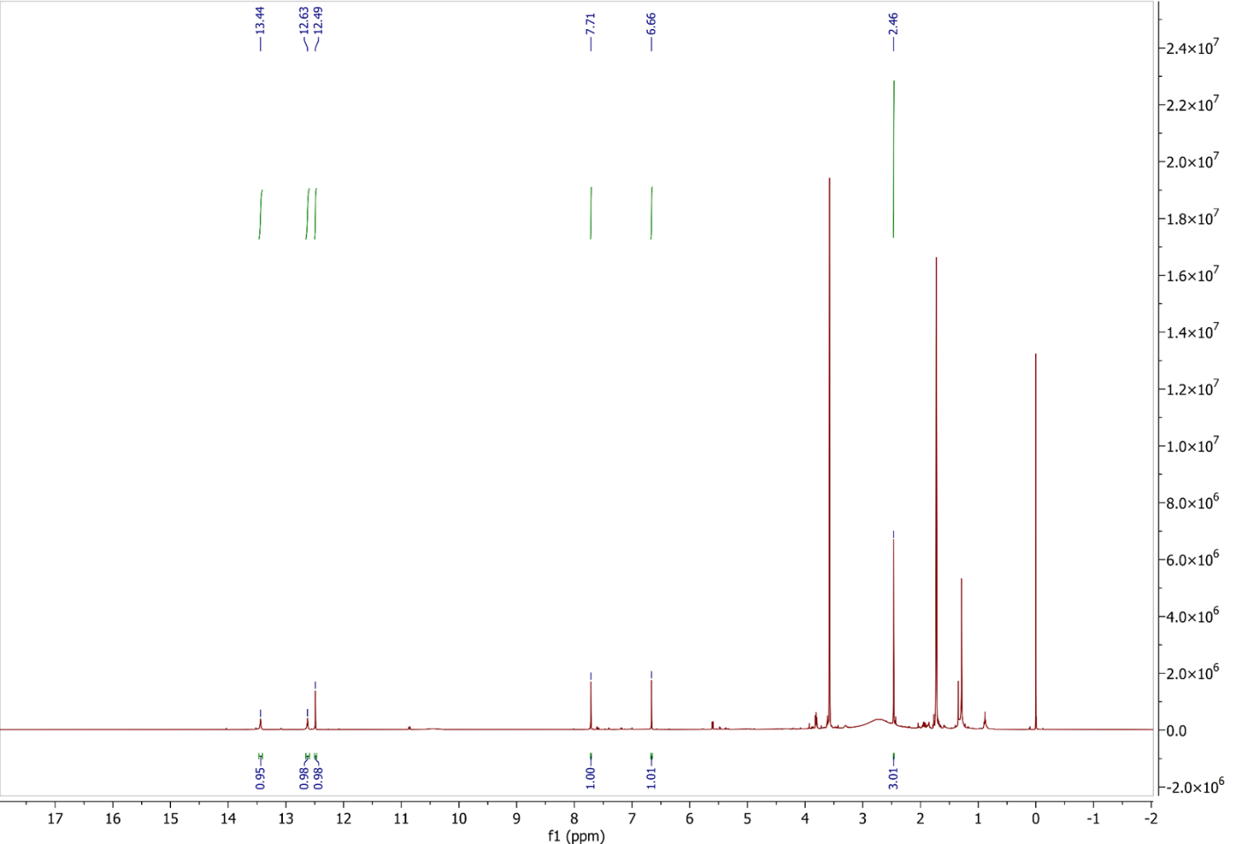
Fig. S47 ¹³C NMR spectrum (125 MHz, THF-d₈) of clavorubin (11).
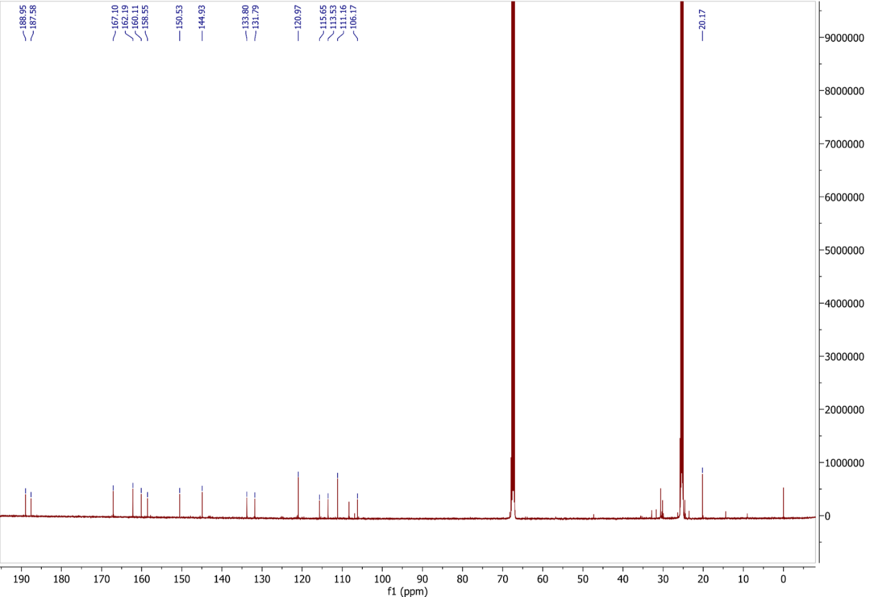

Fig. S48 HSQC spectrum (500/125 MHz, THF-d₈) of clavorubin (11).
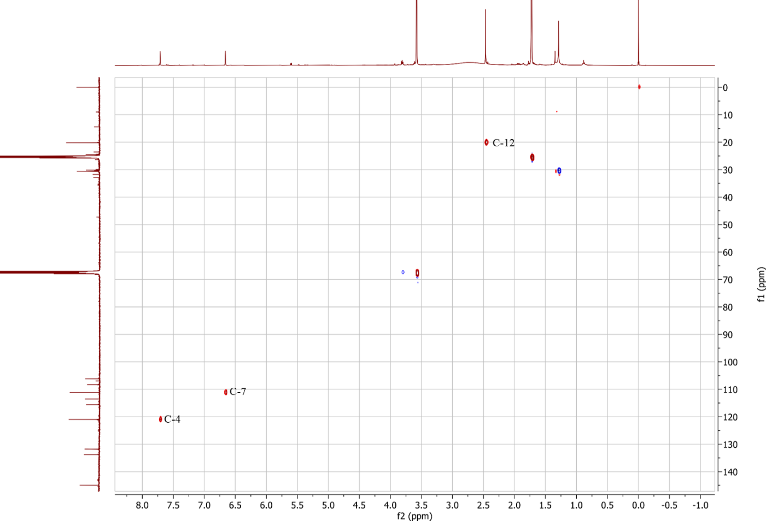
Fig. S49 HMBC spectrum (500/125 MHz, THF-d₈) of clavorubin (11).
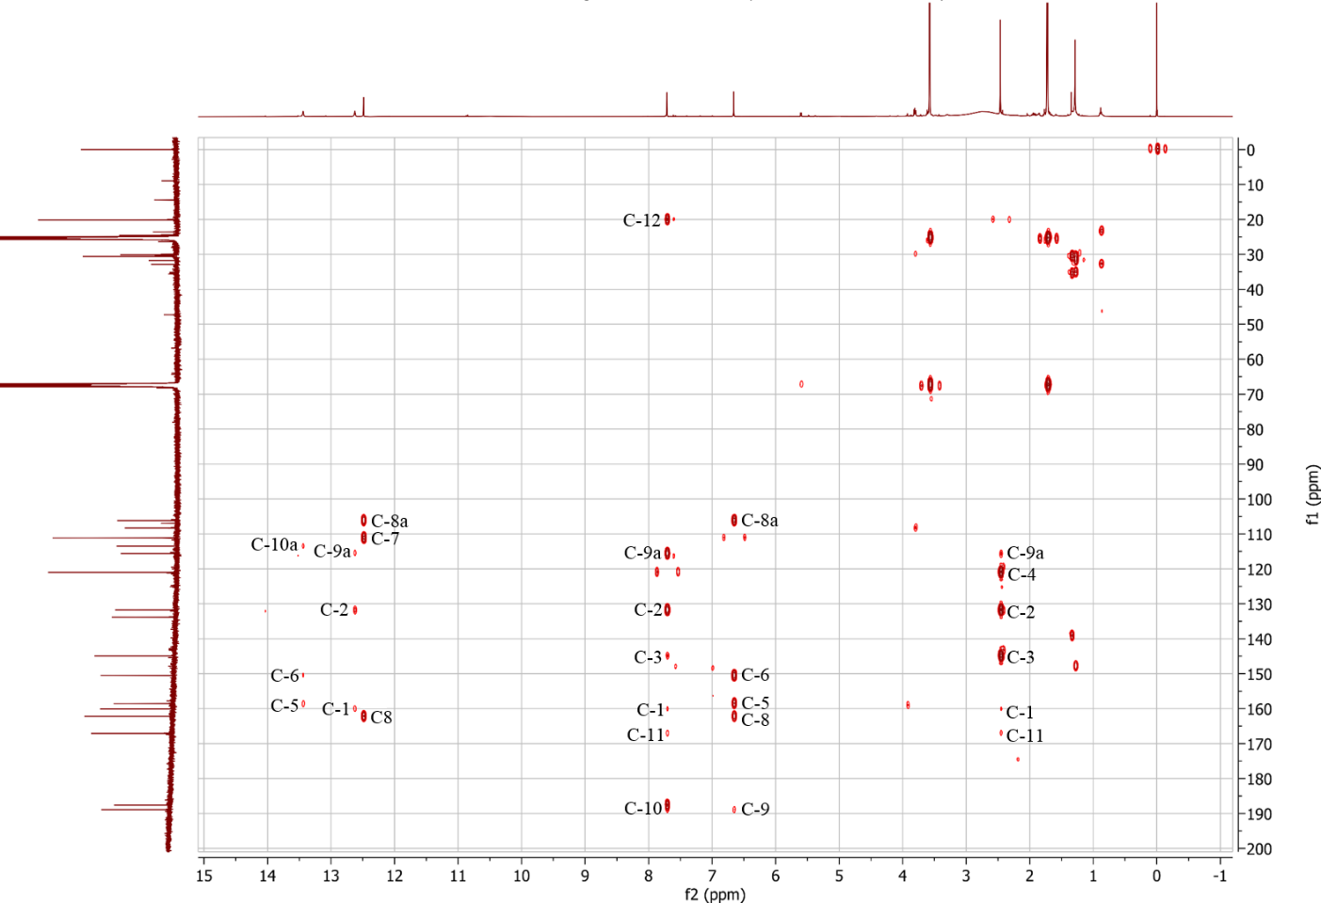

Fig. S50 Maximum likelihood phylogenetic tree of concatenated ITS, LSU, and rpb1 data of selected Cortinarius taxa, for the placement of the new species. Shown is the best ML tree with bootstrap values (BS > 60) and Baysian posterior propabilities (BPP > 0.60) provided above the branches. The dataset contains 134 samples, and consist of nrITS, nrLSU, and rpb1-α sequences. The positions are: ITS: 1 – 815, LSU: 816 – 1765, rpb1: 1766 – 2282. Voucher numbers and sections are included in labels. The new species Cortinarius mapuveronicae is printed in red, other species sequenced within this study are printed in pink.
Fig. S51 Isolation scheme.
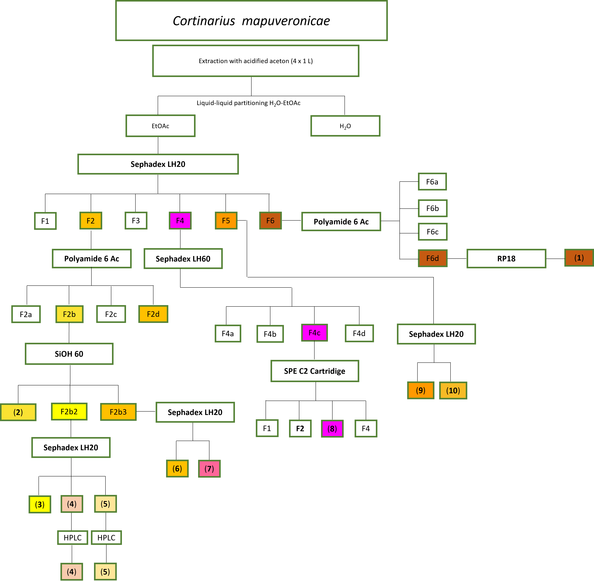

Fig. S52 Cell growth inhibition curves of the active anthraquinoid compounds 1, 3, 7, and 8.

Fig. S53 Growth inhibition curves of the active anthraquinoid compounds 3, 7, and 8.
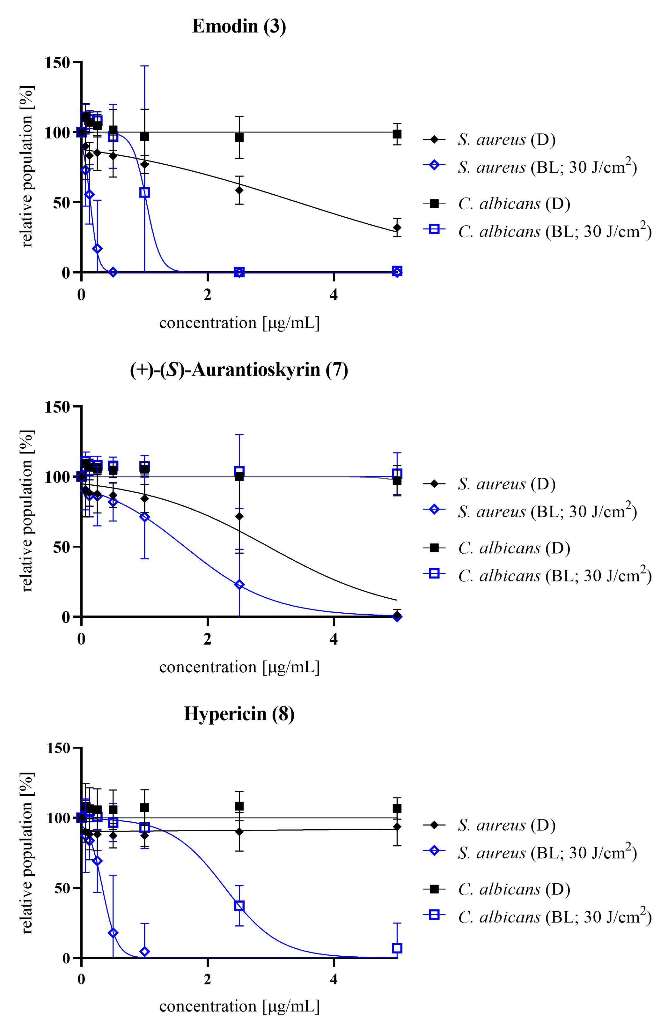

Tab. S1 Collections examined in this study with Genbank Accession numbers, voucher numbers, and collection data.
Genbank number | Herbar number | Name | Collection date | Collection location | leg. & det. | GPS-lat | GPS-long
ITS: PX230457, LSU: PX230475 | IPB-CHL 41/17 | Cortinarius carneolus | 5.2017 | Chile, Chanco, Cauquenes Province | N. Arnold | 35°50'01.9"S | 72°30'30.2"W
ITS: PX230439, LSU: PX230468, RPB1: PX240688 | IBF20230110 | Cortinarius mapuveronicae TYPE | 09.04.2023 | Chile, Patagonia, Chaíten | L. Huymann, B. Siewert, U. Peintner | 43°20'55.93''S | 73°10'18.73''W
ITS: PX230432, LSU: PX230462 RPB1: PX240687 | IBF20220019 | Cortinarius mapuveronicae | 14.05.2022 | Chile, Llancacura | U. Peintner, L. Huymann, N. Arnold | 40°13'32.92''S | 73°21'35.63''W
ITS: PX230433 | IBF20220020 | Cortinarius mapuveronicae | 14.05.2022 | Chile, Llancacura | U. Peintner, L. Huymann, N. Arnold | 40°13'32.92''S | 73°21'35.63''W
ITS: PX230434, LSU: PX230463, RPB1: PX240689 | IBF20220064 | Cortinarius mapuveronicae | 17.05.2022 | Chile, Curanilahue - Trongo Alto | U. Peintner, L. Huymann, N. Arnold | 37°41'23.21''S | 73°21'35.85''W
ITS: PX230435, LSU: PX230464 | IBF20220073A | Cortinarius mapuveronicae | 18.05.2022 | Chile, Cañete | U. Peintner, L. Huymann, N. Arnold | 37°41'23.21''S | 73°21'35.85''W
ITS: PX230436, LSU: PX230465 | IBF20220073B | Cortinarius mapuveronicae | 18.05.2022 | Chile, Cañete | U. Peintner, L. Huymann, N. Arnold | 37°41'23.21''S | 73°21'35.85''W
LSU: PX230466 | IBF20220073C | Cortinarius mapuveronicae | 18.05.2022 | Chile, Cañete | U. Peintner, L. Huymann, N. Arnold | 37°41'23.21''S | 73°21'35.85''W
ITS: PX230437 | IBF20220104 | Cortinarius mapuveronicae | 21.05.2022 | Chile, Curanilahue | U. Peintner, L. Huymann, N. Arnold | 37°41'23.21''S | 73°21'35.85''W
ITS: PX230438, LSU: PX230467 | IBF20230090 | Cortinarius mapuveronicae | 09.04.2023 | Chile, Patagonia, Chaíten | L. Huymann, B. Siewert, U. Peintner | 43°20'55.93''S | 73°10'18.73''W
ITS: PX230440, LSU: PX230469 | IBF20230111 | Cortinarius mapuveronicae | 09.04.2023 | Chile, Patagonia, Chaíten | L. Huymann, B. Siewert, U. Peintner | 43°20'48.41''S | 72°23'59.92''W
ITS: PX230441 | IBF20230112 | Cortinarius mapuveronicae | 09.04.2023 | Chile, Patagonia, Chaíten | L. Huymann, B. Siewert, U. Peintner | 43°20'48.41''S | 72°23'59.92''W
ITS: PX230442, LSU: PX230470 | IBF20230104 | Cortinarius mapuveronicae | 09.04.2023 | Chile, Patagonia, Chaíten | L. Huymann, B. Siewert, U. Peintner | 43°20'48.41''S | 72°23'59.92''W
ITS: PX230443, LSU: PX230471 | CONCF2088a | Cortinarius mapuveronicae | 18.06.2022 | Chile, Curanilahue, Trongol Alto | G.Palfner,J. Farias | 37°31'21.72''S | 72°23'58.16''W
ITS: PX230444, LSU: PX230472 | CONCF2088b | Cortinarius mapuveronicae | 26.06.2022 | Chile, Curanilahue, Trongol Alto | G.Palfner, J. Farias | 37°31'21.7''S | 72°23'58.16''W
ITS: PX230445 | CONCF2069 | Cortinarius mapuveronicae | 28.05.2022 | Chile, Cañete, Butamalal | G.Palfner, J. Farias | 37°31'21.7''S | 72°23'58.16''W
ITS: PX230446 | CONCF1787 | Cortinarius mapuveronicae | 21.05.2017 | Chile, Los Álamos, Caramahuida | N. Arnold | 37°31'21.7''S | 72°23'58.16''W
ITS: PX230447 | IPB-CHL 9/18 | Cortinarius mapuveronicae | 03.05.2018 | Chile, La Union, Ranco Province | N. Arnold | 40°13'32.1"S | 73°21'36.9"W
ITS: PX230448 | IPB-CHL 46/18 | Cortinarius mapuveronicae | 01.05.2018 | Chile, Nahuelbuta, Arauco Province, Parque Nacional Nahuelbuta | N. Arnold | 37°49'38.1"S | 73°00'36.6"W
ITS: PX230449 | IPB-CHL 61/18 | Cortinarius mapuveronicae | 26.05.2018 | Chile, Nahuelbuta, Arauco Province, Parque Nacional Nahuelbuta | N. Arnold | 37°49'39.1"S | 73°00'35.6"W
ITS: PX230450 | IPB-CHL 11/22 | Cortinarius mapuveronicae | 30.04.2022 | Chile, La Union, Ranco Province | N. Arnold | 40°13'32.5"S | 73°21'35.7"W
ITS: PX230451 | IPB-CHL 32/22 | Cortinarius mapuveronicae | 08.05.2022 | Chile, Caramavida, Arauco Province | N. Arnold | 37°41'42.4"S | 73°07'52.7"W
ITS: PX230452 | IPB-CHL 43/22 | Cortinarius mapuveronicae | 18.05.2022 | Chile, Canete, Bío-Bío, Cañete | N. Arnold | 37°48'31.3"S | 73°09'38.2"W
ITS: PX230453 | IPB-CHL 51/22 | Cortinarius mapuveronicae | 21.05.2022 | Chile, Trongol Alto, Arauco Province | N. Arnold | 37°33'19.1"S | 73°11'00.1"W
ITS: PX230454 | IPB-CHL 92/22 | Cortinarius mapuveronicae | 28.05.2022 | Chile, Canete, Bío-Bío, Cañete | N. Arnold | 37°49'03.9"S | 73°05'21.5"W
ITS: PX230455 | IPB-CHL 19/23 | Cortinarius mapuveronicae | 13.05.2023 | Chile, La Union, Ranco Province | N. Arnold | 40°13'33.2"S | 73°21'35.4"W
ITS: PX230461 | IBF19630173 | Cortinarius rubrobasalis TYPE | 24.03.1963 | Argentina, Rio Negro | M. Moser
ITS: PX230456, LSU: PX230474 | IPB-CHL 64/22 | Cortinarius rubrobasalis | 21.05.2022 | Chile, Trongol Alto, Arauco Province | N. Arnold | 37°33'18.5"S | 73°10'59.8"W
ITS: PX230460, LSU: PX230477, RPB1: PX240690 | IBF20230155 | Cortinarius teresae | 13.04.2023 | Argentina, Chubut, Cushamen | L. Huymann, B. Siewert, U. Peintner | 42°5'57.15''S | 71°42'29.8''W
ITS: PX230459, LSU: PX230476 | WAT26645 | Cortinarius veronicae | 5.1995 | New Zealand, South Otago | R. Watling

Tab. S2 Key ions in the negative HRESIMS² (ª) and HRESIMS³ (^{b}) spectra of the anthraquinones (2-11).

Compound | m/z | Molecular formula | Key ions in the negative ESI-MS² (ª) and MS³ (^{b}) spectra, m/z (elemental composition, rel. intensity [%]) | Structure
(+)-7,7’-Emodinphyscion (2) | 551.0995 | C₃₁H₁₉O₁₀⁻ | 520.0797 (C₃₀H₁₆O₉^{●-}, [M-H-OCH₃]^{●-}, 100.00)ª  519.0721 (C₃₀H₁₅O₉⁻, [M-H-OCH₃]⁻, 100.00)^{b}  503.0773 (C₃₀H₁₅O₈⁻, [M-H-OCH₃-OH]⁻, 21.03)^{b}  492.0848 (C₂₉H₁₆O₈^{●-}, [M-H-OCH₃-CO]^{●-}, 12.85)^{b}  474.0745 (C₂₉H₁₄O₇^{●-}, [M-H-OCH₃-CO-H₂O]^{●-}, 10.39)^{b}  448.0952 (C₂₇H₁₂O₇^{●-}, [M-H-OCH₃-CO-H₂O-C₂H₂]^{●-}, 6.17)^{b}
Emodin (3) | 269.0458 | C₁₅H₉O₅⁻ | 241.0511 (C₁₄H₉O₄⁻, [M-H-CO]⁻, 23.04)ª  225.0562 (C₁₄H₉O₃⁻, [M-H-CO₂]⁻,100.00)ª  213.0561 (C₁₃H₉O₃⁻, [M-H-2CO]⁻, 6.00)^{b}  210.0325 (C₁₃H₆O₃^{●-}, [M-H-CO₂-CH₃]^{●-}, 71.68)^{b}  197.0610 (C₁₃H₉O₂⁻, [M-H-CO₂-CO]⁻, 30.26)^{b}  181.0661 (C₁₃H₉O⁻, [M-H-2CO₂]⁻, 100.00)^{b}
Emodin-6,8-di-O-methylether (4) | 297.1535 | C₁₇H₁₃O₅⁻ | 283.0614 (C₁₆H₁₁O₅⁻, [M-H-CH₃]⁻, 9.32)ª  268.0378 (C₁₅H₈O₅^{●-}, [M-H-2CH₃]^{●-}, 33.66)ª  240.0429 (C₁₄H₈O₄^{●-}, [M-H-CH₃-CO]^{●-}, 100.00)ª  183.0124 (C₁₂H₇O₂⁻, [M-H-2CH₃-OCH₃-2CO]⁻, 5.20)ª
Questin (5) | 283.0613 | C₁₆H₁₁O₅⁻ | 268.0379 (C₁₅H₈O₅^{●-}, [M-H-CH₃]^{●-}, 30.61)ª  240.0430 (C₁₄H₈O₄^{●-}, [M-H-CH₃-CO]^{●-}, 100.00)ª  212.0479 (C₁₃H₈O₃^{●-}, [M-H-CH₃-CO-CO]^{●-}, 100.00)^{b}  196.0530 (C₁₃H₈O₂^{●-}, [M-H-CH₃-CO-CO₂]^{●-}, 4.74)^{b}
(+)-(S)-Skyrin (6) | 537.0826 | C₃₀H₁₇O₁₀⁻ | 519.0723 (C₃₀H₁₅O₉⁻, [M-H-H₂O]⁻, 21.46)ª  493.0930 (C₂₉H₁₇O₈⁻, [M-H-CO₂]⁻, 100.00)ª  469.0929 (C₂₇H₁₇O₈⁻, [M-H-C₃O₂]⁻, 73.98)ª  475.0823 (C₂₉H₁₅O₇⁻, [M-H-CO₂-H₂O]⁻, 65.09)^{b}  465.0975 (C₂₈H₁₇O₇⁻, [M-H-CO₂-CO]⁻, 92.00)^{b}  449.1028 (C₂₈H₁₇O₆⁻, [M-H-2CO₂]⁻, 100.00)^{b}  447.0876 (C₂₇H₁₁O₇⁻, [M-H-CO₂-H₂O-2CH₃]⁻, 26.68)^{b}  437.1029(C₂₈H₁₇O₆⁻, [M-H-2CO₂]⁻, 3.28)^{b}  434.0795 (C₂₇H₁₄O₆^{●-}, [M-H-2CO₂-CH₃]^{●-}, 2.97)^{b}  431.0927 (C₂₈H₁₅O₅⁻, [M-H-2CO₂-H₂O]⁻, 4.03)^{b}  421.1084 (C₂₇H₁₇O₅⁻, [M-H-2CO₂-CO]⁻, 8.08)^{b}  405.1132 (C₂₇H₁₇O₄⁻, [M-H-3CO₂]⁻, 19.75)^{b}

(+)-(S)-Aurantioskyrin (7) | 553.0774 | C₃₀H₁₇O₁₁⁻ | 535.0670 (C₃₀H₁₅O₁₀⁻, [M-H-H₂O]⁻, 100.00)ª  517.0561 (C₃₀H₁₃O₉⁻, [M-H-2H₂O]⁻, 1.49)ª  509.0880 (C₂₉H₁₇O₉⁻, [M-H-CO₂]⁻, 22.29)ª  507.0717 (C₂₉H₁₅O₉⁻, [M-H-H₂O-CO]⁻, 100.00)^{b}  491.0775 (C₂₉H₁₅O₈⁻, [M-H-H₂O-CO₂]⁻, 2.93)^{b}
Hypericin (8) | 503.0768 | C₃₀H₁₅O₈⁻ | 487.0466 (C₂₉H₁₁O₈⁻, [M-H-CH₄]⁻, 19.49)ª  475.0827 (C₂₉H₁₅O₇⁻, [M-H-CO]⁻, 3.04)ª  461.0672 (C₂₈H₁₃O₇⁻, [M-H-CH₂CO]⁻, 35.21)ª  459.0877 (C₂₉H₁₅O₆⁻, [M-H-CO₂]⁻, 100.00)ª  447.0880 (C₂₈H₁₁O₆⁻, [M-H-2CO]⁻, 4.86)ª  444.0643 (C₂₈H₁₂O₆^{●-}, [M-H-CO₂-CH₃]^{●-}, 22.35)^{b}  431.0928 (C₂₈H₁₅O₅⁻, [M-H-CO₂-CO]⁻, 100.00)^{b}
Dermolutein (9) | 327.0509 | C₁₇H₁₁O₇⁻ | 283.0617 (C₁₆H₁₁O₅⁻, [M-H-CO₂]⁻, 100.00)ª  268.0379 (C₁₅H₈O₅^{●-}, [M-H-CO₂-CH₃]^{●-}, 24.85)^{b}  265.0509 (C₁₆H₉O₄⁻, [M-H-CO₂-H₂O]⁻, 44.10)^{b}  240.0430 (C₁₄H₈O₄^{●-}, [M-H-2CO₂-CH₃-CO]^{●-}, 100.00)^{b}
Endocrocin (10) | 313.0358 | C₁₆H₉O₇⁻ | 269.0458 (C₁₅H₉O₅⁻, [M-H-CO₂]⁻, 100.00)ª  241.0510 (C₁₄H₉O₄⁻, [M-H-CO₂-CO]⁻, 18.77)^{b}  225.0560 (C₁₄H₉O₃⁻, [M-H-2CO₂]⁻,100.00)^{b}  210.0324 (C₁₃H₆O₃^{●-}, [M-H-2CO₂-CH₃]^{●-}, 0.19)^{b}  197.0611 (C₁₃H₉O₂⁻, [M-H-CO₂-CO-CO₂]⁻, 0.42)^{b}  181.0661 (C₁₃H₉O⁻, [M-H-3CO₂]⁻, 0.27)^{b}
Clavorubin (11) | 329.0291 | C₁₆H₉O₈⁻ | 311.0193 (C₁₆H₇O₇⁻, [M-H-H₂O]⁻, 1.15)ª  285.0398 (C₁₅H₉O₆⁻, [M-H-CO₂]⁻, 100.00)ª  269.0455 (C₁₄H₅O₆⁻, [M-H- H₂O-CH₃-CO]⁻, 8.12)ª  270.0530 (C₁₄H₅O₆^{●-}, [M-H- H₂O-CH₃-CO]^{●-}, 78.18)^{b}  257.0451 (C₁₄H₉O₅⁻, [M-H-CO₂-CO]⁻, 100.00)^{b}  241.0503 (C₁₄H₉O₄⁻, [M-H-CO₂-CO₂]⁻, 95.34)^{b}  226.0632 (C₁₃H₆O₄^{●-}, [M-H-CO₂-CO₂-CH₃]^{●-}, 2.63)^{b}  217.0504 (C₉H₉O₃⁻, [M-H-CO₂-CO-C₃O₂]⁻, 15.63)^{b}  213.0554 (C₁₃H₉O₃⁻, [M-H-CO₂-CO₂-CO]⁻, 8.66)^{b}

Tab. S3 Collections of C. mapuveronicae used for pigment-chemical studies.
IPB-CHL 9/18 | Cortinarius mapuveronicae | 03.05.2018 | Chile, La Union, Ranco Province | N. Arnold | 40°13'32.1"S | 73°21'36.9"W
IPB-CHL 46/18 | Cortinarius mapuveronicae | 01.05.2018 | Chile, Nahuelbuta, Arauco Province, Parque Nacional Nahuelbuta | N. Arnold | 37°49'38.1"S | 73°00'36.6"W
IPB-CHL 61/18 | Cortinarius mapuveronicae | 26.05.2018 | Chile, Nahuelbuta, Arauco Province, Parque Nacional Nahuelbuta | N. Arnold | 37°49'39.1"S | 73°00'35.6"W
IPB-CHL 11/22 | Cortinarius mapuveronicae | 30.04.2022 | Chile, La Union, Ranco Province | N. Arnold | 40°13'32.5"S | 73°21'35.7"W
IPB-CHL 32/22 | Cortinarius mapuveronicae | 08.05.2022 | Chile, Caramavida, Arauco Province | N. Arnold | 37°41'42.4"S | 73°07'52.7"W
IPB-CHL 43/22, | Cortinarius mapuveronicae | 18.05.2022 | Chile, Canete, Bío-Bío, Cañete | N. Arnold | 37°48'31.3"S | 73°09'38.2"W
IPB-CHL 51/22 | Cortinarius mapuveronicae | 21.05.2022 | Chile, Trongol Alto, Arauco Province | N. Arnold | 37°33'19.1"S | 73°11'00.1"W
IPB-CHL 92/22 | Cortinarius mapuveronicae | 28.05.2022 | Chile, Canete, Bío-Bío, Cañete | N. Arnold | 37°49'03.9"S | 73°05'21.5"W
IPB-CHL 19/23 | Cortinarius mapuveronicae | 13.05.2023 | Chile, La Union, Ranco Province | N. Arnold | 40°13'33.2"S | 73°21'35.4"W

Tab. S4 Basidiospore sizes of measured C. mapuveronicae collections
Collection | Basidiospore Size
IBF202200104 | (7.9) 8.8 ± 0.4 (9.9) x (5.0) 5.7 ± 0.3 (6.4) (n = 71)
IBF20220019 | (8.7) 9.3 ± 0.4 (10.6) x (5.5) 5.9 ± 0.3 (6.9) (n = 50)
IBF20220020 | (8.5) 9.5 ± 0.5 (11.1) x (5.4) 5.9 ± 0.2 (6.4) (n = 63)
IBF20220064 | (9.0) 9.7 ± 0.4 (10.8) x (5.6) 6.0 ± 0.2 (6.6) (n = 52)
IBF20220073B | (8.0) 8.7 ± 0.3 (9.3) x (5.4) 5.7 ± 0.2 (6.1) (n = 36)
IBF20230090 | (8.7) 9.4 ± 0.4 (10.5) x (5.3) 5.9 ± 0.3 (6.5) (n = 39)
IBF20230110 | (8.1) 9.8 ± 0.6 (11.0) x (4.4) 5.8 ± 0.3 (6.6) (n = 171)

Tab. S5 EC50 with positive and negative confidence interval (95%) of the isolated compounds 1-10 tested against A549 and T24 cells under dark (D) and blue light (BL) irradiation conditions. Colchicine was used as positive control.
 | EC50 values [µg/mL]
 | T24 (D) |  | T24 (BL) |  | A549 (D) |  | A549 (BL)
Clavorubin-8-O-methylether (1) | >50 |  | >50 |  | >50 |  | 38.6 | 61.6
Clavorubin-8-O-methylether (1) | >50 |  | >50 |  | >50 |  | 38.6 | 11.5
(+)-7,7´-Emodinphyscion (2) | >50 |  | >50 |  | >50 |  | >50
Emodin (3) | >50 |  | 20.8 | 79.6 | >50 |  | >50
 |  |  |  | 12.2
Emodin-6,8-di-O-methylether (4) | >50 |  | >50 |  | >50 |  | >50
Questin (5) | >50 |  | >50 |  | >50 |  | >50
(+)-(S)-Skyrin (6) | >50 |  | >50 |  | >50 |  | >50
(+)-(S)-Aurantioskyrin (7) | >50 |  | 9.8 | 3.5 | >50 |  | >50
 |  |  |  | 2.6
Hypericin (8) | 2.0 | n.d | 0.2 | 0.9 | 9.2 | 5.9 | 0.4 | 0.4
Hypericin (8) | 2.0 | 2.0 | 0.2 | 0.2 | 9.2 | 3.6 | 0.4 | 0.2
Dermolutein (9) | >50 |  | >50 |  | >50 |  | >50
Endocrocin (10) | >50 |  | 9.8 | 3.5 | >50 |  | >50
 |  |  |  | 2.6
Colchicine | 0.1 | 0.5 | 0.1 | 0.5 | 0.2 | 0.3 | 0.2 | 0.4
Colchicine | 0.1 | 0.1 | 0.1 | 0.1 | 0.2 | 0.1 | 0.2 | 0.1

