Supplementary Material:

Deacetylforskolin ameliorates bleomycin-induced pulmonary fibrosis by suppressing inflammation and TGF-β1-induced epithelial-mesenchymal transition
Yan Zhong^{1, 2†}, Chuang Xiao^{1†}, Yaping Liang¹, Peng Wang¹, Yun Long¹, Shuyi Li¹, Na Song¹, Wenbin Shang^{1*}, Weimin Yang^{1*}, Xuan Zhang^{1*}

¹ School of Pharmaceutical Science and Yunnan Key Laboratory of Pharmacology for Natural Products / College of Modern Biomedical Industry, Kunming Medical University, Kunming, 650500, China
² The People’s Hospital of Dechang County, Liangshan Yi Autonomous Prefecture, Sichuan, 615500, China

†These authors have contributed equally to this work.
*Correspondence: Wenbin Shang (shangwenbin@kmmu.edu.cn); Weimin Yang (ywmbessie@yeah.net); Xuan Zhang (zhangxuan@kmmu.edu.cn).

Supplementary Figure:
Fig. S1 Concentration-response curve of DFSK stimulating cAMP production in HEK293 cells overexpressing hAC1 or hAC2. The AC activation potency of DFSK was detected by a FRET-based assay in HEK293 cells overexpressing hAC1 or hAC2 as previously described (Xiao C. Phytomedicine. 2021, 91:153701). The calculated EC₅₀ values of DFSK were 11.76 ± 1.14 μM and 10.65 ± 1.07 μM, respectively.

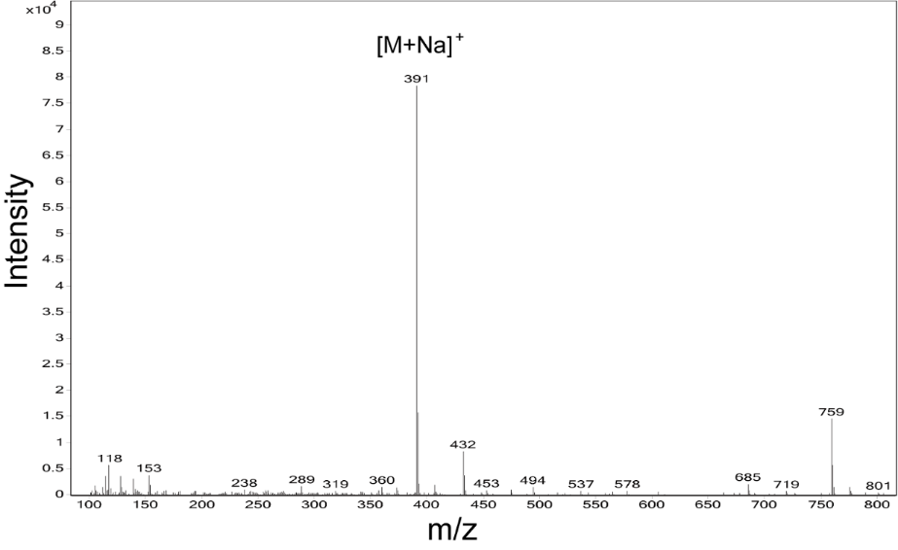
Fig. S2 MS fragments of DFSK

Fig. S3 Original western blot images presented in this study

Fig. S3 (continued) Original western blot images presented in this study
Supplementary Tables:

Table S1. The equilibrium solubility of DFSK in different solutions ª
Solvent | Equilibrium solubility (μg/mL)
Solvent | DFSK | ISOF | FSK
H₂O | 786.19 | 144.86 | 22.57
HCl (0.1 mol/L) | 693.79 | 184.84 | 23.39
Phosphate buffer with pH=2.7 | 615.69 | 117.56 | 15.83
Phosphate buffer with pH=3.5 | 610.11 | 116.06 | 14.79
Phosphate buffer with pH=4.5 | 620.50 | 114.52 | 15.31
Phosphate buffer with pH=5.5 | 598.84 | 114.49 | 16.07
Phosphate buffer with pH=6.5 | 585.82 | 111.30 | 15.04
Phosphate buffer with pH=7.5 | 535.58 | 105.74 | 15.20
ª An excess of DFSK, ISOF, or FSK was weighed and placed into 10 mL test tubes. In each tube, 5 mL of deionized water, 0.1 mol/L hydrochloric acid solution, or phosphate buffer solutions with pH values of 2.7, 3.5, 4.5, 5.5, 6.5, and 7.5 were added. The mixtures were oscillated at 25 °C for 24 hours, then centrifuged at 12,000 r/min for 10 minutes. The supernatant was filtered through a 0.22 μm microporous membrane, and the subsequent filtrate was detected by HPLC. The peak area was measured, and the concentration of each compound was calculated.

Table S2. The lipid-water partition coefficient of DFSK in different solutions ª
Solvent | Lipid-water partition coefficient (log P)
Solvent | DFSK | ISOF | FSK
H₂O | 2.29 | 2.53 | 3.37
Phosphate buffer with pH=3.5 | 2.28 | 2.54 | 3.24
Phosphate buffer with pH=5.5 | 2.31 | 2.62 | 3.27
Phosphate buffer with pH=6.5 | 2.29 | 2.54 | 3.37
ª Appropriate amounts of DFSK, ISOF, or FSK was dissolved in water-saturated n-octanol to prepare solutions with a mass concentration of 10 mg/mL. Then, 1 mL of each solution was transferred into a 4 mL test tube, and 1 mL of either deionized water or phosphate buffer solution (pH 3.5, 5.5, or 6.5) was added. The mixtures were oscillated at 25 °C for 72 hours, followed by centrifugation at 12,000 r/min for 10 minutes. Subsequently, 20 μL of the aqueous phase was detected by HPLC. The peak area was measured, and the concentration of each compound was determined. The lipid-water partition coefficient was calculated using the formula: log P = log (A / B), where A is the original concentration of the compound in n-octanol, and B is the concentration of the compound in the aqueous phase.

