Facile synthesis and biological evaluation of glomuferrin and rhizoferrin as ferroptosis inhibitors in rice blast disease

Anna Fusetti, Francesca Annunziata, Michael S. Christodoulou, Andrea Pinto, Andrea Kunova, Salvatore Princiotto,* and Sabrina Dallavalle

Department of Food, Environmental and Nutritional Sciences, University of Milan, via Celoria 2, 20133, Milan, Italy

Supporting information

HPLC chromatograms of rac-(1) and meso-(1) Page S1
HPLC chromatograms of rac-(3) and (R)-(3) Page S2
¹H- and ¹³C-NMR Page S3

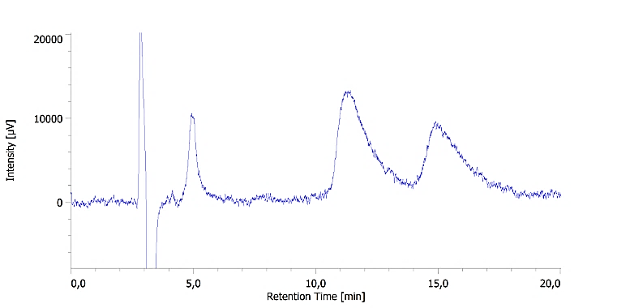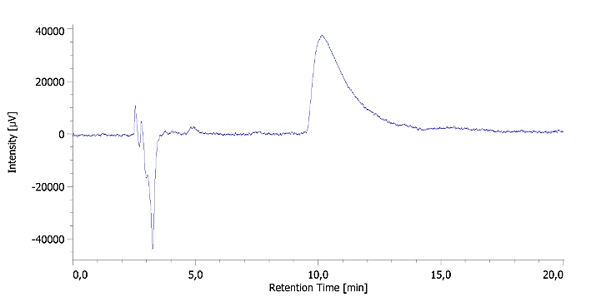
Figure S1. HPLC chromatogram of a) rac-1 and b) meso-1. hexane:isopropanol 1:9 + 0.2% formic acid. Chiral column Kromasyl AmyCoat 5 (4.6 x 250 mm, 5 μM particle size), λ = 210 nm, Φ = 1 mL/min.

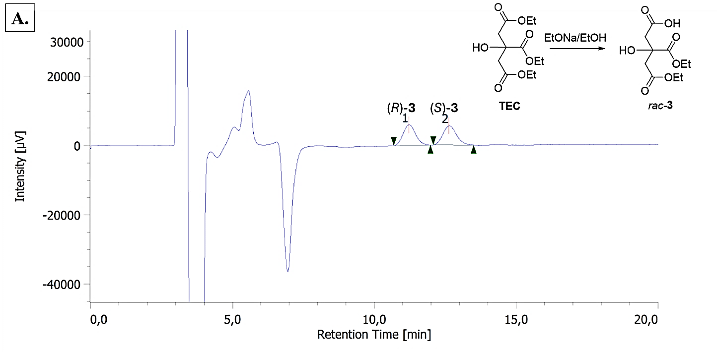
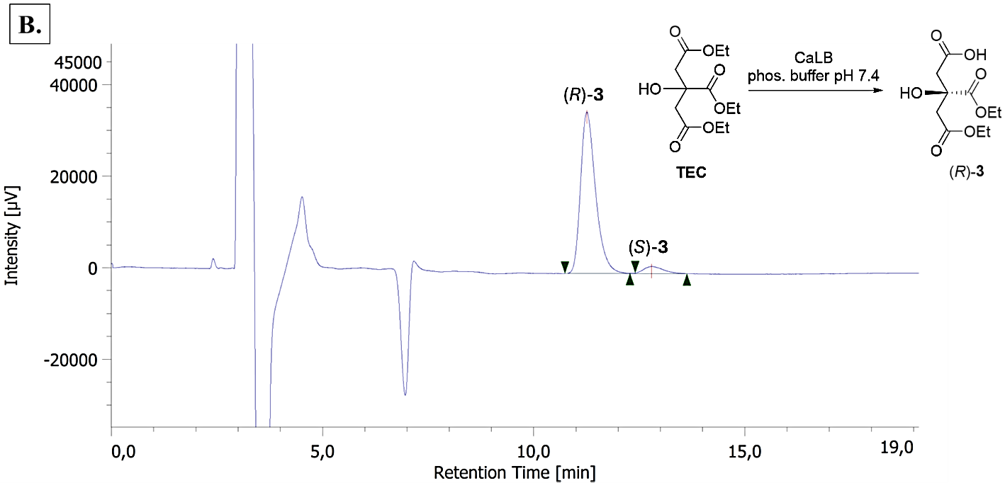
Figure S2. Comparison between HPLC chromatograms of rac-3, obtained by alkaline hydrolysis (A) and enantioenriched 3, obtained by CaLB-catalyzed hydrolysis (B).

