Supplementary Information
Virtual Screening of Azoles Libraries: The Search for Potential Anti-mucormycotic Agents Using Computational Tools.
Ahlam Haj Hasan^{1,2}, Gagan Preet¹, Rishi Astakala¹, Emmanuel Oluwabusola¹, Rainer Ebel¹, and Marcel Jaspars^{1,*}
¹ Marine Biodiscovery Centre, Department of Chemistry, University of Aberdeen, AB24 3UE.; a.hajhasan.20@ abdn.ac.uk (AH); gagan.preet1@abdn.ac.uk (GP); r.astakala.19@abdn.ac.uk (RVA); emmanuel.oluwabusola3@abdn.ac.uk (EO); r.ebel@abdn.ac.uk (RE); m.jaspars@abdn.ac.uk (MJ)
² Department of Medicinal Chemistry and Pharmacognosy, Faculty of Pharmacy, Jordan University of Science and Technology, Irbid 22110, Jordan.
* Correspondence: m.jaspars@abdn.ac.uk.

Fig. S1
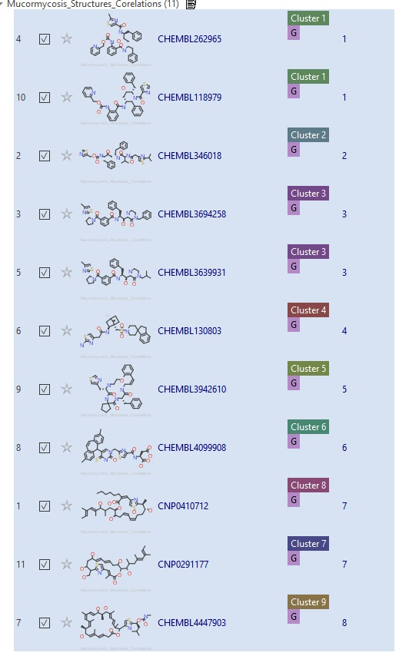
Similarity clustering of top azoles (1-11) using Cresset Flare

Fig. S2
Protein-ligand contacts of 1,3-beta-glucan synthase-compound (1) complex throughout molecular dynamics.

Fig. S3
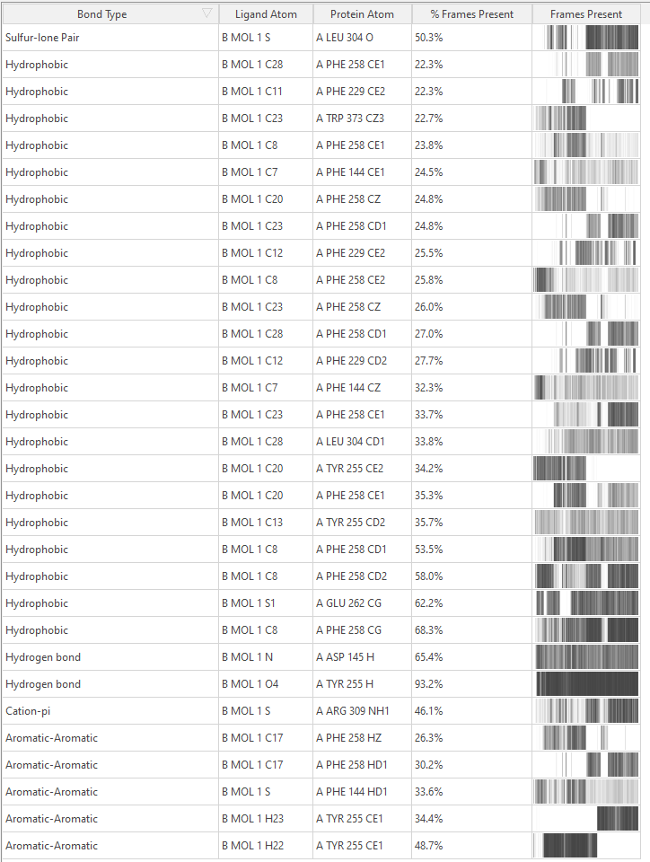
Protein-ligand contacts of 1,3-beta-glucan synthase-compound (2) complex throughout molecular dynamics.

