Discovery of Novel Anticancer Candidates Based on a Combination Strategy of Synthesis, Characterization, Biological Activity Evaluation, Consensus Docking and Molecular Modeling
Faten M. Atlam*, Hend A. Hekal
Chemistry Department, Faculty of Science, Tanta University, 31527, Egypt
faten.atlam@science.tanta.edu.eg
hend_hekal@yahoo.com

Table S1. FT-IR spectral data of α-aminophosphonates compounds, IVa-f.
Compound | Band assignment (cm⁻¹)
Compound | NH/OH stretch | CH_{Ar.}  stretch | CH_{aliph}  stretch | C=_{Oaliphatic}  stretch | C=O_{quinazoline}  stretch | C=C_{Ar}  stretch | C=N  stretch | C-C_{Ar}  stretch | P=O  stretch | P-O-C  stretch | P-CH  stretch
IVa | 3425 | 3076 | 2920 | 1709 | 1668 | 1648 | 1595 | 1488 | 1252 | 1067 | 771
IVb | 3418 | 3076 | 2960 | 1709 | 1668 | 1648 | 1560 | 1483 | 1253 | 1075 | 770
IVc | 3377 | 3065 | 2962 | 1709 | 1666 | 1611 | 1549 | 1442 | 1241 | 1075 | 769
IVd | 3422 | 3073 | 2920 | 1709 | 1668 | 1647 | 1592 | 1488 | 1245 | 1072 | 770
IVe | 3425 | 3075 | 2958 | 1709 | 1668 | 1647 | 1559 | 1481 | 1257 | 1073 | 769
IVf | 3434 | 3066 | 2919 | 1711 | 1661 | 1612 | 1544 | 1483 | 1295 | 1088 | 771

Table S2. ¹H-NMR spectral data of α-aminophosphonates compounds, IVa-f.
Compound | Type of Proton (δ ppm)
Compound | CH₂ proton | CH-P proton | Aromatic protons | NH proton | Other protons
IVa | 2.50 | 5.70-5.74 | 6.77-8.29 | 8.57 | -----
IVb | 2.50 | 4.95-5.01 | 5.96-8.39 | 8.66 | 9.80 (OH)
IVc | 2.52 | 5.24-5.26 | 5.55-7.76 | 7.92 | 8.20 (OH)  8.58 (OH)
IVd | 2.50 | 5.02-5.08 | 6.69-8.17 | 8.65 | 3.70 (CH₃), 3.74 (CH₃)
IVe | 2.51 | 5.45-5.48 | 5.95-8.19 | 8.61 | ----
IVf | 2.53 | 5.95-5.98 | 6.16-8.18 | 8.84 | 3.98 (CH₃), 9.79 (OH)

Table S3. Anti-oxidant assays of compounds III and IVa-f.
No. | Compounds | Conc. µg/ml
No. | Compounds | IC₅₀
 | Vit - C | 36.3±0.03
1 | III | 71.6±0.08
2 | IVa | 84.4±0.11
3 | IVb | 51.5±0.05
4 | IVc | 32.4±0.02
5 | IVd | 93.8±0.13
6 | IVe | 77.2±0.09
7 | IVf | 41.3±0.02

Table S4. Anti-hemolytic assays of compounds III and IVa-f.
No. | Compounds | Erythrocyte hemolysis  A/B x 100
No. | Compounds | Absorbance of samples (A) | % hemolysis
No. | Absorbance of H₂O (B) | 0.775 | -----
No. | Ascorbic acid | 0.030 | 3.9%
1 | III | 0.035 | 4.5%
2 | IVa | 0.033 | 4.2%
3 | IVb | 0.353 | 45.5%
4 | IVc | 0.022 | 2.8%
5 | IVd | 0.038 | 4.9%
6 | IVe | 0.069 | 89.0%
7 | IVf | 0.023 | 3.0%

Scheme S1
Scheme S2

Fig S1: FT-IR spectra of compounds, III and IVa-f.
Fig. S2. ¹H-NMR and D₂O ¹H-NMR spectrum of compound, III.

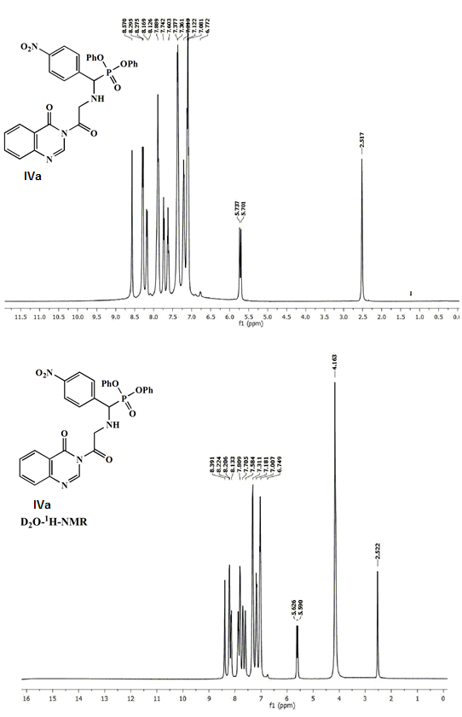
Fig. S3. ¹H-NMR spectrum of α-aminophosphonates, IVa-f.

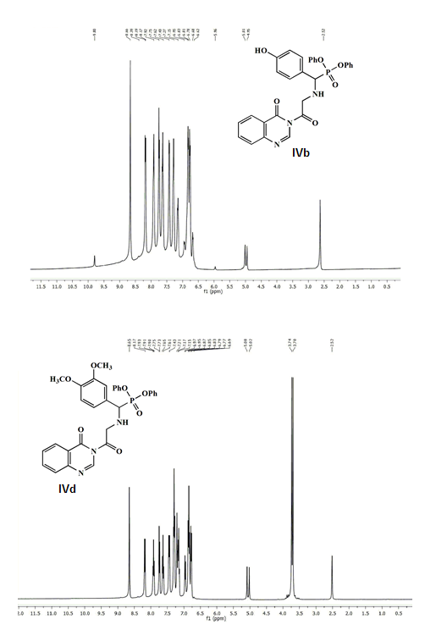
Fig. S3. Continued.

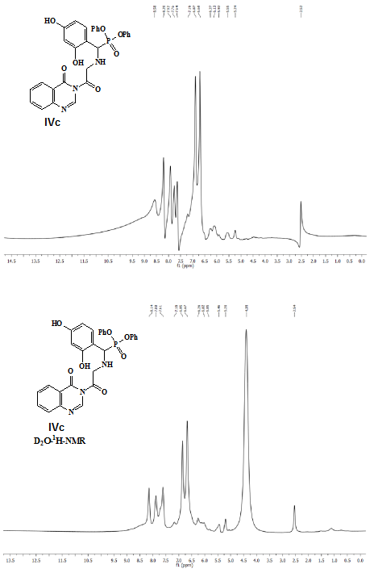
Fig. S3. Continued.

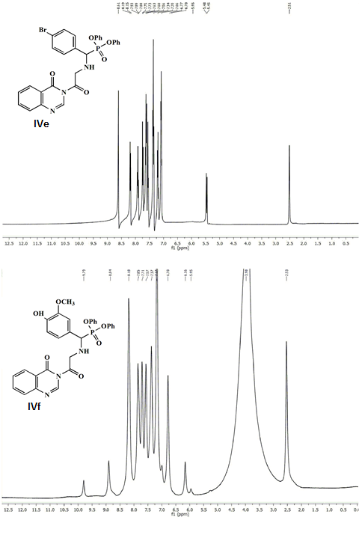
Fig. S3. Continued.

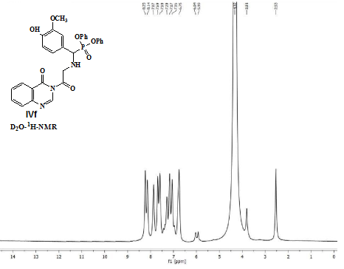
Fig. S3. Continued.
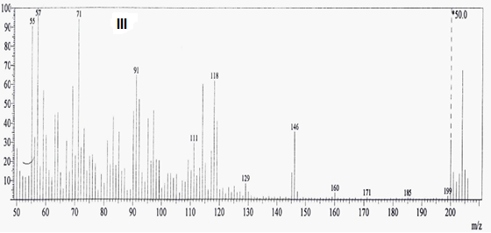
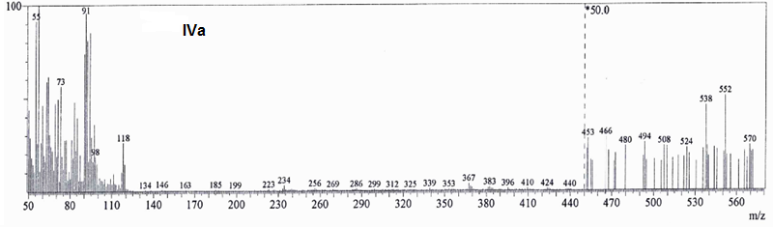Fig. S4. Mass spectrum of the investigated compounds.

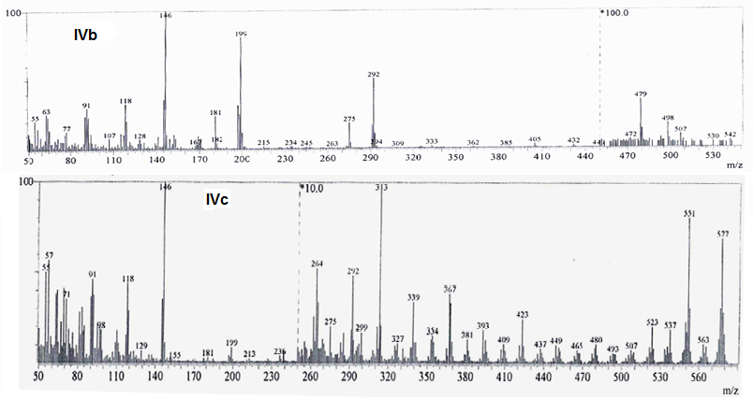
Fig. S4. Continued.

