Precipitation and Interannual Variability Shape the Phenology and Abundance of the Endangered Butterfly Baronia brevicornis

Running title: Phenology and abundance of Baronia brevicornis

Yesenia Alvarado-Campos¹, Gloria Ruiz-Guzmán¹, Carlos A. Anaya Merchant¹, Elaine M. Méndez Muñiz^{1,2} & Jorge Contreras-Garduño^{1*}

¹ Escuela Nacional de Estudios Superiores, Unidad Morelia, UNAM, Morelia, Michoacán, México.
² Posgrado en Ciencias Biológicas, UNAM, México.

*Correspondence: Jorge Contreras-Garduño, Escuela Nacional de Estudios Superiores, Unidad Morelia, UNAM, Antigua Carretera a Pátzcuaro No.8701, Col. Ex-Hacienda San José de la Huerta. CP 58190, Morelia, Michoacán, México. E-mail: jcg@enesmorelia.unam.mx

KEYWORDS
Panchronic species; Diapause; Polymorphism; Climate change; Endemic; Plasticity; Precipitation

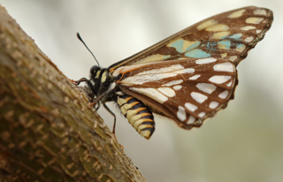
ESM_Figure 1 A female brown morph of Baronia brevicornis perched on Acacia cochliacantha (the blue spots on the wing are due to marking)

ESM_Figure 2 Historical data of annual precipitation (blue bars) and average annual maximum temperature (red line) of the study site from 1990 to 2024

ESM_Figure 3 Monthly accumulated precipitation (blue bars) and monthly mean maximum temperature (red line) in the study area from 2015 to 2024

ESM_Figure 4 Pearson correlation matrix among the covariates used in the N-mixture model. All pairwise correlations were below 0.7, indicating low collinearity among predictors (Dorman et al., 2013)

ESM_Figure 5 Pearson residuals plotted against fitted values for the N-mixture model. Residuals show no clear patterns, supporting the adequacy of the model fit

References

Dormann, C. F., Elith, J., Bacher, S., Buchmann, C., Carl, G., Carré, G., ... & Lautenbach, S. (2013). Collinearity: a review of methods to deal with it and a simulation study evaluating their performance. Ecography, 36(1), 27-46.

