Appendix A
App. A. Examples of simplex lattice designs with three and four components

Appendix B
Mass ratio of the coals and biomass
No of experiments | Coal 1 | Coal 2 | Biomass 1 | Biomass 2
No of experiments | Percentage of ash in mixture
1 | 1.0 | 0.0 | 0.0 | 0.0
2 | 0.0 | 1.0 | 0.0 | 0.0
3 | 0.0 | 0.0 | 1.0 | 0.0
4 | 0.0 | 0.0 | 0.0 | 1.0
5 | 0.5 | 0.5 | 0.0 | 0.0
6 | 0.5 | 0.0 | 0.5 | 0.0
7 | 0.5 | 0.0 | 0.0 | 0.5
8 | 0.0 | 0.5 | 0.5 | 0.0
9 | 0.0 | 0.5 | 0.0 | 0.5
10 | 0.0 | 0.0 | 0.5 | 0.5
11 | 0.7 | 0.1 | 0.1 | 0.1
12 | 0.1 | 0.7 | 0.1 | 0.1
13 | 0.1 | 0.1 | 0.7 | 0.1
14 | 0.1 | 0.1 | 0.1 | 0.7
15 | 0.25 | 0.25 | 0.25 | 0.25

Appendix C
Results of proximate and ultimate analysis
Parameter | A^{d} | V^{d} | Q_{s}ª | Q_{i}^{r} | C_{t}^{d} | H_{t}^{d} | N^{d} | S_{t}ª | O_{t}ª
Unit | % | % | J/g | J/g | % | % | % | % | %
Mu | 0.2 | 0.54 | 201 | 210 | 0.6 | 0.32 | 0.05 | 0.12 | -
1 | 3.73 | 32.29 | 33266.48 | 30891.95 | 82.50 | 4.83 | 1.33 | 0.22 | 6.92
2 | 3.79 | 32.51 | 32333.76 | 30511.01 | 82.28 | 4.50 | 1.34 | 0.21 | 8.47
3 | 0.49 | 82.78 | 20291.10 | 16737.28 | 49.43 | 5.98 | 0.30 | 0.03 | 43.20
4 | 4.60 | 77.83 | 18486.99 | 15815.51 | 46.52 | 5.86 | 0.47 | 0.12 | 43.68
5 | 3.70 | 31.40 | 32343.05 | 30584.82 | 83.01 | 4.63 | 1.30 | 0.21 | 7.62
6 | 2.78 | 36.55 | 27466.61 | 25656.65 | 70.38 | 4.50 | 1.05 | 0.17 | 11.63
7 | 3.38 | 36.18 | 27921.85 | 26001.39 | 68.92 | 4.57 | 1.05 | 0.18 | 11.45
8 | 2.93 | 37.17 | 26551.40 | 24954.00 | 69.88 | 4.30 | 1.02 | 0.16 | 12.63
9 | 3.53 | 35.45 | 26966.93 | 24989.55 | 68.61 | 4.38 | 1.06 | 0.18 | 12.99
10 | 2.57 | 81.84 | 19465.50 | 16739.04 | 48.47 | 5.91 | 0.38 | 0.07 | 43.33
11 | 3.58 | 37.31 | 31778.21 | 29139.80 | 77.64 | 4.87 | 1.24 | 0.20 | 10.98
12 | 3.55 | 36.29 | 30415.43 | 28994.67 | 77.77 | 4.80 | 1.25 | 0.20 | 11.45
13 | 3.29 | 42.43 | 30176.03 | 28667.24 | 76.85 | 5.07 | 1.12 | 0.18 | 14.79
14 | 3.66 | 41.24 | 29573.04 | 27412.14 | 74.97 | 4.83 | 1.12 | 0.19 | 15.02
15 | 3.46 | 41.11 | 30155.55 | 28445.39 | 76.01 | 4.93 | 1.15 | 0.19 | 14.98

Appendix D
Results of characteristic melting temperature [ºC] of ashes from studied fuels
Parameter | t_{s(O)} | t_{A(O)} | t_{B(O)} | t_{C(O)} | t_{s(Or)} | t_{A(Or)} | t_{B(Or)} | t_{C(Or)}
Mu | 30 | 20 |  |  | 30 | 20
1 | 1060 | 1340 | 1350 | 1350 | 850 | 1310 | 1320 | 1330
2 | 1190 | 1270 | 1310 | 1320 | 1070 | 1160 | 1200 | 1210
3 | 1280 | 1360 | 1360 | 1370 | 1110 | 1310 | 1320 | 1340
4 | 680 | 840 | 1220 | 1280 | 670 | 810 | 1290 | 1360
5 | 1100 | 1290 | 1310 | 1320 | 1120 | 1270 | 1280 | 1290
6 | 1040 | 1340 | 1350 | 1350 | 890 | 1310 | 1310 | 1320
7 | 1060 | 1300 | 1300 | 1310 | 850 | 1260 | 1280 | 1280
8 | 1190 | 1260 | 1290 | 1300 | 1050 | 1160 | 1210 | 1220
9 | 1140 | 1230 | 1260 | 1270 | 1070 | 1140 | 1170 | 1180
10 | 710 | 1200 | 1220 | 1220 | 700 | 1180 | 1200 | 1210
11 | 1110 | 1300 | 1310 | 1310 | 1130 | 1260 | 1290 | 1300
12 | 1120 | 1260 | 1270 | 1280 | 1080 | 1190 | 1220 | 1230
13 | 1090 | 1300 | 1300 | 1310 | 1120 | 1260 | 1290 | 1300
14 | 1120 | 1230 | 1240 | 1240 | 1090 | 1170 | 1210 | 1220
15 | 1120 | 1260 | 1270 | 1270 | 1070 | 1180 | 1230 | 1240

Appendix E
Chemical composition of ashes [%] from studied fuels
Parameter | SiO₂ | Al₂O₃ | Fe₂O₃ | CaO | MgO | P₂O₅ | SO₃ | Mn₃O₄ | TiO₂ | BaO | SrO | Na₂O | K₂O
Mu | 2.15 | 1.10 | 0.29 | 0.50 | 0.14 | 0.08 | 0.27 | 0.04 | 0.08 | 0.08 | 0.04 | 0.04 | 0.14
1 | 17.71 | 12.89 | 13.65 | 18.61 | 10.67 | 0.87 | 18.23 | 0.24 | 0.47 | 0.41 | 0.25 | 2.95 | 0.85
2 | 23.07 | 17.72 | 13.91 | 14.21 | 9.03 | 0.27 | 13.96 | 0.33 | 0.82 | 0.36 | 0.15 | 4.81 | 0.98
3 | 13.72 | 9.27 | 14.82 | 22.48 | 11.37 | 1.13 | 3.74 | 0.31 | 0.32 | 0.23 | 0.12 | 1.53 | 1.80
4 | 58.03 | 1.14 | 0.54 | 8.63 | 3.72 | 3.21 | 2.33 | 0.62 | 0.08 | 0.06 | 0.03 | 0.24 | 10.94
5 | 20.34 | 15.28 | 14.10 | 16.43 | 9.81 | 0.56 | 16.05 | 0.28 | 0.64 | 0.39 | 0.20 | 3.84 | 0.90
6 | 15.32 | 11.25 | 12.60 | 17.35 | 9.74 | 0.81 | 14.02 | 0.23 | 0.41 | 0.34 | 0.21 | 2.39 | 0.91
7 | 21.62 | 9.92 | 10.15 | 15.67 | 8.51 | 1.12 | 13.65 | 0.28 | 0.36 | 0.32 | 0.19 | 2.22 | 2.33
8 | 19.05 | 14.37 | 12.75 | 14.29 | 8.42 | 0.37 | 10.79 | 0.30 | 0.66 | 0.31 | 0.13 | 3.87 | 1.01
9 | 25.91 | 13.04 | 10.91 | 11.94 | 7.13 | 0.68 | 10.60 | 0.33 | 0.61 | 0.27 | 0.12 | 3.67 | 2.38
10 | 35.46 | 5.32 | 7.58 | 15.51 | 7.57 | 2.16 | 3.04 | 0.47 | 0.20 | 0.15 | 0.07 | 0.88 | 6.47
11 | 20.73 | 13.67 | 13.24 | 17.45 | 9.87 | 0.82 | 15.17 | 0.29 | 0.54 | 0.37 | 0.20 | 3.34 | 1.44
12 | 22.51 | 15.20 | 13.20 | 15.98 | 9.45 | 0.63 | 13.80 | 0.32 | 0.64 | 0.35 | 0.18 | 3.85 | 1.49
13 | 20.44 | 13.05 | 13.37 | 17.49 | 9.85 | 0.84 | 13.86 | 0.29 | 0.53 | 0.36 | 0.19 | 3.10 | 1.54
14 | 26.01 | 13.38 | 11.96 | 15.01 | 8.85 | 0.95 | 12.82 | 0.34 | 0.56 | 0.32 | 0.16 | 3.39 | 2.51
15 | 23.16 | 13.34 | 12.64 | 16.25 | 9.22 | 0.88 | 13.20 | 0.32 | 0.54 | 0.34 | 0.17 | 3.28 | 2.01

Appendix F
Slagging hazard determination
Parameter | B/A | R_{s} | Fe-Ca_{ratio} | Fe&Ca | F_{u} | S_{R}
1 | 1.50 | 0.32 | 0.96 | 26.29 | 5.80 | 29.17
2 | 1.05 | 0.22 | 1.20 | 31.60 | 5.92 | 38.19
3 | 2.26 | 0.07 | 0.65 | 24.09 | 7.56 | 21.43
4 | 0.40 | 0.05 | 2.06 | 1.71 | 5.19 | 82.12
5 | 1.25 | 0.27 | 1.11 | 29.66 | 5.93 | 33.03
6 | 1.60 | 0.27 | 0.91 | 23.77 | 5.41 | 27.62
7 | 1.20 | 0.22 | 0.97 | 20.46 | 5.62 | 39.10
8 | 1.14 | 0.19 | 1.14 | 27.11 | 5.60 | 35.97
9 | 0.90 | 0.16 | 1.23 | 24.08 | 5.43 | 46.38
10 | 0.92 | 0.07 | 0.68 | 12.79 | 7.18 | 54.06
11 | 1.28 | 0.26 | 1.04 | 26.87 | 6.19 | 34.20
12 | 1.14 | 0.23 | 1.12 | 28.80 | 6.07 | 36.75
13 | 1.32 | 0.24 | 0.99 | 26.74 | 6.37 | 33.53
14 | 1.06 | 0.20 | 1.10 | 25.58 | 6.28 | 41.34
15 | 1.19 | 0.22 | 1.03 | 25.68 | 6.43 | 37.53

Appendix G
Limiting values for slagging factors
Parameter | Slagging propensity
Parameter | Low | Medium |  | High |  | Severe
B/A | <0.4 or > 0.7 |  |  | 0.4 – 0.7
R_{s} | <0.6 | 0.6 – 2.0 |  | 2.0 – 2.6 |  | 2.6>
Fe-Ca_{ratio} | <0.3 or >3.0 |  |  | 0.3–3.0
ΣFe&Ca [%] | <10 |  |  | –
F_{u} | ≤0.6 |  | 0.6 – 40 |  | >40
S_{R} | >72 |  | 72-65 |  | ≤65

Appendix H
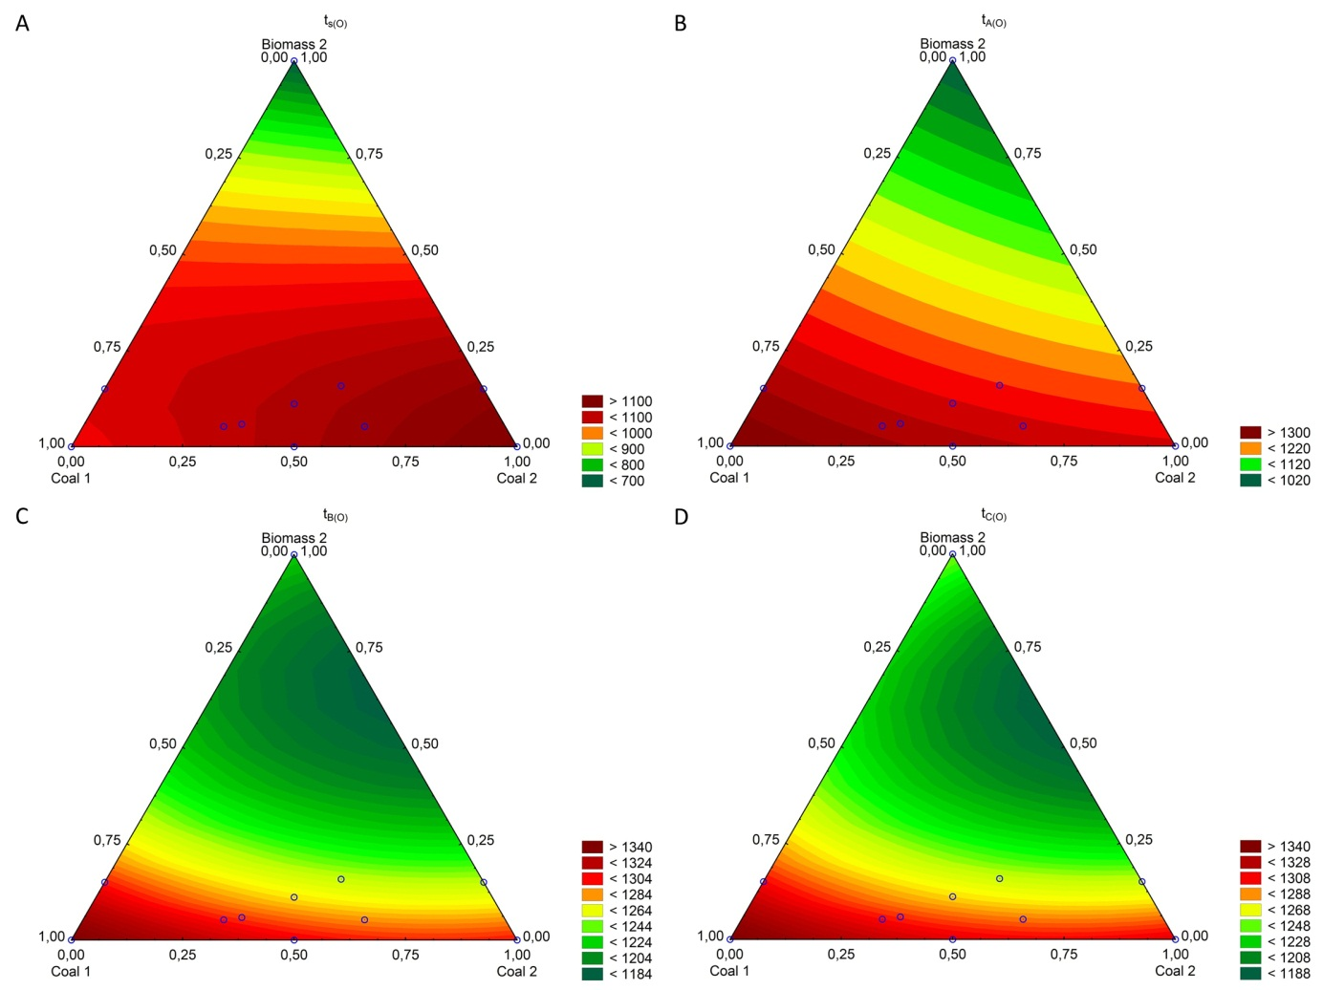
App. H. Changing of the ash fusibility temperatures in an oxidizing atmosphere a function of the coal 1: carbon 2: biomass 2 A - sintering temperature t_{s(O)}, B – softening temperature t_{A(O)}, C – melting temperature t_{B(O)}, D – flowing temperature t_{C(O)}.

Appendix I
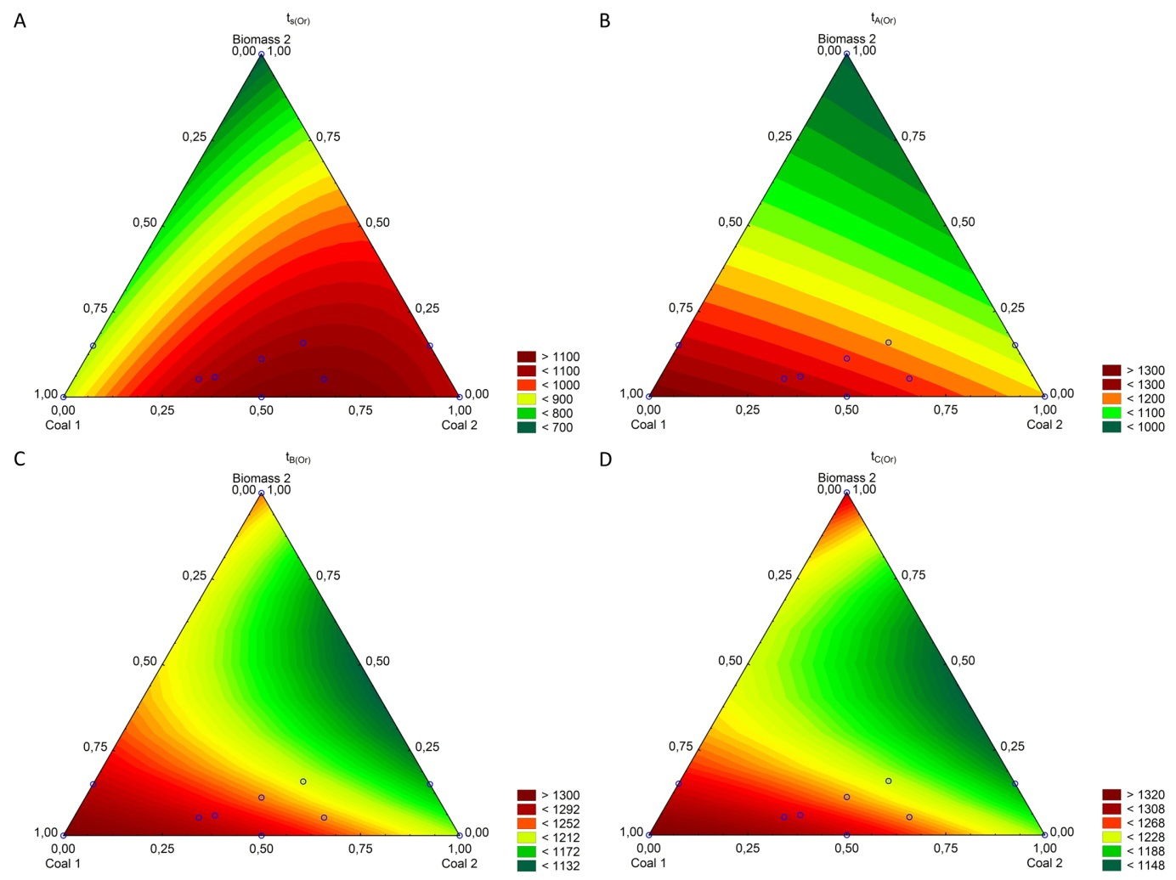
App. I. Changing of the ash fusibility temperatures in an reducing atmosphere a function of the coal 1: carbon 2: biomass 2 A - sintering temperature t_{s(O)}, B – softening temperature t_{A(O)}, C – melting temperature t_{B(O)}, D – flowing temperature t_{C(O)}.

Appendix J
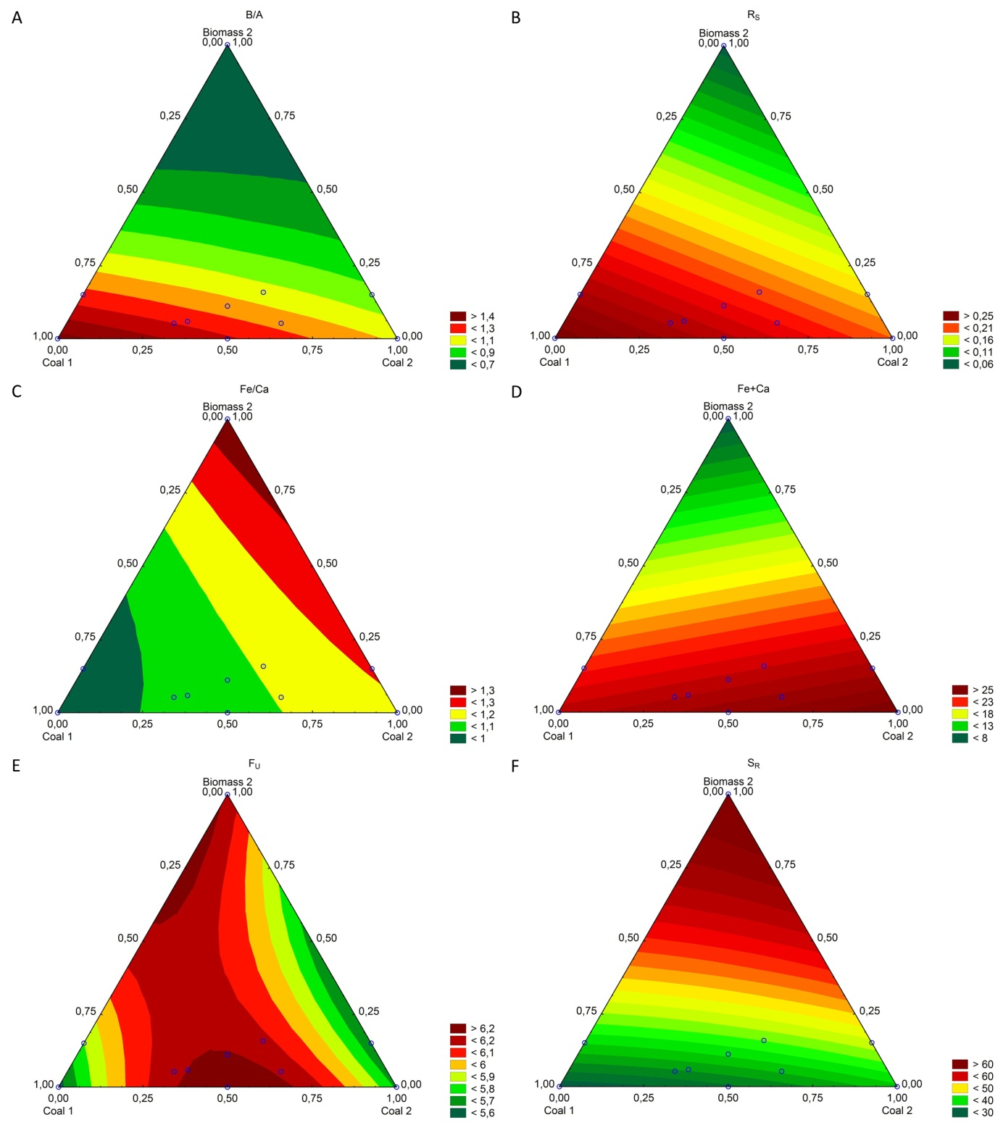
App. J. The change of characteristic slagging hazard coefficients of fuel a depending on the coal 1: carbon 2: biomass 1, A – ratio of basic compounds to acidic compounds, B – slagging (Babcock)—index R_{s}, C – fouling index Fu, D – slag viscosity index, E – iron-calcium ratio, F – iron plus calcium,

Measurement uncertainty
Measurement uncertainty
Measurement uncertainty

