Supplementary materials
Efficient dewatering of polymer-rich aerobic granular sludge with cationic polymer containing hydrocarbons
International Journal of Environmental Science and Technology

Agnieszka Cydzik-Kwiatkowska*, Dawid Nosek, Irena Wojnowska-Baryła, Artur Mikulski
University of Warmia and Mazury in Olsztyn, Department of Environmental Biotechnology, 10-709 Olsztyn, Słoneczna 45 G
*Corresponding author: agnieszka.cydzik@uwm.edu.pl, tel. +48 89 5234149, fax +48 89 5234131

- b)
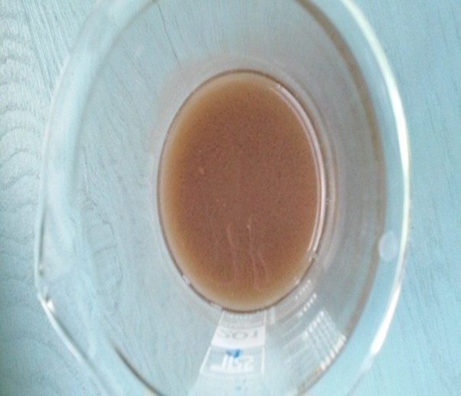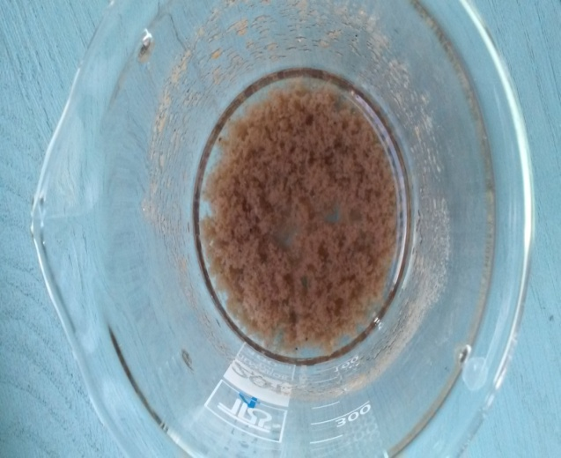
1 cm
- d)
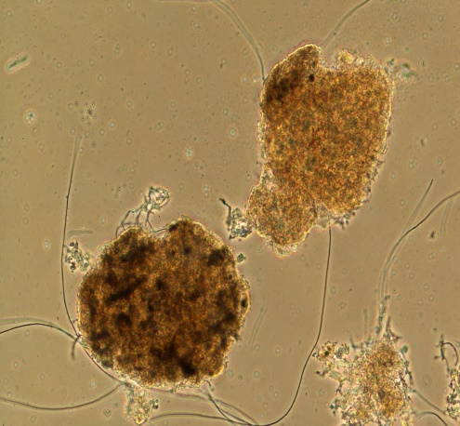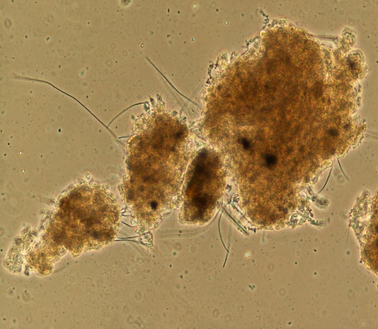
100 µm

Fig. 1SM Aerobic granular sludge a) in a flask before polymer addition, b) in a flask after polymer addition, c) under a microscope (100x magnification) before polymer addition, d) under a microscope (100x magnification) after polymer addition

