Supplement 1

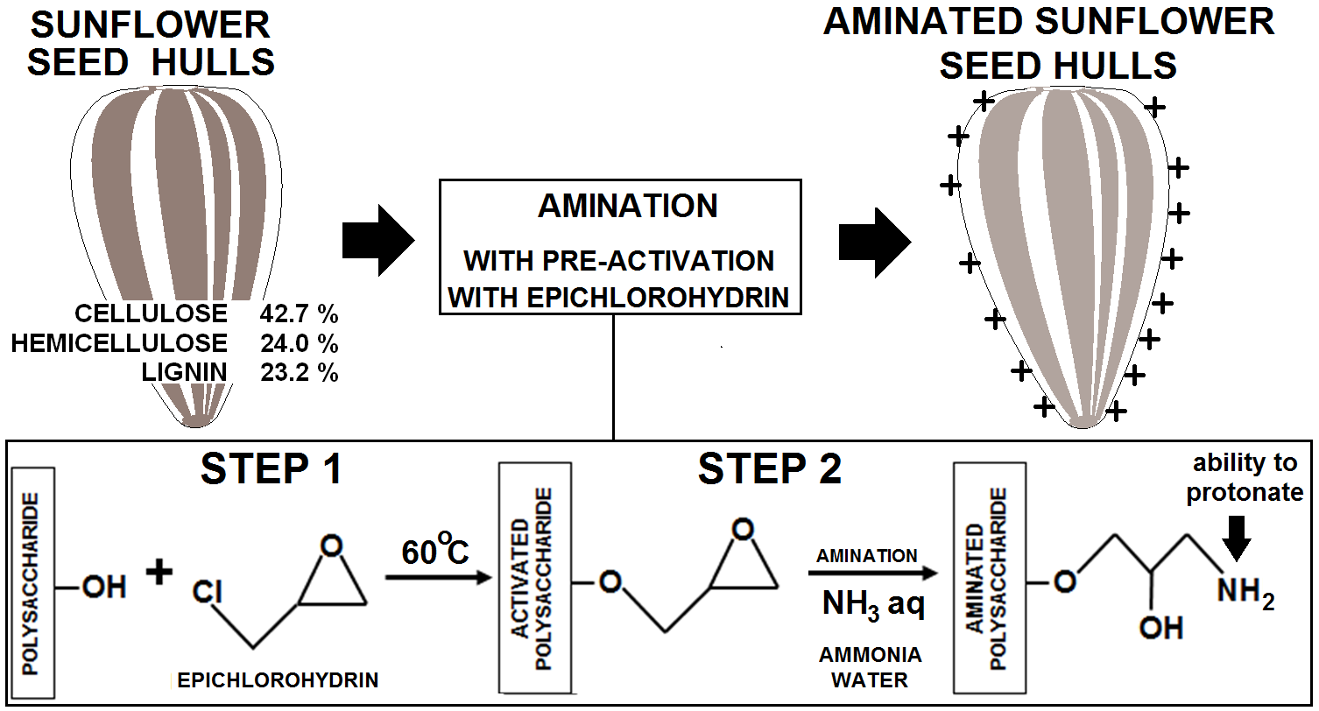
Suppl. 1 Scheme of modification of sunflower seed hulls.

Supplement 2
Suppl. 2 Changes in concentrations of dyes in the solution during sorption: A) RB5 on SSH, B) RB5 on SSH-AM C) RY84 on SSH, D) RY84 on SSH-AM, E) AY23 on SSH, F) AY23 on SSH-AM, G) AR18 on SSH, H) AR18 on SSH-AM.
Supplement 3

Suppl. 3 Intramolecular diffusion model of dyes sorption: A) RB5 on SSH, B) RY84 on SSH, C) AY23 on SSH, D) AR18 on SSH, E) RB5 on SSH-AM, F) RY84 on SSH-AM, G) AY23 on SSH-AM, H) AR18 on SSH-AM
Supplement 4

Suppl. 4 Isotherms of dyes: A) RB5, B) RY84, C) AY23, D) AR18 sorption on SSH and SSH-AM.

Supplement 5

Suppl. 5 carbon and nitrogen content in SSH and SSH-AM. Analyzes carried out on the elemental analyzer - FLASH 2000 (THERMO SCIENTIFIC, USA).

Type of sorbent | carbon content [%] |  | nitrogen content [%] |  | C/N ratio | N/C ratio
Type of sorbent | range of content | average content | range of content | average content | based on average content | based on average content
SSH | 46.35-48.49 | 47.50 | 0.52-0.62 | 0.59 | 80.51 | 0.0124
SSH-AM | 42.41-44.92 | 43.77 | 0.90-1.12 | 1.04 | 42.09 | 0.0238

