Supplementary information

Organic matter in drinking water or wastewater vary in its influence on micropollutants adsorption to activated carbon
Table S1 Tucker’s congruency coefficient (TCC) obtained in split-half analysis of PARAFAC model
Table S2 Ratio of mciropolllutants concentration after 7 and 14 days in relation to day 0 in biodegradability tests
Table S3 Freundlich coefficients fitted to adsorption isotherms
Fig. S1 Excitation and emission loadings at different wavelengths of models tested in the split-half analysis
Fig. S2 Micropollutants breakthrough curves in lab-scale GAC filter treating wastewater effluent spiked with micropollutants
Fig. S3 Micropollutants load on GAC over time in influent of GAC filters in drinking water plants (infGAC) and wastewater effluent (WWef) at three DOC levels: low ~ 3 mg/L, medium ~ 6 mg/L, high ~ 10 mg/L
Fig. S4 Fluorescence spectra of 4 components identified in the PARAFAC analysis
Fig. S5 Relative loading (effluent:influent) of PARAFAC components in effluent of lab-scale GAC filter treating wastewater treatment plant effluent spiked with micropollutants

Table S1 Tucker’s congruency coefficient (TCC) obtained in split-half analysis of PARAFAC model
Component | Combination | TCC emission | TCC excitation
C1 | ABvsCD | 0.9997660 | 0.9820451
C1 | ACvsBD | 0.9986763 | 0.9945762
C1 | ADvsBC | 0.9999741 | 0.9997069
C2 | ABvsCD | 0.9837282 | 0.9998252
C2 | ACvsBD | 0.9959500 | 0.9997660
C2 | ADvsBC | 0.9994648 | 0.9999225
C3 | ABvsCD | 0.9992624 | 0.9960166
C3 | ACvsBD | 0.9997029 | 0.9959541
C3 | ADvsBC | 0.9994291 | 0.9987357
C4 | ABvsCD | 0.9987918 | 0.9983389
C4 | ACvsBD | 0.9940932 | 0.9997683
C4 | ADvsBC | 0.9996818 | 0.9997756

Table S2 Ratio of mciropolllutants concentration after 7 and 14 days in relation to day 0 in biodegradability tests
Micropollutant | Condition | Ratio concentration day 7:day 0 | Ratio concentration day 14:day 0
Benzotriazole | abiotic | 1.06 | 1.14
Benzotriazole | biotic | 0.97 | 0.96
Carbamazepine | abiotic | 1.04 | 1.11
Carbamazepine | biotic | 0.98 | 0.96
DEET | abiotic | 1.04 | 1.16
DEET | biotic | 0.99 | 0.98
Furosemide | abiotic | 1.15 | 1.20
Furosemide | biotic | 1.03 | 1.00
Mecoprop | abiotic | 1.10 | 1.17
Mecoprop | biotic | 1.00 | 1.00
Pyrimethanil | abiotic | 1.05 | 1.16
Pyrimethanil | biotic | 1.02 | 0.97
Sulfamethoxazole | abiotic | 1.06 | 1.15
Sulfamethoxazole | biotic | 0.99 | 0.96
Trimethoprim | abiotic | 1.08 | 1.17
Trimethoprim | biotic | 0.99 | 0.91

Table S3 Freundlich coefficients fitted to adsorption isotherms
Matrix | DOC level | Micropollutant | K_{f} | n | R²
demi | 0 | Benzotriazole | 4231 | 1.11 | 0.72
WWef | low | Benzotriazole | 3464 | 2.63 | 0.99
WWef | medium | Benzotriazole | 3450 | 3.75 | 0.91
WWef | high | Benzotriazole | 1878 | 2.57 | 0.80
infGAC | low | Benzotriazole | 4426 | 3.89 | 0.97
infGAC | medium | Benzotriazole | 4230 | 3.16 | 0.90
infGAC | high | Benzotriazole | NA | NA | NA
demi | 0 | Carbamazepine | NA | NA | NA
WWef | low | Carbamazepine | 4315 | 1.43 | 0.87
WWef | medium | Carbamazepine | 2894 | 2.61 | 0.77
WWef | high | Carbamazepine | 192 | 1.75 | 0.83
infGAC | low | Carbamazepine | 12707 | 0.80 | 0.88
infGAC | medium | Carbamazepine | NA | NA | NA
infGAC | high | Carbamazepine | 137 | 1.76 | 0.80
demi | 0 | DEET | 11864 | 0.77 | 0.88
WWef | low | DEET | 3106 | 1.85 | 0.84
WWef | medium | DEET | 2168 | 2.92 | 0.81
WWef | high | DEET | 386 | 2.49 | 0.70
infGAC | low | DEET | 5103 | 1.47 | 0.75
infGAC | medium | DEET | NA | NA | NA
infGAC | high | DEET | 110 | 1.64 | 0.87
demi | 0 | Furosemide | NA | NA | NA
WWef | low | Furosemide | 1865 | 3.25 | 0.80
WWef | medium | Furosemide | 1402 | 3.70 | 0.83
WWef | high | Furosemide | 1 | 0.89 | 28.75
infGAC | low | Furosemide | NA | NA | NA
infGAC | medium | Furosemide | NA | NA | NA
infGAC | high | Furosemide | 1 | 0.90 | 31.04
demi | 0 | Mecoprop | NA | NA | NA
WWef | low | Mecoprop | 868 | 2.50 | 0.78
WWef | medium | Mecoprop | 749 | 3.02 | 0.82
WWef | high | Mecoprop | 8 | 1.01 | 0.87
infGAC | low | Mecoprop | NA | NA | NA
infGAC | medium | Mecoprop | NA | NA | NA
infGAC | high | Mecoprop | 27 | 1.42 | 0.83
demi | 0 | Pyrimethanil | NA | NA | NA
WWef | low | Pyrimethanil | 8612 | 0.86 | 0.81
WWef | medium | Pyrimethanil | 4244 | 1.05 | 0.93
WWef | high | Pyrimethanil | NA | NA | NA
infGAC | low | Pyrimethanil | 14840 | 0.90 | 0.70
infGAC | medium | Pyrimethanil | 5530 | 0.60 | 0.77
infGAC | high | Pyrimethanil | 309 | 1.99 | 0.74
demi | 0 | Sulfamethoxazole | 3967 | 1.41 | 0.84
WWef | low | Sulfamethoxazole | 2767 | 2.16 | 0.92
WWef | medium | Sulfamethoxazole | 1690 | 3.16 | 0.83
WWef | high | Sulfamethoxazole | 62 | 1.37 | 0.71
infGAC | low | Sulfamethoxazole | 6125 | 1.99 | 0.84
infGAC | medium | Sulfamethoxazole | NA | NA | NA
infGAC | high | Sulfamethoxazole | 219 | 2.08 | 0.82
demi | 0 | Trimethoprim | NA | NA | NA
WWef | low | Trimethoprim | 6242 | 1.05 | 0.92
WWef | medium | Trimethoprim | 4266 | 1.67 | 0.86
WWef | high | Trimethoprim | NA | NA | NA
infGAC | low | Trimethoprim | 6557 | 1.27 | 0.84
infGAC | medium | Trimethoprim | 6390 | 0.72 | 0.72
infGAC | high | Trimethoprim | 140 | 1.73 | 0.77

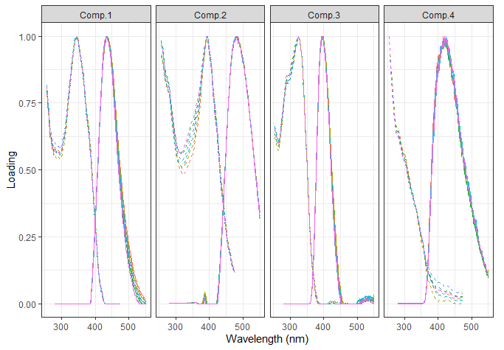

Fig. S1 Excitation and emission loadings at different wavelengths of models tested in the split-half analysis

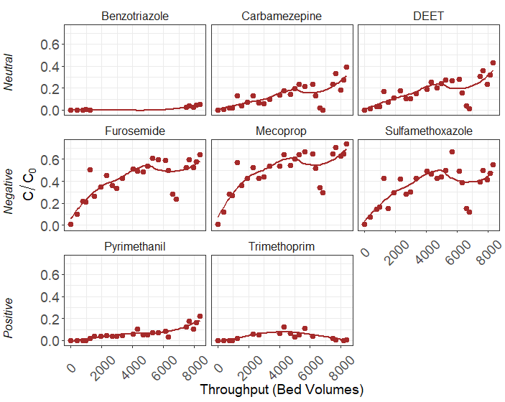
Fig. S2 Micropollutants breakthrough curves in lab-scale GAC filter treating wastewater effluent spiked with micropollutants

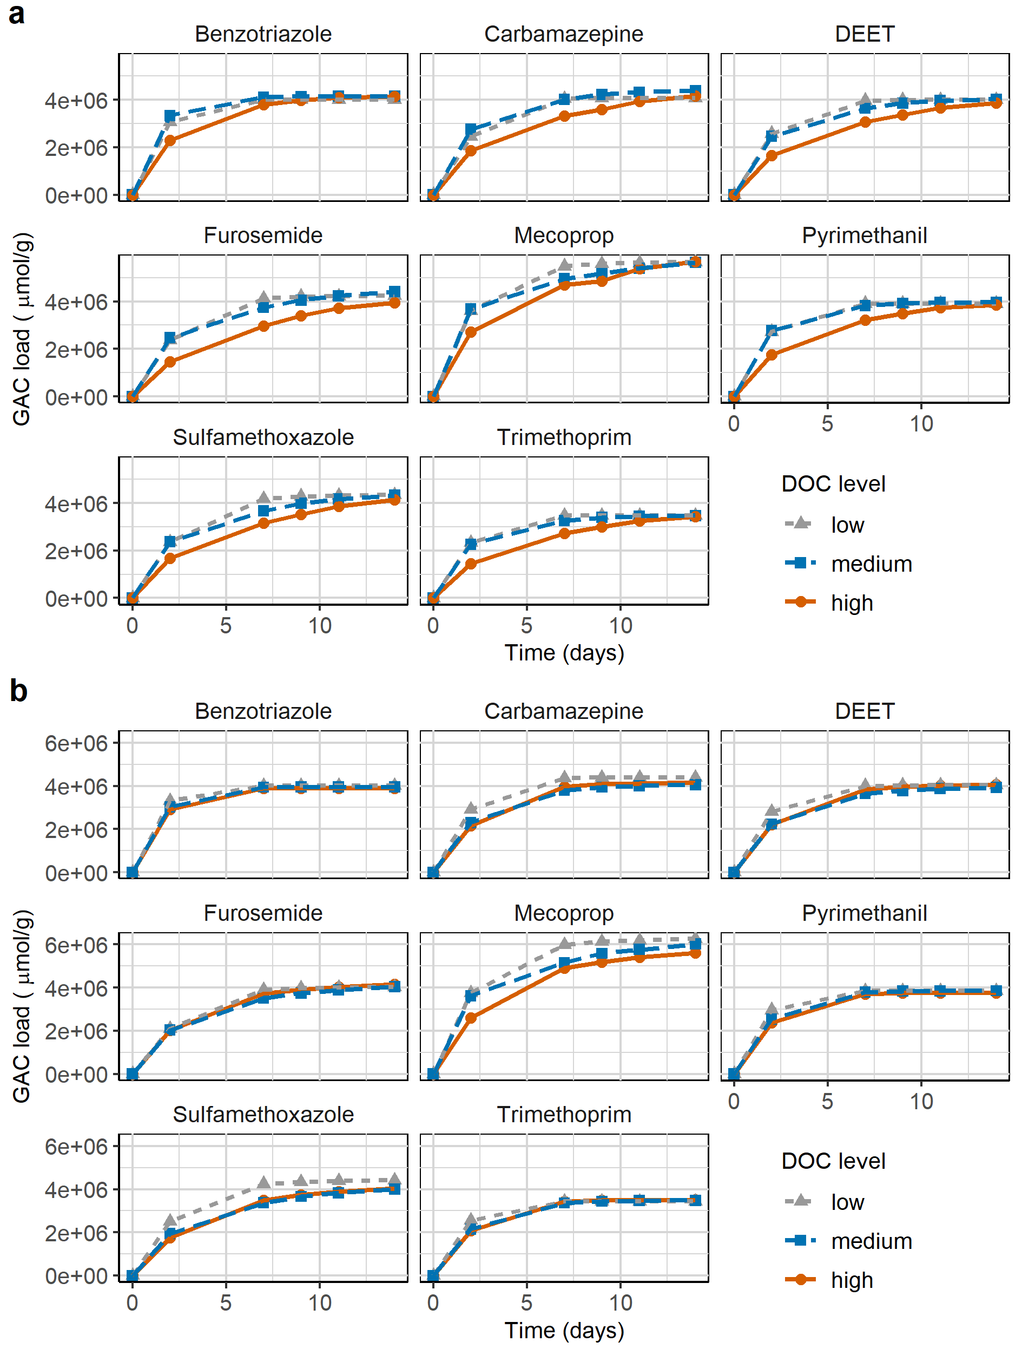
Fig. S3 Micropollutants load on GAC over time in influent of GAC filters in drinking water plants (infGAC) and wastewater effluent (WWef) at three DOC levels: low ~ 3 mg/L, medium ~ 6 mg/L, high ~ 10 mg/L

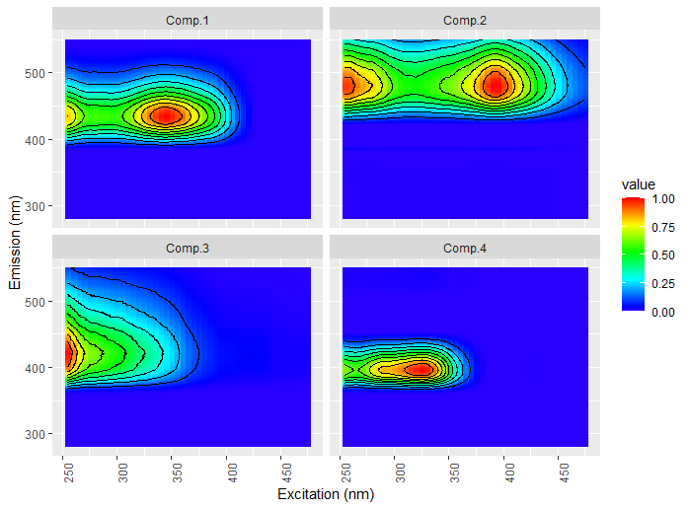
Fig. S4 Fluorescence spectra of 4 components identified in the PARAFAC analysis

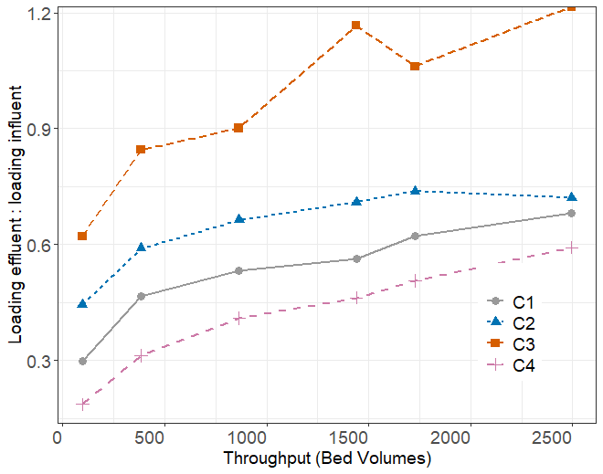
Fig. S5 Relative loading (effluent:influent) of PARAFAC components in effluent of lab-scale GAC filter treating wastewater effluent spiked with micropollutants

