Effect of some process parameters on the photodestruction of 2CBP using a heterojunction under simulated sunlight
Photocatalytic mediated destruction of 2-chlorobiphenyl by a ZnO-[10%]BiOI p-n heterojunction: Effect of some process parameters
Darlington .C. Ashiegbu^{1,*} and Herman Potgieter^{1,2,**}
¹School of Chemical and Metallurgical Engineering, University of the Witwatersrand Johannesburg, Private Bag X3 PO Wits 2050, Johannesburg, South Africa
²Department of Natural Science, Manchester Metropolitan University, Chester Street M1 5GD, Manchester, UK.
*Corresponding author: E-mail: darlington.ashiegbu@wits.ac.za; darlingtonashiegbu1985@yahoo.com ORCID: 0000-0003-2204-6248 (D.C. Ashiegbu); herman.potgieter@wits.ac.za ORCID: 0000-0003-2833-7986 (H. Potgieter)

SUPPLEMENTARY INFORMATION

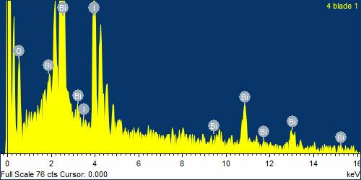
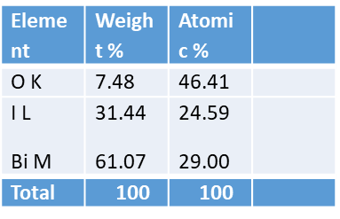
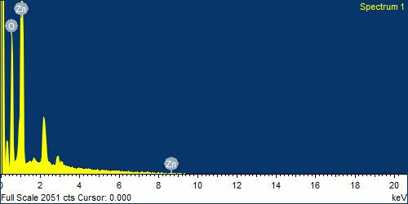
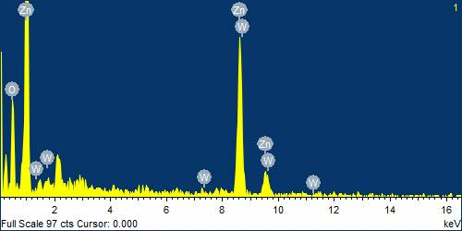
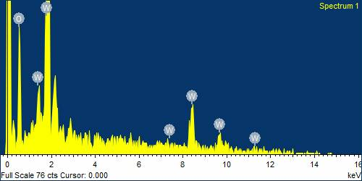
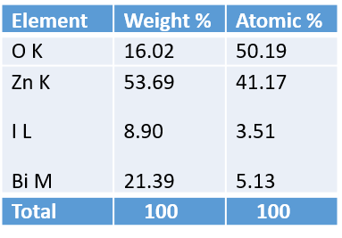
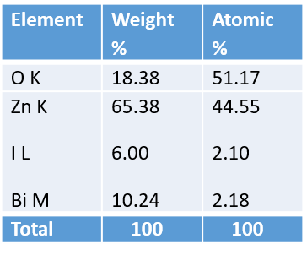
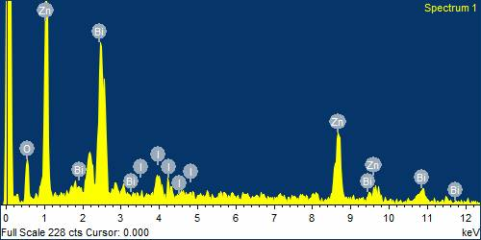
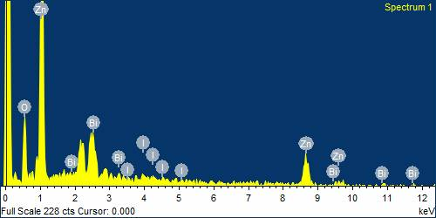
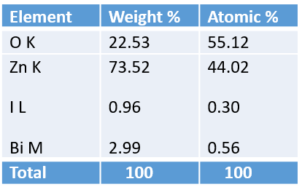
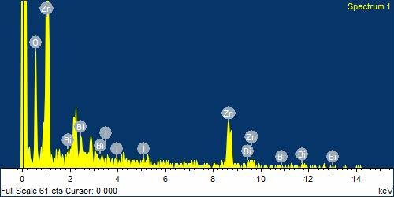
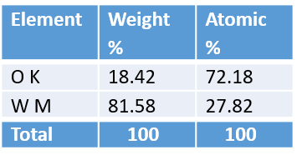
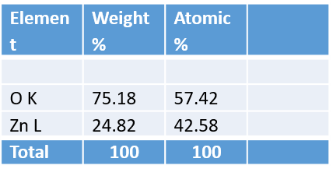
f
b
e
d
c
a
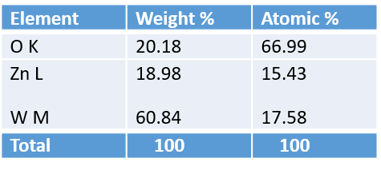
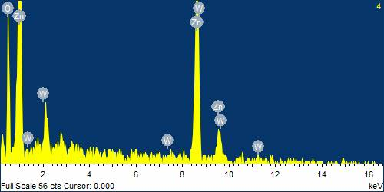
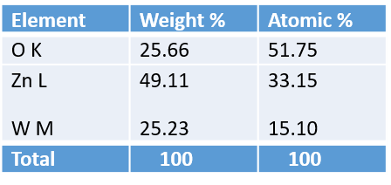
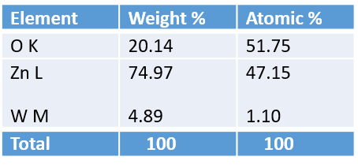
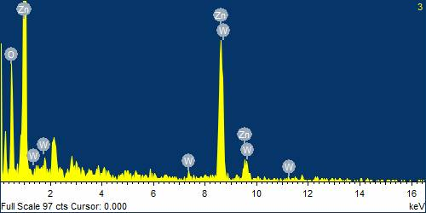
i
h
g

Fig. S1 EDS spectra and stoichiometry of: a ZnO; b BiOI; c WO₃; d ZnO-[5%]BiOI; e ZnO-[10%]BiOI; f ZnO-[20%]BiOI; g ZnO-[5%]WO₃; h ZnO-[10%]WO₃; i ZnO-[20%]WO₃
a
b
Fig. S2 Absorption spectra and Tauc plots of: a ZnO-[X]BiOI absorbance; b ZnO-[X]BiOI Tauc plots; c ZnO-[X]WO₃ absorbance; d ZnO-[X]WO₃ absorbance Tauc plots; e ZnO, BiOI and WO₃ absorption spectra; f ZnO Tauc plot; g WO₃ Tauc plot; h BiOI Tauc plot

Fig. S3 (a) Effect of catalyst dose (b) pseudo-first order plots of effect of catalyst dose
Fig. S4 (a) Effect of pH (b) Pseudo-first order plot for the photocatalytic degradation of 2CBP at pH of 2, 5, 7.2, 9 and 11
Fig. S5 Pseudo-first order plot for the photocatalytic degradation of 2CBP by all the synthesized photocatalysts and heterostructures
Table S1 Apparent first order kinetics data for the photodestruction of 2-CBP.
S/N | Photocatalyst | K (min⁻¹) | R²(Ln Cb/Cb_{o}) | t_{1/2} (min)
1 | ZnO | 0.0012 | 0.966 | 577.6
2 | WO₃ | 0.0010 | 0.990 | 693.1
3 | BiOI | 0.0046 | 0.983 | 150.7
4 | ZnO-BiOI 5% | 0.0005 | 0.983 | 1386.3
5 | ZnO-BiOI 10% | 0.0054 | 0.964 | 128.4
6 | ZnO-BiOI 20% | 0.0016 | 0.996 | 433.2
7 | ZnO-WO₃ 5% | 0.0036 | 0.987 | 192.5
8 | ZnO-WO₃ 20% | 0.0029 | 0.978 | 239.0
9 | ZnO-WO₃ 10% | 0.0049 | 0.969 | 141.5

Table S2 Effect of catalyst dose on the photodegradation of 2CBP.
Catalyst dose(mg) | Degradation (%) | K_{app} (min⁻¹) | R²
35 | 57 | 0.0054 | 0.964
70 | 57 | 0.0085 | 0.989
85 | 71 | 0.0077 | 0.999
100 | 30 | 0.0013 | 0.997
150 | 4 | 0.0003 | 0.998

Table S3 Effect of pH on the photodegradation of 2CBP.
pH | Degradation (%) | K_{app} (min⁻¹) | R²
2 | 20 | 0.0015 | 0.999
5 | 34 | 0.0027 | 0.999
7.2 | 57 | 0.0054 | 0.964
9.1 | 10 | 0.0007 | 0.995
11.3 | 5 | 0.0003 | 0.997

Table S4 Average crystallite sizes of the bare photocatalysts and heterostructures
Sample | FWHM | Average crystallite size (nm)
ZnO | 0.2295 | 37.6
WO₃ | 0.6533 | 12.9
BiOI | 0.2068 | 40.0
ZnO-BiOI 5% | 0.5276 | 16.4
ZnO-BiOI 10% | 0.2797 | 31.0
ZnO-BiOI 20% | 0.1887 | 45.0
ZnO-WO₃ 5% | 0.2441 | 35.4
ZnO-WO₃ 10 % | 0.1759 | 49.0
ZnO-WO₃ 20 % | 0.2687 | 31.0

