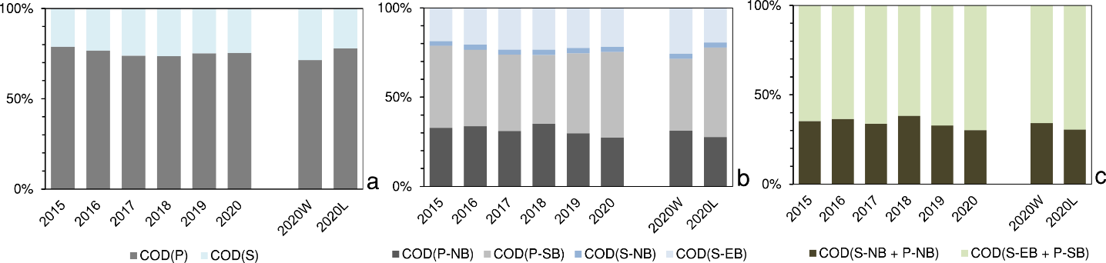
Figure S3. COD fractions in the raw wastewater entering WWTP
where: CODS – soluble organic compounds, CODP – particulate organic compounds, CODS-EB – soluble readily biodegradable organic substrates, CODS-NB – soluble non-biodegradable organic compounds (COD inert soluble fraction), CODP-SB – particulate, slowly biodegradable organic compounds, CODP-NB - particulate, non-biodegradable biodegradable organic compounds (COD inert particulate fraction).

