Enhanced Photocatalytic Degradation of Methylene Blue Using Aluminum and Cerium Co-doped ZnO Nanocomposite
Supplementary Information
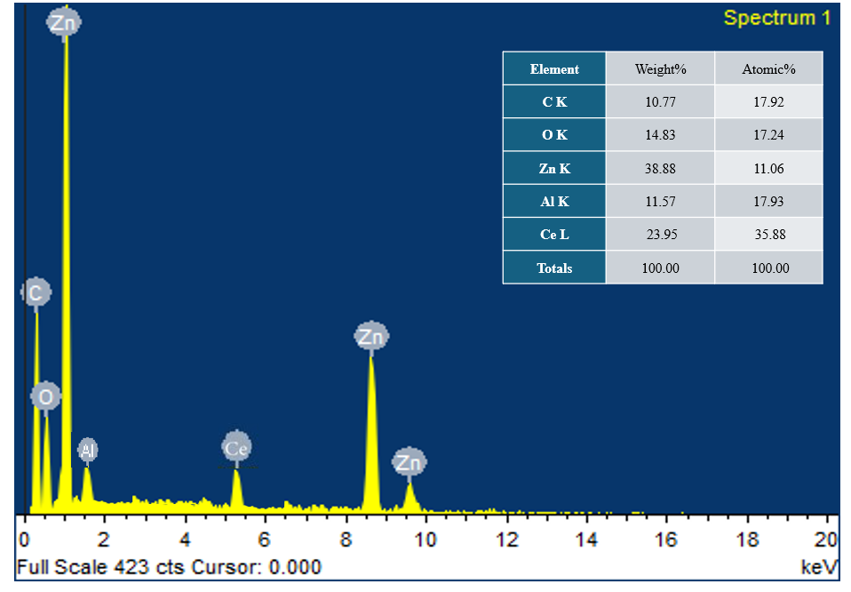
Figure S1 EDS spectra of ACZn photocatalyst.
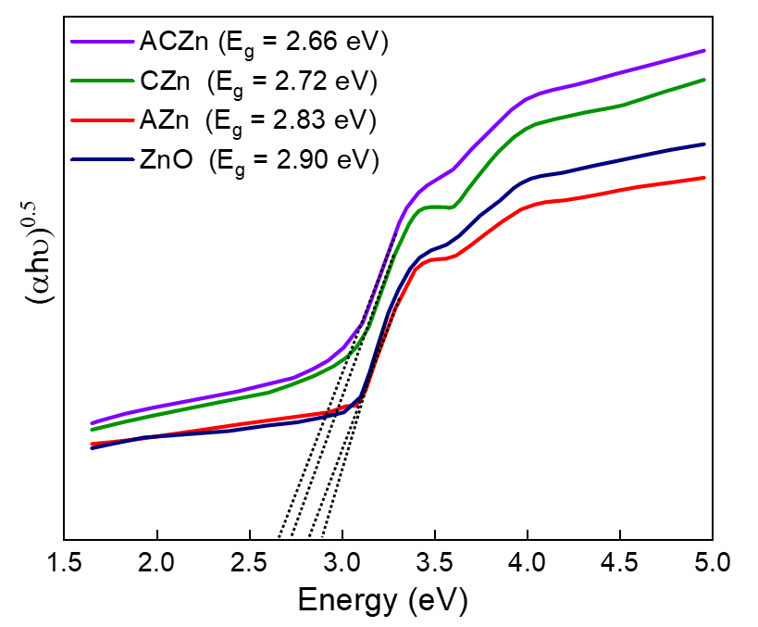
Figure S2 Tauc plots of ACZn, CZn, AZn, and ZnO photocatalyst.

Influence of pH
The effect of solution pH on MB photodegradation was examined from pH 3.0 to 9.0 at 15 mg/L MB and 0.75 g/L ACZn. As shown in Figure S3, maximum degradation occurred at a pH of 7. Poor degradation at pH 3.0 and 5.0 was primarily due to competition from Cl⁻ ions in HCl. At lower pH values (3 and 5), a competition between Cl⁻ ions, introduced during pH adjustment, and hydroxyl radicals (•OH) reduces the availability of •OH for photocatalytic reactions, thereby diminishing the photocatalytic efficiency, while at pH 9.0, NaOH ions adsorbed on the photocatalyst surface, reducing efficiency. Thus, pH 7.0 was optimal for MB degradation.
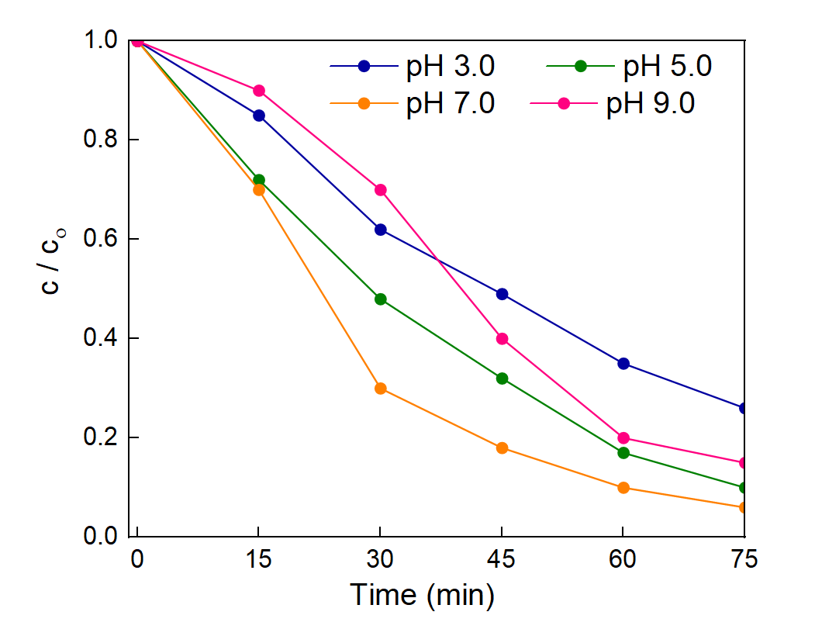

Figure S3 Impact of pH with 0.75g/L concentration of ACZn photocatalyst and 15 mg/L initial MB concentration.

Photocatalytic Mechanism
The enhanced photocatalytic activity of ACZn nanocomposites arises from the synergistic effects of Al and Ce co-doping. Under simulated solar irradiation, photogenerated electron-hole pairs form in the ZnO lattice. Al³⁺ and Ce³⁺, acting as strong Lewis acids, efficiently trap electrons, reducing recombination with holes as shown in Figure S4. The trapped electrons are transferred to O₂, forming reactive O₂*⁻ species, while photogenerated holes oxidize adsorbed water or hydroxide to produce *OH radicals. This co-doping strategy improves charge separation, accelerates redox reactions, and enhances the generation of active radicals, facilitating the degradation of MB.
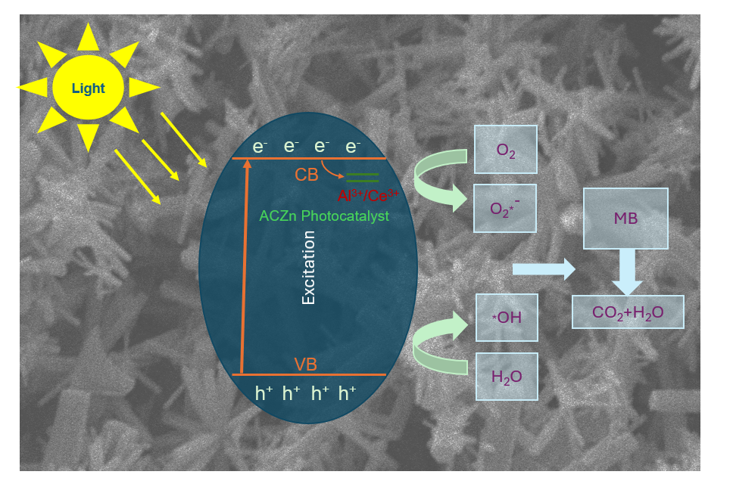
Figure S4 Photocatalytic mechanism of ACZn

