Supplementary Data
Fig.S1 Nitrogen adsorption–desorption isotherm of a) WBS and b) Al₂O₃@WBS measured at 333 K

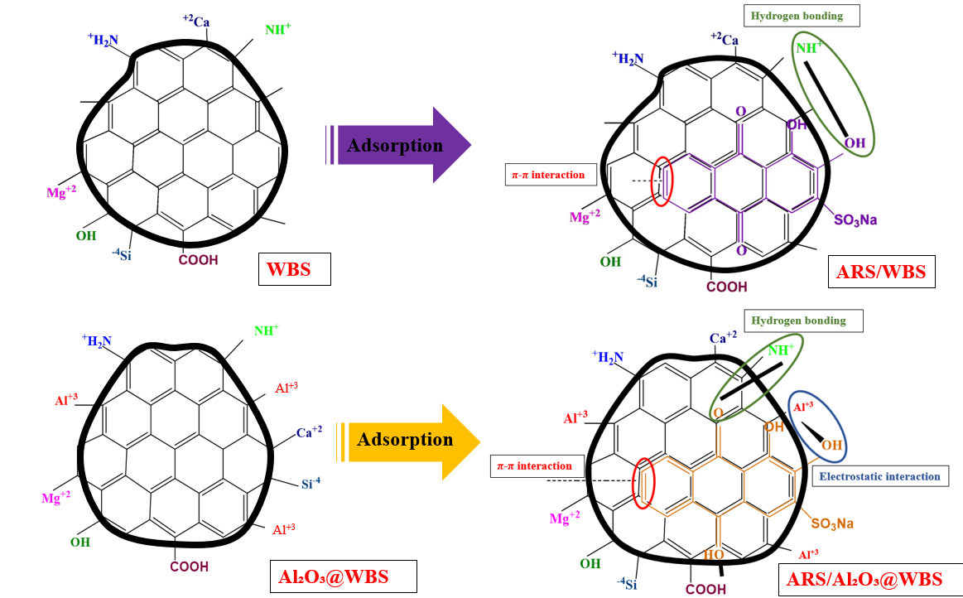
Fig.S2 Proposed adsorption mechanism of WBS and Al₂O₃@WBS with ARS

(a)
(c)
(b)
Fig.S3 Experimental and simulated (Thomas model) breakthrough curves for ARS at different (a) initial concentration, (b) initial flow rate, and (c) bed heights

(c)
(b)
(a)
Fig.S4 Experimental and simulated (Yoon‑Nelson Model) breakthrough curves for ARS at different (a) initial concentration, (b) initial flow rate, and (c) bed heights

(c)
(b)
(a)

Fig.S5 Experimental and simulated (Adams–Bohart Model) breakthrough curves for ARS at different (a) initial concentration, (b) initial flow rate, and (c) bed heights

Fig.S6 Experimental results for regeneration cycles of Al₂O₃@WBS

Table S1 Kinetic and Isotherm models parameters
Kinetic Model | Parameter | ARS/WBS | ARS/ Al₂O₃@WBS | Isotherm Model | Parameter | ARS/WBS | ARS/ Al₂O₃@WBS
Experimental | q_{e,exp} (mg/g) | 7.202 | 7.135 | Experimental | Q_{max,exp} (mg/g) | 56.8 | 73.4
Pseudo-first-order | q_{e(cal)}(mg/g) | 1.43 | 2.53 | Langmuir | Q_{max}(mg/g) | 30.12 | 86.95
 | K₁(min⁻¹) | 0.0318 | 0.0906 |  | K_{L}(L/mg) | 0.316 | 0.089
 | R² | 0.631 | 0.7189 |  | R² | 0.955 | 0.9658
 | SSE | 277.82 | 170.68 |  | SSE | 1678.9 | 2959.33
 | RMSE | 5.56 | 4.35 |  | RMSE | 15.49 | 20.56
Pseudo-second-order | q_{e(cal)}(mg/g) | 7.24 | 7.147 | Freundlich | K_{f} (mg/L) | 6.839 | 8.28
 | K₂ (g mg ⁻¹ min⁻¹) | 0.139 | 0.449 |  | 1/n | 0.887 | 1.223
 | R² | 0.999 | 0.9999 |  | R² | 0.9864 | 0.9458
 | SSE | 0.038 | 0.058 |  | SSE | 19.87 | 415.38
 | RMSE | 0.065 | 0.08 |  | RMSE | 1.69 | 7.7

