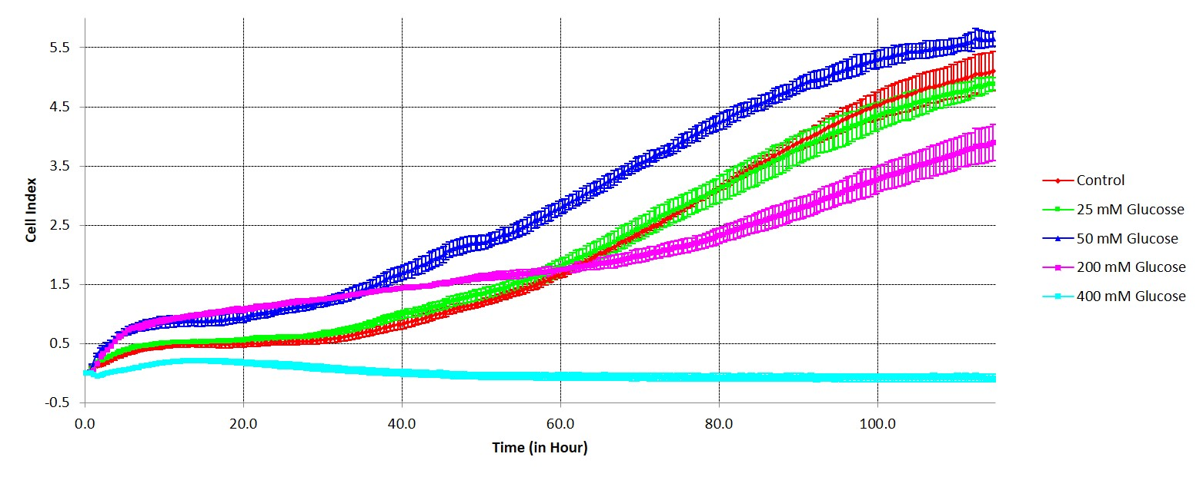
Supplementary figure 1. Proliferation of DBMSC in high glucose condition for 120 hours using xCelligence Real time analyzer

