Supplementary Material.
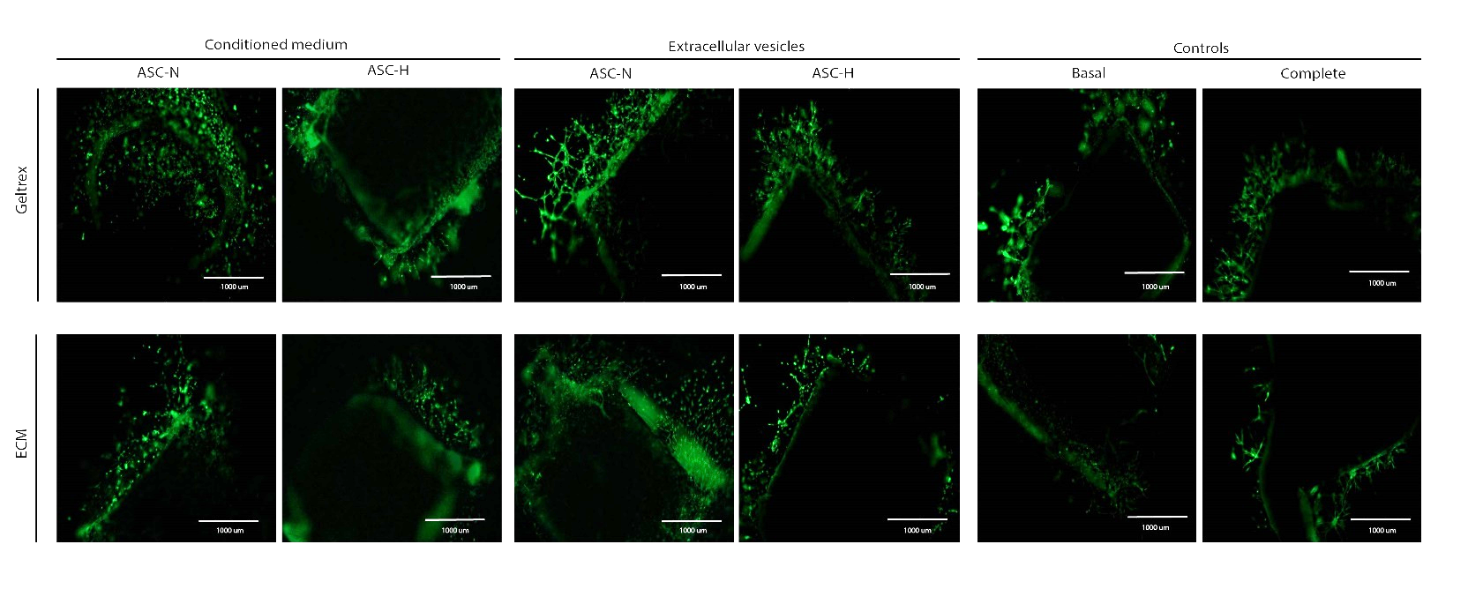
Supplementary Figure 1: Aortic sprouting. Compared to Figure 3, brightness was increased while background was removed, essentially obscuring the (central) aorta from the images, to emphasize the vascular sprouts. Staining with calcein AM, GFP channel, 4x magnification.

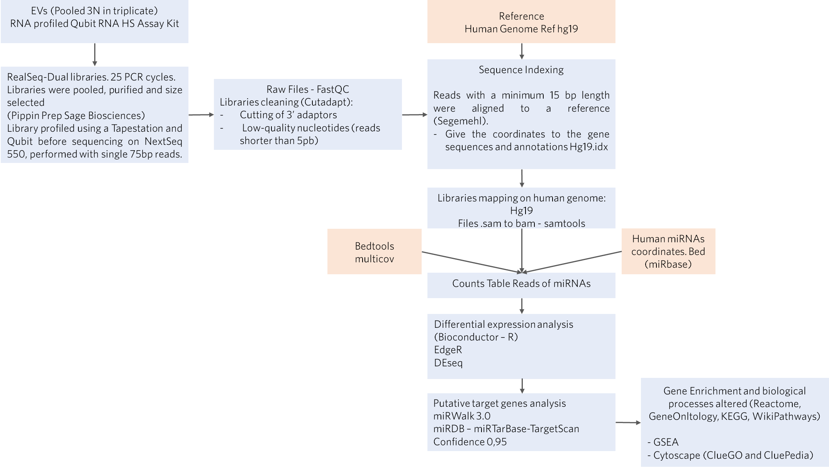
Supplementary Figure 2. Sequencing and data analysis procedure layout

Supplementary Table 1. Average data set summary of sequencing profile in ASC-EV samples. The commands used for adapter trimming were Trim5 (cutadapt -j 6 --nextseq-trim=15 -u 1 -a TGGAATTCTCGGGTGCCAAGG -m 5) and Trim15 (cutadapt -j 6 --nextseq-trim=15 -u 1 -a TGGAATTCTCGGGTGCCAAGG -m 15). The commands used for the alignments were miRbase (bowtie -S --chunkmbs 512 -p 4 -n 1 -I 17 -a -q -m 25 -e 2000 --best --strata) and hg19 (bowtie -S --chunkmbs 512 -p 6 -n 1 -I 19 -m 25 --best --strata -e 2000). Extra data may be available upon request.
EVs Sample | Raw  Reads | Trimmed Reds (minimum length 5) | Percentage Reds (minimum length 5) | Trimmed Reds (minimum length 15) | Percentage Reds (minimum length 15) | # Reads aligned to human genome | % Reads aligned to human genome | # Reads aligned to hsa miRBase | % Reads aligned to hsa miRBase
ASCs-H | 57891767 | 55883669 | 96.5 % | 52931730 | 91.4 % | 49845413 | 94.17 % | 484856 | 0.92 %
ASCs-N | 63500040 | 62012798 | 97.7 % | 59901767 | 94.3 % | 56053119 | 93.58 % | 472331 | 0.79 %

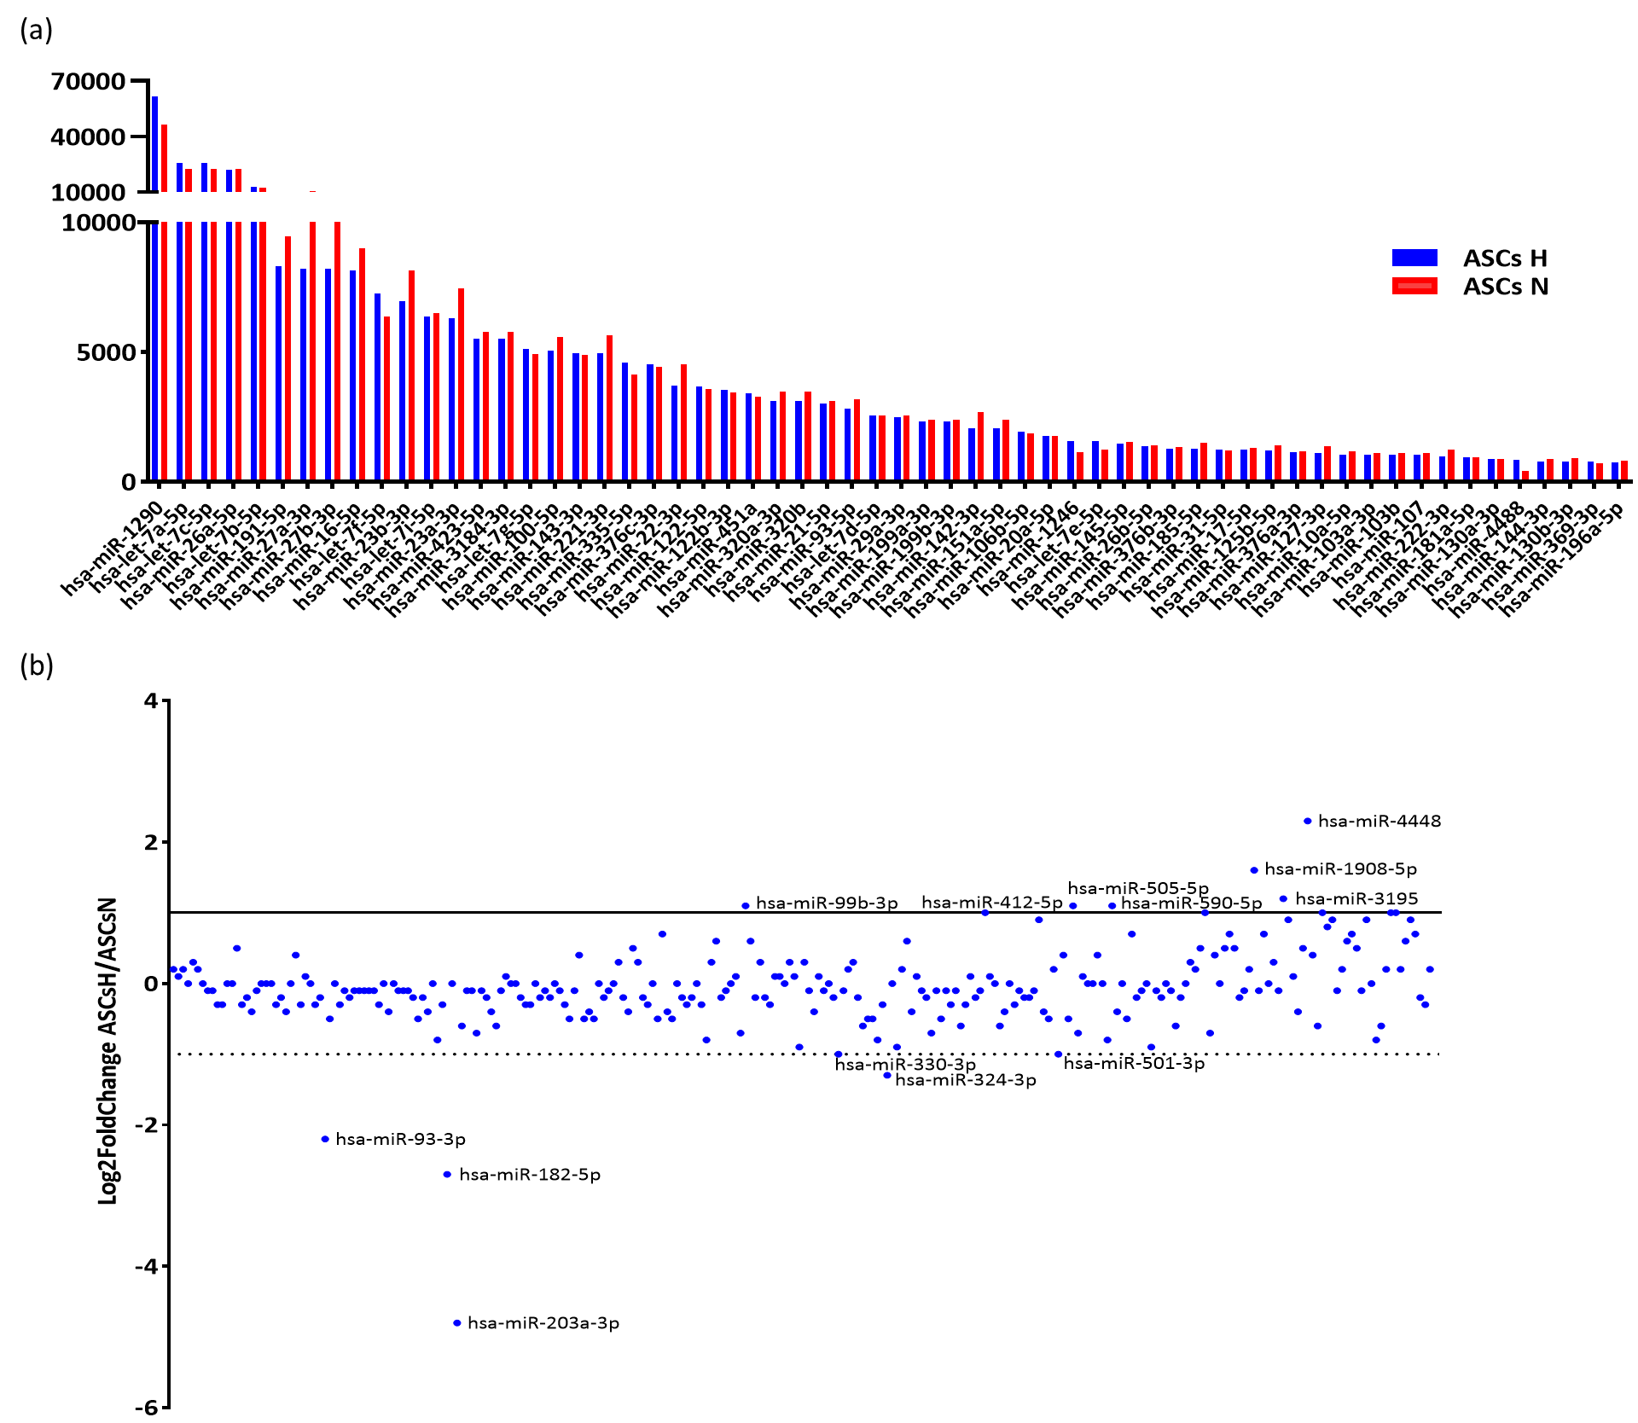

Supplementary Figure 3. (a) Graphic representation of the top 60 enriched miRNAs. (b) miRNA differentially expressed. We found 11 miRNAs to be upregulated and 8 to be downregulated. When we observed the number of reads of these miRNAs, we found that most have a low number of reads, making this differential expression depreciable regarding biological relevance. All values are below the average reads number (Supplementary Table 2).

Supplementary Table 2. Differentially expressed miRNAs in ASC-derived Evs. Upregulated and downregulated miRNAs in ASC-EVs. We found 11 miRNAs to be upregulated and 8 to be downregulated. When we observed the number of reads of these miRNAs we found that most of those miRNAs have a low number of reads, making this differential expression depreciable in terms of biological relevance. Normalized count number_100 of miRNAs in ASC-H and ASC-H EVs, fold change (FC) number, and Log2FC for every miRNA.
 | miRNA | ASC H | ASC N | FC | Log2FC
Upregulated | hsa-miR-4488 | 839,4 | 419,2 | 2,0 | 1,0
Upregulated | hsa-miR-6836-3p | 109,3 | 53,3 | 2,0 | 1,0
Upregulated | hsa-miR-3195 | 63,4 | 27,3 | 2,3 | 1,2
Upregulated | hsa-miR-412-5p | 45,3 | 22,6 | 2,0 | 1,0
Upregulated | hsa-miR-505-5p | 19,8 | 9,3 | 2,1 | 1,1
Upregulated | hsa-miR-99b-3p | 15.7 | 7,5 | 2,1 | 1,1
Upregulated | hsa-miR-6724-5p | 8,1 | 4,1 | 2,0 | 1,0
Upregulated | hsa-miR-590-5p | 6,4 | 2,9 | 2,2 | 1,1
Upregulated | hsa-miR-940 | 4,7 | 2,3 | 2,0 | 1,0
Upregulated | hsa-miR-4448 | 2,9 | 0,6 | 5,0 | 2,3
Upregulated | hsa-miR-1908-5p | 1,7 | 0,6 | 3,0 | 1,6
Downregulated | hsa-miR-671-5p | 72,7 | 136,3 | 0,5 | -0,9
Downregulated | hsa-miR-370-3p | 20,9 | 39,4 | 0,5 | -0,9
Downregulated | hsa-miR-330-3p | 16,9 | 34,2 | 0,5 | -1,0
Downregulated | hsa-miR-501-3p | 12,8 | 25,5 | 0,5 | -1,0
Downregulated | hsa-miR-324-3p | 2,3 | 5,8 | 0,4 | -1,3
Downregulated | hsa-miR-93-3p | 2,3 | 11,0 | 0,2 | -2,2
Downregulated | hsa-miR-182-5p | 1,7 | 11,0 | 0,2 | -2,7
Downregulated | hsa-miR-203a-3p | 0,6 | 15,7 | 0,0 | -4,8

Supplementary Table 3. The average normalized reads from the top 60 enriched miRNA in ASC-derived EVs.

ASCs Normoxia |  |  |  | ASCs Hypoxia
miRNA | Normalized counts |  |  |  | miRNA | Normalized counts
hsa-miR-1290 | 46570 |  |  |  | hsa-miR-1290 | 61731
hsa-miR-26a-5p | 22621 |  |  |  | hsa-let-7a-5p | 25869
hsa-let-7a-5p | 22343 |  |  |  | hsa-let-7c-5p | 25810
hsa-let-7c-5p | 22310 |  |  |  | hsa-miR-26a-5p | 21958
hsa-let-7b-5p | 12342 |  |  |  | hsa-let-7b-5p | 12853
hsa-miR-27a-3p | 10367 |  |  |  | hsa-miR-191-5p | 8308
hsa-miR-27b-3p | 10358 |  |  |  | hsa-miR-27a-3p | 8211
hsa-miR-191-5p | 9443 |  |  |  | hsa-miR-27b-3p | 8200
hsa-miR-16-5p | 9005 |  |  |  | hsa-miR-16-5p | 8142
hsa-miR-23b-3p | 8141 |  |  |  | hsa-let-7f-5p | 7233
hsa-miR-23a-3p | 7441 |  |  |  | hsa-miR-23b-3p | 6970
hsa-let-7i-5p | 6505 |  |  |  | hsa-let-7i-5p | 6346
hsa-let-7f-5p | 6359 |  |  |  | hsa-miR-23a-3p | 6311
hsa-miR-423-5p | 5772 |  |  |  | hsa-miR-423-5p | 5502
hsa-miR-3184-3p | 5772 |  |  |  | hsa-miR-3184-3p | 5502
hsa-miR-221-3p | 5629 |  |  |  | hsa-let-7g-5p | 5110
hsa-miR-100-5p | 5577 |  |  |  | hsa-miR-100-5p | 5054
hsa-let-7g-5p | 4920 |  |  |  | hsa-miR-143-3p | 4951
hsa-miR-143-3p | 4878 |  |  |  | hsa-miR-221-3p | 4937
hsa-miR-22-3p | 4538 |  |  |  | hsa-miR-335-5p | 4581
hsa-miR-376c-3p | 4424 |  |  |  | hsa-miR-376c-3p | 4514
hsa-miR-335-5p | 4120 |  |  |  | hsa-miR-22-3p | 3717
hsa-miR-122-5p | 3572 |  |  |  | hsa-miR-122-5p | 3663
hsa-miR-320a-3p | 3457 |  |  |  | hsa-miR-122b-3p | 3537
hsa-miR-320b | 3457 |  |  |  | hsa-miR-451a | 3412
hsa-miR-122b-3p | 3424 |  |  |  | hsa-miR-320a-3p | 3110
hsa-miR-451a | 3278 |  |  |  | hsa-miR-320b | 3108
hsa-miR-93-5p | 3186 |  |  |  | hsa-miR-21-5p | 3003
hsa-miR-21-5p | 3108 |  |  |  | hsa-miR-93-5p | 2823
hsa-miR-142-3p | 2681 |  |  |  | hsa-let-7d-5p | 2536
hsa-let-7d-5p | 2552 |  |  |  | hsa-miR-29a-3p | 2473
hsa-miR-29a-3p | 2537 |  |  |  | hsa-miR-199a-3p | 2311
hsa-miR-151a-5p | 2377 |  |  |  | hsa-miR-199b-3p | 2311
hsa-miR-199a-3p | 2374 |  |  |  | hsa-miR-142-3p | 2065
hsa-miR-199b-3p | 2374 |  |  |  | hsa-miR-151a-5p | 2049
hsa-miR-106b-5p | 1854 |  |  |  | hsa-miR-106b-5p | 1915
hsa-miR-20a-5p | 1773 |  |  |  | hsa-miR-20a-5p | 1771
hsa-miR-145-5p | 1539 |  |  |  | hsa-miR-1246 | 1574
hsa-miR-185-5p | 1507 |  |  |  | hsa-let-7e-5p | 1545
hsa-miR-26b-5p | 1396 |  |  |  | hsa-miR-145-5p | 1472
hsa-miR-125b-5p | 1389 |  |  |  | hsa-miR-26b-5p | 1371
hsa-miR-127-3p | 1376 |  |  |  | hsa-miR-376b-3p | 1281
hsa-miR-376b-3p | 1316 |  |  |  | hsa-miR-185-5p | 1249
hsa-miR-17-5p | 1293 |  |  |  | hsa-miR-31-5p | 1241
hsa-miR-222-3p | 1247 |  |  |  | hsa-miR-17-5p | 1223
hsa-let-7e-5p | 1230 |  |  |  | hsa-miR-125b-5p | 1197
hsa-miR-31-5p | 1193 |  |  |  | hsa-miR-376a-3p | 1141
hsa-miR-376a-3p | 1184 |  |  |  | hsa-miR-127-3p | 1107
hsa-miR-10a-5p | 1174 |  |  |  | hsa-miR-10a-5p | 1040
hsa-miR-1246 | 1132 |  |  |  | hsa-miR-103a-3p | 1038
hsa-miR-103a-3p | 1092 |  |  |  | hsa-miR-103b | 1038
hsa-miR-103b | 1092 |  |  |  | hsa-miR-107 | 1037
hsa-miR-107 | 1091 |  |  |  | hsa-miR-222-3p | 967
hsa-miR-181a-5p | 949 |  |  |  | hsa-miR-181a-5p | 942
hsa-miR-138-5p | 897 |  |  |  | hsa-miR-130a-3p | 854
hsa-miR-130b-3p | 891 |  |  |  | hsa-miR-4488 | 839
hsa-miR-130a-3p | 884 |  |  |  | hsa-miR-144-3p | 775
hsa-miR-144-3p | 871 |  |  |  | hsa-miR-130b-3p | 773
hsa-miR-6529-5p | 858 |  |  |  | hsa-miR-369-3p | 761
hsa-miR-196a-5p | 818 |  |  |  | hsa-miR-196a-5p | 740
Total ASC-N= 334296.07 _100 normalized counts, top 60= 308666.89 92% of total reads
Total ASC-H= 341591.10 _100 normalized counts, top 60= 317811.38 93% of total reads

