Supplementary Information – Tissue Engineering and Regenerative Medicine
Lipid priming of human adipose mesenchymal stromal cells with docosahexaenoic acid: Impact on cell differentiation, senescence and the secretome neuroregulatory profile
Jonas Campos^{1,2}, Belém Sampaio-Marques^{1,2}, Diogo Santos^{1,2}, Sandra Barata-Antunes^{1,2}, Miguel Ribeiro^{1,2}, Sofia C. Serra^{1,2}, Tiffany S. Pinho^{1,2}, João Canto-Gomes^{1,2}, Ana Marote^{1,2}, Margarida Cortez^{1,2}, Nuno A. Silva^{1,2} Adina T. Michael-Titus³, António J. Salgado^{1,2*}
1 Life and Health Sciences Research Institute (ICVS), School of Medicine, University of Minho, 4710-057 Braga, Portugal
2 ICVS/3B’s – PT Government Associate Laboratory, Braga/Guimarães, Portugal
3 Centre for Neuroscience, Surgery and Trauma, The Blizard Institute, Barts and The London School of Medicine and Dentistry, Queen Mary University of London, London, E1 2AT, UK
*Corresponding Author: António J. Salgado – asalgado@med.uminho.pt

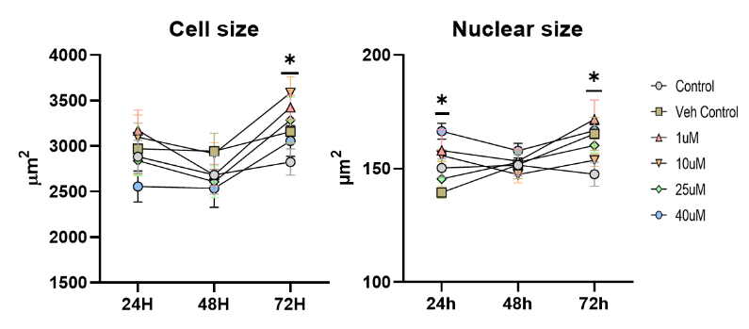
Supplementary Figure 1. Temporal analysis of morphometric parameters after exposure of A-MSCs to increasing concentrations of DHA. Data shown as mean ± SEM. (n=8 to 12/group for cell size) and (n=8/group for nuclear size), *P<0.05.

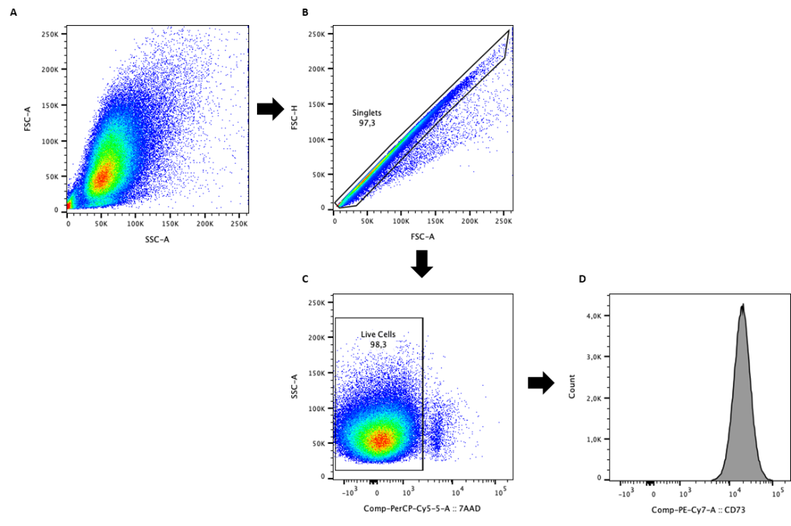
Supplementary Figure 2. Gating strategy for phenotypic characterization of mesenchymal stem cells (MSCs). Singlets were identified based on the area and height of the forward scatter (FSC) (A). Viable cells were selected by excluding 7-AAD positive cells (B and C). MSC lineage markers were then assessed through histograms (D), confirming the presence of CD90, CD73, CD105, CD44 and the absence of CD45 and HLA-DR. Example histogram provided of cells expressing CD73.
Supplementary Figure 3. Experimental outline for DHA priming and cell growth for the secretome collection (Fig 3.B) and for the replicative senescence (Fig 3.C) paradigms, as well as for SA-β-gal staining (Fig 3.E and G) and senescence associated gene expression analysis (Fig 3.H) (Created with BioRender.com) (A). Representative imaging pipeline and quantification of adhered cells (B and C). Representative immunofluorescence photomicrographs of cleaved-caspase-3 (ab3623, Milipore, 1:100) and acetylated tubulin (T6793, Sigma, 1:100) immunofluorescence (D). Quantification of nuclear versus cytosolic localization of cleaved-caspase-3 in A-MSCs treated with DHA and imaged at 48 h post treatment (E and F). Data shown as mean±SEM. (n=9/group for C) and (n=4/group for E and F), *P<0.05, ns = non-significant.
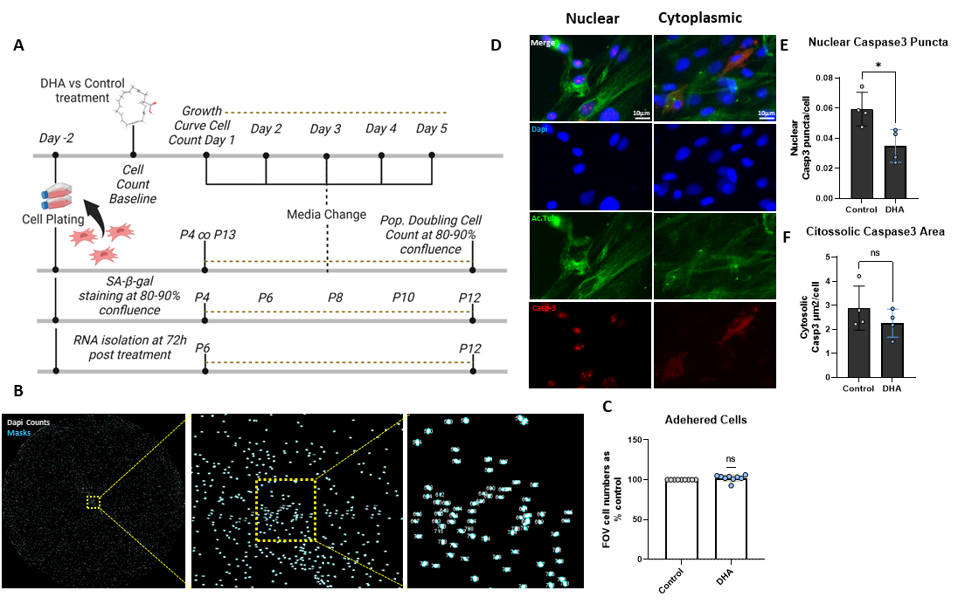

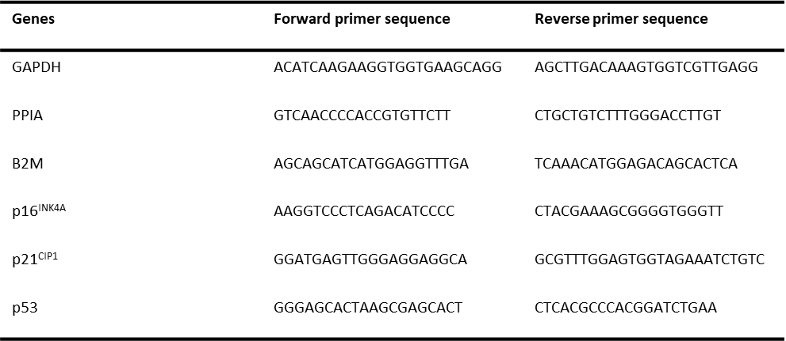
Supplementary Table 1. Real-Time Quantitative PCR primer sequence information.

Supplementary Table 2. Statistical reporting.
Figure | Statistical report | Sample size
1 D | Two-way Anova  Time x Treatment Dosage Effect: F (10, 84) = 0.8818, P = 0.5534, η2p = 0.0950031  Time Effect: F (1.897, 79.66) = 5.563, P = 0.0063, η2p = 0.1169788  Treatment Dosage Effect: F (5, 42) = 7.600, P < 0.0001, η2p = 0.475 | 8 (per group)
1 E | One-way Anova - F (5, 64) = 7.440, P<0.0001, Cohen's F=0.678233 | 10 to 12 (per group)
1 F | One-way Anova - F (5, 54) = 17.15, P<0.0001, Cohen's F = 1.1601006 | 10 (per group)
2 B | Unpaired T-test - t=5.784, df=4, P = 0.0044, Cohen’s d = 4.723307 | 3 (per group)
2 G | Unpaired T-test - t=3.085, df=6, P = 0.0215, Cohen’s d = 2.18257 | 4 (per group)
2 H | Unpaired T-test - t=5.179, df=6, P = 0.0021, Cohen’s d = 3.662952 | 4 (per group)
3 B | Two-way Anova  Time x Treatment Effect: F (5, 67) = 8.251, P<0.0001, η2p = 0.3810909  Time Effect: F (5, 67) = 136.6, P<0.0001, η2p = 0.9106667  Treatment Effect: F (1, 16) = 6.403, P = 0.0223, η2p = 0.2858099 | 6 to 9 (per group)
3 C | Two-way Anova  Time x Treatment Effect: F (9, 36) = 21.91, P<0.0001, η2p = 0.8456195  Time Effect: F (9, 36) = 1333, P<0.0001, η2p = 0.9538533  Treatment Effect: F (1, 4) = 80.44, P=0.0009, η2p = 0.9526291 | 3 (per group)
3 E | Two-way Anova  Time x Treatment Effect: F (4, 16) = 2.712, P=0.0673, η2p = 0.4040524  Time Effect: F (4, 16) = 82.68, P<0.0001, η2p = 0.9970082  Treatment Effect: F (1, 4) = 1.391, P=0.3036, η2p = 0.2580226 | 3 (per group)
3 G | Two-way Anova  Time x Treatment Effect: F (4, 16) = 4.381, P=0.0140, η2p = 0.52273  Time Effect: F (4, 16) = 147.8, P<0.0001, η2p = 0.9736495  Treatment Effect: F (1, 4) = 18.12, P=0.0131, η2p = 0.8191682 | 3 (per group)
3 H | P16 - Two-way Anova  Time x Treatment Effect: F (1, 4) = 3.969, P=0.1172, η2p = 0.498055  Time Effect: F (1, 4) = 3.969, P=0.1172, η2p = 0.498055  Treatment Effect: F (1, 4) = 317.3, P<0.0001, η2p = 0.9875506  P53 - Two-way Anova  Time x Treatment Effect: F (1, 4) = 97.54, P=0.0006, η2p = 0.9606067  Time Effect: F (1, 4) = 97.54, P=0.0006, η2p = 0.9606067  Treatment Effect: F (1, 4) = 130.0, P=0.0003, η2p = 0.9701493 | 3 (per group)
4 E | One-way Anova - F (3, 29) = 37.91, P<0.0001, Cohen's F=1.83179 | 4 to 11 (per group)
4 F | One-way Anova - F (3, 29) = 31.13, P<0.0001, Cohen's F=1.6550199 | 4 to 11 (per group)
4 G | One-way Anova - F (3, 30) = 52.01, P<0.0001, Cohen's F=2.1215283 | 5 to 11 (per group)
4 I | HB-EGF - Unpaired T-test - t=3.629, df=6, P = 0.0110, Cohen’s d = 2.566358  S100B - Unpaired T-test - t=2.920, df=6, P = 0.0266, Cohen’s d = 2.064681 | 4 (per group)
Supp. Fig 1  Cell Size  Nuclei Size | Two-way Anova  Time x Treatment Dosage Effect: F (10, 84) = 1.865, P=0.0617, η2p = 0.1816853  Time Effect: F (1.915, 80.44) = 5.875, P=0.0047, η2p = 0.122702  Treatment Effect: F (5, 42) = 2.631, P=0.0371, η2p = 0.2385097  Two-way Anova  Time x Treatment Dosage Effect: F (10, 113) = 1.103, P = 0.3660, η2p = 0.0889301  Time Effect: F (1.957, 110.6) = 12.23, P< <0.0001, η2p = 0.1779037  Treatment Effect: F (5, 65) = 1.693, P=0.1488, η2p = 0.1152249 | 10 to 12 (per group)  8 (per group)
Supp. Fig 3  Nuclei Casp-3 | Unpaired T-test - t=3.136, df=6, P = 0.0202, Cohen’s d = 2.217687 | 4 (per group)

Supplementary Figure 4. Volcano plot of identified proteins in the secretome of untreated and DHA-treated A-MSCs, showing increase in the expression of HB-EGF and S100B.
Supplementary Table 3. List of reagents and catalogs.
Reagent | Company | Catalog
Cell culture reagents
α-MEM | Invitrogen | 12000-063
Neurobasal | Gibco | 21103-049
NeuroCult | STEMCELL Techonologies | #05750
FBS | Sigma-Aldrich | S0615
PenStrep | Invitrogen | 15070-063
Kanamycin | Gibco | 15160-047
Trypsin | Gibco | 25300-062
Adipogenic Media | STEMCELL Technologies | #05414  #05415
Osteogenic Media | STEMCELL Technologies | #05467
Chondrogenic Media | STEMCELL Technologies | #05457
NBCS | ThermoFisher | 1610-159
Priming reagents
DHA | Sigma-Aldrich | D2534
FFA-BSA | Sigma-Aldrich | A8806
Dyes and antibodies
Phalloidin | Sigma-Aldrich | P1951
DAPI | Invitrogen | D1306
Anti Osteocalcin | RD Systems | 967801
Anti FABP4 | RD Systems | 967799
Anti Aggrecan | RD Systems | 967800
Anti CD90 | Biolegend | 328110
Anti CD73 | Biolegend | 344010
Anti CD105 | Biolegend | 323204
Anti CD44 | Biolegend | 103001
Anti CD45 | Biolegend | 304042
Anti HLA-DR | Biolegend | 307646
Anti Doublecortin | Abcam | AB18723
Anti MAP2 | Milipore | M4403
Goat- anti MS Alexa 488 | ThermoFisher | A11029
Rabbit- anti GT Alexa 488 | ThermoFisher | A11078
Other Reagents
MTS – Cell Titer 96 | Promega | G3581
Bradford (Quick StartTM) | BioRad | #5000205
SA-B-Gal kit | Abcam | Ab65351
TripleXtractor | Grisp | #GB23.0100
Xpert cDNA Supermix with gDNA eraser | Grisp | #GK86.0100
XPert Fast SYBR mastermix | Grisp | #GE22.0100
Human Neuro Discovery Array C1 | Ray Biotech | AAH-NEU-1–2

