Online supplement

Index

Methods
Additional Results
Online Table 1
Online Figure 1
Online Figure 2
Online Figure 3
Methods

Testing for MERS-CoV was performed by real-time reverse-transcription polymerase chain reaction (RT-PCR) by extracting RNA from respiratory specimens (nasopharyngeal swab, tracheal aspirate, bronchoalveolar lavage) and plasma using the MagNA Pure 96 Viral NA Kit (Roche Applied Science, Indianapolis, Indiana). We included sigma virus RNA as a control for the extraction procedure for the cerebrospinal fluid (CSF) to ensure the absence of inhibitors. We tested extracted nucleic acids by RT-PCR targeting the E-gene (UpE) or within open reading frame (ORF1a) regions of the MERS-CoV genome on a LightCycler 480® system (Roche Diagnostics, Mannheim, Germany). Positive control for Orf1a and UpE real-time RT-PCR was performed as per the manufacturer’s instructions.

Other testing were done according to the manufacturer's instructions, including serology tests (Abbott Laboratories), QuantiFERON-TB-Gold In-Tube test (Cellestis Ltd., Carnegie, Victoria, Australia), cytomegalovirus antibodies (CMV) (DiaSorin, Saluggia Vercelli, Italy), brucella antibody (Plasmatec, Dorset, UK), lymphocyte subset analysis (BD Biosciences, San Jose, CA).

Additional Results
Patient 1
Other microbiologic workup was negative for bacteria, acid-fast bacilli, legionella, influenza A and B including H1N1. Mycoplasma and chlamydia antibodies were negative. BAL was negative for AFB, pneumocystis jirovecii and malignant cells.
CSF glucose was >7.81 mmol/L (reference 2.20-3.9 mmol/L) and there was no organism on gram stain. VDRL was non-reactive. CSF was negative for Epstein–Barr virus (EBV), herpes simplex virus (HSV), tuberculosis, cytomegalovirus (CMV) and. CSF Brucella melitensis and Brucella abortus antibodies and cryptococcal antigen were negative.

Serum toxoplasma IgG antibodies were positive, 23.7 IU/mL (reference <7.2 IU/mL) but IgM antibodies were negative. QuantiFERON-TB-Gold In-Tube test was intermediate. Autoimmune serology workup was negative for antinuclear antibody (ANA), Anti-granulocyte antibodies (C-ANCA, P-ANCA), Anti-SS-A, Anti-SS-B and anti-mitochondrial antibodies.
Serum IgM 0.76 g/L (reference 0.4-2.3), IgG 7.97 g/L (reference 7.0-16.0, IgA4.83 g/L (reference 0.7-4). HIV test was negative.

Patient 3
Microbiologic workup was negative for bacteria, acid-fast bacilli, legionella, influenza A and B including H1N1. Mycoplasma and chlamydia antibodies were negative.

CSF analysis showed a white cell count of 2 cells, glucose of > 3.84 mmol/L, protein of 0.85 g/L, CSF lactic acid 1.61 mmol/L (normal <=2.5 mmo/L), no organism seen in gram stain, and negative PCR for HSV and tuberculosis.
EBV IgG >600 u/ml (refrence <10) and IgM negative. Measles IgM negative. CMV IgM negative.
Serum IgM 1.2 g/L (reference 0.4-2.3), IgG 8.2 g/L (reference 7.0-16.0, IgA 3.0 g/L (reference 0.7-4). HIV test was negative.

Online Table 1: Genetic analysis of specimens. Ct=cycle threshold. TA: tracheal aspirate, BA: bronchoalveolar lavage, CSF: cerebrospinal fluid NPS=nasopharyngeal swab, nm: nanometer.

 | Specimen Type | Ct Value | Fluorescence wave length (nm)
 |  |  | E-gene | Orf 1a
Patient 1
Hospital day
7 | TA | 31 | 18.255 | 18.1
14 | TA | 34 | 26.421 | 15.25
15 | TA | 31 | 26.1 | 14.8
18 | TA | 26 | 28.8 | 17.141
20 | TA | 30 | 23 | 20
25 | TA | 35 | 13 | 16
28 | BAL | 37 | 6.0 | 2.0
28 | CSF | NEG | NEG | NEG
29 | TA | NEG | NEG | NEG
Patient 2
Hospital day
6 | TA | 22.1 | 55.415 | 23.2
Patient 3
Hospital day
3 | TA | 28.1 | 23.5 | 21.52
12 | NPS | 33.2 | 17.125 | 2.125
19 | Plasma | Negative
19 | TA | Negative
23 | TA | Negative
26 | TA | 35 | Negative | 7.509
26 | CSF | Negative | Negative

Online Figure 1. Chest radiographs before intubation and after intubation for patients 1 (Panels A, B), 2 (C, D) and 3 (E, F).

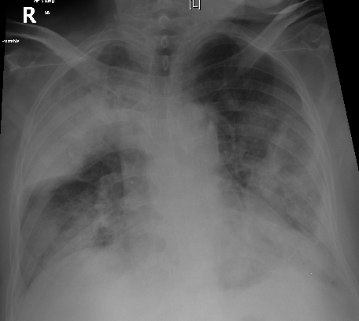 | 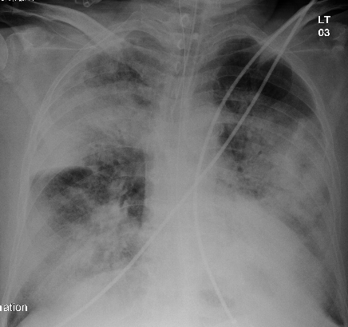
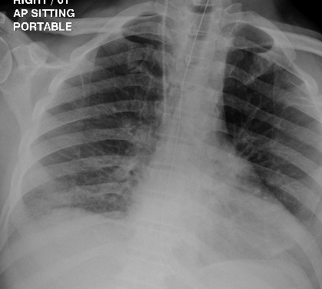 | 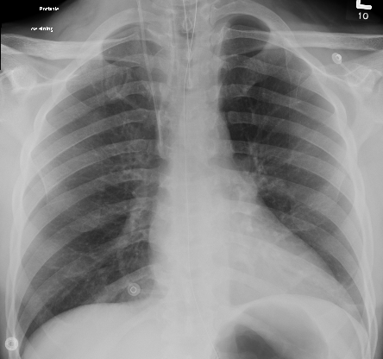
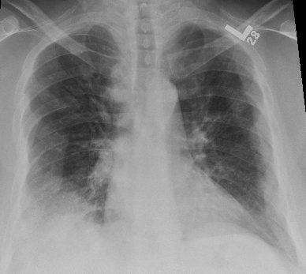 | 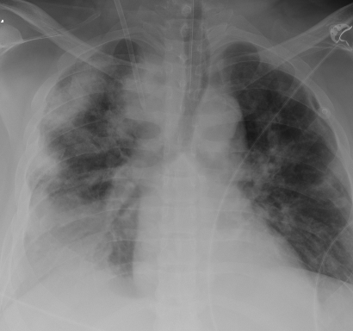
Online Figure 2: Lymphocyte counts throughout the hospital stay for the three patients. The two lines refer to the normal range.

Online Figure 3: 3D Image from CT angiogram (patient 2) showed patent anterior cerebral arteries bilaterally

