Supplements
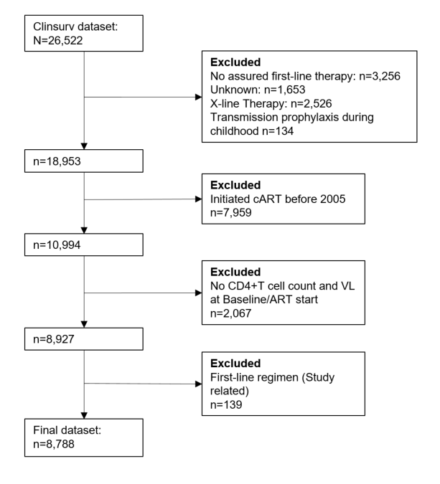Figure S1. Flow chart of selected cases due to predefined in- and exclusion criteria.

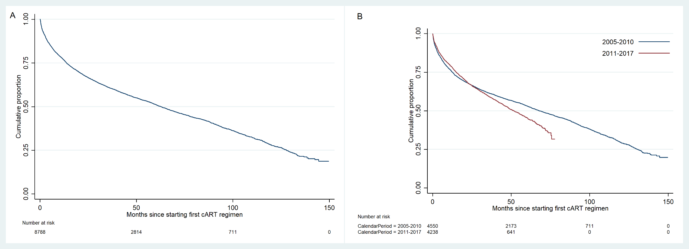
Figure S2 A&B. Unadjusted cumulative proportion of first-line cART durability A) Overall and stratified by B) Year of first-line initiation, calendar period 2005-2010 and 2011-2017.

