Supplementary material
A. Handling of missing values
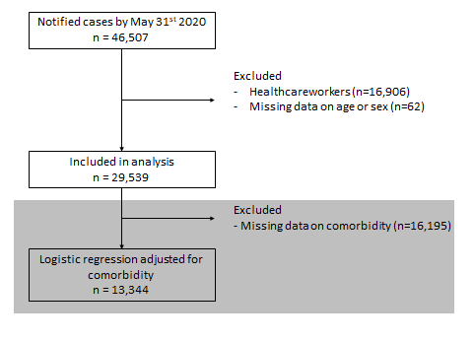
B. Case fatality rates by age-group for all notified COVID-19 cases (excluding health care workers) N=29,539, and for hospitalized COVID-19 cases, N=11,227.
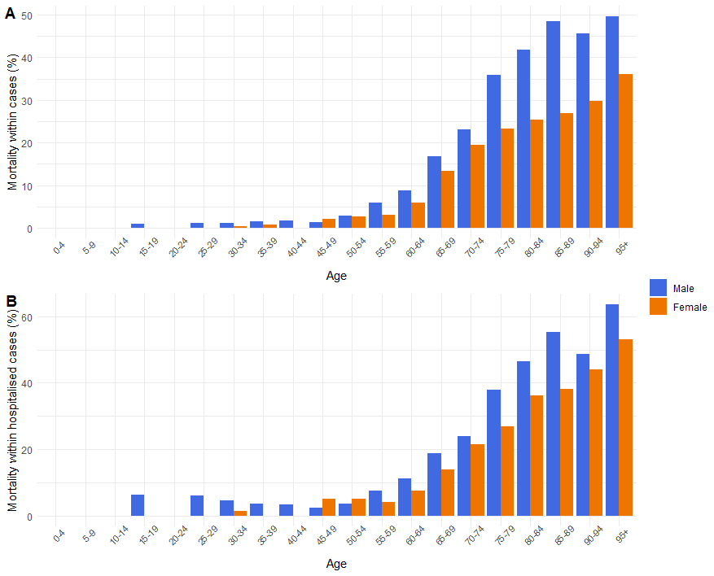

C. Comorbidities as risk factor for death among notified male and female cases, adjusted for differences in age
 | Males |  | Females |  | Total
 | OR | 95% CI | OR | 95% CI | OR | 95%CI
Cardiovascular disease or hypertension | 1.14 | 0.99-1.31 | 1.20 | 1.07-1.35 | 1.17 | 1.07-1.28
Diabetes | 1.42 | 1.20-1.67 | 1.36 | 1.17-1.57 | 1.38 | 1.24-1.54
Liver disease | 1.00 | 0.43-2.11 | 1.19 | 0.63-2.15 | 1.08 | 0.66-1.73
Chronic neuromuscular disease | 1.55 | 1.27-1.87 | 2.25 | 1.87-2.71 | 1.87 | 1.64-2.13
Immunodeficiency | 0.77 | 0.32-1.63 | 0.91 | 0.49-1.61 | 0.85 | 0.52-1.34
Renal impairment | 1.48 | 1.18-1.86 | 1.53 | 1.24-1.88 | 1.51 | 1.30-1.76
Chronic lung disease | 1.30 | 1.10-1.53 | 1.18 | 1.02-1.36 | 1.23 | 1.10-1.37
Malignancy | 1.50 | 1.18-1.89 | 1.38 | 1.15-1.67 | 1.44 | 1.24-1.66
Other underlying disease | 1.15 | 0.96-1.36 | 1.27 | 1.08-1.48 | 1.22 | 1.08-1.37

D. Reported COVID-19 deaths per day, moving average over 14 days
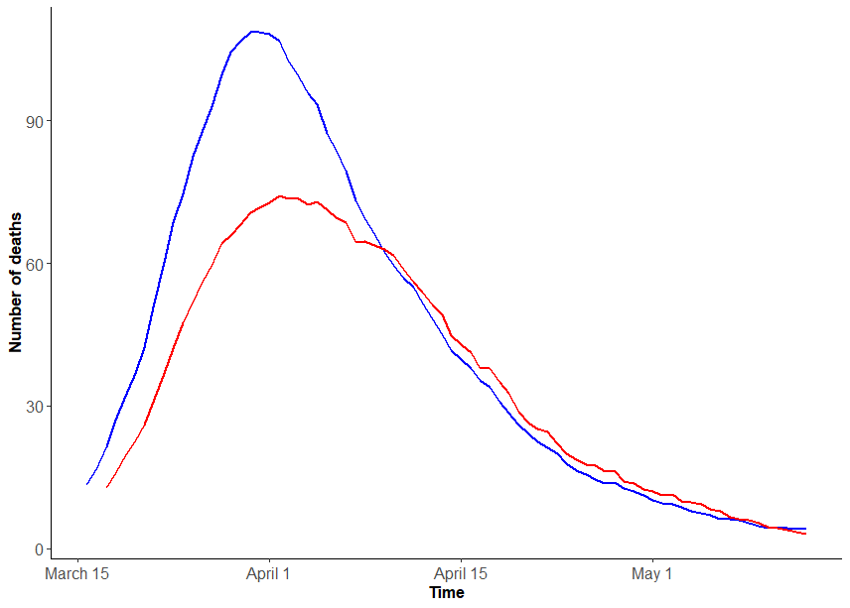
Males
Females

Reported COVID-19 deaths per day stratified by household

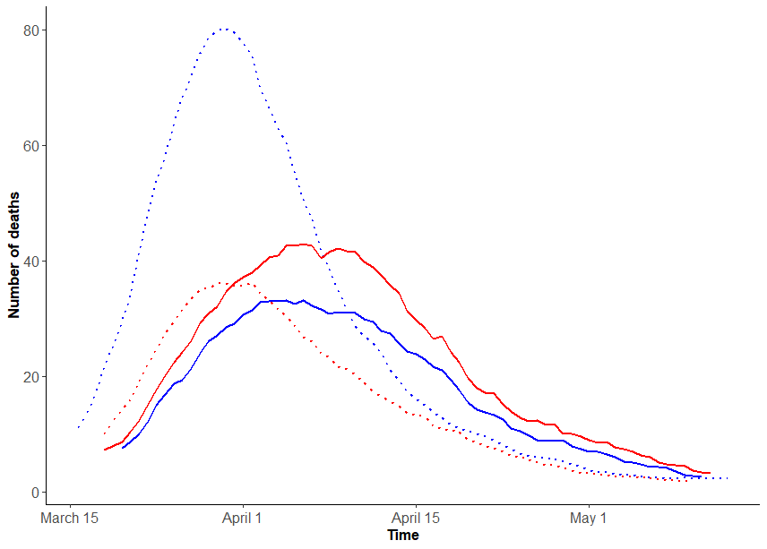
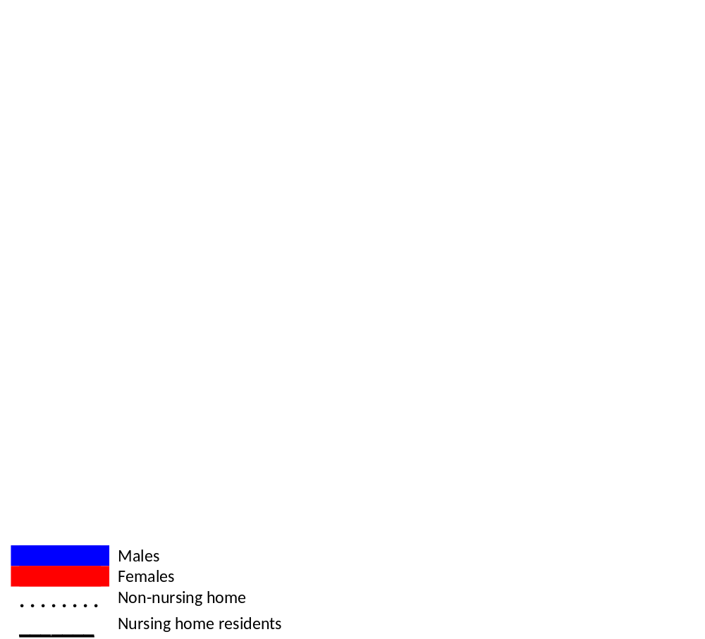
E. Absolute number of deaths in notified COVID-19 cases (figure A) and population mortality rates per 100.000 inhabitants (figure B)
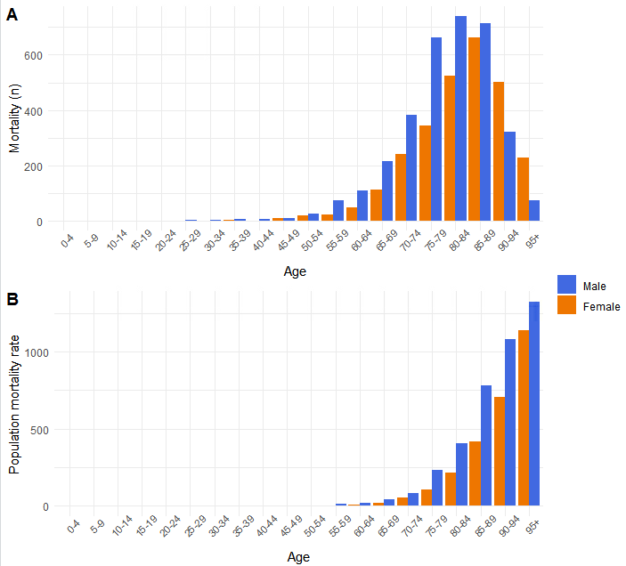
A) Absolute number of deaths by age, B) Mortality rate per 100.000 Dutch inhabitants, by age

F. Male-female mortality rate ratios compared to mortality rate ratios of different causes of death

