Supplementary Information

Recovery and Sequelae in 523 Adults and Children with Tick-Borne Encephalitis in Germany

Journal: Infection

Authors: Teresa M. Nygren, Antonia Pilic, Merle M. Böhmer, Christiane Wagner-Wiening, Ole Wichmann, Wiebke Hellenbrand
Corresponding author: Teresa M. Nygren, Affiliation: Immunization Unit, Robert Koch Institute, Berlin, Germany, E-Mail: NygrenT@rki.de

Appendix 1. Modified RANKIN scale translated to German, as used in study interviews with TBE cases. Full recovery was defined as score 0 on this scale. Source of English original modified RANKIN scale: (1)
Version for adults:
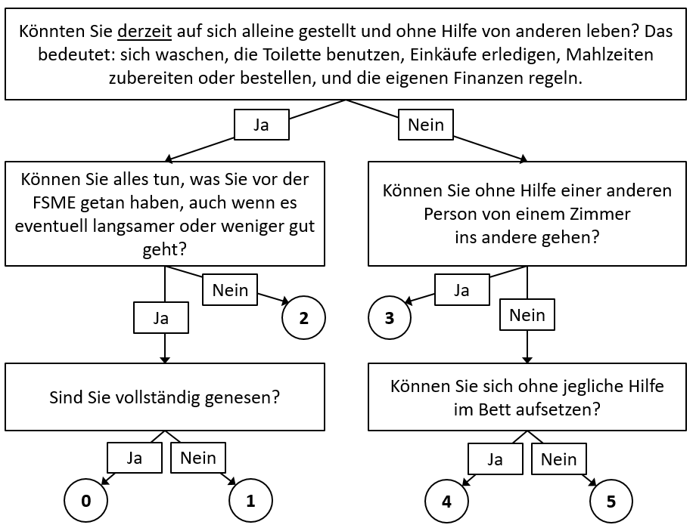
Version for children:
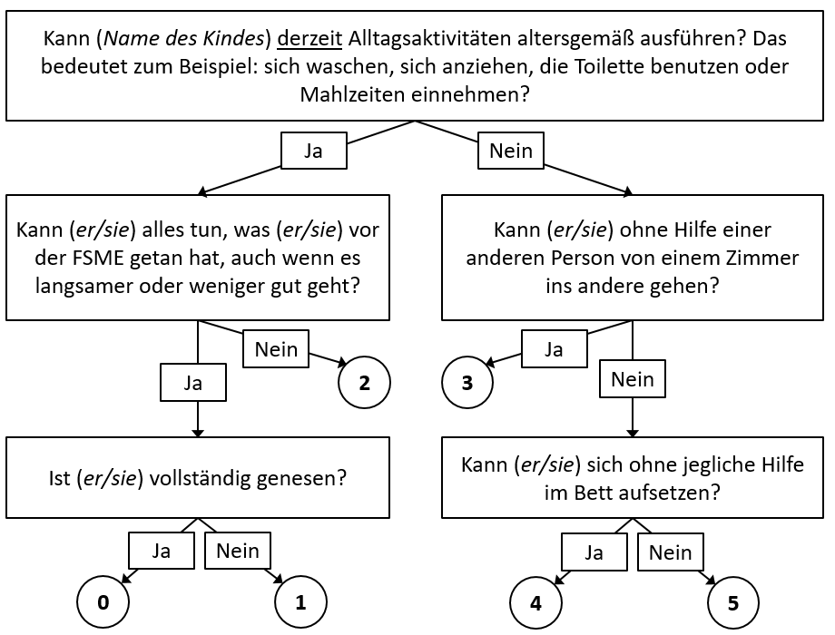

Appendix 2. Directed acyclic graph (DAG) of the causal structure underlying mechanisms connecting potential exposures to the outcome recovery from TBE, as determined by subject-specific knowledge. Created with Dagitty (2).
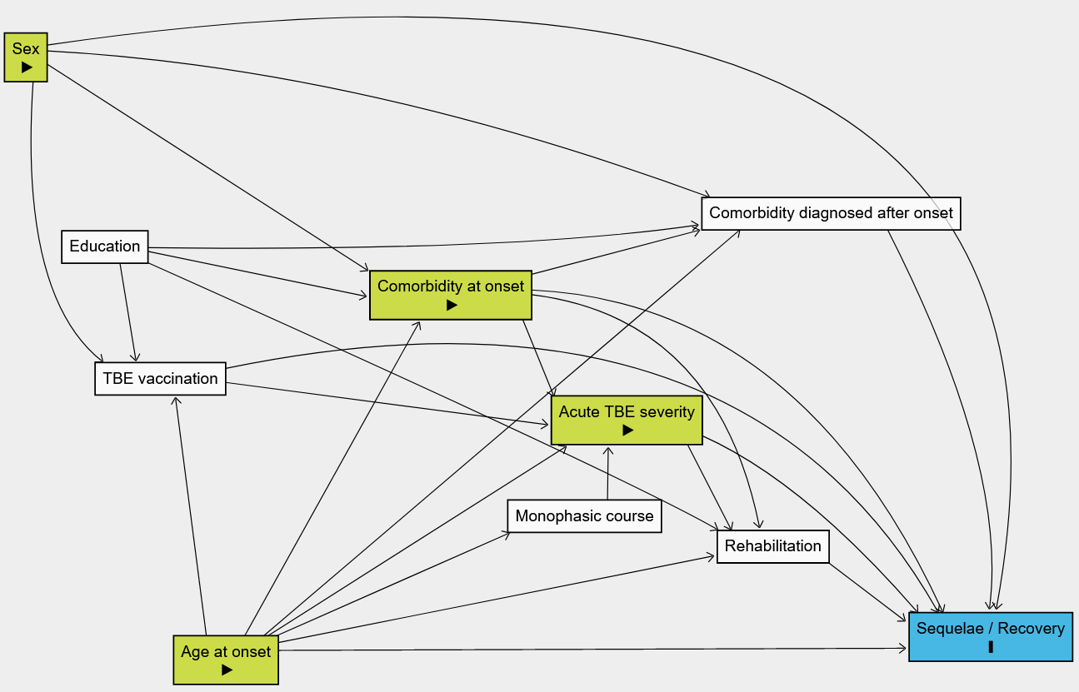
Blue node (I) = outcome. Green nodes (►) = exposures of interest. One exposure was selected at a time to identify the minimal sufficient adjustment set of covariates necessary to estimate the adjusted total causal effect of that exposure on the outcome.

Appendix 3. Percentage of patients reporting TBE symptoms at different time points
 |  | Symptom | Proportion of cases reporting symptoms at different time points (in months) since symptom onset |  |  |  |  |  |  |  |  |  |  | Data
General symptoms/sequelae |  | absent | <2 | 2 | 4 | 6 | 8 | 10 | 12 | 14 | 16 | ≥18 | missing
 | Fatigue | 8% | 91% | 64% | 48% | 40% | 33% | 30% | 29% | 27% | 26% | 17% | 1%
 | Headache | 15% | 83% | 44% | 28% | 24% | 20% | 19% | 18% | 16% | 16% | 10% | 1%
 | General weakness | 24% | 76% | 59% | 42% | 37% | 28% | 26% | 26% | 23% | 23% | 13% | 1%
 | Myalgia | 35% | 64% | 38% | 27% | 24% | 20% | 19% | 18% | 17% | 16% | 12% | 0%
 | Poor sleep quality | 60% | 38% | 30% | 23% | 21% | 19% | 18% | 18% | 17% | 17% | 11% | 1%
 | Handwriting deficit | 62% | 36% | 22% | 14% | 11% | 9% | 8% | 8% | 7% | 7% | 3% | 2%
 | Excessive sweating | 69% | 29% | 21% | 19% | 17% | 15% | 15% | 15% | 14% | 14% | 8% | 2%
Neurological symptoms/sequelae |  |  | <2 | 2 | 4 | 6 | 8 | 10 | 12 | 14 | 16 | ≥18
 | Impaired balance | 20% | 80% | 46% | 30% | 26% | 21% | 19% | 19% | 18% | 17% | 12% | 0%
 | Concentration deficit | 26% | 74% | 46% | 36% | 31% | 25% | 24% | 24% | 22% | 22% | 13% | 0%
 | Memory deficit | 49% | 49% | 35% | 27% | 23% | 20% | 19% | 19% | 18% | 17% | 11% | 2%
 | Impaired coordination (ataxia) | 54% | 44% | 25% | 17% | 16% | 11% | 10% | 10% | 9% | 9% | 6% | 1%
 | Dysphasia (speaking) | 56% | 43% | 21% | 15% | 13% | 11% | 10% | 10% | 8% | 8% | 5% | 1%
 | Tremor | 62% | 38% | 21% | 17% | 16% | 13% | 13% | 12% | 11% | 11% | 7% | 0%
 | Impaired consciousness | 64% | 35% | 16% | 10% | 9% | 7% | 6% | 6% | 5% | 5% | 3% | 1%
 | Sensory impairment | 71% | 28% | 20% | 15% | 15% | 13% | 13% | 13% | 11% | 11% | 8% | 1%
 | Pareses | 83% | 17% | 11% | 8% | 8% | 7% | 7% | 7% | 6% | 6% | 4% | 0%
 | Hearing impairment | 84% | 16% | 12% | 11% | 10% | 9% | 9% | 9% | 9% | 9% | 6% | 0%
 | Dysphagia (swallowing) | 90% | 9% | 5% | 3% | 3% | 2% | 2% | 2% | 2% | 1% | 1% | 0%
 | Seizures | 92% | 7% | 4% | 3% | 3% | 3% | 3% | 3% | 3% | 3% | 2% | 1%

Appendix 4. Presence of post-encephalitic syndrome (PES) reported by adults and children at 6, 12, and 18 months after TBE symptom onset

Mild PES: presence of 2–3 subjective symptoms reported due to TBE virus infection, following the definition in (3). Moderate PES: 4–5 subjective symptoms. Severe PES: ≥6 subjective symptoms.

Appendix 5. Factors associated with time to recovery from TBE: Results of univariable logistic regression analyses
Exposure of Interest | Levels | Cases | Recovered cases | Median time to recovery (months) | HR | 95% CI | AIC
Age group at onset | <18 years | 59 | 56 (95%) | 1.8 | 1.79 | 1.25 – 2.56 | 4057.78
Age group at onset | 18–39 years | 80 | 65 (81%) | 3.0 | Ref. |  | 4057.78
Age group at onset | 40–49 years | 80 | 49 (61%) | 10.5 | 0.55 | 0.38 – 0.80 | 4057.78
Age group at onset | ≥50 years | 304 | 182 (60%) | 7.5 | 0.56 | 0.42 – 0.75 | 4057.78
Sex | Male | 333 | 227 (68%) | 5.0 | Ref. |  | 4108.09
Sex | Female | 190 | 125 (66%) | 6.0 | 0.88 | 0.71 – 1.09 | 4108.09
Acute severity | Mild | 96 | 82 (85%) | 2.0 | Ref. |  | 4063.89
Acute severity | Moderate | 320 | 222 (69%) | 6.0 | 0.55 | 0.43 – 0.71 | 4063.89
Acute severity | Severe | 107 | 48 (45%) | * | 0.29 | 0.20 – 0.42 | 4063.89
Comorbidity at onset | Absent | 298 | 224 (75%) | 5.0 | Ref. |  | 4091.34
Comorbidity at onset | Present | 225 | 128 (57%) | 9.0 | 0.63 | 0.51 – 0.78 | 4091.34
Hypertension at onset | Absent | 411 | 293 (71%) | 6.0 | Ref. |  | 4096.09
Hypertension at onset | Present | 112 | 59 (53%) | 12.0 | 0.61 | 0.46 – 0.81 | 4096.09
* Only 45% of cases in this stratum had recovered by 18 months, hence the median time to recovery could not be determined.
HR = hazard ratio; CI = confidence interval; AIC = Akaike information criterion; Ref. = reference
Appendix 6. Definition of acute TBE disease severity for the 581 TBE cases who participated at the first data collection point. Source: (4)
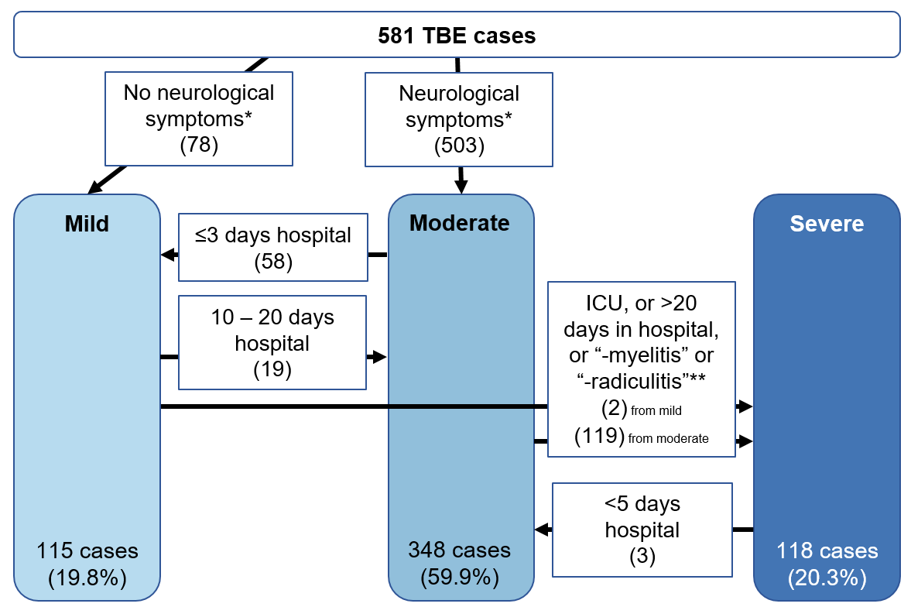
ICU: intensive care unit
* symptoms occurring at any point during the acute disease course. At least 1 of: ataxia, sensory impairment, dysphasia, dysphagia, pareses, impaired consciousness, seizures, hearing impairment, respiratory difficulty/paralysis
** according to hospital discharge summaries

References
1. Bruno A, Akinwuntan AE, Lin C, Close B, Davis K, Baute V, et al. Simplified modified rankin scale questionnaire: reproducibility over the telephone and validation with quality of life. Stroke. 2011;42(8):2276-9.
2. Textor J, van der Zander B, Gilthorpe MS, Liskiewicz M, Ellison GT. Robust causal inference using directed acyclic graphs: the R package 'dagitty'. Int J Epidemiol. 2016;45(6):1887-94.
3. Bogovič P, Stupica D, Rojko T, Lotrič-Furlan S, Avšič-Županc T, Kastrin A, et al. The long-term outcome of tick-borne encephalitis in Central Europe. Ticks Tick Borne Dis. 2018;9(2):369-78.
4. Nygren TM, Pilic A, Böhmer MM, Wagner-Wiening C, Went S-B, Wichmann O, et al. Tick-Borne Encephalitis: Acute Clinical Manifestations and Severity in 581 cases from Germany, 2018-2020. J Infect. 2023.

