Supplementary Files

Supplementary Methods
We used ICD-10 codes from the Norwegian Patient Registry (NPR) to define sepsis as implicit (known infection plus organ dysfunction), explicit (unknown infection) and COVID-19 related-sepsis

Implicit sepsis was retrieved with ICD-10 codes for infection together with ICD-10 codes for acute organ dysfunction in the same hospital admission. Here is a list of the codes we combined for infection and acute organ dysfunction:
ICD-10 codes for infection:
A00/09, A19/28, A30/32, A36/39, A42/ 44, A46, A48/49, A54, A59, A69.0, A69.1, A69.9, A70, A74/75, A77/81, A83/89, A92/99, B00/09, B25/27, B33/34, B37/46, B48/50, B54/55, B57/58, B60, B64, B67, B95/97, B99, G00/08, H05.0, H60.2, H70.0, I00, I33, I38/40.0, J01/06, J09/22, J36, J39.0, J39.1, J85, J86, K35/37, K61, K63.0/63.1, K65, K75.0, K81.0, K83.0, L02/04, L08, M00/01, M86, M72.6,N10, N15.1, N30, N39.0, N41.0, N41.2, N41.3, N45, N70/74, N98.0, N49, O03.0, O03.5, O04.5, O08.0, O23, O75.3, O85/86, O88.3, O91, O98, T80.2, T81.4, T82.6/82.7, T83.5/83.6, T84.5/84.7, T85.7, T88.0, U04
ICD-10 codes for acute organ dysfunction
D65, D69.5, E87.2, G93.4, I46, I95.9, J80, J95.2, J96, K72.0, K72.9, N00, N17, N99.0, R02, R09.0, R09.2, R40.0/40.2, R41, R55, R57, R57.2, R65.1

Explicit sepsis was retrieved for these ICD-10 codes:
A02.1, A20.7, A21.7, A22.7, A24.1, A26.7, A28.2, A32.7, A39.2, A39.4, A40, A41, A42.7, B00.7, B37.7

COVID-19-related sepsis was retrieved using ICD-10 codes for COVID-19-infection U07.1 and U07.2 together with codes for acute organ dysfunction. We used the same codes for acute organ dysfunction as for implicit sepsis (see above).

Comorbidities was also retrieved using ICD-10 codes. In the selection process we defined comorbidities from groups of comorbidities. Here is a list of how we categorized the comorbidities according to ICD-10-codes::
Chronic heart- and vascular disease; G45, H34, I00/31, I34/37, I42/45, I47/95.8, I97/99. Cancer; C00/97, D32/33, D35.2/35.4, D42, D43, D44.3/44.5, D45/47. Chronic lung disease; J41/47, J84, J98. Chronic renal disease; N18.3/18.5. Diabetes; E10/11. Dementia; F00/03, G30, G31.0, G31.2, G31.8. Chronic immune disease; D80/84, Z94.0/94.4, Z94.8. Chronic liver disease; K70.4, K72.

Infection Site was categorized according to these ICD-10 diagnoses: :
Respiratory; J09/18, J20/22, J85/86, U04. Genitourinary: N10, N15.1, N30, N39.0, N41.0, N41.2/41.3, N45, N49, N70, N71/74, N98.0; Gastrointestinal-infections; A00/09. Intra-abdominal; K35/37, K57, K61/61.1 K61.3, K63.0/63.1, K65, K75.0, K81.0, K83.0. Endocarditis/myocarditis; I32/33, I38/41. Skin/ Soft tissue; A46, B08/09, L02/04, L08, M72.6. Infection after procedure; T80.2, T81.4, T82.6/82.7, T83.5/83.6, T84.5/84.7, T85.7, T88. Other; A19/28, A30/32, A36/39, A42/44, A48/49, A54, A59, A69.0, A69.1, A69.9, A70, A74/75, A77/80, A81, A83/89, A92/B06, B25/27, B33/34, B37/46, B48/50, B54/55, B57/58, B60, B64, B67, B95/97, B99, G00/08, H05.0, H60.2, H70.0, J01/06, J36, J39.0/39.1, M00/01, M86, O03.0, O03.5, O04.5, O08.0, O23, O75.3, O85/86, O88.3, O91, O98.

Acute organ dysfunction was categorized according to these ICD-10 diagnoses::
Respiratory; J80, J95.2, J96, R09.0, R09.2. Circulatory; I46, I95.9, R57, R57.2. Renal; N00, N17, N99.0. Hepatic; K72.0, K72.9. Coagulation; D65, D69.5. Other acute organ dysfunctions; G93.4, R40.0/40.2, R41, R55, E87.2, R02, R65.1.

Supplementary Results
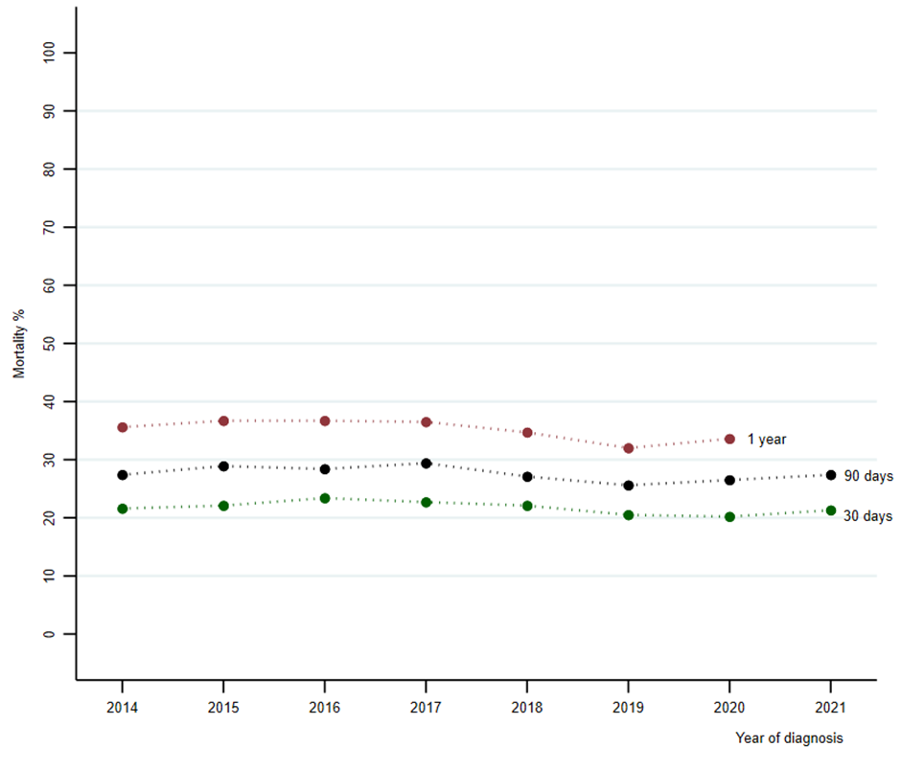
Supplementary Figure 1 Age-standardized mortality at 30- and 90-day and 1-year for patients with sepsis receiving intensive care treatment

Supplementary Table 1 Hazard ratio for death from Cox regression by sepsis characteristics during follow-up of sepsis patients.
Variable | No. of patients | Person year at risk | Deaths | Mortality  per 100 person year | Crude HR | Adjusted HRª (95% CI)
Sepsis subgroup^{b}
Implicit | 17 315 | 11 079 | 5 598 | 50.5 | 1.00 | 1.00 (Reference)
Explicit | 8 258 | 5 526 | 2 660 | 48.1 | 0.99 | 1.09 (1.04–1.14)
COVID-19-related | 2 845 | 1 841 | 490 | 26.6 | 0.53 | 0.85 (0.77–0.93)
Abbrevation: HR=Hazard Ratio, CI= Confidence Interval.
ª Cox regression with time to death as dependent variable, the listed variable as covariate, adjusted for indicator covariate for the year 2020, sex and age.
^{b} All patients entered after 27th February 2020

Supplementary Table 2 Hazard ratio for death from Cox regression by sepsis characteristics during follow-up of sepsis patients.
Variable | No. of patients | Person year at risk | Deaths | Mortality  per 100 person year | Crude HR | Adjusted HRª (95% CI)
Infection site
Respiratory^{b} | 81 881 | 225 907 | 51 954 | 23.0 | 1.31 | 1.28 (1.27–1.30)
Genitourinary^{b} | 44 782 | 128 256 | 25 781 | 18.6 | 0.95 | 0.76 (0.75–0.77)
Intra-abdominal^{b} | 12 340 | 39 111 | 6 995 | 17.9 | 0.99 | 0.99 (0.97–1.02)
Gastrointestinal infections^{b} | 10 810 | 44 706 | 5 126 | 11.5 | 0.67 | 0.72 (0.70–0.74)
Skin and soft tissue^{b} | 8 265 | 20 173 | 2 395 | 11.9 | 0.69 | 0.80 (0.78–0.82)
Infections following a procedure^{b} | 8 290 | 33 392 | 3 674 | 11.0 | 0.64 | 0.74 (0.72–0.77)
Endocarditis/myocarditis^{b} | 2 530 | 8 033 | 1 371 | 17.1 | 0.94 | 1.09 (1.03–1.15)
Other infections^{b,c} | 43 085 | 141 556 | 21 391 | 15.1 | 0.75 | 0.86 (0.85–0.87)
Comorbidities
Heart and vascular^{d} | 100 062 | 277 421 | 69 884 | 25.2 | 1.66 | 1.14 (1.13–1.16)
Cancer^{d} | 39 368 | 75 212 | 30 876 | 41.1 | 2.10 | 2.41 (2.38–2.44)
Lung^{d} | 36 165 | 100 190 | 25 675 | 25.6 | 1.37 | 1.32 (1.31–1.43)
Diabetes^{d} | 24 416 | 78 015 | 15 519 | 19.9 | 1.08 | 1.03 (1.01–1.05)
Dementia^{d} | 8 100 | 11 800 | 7 187 | 60.9 | 2.39 | 1.47 (1.43–1.51)
Renal^{d} | 8 949 | 17 553 | 6 140 | 35.0 | 1.50 | 1.24 (1.21–1.27)
Immune^{d} | 3 140 | 12 369 | 1 535 | 12.4 | 0.72 | 1.21(1.16–1.28)
Liver^{d} | 994 | 1 902 | 746 | 39.2 | 1.83 | 3.01 (2.81–3.25)
Type of acute organ dysfunction
Respiratory^{e} | 61 864 | 169 225 | 39 335 | 23.2 | 1.29 | 1.47 (1.45–1.48)
Renal^{e} | 67 242 | 186 433 | 40 216 | 21.6 | 1.15 | 0.95 (0.94–0.96)
Circulatory^{e} | 14 982 | 35 239 | 9 278 | 26.3 | 1.38 | 1.55 (1.52–1.59)
Coagulation^{e} | 6 471 | 18 820 | 3 831 | 20.4 | 1.08 | 1.72 (1.67–1.78)
Hepatic^{e} | 3 209 | 6 232 | 2 337 | 37.5 | 1.84 | 2.63 (2.52–2.74)
Other acute organ dysfunctions^{e,f} | 22 173 | 78 441 | 12 249 | 15.6 | 0.85 | 0.72 (0.70–0.73)
Abbrevation: HR=Hazard Ratio, CI= Confidence Interval.
ª Cox regression with time to death as dependent variable, the listed variable as covariate (one at the time), adjusted for per year 2009-2019 as continuous covariate, indicator covariates for the years 2008, 2020 and 2021, and sex and age.
^{b} Reference group= All other infection sites
^{c} Other infections= Bone, obstetric, upper airway, central nervous system and unknown
^{d} Reference group= All other comorbidities
^{e} Reference group= All other acute organ dysfunctions
^{f} Other acute organ dysfunctions= Acidosis, unspecific gangrene, central nervous system dysfunctions and Systemic Inflammatory Response Syndrome.

Supplementary Table 3 Hazard ratio for death from Cox regression by admission year 2008-2021 of sepsis patients.
 | Crude HR | Adjustedª HR ( 95% CI)
2008 | 1.059 | 1.058 (1.037-1.080)
2009 | 1 | 1
2010 | 0.984 | 0.975 (0.973–0.976)
2011 | 0.969 | 0.950 (0.946–0.953)
2012 | 0.954 | 0.930 (0.920–0.931)
2013 | 0.934 | 0.902 (0.895–0.909)
2014 | 0.925 | 0.879 (0.870–0.888)
2015 | 0.910 | 0.857 (0.846–0.867)
2016 | 0.896 | 0.835 (0.823–0.846)
2017 | 0.882 | 0.813 (0.801–0.826)
2018 | 0.869 | 0.793 (0.779–0.807)
2019 | 0.855 | 0.773 (0.757–0.788)
2020 | 0.884 | 0.794 (0.772–0.817)
2021 | 0.904 | 0.829 (0.803–0.856)
ª Cox regression with time to death by year as dependent variable, unadjusted (crude), and adjusted for age and sex. The year 2009 is reference.

