NEED FOR ICU AND OUTCOME OF CRITICALLY ILL PATIENTS WITH COVID-19 AND HAEMATOLOGICAL MALIGNANCIES: RESULTS FROM THE EPICOVIDEHA SURVEY

Supplementary figures

Supplementary figure 1. Survival probability of patients with haematological malignancy and COVID-19, by need for intensive care and previous vaccination and country (for countries with n>100).
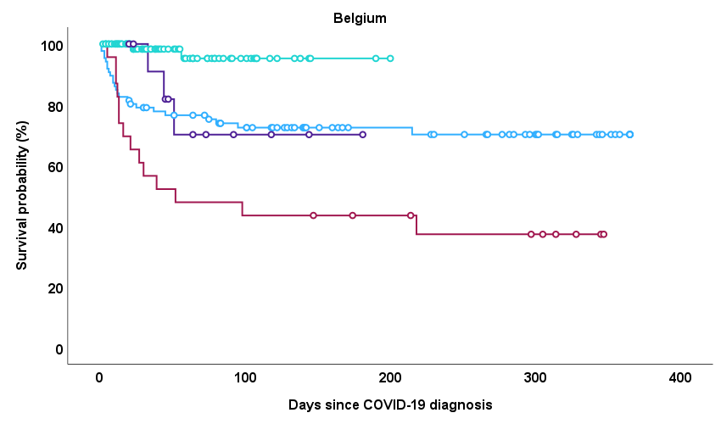
  <0.001 | No ICU no vax | ICU no vax | No ICU vax
  ICU no vax | 0.009
  No ICU vax | <0.001 | <0.001
  ICU vax | 0.814 | 0.088 | 0.014
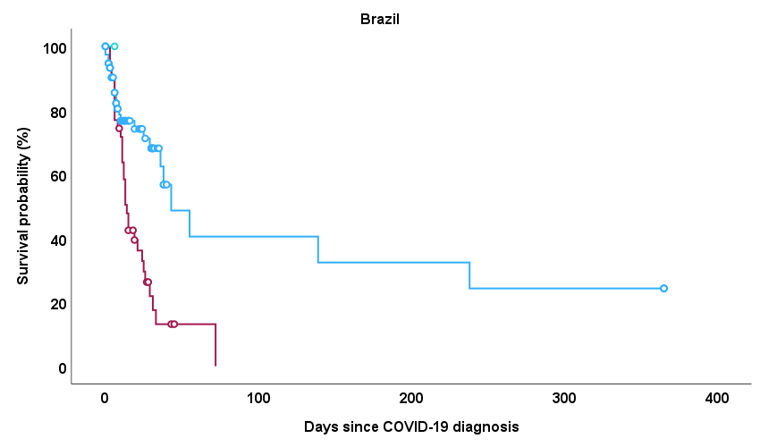
  <0.001 | No ICU no vax | ICU no vax
  ICU no vax | <0.001
  No ICU vax | 0.692 | 0.604
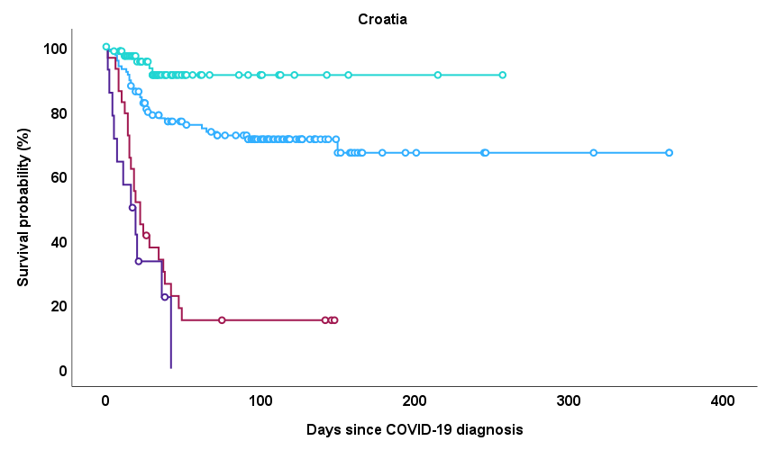
  <0.001 | No ICU no vax | ICU no vax | No ICU vax
  ICU no vax | <0.001
  No ICU vax | 0.010 | <0.001
  ICU vax | <0.001 | 0.245 | <0.001
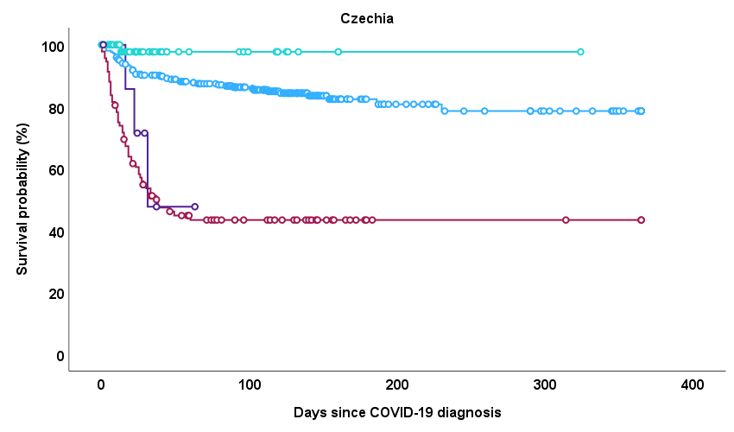
  <0.001 | No ICU no vax | ICU no vax | No ICU vax
  ICU no vax | <0.001
  No ICU vax | 0.058 | <0.001
  ICU vax | 0.008 | 0.590 | <0.001
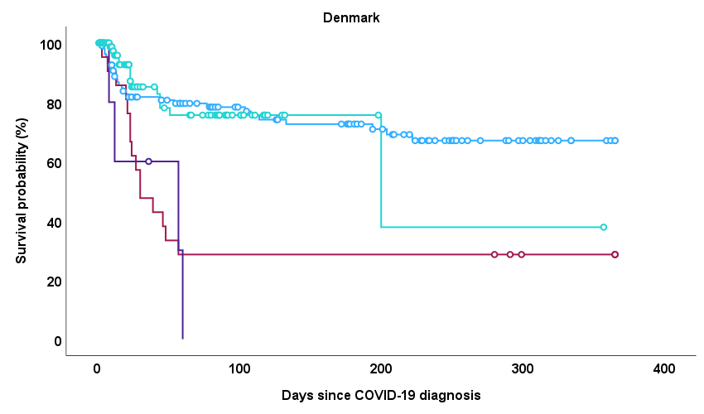
  <0.001 | No ICU no vax | ICU no vax | No ICU vax
  ICU no vax | <0.001
  No ICU vax | 0.868 | <0.001
  ICU vax | 0.001 | 0.724 | 0.001
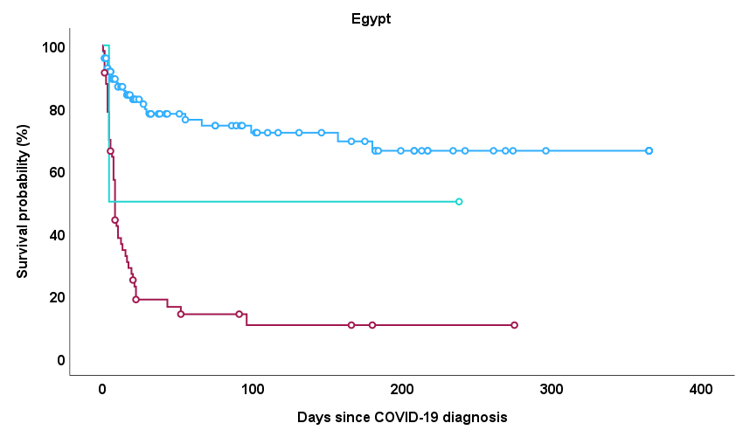
  <0.001 | No ICU no vax | ICU no vax
  ICU no vax | <0.001
  No ICU vax | 0.479 | 0.358
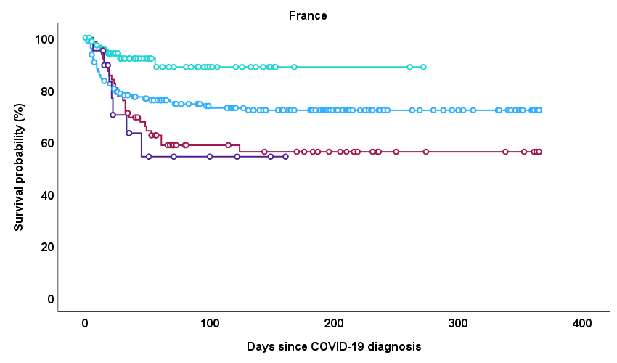
  0.003 | No ICU no vax | ICU no vax | No ICU vax
  ICU no vax | 0.070
  No ICU vax | 0.011 | 0.001
  ICU vax | 0.292 | 0.677 | 0.002
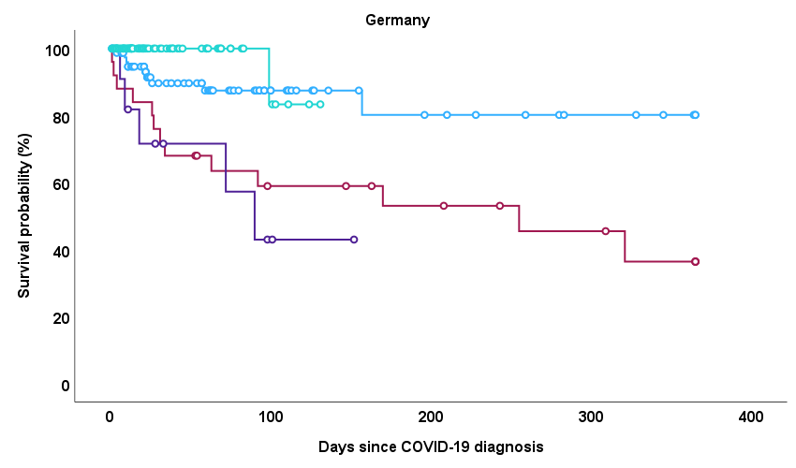
  <0.001 | No ICU no vax | ICU no vax | No ICU vax
  ICU no vax | 0.003
  No ICU vax | 0.100 | 0.001
  ICU vax | 0.003 | 0.562 | 0.001
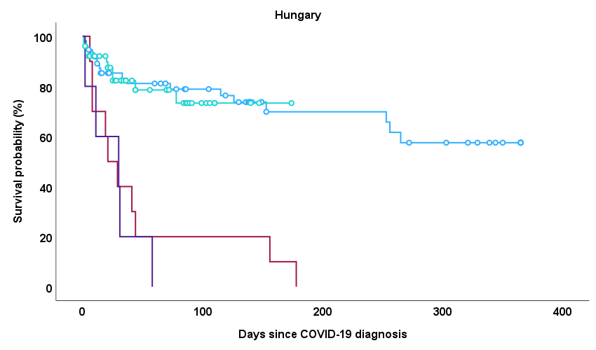
  <0.001 | No ICU no vax | ICU no vax | No ICU vax
  ICU no vax | <0.001
  No ICU vax | 0.806 | <0.001
  ICU vax | <0.001 | 0.609 | <0.001
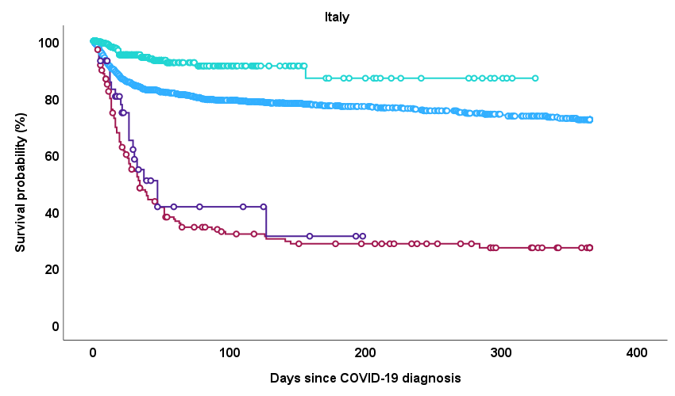
  <0.001 | No ICU no vax | ICU no vax | No ICU vax
  ICU no vax | <0.001
  No ICU vax | <0.001 | <0.001
  ICU vax | <0.001 | 0.347 | <0.001
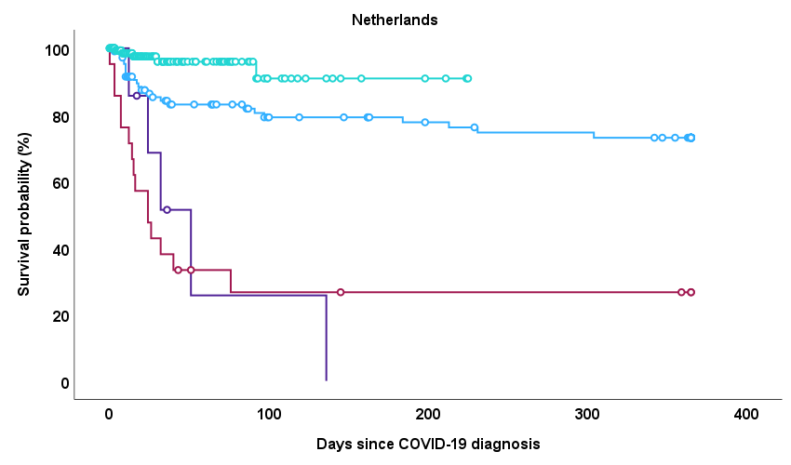
  <0.001 | No ICU no vax | ICU no vax | No ICU vax
  ICU no vax | <0.001
  No ICU vax | 0.006 | <0.001
  ICU vax | 0.001 | 0.821 | <0.001
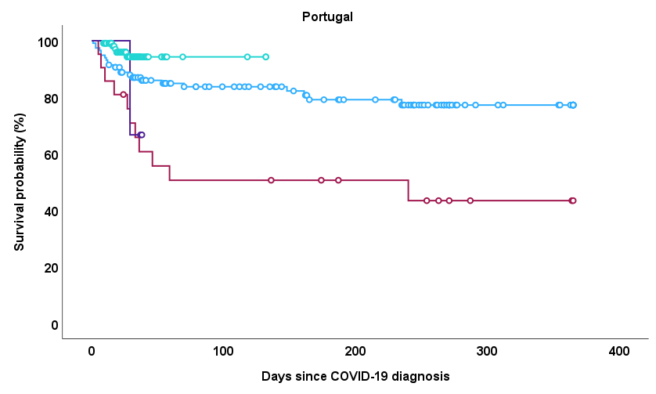
  <0.001 | No ICU no vax | ICU no vax | No ICU vax
  ICU no vax | 0.001
  No ICU vax | 0.046 | <0.001
  ICU vax | 0.385 | 0.785 | 0.101
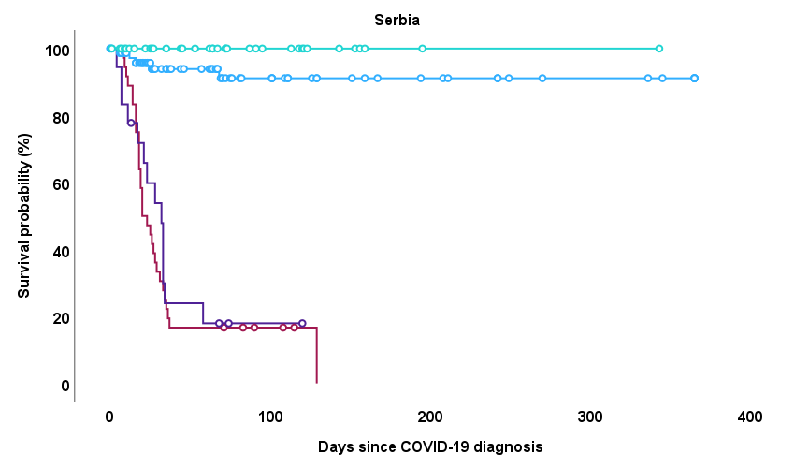
  <0.001 | No ICU no vax | ICU no vax | No ICU vax
  ICU no vax | <0.001
  No ICU vax | 0.123 | <0.001
  ICU vax | <0.001 | 0.625 | <0.001
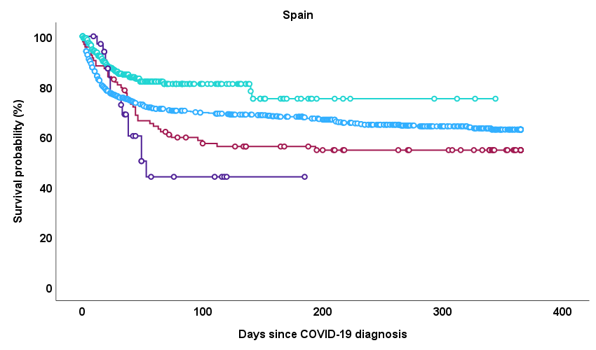
  <0.001 | No ICU no vax | ICU no vax | No ICU vax
  ICU no vax | 0.159
  No ICU vax | <0.001 | <0.001
  ICU vax | 0.161 | 0.284 | 0.001
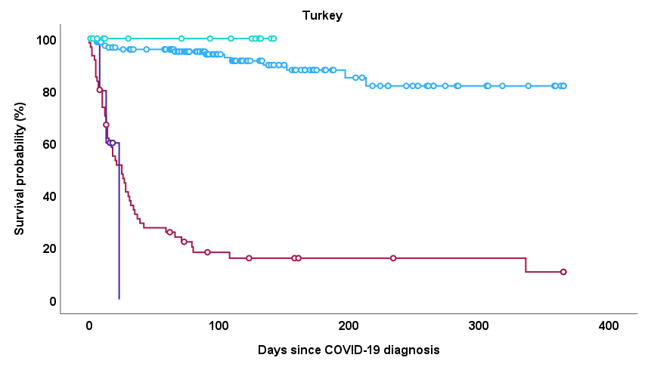
  <0.001 | No ICU no vax | ICU no vax | No ICU vax
  ICU no vax | <0.001
  No ICU vax | 0.338 | <0.001
  ICU vax | <0.001 | 0.661 | 0.001
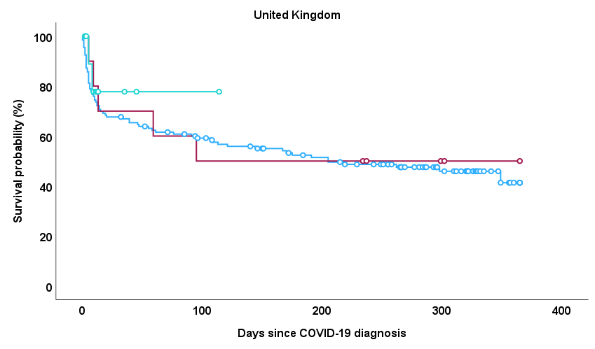
  0.753 | No ICU no vax | ICU no vax
  ICU no vax | 0.798
  No ICU vax | 0.466 | 0.702

