Table-S1. Patient characteristics and comparison of azithromycin resistant Mycoplasma genitalium episodes vs. all other episodes – ‘overcorrection’ for symptoms caused by coinfections.
 | All Episodes  N=199 | Azithromycin resistance negative or non-available episodes  N=121 | Azithromycin resistant episodes  N=78 | p-value
Leading Symptom§
Asymptomatic | 77% (153/199) | 78% (94/121) | 76% (59/78) | 0.049
Urethritis | 16% (32/199) | 18% (22/121) | 13% (10/78) | 0.049
Proctitis | 5% (10/199) | 2% (2/121) | 10% (8/78) | 0.049
Pharyngitis | 1% (1/199) | 1% (1/121) | 0% (0/78) | 0.049
Cervicitis | 2% (3/199) | 2% (2/121) | 1% (1/78) | 0.049
§ for this analysis it was assumed that the symptoms of all individuals with an active chlamydia or gonorrhea coinfection detected at the same sampling site as the mycoplasma genitalium infection were solely caused by chlamydia or gonorrhea. Thus, coinfections were categorized as asymptomatic mycoplasma genitalium infections.

Table-S2. Patient characteristics of individuals with azithromycin susceptible Mycoplasma genitalium infections next to a comparison of patient characteristics before and after availability of azithromycin resistance analysis.
 | Azithromycin resistance negative  N=36 |  | Resistance analysis unavailable  N=85 | Resistance analysis available  N=114 | p-value
Age | 36.1 ± 11.8 |  | 34.3 ± 11.7 | 36.6 ± 9.9 | 0.142
Male | 89% (32/36) |  | 89% (76/85) | 96% (109/114) | 0.091
MSM | 81% (29/36) |  | 69% (59/85) | 90% (102/114) | <0.001
On HIV-PrEP | 33% (12/36) |  | 35% (30/85) | 42% (48/114) | 0.330
HIV | 42% (15/36) |  | 25% (21/85) | 39% (44/113) | 0.035
History of HIV-PEP | 8% (3/36) |  | 11% (9/85) | 12% (14/114) | 0.712
History of syphilis | 50% (18/36) |  | 39% (33/85) | 47% (54/114) | 0.229
Leading Symptom
Asymptomatic | 81% (29/36) |  | 59% (50/85) | 75% (85/114) | <0.001
Urethritis | 11% (4/36) |  | 34% (29/85) | 12% (14/114) | <0.001
Proctitis | 6% (2/36) |  | 2% (2/85) | 11% (13/114) | <0.001
Pharyngitis | 0% (0/36) |  | 1% (1/85) | 0% (0/114) | <0.001
Cervicitis | 3% (1/36) |  | 4% (3/85) | 2% (2/114) | <0.001
Site of manifestation
Urethral | 44% (16/36) |  | 76% (65/85) | 39% (45/114) | <0.001
Anal | 47% (17/36) |  | 20% (17/85) | 55% (63/114) | <0.001
Pharyngeal | 3% (1/36) |  | 1% (1/85) | 3% (3/114) | <0.001
Cervical | 6% (2/36) |  | 2% (2/85) | 3% (3/114) | <0.001
Treatment | 92% (33/36) |  | 88% (75/85) | 90% (103/114) | 0.631
Doxycycline | 6% (2/33) |  | 16% (12/75) | 9% (9/103) | 0.142
Negative follow-up test | N/A |  | 57% (4/7) | 100% (1/1) | 1
Azithromycin | 94% (31/33) |  | 80% (60/75) | 31% (32/103) | <0.001
Negative follow-up test | 90% (18/20) |  | 68% (26/38) | 90% (18/20) | 0.106
Moxifloxacin | 0% (0/33) |  | 4% (3/75) | 60% (62/103) | <0.001
Negative follow-up test | N/A |  | N/A | 85% (34/40) | N/A
Concomitant infection
Gonorrhea | 14% (5/36) |  | 13% (11/85) | 13% (15/114) | 0.163
Chlamydia | 22% (8/36) |  | 22% (19/85) | 16% (18/114) | 0.239
Syphilis | 14% (5/36) |  | 9% (8/85) | 18% (20/114) | 0.103
Abbreviations: HIV, human immunodeficiency virus; MSM, men who have sex with men; PEP, post-exposure prophylaxis, PrEP, pre-exposure prophylaxis.

Table-S3. Patient characteristics per treatment outcome availability.
 | All episodes receiving treatment  N=178 | Treatment outcome not available  N=72 | Treatment outcome available  N=106 | p-value
Age | 36.0 ± 10.6 | 34.4 ± 11.3 | 37.0 ± 10.0 | 0.053
Male | 93% (165/178) | 88% (63/72) | 96% (102/106) | 0.028*
MSM | 20% (35/178) | 29% (21/72) | 13% (14/106) | 0.009*
On HIV-PrEP | 40% (72/178) | 28% (20/72) | 49% (52/106) | 0.005*
HIV | 32% (57/177) | 29% (21/72) | 34% (36/105) | 0.474
History of HIV-PEP | 12% (22/178) | 14% (10/72) | 11% (12/106) | 0.609
History of syphilis | 43% (77/178) | 38% (27/72) | 47% (50/106) | 0.201
Azithromycin resistance available | 58% (103/178) | 58% (42/72) | 58% (61/106) | 0.917
Azithromycin resistant episode | 68% (70/103) | 69% (29/42) | 67% (41/61) | 0.845
Leading Symptom
Asymptomatic | 66% (118/178) | 65% (47/72) | 67% (71/106) | 0.143
Urethritis | 22% (40/178) | 25% (18/72) | 21% (22/106) | 0.143
Proctitis | 8% (14/178) | 4% (3/72) | 10% (11/106) | 0.143
Pharyngitis | 1% (1/178) | 0% (0/72) | 1% (1/106) | 0.143
Cervicitis | 3% (5/178) | 6% (4/72) | 1% (1/106) | 0.143
Site of manifestation
Urethral | 53% (95/178) | 64% (46/72) | 46% (49/106) | 0.026*
Anal | 42% (74/178) | 32% (23/72) | 48% (51/106) | 0.026*
Pharyngeal | 2% (4/178) | 0% (0/72) | 4% (4/106) | 0.026*
Cervical | 3% (5/178) | 4% (3/72) | 2% (2/106) | 0.026*

* We observed an increased proportion of available treatment outcomes for males, for MSM, for PrEP-users and for anal infections. This pattern suggests that the variables are dependent. To further investigate the underlying factors, we performed a binary logistic regression analysis with “outcome availability” being the dependent variable. Multivariate analysis enabled us to identified “PrEP-use” as the main contributor (aOR 2.14, 95%-CI 1.09-4.19) for treatment outcome availability. This finding seems plausible, since PrEP-users are usually connected to STI surveillance.

Figure-S1:
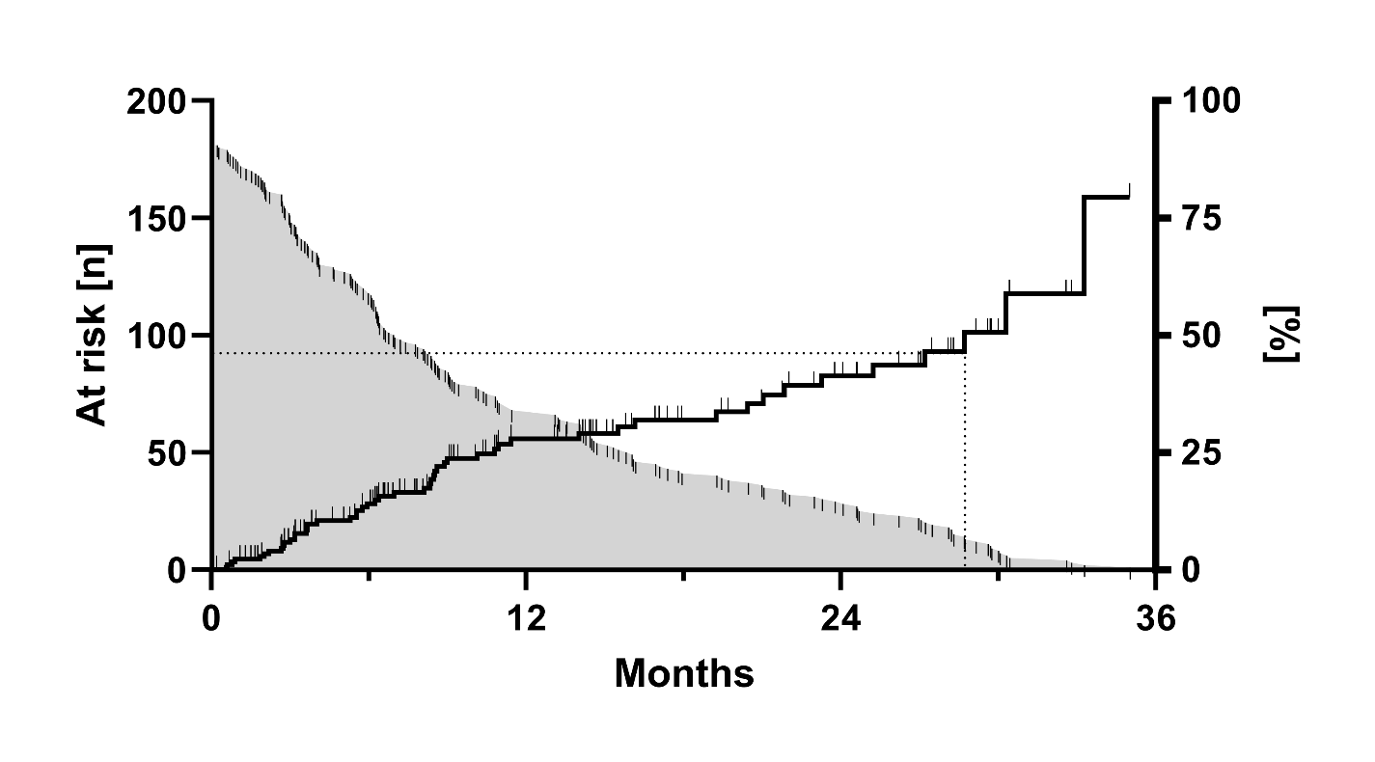

Figure-S1. Subanalysis on PrEP-users: Kaplan-Meier-Curve describing the probability of the first Mycoplasma genitalium infection.
Screening for sexually transmitted infections, including testing for Mycoplasma genitalium, every three months was performed for users of HIV pre-exposure prophylaxis. Thus, we had systematic follow-up data available for this specific population of interest and were able to perform a subgroup analysis: A survival analysis was used to calculate the median time from inclusion in the analysis (=first test) to first detection of Mycoplasma genitalium. Hundred-eighty-one PrEP-users with more than one available data point were analyzed, providing a median follow-up of 14.3 months. After 12 months, 28% had acquired a MG infection, whereas the median time until first positive MG test was 28.7 months. While the black line shows the longitudinal probability to acquire the first Mycoplasma genitalium infection, the grey curve indicates the declining number of individuals at risk.

