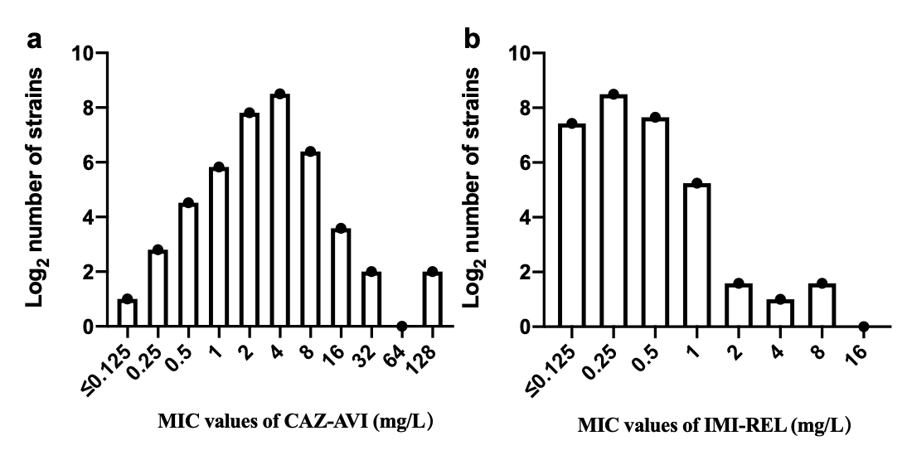
Figure S1. MIC distribution of a) CAZ-AVI and b) IMI-REL against 782 KPC-Kp strains. The longitudinal axis is the MIC value (mg/L) and the horizontal axis is the Log₂ logarithm value of the number of strains.

