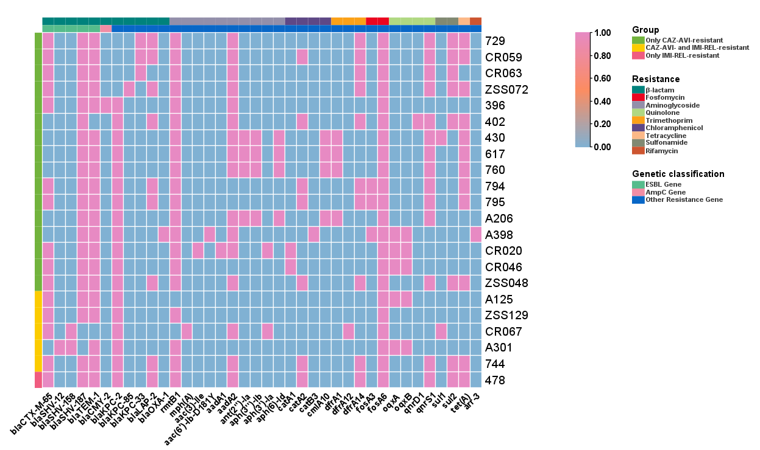
Figure S2. Resistance gene analysis of 22 KPC-Kp strains resistant to CZA-AVI and/or IMI-REL. The genomes were comprehensively compared to the data in the NCBI database using ABRicate v1.0.1, with genes that are present indicated in pink and genes that are absent depicted in blue.

