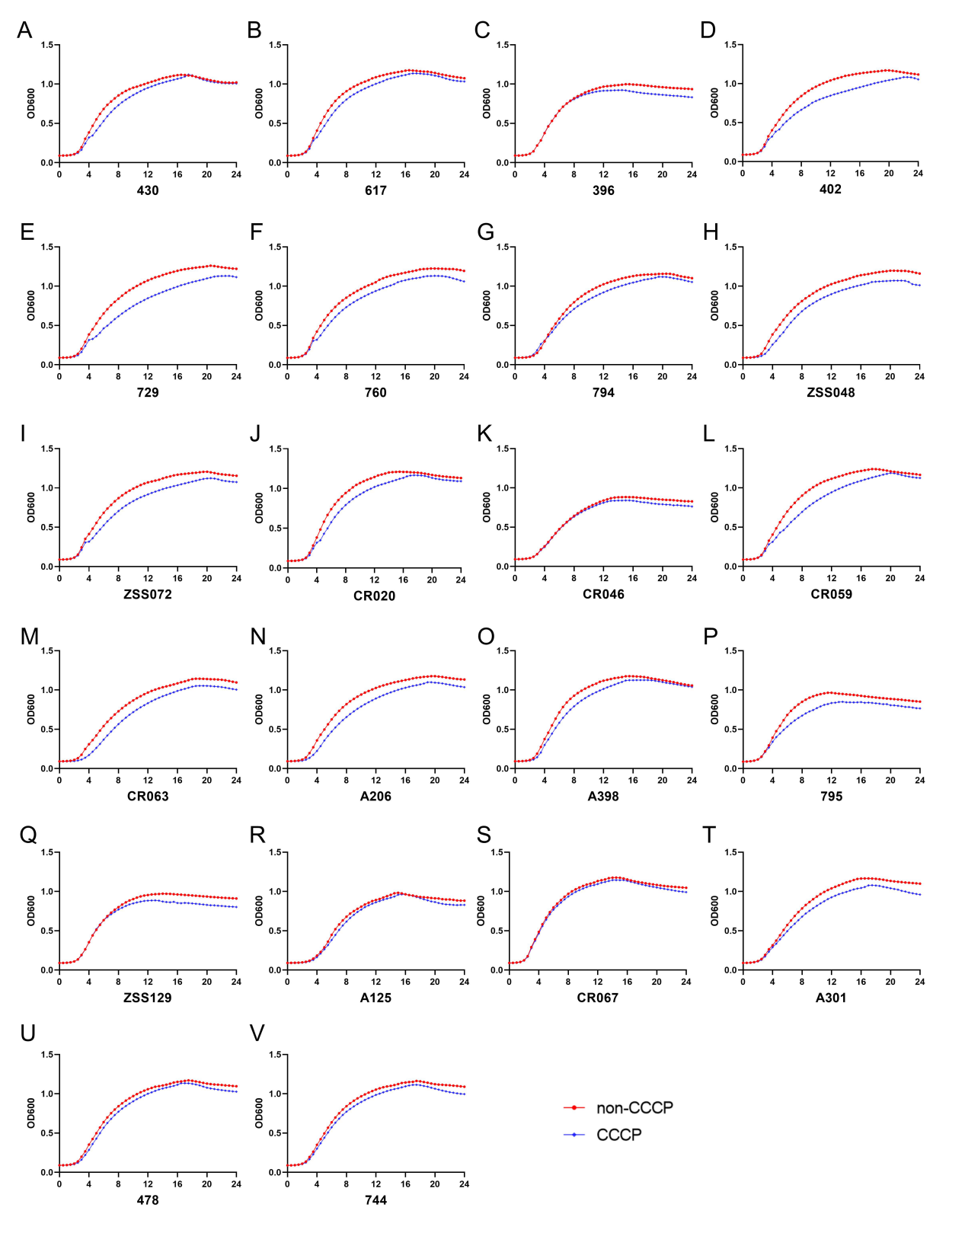
Figure S3. Growth curves of IMI-REL- and/or CAZ-AVI-resistant KPC-Kp strains with and without CCCP. The horizontal axis is the culture time (hours). The vertical axis is the OD600 of the culture. Graphs A to V represent the growth curves of strains 430, 617, 396, 402, 729, 760, 794, ZSS048, ZSS072, CR020, CR046, CR059, CR063, A206, A398, 795, ZSS129, A125, CR067, A301, 478, and 744, respectively.

