Supplementary Information
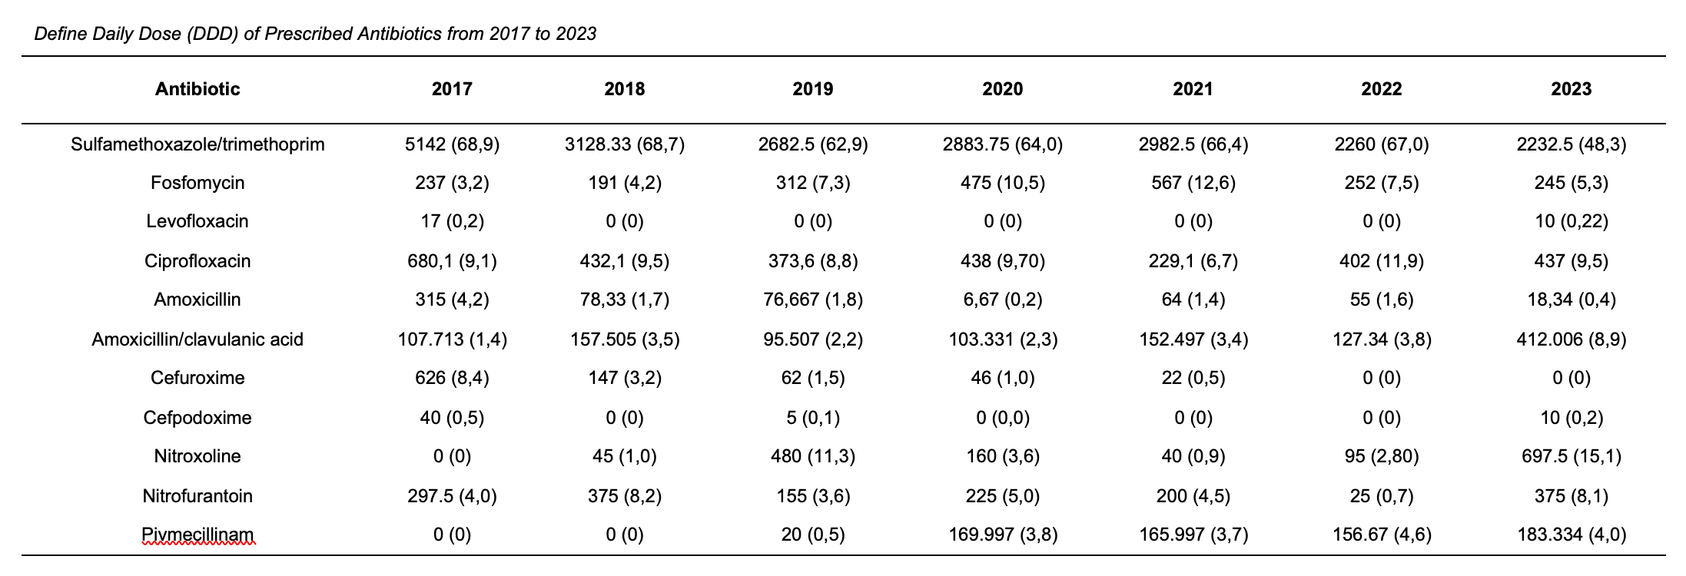
Supplementary Table 1 Defined Daily Doses (DDD) of Prescribed Antibiotics from 2017 to 2023
In parentheses: percentage share of the DDD within a year

Supplementary Figure 1 Antibiotic Resistance of Pseudomonas aeruginosa 2013-2022
Supplementary Figure 2 Antibiotic Resistance of Enterococcus faecium 2013-2022

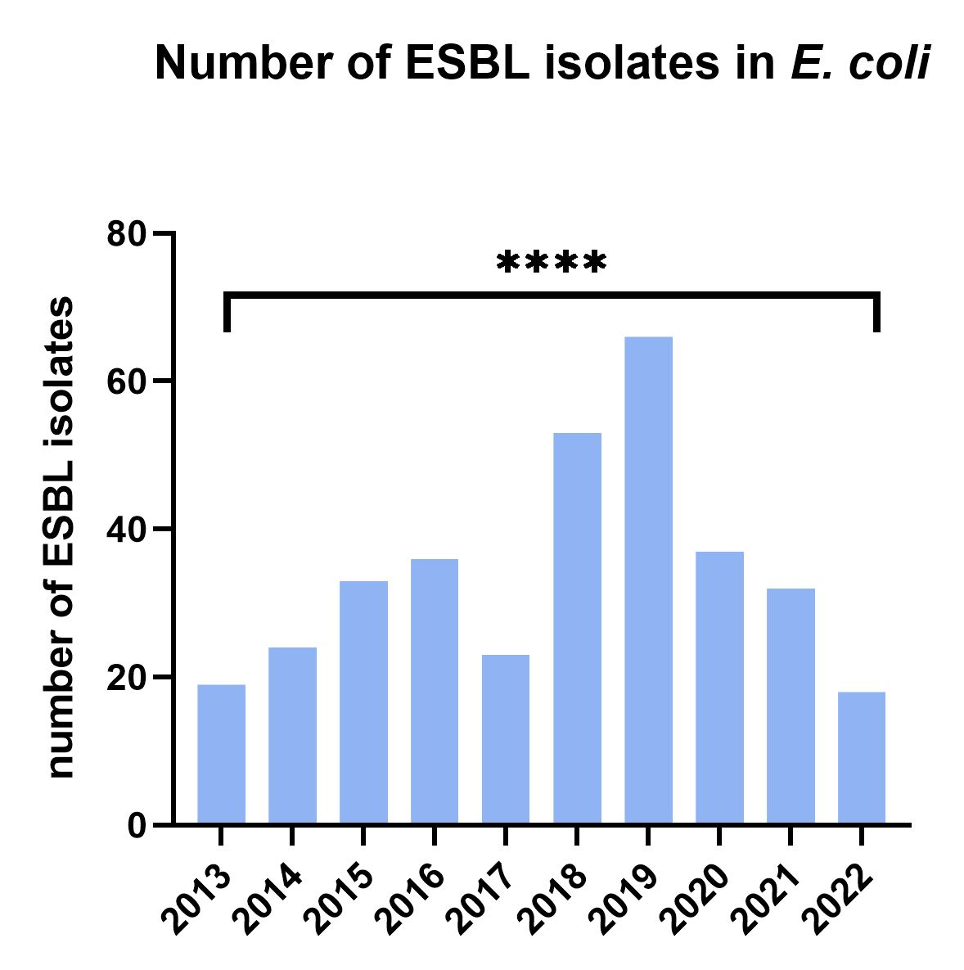
Supplementary Figure 3 ESBL isolates in E. coli 2013-2022
Significance: **** p < 0.0001 (chi-square test)

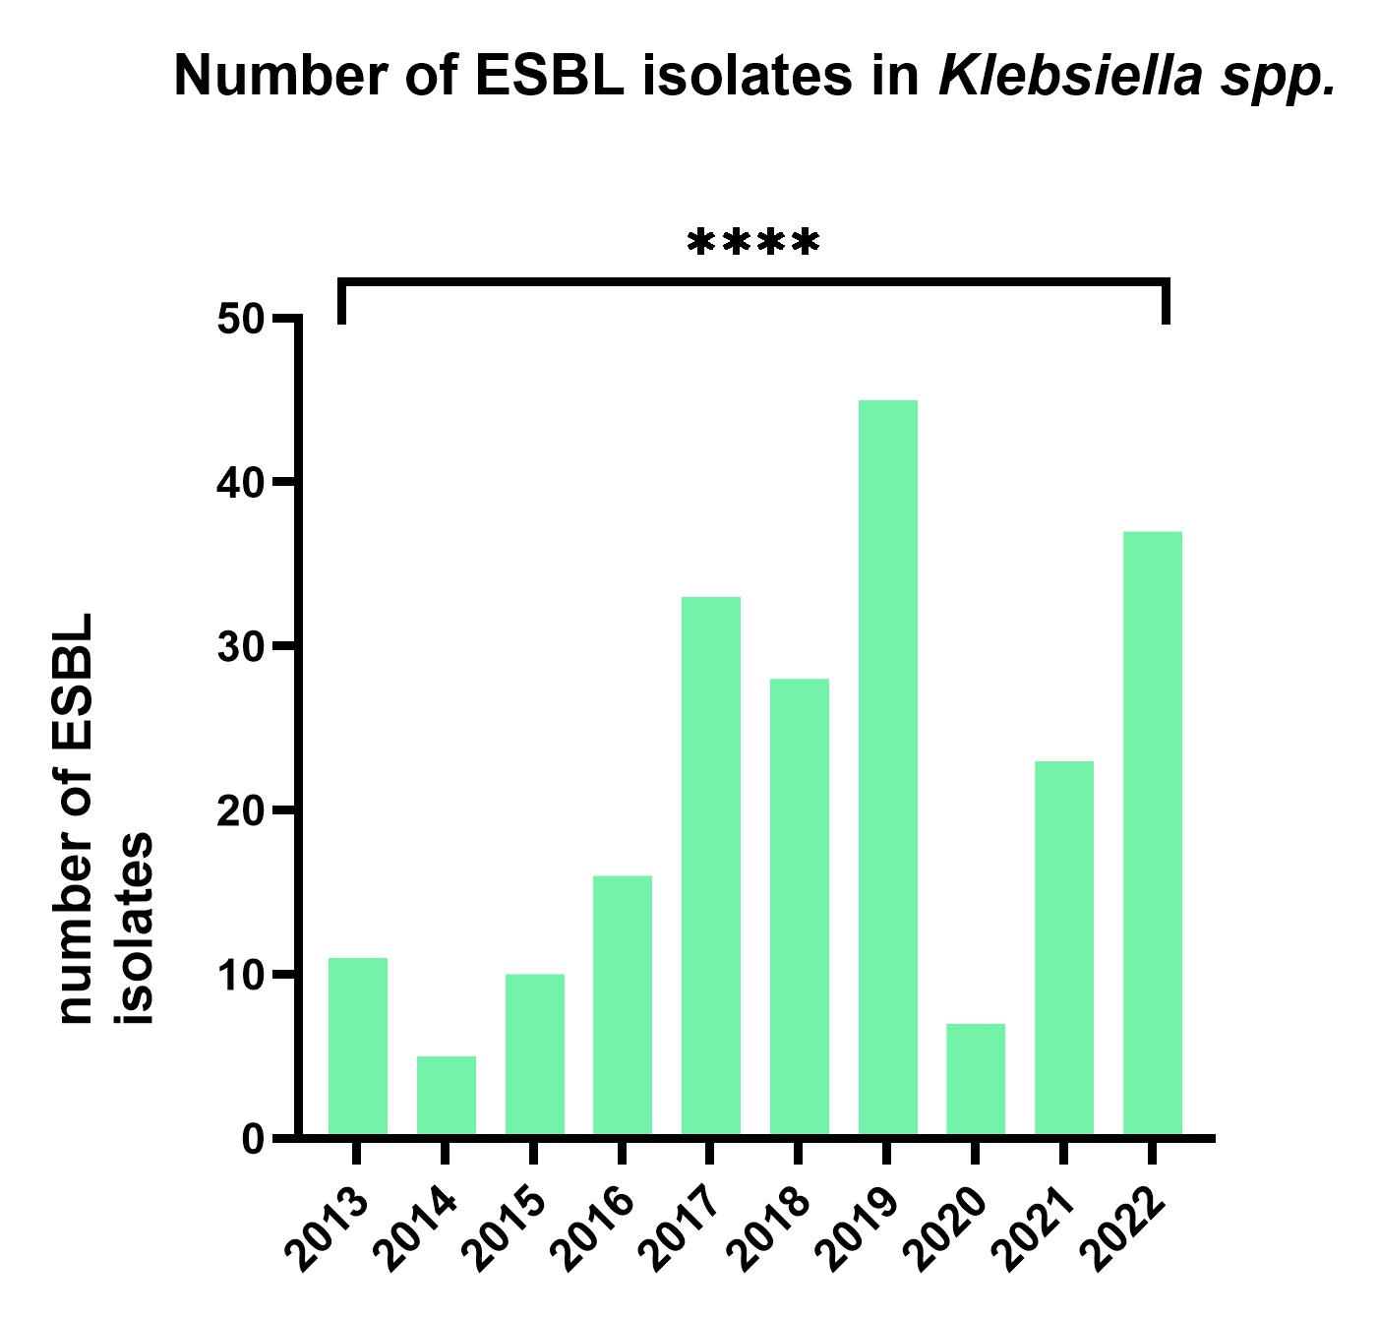
Supplementary Figure 4 ESBL isolates in Klebsiella ssp. 2013-2022
Significance: **** p < 0.0001 (chi-square test)

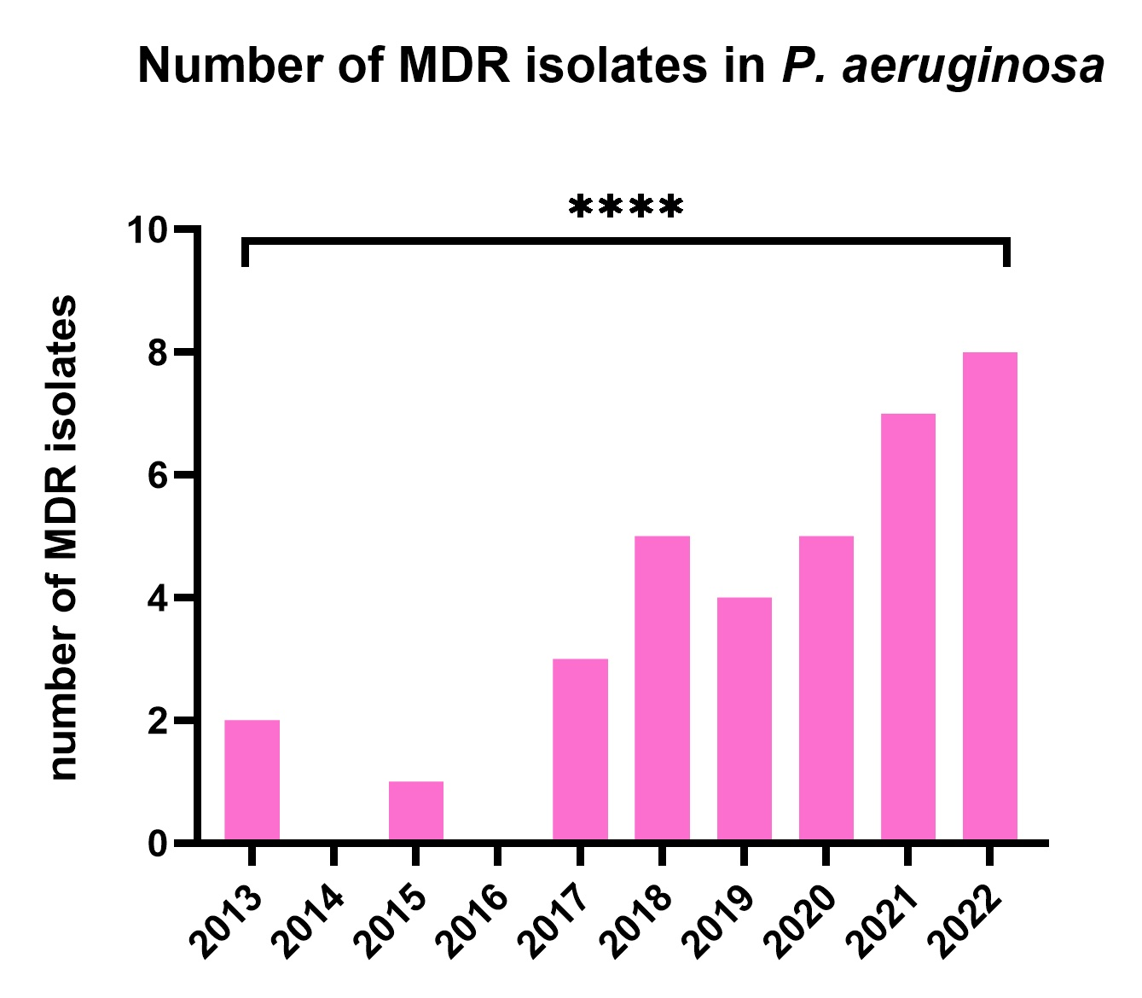
Supplementary Figure 5 MDR isolates in P. aeruginosa 2013-2022
Significance: **** p < 0.0001 (chi-square test)

Supplementary Table 2 Sepsis or pyelonephritis pathogens 2013-2022

