Title: Piperacillin/tazobactam versus carbapenems for 30-day mortality in patients with ESBL-producing Enterobacterales bloodstream infections: a retrospective, multicenter, non-inferiority, cohort study
Journal: Infection

Authors:
Thomas Sahlström Månsson^{1, 5}, Alice Askemyr⁴, Torgny Sunnerhagen^{3, 4}, Johan Tham^{2, 5}, Kristian Riesbeck^{3, 5}, Lisa Mellhammar^{2, 4}

Corresponding author: Thomas Sahlström Månsson
Phone number: +46 734 33 83 72
e-mail: Thomas.sahlstrom-mansson@med.lu.se
Postal address: Clinical Research Centre, CRC, plan 11,
Jan Waldenströms gata 35, 205 02 Malmö, Sweden
Orcid: 0000-0003-4696-4588

¹Department of Infectious Diseases, Sahlgrenska University Hospital, Gothenburg, Sweden.
²Department of Infectious Diseases, Skåne University Hospital, Malmö/Lund, Sweden.
³Clinical Microbiology, Infection Prevention and Control, Lund, Sweden.
⁴Department of Clinical Sciences Lund, division of Infection Medicine, Lund University, Lund, Sweden.
⁵Infectious Diseases and Clinical Microbiology, Department of Translational Medicine, Faculty of Medicine, Lund University, Malmö, Sweden.

Supplementary material
Supplementary Fig. 1 Standardized mean differences (SMD) for the propensity score (PS) matched empirical cohort
Supplementary Fig. 2 Distribution of propensity scores
Supplementary Table 1 Microbiology and antimicrobial therapy, by treatment group
Supplementary Table 2 Predictors of 30-day mortality, after univariate logistic regression analysis
Supplementary Table 3 Multivariate logistic regression analysis with the outcome 30-day mortality
Supplementary Fig. 3 Absolute risk difference and non-inferiority for the three cohorts, expressed as a forest plot
Supplementary Fig. 4 The estimated crude mortality for the background population for each treatment group, expressed as a forest plot
Supplementary Fig. 5 Kaplan-Meier curves showing survival probability between baseline and one year for both treatment groups
Supplementary Fig. 1 Standardized mean differences (SMD) for the propensity score (PS) matched empirical cohort
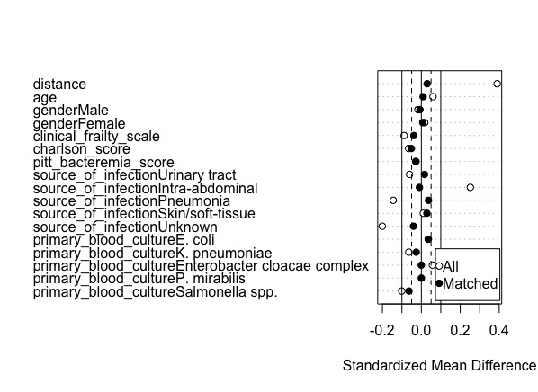
The SMD for each covariate before and after the PS matching process in the empirical therapy cohort. A caliper width of 0.2 standard deviations of the logit of the PS, along with the nearest-neighbor matching method, were used. Following matching, the SMD for each covariate should approach zero, indicating that the balance between the treatment groups (PTZ and carbapenem) has been successfully achieved.

Supplementary Fig. 2 Distribution of propensity scores
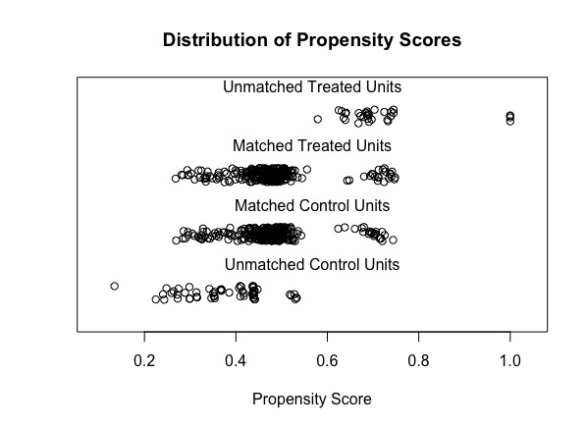
A jitter plot displaying the individual observations of each covariate in both the treatment (PTZ) and control (carbapenem) groups after matching. This plot visually represents the spread and overlap of propensity scores between the two groups, providing insight into the balance achieved through the matching process.

Supplementary Table 1 Microbiology and antimicrobial therapy, by treatment group
Variable | Carbapenem, N = 335ª | PTZ, N = 309ª | p^{b}
Primary blood culture^{c}
Escherichia coli | 299 (89) | 279 (90)
Klebsiella pneumoniae | 33 (9.9) | 25 (8.1)
Enterobacter cloacae complex | 0 (0) | 1 (0.3)
Proteus mirabilis | 0 (0) | 3 (1.0)
Salmonella spp. | 3 (0.9) | 1 (0.3)
Phenotypic resistance
ESBL_{A} | 303 (90) | 283 (92)
ESBL_{M} | 26 (7.8) | 22 (7.1)
ESBL_{A} and ESBL_{M}, or unknown | 6 (1.8) | 4 (1.3)
BLBLI resistance (EUCAST SIR interpretation)
S | 240 (73) | 259 (84)
I | 28 (8.5) | 15 (4.9)
R | 63 (19) | 33 (11)
Time to positive blood culture (hours) | 11 [9, 13] | 11 [9, 12] | 0.61
Clostridioides difficile | 8 (2.4) | 7 (2.3) | 0.92
Candidemia | 1 (0.3) | 0 (0) | >0.99
Oral candidiasis or candida in other culture than blood | 19 (5.7) | 10 (3.2) | 0.14
Time to effective antibiotics (hours) | 21 [1, 38] | 15 [1, 43] | 0.73
Days with PTZ | 0 [0, 0] | 4 [2, 6] | <0.001
Days with carbapenem | 8 [4, 11] | 0 [0, 7] | <0.001
Total effective IV treatment (days) | 8 [5, 11] | 6 [4, 10] | <0.001
Total effective oral treatment (days) | 0 [0, 7] | 5 [0, 8] | 0.006
Total effective antibiotics treatment (days) | 11 [10, 14] | 11 [9, 14] | 0.92
PTZ to carbapenem | 0 (0) | 99 (32) | <0.001
Escalation due to suspected therapy failure | 0 (0) | 17 (17)
Escalation due to antimicrobial resistance | 0 (0) | 36 (34)
ªN (%); Median [IQR]
^{b}Fisher's exact test; Pearson's Chi-squared test; Wilcoxon rank sum test
^{c}These were the only identified samples of EPE in this study

Supplementary Table 2 Predictors of 30-day mortality, after univariate logistic regression analysis
Variable | ORª | 95% CIª | p
Age (years) | 1.03 | 1.01, 1.06 | 0.002
Gender |  |  | 0.16
Male | — | —
Female | 1.50 | 0.85, 2.65
Charlson comorbidity index | 1.32 | 1.17, 1.49 | <0.001
Pitt bacteremia score |  |  | 0.001
<4 | — | —
≥4 | 3.64 | 1.72, 7.25
Lactate >2 (mmol/L) |  |  | 0.001
Yes | — | —
No | 0.30 | 0.13, 0.64
Missing | 1.07 | 0.57, 2.02
Primary blood culture |  |  | 0.64
Escherichia coli | — | —
Klebsiella pneumoniae | 0.82 | 0.24, 2.11
Enterobacter cloacae complex | 0.00
Proteus mirabilis | 5.52 | 0.25, 58.6
Salmonella spp. | 0.00
Phenotypic resistance |  |  | 0.44
ESBL_{A} | — | —
ESBL_{M} | 0.75 | 0.18, 2.15
ESBL_{A} and ESBL_{M}, or unknown | 2.80 | 0.42, 11.6
BLBI resistance (EUCAST SIR interpretation) |  |  | 0.37
S | — | —
I | 1.97 | 0.71, 4.66
R | 1.25 | 0.55, 2.58
Time to positivity (hours) | 0.95 | 0.88, 1.00 | 0.087
Hospital-acquired infection |  |  | 0.006
Yes | — | —
No | 0.39 | 0.21, 0.75
Source of infection |  |  | 0.25
Urinary tract | — | —
Intra-abdominal | 0.91 | 0.30, 2.20
Pneumonia | 1.27 | 0.07, 6.93
Skin/soft-tissue | 1.41 | 0.08, 7.84
Unknown | 2.45 | 1.13, 4.96
Source control |  |  | 0.17
Yes | — | —
No | 4.65 | 0.72, 37.2
Missing | 2.92 | 0.88, 18.2
Time to effective antibiotics (hours) | 0.99 | 0.98, 1.01 | 0.39
Treatment group |  |  | 0.87
Carbapenem | — | —
PTZ | 1.05 | 0.60, 1.84
ªOR = Odds Ratio, CI = Confidence Interval

Supplementary Table 3 Multivariate logistic regression analysis with the outcome 30-day mortality

Variable | ORª | 95% CIª | p
Age (years) | 1.02 | 1.00, 1.05 | 0.10
Gender |  |  | 0.016
Male | — | —
Female | 2.22 | 1.16, 4.33
Treatment group |  |  | 0.65
Carbapenem | — | —
PTZ | 1.16 | 0.61, 2.25
Charlson comorbidity index | 1.37 | 1.19, 1.59 | <0.001
Pitt bacteremia score |  |  | <0.001
<4 | — | —
≥4 | 4.74 | 2.04, 10.6
Hospital-acquired infection |  |  | 0.047
Yes | — | —
No | 0.43 | 0.20, 0.99
Time to positivity (hours) | 0.96 | 0.88, 1.00 | 0.086
ªOR = Odds Ratio, CI = Confidence Interval
A p<0.05 was considered statistically significant. Variables were chosen based on known predictors of 30-day mortality, while addressing potential multicollinearity. The relatively small number of patients meeting the primary outcome did not favor a relative risk calculation as the primary analysis.

Supplementary Fig. 3 Absolute risk difference and non-inferiority for the three cohorts, expressed as a forest plot

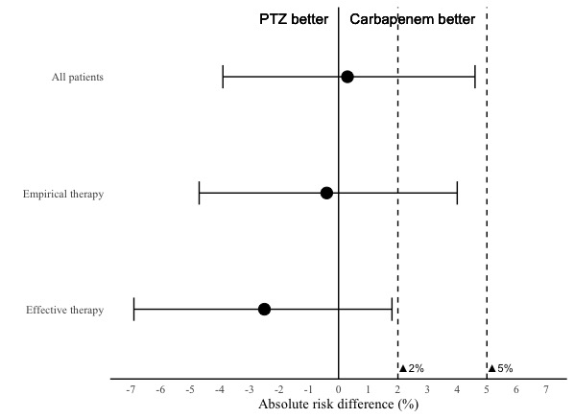

The dashed lines demonstrate the delta limits 2% and 5%. The horizontal lines represent the 95% CIs and the dot on each line represent the actual absolute risk difference.

Supplementary Fig. 4 The estimated crude mortality for the background population for each treatment group, expressed as a forest plot

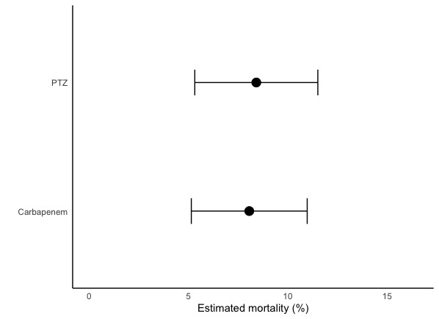
The horizontal lines represent the 95% CIs and the dot on each line represent the estimated mortality for each treatment group.

Supplementary Fig. 5 Kaplan-Meier curves showing survival probability between baseline and one year for both treatment groups
