Supplementary Figure 1

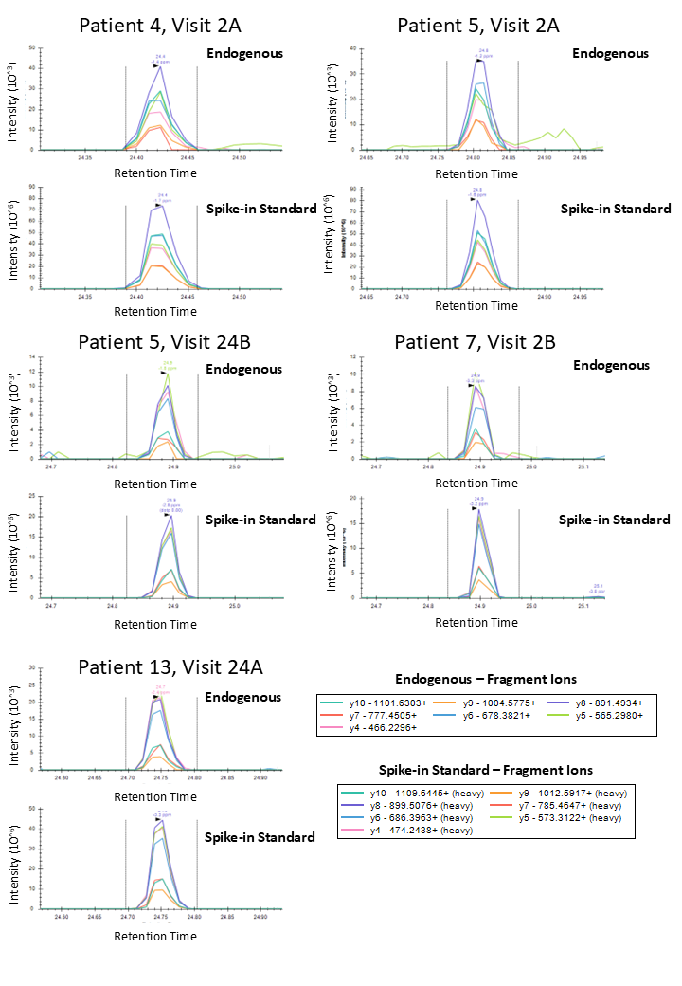

Supplementary Figure 1 legend
Spectral plots showing the endogenous Pp1ab peptide “GSLPINVIVFDGK” (top panel) in five representative EV samples from long COVID patients, verified by high-resolution targeted PRM assay on the Orbitrap Eclipse. The endogenous peptide co-elutes with the heavy stable isotope-labeled synthetic spike-in peptide (bottom panel) and shares the same fragmentation pattern. Each colored trace represents a distinct y-ion fragment from peptide fragmentation. PRM: Parallel reaction monitoring.

