Supplementary material
Supplementary Table 7 Calculations for Figure 1 Decision tree.
I | €5,212.78 = (6.2% $*$ €6,357.14) + (93.8% $*$€5,137.14)
II | €5,462.88 = (26.7% $*$ €6,357.14) + (73.3% $*$€5,137.14)
IIIa | €5,322.12 = (79.1% $*$ €5,121.78) + (13.4% $*$ €5,462.88) + (7.5% $*$ €6,357.14)
IIIb | €5,414.83 = (58.9% $*$ €5,121.78) + (30.0% $*$ €5,462.88) + (11.1% $*$ €6,357.14)

Supplementary Table 8 Key for ICD codes (18).
A41.0 | Sepsis caused by Staphylococcus aureus
A41.1 | Sepsis caused by other specified staphylococci
A41.2 | Sepsis caused by other non-specified staphylococci
A41.51 | Sepsis caused by other gram-negative pathogens: Escherichia coli [E. coli]
A41.52 | Sepsis caused by other gram-negative pathogens: Pseudomonas
A41.58 | Sepsis caused by other gram-negative pathogens: other gramnegative pathogens
A41.8 | Sepsis caused by other gram-negative pathogens: Escherichia coli [E. coli]
A41.9 | Other specified sepsis
N10 | Acute tubulointerstitial nephritis
N13.0 | Hydronephrosis caused by ureteropelvic obstruction
N13.1 | Hydronephrosis caused by ureteral stricture not elsewhere classified
N13.20 | Hydronephrosis due to obstruction caused by kidney stone
N13.21 | Hydronephrosis in obstruction caused by ureteral calculi
N13.29 | Hydronephrosis in obstruction caused by kidney and ureteral stone stone localisation unspecified
N13.3 | Other and unspecified hydronephrosis
N13.4 | Hydroureter
N13.5 | Kinking and stricture of the ureter without hydronephrosis
N13.60 | Hydronephrosis in ureteropelvic obstruction with infection of the kidney
N13.61 | Hydronephrosis caused by ureteral stricture not elsewhere classified with infection of the kidney
N13.62 | Hydronephrosis caused by obstruction due to kidney stone with infection of the kidney
N13.63 | Hydronephrosis caused by obstruction due to ureteral calculus with infection of the kidney
N13.64 | Hydronephrosis caused by obstruction due to kidney and ureteral stone, stone localisation unspecified, with infection of the kidney
N13.65 | Other and unspecified hydronephrosis with infection of kidney
N13.66 | Hydroureter with infection of kidney
N13.67 | Kinking and stricture of ureter without hydronephrosis with infection of kidney
N13.68 | Other and unspecified pyonephrosis
N13.7 | Uropathy in connection with vesicoureteral reflux
N13.8 | Other obstructive uropathy and reflux uropathy
N13.9 | Obstructive uropathy and reflux uropathy, not further specified
N17.01 | Acute renal failure with tubular necrosis, stadium 1
N17.02 | Acute renal failure with tubular necrosis, stadium 2
N17.03 | Acute renal failure with tubular necrosis, stadium 3
N17.09 | Acute renal failure with tubular necrosis, not further specified
N17.11 | Acute renal failure with cortical necrosis, stadium 1
N17.12 | Acute renal failure with cortical necrosis, stadium 2
N17.13 | Acute renal failure with cortical necrosis, stadium 3
N17.19 | Acute renal failure with cortical necrosis, not further specified
N17.21 | Acute renal failure with medullary necrosis, stadium 1
N17.22 | Acute renal failure with medullary necrosis, stadium 2
N17.23 | Acute renal failure with medullary necrosis, stadium 3
N17.29 | Acute renal failure with medullary necrosis, not further specified
N17.81 | Other acute renal failure, stadium 1
N17.82 | Other acute renal failure, stadium 2
N17.83 | Other acute renal failure, stadium 3
N17.89 | Other acute renal failure, not further specified
N17.91 | Acute renal failure, not further specified, stadium 1
N17.92 | Acute renal failure, not further specified, stadium 2
N17.93 | Acute renal failure, not further specified, stadium 3
N17.99 | Acute renal failure, not further specified, stadium not further specified
N30.3 | Sepsis, not further specified
N30.0 | Acute cystitis
N30.1 | Interstitial cystitis (chronic)
N30.2 | Trigonum cystitis
N30.8 | Other cystitis
N30.9 | Cystitis, not further specified
N39.0 | Urinary tract infection, localisation unspecified
N39.88 | Other specified diseases of the urinary system
R10.2 | Pelvic and perineal pain
R10.3 | Pain localised in other parts of the lower abdomen
R11 | Nausea and vomiting
R33 | Urinary retention
T83.5 | Infection and inflammatory reaction caused by prosthesis implant or transplant in the urinary tract

Supplementary Table 9 Key for OPS codes (19).
8-987.00 | Complex treatment for colonisation or infection with multidrug-resistant pathogens [MDR]: Complex treatment in a special isolation unit, up to 6 treatment days
8-987.01 | Complex treatment for colonisation or infection with multidrug-resistant pathogens [MDR]: Complex treatment in a special isolation unit, minimum 7 to maximum 13 treatment days
8-987.02 | Complex treatment for colonisation or infection with multidrug-resistant pathogens [MDR]: Complex treatment in a special isolation unit, minimum 14 to maximum 20 treatment days
8-987.03 | Complex treatment for colonisation or infection with multidrug-resistant pathogens [MDR]: Complex treatment in a special isolation unit, minimum 21 treatment days
8-987.10 | Complex treatment for colonisation or infection with multidrug-resistant pathogens [MDR]: Complex treatment in no special isolation unit, up to 6 treatment days
8-987.11 | Complex treatment for colonisation or infection with multidrug-resistant pathogens [MDR]: Complex treatment in no special isolation unit, minimum 7 to maximum 13 treatment days
8-987.12 | Complex treatment for colonisation or infection with multidrug-resistant pathogens [MDR]: Complex treatment in no special isolation unit, minimum 14 to maximum 20 treatment days
8-987.13 | Complex treatment for colonisation or infection with multidrug-resistant pathogens [MDR]: Complex treatment in no special isolation unit, minimum 21 treatment days

Supplementary Table 10 Queries for InEK DataBrowser (17).
No. | Main diagnosis | Secondary diagnosis I | Secondary diagnosis II | OPS
1 | N39.0 | N17.01, N17.02, N17.03, N17.09, N17.11, N17.12, N17.13, N17.19, N17.21, N17.22, N17.23, N17.29, N17.81, N17.82, N17.83, N17.89, N17.91, N17.92, N17.93, N17.99 | A41.0, A41.1, A41.2, A41.51, A41.52, A41.58, A41.8, A41.9 | 8-987.00, 8-987.01, 8-987.02, 8-987.03,  8-987.10, 8-987.11, 8-987.12, 8-987.13
2 | N39.0 | N17.01, N17.02, N17.03, N17.09, N17.11, N17.12, N17.13, N17.19, N17.21, N17.22, N17.23, N17.29, N17.81, N17.82, N17.83, N17.89, N17.91, N17.92, N17.93, N17.99 | R10.2, R10.3 | 8-987.00, 8-987.01, 8-987.02, 8-987.03,  8-987.10, 8-987.11, 8-987.12, 8-987.13
3 | N39.0 | N17.01, N17.02, N17.03, N17.09, N17.11, N17.12, N17.13, N17.19, N17.21, N17.22, N17.23, N17.29, N17.81, N17.82, N17.83, N17.89, N17.91, N17.92, N17.93, N17.99 | T83.5 | 8-987.00, 8-987.01, 8-987.02, 8-987.03,  8-987.10, 8-987.11, 8-987.12, 8-987.13
4 | N39.0 | N17.01, N17.02, N17.03, N17.09, N17.11, N17.12, N17.13, N17.19, N17.21, N17.22, N17.23, N17.29, N17.81, N17.82, N17.83, N17.89, N17.91, N17.92, N17.93, N17.99 | R11 | 8-987.00, 8-987.01, 8-987.02, 8-987.03,  8-987.10, 8-987.11, 8-987.12, 8-987.13
5 | N39.0 | A41.0, A41.1, A41.2, A41.51, A41.52, A41.58, A41.8, A41.9 | R10.2, R10.3 | 8-987.00, 8-987.01, 8-987.02, 8-987.03,  8-987.10, 8-987.11, 8-987.12, 8-987.13
6 | N39.0 | A41.0, A41.1, A41.2, A41.51, A41.52, A41.58, A41.8, A41.9 | T83.5 | 8-987.00, 8-987.01, 8-987.02, 8-987.03,  8-987.10, 8-987.11, 8-987.12, 8-987.13
7 | N39.0 | A41.0, A41.1, A41.2, A41.51, A41.52, A41.58, A41.8, A41.9 | R11 | 8-987.00, 8-987.01, 8-987.02, 8-987.03,  8-987.10, 8-987.11, 8-987.12, 8-987.13
8 | N39.0 | R10.2 / R10.3 | T83.5 | 8-987.00, 8-987.01, 8-987.02, 8-987.03,  8-987.10, 8-987.11, 8-987.12, 8-987.13
9 | N39.0 | R10.2 / R10.3 | R11 | 8-987.00, 8-987.01, 8-987.02, 8-987.03,  8-987.10, 8-987.11, 8-987.12, 8-987.13
10 | N39.0 | T83.5 | R11 | 8-987.00, 8-987.01, 8-987.02, 8-987.03,  8-987.10, 8-987.11, 8-987.12, 8-987.13
11 | N39.0 | R33 | N17.01, N17.02, N17.03, N17.09, N17.11, N17.12, N17.13, N17.19, N17.21, N17.22, N17.23, N17.29, N17.81, N17.82, N17.83, N17.89, N17.91, N17.92, N17.93, N17.99 | 8-987.00, 8-987.01, 8-987.02, 8-987.03,  8-987.10, 8-987.11, 8-987.12, 8-987.13
12 | N39.0 | R33 | A41.0, A41.1, A41.2, A41.51, A41.52, A41.58, A41.8, A41.9 | 8-987.00, 8-987.01, 8-987.02, 8-987.03,  8-987.10, 8-987.11, 8-987.12, 8-987.13
13 | N39.0 | R33 | R10.2, R10.3 | 8-987.00, 8-987.01, 8-987.02, 8-987.03,  8-987.10, 8-987.11, 8-987.12, 8-987.13
14 | N39.0 | R33 | T83.5 | 8-987.00, 8-987.01, 8-987.02, 8-987.03,  8-987.10, 8-987.11, 8-987.12, 8-987.13
15 | N39.0 | R33 | R11 | 8-987.00, 8-987.01, 8-987.02, 8-987.03,  8-987.10, 8-987.11, 8-987.12, 8-987.13
16 | N39.0 | N13.0, N13.1, N13.20, N13.21, N13.29, N13.3, N13.4, N13.60, N13.61, N13.62, N13.63, N13.64, N13.65, N13.66, N13.67, N13.68, N13.7, N13.8, N13.9 | N17.01, N17.02, N17.03, N17.09, N17.11, N17.12, N17.13, N17.19, N17.21, N17.22, N17.23, N17.29, N17.81, N17.82, N17.83, N17.89, N17.91, N17.92, N17.93, N17.99 | 8-987.00, 8-987.01, 8-987.02, 8-987.03,  8-987.10, 8-987.11, 8-987.12, 8-987.13
17 | N39.0 | N13.0, N13.1, N13.20, N13.21, N13.29, N13.3, N13.4, N13.60, N13.61, N13.62, N13.63, N13.64, N13.65, N13.66, N13.67, N13.68, N13.7, N13.8, N13.9 | A41.0, A41.1, A41.2, A41.51, A41.52, A41.58, A41.8, A41.9 | 8-987.00, 8-987.01, 8-987.02, 8-987.03,  8-987.10, 8-987.11, 8-987.12, 8-987.13
18 | N39.0 | N13.0, N13.1, N13.20, N13.21, N13.29, N13.3, N13.4, N13.60, N13.61, N13.62, N13.63, N13.64, N13.65, N13.66, N13.67, N13.68, N13.7, N13.8, N13.9 | R10.2 / R10.3 | 8-987.00, 8-987.01, 8-987.02, 8-987.03,  8-987.10, 8-987.11, 8-987.12, 8-987.13
19 | N39.0 | N13.0, N13.1, N13.20, N13.21, N13.29, N13.3, N13.4, N13.60, N13.61, N13.62, N13.63, N13.64, N13.65, N13.66, N13.67, N13.68, N13.7, N13.8, N13.9 | T83.5 | 8-987.00, 8-987.01, 8-987.02, 8-987.03,  8-987.10, 8-987.11, 8-987.12, 8-987.13
20 | N39.0 | N13.0, N13.1, N13.20, N13.21, N13.29, N13.3, N13.4, N13.60, N13.61, N13.62, N13.63, N13.64, N13.65, N13.66, N13.67, N13.68, N13.7, N13.8, N13.9 | R11 | 8-987.00, 8-987.01, 8-987.02, 8-987.03,  8-987.10, 8-987.11, 8-987.12, 8-987.13
21 | N39.0 | N10, N39.88 | N17.01, N17.02, N17.03, N17.09, N17.11, N17.12, N17.13, N17.19, N17.21, N17.22, N17.23, N17.29, N17.81, N17.82, N17.83, N17.89, N17.91, N17.92, N17.93, N17.99 | 8-987.00, 8-987.01, 8-987.02, 8-987.03,  8-987.10, 8-987.11, 8-987.12, 8-987.13
22 | N39.0 | N10, N39.88 | A41.0, A41.1, A41.2, A41.51, A41.52, A41.58, A41.8, A41.9 | 8-987.00, 8-987.01, 8-987.02, 8-987.03,  8-987.10, 8-987.11, 8-987.12, 8-987.13
23 | N39.0 | N10, N39.88 | R10.2, R10.3 | 8-987.00, 8-987.01, 8-987.02, 8-987.03,  8-987.10, 8-987.11, 8-987.12, 8-987.13
24 | N39.0 | N10, N39.88 | T83.5 | 8-987.00, 8-987.01, 8-987.02, 8-987.03,  8-987.10, 8-987.11, 8-987.12, 8-987.13
25 | N39.0 | N10, N39.88 | R11 | 8-987.00, 8-987.01, 8-987.02, 8-987.03,  8-987.10, 8-987.11, 8-987.12, 8-987.13
26 | N39.0 | A41.0, A41.1, A41.2, A41.51, A41.52, A41.58, A41.8, A41.9, N10,  N13.0, N13.1, N13.20, N13.21, N13.29, N13.3, N13.4, N13.60, N13.61, N13.62, N13.63, N13.64, N13.65, N13.66, N13.67, N13.68, N13.7, N13.8, N13.9,  N17.01, N17.02, N17.03, N17.09, N17.11, N17.12, N17.13, N17.19, N17.21, N17.22, N17.23, N17.29, N17.81, N17.82, N17.83, N17.89, N17.91, N17.92, N17.93, N17.99,  N30.0, N30.1, N30.2, N30.3, N30.8, N30.9,  N39.88,  R10.2, R10.3,  R11,  R33,  T83.5 | U81.40, U81.41, U81.42, U81.43, U81.44, U81.45, U81.46, U81.47, U81.48, U81.50, U81.51 | -/-

Table 11 Probabilities for decision-tree sensitivity analysis.
 | Clinical cure AND microbiological eradication |  | Clinical cure AND microbiological persistence |  | NO clinical cure AND microbiological persistence
Cefepime/ enmetazobactam | 79.1% |  | 13.4% |  | 7.5%
Piperacillin/ tazobactam | 58.9% |  | 30.0% |  | 11.1%
 | 5.1% | 94.9% | 17.5% | 72.5% | 100% | 0%
 | Clinical relapse | No relapse/ readmission | Clinical relapse | No relapse/ readmission | Clinical relapse | No relapse/ readmission

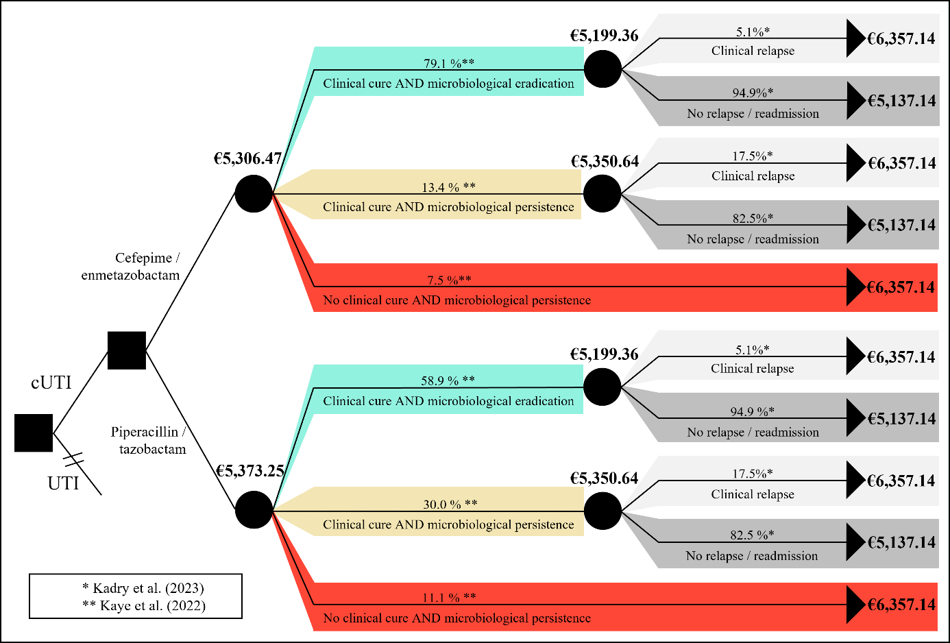
Supplementary Figure 2 Decision tree sensitivity analysis.

Supplementary Table 12 Calculations for Figure 2 Decision tree sensitivity analysis.
I | €5,199.36 = (5.1% $*$ €6,357.14) + (94.9% $*$€5,137.14)
II | €5,350.64 = (17.5% $*$ €6,357.14) + (82.5% $*$€5,137.14)
IIIa | €5,306.47 = (79.1% $*$ €5,199.36) + (13.4% $*$ €5,350.64) + (7.5% $*$ €6,357.14)
IIIb | €5,373.25 = (58.9% $*$ €5,199.36) + (30.0% $*$ €5,350.63) + (11.1% $*$ €6,357.14)

