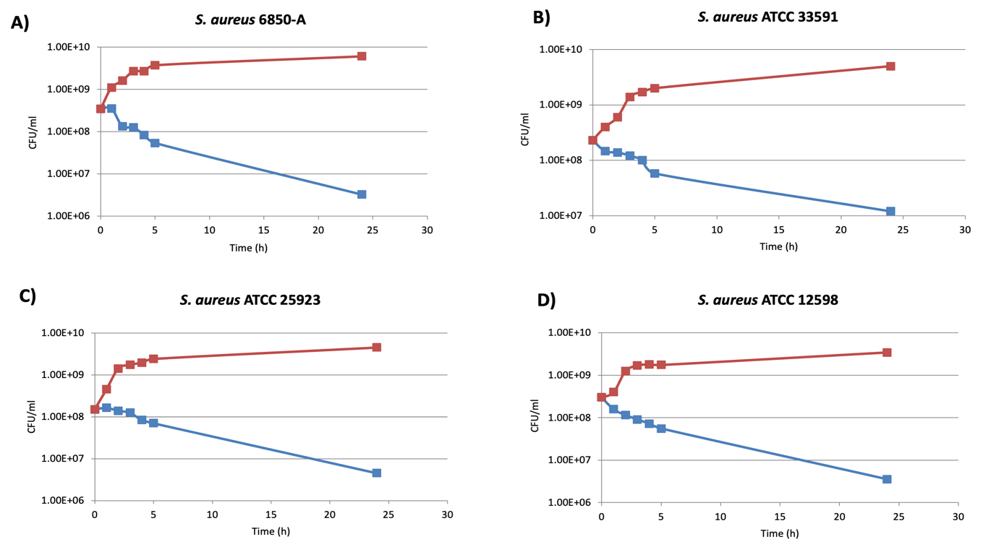
Supplementary Figure 1: Time-kill kinetics of Corallopyronin A against four Staphylococcus aureus strains (A) S. aureus 6850A, (B) ATCC 33591, (C) ATCC 25923, and (D) ATCC 12598). Bacterial cultures were exposed to CorA at 2 µg/mL (blue curves), corresponding to 4 × MIC for all strains (Table 1 & 2). Untreated control cultures are shown in red. Viable counts (CFU/mL) were determined at the indicated time points over 24 h of incubation at 37 °C. The data shown are representative of three independent experiments.

