Supplementary Material

Supplementary Fig. 1. Geographic location of the primary care centers that recruited PMR patients to the study
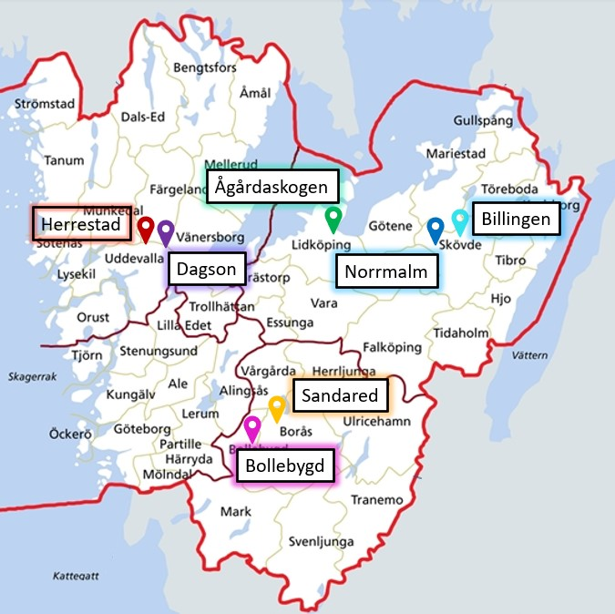
The seven primary care clinics in the Västra Götaland Region of Sweden that recruited PMR patients were Närhälsan vårdcentral of Norrmalm, Billingen, Herrestad, Dagson, Sandared, Ågårdskogen and Bollebygd.
Symptoms | Co-morbidities
Achilles tendon rupture | Diabetes
Arm pain | Heart disease
Back pain | Hematologic disorder
Bruising due to corticosteroid treatment | History of thrombosis
Chills | History of heart disease
Cold feet | Immunodeficiency
Constipation | Kidney disease
Cramps in calves and feet | Previously treated for cancer
Depression | Pulmonary disease
Difficulty initiating movement, slow motor function | Skin disease
Dizziness
Dry eyes
Easily stumbles, weakness
Eyes watering
Fatigue
Feeling unwell
Feeling warm (especially at night)
Fever
Fragile skin
Headache
High blood pressure
Lack of energy / fatigue
Leg cramps / Calf cramps during walking
Mental fatigue / brain fog
Morning stiffness
Movement pain
Muscle weakness / Weakness in arms, pelvis and legs
Nausea
Neck pain
Night sweats
Nocturnal pain
Numbness in legs and feet
Pain reduced with pain medication
Palpitations
Pelvic pain
Poor appetite
Rash
Restless legs
Severe cramps (legs, hands)
Shoulder pain
Stiffness
Sweating (mostly in the evening)
Swelling (feet, hands, eyelids, etc.)
Temporal arteritis
Thigh pain
Thin skin
Weakness (Fatigue due to all symptoms)
Worsened cataract

Supplementary Table 1. Symptoms and co-morbidities of PMR patients

Supplementary Table 2. Inflammatory markers and antibodies analyzed in serum samples
Cytokines | Inflammatory profile  at diagnosis of PMR | Antibodies
Angiopoietin-1 | B-Hemoglobin | Cytosolic AECA IgG
Angiopoietin-2 | WBC | Cytosolic AECA IgM
CXCL8 - Cytokine C-X-C motif chemokine ligand 8 | B-Platelets | Membrane AECA IgG
Cystatin C | S-C-reactive protein | Membrane AECA IgM
EGF - Epidermal Growth Factor | S-Albumin | Borrelia IgG
FGF-basic - Fibroblast Growth Factor basic | S-Antitrypsin | Borrelia IgM
TGF-β - Transforming Growth Factor Beta | S-Haptoglobin | N. mikurensis IgG
GM-CSF - Granulocyte-Macrophage Colony-Stimulating Factor | S-IgA | N. mikurensis IgM
ICAM-1 - Intercellular Adhesion Molecule 1 | S-IgG
IFN-α2 - Interferon Alpha-2 | S-IgM
IFN-β - Interferon Beta | S-Orosomucoid
IFN-γ - Interferon Gamma | ESR
IFN-λ1 - Interferon Lambda 1
IFN-λ2/3 - Interferon Lambda 2/3
IGFBP-4 - Insulin-like Growth Factor Binding Protein 4
IL-10 - Interleukin-10
IL-12p70 - Interleukin-12 p70
IL-17A - Interleukin-17A
IL-1β - Interleukin-1 Beta
IL-2 - Interleukin-2
IL-4 - Interleukin-4
IL-6 - Interleukin-6
IL-8 - Interleukin-8 (also known as CXCL8)
IP-10 - Interferon gamma-induced protein 10
MCP-1 - Monocyte Chemoattractant Protein-1
MMP-2 - Matrix Metalloproteinase-2
MMP-9 - Matrix Metalloproteinase-9
MPO - Myeloperoxidase
MRP8/14 - Myeloid-related Protein 8/14
Myoglobin
NGAL - Neutrophil Gelatinase-Associated Lipocalin
OPN - Osteopontin
PECAM-1 - Platelet Endothelial Cell Adhesion Molecule-1
PlGF - Placental Growth Factor
SAA - Serum Amyloid A
TNF-α - Tumor Necrosis Factor Alpha
VCAM-1 - Vascular Cell Adhesion Molecule-1
VEGF - Vascular Endothelial Growth Factor

