Figure S1. Age distribution across study groups. Individual data points represent participant age in years, stratified by clinical cohort. Central horizontal lines indicate the median, and error bars represent the IQR

Figure S2. Distribution of CDC states across cohorts.
Stacked bar chart showing the proportional composition of CDC stages in each cohort. Each colored segment represents a distinct immune cell population, illustrating differences in immune cell distribution between the four study groups.

Figure S3. Distribution of values across three study groups (neurosyphilis, syphilis, and serological scar). Individual data points are shown as colored dots. The neurosyphilis group demonstrates higher and more widely distributed values compared with the syphilis and serological scar groups, which show lower and more clustered distributions. Central horizontal lines indicate the median, and error bars represent the IQR.

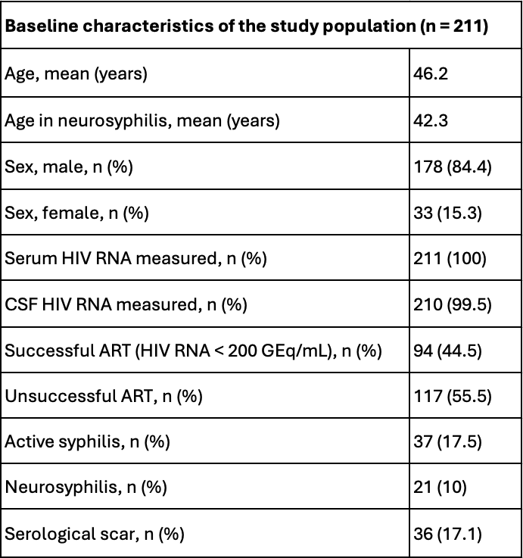
Table S1. Baseline characteristics of the study population.
This table summarizes demographic, laboratory, and treatment-related characteristics of the study cohort (N = 211).

