S1. ROC analysis showing optimal cut-off point for diagnostic delay

S2. Coordinates of the ROC curve

Test Result Variable(s): Duration from symptoms to diagnosis of malaria (days)
Positive if greater than or equal to | Sensitivity | 1 - Specificity | Youden's Index
.0000 | 1.000 | 1.000 | .000
1.5000 | .981 | .982 | .000
2.5000 | .981 | .939 | .042
3.5000 | .926 | .797 | .129
4.5000 | .704 | .564 | .140
5.5000 | .593 | .397 | .196
6.5000 | .463 | .270 | .193
7.5000 | .278 | .212 | .066
8.5000 | .148 | .148 | .000
9.5000 | .093 | .127 | -.035
10.5000 | .056 | .115 | -.060
11.5000 | .056 | .097 | -.041
13.0000 | .056 | .094 | -.038
14.5000 | .056 | .073 | -.017
15.5000 | .019 | .048 | -.030
16.5000 | .019 | .042 | -.024
17.5000 | .019 | .039 | -.021
19.0000 | .019 | .033 | -.015
22.0000 | .019 | .024 | -.006
24.5000 | .019 | .021 | -.003
27.0000 | .000 | .021 | -.021
29.5000 | .000 | .018 | -.018
33.5000 | .000 | .006 | -.006
50.5000 | .000 | .003 | -.003
65.0000 | .000 | .000 | .000

S3. Distribution of care-seeking delay, medical diagnostic delay, total diagnostic delay, and treatment delay among Thai and non-Thai patients

Delay | Distribution and mean ranks | Mann-Whitney U, p-value
Care-seeking delay | 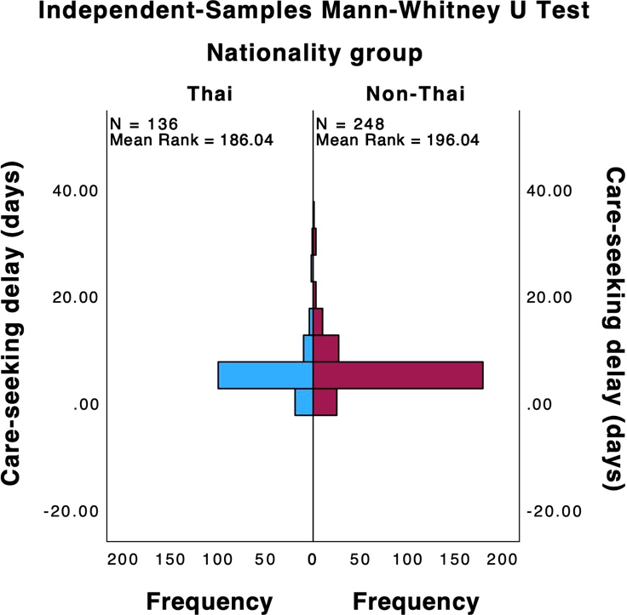 | Mann-Whitney U = 17,742.50, p = 0.393
Medical diagnostic delay | 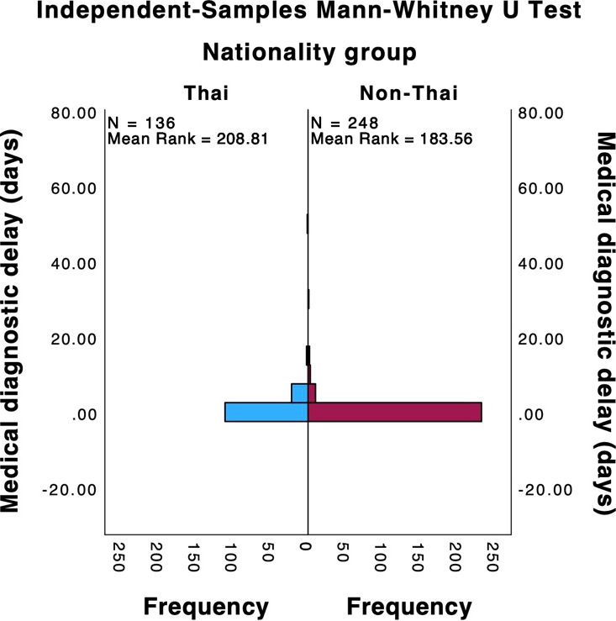 | Mann-Whitney U = 14,646.50, p = 0.003
Total diagnostic delay | 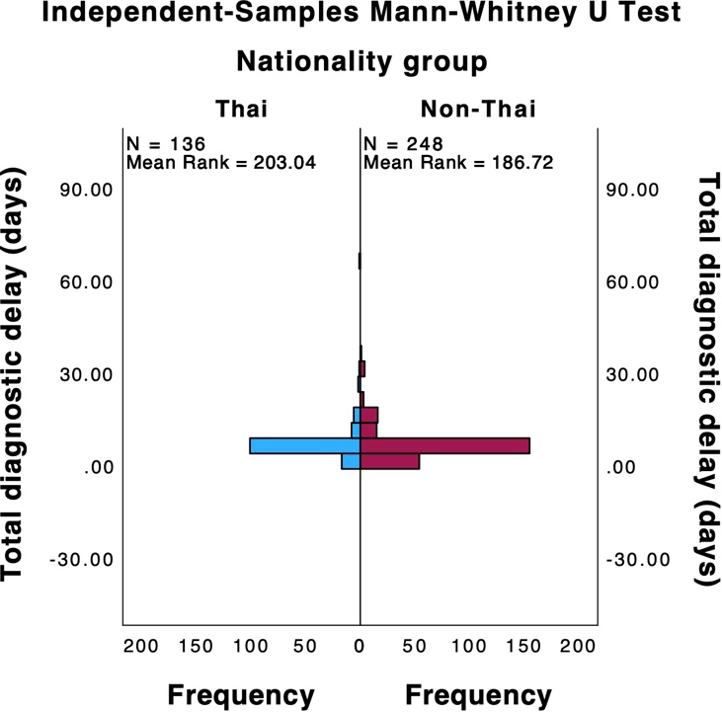 | Mann-Whitney U = 15,431.00, p = 0.164
Treatment delay | 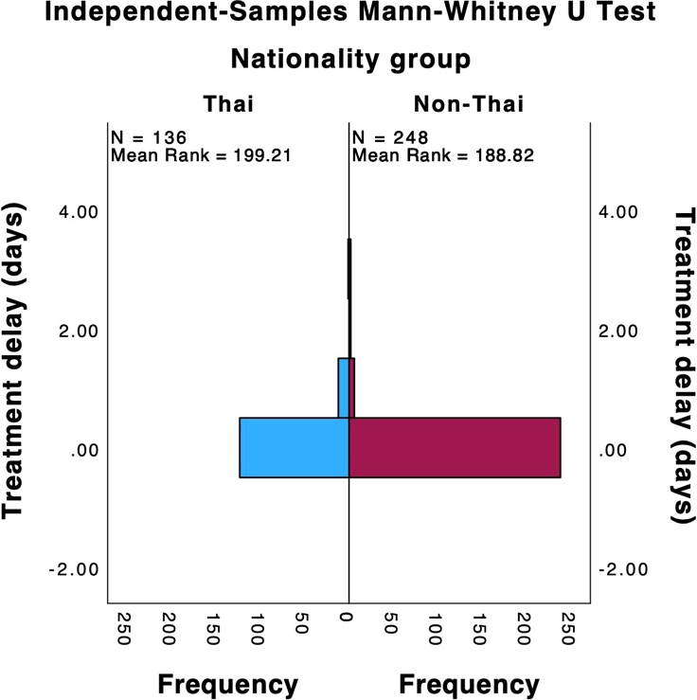 | Mann-Whitney U = 15,952.00, p = 0.033

S4. Multicollinearity test results

Model | Collinearity Statistics
Model | Tolerance | VIF
Age | .742 | 1.348
Prior history of malaria infection | .914 | 1.094
Nationality | .402 | 2.486
Body temperature | .903 | 1.107
Purpose of travel | .649 | 1.541
First medical visit | .630 | 1.587
Country of malaria acquisition | .727 | 1.376
Headache | .823 | 1.215
Occupation | .603 | 1.658
Initial diagnosis | .654 | 1.529

S5. Univariable and multivariable logistic regression of factors associated with P. vivax total diagnostic delay (> 4 days) in Hospital for Tropical Diseases, Bangkok, Thailand.

Variable | Total diagnostic delay (> 4 days) |  | OR (95% CI) | P-value | Adjusted OR (95% CI) | P-value
Variable | No  n (%) | Yes  n (%)
Gender
Male | 136 (85.0) | 190 (84.8) | Reference
Female | 24 (15.0) | 34 (15.2) | 1.01 (0.58-1.79) | 0.962
Age (years)
15-24 | 77 (48.1) | 75 (33.5) | Reference |  | Reference
25-34 | 42 (26.3) | 67 (29.9) | 1.64 (0.99-2.70) | 0.053 | 1.63 (0.93-2.84) | 0.088
35-44 | 23 (14.4) | 40 (17.9) | 1.79 (0.98-3.27) | 0.060 | 1.63 (0.82-3.24) | 0.166
45-54 | 11 (6.9) | 24 (10.7) | 2.24 (1.03-4.89) | 0.043 | 2.79 (1.12-6.94) | 0.027*
≥ 55 | 7 (4.4) | 18 (8.0) | 2.64 (1.04-6.69) | 0.041 | 2.61 (0.81-8.42) | 0.110
Nationality
Thai | 47 (29.4) | 89 (39.7) | Reference |  | Reference
Migrants ^{A} | 113 (70.6) | 135 (60.3) | 0.63 (0.41-0.97) | 0.037 | 1.43 (0.64-3.18) | 0.384
Occupation
Laborer/agriculturist/farmer | 120 (75.0) | 138 (61.6) | Reference |  | Reference
Employee/office worker/business owner | 24 (15.0) | 54 (24.1) | 4.64 (1.32-16.30) | 0.017 | 4.93 (1.19-20.50) | 0.028*
Worker in forested areas ^{B} | 3 (1.9) | 16 (7.1) | 1.96 (1.14-3.36) | 0.015 | 1.21 (0.57-2.56) | 0.627
Unemployed | 13 (8.1) | 16 (7.1) | 1.07 (0.50-2.32) | 0.863 | 0.66 (0.24-1.82) | 0.424
Having comorbidities
No | 148 (92.5) | 202 (90.2) | Reference
Yes ^{C} | 12 (7.5) | 22 (9.8) | 1.34 (0.64-2.80) | 0.431
Prior history of malaria infection
≥ 2 times | 42 (26.3) | 28 (12.5) | Reference |  | Reference
1 time | 56 (35.0) | 63 (28.1) | 1.69 (0.93-3.07) | 0.087 | 1.71 (0.89-3.31) | 0.110
No prior history of malaria | 45 (28.1) | 101 (45.1) | 3.22 (1.83-5.66) | < 0.001 | 2.36 (1.26-4.42) | 0.008*
Country of P. vivax malaria acquisition
Thailand | 98 (61.3) | 128 (57.1) | Reference |  | Reference
Myanmar | 23 (14.4) | 48 (21.4) | 1.60 (0.91-2.80) | 0.102 | 1.59 (0.81-3.15) | 0.180
Lao | 22 (13.8) | 33 (14.7) | 1.15 (0.63-2.09) | 0.651 | 1.44 (0.69-3.03) | 0.334
Cambodia | 15 (9.4) | 12 (5.4) | 0.61 (0.27-1.37) | 0.232 | 0.56 (0.21-1.52) | 0.256
Others ^{D} | 2 (1.3) | 3 (1.3) | 1.15 (0.19-7.01) | 0.881 | 0.73 (0.08-6.70) | 0.783
Purpose of travel to/stay in malaria endemic areas
No travel history (living in endemic areas) | 119 (74.4) | 125 (55.8) | Reference |  | Reference
Visiting friends and relatives | 19 (11.9) | 41 (18.3) | 2.05 (1.13-3.74) | 0.019 | 1.30 (0.65-2.59) | 0.456
Tourism | 12 (7.5) | 37 (16.5) | 2.94 (1.46-5.90) | 0.002 | 2.18 (0.83-5.69) | 0.113
Work | 10 (6.3) | 21 (9.4) | 2.00 (0.90-4.42) | 0.087 | 1.49 (0.53-4.16) | 0.446
Body temperature (ºC)
< 38.0 | 122 (76.3) | 152 (67.9) | Reference |  | Reference
≥ 38.0 | 28 (23.8) | 72 (32.1) | 1.52 (0.96-2.41) | 0.074 | 1.35 (0.79-2.29) | 0.269
Respiratory rate (times/min)
≤ 20 | 101 (63.1) | 153 (68.3) | Reference
> 20 | 59 (36.9) | 71 (31.7) | 0.79 (0.52-1.22) | 0.291
Blood pressure (mmHg)
≥ 90/60 | 152 (95.0) | 218 (97.3) | Reference
< 90/60 | 8 (5.0) | 6 (2.7) | 0.52 (0.18-1.54) | 0.239
Pulse rate (beats per minute)
≤ 100 | 131 (81.9) | 177 (79.0) | Reference
> 100 | 29 (18.1) | 47 (21.0) | 1.20 (0.72-2.01) | 0.489
Initial symptoms ^{E}
Chill
No | 19 (11.9) | 31 (13.8) | Reference
Yes | 141 (88.1) | 193 (86.2) | 0.84 (0.46-1.55) | 0.573
Myalgia
No | 68 (42.5) | 98 (43.8) | Reference
Yes | 92 (57.5) | 126 (56.3) | 0.95 (0.63-1.43) | 0.807
Headache
No | 64 (40.0) | 112 (50.0) | Reference |  | Reference
Yes | 96 (60.0) | 112 (50.0) | 0.67 (0.44-1.01) | 0.053 | 0.90 (0.55-1.48) | 0.675
Loss of appetite
No | 93 (58.1) | 133 (59.4) | Reference
Yes | 67 (41.9) | 91 (40.6) | 0.95 (0.63-1.43) | 0.806
Weakness/fatigue
No | 108 (67.5) | 148 (66.1) | Reference
Yes | 52 (32.5) | 76 (33.9) | 1.07 (0.69-1.64) | 0.770
Nausea
No | 104 (65.0) | 156 (69.6) | Reference
Yes | 56 (35.0) | 68 (30.4) | 0.81 (0.53-1.25) | 0.338
Vomiting
No | 131 (81.9) | 178 (79.5) | Reference
Yes | 29 (18.1) | 46 (20.5) | 1.17 (0.70-1.96) | 0.557
Hepatosplenomegaly
No | 133 (83.1) | 183 (81.7) | Reference
Yes | 27 (16.9) | 41 (18.3) | 1.10 (0.65-1.88) | 0.718
Dizziness
No | 131 (81.9) | 189 (84.4) | Reference
Yes | 29 (18.1) | 35 (15.6) | 0.84 (0.49-1.44) | 0.517
Jaundice
No | 137 (85.6) | 193 (86.2) | Reference
Yes | 23 (14.4) | 31 (13.8) | 0.96 (0.54-1.71) | 0.882
Abdominal pain
No | 139 (86.9) | 199 (88.8) | Reference
Yes | 21 (13.1) | 25 (11.2) | 0.83 (0.45-1.55) | 0.559
Diarrhea
No | 152 (95.0) | 210 (93.8) | Reference
Yes | 8 (5.0) | 14 (6.3) | 1.27 (0.52-3.10) | 0.604
Pallor
No | 156 (97.5) | 213 (95.1) | Reference
Yes | 4 (2.5) | 11 (4.9) | 2.01 (0.63-6.44) | 0.238
Sweating
No | 157 (98.1) | 217 (96.9) | Reference
Yes | 3 (1.9) | 7 (3.1) | 1.69 (0.43-6.63) | 0.453
Shortness of breath
No | 157 (98.1) | 217 (96.9) | Reference
Yes | 3 (1.9) | 7 (3.1) | 1.69 (0.43-6.63) | 0.453
Oliguria/anuria
No | 155 (96.9) | 220 (98.2) | Reference
Yes | 5 (3.1) | 4 (1.8) | 0.56 (0.15-2.13) | 0.398
Bleeding
No | 157 (98.1) | 221 (98.7) | Reference
Yes | 3 (1.9) | 3 (1.3) | 0.71 (0.14-3.57) | 0.678
Impaired consciousness
No | 157 (98.1) | 222 (99.1) | Reference
Yes | 3 (1.9) | 2 (0.9) | 0.47 (0.08-2.86) | 0.413
Facility of first medical visit
Hospital for Tropical Diseases | 59 (58.8) | 88 (39.3) | Reference |  | Reference
Public hospital | 69 (30.8) | 106 (27.6) | 2.23 (1.05-4.70) | 0.036 | 0.81 (0.33-1.99) | 0.641
Primary care outpatient clinics | 17 (10.6) | 42 (18.8) | 1.99 (1.22-3.27) | 0.006 | 1.12 (0.59-2.15) | 0.728
Private hospital | 12 (7.5) | 25 (11.2) | 2.64 (1.40-4.98) | 0.003 | 1.51 (0.68-3.36) | 0.317
Diagnosis of P. vivax at first medical visit
Correct diagnosis | 140 (87.5) | 146 (65.2) | Reference |  | Reference
Misdiagnosis | 20 (12.5) | 78 (34.8) | 3.74 (2.17-6.44) | < 0.001 | 2.99 (1.52-5.89) | 0.002*
^{A} Includes Myanmese, Laotian, and Cambodian
^{B} Includes forest workers, patrol policeman and military personnels, pilgrim monks
^{C} Includes hypertension, diabetes mellitus, cardiovascular diseases, non-malignancy hematologic diseases, hyperlipidemia, lung diseases, and liver diseases
^{D} Includes Tanzania, Somalia, Pakistan, and Indonesia
^{E} Most cases had more than one symptom
* Statistical significant at 95% CI

S6. Secondary analysis of factors associated with P. vivax total diagnostic delay by using a 6-day cut-off (> 6 days)
Variable | Total diagnostic delay (> 6 days) |  | OR (95% CI) | P-value | Adjusted OR (95% CI) | P-value
Variable | No  n (%) | Yes  n (%)
Gender
Male | 232 (85.9) | 94 (82.5) | Reference
Female | 38 (14.1) | 20 (17.5) | 1.30 (0.72-2.35) | 0.387
Age (years)
15-24 | 108 (40.0) | 44 (38.6) | Reference
25-34 | 75 (27.8) | 34 (29.8) | 1.11 (0.65-1.9) | 0.696
35-44 | 44 (16.3) | 19 (16.7) | 1.06 (0.56-2.01) | 0.859
45-54 | 24 (8.9) | 11 (9.6) | 1.13 (0.51-2.49) | 0.772
≥ 55 | 19 (7.0) | 6 (5.3) | 0.78 (0.29-2.07) | 0.611
Nationality
Thai | 95 (35.2) | 41 (36.0) | Reference
Migrants ^{A} | 175 (64.8) | 73 (64.0) | 0.97 (0.61-1.53) | 0.884
Occupation
Laborer/agriculturist/farmer | 188 (69.6) | 70 (61.4) | Reference |  | Reference
Employee/office worker/business owner | 51 (18.9) | 27 (23.7) | 2.42 (0.94-6.20) | 0.066 | 2.44 (0.88-6.73) | 0.086
Worker in forested areas ^{B} | 10 (3.7) | 9 (7.9) | 1.42 (0.83-2.44) | 0.202 | 1.24 (0.64-2.38) | 0.526
Unemployed | 21 (7.8) | 8 (7.0) | 1.023 (0.43-2.42) | 0.958 | 0.86 (0.33-2.26) | 0.766
Having comorbidities
No | 249 (92.2) | 101 (88.6) | Reference
Yes ^{C} | 21 (7.8) | 13 (11.4) | 1.53 (0.74-3.17) | 0.256
Prior history of malaria infection
≥ 2 times | 53 (19.6) | 17 (14.9) | Reference |  | Reference
1 time | 90 (33.3) | 29 (25.4) | 1.00 (0.51-2.00) | 0.990 | 0.96 (0.45-2.03) | 0.904
No prior history of malaria | 127 (47.0) | 68 (59.6) | 1.67 (0.90-3.11) | 0.106 | 1.24 (0.62-2.50) | 0.545
Country of P. vivax malaria acquisition
Thailand | 169 (62.6) | 57 (50.0) | Reference |  | Reference
Myanmar | 45 (16.7) | 26 (22.8) | 1.71 (0.97-3.03) | 0.064 | 1.50 (0.77-2.89) | 0.231
Lao | 31 (11.5) | 24 (21.1) | 2.30 (1.25-4.23) | 0.008 | 2.48 (1.26-4.87) | 0.009*
Cambodia | 21 (7.8) | 6 (5.3) | 0.85 (0.33-2.20) | 0.734 | 0.71 (0.25-2.05) | 0.526
Others ^{D} | 4 (1.5) | 1 (0.9) | 0.74 (0.08-6.77) | 0.791 | 0.53 (0.50-5.63) | 0.600
Purpose of travel to/stay in malaria endemic areas
No travel history (living in endemic areas) | 177 (65.6) | 67 (58.8) | Reference
Visiting friends and relatives | 39 (14.4) | 21 (18.4) | 1.42 (0.78-2.59) | 0.250
Tourism | 33 (12.2) | 16 (14.0) | 1.28 (0.66-2.48) | 0.462
Work | 21 (7.8) | 10 (8.8) | 1.26 (0.56-2.81) | 0.576
Body temperature (ºC)
< 38.0 | 195 (72.2) | 79 (69.3) | Reference
≥ 38.0 | 75 (27.8) | 35 (30.7) | 1.15 (0.71-1.86) | 0.563
Respiratory rate (times/min)
≤ 20 | 174 (64.4) | 80 (70.2) | Reference
> 20 | 96 (35.6) | 34 (29.8) | 0.77 (0.48-1.24) | 0.279
Blood pressure (mmHg)
≥ 90/60 | 259 (95.9) | 111 (97.4) | Reference
< 90/60 | 11 (4.1) | 3 (2.6) | 0.64 (0.17-2.33) | 0.494
Pulse rate (beats per minute)
≤ 100 | 222 (82.2) | 86 (75.4) | Reference |  | Reference
> 100 | 48 (17.8) | 28 (24.6) | 1.51 (0.89-2.55) | 0.129 | 1.27 (0.70-2.29) | 0.433
Initial symptoms ^{E}
Chill
No | 35 (13.0) | 15 (13.2) | Reference
Yes | 235 (87.0) | 99 (86.8) | 0.98 (0.51-1.88) | 0.959
Myalgia
No | 116 (43.0) | 50 (43.9) | Reference
Yes | 154 (57.0) | 64 (56.1) | 0.96 (0.62-1.50) | 0.871
Headache
No | 114 (42.2) | 62 (54.4) | Reference |  | Reference
Yes | 156 (57.8) | 52 (45.6) | 0.61 (0.39-0.95) | 0.029 | 0.71 (0.42-1.19) | 0.191
Loss of appetite
No | 156 (57.8) | 70 (61.4) | Reference
Yes | 114 (42.2) | 44 (38.6) | 0.86 (0.55-1.35) | 0.510
Weakness/fatigue
No | 179 (66.3) | 77 (67.5) | Reference
Yes | 91 (33.7) | 37 (32.5) | 0.95 (0.59-1.51) | 0.813
Nausea
No | 181 (67.0) | 79 (69.3) | Reference
Yes | 89 (33.0) | 35 (30.7) | 0.90 (0.56-1.44) | 0.665
Vomiting
No | 218 (80.7) | 91 (79.8) | Reference
Yes | 52 (19.3) | 23 (20.2) | 1.06 (0.61-1.83) | 0.836
Hepatosplenomegaly
No | 227 (84.1) | 89 (78.1)) | Reference |  | Reference
Yes | 43 (15.9) | 25 (21.9) | 1.48 (0.86-2.57) | 0.161 | 1.79 (0.96-3.33) | 0.067
Dizziness
No | 217 (80.4) | 103 (90.4) | Reference |  | Reference
Yes | 53 (19.6) | 11 (9.6) | 0.44 (0.22-0.88) | 0.019 | 0.67 (0.30-1.49) | 0.325
Jaundice
No | 234 (86.7) | 96 (84.2) | Reference
Yes | 36 (13.3) | 18 (15.8) | 1.22 (0.66-2.25) | 0.527
Abdominal pain
No | 235 (87.0) | 103 (90.4) | Reference
Yes | 35 (13.0) | 11 (9.6) | 0.72 (0.35-1.47) | 0.363
Diarrhea
No | 253 (93.7) | 109 (95.6) | Reference
Yes | 17 (6.3) | 5 (4.4) | 0.68 (0.25-1.90) | 0.464
Pallor
No | 262 (97.0) | 107 (93.9) | Reference |  | Reference
Yes | 8 (3.0) | 7 (6.1) | 2.14 (0.76-6.06) | 0.151 | 1.95 (0.63-6.05) | 0.25
Sweating
No | 264 (97.8) | 110 (96.5) | Reference
Yes | 6 (2.2) | 4 (3.5) | 1.60 (0.44-5.78) | 0.473
Shortness of breath
No | 266 (98.5) | 108 (94.7) | Reference |  | Reference
Yes | 4 (1.5) | 6 (5.3) | 3.69 (1.02-13.35) | 0.046 | 2.22 (0.54-9.15) | 0.27
Oliguria/anuria
No | 263 (97.4) | 112 (98.2) | Reference
Yes | 7 (2.6) | 2 (1.8) | 0.67 (0.14-3.28) | 0.622
Bleeding
No | 267 (98.9) | 111 (97.4) | Reference
Yes | 3 (1.1) | 3 (2.6) | 2.41 (0.48-12.10) | 0.287
Impaired consciousness
No | 266 (98.5) | 113 (99.1) | Reference
Yes | 4 (1.5) | 1 (0.9) | 0.59 (0.07-5.32) | 0.637
Facility of first medical visit
Hospital for Tropical Diseases | 146 (54.1) | 36 (31.6) | Reference |  | Reference
Public hospital | 67 (24.8) | 39 (34.2) | 1.95 (0.89-4.24) | 0.094 | 0.79 (0.31-1.99) | 0.619
Primary care outpatient clinics | 32 (11.9) | 27 (23.7) | 2.36 (1.38-4.04) | 0.002 | 1.20 (0.61-2.35) | 0.604
Private hospital | 25 (9.3) | 12 (10.5) | 3.43 (1.83-6.42) | < 0.001 | 1.66 (0.76-3.62) | 0.201
Diagnosis of P. vivax at first medical visit
Correct diagnosis | 218 (80.7) | 68 (59.6) | Reference |  | Reference
Misdiagnosis | 52 (19.3) | 46 (40.4) | 2.84 (1.75-4.59) | < 0.001 | 2.25 (1.20-4.20) | 0.012*
^{A} Includes Myanmese, Laotian, and Cambodian
^{B} Includes forest workers, patrol policeman and military personnels, pilgrim monks
^{C} Includes hypertension, diabetes mellitus, cardiovascular diseases, non-malignancy hematologic diseases, hyperlipidemia, lung diseases, and liver diseases
^{D} Includes Tanzania, Somalia, Pakistan, and Indonesia
^{E} Most cases had more than one symptom
* Statistical significant at 95% CI

