Supplemental Tables
S-T1. Exact Item & Scale Information
Construct | Label | Values | Reliability
Child’s ratings on Maternal warmth (Child ratings on mothers’ maternal warmth: WarmCM)
1. Item Grade 3 – 9  Child Mother (item 1) | Child: Mother shows you that she/he likes you. | 1 = Never to 5 = Very often | Grade 3: 𝛼 = .73/ 𝜔 = .73  Grade 4: 𝛼 = .76/ 𝜔 = .76  Grade 5: 𝛼 = .77/ 𝜔 = .79  Grade 6: 𝛼 = .79/ 𝜔 = .81  Grade 7: 𝛼 = .86/ 𝜔 = .87  Grade 8: 𝛼 = .86/ 𝜔 = .87  Grade 9: 𝛼 = .87/ 𝜔 = .88
2. Item Grade 3 – 9  Child Mother (item 2) | Child: Mother cheers you up when you are sad. | 1 = Never to 5 = Very often
3. Item Grade 3 – 9  Child Mother (item 3) | Child: Mother praises you. | 1 = Never to 5 = Very often
Mother’s ratings on Maternal warmth (Mothers’ ratings about her maternal warmth towards child: WarmMC)
1. Item Grade 3 – 9  Mother Child (item 1) | Mother: You show your child with words and gestures that you like him/her. | 1 = Never to 5 = Very often | Grade 3: 𝛼 = .84/ 𝜔 = .85  Grade 4: 𝛼 = .84/ 𝜔 = .85  Grade 5: 𝛼 = .84/ 𝜔 = .85  Grade 6: 𝛼 = .84/ 𝜔 = .85  Grade 7: 𝛼 = .88/ 𝜔 = .89  Grade 8: 𝛼 = .90/ 𝜔 = .91  Grade 9: 𝛼 = .91/ 𝜔 = .91
2. Item Grade 3 – 9  Mother Child (item 2) | Mother: You cheer up your child when he/she is sad. | 1 = Never to 5 = Very often
3. Item Grade 3 – 9  Mother Child (item 3) | Mother: You praise your child. | 1 = Never to 5 = Very often
Psychological Adjustment (Child’s ratings on Emotional Problems: cEMO)
1. Item Grade 3 – 9  Emotional Problems (item 1) | Emotional Problems: Have many fears/easily scared. | 0 = Not true to 2 = Certainly true | Grade 3: 𝛼 = .68/ 𝜔 = .68  Grade 4: 𝛼 = .68/ 𝜔 = .68  Grade 5: 𝛼 = .67/ 𝜔 = .69  Grade 6: 𝛼 = .71/ 𝜔 = .73  Grade 7: 𝛼 = .67/ 𝜔 = .70  Grade 8: 𝛼 = .73/ 𝜔 = .76  Grade 9: 𝛼 = .77/ 𝜔 = .78
2. Item Grade 3 – 9  Emotional Problems (item 2) | Emotional Problems: Often unhappy/depressed or tearful. | 0 = Not true to 2 = Certainly true
3. Item Grade 3 – 9  Emotional Problems (item 3) | Emotional Problems: Worry a lot. | 0 = Not true to 2 = Certainly true
Note. Information about the measurement instruments is taken from the pairfam scales manual (Thönnissen, Wilhelm, Alt, Greischl, & Walper, 2018); WarmCM represents the mother–child maternal warmth from the child’s perspective; WarmMC represents the mother–child maternal warmth from the mothers’ perspective; cEMO represents emotional problems from the child’s perspective; Reliability corresponds to the reliability 𝛼 = ‘alpha’ and 𝜔 = ‘omega’.
Table S-T2a. Model Fits of Model Emotional Problems Testing Measurement Invariance
Model | 𝜒² | df | SRMR | RMSEA | CFI | TLI | Δ  SRMR | Δ RMSEA | Δ  CFI
Configural | 385.14 | 105 | .02 | .03 | .99 | .97
Metric | 547.28 | 117 | .04 | .03 | .98 | .96 | .023 | .006 | -.009
Scalar | 955.32 | 129 | .05 | .05 | .95 | .92 | .013 | .013 | -.027 ª
Note: Longitudinal invariance across 3rd to 9th grade; SRMR standardized root mean-square residual, RMSEA root-mean-square error of approximation, CFI comparative fit index, TLI Tucker-Lewis index,; Δ CFI ≤−.010, Δ RMSEA ≤.015, Δ SRMR ≤.030; *****p<.001; ªThis minor deviation from the proposed cut-off criterion was accepted, because of the , Δ RMSEA and ΔSRMR met the indicated scalar invariance.

Table S-T2b. Model Fits of Model Maternal warmth Testing Measurement Invariance
Model | 𝜒² | df | SRMR | RMSEA | CFI | TLI | Δ SRMR | Δ RMSEA | Δ CFI
Configrual | 1095.1 | 455 | .02 | .02 | .99 | .99
Metric | 1473.8 | 481 | .04 | .02 | .99 | .98 | .03 | .005 | -.005
Scalar | 2352.8 | 507 | .05 | .03 | .97 | .96 | .005 | .01 | -.014 ª
Note: Longitudinal invariance across 3rd to 9th grade; SRMR standardized root mean-square residual, RMSEA root-mean-square error of approximation, CFI comparative fit index, TLI Tucker-Lewis index,Δ 𝜒2 p = Satorra-Bentler Scaled Chi-Square difference; Δ CFI change ≤−0.010, Δ RMSEA change≤0.015, Δ SRMR change≤0.030; *****p<0.001; ªThis minor deviation from the proposed cut-off criterion was accepted, because of the , Δ RMSEA and ΔSRMR met the indicated scalar invariance.

Table S-T3. Model Fit Indices RI-CLPMs
Model | 𝜒² | df | AIC | BIC | SRMR | RMSEA | CFI | TLI | Δ 𝜒² p
unconstrained  RI-CLPM | 1310.91 | 168 | 27068.69 | 27806.15 | .058 | .054 | .970 | .955
Constrained RI-CLPM (autoregressive paths) | 1538.21 | 183 | 27265.98 | 27919.00 | .068 | .060 | .965 | .951 | 227.29 (15); p<.001
Constrained RI-CLPM (cross-lagged paths) | 1345.27 | 188 | 27063.04 | 27687.92 | .059 | .055 | .970 | .959 | 34.356(20); p=0.024
Note: AIC Akaike information criterion, BIC Bayesian information criterion, RMSEA root-mean-square error of approximation, CFI comparative fit index, TLI Tucker-Lewis index, Δ 𝜒² p = Satorra-Bentler Scaled Chi- Square difference, Constrained RI-CLPM Random Intercept Cross-Lagged Panel Model with constrained associations over time; **p<.01

Table S-T4. Latent correlations across Grade Levels
 |  | 1 | 2 | 3 | 4 | 5 | 6 | 7 | 8 | 9 | 10 | 11 | 12 | 13 | 14 | 15 | 16 | 17 | 18 | 19 | 20 | 21
1 | LevelW3 | 1.000
2 | LevelW4 | .774 | 1.000
3 | LevelW5 | .781 | .792 | 1.000
4 | LevelW6 | .759 | .781 | .810 | 1.000
5 | LevelW7 | .764 | .792 | .811 | .839 | 1.000
6 | LevelW8 | .749 | .783 | .800 | .827 | .862 | 1.000
7 | LevelW9 | .756 | .783 | .784 | .819 | .854 | .881 | 1.000
8 | DiscW3 | -.101 | .028 | -.019 | .023 | .000 | .072 | .061 | 1.000
9 | DiscW4 | -.028 | -.112 | -.028 | .008 | .003 | .051 | .053 | .517 | 1.000
10 | DiscW5 | -.003 | .023 | -.077 | .008 | -.023 | .048 | .025 | .573 | .542 | 1.000
11 | DiscW6 | -.013 | -.021 | -.033 | -.096 | -.072 | -.014 | -.018 | .504 | .511 | .566 | 1.000
12 | DiscW7 | -.051 | -.054 | -.074 | -.069 | -.155 | -.050 | -.045 | .533 | .500 | .601 | .630 | 1.000
13 | DiscW8 | .060 | .023 | .024 | .024 | -.026 | -.045 | .004 | .522 | .488 | .550 | .594 | .624 | 1.000
14 | DiscW9 | .059 | .064 | .040 | .030 | -.008 | .019 | -.034 | .509 | .439 | .541 | .589 | .630 | .654 | 1.000
15 | EMO3 | -.075 | -.066 | -.059 | -.052 | -.026 | -.026 | -.038 | .066 | .060 | .045 | .050 | .060 | .078 | .049 | 1.000
16 | EMO4 | -.118 | -.120 | -.110 | -.098 | -.065 | -.064 | -.082 | .034 | .050 | .027 | .043 | .051 | .046 | .047 | .565 | 1.000
17 | EMO5 | -.120 | -.128 | -.121 | -.110 | -.098 | -.086 | -.089 | .056 | .049 | .020 | .043 | .078 | .046 | .034 | .570 | .582 | 1.000
18 | EMO6 | -.114 | -.118 | -.123 | -.115 | -.086 | -.079 | -.091 | .063 | .073 | .056 | .055 | .085 | .073 | .070 | .551 | .574 | .629 | 1.000
19 | EMO7 | -.149 | -.147 | -.147 | -.135 | -.162 | -.110 | -.143 | .096 | .070 | .071 | .084 | .135 | .113 | .100 | .459 | .501 | .526 | .623 | 1.000
20 | EMO8 | -.132 | -.124 | -.135 | -.128 | -.113 | -.115 | -.119 | .075 | .053 | .039 | .055 | .074 | .089 | .092 | .491 | .515 | .545 | .614 | .639 | 1.000
21 | EMO9 | -.199 | -.176 | -.189 | -.185 | -.166 | -.164 | -.190 | .078 | .042 | .053 | .075 | .091 | .066 | .104 | .501 | .481 | .525 | .583 | .607 | .719 | 1.000
Note: Baseline Model without autoregressive and cross-lagged paths (no predictions); Model Fit: 𝜒² = 102.420 (df=24), p<0.001; CFI=0.998; TLI=0.978; RMSEA=0.040; EMO represents child’s perspective at each grade (states); Level represents the grand mean of mother and child reports of maternal warmth; Disc represents the average difference between mothers’ and child’s ratings on maternal warmth; W3 to W9 represents grade level 3 to 9
Table S-T5. Overview of Analytical Steps and Descriptions
The following table provides an overview of the key analytical steps taken in the study. Each step is described in detail to ensure transparency and comprehensibility of the analysis process.
Step | Description
1 | MCAR Test: A nonparametric MCAR test indicated that data were missing completely at random across time (p = .089; Jamshidian et al., 2014).
2 | Handling Missing Data: Missing data were handled using the random forest algorithm, such that all models were estimated based on a sample of n = 2,101. The algorithm estimates missing values in various data types (categorical and continuous variables), iteratively imputing missing data points based on the available data (Stekhoven & Buhlmann, 2012).
3 | Testing Invariance: Invariance across time (grades 3 to 9) and perspectives (mothers vs. children) was tested, ensuring that constructs maintained consistent and valid meanings over the years (McCurdy et al., 2020) and across different respondents (Russell et al., 2016). Three consecutive steps—a configural (no constraints across time and perspectives), metric (same factor loadings across time and perspectives), and scalar model (same factor loadings and manifest intercepts across time and perspectives)—were tested to ensure interpretability (Jorgensen et al., 2022). According to Chen (2007), a combination of the following criteria was applied: ΔCFI ≤−.010, ΔRMSEA ≤.015, ΔSRMR ≤ .030. For emotional problems, invariance constraints resulted in negligible changes in model fit across grades (Table S-T2a in the supplemental material). Further, invariance across grades and perspectives was shown for parental warmth (Table S-T2b in the supplemental material). Therefore, a strong (scalar invariance model) invariant measurement model was assumed for both emotional problems and parental warmth.
4 | Model Construction: The final model was constructed using structural equation modeling techniques (Rosseel, 2012), with model fit indicators of RMSEA (below .05 indicates good model fit), SRMR (below .08 indicates good model fit), and CFI and TLI (above .90 indicates adequate model fit; above .95 indicates good model fit). In addition to the information provided by the mothers (parental warmth) and their children (parental warmth and emotional problems), the children’s gender (1 = male and 2 = female) and families’ highest educational level (range: 8 to 20 years of education) served as control variables to keep the model as parsimonious as possible. This final model integrated a latent congruence score model (LCM) into the random intercept cross-lagged panel model (RI-CLPM). Through the LCM, the level and discrepancy in the ratings between children and mothers in parental warmth (Cheung, 2009; for further details, see Gniewosz et al., 2020) were specified (see S-Figure 1 in the supplemental material). To model the bidirectional relationships between parental warmth (discrepancy and level) and emotional problems across grades, the RI-CLPM was used. This model was preferred over the simple CLPM as it separates within-person effects (i.e., individual changes across grades 3 to 9) from between-person (i.e., the stable individual differences) variances (Hamaker et al., 2015; see S-Figure 2a and 2b in the supplemental material).
5 | RI-CLPM: Based on measurement invariant models (across grades and perspectives), the LCM was used to assess the level and disagreement among mothers and children regarding parental warmth, focusing on the concept of “discrepancy” (Cheung, 2009). At each grade, the LCM was specified as a second-order CFA with two higher-order latent variables (see S-Figure 1 in the supplemental material), one representing the average level (or grand mean) of mother and child ratings of parental warmth, and the other representing the discrepancy between these ratings. To specify the second-order latent level of parental warmth, the factor loadings for both mother and child first-order ratings were set at a constant value of 1.0. For assessing the mother–child second-order latent discrepancies, factor loadings were fixed to 0.5 for mothers’ reports and −0.5 for children’s reports (for a detailed explanation, see Gniewosz et al., 2020). Positive values of the latent discrepancy variables indicated that mothers overrated parental warmth relative to the child (equivalent to children underestimating the warmth), and negative values meant that children overreported maternal warmth relative to the mother (equivalent to mothers underestimating the warmth). In this model, discrepancy and level variables were allowed to covary (within grades). The LCM model on maternal warmth was then extended to a full RI-CLPM with emotional problems, level and discrepancy in maternal warmth, and the specific control variables (child gender, family education level). The RI-CLPM (Hamaker et al., 2015) can disentangle effects on the within-person level (autoregressive paths, concurrent paths, cross-lagged paths; see S-Figure 2a in the supplemental material) from effects on the between-person level (random intercepts; see S-Figure 2b in the supplemental material). The autoregressive paths capture the within-person stability of each construct over time (emotional problems and level and discrepancy across 3rd to 9th grades). Within each construct, the autoregressive paths were set equal across time. The cross-lagged paths reflect how emotional problems and the level and discrepancy in maternal warmth mutually influence each other over time, revealing whether a child’s earlier emotional state impacts changes in parent–child levels and discrepancies in maternal warmth and vice versa. The concurrent correlative paths were additionally specified and represent the association between emotional problems and maternal warmth (level and discrepancy) on the same measurement occasion. In contrast to the within-person level, the random intercepts are stable, time-invariant between-person differences in emotional problems and level and discrepancy in maternal warmth. Factor loadings for these random intercepts were fixed at 1. The random intercept factors were allowed to correlate with each other. Further, the random intercept factors were predicted by the control variables, namely child gender and family educational level. All latent means (random intercepts, wave-specific residual factors) were fixed at 0; variances were freely estimated.
6 | Model Comparisons: In two model comparisons, we tested a fully unconstrained model (freely estimated autoregressive and cross-lagged paths) against a model with constrained autoregressive paths (Model Comparison 1) and a model with constrained cross-lagged paths (Model Comparison 2). The model comparisons indicated a better fit of the model without constrained paths (see Table S-T3 in the supplemental material).

Supplemental Figures
S-Figure 1. Latent Congruence Model
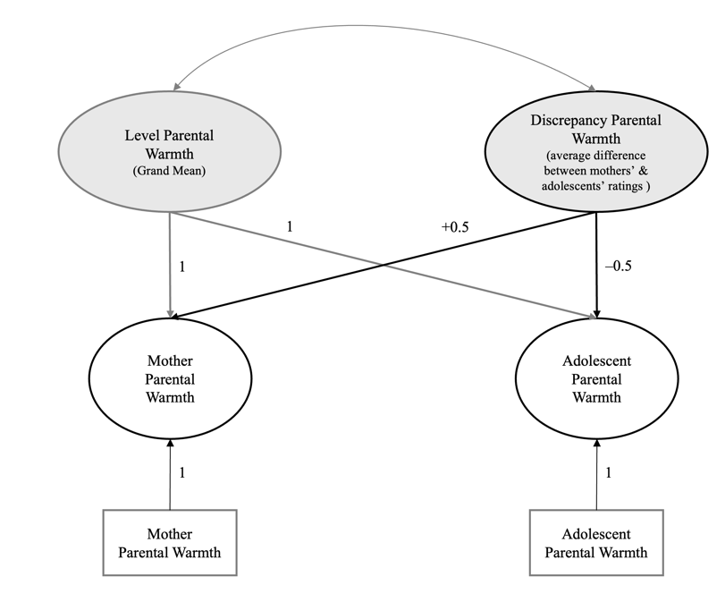
Note. Estimation of latent mean level and difference in maternal warmth illustrated for the 3rd grade. These latent variables were estimated on the within-family level, for each grade separately (3rd to 9th grade). The residuals of the observed variables were fixed to 0

Figure 2a. RI-CLPM - Within-Person Level
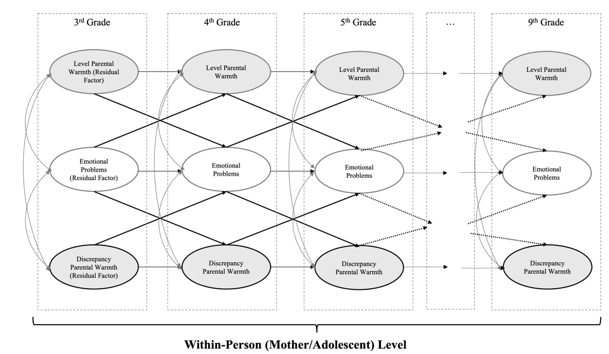
Note. Simple representation of the cross-lagged and autoregressive paths on the within-mother/child level.

Figure 2b. RI-CLPM - Between-Person Level
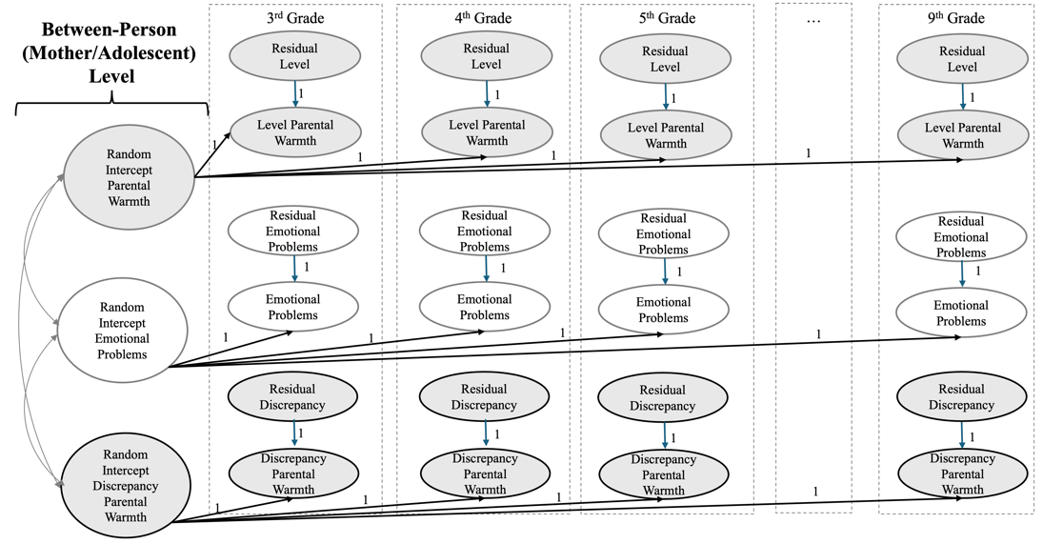
Note. Simple representation of the correlational structure on the between-mother/child level. Predictions on the random intercept factors by the control variables are not shown.

