Supplemental Information
The combination of HDACi encapsulated liposomal vaccines with oncolytic peptide QR-KLU induces an immune-mediated abscopal effect for cancer immunotherapy
Tao Sun^{2#}, Jingjing Du^{3#}, Yu Lei^{2#}, Jun Guo⁴, Chuansheng Zheng²*, Dongyuan Wang¹*
- Department of Pharmacy, Union Hospital, Tongji Medical College, Huazhong University of Science and Technology, Wuhan, China.
- Department of Radiology, Union Hospital, Tongji Medical College, Huazhong University of Science and Technology, Wuhan 430022, China.
3.Hubei Key Laboratory of Kidney Disease Pathogenesis and Intervention, College of Medicine, Hubei Polytechnic University, Huangshi, China
4. Key Laboratory of Pesticide and Chemical Biology of Ministry of Education, Hubei International Scientific and Technological Cooperation Base of Pesticide and Green Synthesis, International Joint Research Center for Intelligent Biosensing Technology and Health, College of Chemistry, Central China Normal University, Wuhan, China.

#These authors contributed equally to this work.
*Correspondence to: Wang Dongyuan, E-mail: wangdy2019@hust.edu.cn；Zheng Chuansheng, Email: hqzcsxh@sina.com.

Fig. S1. HPLC and MS analyses of Pam2-MUC1 peptide were performed applying a linear gradient (30-90%) of buffer B (acetonitrile) in buffer A (water) over 25 min, afforded pure product as a while solid. HRMS: Calcd for C59H99N18O23 [M+2H]2+ m/z = 773.01; [M+H+Na]2+ m/z = 784.01; observed: 773.40 [M+2H]2+, 784.00 [M+ H+Na]2+.

Fig. S2. The molar ratio of SAHA encapsulated in liposomal vaccines was screened according to encapsulation efficiency. The molar ratio of SAHA: DSPC was screened at 1:10,2:10, 4:10, 6:10, 8:10.

Fig. S3. The selective cell toxicity of SAHA@liposomal vaccines to B16-MUC1 cells but negligible toxicity to AML-12 cell. The SAHA@liposomal vaccines were composed of MUC1 antigens, αGalcer, DSPC, cholesterol and SAHA(a 10:5:50:40 :5molar ratio). The final concentration of SAHA was 0 μM, 2.5 μM, 5 μM, 10 μM, respectively.

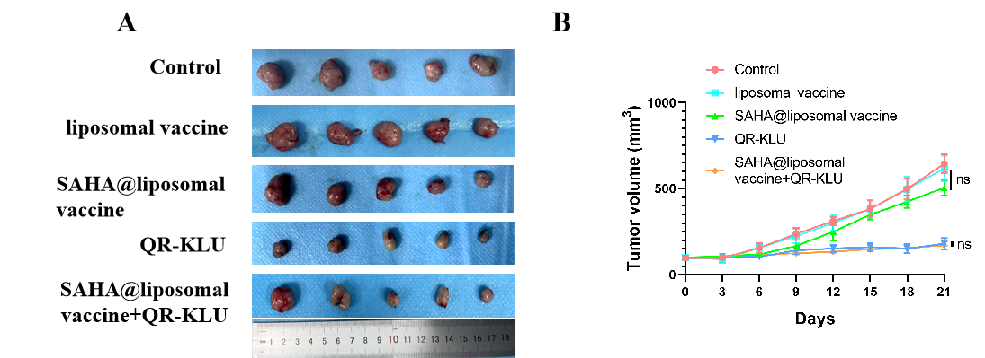
Fig.S4. Evaluation of tumor growth inhibition in subcutaneous liver cancer bearing mouse model by different treatment regimens (n=5). (A) Photograph of tumor samples collected from mice in each treatment group. (B) A line chart depicting the temporal progression of tumor size. (Ns, no signiﬁcant diﬀerence; *p<0.05; **p<0.01; ***p<0.001).

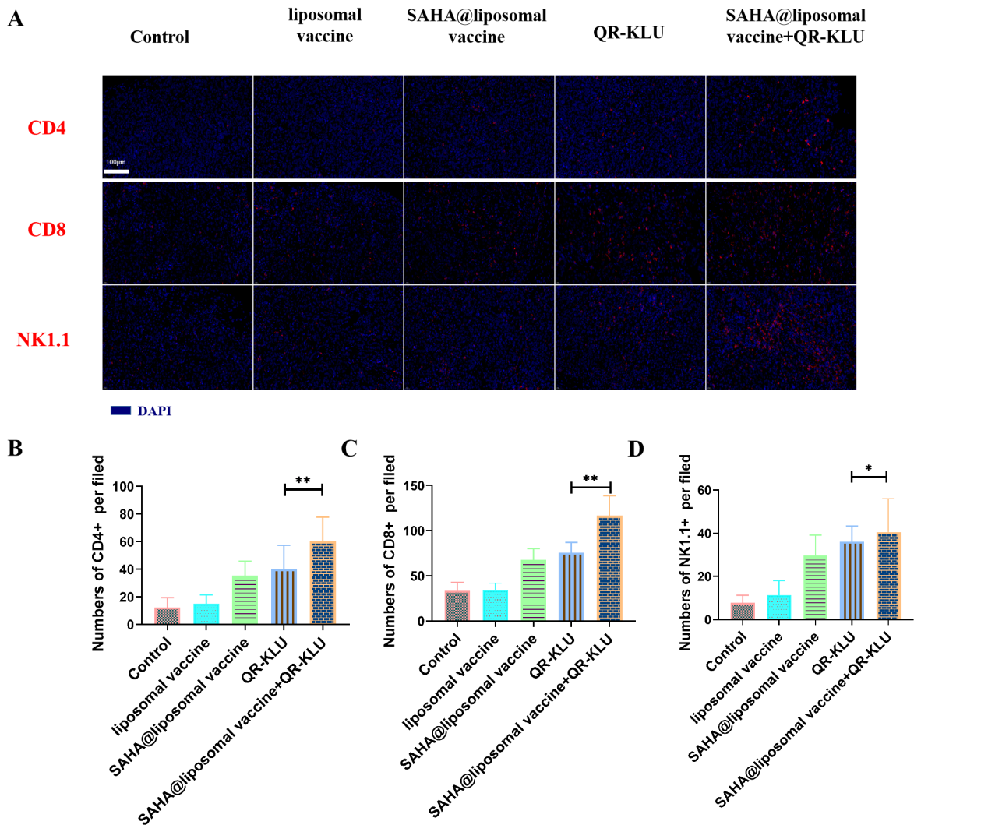
Fig. S5. Quantification of immune cell infiltration in melanoma tumor tissues following various treatments. (A) Representative immunofluorescence of CD4⁺T cells, CD8⁺T cells and NK cells in tumors; (B-D) Quantitative analysis of the percentages of CD4⁺T cells, CD8⁺T cells and NK cells in tumors 14 days after treatments. (Ns, no significant difference; *p<0.05; **p<0.01; ***p<0.001).

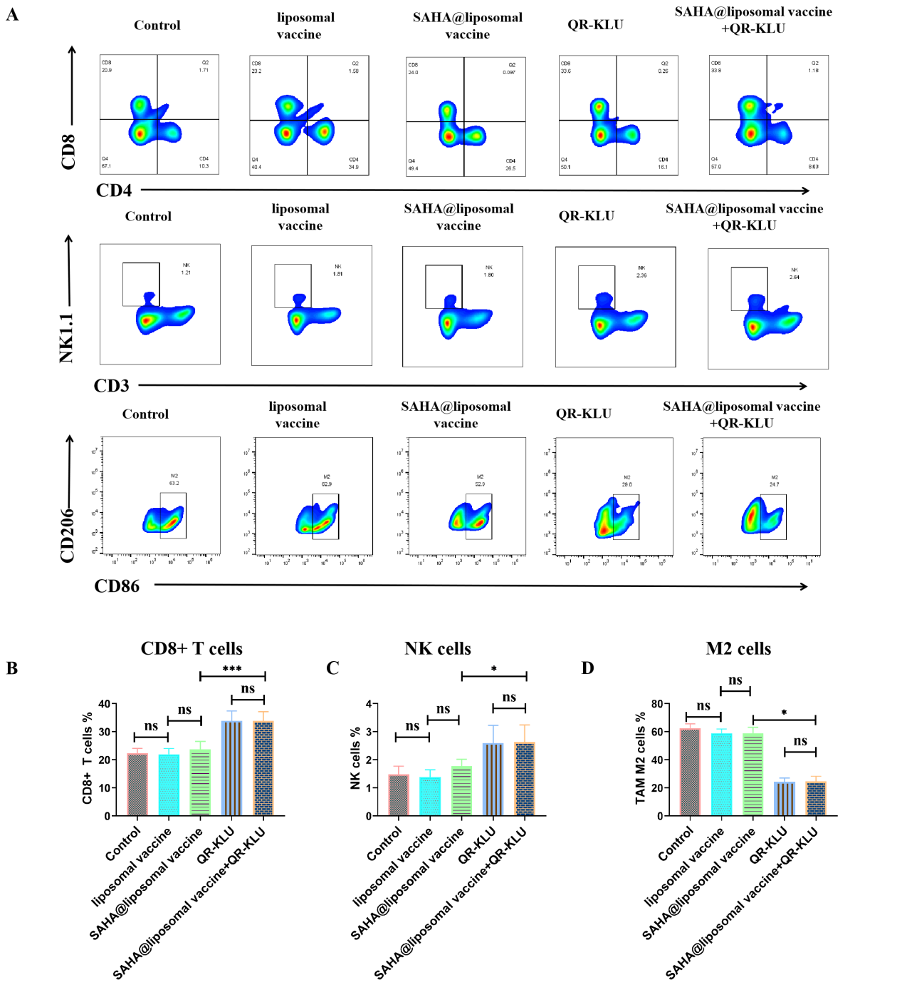
Fig. S6. Enhanced anti-tumor immunity after SAHA@liposomal vaccine+QR-KLU in liver cancer bearing mice model (n=5). (A) Representative dot plots of CD8⁺T cells, NK cells, and TAM of tumors；(B-D) Quantitative analysis of the percentages of CD8⁺ T cells, NK cells, and M2 in tumors 14 days after treatments. (Ns, no significant difference; *p<0.05; **p<0.01; ***p<0.001).

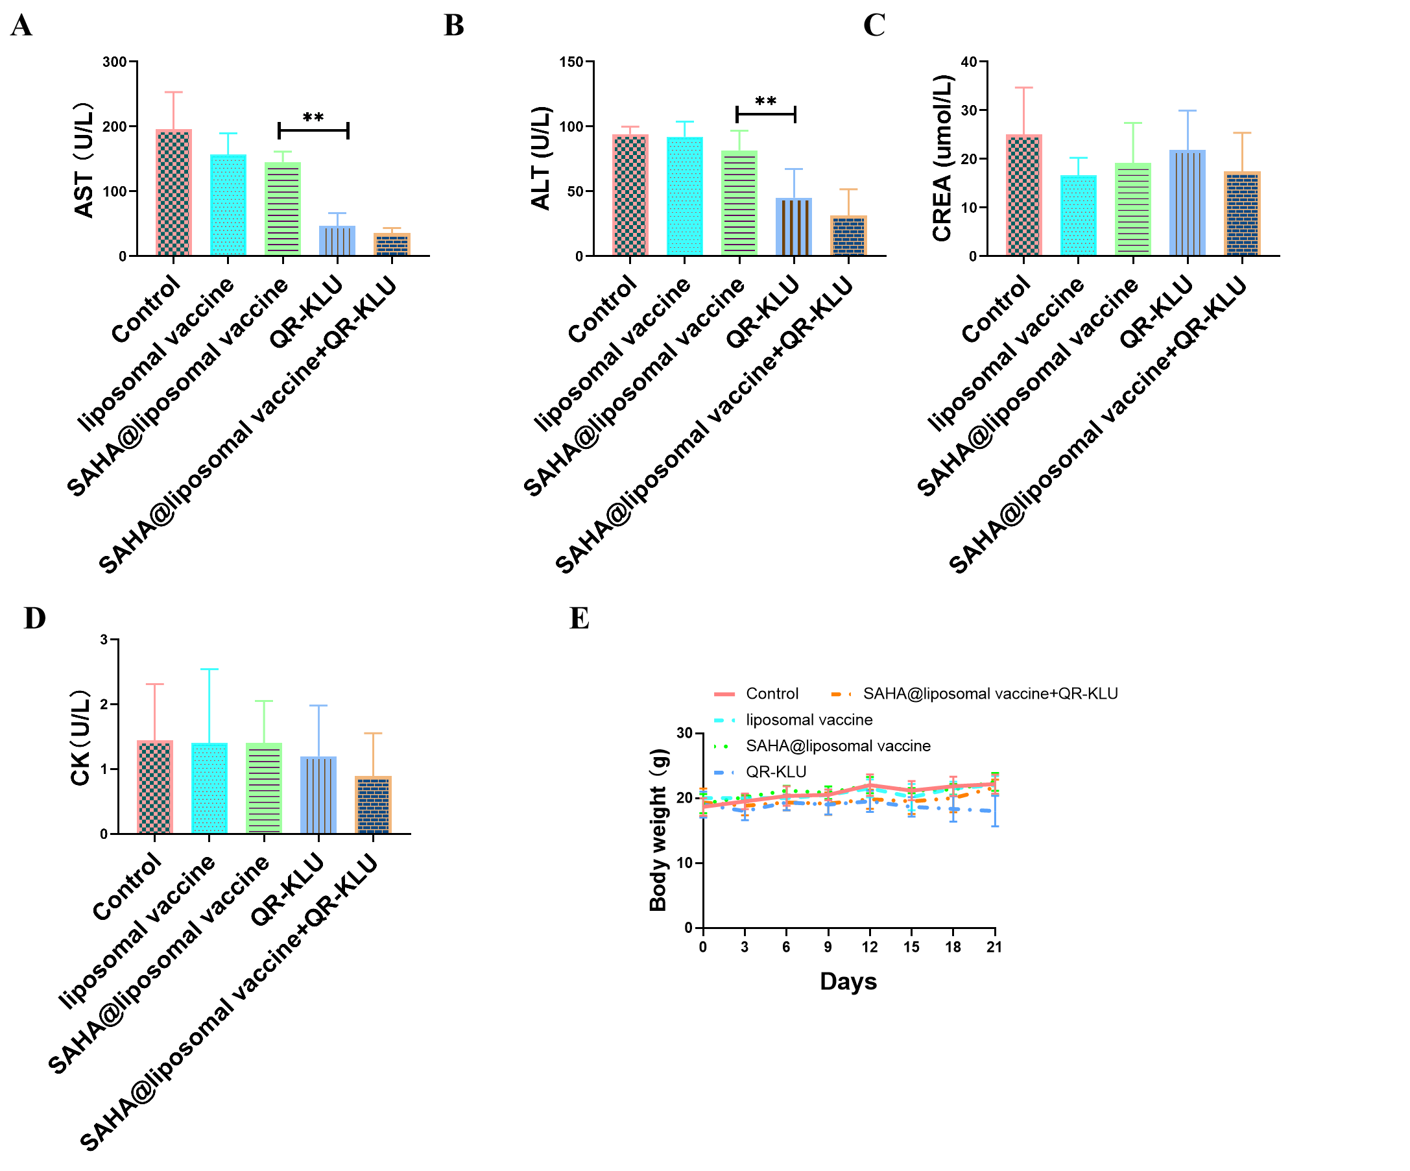
Fig. S7. Safety assessment of SAHA@liposomal vaccine+QR-KLU therapy (n=5; Ns, no significant difference; *p<0.05; **p<0.01; ***p<0.001).

Fig.S8 Histopathological analysis of major organs in mice following various treatments.

