Supplementary Material
Fig. S1 (A) Chemical structure of TPZ and (B) M1, a metabolite of TPZ
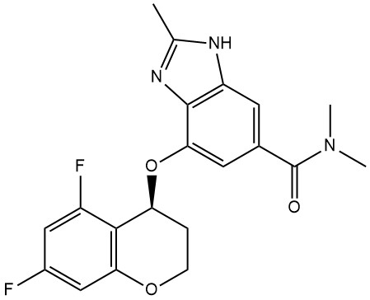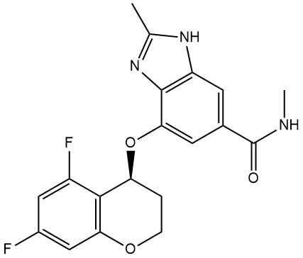
(A)
(B)

Table S1. Incidence of treatment-emergent adverse events post-dosing
 | Test(N=40) | Ref(N=41)
Any Event | 6(15.00), [6] | 7(17.07), [16]
p-value^{[A]} | 0.7794^{[C]}
Investigations | 5(12.50), [5] | 6(14.63), [14]
Haemoglobin decreased | 1(2.50), [1] | 3(7.32), [3]
White blood cells urine positive | 0(0.00), [0] | 2(4.88), [2]
Bacterial test positive | 1(2.50), [1] | 1(2.44), [1]
Neutrophil count decreased | 2(5.00), [2] | 0(0.00), [0]
Blood bilirubin increased | 0(0.00), [0] | 1(2.44), [1]
Blood cholesterol increased | 1(2.50), [1] | 0(0.00), [0]
Lymphocyte count decreased | 0(0.00), [0] | 1(2.44), [1]
Neutrophil count increased | 0(0.00), [0] | 1(2.44), [1]
Red blood cell count decreased | 0(0.00), [0] | 1(2.44), [1]
Urinary squamous epithelial cells increased | 0(0.00), [0] | 1(2.44), [1]
White blood cell count increased | 0(0.00), [0] | 1(2.44), [1]
Infections and infestations | 0(0.00), [0] | 2(4.88), [2]
Hordeolum | 0(0.00), [0] | 1(2.44), [1]
Overgrowth fungal | 0(0.00), [0] | 1(2.44), [1]
Nervous system disorders | 1(2.50), [1] | 0(0.00), [0]
Dizziness | 1(2.50), [1] | 0(0.00), [0]
Test: TPZ-ASD tablet; Reference : K-Cab Tab®.
Explanation: Number of subjects(percentage of subjects), [number of cases]
Dictionary: Medical dictionary for regulatory activities (MedDRA) version 27.0
[A] Comparison between groups: Pearson’s chi-square teest [C] or Fisher’s exact test [F]

