Supplementary material

Studies on pH dependent color variation and decomposition mechanism of Brilliant Green dye in Fenton reaction

Ch.Venkatanarasimha Rao, Ardendu Sekhar Giri,
Vibhav V Goud and Animes Kumar Golder

Table S1 Composition of industrial dyeing effluents.
Background anions, mg L⁻¹ |  |  | Background cations,  mg L⁻¹ |  |  | Source
Cl⁻ | SO₄²⁻ | PO₄³⁻ | Na⁺ | Ca²⁺ | Mg²⁺ | Source
3200 | 412 | 6.25 | 1600 | 368 | 221 | Vijayageetha et al., 2014
78.03 | 34.34 | 2.63 | 88.45 | 62.9 | 8.87 | Jolly et al., 2012
557 | 4.2 | 2.4 | - | - | - | Doble and Anil, 2005
189 | 120 | - | 159 | 27 | - | Kumar et al., 2003
1006 | 142.6 | 3.8 | 615.8 | 152.6 | 114.9 | Average value

Table S2 Composition of BG dye solution spiked with background species.
Salts added |  | Anions |  |  | Cations
Salt name | Concentration, mg L⁻¹ | Cl⁻ | SO₄²⁻ | PO₄³⁻ | Na⁺ | Ca²⁺ | Mg²⁺
CaCl₂ | 415.5 | 1005 | 140 | 3.8 | 618.8 | 150 | 115
MgCl₂ | 450.4
Na₂HPO₄ | 5.641
NaCl | 1397
Na₂SO₄ | 207

Fig. S1 Effect of Fe²⁺/H₂O₂ on dye decolorization and COD reduction. Experimental conditions: initial BG dye concentration 50 mg L⁻¹, Fe²⁺ concentration 56 mg L⁻¹, H₂O₂ concentration 170 mg L⁻¹, pH 3, agitation speed 270 rpm, temperature 25 2 ºC and solution volume 400 mL.

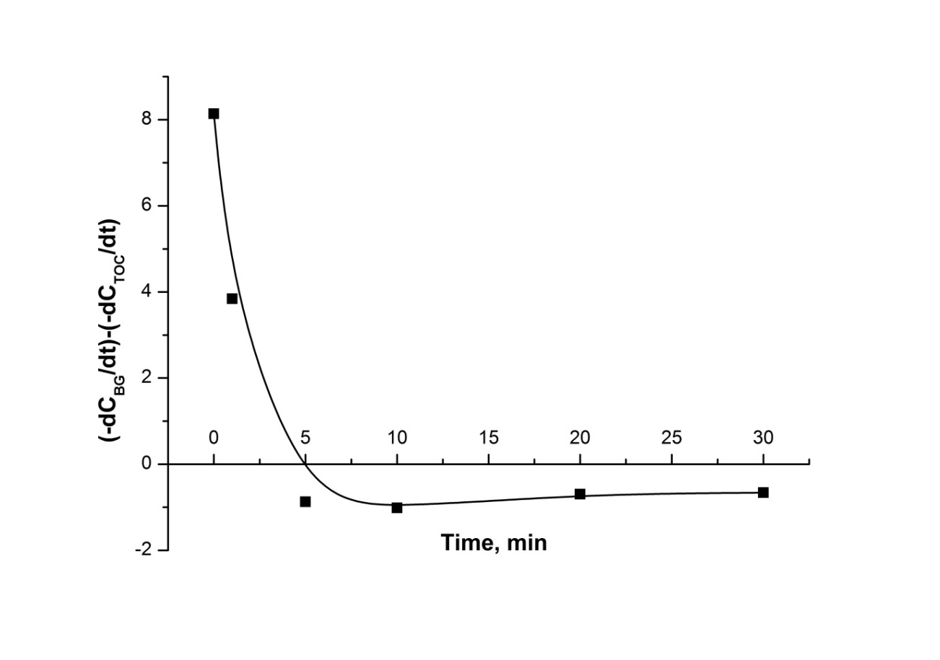
Fig. S2 Effect of the reaction time on decolorization and mineralization rates. Experimental conditions: initial BG dye concentration 50 mg L⁻¹, Fe²⁺ concentration 56 mg L⁻¹, H₂O₂ concentration 170 mg L⁻¹, pH 3, agitation speed 270 rpm, temperature 252 ºC and solution volume 400 mL.

Fig. S3 MS spectra acquired in Fenton oxidation of BG dye at 30 min of reaction time. Experimental conditions: initial BG concentration 50 mg L⁻¹, Fe²⁺ concentration 56 mg L⁻¹, H₂O₂ concentration 340 mg L⁻¹, Fe³⁺ concentration 56 mg L⁻¹, pH 3, agitation speed 270 rpm, temperature 252 ºC and solution volume 400 mL. Salt concentrations (mg L⁻¹): CaCl₂ 415.5, MgCl₂ 450.4, Na₂HPO₄ 5.641, NaCl 1397.4, Na₂SO₄ 207.

References
Vijayageetha VA, Rajan AP, Arockiaraj SP, Annamalai V, Janakarajan VN, Saravana MD, Dheenadhayalan MS (2014) Treatment study of dyeing industry effluents using reverse osmosis technology. Res J Recent Sci 3: 58-61
Jolly YN, Islam A, Mustafa AI (2012) Impact of dying industry effluent on soil and crop. Univers J Environ Res Technol 2: 560-568
Doble M, Anil K (2005) Biotreatment of industrial effluents. Butterworth-Heinemann, UK
Kumar A, Bohra C, Singh LK (2003) Environment, pollution and management. APH, India

